**POPULATION STATISTICS:** Dataset was provided by the World Bank Group (2022). I used R programming to perform clustering analysis.

**Hierarchical Clustering-Countries**

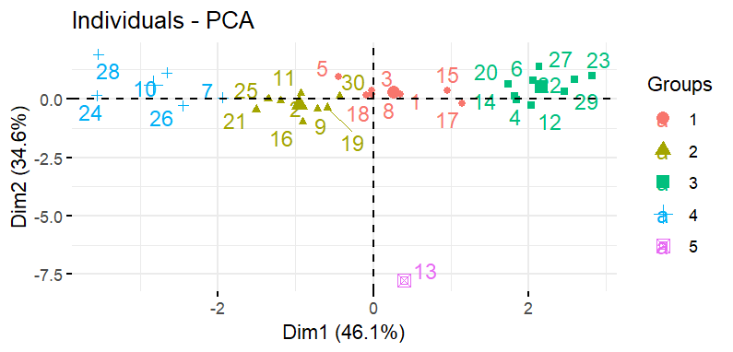

**Kmeans clustering-Countries**

