**STATE DATA**: Data set was provided by Rowan University. I used R programming to do clustering analysis to classify states according to their data in the dataset.

**Hierarchical Clustering-States**

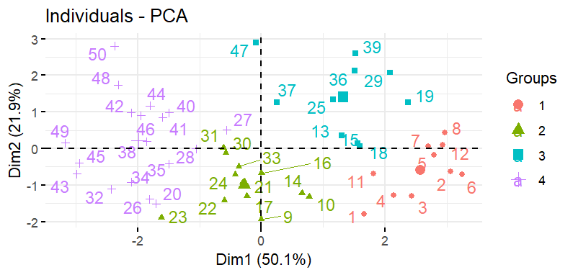

**Kmeans clustering-States**

