WasteKart – Game Design Document
Oct 11, 2026 · @You

Overview
WasteKart is a top-down, SNES-Mario-Kart-inspired racer in which nobody steers: each player draws the line their kart will drive, then all karts race their lines for one lap. It supports 1–4 players on one device, plays in the browser with the iPad as its main target device, and ships as a minigame inside GameHub. Players may choose Single Race for one track and repeatable practice, or Cup Racing for a four-track championship with cumulative points.
Design pillars
- Draw to win. The race is decided by the line, not by reflexes. Smooth, wide curves and staying on the road are faster; shortcuts across grass are slower.
- Fast rounds. A race is draw (timed), countdown, one lap. Nothing needs to be learned beyond "draw a line".
- Readable at a glance. Flat top-down tracks, clear road edges, and one colour per player line.
- Original assets. Tracks and karts are our own designs. The SNES Mario Circuit map is a layout reference only and is not copied.
Platform: Python with pygame, packaged to WebAssembly with pygbag, built and published to GitHub Pages by GitHub Actions (already in place).

Core gameplay loop
One race has five steps. Single Race runs the loop once on a chosen track; Cup Racing repeats it across all four tracks of the selected cup.
- Set up. Choose Single Race or Cup Racing, player count, drawing time, a cup (and in Single Race, a track), and a kart for each player.
- Draw, in turns. Each player in order draws their driving line on the track within the time limit. Lines already drawn stay visible as light dashed lines in their owners' colours.
- Countdown. A Mario-Kart-style traffic light runs (red, red, red, green) once every line is drawn.
- Race. All karts start together and follow their own lines. Speed depends on the curve radius at the kart's position and on whether it is on the road.
- Finish. After one lap, results show finish order and times. Single Race offers replay or another track; Cup Racing shows cumulative standings, advances to the next course, and celebrates the cup champion after race four.
The tension of the loop sits in step 2: a straight, wide line is fast but may cut across grass, while a careful line hugs the road and costs distance.

Game flow and menus
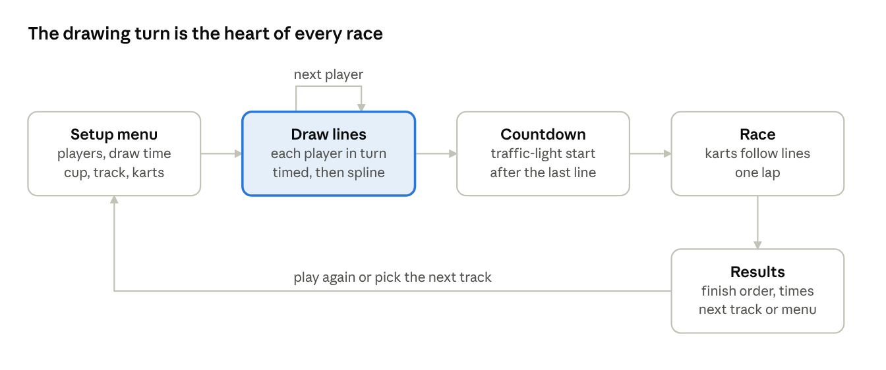
game flow · 5 stages, 1 per-player loop
Race modes. Single Race is a standalone one-lap race on any of the 16 tracks, with replay for practice. Cup Racing runs all four tracks of a selected cup in order and crowns a winner from cumulative points. Both modes support 1–4 players and use identical drawing and driving rules.
The setup menu has three steps before any drawing starts:
- Mode, players and time. Choose Single Race or Cup Racing, 1–4 players, and 15, 30 or 60 seconds of drawing time per turn, or unlimited.
- Cup and track. Single Race: choose any cup and one of its four tracks. Cup Racing: choose a cup and race all four tracks in sequence.
- Karts. Each player picks a kart.
Players act only during setup and their drawing turns. Countdown and racing run automatically. Single Race ends with Race Again, Choose Track or Home. In Cup Racing, each result shows the race order and cumulative points, then Next Track; after track four the cup podium offers Replay Cup or Home.

Drawing phase
Each player draws one continuous line with mouse or touch; the game turns the raw stroke into a smooth spline the kart can follow.
- Input. Touch is the primary input, with the iPad as the target device, and a mouse works too. Points are recorded while the finger or pointer is down, and a new point is stored only after the pointer has moved a minimum distance (about 8 px in track space) to keep jitter out.
- Start. The line is anchored to the player's grid slot on the start line, so the kart always begins on the grid.
- Smoothing. The stored points are the control points of a Catmull-Rom spline, which passes through every point. Sampling the spline at a fixed step gives a dense polyline for driving and for radius calculation.
- Timer. A per-turn countdown is shown on screen, with a choice of 15, 30 or 60 seconds, or unlimited. When it hits zero, the stroke is cut off where it is.
- Redraw. A player may clear and redraw as long as time remains.
- Unfinished lines. If the line does not reach the finish line, the game extends it with a straight segment from the last point to the finish line, so every kart can complete the lap. Because a straight cut usually leaves the road, this is slow, which is the penalty.
- Visibility. Lines are coloured per player. Other players' lines are drawn as light dashed lines in their owners' colours during a turn, so later players can react to them.

Race phase and speed model
Karts do not steer. Each kart moves along its own sampled spline by arc length, and its speed at every step comes from the local curve radius and the surface under it.
Radius. At each sample, the radius r is the circumradius of that sample and its neighbours a few samples either side, averaged over a short window so hand jitter does not read as a tight corner. A straight stretch has a very large r.
Speed. Speed rises with radius up to a cap and is then scaled by the surface:
v = \left(v_{min} + (v_{max} - v_{min}) \cdot \min\!\left(1, \frac{r}{r_{max}}\right)\right) \cdot k_{surface}
Parameter | Starting value | Meaning
v_min | 40% of v_max | Speed in the tightest corner
v_max | tuned per track | Speed on a straight on the road
r_max | about 4 track widths | Radius at or above which a curve counts as straight
k_surface, road | 1.0 | Kart is on the road
k_surface, off-road | 0.55 | Kart is on grass or any non-road tile
All values are first guesses to be tuned by playtesting.
On-track test. Each track has a road mask. The kart's centre pixel is looked up in the mask every frame, so the check costs one lookup per kart.
Lap and finish. One lap equals the kart's full path length. A kart finishes when it reaches the end of its line after crossing the finish line. Position is ranked by finish time, and unfinished karts are ranked by distance covered.
Kart look. The sprite rotates to the spline tangent, so a smooth line looks like smooth driving.
Single player and ghost. With one player, the opponent is a ghost: the fastest line driven on that track earlier in the current session, similar to the ghost in Gran Turismo. On the first run there is no ghost, so the player races alone. If a new run is faster than the stored best, its line becomes the new ghost. The ghost drives with the same speed model as a normal kart. It is held in memory only and is lost when the game is closed. Nothing is saved on the device, so no cookies or local storage are used.

Tracks, cups and assets
There are four cups of four tracks each, 16 tracks in total. Tracks are simple top-down circuits in the spirit of SNES Mario Circuit 1, used as a layout reference only. Every track has its own artwork and geometry.
Asset folders
assets/WasteKart/
Karts/
Tracks/
Cups/
Cup1/
Cup2/
Cup3/
Cup4/
Per-track data (proposed). Each track folder entry holds three things:
Item | Purpose
Track image | The artwork shown on screen
Road mask | A matching image where road pixels are marked, used for the on-track test
Track metadata | Name, cup and number, start/finish line, grid slots for 1–4 karts, default v_max
The road mask is kept separate from the artwork so the art can change without changing gameplay.
Karts. Players pick from a set of kart sprites in the Karts folder. Eight kart sprites exist in the first build. For now a kart is cosmetic only and does not change speed, so the race stays decided by the drawn line. Later, karts should get different driving parameters, as in Mario Kart 64, so the speed model should read its constants per kart.
Cups. A cup is scored across all of its races, as in Mario Kart 64: each race awards points by finishing place, and the player with the most points after the last race wins the cup. Points are 9 for first place, 6 for second, 3 for third and 1 for fourth. Single Race does not contribute championship points; its result is independent of the cup standings.

Technical architecture
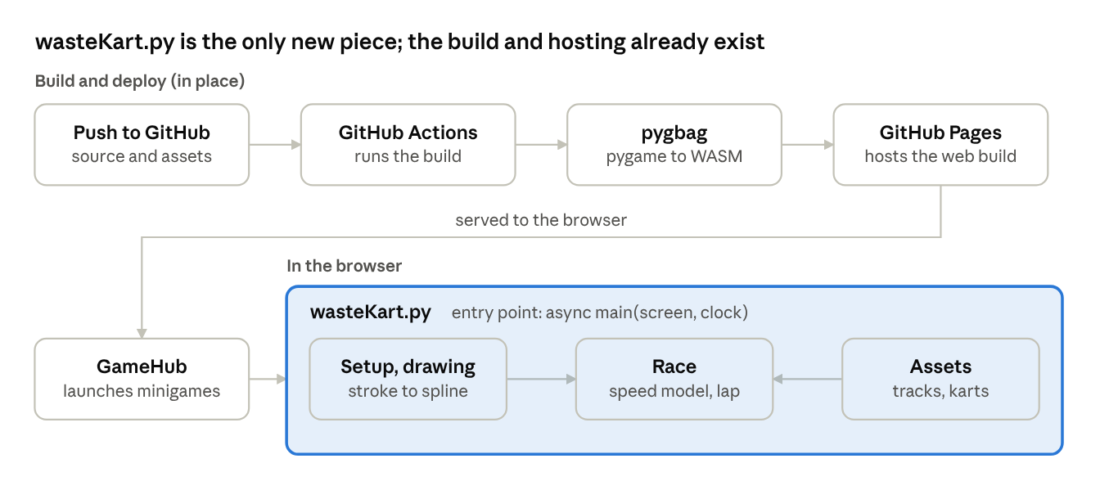
architecture · build pipeline and runtime
A push triggers GitHub Actions, which builds the pygame project with pygbag into a WebAssembly bundle and publishes it to GitHub Pages. That path is already working. WasteKart is a new minigame, wasteKart.py, launched from GameHub through the same async main(screen, clock) entry point the existing minigames use.
- Async main loop. pygbag needs the game loop to hand control back to the browser every frame, so the loop awaits asyncio.sleep(0) once per frame.
- Precompute before racing. The spline is sampled and its radii computed once when drawing ends. The race loop then only advances each kart along an array and reads the road mask.
- Assets. Tracks, masks and kart sprites are loaded from assets/WasteKart/ and are packaged by the pygbag build with the game.
- State. The game is a small state machine (setup, drawing, countdown, race, results) matching the flow above, so each stage can be tested on its own.

Stretch goals
None of these are in the first version. The first version only keeps small hooks so they can be added without rewriting the race code.
Goal | What it adds | Hook to keep in v1
A. Reflex start | Four buttons, one per player. After the green light each player presses theirs, and reaction time sets a start boost; pressing too early gives a penalty. | Each kart has a start-speed modifier that defaults to 1.0.
B. Power-ups | Random pickups on the road, used with the same per-player button as the reflex start. | One input action per player, and a list of track entities that karts can overlap.
C. Kart interaction | Karts that drive the same line interact, for example by slipstreaming or blocking each other. | Every kart exposes its position along its path and a list of speed modifiers.
Building A first is the cheapest, because it only needs the countdown to read one input per player and write one number per kart.

Open questions, risks and milestones
Open questions
- ☒ A single player races against a ghost of their fastest earlier line; the first run has no opponent.
- ☒ Lines already drawn stay visible as light dashed lines in their owners' colours.
☒ Both Single Race (one track) and Cup Racing (four tracks) are offered.
- ☒ A cup is scored across all of its races, as in Mario Kart 64.
- ☒ Karts are cosmetic for now; different driving parameters come later.
- ☒ Drawing times are 15, 30 and 60 seconds, plus unlimited.
- ☒ Touch input is required, with the iPad as the target device.
- ☒ Points per race are 9, 6, 3 and 1 for places one to four.
- ☒ Nothing is saved on the device, so the ghost lives only for the current session.
Risks
- Balance. The speed model rewards wide curves, so the best line may always be the same one per track. Playtesting and track design must create several good choices.
- Browser performance. Per-frame mask lookups and spline sampling for four karts must stay smooth under pygbag. Precomputing the sampled path before the race keeps the per-frame work small.
- Input differences. Touch on the iPad is the main input. Safari can treat finger drags as page scrolling or gestures, so the drawing area must capture touch input, and it needs testing on a real iPad as well as with a mouse.
Milestones
- First playable: setup menu, turn-based drawing, countdown, one-lap race, 16 tracks, 8 karts. A first build exists and is being tested for lap completion, the speed model, unfinished drawings and off-road shortcuts.
- Balance pass: tune the speed parameters and check every track for a dominant line.
- Race modes: keep Single Race practice; add four-track Cup Racing with points and a final podium.
- Stretch A: reflex start.
- Stretch B: power-ups.
- Stretch C: kart interaction. After that, per-kart driving parameters.

