REFERENCE: Generic_SW_SDD_0000118700000234
Confidential
IK_PSA_OS
Generic

Software Detailed Design (SDD)
OS SW component
VERSION | AUTHOR |  | APPROVAL
 | NAME | DATE | NAME | DATE
01.2 | S.GENTNER | 26-April-10
Revision history

VERSION | DATE | STATE | AUTHOR | CHANGE DESCRIPTION
1.2 | 26-April-10 | Draft | S.GENTNER | New OS interfaces with variable messages parameters

States of this document: draft, reviewed, approved

Template revision history

VERSION | DATE | STATE | AUTHOR | CHANGE DESCRIPTION
00.1 | 14-Jan-08 | draft | C. JACQUIN | Initial version of SDD template

States of template: draft, reviewed, approved

Table of contents

1 Introduction 5
1.1 Scope of the document 5
1.2 Abbreviations 5
1.3 Reference documents 5
2 Software component overview 6
2.1 Functional overview 6
2.1.1 Sub-functionality “Task Scheduling” 7
2.1.2 Sub-functionality “Communication and Code Execution By Message Posting 7
2.1.3 Sub-functionality “One Shot and Cyclic Timers” 7
2.1.4 Sub-functionality “Event Communication” 7
2.1.5 Sub-functionality “CPU Load Computation/Perfmeter function” 7
2.2 Interfaces 7
2.3 Internal structure overview 8
2.3.1 SW units 8
2.3.2 SW files 8
3 Detailed description of the SW component 9
3.1 SW Unit: Os_Task 9
3.1.1 Operations and attributes 9
3.1.1.1 Types 9
3.1.1.2 Operations 10
3.1.1.3 Attributes 11
3.1.1.4 Macros 11
3.2 SW Unit: Os_Timer 12
3.2.1 Operations and attributes 12
3.2.1.1 Types 12
3.2.1.2 Operations 12
3.2.1.3 Attributes 13
3.2.1.4 Macros 13
3.3 SW Unit: Os_Fifo 13
3.3.1 Operations and attributes 13
3.3.1.1 Types 13
3.3.1.2 Operations 14
3.3.1.3 Attributes 15
3.3.1.4 Macros 15
3.4 SW Unit: Os_Event 16
3.4.1 Operations and attributes 16
3.4.1.1 Types 16
3.4.1.2 Operations 16
3.4.1.3 Attributes 17
3.4.1.4 Macros 17
3.5 SW Unit: Os_Cfg 18
3.5.1 Operations and attributes 18
3.5.1.1 Types 18
3.5.1.2 Operations 20
3.5.1.3 Attributes 21
3.5.1.4 Macros 22
3.5.2 Dynamic behavior description 23
3.5.2.1 Sequence diagrams 25
4 Requirements traceability 26
5 Resources allocation 27
5.1 Memory consumption 27
5.2 CPU load / Execution timings 27
5.3 Verification criteria 27
6 Open issues 29

Introduction

Scope of the document
This document describes the Detailed Design for the SW component OS of the embedded software for ICP_B7 project that use a RTC Timer on a MC9S08DZ60 or MC9S08DZ96 microcontroller, and is composed of the following items:
- Abbreviations glossary
- Reference documents
- Software component overview
- Detailed description of the software component
- Resources allocation.

Abbreviations
This paragraph gives the list of all abbreviations and acronyms used in this document.

ABBREVIATION | SIGNIFICATION
RTC | Real time clock
IPC | Inter process communication
OS | Operating System
SDD | Software Design Document
REQ | REQuirement
SW | SoftWare

Reference documents
Nr | Reference | Document title | Version | Date
[1] |  | OS_SW_Detailed Design : IK_OS | B | 22nd Mar 06
[2]
[3]
[4]
[5]

Software component overview
The graphical modelling language used for diagrams in this chapter is OMG UML 2.1.

Functional overview
SDD_OS-2.0-2.1.01: The Application components and software components in the various layers of s/w uses different functionalities of OS. OS manages the hardware resources of the microcontroller effectively.

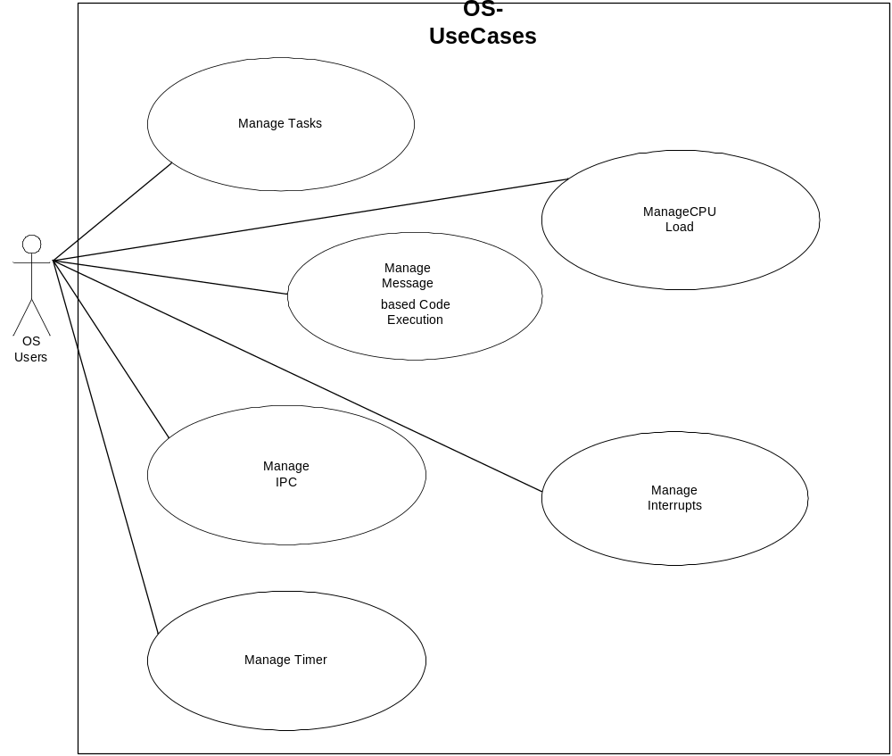

Sub-functionality “Task Scheduling”
SDD_OS-2.0-2.1.1.01: Task Scheduling supports both cyclic and one time scheduling. There is no priority between tasks. All pending tasks are scheduled before any message is processed.
  - OS Activate Task: The task will be scheduled after expiration time and every cyclic time ticks.
  - OS Cancel Task: Cancel the scheduling of the mentioned task
  - OS Cancel All Task: Cancel the scheduling of all Tasks.

Sub-functionality “Communication and Code Execution By Message Posting
SDD_OS-2.0-2.1.2.01: The execution of a function by posting the details of function to be executed to the message queue.
  - OS Post Message: The message will be posted at the end of OS Queue.
  - OS Post Priority Message: The message will be posted at the front of OS Queue.

Sub-functionality “One Shot and Cyclic Timers”
SDD_OS-2.0-2.1.3.01: The software timers are configured to send the message to OS queue.
  - OS Set Relative Timer: Sets the OS software timer to send a message after an expiration time and cyclically at a periodic rate thereafter.
  - OS Cancel Timer: To cancel the particular timer.
  - OS Cancel All Timers: To cancel all the OS s/w timers

Sub-functionality “Event Communication”
SDD_OS-2.0-2.1.4.01: Different processes can communicate via events. An event is a shared variable identified by a unique ID.
  - OS Set Event: Bits set in the mask variable will be set in the corresponding event, other bits will remain unchanged.
  - OS Clear Event: Bits set in the mask variable will be cleared in the corresponding event, other bits will remain unchanged.
  - OS Get Event: Bits set in the mask variable will be copied
  - OS Clear All Events: All events will be cleared

Sub-functionality “CPU Load Computation/Perfmeter function”
SDD_OS-2.0-2.1.5.01: This functionality is used for computation of system load, Ideal load.
  - OS Perf Meter: This OS function computes the system load at a particular rate ( egs 10ms)

Interfaces
SDD_OS-2.0-2.2.01: The OS Component is in relation with:
- Hardware Components that use a Real time clock for Basic Clock Ticks of 1 ms.
- Microcontroller hardware registers for basic initialisation.

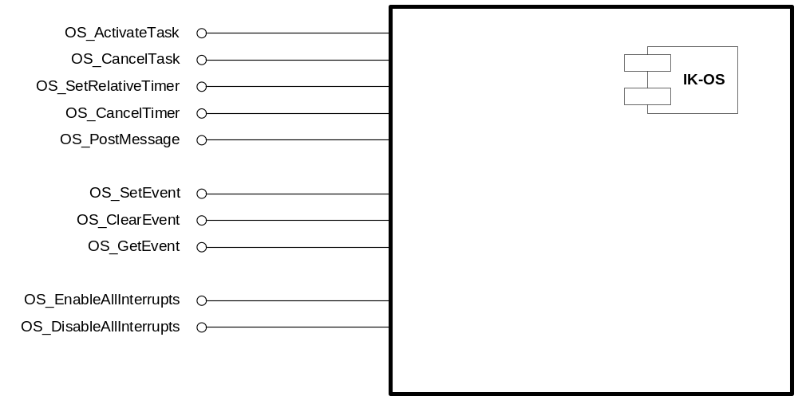

Internal structure overview

SW units
The SW component OS is subdivided into SW units.

SW files
The SW component OS is composed of 17 SW files:
- OS_DataPipe.c, OS_Event.c, OS_FifoSys.c, OS_Main.c, OS_MsgPipe.c, OS_Task.c, OS_Timer.c, OS_Cfg.c: C source file.
- OS.h, OS_DataPipe.h, OS_Event.h, OS_FifoSys.h, OS_MsgPipe.h, OS_Task.h, OS_Timer.h, templ_fifo.h: Header file.
- OS_Cfg.h: Configuration file.

Detailed description of the SW component

SW Unit: Os_Task

Operations and attributes

Types

Name | OS_TimeType
Visibility | Public
Type | Unsigned short
Range | 0-65535
Description | Defining time value

Name | OS_IndexType
Visibility | Public
Type | Unsigned short
Range | 0-65535
Description | Defining index values of 16bit resolution

Name | pTaskHandler
Visibility | Public
Type | typedef void (* const pTaskHandler)(void)
Range | NA
Description | The Task function pointer type

Name | OS_TaskType
Visibility | Public
Type | struct
Range | typedef struct  {  OS_TimeType Expiration;  OS_TimeType Reload;  OS_IndexType Schedule;  pTaskHandler pTaskFct;  } OS_TaskType
Description | Data type for defining a task

Name | OS_TaskID
Visibility | Public
Type | enum
Range | 0-255
Description | The task ID’s are defined as an enumeration

Name | OS_Error
Visibility | Public
Type | enum
Range | OS_NoError=0,  OS_IdOutOfRange=1,  OS_TimerInUse=2,  OS_PipeEmpty=3,  OS_PipeNotEmpty=4,  OS_PipeFull=5,  OS_BufferTooSmall=5,  OS_InvalidParameter=6
Description | The error returned by OS functions are defined as per the above Range

Operations

Name | OS_ActivateTask
Visibility | Public
Signature | OS_Error OS_ActivateTask(OS_TaskID TaskID, OS_TimeType Expiration Time, OS_TimeType Cyclic Time)
Input parameter(s) | OS_TaskID, OS_TimeType, OS_TimeType
Output parameter(s) | None
Return value | OS_NoError | The task has been successfully scheduled.
Return value | OS_IdOutOfRange | The TaskID mentioned as 1st argument is not with in valid task range
Global data used | None
Global function/macro used | None
Description | Schedule a task for activation. This call MUST NOT BE made under IRQ
Linked REQ

Name | OS_CancelTask
Visibility | Public
Signature | OS_Error OS_CancelTask(OS_TaskID TaskID)
Input parameter(s) | OS_TaskID
Output parameter(s) | None
Return value | OS_NoError | The task has been successfully scheduled.
Return value | OS_IdOutOfRange | The TaskID mentioned as 1st argument is not with in valid task range
Global data used | None
Global function/macro used | None
Description | To Cancel a scheduled task. This call MUST NOT BE made under IRQ
Linked REQ

Name | OS_CancelAllTasks
Visibility | Public
Signature | void OS_CancelAllTasks(void)
Input parameter(s) | None
Output parameter(s) | None
Return value | None
Global data used | None
Global function/macro used | None
Description | To Cancel all scheduled tasks.
Linked REQ

Attributes
Name | OS_TaskArray[OS_MaxTask]
Visibility | Public
Type & data structure | OS_TaskType
Description | The array of Task Data structure
Linked REQ

Macros

Name | BEGIN_TASKS
Visibility | Public
Type & data structure | #define
Value | OS_TaskType OS_TaskArray[OS_MaxTask] = {
Description | To improve the readability the start ofTask Data structure decalaration is represented in an easier way

Name | END_TASKS
Visibility | Public
Type & data structure | #define
Value | };
Description

Name | #define DECLARE_TASK(name, time)
Visibility | Public
Type & data structure | #define
Value | {time,time,0,name},
Description

SW Unit: Os_Timer

Operations and attributes

Types

Name | OS_MsgIdType
Visibility | Public
Type | Unsigned char
Range | 0-255
Description | Defining message ID

Name | OS_TimerID
Visibility | Public
Type | enum
Range | 0-255
Description | Defining Timer ID

Name | OS_TimerType
Visibility | Public
Type | struct
Range | typedef struct  {  OS_BoolType Activ;  OS_TimeType Expiration;  OS_TimeType Reload;  OS_MsgIdType PostMsg;  }
Description | Defining Timer Type

Operations

Name | OS_SetRelativeTimer
Visibility | Public
Signature | OS_Error OS_SetRelativeTimer(OS_TimerID TimerID, OS_TimeType ExpirationTime, OS_TimeType CyclicTime,  OS_MsgIdType msgID)
Input parameter(s) | OS_TimerID,OS_TimeType,OS_TimeType,OS_MsgIdType
Output parameter(s) | None
Return value | OS_NoError | The relative timer has been successfully Set.
Return value | OS_IdOutOfRange | The Timer ID mentioned argument is not with in valid Timer ID range
Global data used | None
Global function/macro used | None
Description | To set a relative timer. This call MUST NOT BE made under IRQ
Linked REQ

Name | OS_CancelTimer
Visibility | Public
Signature | OS_Error OS_CancelTimer(OS_TimerID TimerID)
Input parameter(s) | TimerID
Output parameter(s) | None
Return value | OS_NoError | The relative timer has been successfully Cancelled
Return value | OS_IdOutOfRange | The Timer ID mentioned argument is not with in valid Timer ID range
Global data used | None
Global function/macro used | None
Description | To Cancel a Timer. This call MUST NOT BE made under IRQ
Linked REQ

Attributes
NA

Macros
NA

SW Unit: Os_Fifo

Operations and attributes

Types

Name | OS_MsgParamType1
Visibility | Public
Type | Unsigned short
Range | 0-65535
Description | For defining message parameters

Name | OS_MsgParamType2
Visibility | Public
Type | Unsigned short
Range | 0-65535
Description | For defining message parameters

Name | pMsgHandler
Visibility | Public
Type | Function Ptr
Range | typedef void (*pMsgHandler)(OS_MsgParamType1, OS_MsgParamType2);
Description | For defining message with two parameters

Name | pMsgHandler0
Visibility | Public
Type | Function Ptr
Range | typedef void (*pMsgHandler0)(void);
Description | For defining message without parameters

Name | pMsgHandler1
Visibility | Public
Type | Function Ptr
Range | typedef void (*pMsgHandler1)(OS_MsgParamType1);
Description | For defining message with one parameter

Name | OS_MsgHandlerType
Visibility | Public
Type | struct
Range | typedef struct  {  #ifdef OS_DEBUG  OS_MsgIdType MsgId;  #endif  UINT8 ui8ParamNb;  pMsgHandler0 pFct;  } OS_MsgHandlerType;
Description | Data type for defining a Message

Name | OS_Msg
Visibility | Public
Type | struct
Range | typedef struct  {  OS_MsgIdType MsgId;  OS_MsgParamType1 Param1;  OS_MsgParamType2 Param2;  } OS_Msg
Description | Defining a structure of message exchanged by OS

Operations

Name | OS_FifoSys_PushBack
Visibility | Public
Signature | PUBLIC void OS_FifoSys_PushBack( const OS_Msg* elt )
Input parameter(s) | const OS_Msg*
Output parameter(s) | None
Return value | None
Global data used | None
Global function/macro used | None
Description | Push a message for execution to the end of FIFO with 2 parameters
Linked REQ

Name | OS_FifoSys_PushBack0
Visibility | Public
Signature | PUBLIC void OS_FifoSys_PushBack0(OS_MsgIdType MsgId )
Input parameter(s) | const OS_Msg*
Output parameter(s) | None
Return value | None
Global data used | None
Global function/macro used | None
Description | Push a message for execution to the end of FIFO without parameters
Linked REQ

Name | OS_FifoSys_PushBack1
Visibility | Public
Signature | PUBLIC void OS_FifoSys_PushBack1( const OS_Msg* elt )
Input parameter(s) | const OS_Msg*
Output parameter(s) | None
Return value | None
Global data used | None
Global function/macro used | None
Description | Push a message for execution to the end of FIFO with one parameter
Linked REQ

Name | OS_FifoSys_PushFront
Visibility | Public
Signature | PUBLIC void OS_FifoSys_PushFront ( const OS_Msg* elt )
Input parameter(s) | const OS_Msg*
Output parameter(s) | None
Return value | None
Global data used | None
Global function/macro used | None
Description | Push a message for execution to the Front of FIFO
Linked REQ

Attributes
Name | MsgHandler[OS_MsgIDmax]
Visibility | Public
Type & data structure | OS_MsgHandlerType
Description | The array of Message map
Linked REQ

Macros
Name | OS_PostMessage(msg)
Visibility | Public
Type & data structure | #define
Value | OS_FifoSys_PushBack(msg)
Description | This is an API used for posting a message to tail of message queue

Name | OS_PostMessage0(msg)
Visibility | Public
Type & data structure | #define
Value | OS_FifoSys_PushBack0(msg)
Description | This is an API used for posting a message to tail of message queue

Name | OS_PostMessage1(msg)
Visibility | Public
Type & data structure | #define
Value | OS_FifoSys_PushBack1(msg)
Description | This is an API used for posting a message to tail of message queue

Name | OS_PostPriorityMessage(msg)
Visibility | Public
Type & data structure | #define
Value | OS_FifoSys_PushFront(msg)
Description | This is an API used for posting a message to front of message queue

Name | MSG_QUEUE_SIZE
Visibility | Public
Type & data structure | #define
Value | 32
Description | The size of OS message queue

Name | BEGIN_MESSAGE_MAP
Visibility | Public
Type & data structure | #define
Value | OS_MsgHandlerType MsgHandler[OS_MsgIDmax] = {
Description | To improve the readability the start of Message map Data structure decalaration is represented in an easier way

Name | END_MESSAGE_MAP
Visibility | Public
Type & data structure | #define
Value | };
Description

Name | ON_MESSAGE(msg, param, fct)
Visibility | Public
Type & data structure | #define
Value | { msg , param, (void *)&fct() },
Description

SW Unit: Os_Event

Operations and attributes

Types

Name | OS_EventType
Visibility | Public
Type | Unsigned short
Range | 0-65535
Description | For defining Events

Operations

Name | OS_SetEvent
Visibility | Public
Signature | OS_Error OS_SetEvent(OS_EventID EventID, OS_EventType mask)
Input parameter(s) | OS_EventID, OS_EventType
Output parameter(s) | None
Return value | OS_NoError | The Event has been successfully set.
Return value | OS_IdOutOfRange | The EventID mentioned as 1st argument is not with in valid Event ID range
Global data used | None
Global function/macro used | None
Description | This OS service is used to set an event.
Linked REQ

Name | OS_ClearEvent
Visibility | Public
Signature | OS_Error OS_ClearEvent(OS_EventID EventID, OS_EventType mask)
Input parameter(s) | OS_EventID, OS_EventType
Output parameter(s) | None
Return value | OS_NoError | The Event has been successfully set.
Return value | OS_IdOutOfRange | The EventID mentioned as 1st argument is not with in valid Event ID range
Global data used | None
Global function/macro used | None
Description | This OS service is used to Clear an event.
Linked REQ

Name | OS_GetEvent
Visibility | Public
Signature | OS_Error OS_GetEvent(OS_EventID EventID, OS_EventType mask, OS_EventType *event)
Input parameter(s) | OS_EventID, OS_EventType, OS_EventType *
Output parameter(s) | None
Return value | OS_NoError | The Event has been successfully returned.
Return value | OS_IdOutOfRange | The EventID mentioned as 1st argument is not with in valid Event ID range
Global data used | None
Global function/macro used | None
Description | This OS service is used to Get an event.
Linked REQ

Attributes
Name | OS_EventArray[OS_EventMax]
Visibility | Public
Type & data structure | OS_EventType
Description | The array of Event Data structure
Linked REQ

Macros

Name | BEGIN_EVENTS
Visibility | Public
Type & data structure | #define
Value | OS_EventType OS_EventArray[OS_EventMax] = {
Description | To improve the readability the start of Event Data structure declaration is represented in an easier way

Name | END_EVENTS
Visibility | Public
Type & data structure | #define
Value | };
Description

Name | DECLARE_EVENT(name)
Visibility | Public
Type & data structure | #define
Value | 0,
Description

SW Unit: Os_Cfg

Operations and attributes

Types

Name | OS_PerfCtrl
Visibility | Public
Type | struct
Range | typedef struct  {  OS_Level CurrentLevel;  int InterruptLevel;  OS_TimeType FreeRunCounter;  unsigned short SystemLoad;  unsigned short UserLoad;  unsigned short InterruptLoad;  unsigned short MaxTaskTime;  OS_IndexType OS_LastIdle;  OS_TimeType P1itLoad;  OS_TimeType P1Enter;  OS_TimeType P1Load;  OS_TimeType P2itLoad;  OS_TimeType P2Enter;  OS_TimeType P2Load;  }
Description | This Data type is used by the Perfmeter used for CPU load computation

Name | OS_ControlType
Visibility | Public
Type | struct
Range | typedef struct  {  volatile OS_TimeType Tick;  #ifdef OS_TASK_USED  volatile OS_IndexType TasksToSchedule;  #endif  #ifdef OS_TIMER_USED  #ifndef OS_1TICK_TIMER_OPTIMISED  volatile OS_TimeType TimerNextEvent;  #endif  OS_IndexType TimerActivity;  OS_TimerType Timer[OS_MaxTimer];  #endif  }
Description | This Data type is used for internal use of OS

Operations

Name | OS_InitTimer
Visibility | Public
Signature | Void OS_InitTimer(void)
Input parameter(s) | Void
Output parameter(s) | None
Return value | void
Global data used | None
Global function/macro used | None
Description | This operation initializes the Real time clk timer unit.
Linked REQ

Name | OS_StartupHook
Visibility | Public
Signature | Void OS_StartupHook(void)
Input parameter(s) | void
Output parameter(s) | None
Return value | void
Global data used | None
Global function/macro used | None
Description | This function initializes Timer and Interrupt
Linked REQ

Name | OS_PerfMeterHook
Visibility | Public
Signature | void OS_PerfMeterHook(void)
Input parameter(s) | void
Output parameter(s) | None
Return value | None
Global data used | None
Global function/macro used | None
Description | Called at a rate of 10ms by OS Perfmeter Task. This function is used to update the data of the CAN frame used to send the perfmeter data on the CAN bus.
Linked REQ

Attributes
Name | OS_PerfControl
Visibility | Public
Type & data structure | OS_PerfCtrl
Description
Linked REQ

Name | OS_Control
Visibility | Public
Type & data structure | OS_ControlType
Description
Linked REQ

Macros

Name | OS_PERF_REFRESH
Visibility | Public
Type & data structure | #define
Value | 10
Description | The OS_PerfMeter function is called every 10ms by OS periodic task

Dynamic behavior description
One of the major functionality of the OS module is to compute the CPU load of the software in ideal and full load condition. This System load data is transmitted through the CAN bus using the version frame. The CPU load measurement functionality is not available as a part of normal application software. This feature is available by re-building the software using OS_CPU_LOAD macro enabled. The Timer 2 is configured as a free running timer with 1 Micro Sec resolution.

The OS_PERF_EMPTY_LOAD configured for NEC 78K0R micros is 20 Micro sec, which is the Ideal Loop time. When ever CPU job time exceeds Ideal Loop time, the system load value gets added with earlier value. This is repeated every 10ms rate. Hence the CPU load value that’s transmitted through the version frame is the consolidation of the load for every 10ms. The periodicity of the OS_PerfMeter task function has to maintain at 10ms, and increase in this time results in a CPU load value more than 100%.

The CPU load computation is done at the back ground of the OS loop, which is explained with the instruction flow as shown below:
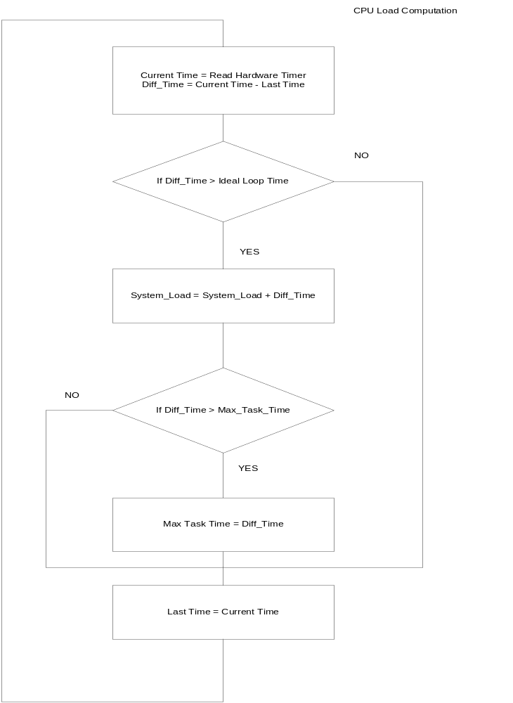

Sequence diagrams
The computation of CPU load is done at the back ground by the OS_Run function. The OS_PerfMeter function is configured as an OS Task of 10ms rate. This task updates the OS_PerfControl.SystemLoad data structure variable with consolidated CPU load value and call the OS_PerfMeterHook function for updating the CAN version frame bytes from the OS_PerfControl datastructure. The OS_PerfMeterHook function calls the CAN_IPL_vSendCanMsg function of the CAN IPL layer for transmitting the version frame with the CPU load data.

Sequence of Computation of CPU Load to Sending the Data through CAN version frame:

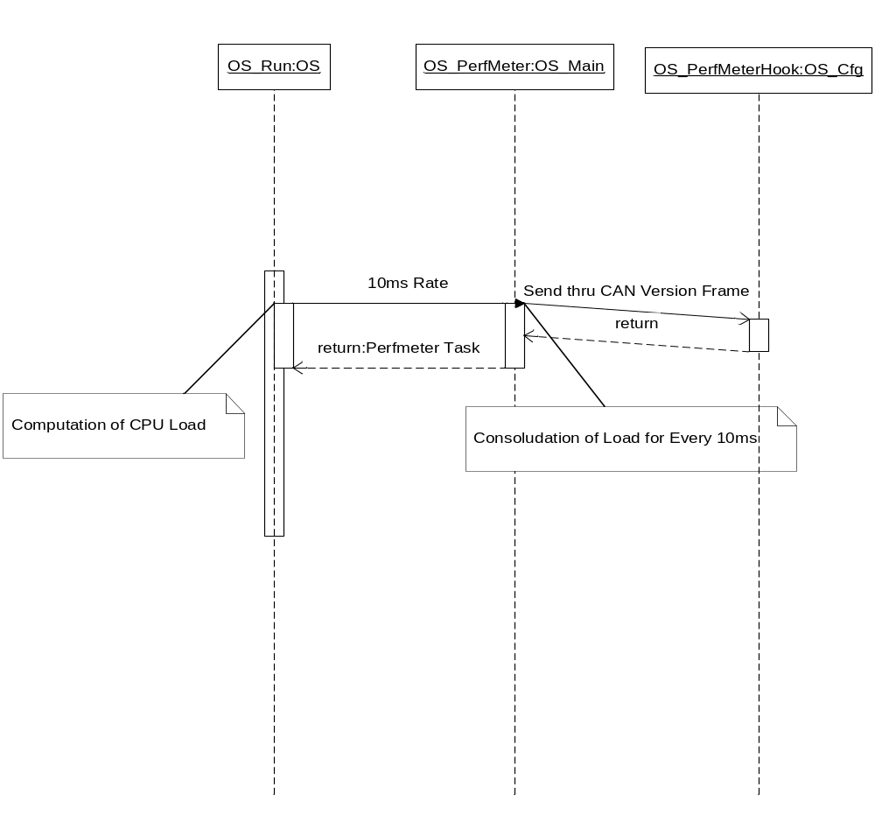

Requirements traceability
SDD Requirements | Satisfies

Resources allocation

Memory consumption
The following array presents the estimation – for the SW components OS – of the memory consumption: ROM (flash), RAM and EEPROM (flash emulation).

For the moment, the RAM and ROM is an estimation size.

 |  | RAM (Bytes) | ROM (Bytes)
OS |  | 350 | 1400
TOTAL |  | 350 | 1500

CPU load / Execution timings
Microprocessor bus frequency: 16 MHz

For the moment, execution time is estimation.

SW unit | C function | Execution time (average) | Execution time (max.)
Os_Task | OS_ActivateTask | 10Microsec | 20Microsec
 | OS_CancelTask | 5Microsec | 10Microsec
 | OS_CancelAllTasks | 5Microsec | 50Microsec
Os_Timer | OS_SetRelativeTimer | 15Microsec | 20Microsec
 | OS_CancelTimer | 10Microsec | 10Microsec
OS_Event | OS_SetEvent | 2Microsec | 2Microsec
 | OS_ClearEvent | 2Microsec | 2Microsec
 | OS_GetEvent | 2Microsec | 2Microsec

Verification criteria
Test Criteria:

The critical functions in the OS module to be tested with full statement coverage. The critical functions are
- OS_ActivateTask
- OS_SetRelativeTimer
- OS_CancelTask
- OS_CancelTimer
- OS_SysTick

VC_ID | Unit, function, functionality, sequence of execution etc. | Test inputs | Proposed code coverage
VC_1 | OS_ActivateTask | Test the Function using different TaskID’s from 0 to OS_MaxTask | 100% Statement Coverage
VC_2 | OS_SetRelativeTimer | Test the Function using different TimerID’s from 0 to OS_MaxTimer | 100% Statement Coverage
VC_3 | OS_CancelTask | Test the Function using different TaskID’s from 0 to OS_MaxTask | 100% Statement Coverage
VC_4 | OS_CancelTimer | Test the Function using different TimerID’s from 0 to OS_MaxTimer | 100% Statement Coverage
VC_5 | OS_SysTick | Test the ISR rate of 1ms | 100% Statement Coverage

Open issues
OI_ID | Issue | Comments / Proposed solution | Person responsible | Due date
OI_1
OI_2
OI_3

