* **Input/Output description**

The input in this code is 2 integer values for the amount of males and females registered in a class.

The output is 2 floating point numbers for the percentage of males and females registered in a class.

* **Variables**

1. **male:** stores the integer input of the amount of males registered in a class.
2. **female:** stores the integer input of the amount of females registered in a class.
3. **m_perc:** stores (males/100)*100 which divides the values stored in **male** by 100 then multiplies it by 100 to get a percentage.
4. **f_perc:** does about the same as **m_perc** just for the values that **female** stores.
5. **total:** male + female

* **Flow chart:**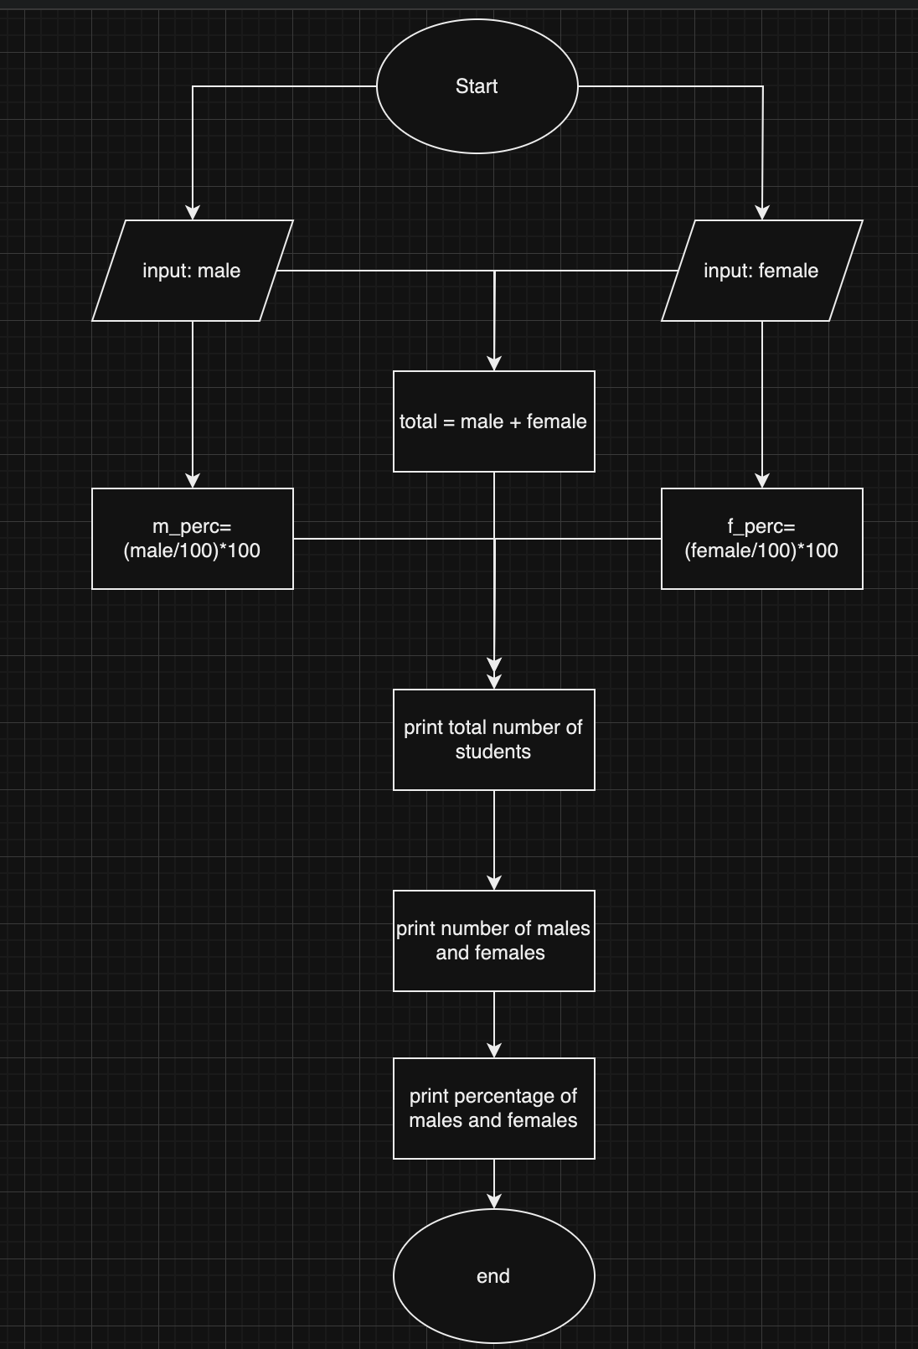

**Errors and lessons:**

I made a simple, but crucial mistake while writing this code.

When calculating the percentage of males or females I was dividing those 2 variables by 100 instead of the total number of students.

It took me a long time to realize this mistake because i was looking in the wrong place.