* **input/output**

There is 1 integer value stored in **celsius**.

The output is **celsius** converted to **fahrenheit.**

* **Variables**

**Celsius:** stores an integer value which is later converted to fahrenheit.

**Fahrenheit**: stores a formula to convert celsius to fahrenheit.

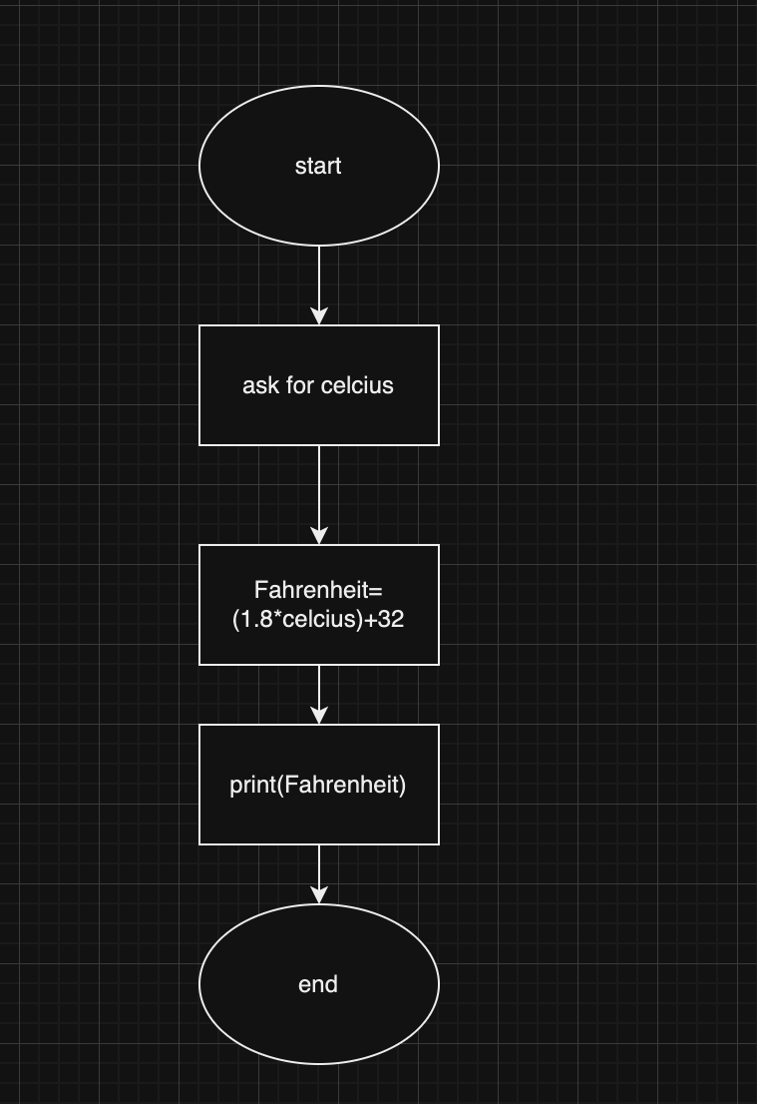

* **Flow chart**
* **Errors:**

This code was simple overall, but it definitely was pretty good practice