**Team Name:** ThunderBots **Team Members:** Tom, Harry, Arnold, James, and Thomas

**Roles:**

Harry - Software – assistance in the basics followed by specific quadrant as well as general software assistance.

Arnold - Software Lead – Basic functions followed by specific quadrant. Maintains functionality of the software throughout project.

James - Software and Networking – assistance in the basics followed by specific quadrant as well as handling the network side (with assistance) of the robot throughout the challenge.

Tom - Hardware, Software, CAD – Hardware required with CAD based design and with assisting in the software design.

Thomas - Hardware, Project Management, CAD – Hardware assistance with some CAD design, managing timelines with other project management aspects, as well as assisting with any form of support needed.

An up to date version of our team's goals are available at

<https://github.com/AVCChallange2016/Challange>

which includes all code, designs and a README

.

**Team Agreement**

By signing below, all team members are acknowledging that they have read and

committed to their part in the AVC. They acknowledge that they will attempt

to complete the tasks agreed on by the group each week and document this on

the team GitHub account. They acknowledge that failure to meet these goals

can result in the team recommending any member receives a lesser grade for

their AVC report. In the event that a team member is unable to complete them

task due to circumstances beyond their control (i.e. sickness, bereavement etc.)

that they will inform the team at the earliest possible time. Finally, the team

acknowledges that a member going a week without contact with other team

members (except when discussed with the team in advance) will constitute the

member in question being considered AWOL. In this instance the team agrees

to inform the ENGR101 course co-ordinator immediately. The penalty this for

this can range from a reduction in the nil grade to immediate failure of the

AVC (and thus the ENGR101 course). Should the team unanimously agree that

a member (or members) have failed to contribute to the AVC saliently for

other reasons, on the day of robot testing the team will be given the opportunity

to anonymously vote for a team member to receive 0% for the robot part of the

AVC. Should the team choose this option they MUST be able to show that the

member in question had been assigned tasks that they failed to complete and

that the team had afforded them an opportunity to make up for past mistakes.

Signed by all team members:

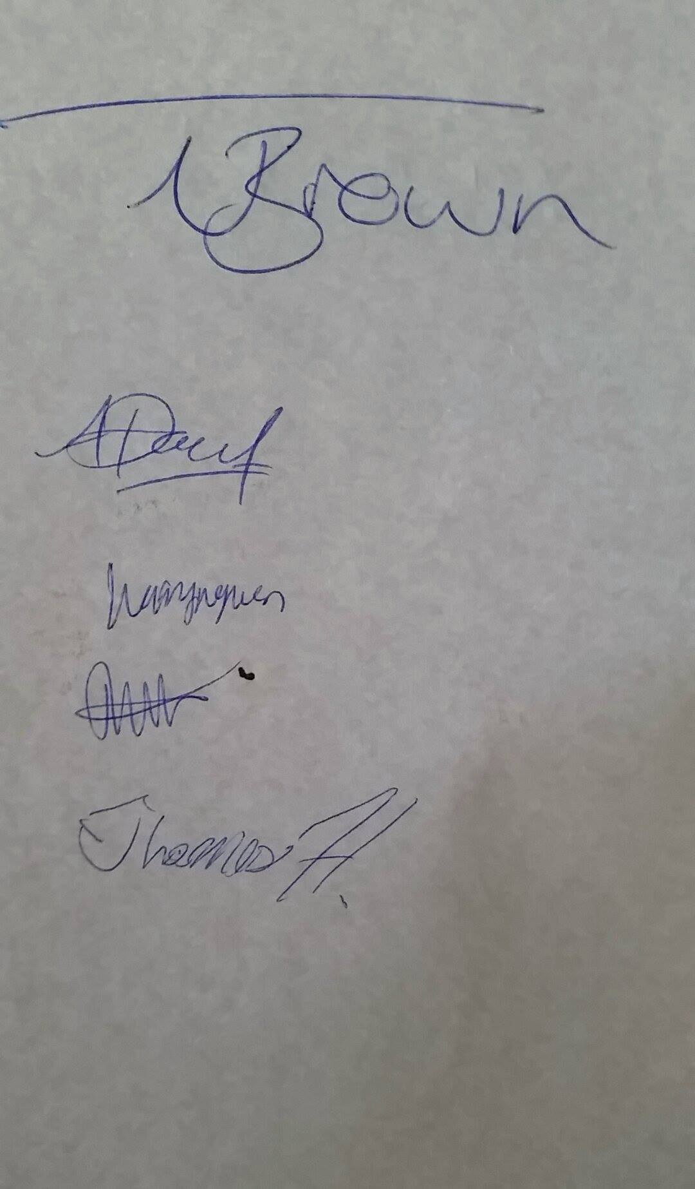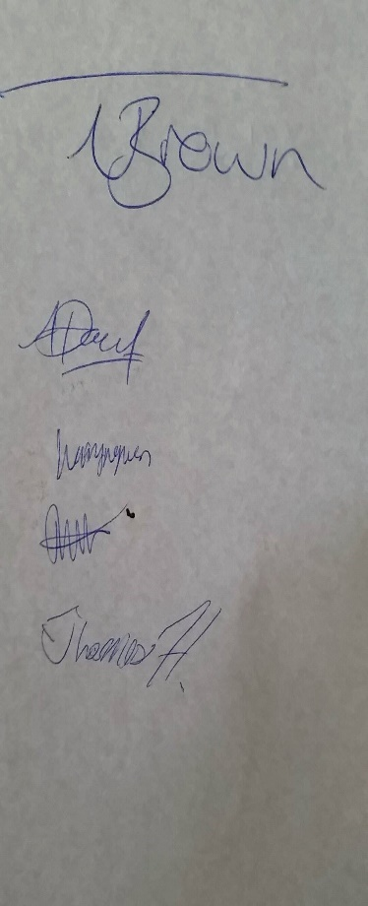

|  |  |  |  |  |  |
| --- | --- | --- | --- | --- | --- |
| Week | Dates | Team  Objectives | Items Due | Conflicting  Commitments | Tasks |
| 1 | 18th April | Robot moving in a straight line | AVC Plan Due | PHYS 122 test | All-Plan completed  James-GitHub accounts  Arnold, Harry-produce code for straight line movement  -tom brown Discuss Draft Chassis  -Thomas, plan meetings, check everyone's signed the agreement. |
| 2 | 25th April | Communicate either my meeting up or online |  |  | Thomas-Check each member's progress  James-update GitHub with progress from meeting, develop network gate code  Tom, Thomas- concept drafted  harry/Arnold- developing robot movement code |
| 3 | 2nd May | Quadrant 1 complete |  |  | All- Discuss if we should split up workload e.g. (one person working on one quadrant 1 another on Quadrant 2.  Thomas-check team member progress  James-network gate code developed,  Harry, Arnold-Develop robot movement and image processing  Tom- chassis build commences, mapped out the chassis and built it. |
| 4 | 9th May | Quadrant 2 complete/writing progress report |  | COMP102 test #2 | All- Discuss if implemented method of splitting up worked or not and decide another method accordingly.  Thom/Thomas- finalise chassis design  Arnold, James, harry- developing code for the next quadrant. |
| 5 | 16th May | Quadrant 3 | Progress Report due | ENGR 121 test #2 | All-need to be working on code for robot movement and completing quadrant. Tom, Thomas-possible chassis development |
| 6 | 23rd May | Quadrant 4(Only if all other milestones have been completed. |  |  | All- working on developing code, chassis should be fully completed, debugging other quadrant code. |
| 7 | 30th May | Due date | Robot due | ENGR 101 test #2 | All- revise work done and testing for bugs |
| 8 | 6th June | Final report writing |  |  | Thomas-arrange meetings to discuss final report  All-write conclusion and abstract sections. |
| 9 | 13th June | Final report writing | Final report due |  |  |

How has each team member performed against their goal set last week?

Have you set a goal for each team member for this week?

Do any team members need more help to complete their assigned task(s)?

Have you updated the task list on GitHub this week?

Is all relevant code, bot photos and design les on the team GitHub?

Have you noted which members attended labs and team meetings?

Have team members shared their draft report sections (if the team decided

they wanted to do that)?

Are there any tasks that need to be done for progress to be made that?

have NOT been assigned to a team m