# Getting Started

**Description: The purpose of this, and other, documents in this repository is to provide a general framework for first steps when setting up the group**

## How to prepare and motivate people who are new to working in the sphere of anti-racism:

* Be patient with yourself and others! We don’t have all of the answers and this kind of work requires constant evolution and critical self-evaluation.
* We are building this together! If you have ideas on things that can be improved, speak up! And if you don’t have ideas, be patient with yourself. The longer you are in this space the more you will learn and be able to contribute
* We value a diversity of perspectives and want to honor that everyone is on their own personal journey with regards to anti-racism work. If you’re just starting out, don’t be intimidated! As long as you are interested and willing to learn, you belong in this space and we want you here. In AVDS, people commonly report that they end up learning much more than they even expected to.

## Documentation is critical

Make sure to **document all actionable steps** taken even in the beginning. For example, if you send a graduate program an email asking them to send out an email of support to their students in response to traumatizing events, add this to a list of action items with dates and consider saving a copy of the email. The purpose of documentation is to save information which can be used later for reference and build template messages that can be recycled later. Also, keeping a list of accomplishments and actions that can be shared allows you to transparently communicate what your group is doing to the community as well as apply for independent funding.

## Writing mission statement and vision statements

A mission statement outlines the focus of your group and the values statement is the greater vision that your actions are building towards:

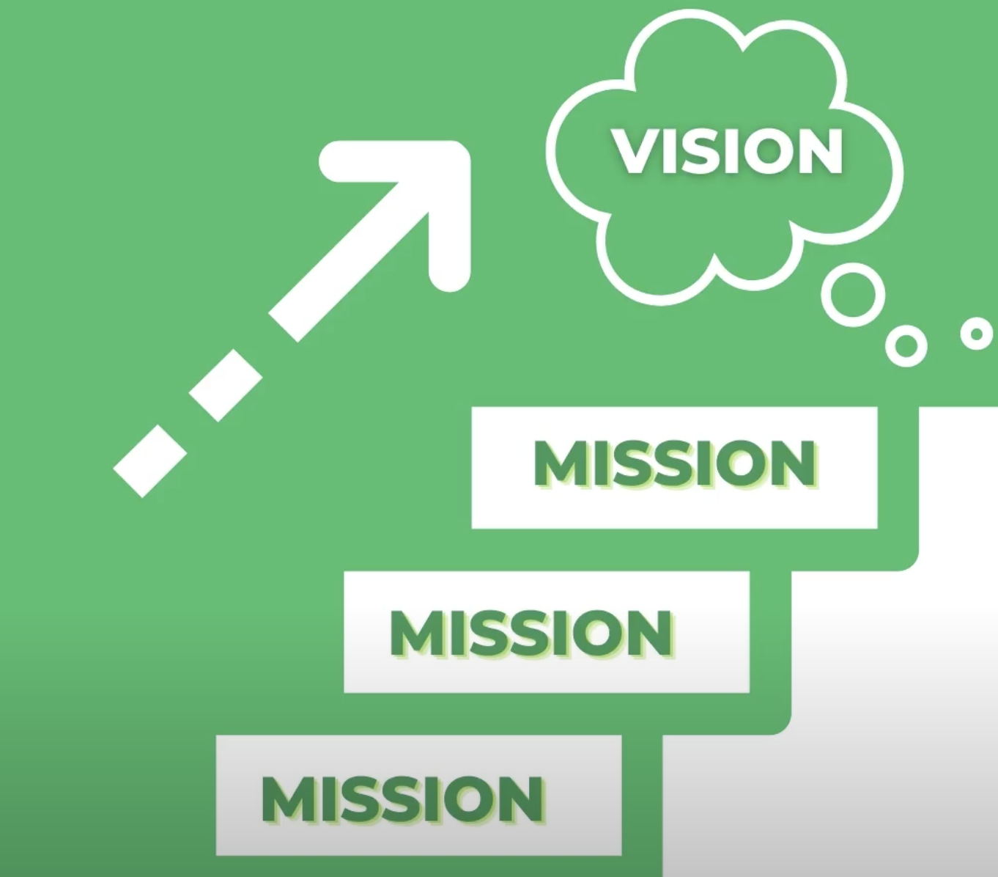

(image from The Petey Greene Program Pre-Service Training)

## Collecting information is the essential first step!

* Figure out the structure of your university and who has decision-making power
* Figure out the state of data collection on racial equity at your institution. Oftentimes this information is not even being tracked, which prevents the ability to make data-driven decisions and policies (the result of which is for institutions to use antiquated approaches to DEI despite any formal metrics for success)
* See what training faculty do around cultural sensitivity and racial equity, if any
* Figure out current anti-racism coursework promoted by the institution (there may be none, which is also useful information)

## Group and leadership structure

Explanation of our decentralized power structure from the [AVDS Full End of Year Report 2019-2020](https://zenodo.org/record/3991192#.YCct8M9Ki-8):

“Academic year 2019-2020 was the first in which AVDS operated under a decentralized power structure. Prior to 2019, AVDS used a centralized and hierarchical leadership model, with a president positioned at the top, a board underneath this, and several committees reporting to the board. Like many new groups, we defaulted to using a Western, centralized and hierarchical leadership model without a full understanding of the values and ideals it reflected and drove. **This model puts the voice of the president and the board above the voices of the larger group and can demotivate those with less positional power. This was in contrast to the equitable structure AVDS sought to build, wherein all voices were heard, valued and empowered.**

In addition to equity, AVDS strives for longevity. Centralized leadership, especially in social justice groups, often revolves around a charismatic and passionate leader.2 Although seemingly beneficial, this style poses a danger. When a charismatic leader drives a movement or group, it becomes susceptible to disassembling when the leader leaves.2 Moreover, history provides examples of how targeting charismatic leaders halts social justice progress, including Reverend Dr. Martin Luther King and the leaders of the Black Panther Party, such as Fred Hampton. In an academic setting, having a centralized structure with a student as president threatens the longevity of AVDS because students graduate.

Recognizing how a hierarchical and centralized leadership model hurt our goals and contrasted with our values, we removed the president position. While our current model (figure to the right) does include aspects of hierarchical organization, as our committees are chaired by 1-2 individuals, the chairs do not hold more power than the committee members. The role of the chair(s) is to help their team organize to carry out action items that are mutually agreed upon. Ultimately, the restructuring process allowed us to understand and shift away from systems designed to withhold power from others. We hope that documenting this journey provides an example of how such tools of oppression are omnipresent in our society, and how to conscientiously identify and rectify use of those tools within an organization.”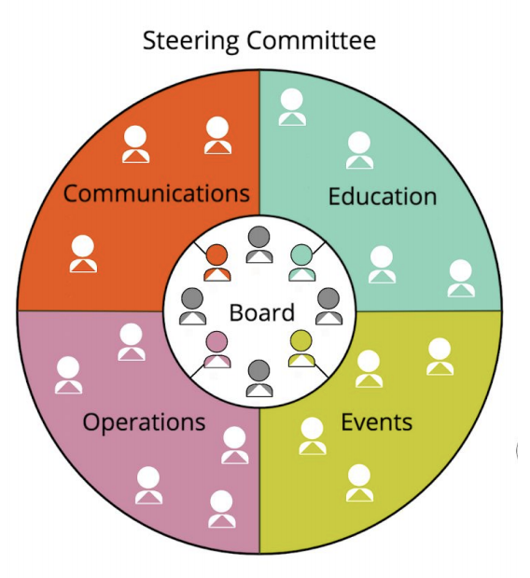

## Affinity/culture vs alliance groups

AVDS is an alliance group, meaning that members come from any racial or other background to work together on policy and community building that improves the state of racial equity at their institution. Conversely, affinity groups are for people of the same racial, ethnic, or other shared identity to come together to support one another. These groups are both very important and may share several similar, but also many different goals. It is important to decide whether you want your group to focus on affinity or alliance, keeping in mind that building an affinity group should focus on cultivating a safe space for those individuals while an alliance group focuses on cultivating a brave space.