
ROBOTs
A free card game for two players
By Steven E. Dambeck – games@dambeck.net
Game Version 1-4
Two opposing laboratories are locked in conflict! Each will use one half of a standard deck of playing cards to build robots, and wreck havoc on the other.

Introduction
The goal of Robots is to get rid of all cards from your opponent's Supply Pile. This is done by attacking with Robots.
Either player may count the cards in any player’s Supply pile, discard pile, or hand. Each player may look through any discard pile.
Number cards have the value of their number. Ace has a value of one. Face cards have a value of nine. If you include them, jokers are face cards.
There are three kinds of game objects. All are represented with a physical playing card, but they act differently because this is a game.
- Cards: Can be in three zones: your hand (facing you), discard pile (face up), and Supply pile (face down). Cards can be Built into Robots.
- Robots: are a new game object separate from cards. They are always face up in the play field. A Robot can attack you opponent, and could be made into Damage. If a Robot leaves the play area in a way other than Damage, it becomes a Card again.
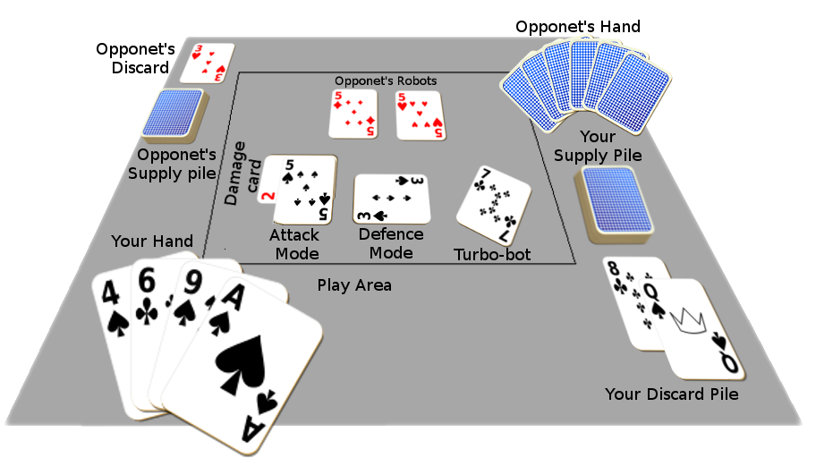
Value: The Value of a Robot is equal to the Value of it’s Blueprint, minus the Value of all its Damage, and plus the number of other Robots that shares a suit with it. If you have no cards in your Supply Pile, you enter Final Showdown, and all of your Robots’ Value is increased by three. If at anytime a Robot’s Value is less than one, it, and all Damage under it, is immediately discarded.
- Damage: which are attached to Robots. Always face up, placed underneath the Robot. Either player may look at them. The Value of Damage is equal to the Value of the playing card representing it.

Building Robots
You need two things to Build a Robot: a Blueprint, and Parts. A Blueprint can be any non-face card in your hand. Parts can be any card in your hand of the same suit as, but a higher value than, the Blueprint.
When you Build a Robot, discard the Parts, and put the Blueprint into play as a Robot in Defense mode (placed horizontally).
You may not have more than four Robots in play at a time.
There are three kinds of Special Robots you might build.
- Twin-bots: If you have two cards in your hand with the same value, you can Build both at once, without any other Parts. Put both into play as separate Robots in Defense mode. If you only have room for one more Robot, you may discard the other.
- Turo-bots: When you Build a Robot if it has a value of exactly four or exactly seven, that Robot is always in both Attack and Defense mode at the same time, even if it’s value changes. Place them on an angle to show this. Turbo-bots can not attack on the turn they’re Built.
- Nano-bots: When you build a Robot if it has a value of two or less, that Robot can never be Blocked, and doesn’t count towards your total number of Robots. Any time during your Build Phase, you can return a Nano-bot to your hand, and an opponet’s Robot of your choice to their hand. Any Damage is discarded.

Set Up
The player who has the most charged cell phone picks the red or the black half of the deck. The other player gets the ot`her half. Each player shuffles their cards and places it face down on their dominant side. This is their Supply Pile.
The player with the black cards draws five cards from their Supply Pile, and will take the first turn. The player with the red cards draws seven cards.
The player with the black cards may Build a Robot. The player with the red cards may Build up to two Robots, but not Twin-bots.

Turns
Each player takes alternating turns, each with six phases in the fallowing order: Program, Research, Build, Combat, Aftermath, Recovery.

The Programming Phase
First, the active player must choose to put each of their Robots either in Defense mode (placed horizontally), or Attack Mode (held vertically). Remember that Turbo-bots are always in both modes.

The Research Phase
Second, the active player must draw a card from their Supply Pile.

The Build Phase
Third, the active player may Build a Robot.

The Combat Phase
Next, the active player may choose any number of their Robots that are in Attack mode to attack the other player. The defending player may assign each and any of their Defense mode Robots to Block the attacking Robots, in any manor they wish. No more than one Robot may Block another.

The Aftermath Phase
Skip this phase if no Robots attacked during the Combat Phase.

Unblocked Step
For each unblocked Robot, the defending player discard a number cards equal to the Robot’s value, from the top of their Supply Pile. If they wish, they may discard cards from their hand in place of some or all of those cards.
The maximum amount of cards that can be discarded this way in a single turn is six, or ten if you have four or more Robots that share a suit.

Victory Step
If you have no card in your Supply Pile, you loose the game, unless you opponent also has an empty supply pile, in which case you win instead.

Blocked Step
If an attacking Robot and the blocking Robot assigned to it have an equal Value, both are Discarded. Otherwise the lesser Valued Robot becomes Damage, and is placed under the other Robot.
Whenever a Robot becomes Damage, any Damage cards on it is discarded

The Recovery Phase
Then, the either player may discard one, and only one, face card to return two or fewer non-face cards from their discard pile to their hand. If the in-active player has no Robots in play, they can do this without discarding.
If both players do this, the inactive player may wait to see what the active player chooses to return.

You are free to distribute, remix, and use this game under the Creative Commons Attribution-ShareAlike 4.0 International license (https://creativecommons.o1rg/licenses/by-sa/4.0/)

