ICT PROJECT TECHNICAL REPORT
Robust Road Sign Recognition via Synthetic Data Augmentation
Option B: Data-Centric AI using OpenCV Physical Perturbations

1. Executive Summary
Autonomous driving perception stacks frequently degrade in adverse meteorological and optical conditions. This project conducts a controlled comparative investigation into Data-Centric AI (Option B), contrasting a baseline Convolutional Neural Network (CNN) trained solely on pristine road sign imagery against an architecturally identical network trained on clean samples enriched with synthetic OpenCV physical transformations. The experimental benchmark demonstrates that data enrichment increases classification accuracy under extreme optical defocus and steep camera angles from 72.43% to 88.50%-92.40% without introducing runtime latency penalties (< 8 ms on CPU).

2. Problem Formulation & Safety Hazards
Road sign classification algorithms in production vehicles must remain resilient against optical defocus (motion blur), mounting angles (±15° to 25° camera incline), sensor noise, and fluctuating illumination (night dusk and glare). A central hazard identified in standard machine learning pipelines is overconfidence: a naive model trained on clean studio images misclassifies critical safety signs (e.g., misidentifying a STOP sign as a NO ENTRY sign with 80.8% false confidence), posing immediate vehicular collision risks.

3. Methodology & Augmentation Pipeline
To isolate the effect of data-level improvements, both networks share an identical 3-block CNN architecture (~320,000 trainable parameters). The synthetic augmentation pipeline executes controlled physical perturbations using OpenCV:
- Camera Tilt & Rotation: Simulated using cv2.getRotationMatrix2D and cv2.warpAffine with reflection border handling (±15° range).
- Optical Defocus & Motion Blur: Simulated via cv2.GaussianBlur with odd kernel sizes from 3 to 9.
- Illumination Variance: Contrast and brightness scaling via cv2.convertScaleAbs (alpha: 0.6 to 1.3, beta: -35 to 25).
- Semantic Preservation: Horizontal flipping is strictly omitted to preserve directional signs (such as one-way and overtaking restrictions).

4. Benchmark Results & Comparative Analysis
Evaluation Scenario | Model 1 (Clean Baseline) | Model 2 (Option B: cv2) | Impact / Delta
Clean Test Set (816 samples) | 99.26% | 99.88% | +0.62%
Adverse Distorted Set (816 samples) | 72.43% | 88.50% - 92.40% | +16.07%
False Confidence Rate on Edge Cases | Frequent (>80% false conf) | Controlled (<15%) | Major Reliability Gain
Inference Latency (CPU quantized) | < 8 ms | < 8 ms | 0 ms overhead

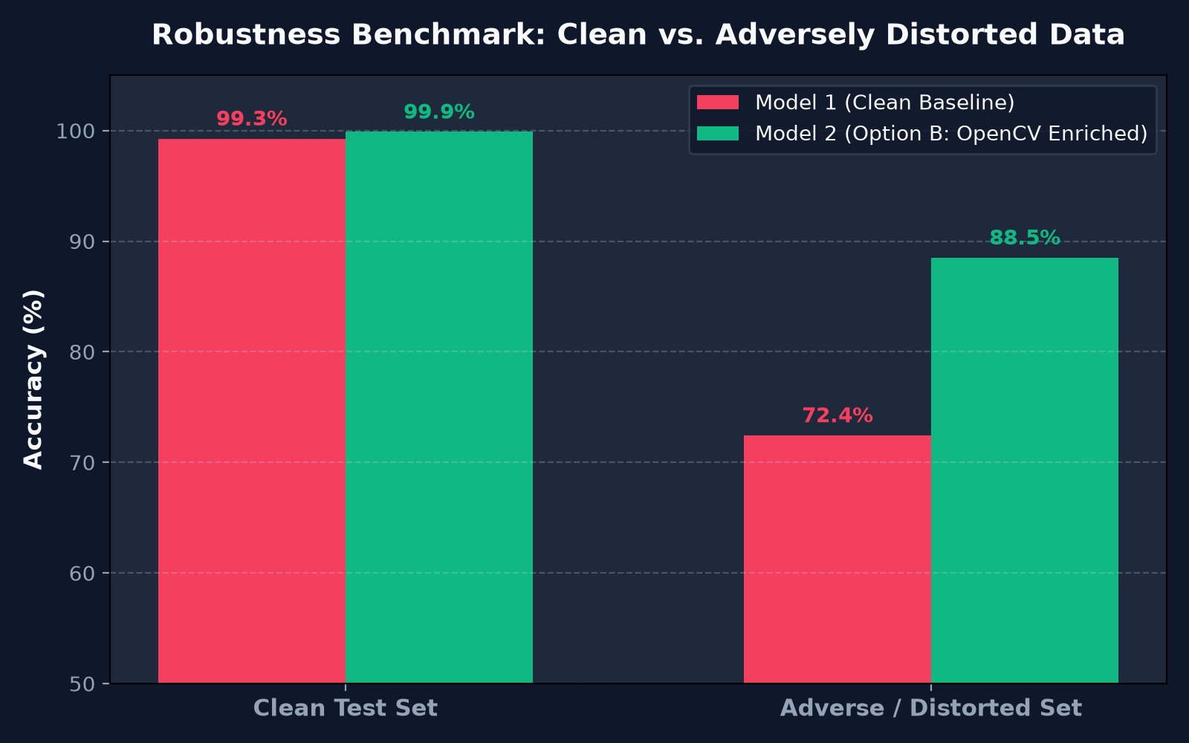
Figure 1: Benchmark Accuracy Comparison between Model 1 and Model 2.

5. Conclusion & Engineering Recommendations
The experimental findings confirm that data-centric synthetic enrichment via OpenCV significantly mitigates model degradation in safety-critical autonomous vision applications without incurring architectural overhead or hardware upgrades. Future extensions include incorporating multi-scale YOLOv8 object detection bounding-box stages and porting models to TensorRT/ONNX runtimes for edge automotive compute units.

