
UNIVERSITY OF BUEA

P.O. Box 63,
Buea, South West Region CAMEROON
Tel : (237) 3332 21 34/3332 26 90
Fax: (237) 3332 22 72

REPUBLIC OF CAMEROON

PEACE-WORK-FATHERLAND

FACULTY OF ENGINEERING AND TECHNOLOGY

DEPARTMENT OF COMPUTER ENGINEERING

PREDICTING STUDENT PERFORMANCE IN HIGHER INSTITUTIONS USING MACHINE LEARNING TECHNIQUES

A dissertation submitted to the Department of Computer Engineering, Faculty of Engineering and Technology, University of Buea, in Partial Fulfilment of the Requirements for the Award of Bachelor of Engineering (B.Eng.) Degree in Computer Engineering.
By :
AV’NYEHBEUHKOHN EZEKIEL HOSANA
Matriculation Number: FE22A160
Option: Software Engineering

Supervisor :
Dr. SOP DEFFO Lionel
University of Buea

2025/2026 Academic Year

PREDICTING STUDENT PERFORMANCE IN HIGHER INSTITUTIONS USING MACHINE LEARNING TECHNIQUES

AV’NYEHBEUHKOHN EZEKIEL HOSANA
Matriculation Number: FE22A160
2025/2026 Academic Year

Dissertation submitted in partial fulfilment of the Requirements for the award of Bachelor of Engineering (B.Eng.) Degree in Computer Engineering.

Department of Computer Engineering
Faculty of Engineering and Technology
University of Buea

CERTIFICATION OF ORIGINALITY

We the undersigned, hereby certify that this dissertation entitled “ PREDICTING STUDENT PERFORMANCE IN HIGHER INSTITUTIONS USING MACHINE LEARNING TECHNIQUES” presented by AV’NYEHBEUHKOHN EZEKIEL HOSANA, Matriculation number FE22A160 has been carried out by her in the Department of Computer Engineering, Faculty of Engineering and Technology, University of Buea under the supervision of Dr. SOP DEFFO Lionel.

This dissertation is authentic and represents the fruits of her own research and efforts.

Date ___________________________

Student Supervisor

___________________________ ___________________________

Head of Department

___________________________

DEDICATION

This dissertation is dedicated to GOD ALMIGHTY

ACKNOWLEDGEMENT

I wish to express my sincere gratitude to God almighty for the strength, wisdom, and health provided during the entire project.

My deepest gratitude and thanks go to my parents, Lobe Doumou Sandrine, Avom Desiré, and Av’Nyet Agniel Esdras, Kiffoueti Njia fridoline, Lobe Nesrine for letting me go this far and providing necessary resources throughout my academic journey.

I am profoundly grateful to my academic supervisor, Dr.SOP DEFFO Lionel, for his exceptional guidance. His feedback, insightful criticism, and reviews throughout the realisation of this project.

I extend my gratitude to the Department of computer Engineering and the Faculty of Engineering and Technology of the University of Buea for the support, the resources and knowledge provided throughout my academic journey in the faculty.

My sincere thanks go to all my lecturers for their support, dedication, and knowledge. Your encouragement has been a real push of my academic and professional journey.
To my fellow course mates, thank you for your collaboration during projects, your feedbacks, ideas, reviews, patience, and the supportive environment we created together. Your assistance made every challenge manageable and every success more meaningful.

My deepest gratitude goes to my family and friends. Your belief in me, and your support have been a source of strength and motivation throughout this entire journey.

And finally to everyone that contributed in one way or the other for the completion of my degree in the faculty of engineering and technology, university of Buea.

ABSTRACT

The rapid expansion of higher education enrolment in Cameroon has intensified the need for data-driven approaches to understanding and improving student academic outcomes. Higher institutions in Cameroon face various challenges including inadequate infrastructure, limited access to educational resources, unstable electricity supply, and significant socioeconomic disparities among students, all of which profoundly influence academic performance. Despite the growing global adoption of machine learning techniques in educational data mining, a critical gap exists in research that contextualises these methods within the Cameroonian higher education environment. This study addresses that gap by developing a machine learning-based predictive system specifically adapted for Cameroonian higher institutions. A synthetic university level dataset of 8,000 student records was used as the primary data source, comprising academic, behavioural, lifestyle, and socioeconomic attributes. The dataset was enhanced through deliberate feature engineering to incorporate ten Cameroon specific contextual factors including electricity availability, home internet accessibility, peer influence, community beliefs regarding education, family support, home study environment, motivation level, lecture quality, physical health, and psychological state. Following thorough exploratory data analysis, the dataset was preprocessed using label encoding, one-hot encoding, StandardScaler normalisation, and SMOTE oversampling to address class imbalance. Four machine learning models were trained and evaluated: Logistic Regression, Decision Tree, Random Forest, and Tuned Random Forest. Logistic Regression achieved the highest overall performance with an accuracy of 74.50% and a weighted F1-score of 74.88%, and was the only model to successfully identify failing students with a Fail class recall of 57.14%. Feature importance analysis confirmed that six of the ten Cameroon-specific engineered features ranked among the top fifteen most predictive variables, validating the research hypothesis that contextual factors unique to Cameroon contribute meaningfully to academic performance prediction. The best performing model was integrated as an interactive web application using Streamlit, providing students, academic counsellors, and institutional administrators with a practical tool for real time performance prediction and early identification of at risk students.

Keywords: Machine Learning, Student Performance Prediction, Educational Data Mining, Feature Engineering.

TABLE OF CONTENTS

CERTIFICATION OF ORIGINALITY ii
DEDICATION iii
ACKNOWLEDGEMENT iv
ABSTRACT v
TABLE OF CONTENTS vi
LIST OF TABLES viii
LIST OF FIGURES ix
LIST OF ABBREVIATIONS x
CHAPTER ONE: GENERAL INTRODUCTION 1
1.1. Background and Context of the Study 1
1.2. Problem Statement 3
1.3. Objectives of the Study 4
1.3.1. General Objective 4
1.3.2. Specific Objectives 4
1.4. Proposed Methodology 4
1.5. Research Questions 6
1.6. Research Hypothesis 6
1.7. Significance of the Study 7
1.8. Scope of the Study 7
1.9. Delimitation of the Study 8
1.10. Definition of Keywords and Terms 8
1.11. Organisation of the Dissertation 9
CHAPTER TWO: LITERATURE REVIEW 11
2.1. Introduction 11
2.2. General Concepts 11
2.2.1. Machine Learning 11
2.2.2. Educational Data Mining 12
2.2.3. Student Performance Prediction 12
2.2.4. Key Machine Learning Algorithms 13
2.2.5. Feature Engineering 15
2.2.6. Class Imbalance and SMOTE 16
2.2.7. Evaluation Metrics for Classification Models 16
Accuracy 16
Precision 16
Recall 16
F1-Score 17
Confusion Matrix 17
2.3. Related Works 17
2.4. Partial Conclusion 19
CHAPTER THREE: ANALYSIS AND DESIGN 21
3.1. Introduction 21
3.2. Methodology 21
3.3. Design 23
3.3.1. Dataset Design and Contextual Adaptation 23
3.4.1. UML Diagrams 27
3.5. Description of the Algorithms 30
3.5.1. Logistic Regression 30
3.6. Description of the Resolution Process 32
3.6.1. Phase 1 : Machine Learning Pipeline 32
3.6.2. Phase 2 : Web Application Development 36
CHAPTER FOUR: IMPLEMENTATION AND RESULTS 39
CHAPTER FIVE: CONCLUSION AND FURTHER WORKS 69
5.1. Summary of Findings 69
5.2. Contribution to Engineering and Technology 69

LIST OF TABLES

Table 3.1: Original dataset features and Cameroonian contextual mapping .... 23
Table 3.2: Categorical encoding mapping .............................................. 33
Table 3.3: Engineered Cameroon-specific features ................................... 31
Table 4.1: Tools and libraries used ..................................................... 36
Table 4.2: Outlier detection results using IQR method ............................. 38
Table 4.3: Logistic Regression classification report ................................ 39
Table 4.4: Decision Tree classification report ........................................ 40
Table 4.5: Random Forest classification report ....................................... 41
Table 4.6: Tuned Random Forest classification report .............................. 41
Table 4.7: Final model comparison summary ........................................... 42
Table 4.8: Comparison with Hashim et al. (2020) .................................... 44

LIST OF FIGURES

Figure 3.1: Global architecture of the proposed system ........................... 26
Figure 3.2: CRISP-DM methodology framework ........................................ 22
Figure 4.1: Distribution of Final Score ................................................ 38
Figure 4.2: Grade distribution — count and percentage ............................ 38
Figure 4.3: Univariate analysis — numeric features ................................. 38
Figure 4.4: Univariate analysis — categorical features ............................. 38
Figure 4.5: Correlation heatmap — numeric features vs Final Score ............. 39
Figure 4.6: Bivariate analysis — key features vs Final Score ..................... 39
Figure 4.7: Bivariate analysis — key features by Grade ........................... 39
Figure 4.8: Bivariate analysis — categorical features vs Final Score ........... 39
Figure 4.9: Logistic Regression confusion matrix .................................... 40
Figure 4.10: Decision Tree confusion matrix ........................................... 40
Figure 4.11: Random Forest confusion matrix .......................................... 41
Figure 4.12: Tuned Random Forest confusion matrix .................................. 42
Figure 4.13: Random Forest top 15 feature importance chart ...................... 42
Figure 4.14: Final model comparison chart ............................................. 43
Figure 4.15: Streamlit web application — home page ................................ 44
Figure 4.16: Streamlit web application — prediction result page ................. 44

LIST OF ABBREVIATIONS
AI Artificial Intelligence
AUC Area Under the Curve
CSV Comma-Separated Values
CRISP-DM Cross-Industry Standard Process for Data Mining
EDM Educational Data Mining
EDA Exploratory Data Analysis
F1 F1-Score (harmonic mean of Precision and Recall)
FET Faculty of Engineering and Technology
FP False Positive
FN False Negative
GCE General Certificate of Education
GPA Grade Point Average
IQR Interquartile Range
KNN K-Nearest Neighbours
ML Machine Learning
MLP Multi-Layer Perceptron
NB Naive Bayes
pkl Pickle file format
ROC Receiver Operating Characteristic
SMOTE Synthetic Minority Oversampling Technique
SVM Support Vector Machine
TP True Positive
TN True Negative
UB University of Buea
XGBoost Extreme Gradient Boosting

CHAPTER ONE: GENERAL INTRODUCTION

Background and Context of the Study

Education is universally recognised as a fundamental driver of socioeconomic development and national progress (UNESCO, 2024). Access to quality education remains one of the primary drivers of sustainable development and national competitiveness. As higher education systems continue to expand globally, universities face increasing pressure to improve student success, reduce dropout rates, and enhance overall academic performance. In Cameroon, higher education has grown fast over the past two decades, with university enrolment rising substantially across public universities and private institutions increasing from approximately 500 students in the early years of the higher education system to more than 350,000 students today. The University of Buea, established in 1993 as Cameroon's first anglophone university, has grown into one of the country's leading higher institutions, offering programmes across engineering, technology, sciences, and arts. Despite this growth, persistent challenges continue to undermine academic outcomes, including failure rates, student dropout, and widespread academic underperformance across faculties and departments.

Historically, institutions relied on traditional statistical methods and manual academic monitoring to evaluate student performance. Academic advisors and lecturers primarily used examination scores, attendance records, and continuous assessment results to identify struggling students. While these methods provided useful insights, they were often reactive rather than predictive, making it difficult to intervene before academic problems became severe (Meylani Rusen, 2024).

Early research on student performance prediction focused primarily on statistical techniques and educational data analysis. With the emergence of Educational Data Mining (EDM) in the early 2000s, researchers began applying data mining and machine learning methods to educational datasets to identify patterns associated with student success and failure. Romero & ventura, (2010) highlighted the growing importance of data mining applications in educational environments and demonstrated their potential for supporting academic decision-making. Similarly, Cortez and Silva (2008) successfully applied data mining techniques to predict student achievement using demographic, social, and academic variables. More recently, Alyahyan and Düştegör (2020), through a systematic review of student performance prediction studies, reported that machine learning approaches consistently achieved promising results in identifying students at risk of poor academic performance. These developments have established machine learning as one of the most effective approaches for educational prediction tasks and have contributed significantly to the growth of Educational Data Mining and Learning Analytics.
The factors contributing to poor academic performance in Cameroon higher institutions are multidimensional and contextualised. Students face academic pressures combined with various socioeconomic constraints such as financial hardship, family responsibilities, and the burden of supporting themselves through part-time employment. Environmental challenges including frequent electricity outages, unreliable internet connectivity, and inadequate study facilities further compromise the conditions under which students learn (African Educational Research Journal, Ndindeng, Atina, 2024). Sociocultural factors such as community beliefs about the value of education, peer influence, and family support structures also play significant roles in shaping academic outcomes (Wang, Ming-Te & Guo, 2020).

Today, machine learning algorithms are capable of identifying complex patterns and nonlinear relationships within large educational datasets that traditional statistical methods may not adequately capture. These capabilities have been applied to a wide range of educational challenges, including early identification of at-risk students, prediction of academic performance, modelling student dropout, and personalisation of learning experiences (Alyahyan & Düştegör, 2020).
However, the vast majority of existing research in this domain has been conducted in the context of developed nations or relies on datasets that do not reflect the realities of students in sub-Saharan African countries such as Cameroon. Key contextual factors including electricity availability for home study, home internet access, the influence of community and cultural beliefs on academic engagement, and the psychological burden of socioeconomic pressure are rarely represented in publicly available educational datasets. This limits the predictive validity and practical applicability of models trained on such data when deployed in the Cameroon setting.
This study seeks to address this critical gap by developing a machine learning based system for predicting student academic performance that is specifically adapted to the higher education context in Cameroon. By augmenting an existing university level dataset with ten Cameroon-specific features through deliberate feature engineering, and by training and evaluating multiple supervised classification algorithms, this research contributes to the growing body of EDM literature while providing a practically deployable tool for academic advisors, lecturers, and students in Cameroon’s higher institutions.

Problem Statement
Higher education institutions should be able to identify students at risk of academic underperformance early and provide timely interventions that improve learning outcomes, reduce failure rates, and enhance student success. Academic advisors and lecturers should have access to reliable tools that support evidence-based decision making and enable proactive rather than reactive academic support.
However, academic underperformance and student failure remain significant challenges within higher education institutions in Cameroon. Students who struggle academically are often identified only after poor examination results have been recorded, limiting opportunities for timely intervention. Current approaches to student performance assessment are largely retrospective, relying primarily on examination and continuous assessment results rather than predictive mechanisms capable of identifying at-risk students before academic difficulties become severe (Meylani Rusen, 2024).
The factors influencing academic performance in Cameroon are multidimensional and extend beyond conventional academic indicators. Socioeconomic pressures, family financial responsibilities, unstable electricity supply affecting home study, limited internet access, peer influence, and parental educational background can all significantly affect student outcomes. Despite the importance of these factors, existing approaches to student monitoring do not adequately account for their combined influence on academic performance.
As a result, lecturers, academic advisors, and institutional administrators have limited capacity to make informed, data-driven decisions regarding student support and intervention strategies. This contributes to continued academic underperformance, increased risk of failure, and missed opportunities to provide targeted assistance to students who may require additional support.
Therefore, there is a need for a predictive system capable of analysing both traditional academic indicators and contextual factors relevant to the Cameroon higher education environment. This study addresses this need by developing and evaluating a machine learning-based model for predicting student academic performance and deploying the resulting model as an accessible web application to support early identification and intervention for at-risk students.

Objectives of the Study

General Objective

The general objective of this study is to develop and deploy a machine learning-based system for predicting the academic performance of students in Cameroonian higher education institutions through an accessible web application.

Specific Objectives

1- To acquire and preprocess a university-level student dataset for use in training and evaluating machine learning models for academic performance prediction.
2- To enhance the dataset through feature engineering by incorporating ten Cameroon-specific socioeconomic, environmental, and contextual variables relevant to student academic performance.
3- To conduct exploratory data analysis on the dataset in order to identify patterns, distributions, correlations, and relationships between student characteristics and academic outcomes.
4- To train multiple supervised machine learning classification algorithms for predicting student academic performance.
5- To evaluate and compare the performance of the trained models using standard classification metrics, including accuracy, precision, recall, and score, and select the best-performing model.
6- To validate the selected model using data collected from University of Buea students and deploy it as a Streamlit-based web application for real-time academic performance prediction.

Proposed Methodology

This study adopts the Cross-Industry Standard Process for Data Mining (CRISP-DM) methodology, a widely recognised framework for structuring machine learning and data mining projects. The methodology consists of six iterative phases: Problem/Business Understanding, Data Understanding, Data Preparation, Modeling, Evaluation, and Deployment.
The Problem Understanding phase focuses on defining the research problem, objectives, and requirements for predicting student academic performance within the context of higher education in Cameroon. During the Data Understanding phase, a synthetic university-level dataset containing 8,000 student records and 17 features related to academic behaviour, lifestyle, and demographic characteristics is collected from kaggle and explored to gain insight into its structure and quality.
The Data Preparation phase involves data cleaning, preprocessing, exploratory data analysis, and feature engineering. Irrelevant attributes are removed, categorical variables are encoded, numerical variables are normalised, and class imbalance is addressed. Additionally, ten Cameroon-specific contextual variables, electricity availability, home internet accessibility, peer influence, community beliefs, family support, home study environment, motivation level, lecture quality, physical health, and psychological state are incorporated into the dataset. Exploratory Data Analysis is conducted to examine feature distributions, identify correlations, detect outliers, and understand relationships between variables and academic outcomes.
In the Modeling phase, three supervised machine learning algorithms, namely Logistic Regression, Decision Tree, and Random Forest, are trained using the prepared dataset. Random Forest is further optimised through hyperparameter tuning using RandomizedSearchCV to improve predictive performance.
The Evaluation phase assesses model performance using accuracy, precision, recall, F1-score, and confusion matrix analysis. The trained models are compared, and the best-performing model is selected based on its overall predictive capability. Additional validation is performed using data collected from selected University of Buea students to assess the model's practical applicability.
Finally, during the Deployment phase, the selected model is serialised and integrated into a Streamlit web application that enables real-time prediction of student academic performance. The deployed system provides an accessible platform through which users can input relevant student information and obtain performance predictions.

Research Questions

The study seeks to address the identified problem by answering a number of research questions related to student academic performance prediction in the context of higher education in Cameroon. Specifically, the study aims to answer the following questions:
- Which academic, socioeconomic, environmental, and contextual factors are most predictive of student academic performance in higher education institutions in Cameroon?
- To what extent can supervised machine learning algorithms accurately predict student academic performance in the Cameroonian higher education context?
- Which of the selected machine learning algorithms, Logistic Regression, Decision Tree, and Random Forest, provides the best predictive performance for student academic performance classification?

Research Hypothesis

Based on the research problem, objectives, and existing literature on student performance prediction, the following hypotheses are formulated to guide the study and provide a basis for evaluating the effectiveness of the proposed machine learning models:
H1: Student academic performance can be predicted using a combination of academic, demographic, and behavioural factors.
H2: The inclusion of Cameroon-specific contextual factors, such as electricity availability, home internet accessibility, and family support, improves the predictive performance of student performance prediction models.
H3: There is a significant difference in predictive performance among Logistic Regression, Decision Tree, and Random Forest models for student academic performance classification.
H4: The best-performing machine learning model can achieve a satisfactory level of predictive accuracy for practical deployment in a student performance prediction system.

Significance of the Study

This study makes several important contributions to both academic research and educational practice in Cameroon. From an academic perspective, it contributes to the growing field of Educational Data Mining by demonstrating how machine learning models for student performance prediction can be adapted to developing-country contexts through the incorporation of contextual variables. The study also provides a methodological framework that can serve as a reference for future researchers interested in applying machine learning techniques to educational challenges in Cameroon and similar environments.
From a practical perspective, the Streamlit web application developed in this study provides a tool through which students can assess factors that may influence their academic performance and obtain predictive insights based on their individual characteristics. For lecturers, and academic advisors, the proposed system offers a mechanism for the early identification of students who may be at risk of poor academic performance, thereby supporting timely intervention and academic guidance.
Furthermore, the study highlights the potential influence of contextual factors such as electricity availability, internet accessibility, family support, and study environment on academic outcomes. The findings may therefore provide useful insights for educational stakeholders seeking to understand and address challenges affecting student success in higher education institutions in Cameroon.

Scope of the Study

This study focuses on the prediction of academic performance of students in higher institutions at the undergraduate level. The machine learning models developed are trained on a synthetic dataset simulating the characteristics of university students, augmented with features reflective of the Cameroonian higher education context. The study covers the full machine learning pipeline from data preprocessing and feature engineering through model training, evaluation, and web application deployment. The study does not involve primary data collection through large-scale surveys or interviews, nor does it address postgraduate students or secondary school learners.

Delimitation of the Study

While this study incorporates Cameroon-specific features through feature engineering, the base dataset used is synthetic and was not collected directly from Cameroonian students. The engineered features are derived from statistical distributions informed by existing literature and contextually grounded assumptions about student conditions in Cameroon, but they do not constitute empirically collected primary data. The study evaluates three distinct machine learning algorithms and does not extend to deep learning or neural network-based approaches, which are proposed as directions for future work. The Streamlit web application developed is intended as a functional prototype and has not been subjected to large-scale user testing or formal clinical deployment.

Definition of Keywords and Terms

Classification: A type of supervised machine learning task in which the model learns to assign input data to one of several predefined categorical classes.

Class Imbalance: A condition in a classification dataset where some classes are represented by significantly more samples than others, potentially biasing model predictions towards the majority class.

CRISP-DM: Cross-Industry Standard Process for Data Mining, a widely adopted iterative process model for data mining and machine learning projects comprising six phases: problem understanding, data understanding, data preparation, modelling, evaluation, and deployment.

Decision Tree: A supervised learning algorithm that models classification decisions as a tree-like structure of hierarchical conditions based on feature values.

Educational Data Mining (EDM): The application of data mining and machine learning techniques to data generated in educational settings for the purpose of improving learning outcomes and institutional decision-making.

Feature Engineering: The process of using domain knowledge to create, transform, or select input variables that improve the predictive performance of machine learning models.

Logistic Regression: A statistical classification algorithm that models the probability of a categorical outcome as a function of one or more predictor variables using the logistic function.

Machine Learning: A branch of artificial intelligence concerned with building systems that learn patterns from data to make predictions or decisions without being explicitly programmed for each specific task.

Random Forest: An ensemble machine learning algorithm that constructs multiple decision trees during training and outputs the class receiving the majority vote across all trees.

SMOTE: Synthetic Minority Oversampling Technique, a method for addressing class imbalance by generating synthetic training samples for minority classes through feature-space interpolation.

Streamlit: A Python based open-source framework for building and deploying interactive data science and machine learning web applications.

Student Performance: The academic achievement of a student as measured by grades, scores, or other formal assessment outcomes within an institutional setting.

Organisation of the Dissertation

This dissertation is organised into five chapters. Chapter One presents the general introduction to the study, including the background and context of the study, statement of the problem, research objectives, proposed methodology, research questions, research hypotheses, significance of the study, scope and delimitations of the study, definition of key terms, and organisation of the dissertation.
Chapter Two provides a comprehensive review of related literature, covering the theoretical foundations of machine learning and Educational Data Mining (EDM), student academic performance prediction, relevant machine learning algorithms, and a critical review of previous studies in the field.
Chapter Three presents the analysis and design of the proposed system. It describes the CRISP-DM framework adopted for the study, data preprocessing procedures, exploratory data analysis, feature engineering process, system architecture, and the design of the machine learning solution.
Chapter Four focuses on the implementation and evaluation of the proposed system. It discusses the tools and technologies used, model development and training, performance evaluation, comparative analysis of the selected algorithms, and the deployment of the best-performing model as a Streamlit web application.
Chapter Five presents the summary of findings, conclusions, contributions of the study, recommendations, limitations, and suggestions for future research.

CHAPTER TWO: LITERATURE REVIEW

Introduction

This chapter presents a review of the literature related to student academic performance prediction using machine learning techniques. The review begins with an exposition of foundational concepts in machine learning, educational data mining, and student performance prediction, followed by a description of the key algorithms employed in this study. The chapter then presents a critical analysis of related works, highlighting the methodologies employed, findings reported, and limitations identified by prior researchers. The chapter concludes with a partial conclusion that situates the present study within the broader research landscape and identifies the specific gap it addresses.

General Concepts

Machine Learning
Machine learning is a subfield of artificial intelligence that focuses on developing algorithms and statistical models capable of learning patterns from data and making predictions or decisions without being explicitly programmed for each specific task (Mitchell, 1997). Unlike traditional rule-based programming, machine learning systems improve their performance progressively as they are exposed to more data. The field is broadly categorised into three learning paradigms: supervised learning, unsupervised learning, and reinforcement learning.
Supervised learning, which is the paradigm employed in this study, involves training a model on a labelled dataset in which each input record is associated with a known output label. The model learns the mapping function from inputs to outputs and subsequently predicts the output for previously unseen inputs. Classification and regression are the two principal tasks in supervised learning. Classification involves predicting a discrete class label, while regression involves predicting a continuous numerical value (geeksforgeeks, 2025).
Unsupervised learning operates on unlabeled datasets and seeks to discover hidden structures or patterns within the data. Common tasks include clustering and association rule mining. Reinforcement learning, on the other hand, enables an agent to learn optimal actions through interactions with an environment by receiving rewards or penalties based on its decisions.
Machine learning has found applications in numerous domains including healthcare, finance, agriculture, cybersecurity, transportation, and education. In educational settings, machine learning is increasingly used to predict student performance, identify learners at risk of failure, personalise learning experiences, and support institutional decision-making.

Educational Data Mining
Educational Data Mining (EDM) is an interdisciplinary field that applies data mining, machine learning, and statistical techniques to data collected in educational environments with the aim of improving teaching and learning outcomes (Romero & Ventura, 2010). EDM draws data from various educational sources including learning management systems, student information systems, examination databases, and online learning platforms.
The primary objective of EDM is to discover meaningful patterns and relationships within educational data that can support educators, learners, and administrators. Common tasks within EDM include student performance prediction, learner behaviour classification, student clustering, recommendation systems, dropout prediction, and learning pathway analysis.
The growth of digital learning environments and the increasing availability of educational data have contributed significantly to the expansion of EDM research. Machine learning algorithms such as decision trees, support vector machines, neural networks, naïve Bayes classifiers, and ensemble methods have been widely applied to educational prediction problems due to their ability to analyse large and complex datasets effectively (Kotsiantis, 2012).

Student Performance Prediction
Student performance prediction refers to the process of forecasting a student's future academic achievement using historical and current data relating to the student's academic, behavioural, demographic, and environmental characteristics. It is one of the most extensively researched applications of Educational Data Mining and Learning Analytics.
The importance of student performance prediction lies in its ability to support early identification of students who may be at risk of poor academic outcomes. Early prediction enables institutions to implement timely interventions, provide targeted academic support, improve student retention rates, and enhance overall educational quality.
Research has identified a broad range of factors that influence academic performance. These factors can generally be categorised into four groups: student-related factors, school-related factors, family and socioeconomic factors, and community or environmental factors (Hanushek, 2011).
Student-related factors include study habits, motivation, attendance, sleep patterns, stress levels, physical health, mental health, time management skills, and previous academic performance. School-related factors encompass lecture quality, course load, class size, learning resources, and academic support services. Family and socioeconomic factors include family income, parental education level, financial responsibilities, family support, and home study environment. Community and environmental factors include internet connectivity, electricity availability, peer influence, and societal perceptions regarding education.
In the Cameroonian context, many of these environmental and socioeconomic factors can significantly affect academic performance, making them important considerations in the development of predictive models.

Key Machine Learning Algorithms
This study employs three supervised machine learning algorithms for student academic performance prediction: Logistic Regression, Decision Tree, and Random Forest. These algorithms were selected because of their popularity in educational prediction tasks, interpretability, and proven effectiveness in classification problems.
- Logistic Regression
Logistic Regression is a supervised machine learning algorithm used for classification tasks. It estimates the probability of a categorical outcome using the logistic (sigmoid) function. The algorithm is widely used because of its simplicity, computational efficiency, and ease of interpretation (Hosmer & Lemeshow, 2000).
For multiclass classification problems, Logistic Regression can be extended using multinomial logistic regression, which estimates probabilities for multiple categories simultaneously. Despite being a relatively simple model, Logistic Regression often serves as a strong baseline for classification tasks.

Advantages
- Easy to interpret.
- Computationally efficient.
- Performs well on linearly separable data.
Limitations
- Assumes linear relationships between variables.
- May perform poorly on highly complex datasets.
- Decision Tree
A Decision Tree is a non-parametric supervised learning algorithm that represents decisions in the form of a tree structure. Internal nodes represent decision rules based on feature values, while leaf nodes represent class labels or outcomes (Quinlan, 1986).
Decision Trees are capable of modelling nonlinear relationships and are highly interpretable because the reasoning process can be visualised easily.
Advantages
- Easy to understand and interpret.
- Handles both numerical and categorical data.
- Captures nonlinear relationships.
Limitations
- Susceptible to overfitting.
- Sensitive to small changes in training data.
- Random Forest
Random Forest is an ensemble learning algorithm that combines multiple Decision Trees to improve predictive performance. Each tree is trained using a random subset of training samples and features, and the final prediction is determined through majority voting (Breiman, 2001).
Random Forest is widely recognised for its robustness, resistance to overfitting, and ability to handle high-dimensional datasets. It can also provide estimates of feature importance, making it valuable for understanding the factors that contribute most strongly to predictions.
Advantages
- High predictive accuracy.
- Robust against overfitting.
- Handles large and complex datasets effectively.
- Provides feature importance measures.
Limitations
- More computationally intensive than individual Decision Trees.
- Less interpretable than simpler models.

Feature Engineering
Feature engineering refers to the process of creating, transforming, selecting, or extracting variables from raw data to improve the performance of machine learning models. It is widely regarded as one of the most important stages in the machine learning pipeline because the quality of input features significantly influences model accuracy.
Feature engineering may involve generating new variables from existing data, encoding categorical variables, normalising numerical attributes, and incorporating domain-specific knowledge into the dataset. In educational data mining, feature engineering has been used extensively to create indicators of student engagement, academic behaviour, and learning outcomes.
In this study, feature engineering plays a central role through the incorporation of ten Cameroon-specific contextual variables designed to capture socioeconomic, environmental, and educational factors that may influence student academic performance.

Class Imbalance and SMOTE
Class imbalance occurs when some classes within a dataset contain significantly more observations than others. In educational datasets, this problem commonly arises when the majority of students fall within average performance categories while relatively few belong to extreme categories such as failure or outstanding achievement.
Machine learning models trained on imbalanced datasets may become biased towards majority classes, resulting in poor predictive performance for minority classes. To address this challenge, researchers often employ resampling techniques.
One of the most widely used methods is the Synthetic Minority Oversampling Technique (SMOTE), introduced by Chawla et al. (2002). SMOTE generates synthetic examples for minority classes by interpolating between existing observations in the feature space. This approach helps create a more balanced dataset and improves model performance across all classes.

Evaluation Metrics for Classification Models
The performance of classification models is commonly assessed using evaluation metrics that measure different aspects of predictive effectiveness.

Accuracy
Accuracy represents the proportion of correctly classified instances relative to the total number of instances evaluated.

Precision
Precision measures the proportion of positive predictions that are actually correct.

Recall
Recall measures the proportion of actual positive instances that are correctly identified by the model.

F1-Score
The F1-Score is the harmonic mean of precision and recall and provides a balanced measure of classification performance.

Confusion Matrix
A confusion matrix is a tabular representation of actual and predicted class labels. It provides detailed insight into classification errors and helps evaluate the strengths and weaknesses of a predictive model.

Related Works

A substantial body of literature exists on the application of machine learning techniques to student performance prediction across different educational environments. Existing studies have explored the use of demographic, behavioural, academic, socioeconomic, and institutional variables to predict student outcomes and support educational decision-making. To provide a structured understanding of prior developments and situate the present study within existing scholarship, related works were reviewed and the following are some of the existing applications of EDM to predict student performance ;

1) Cortez and Silva (2008) conducted one of the earliest and most influential studies on student performance prediction using data collected from Portuguese secondary school students enrolled in mathematics and language courses. The study applied Decision Trees, Random Forest, Neural Networks, and Support Vector Machines to predict final student grades using demographic, social, and academic variables. Their findings showed that previous academic performance, study time, and absenteeism were among the strongest predictors of academic success. However, the study focused on secondary education within a European environment and did not consider broader socioeconomic and infrastructural constraints.
2) Delen (2010) investigated student graduation success prediction using institutional data obtained from approximately 35,000 students at an American university. Logistic Regression, Decision Trees, and Artificial Neural Networks were employed to model student outcomes. The findings indicated that prior academic records and financial factors significantly influenced graduation probability. Although the study demonstrated strong predictive performance, it remained limited to institutional variables and excluded environmental influences.
3) Romero et al. (2013) applied educational data mining techniques using Moodle learning management system data to predict student academic performance. The study implemented Decision Trees, Naïve Bayes, and Neural Networks and found that online engagement indicators strongly influenced learning outcomes. However, the work assumed reliable access to digital educational infrastructure.
4) Amrieh et al. (2016) examined student performance prediction in Jordan using machine learning models trained on behavioural variables extracted from e-learning systems. Random Forest and Naïve Bayes achieved superior performance among evaluated algorithms. While the study demonstrated the predictive value of learning behaviour, its dependence on digital learning environments reduced applicability in infrastructure-constrained contexts.
5) Musso et al. (2020) predicted academic performance among university students in Argentina using machine learning models that incorporated psychological and motivational variables alongside academic history. Random Forest achieved the strongest performance, with motivation and prior achievement identified as major predictors. Despite broadening prediction factors, the study did not incorporate contextual infrastructural variables.
6) Adekitan and Noma-Osaghae (2019) conducted a study in Nigeria aimed at predicting first-year university student performance using admission requirement variables. The study used institutional records including secondary school grades, entry scores, and admission data. Artificial Neural Networks, Decision Trees, Support Vector Machines, and Logistic Regression were evaluated. Results showed that admission variables could effectively predict first-year performance, with neural approaches producing the strongest outcomes. However, the study relied exclusively on pre-admission indicators and excluded environmental and behavioural factors that emerge during university education.
7) Lukman et al. (2021) investigated academic performance prediction in a Nigerian university environment using supervised machine learning classification methods. The study identified attendance, continuous assessment scores, and previous academic records as strong predictors of student outcomes. However, external factors such as family conditions, electricity availability, and home learning environments were not considered.
8) Ndindeng and Atina (2024) examined challenges affecting educational outcomes in higher education institutions in Cameroon. Their findings identified unreliable electricity supply, limited internet access, financial hardship, and inadequate study environments as major contributors to academic difficulties experienced by students. Although the study provided valuable contextual insight into the educational environment in Cameroon, it relied primarily on descriptive educational analysis and did not implement predictive modelling techniques.
Educational research conducted within Cameroonian universities has similarly highlighted socioeconomic conditions, family support structures, institutional constraints, and digital infrastructure limitations as influential determinants of student success. Existing studies have largely focused on explaining academic outcomes through survey-based and statistical approaches rather than developing predictive machine learning systems capable of supporting early intervention.

The reviewed literature demonstrates that machine learning techniques have achieved promising results in predicting student academic performance across multiple educational contexts. Nevertheless, most existing studies focus primarily on academic and demographic variables and originate from developed or technologically mature educational environments. African studies remain relatively limited, while predictive modelling research in Cameroon remains scarce. Furthermore, variables such as electricity availability, internet accessibility, community influence, family support, and broader socioeconomic pressures remain largely unexplored within predictive frameworks. This study addresses these limitations by incorporating Cameroon-specific contextual features through feature engineering and deploying the resulting model as an accessible web application.

Partial Conclusion

This chapter has reviewed the theoretical foundations and empirical literature relevant to the prediction of student academic performance using machine learning. The review has established that supervised machine learning techniques , particularly Logistic Regression, Decision Tree, and Random Forest, have been successfully applied to educational prediction tasks across various contexts. However, existing research largely neglects the specific socioeconomic, infrastructural, and cultural factors characterising student life in Cameroonian higher institutions. This study addresses this gap through deliberate feature engineering and a contextually adapted modelling approach applied to the Cameroonian higher education setting.

CHAPTER THREE: ANALYSIS AND DESIGN

3.1. Introduction

This chapter presents the complete analysis and design of the student performance prediction system developed in this study. It begins with a description of the CRISP-DM research methodology adopted to guide the project pipeline, followed by the design of the solution in terms of dataset structure, contextual adaptations, preprocessing decisions, and web application architecture. The global architecture of the system is then presented, illustrating how the machine learning pipeline and the Streamlit web application are integrated into a single deployable solution. The algorithms employed are described conceptually and in terms of their specific implementation configurations. The chapter then provides a detailed description of the resolution process, covering each phase from exploratory data analysis through feature engineering, preprocessing, model training, and web application development.

3.2. Methodology

This study adopts the Cross-Industry Standard Process for Data Mining (CRISP-DM) as its overarching methodological framework. CRISP-DM is the most widely adopted iterative process model for data mining and machine learning projects, providing a structured and cyclical sequence of six phases: business/problem understanding, data understanding, data preparation, modelling, evaluation, and deployment (Chapman et al., 2000). The framework was selected for its systematic nature, its applicability to classification problems, and its broad use in the educational data mining literature reviewed in Chapter Two.

The iterative nature of CRISP-DM was particularly relevant to this project, as early findings in the data understanding and preparation phases informed revisions to the feature engineering approach, and evaluation results informed the decision to conduct hyperparameter tuning on the Random Forest model before proceeding to deployment. The six CRISP-DM phases as applied in this study are summarised in Table 3.1 below.

CRISP-DM Phase | Activities in This Study | Output
Business/Problem Understanding | Defined the problem of student academic underperformance in Cameroon; identified prediction of grade classification as the ML task; established system objectives and success criteria. | Research objectives, research questions, and hypotheses .
Data Understanding | Sourced the Kaggle Student Lifestyle and GPA Prediction Dataset; conducted full eight-stage EDA; identified class imbalance, outliers, and key predictors. | EDA visualisations, correlation analysis, feature assessment report
Data Preparation | Removed irrelevant features; performed contextual adaptations (GPA rescaling, age range); engineered ten Cameroon-specific features; encoded, scaled, split, and applied SMOTE to the data. | Preprocessed dataset: 8,000 records, 29 features, balanced training set of 17,900 records
Modelling | Trained four models: Logistic Regression, Decision Tree, Random Forest (original), and Tuned Random Forest using RandomizedSearchCV. | Four trained classification models with evaluation metrics
Evaluation | Compared all models on accuracy, precision, recall, F1-score, and Fail class recall; selected Logistic Regression as the best model; conducted feature importance analysis. | Final model comparison table; Logistic Regression selected as best model
Deployment | Serialised best model, scaler, label encoder, and feature names using joblib; developed bilingual Streamlit web application with single-student and batch prediction modes, PDF and CSV export. | Deployed Streamlit web application; saved model artefacts

Table 3.1: CRISP-DM methodology as applied in this study

The study follows a quantitative research design. The complete pipeline was implemented in Python using Jupyter Notebook as the interactive development environment. The scikit-learn library provided machine learning algorithms and preprocessing utilities; imbalanced-learn provided SMOTE; pandas and numpy handled data manipulation; matplotlib and seaborn generated visualisations; joblib serialised model artefacts; and Streamlit provided the web application framework.

3.3. Design

The design of the student performance prediction system includes two integrated components: the machine learning pipeline design and the web application design. Both components were designed to function together as a unified system, with the ML pipeline producing trained model artefacts that the web application loads and uses for real-time prediction.

3.3.1. Dataset Design and Contextual Adaptation

The dataset used in this study is the Student Lifestyle and GPA Prediction Dataset, a synthetic dataset sourced from Kaggle. It contains 8,000 university student records and 18 columns, with zero missing values and zero duplicate rows. The classification version of the dataset, which uses Grade (A, B, C, D, or Fail) as the categorical target variable, was selected as the primary dataset for this study. This choice was made on the basis that grade category prediction offers greater practical utility to students and academic advisors than the prediction of a raw numerical score, since the grade represents a range of GPAs.

Two contextual adaptations were made to existing dataset features to align the data with the Cameroonian higher education context. First, the Previous_GPA column was rescaled from its original range of 1.5 to 6.7 to the University of Buea 0 to 4 GPA scale.
This ensures that GPA values entered by Cameroonian students through the web application are consistent with the scale on which the model was trained. Second, the Age column was regenerated with a realistic probability distribution spanning ages 17 to 29, replacing the original uniform distribution across ages 17 to 24. This adaptation reflects the reality that Cameroonian university students frequently enter or continue their studies at older ages due to General Certificate of Education Advanced Level repeats, financial delays, and other socioeconomic factors.

3.2. Feature Engineering Design

Feature engineering constitutes the most significant original contribution of this study. Ten Cameroon-specific features were designed, generated, and appended to the existing dataset, expanding it from 17 to 27 columns. The design of each feature was guided by three principles: contextual validity (the feature must reflect a real and documented aspect of student life in Cameroon), statistical consistency (the feature must be generated using a distribution that produces realistic values), and logical correlation (where applicable, the feature must correlate with existing dataset variables in a direction consistent with domain knowledge).
Feature | Scale | Distribution Used | Correlated With | Cameroonian Justification
Electricity_Availability | 0.0 – 1.0 | Beta(2,2) + income boost | Family_Income_Level | Frequent ENEO load shedding; higher-income students afford generators
Internet_Accessibility | 0, 1, 2 | Mapped + random noise | Internet_Quality | Home internet differs from institutional internet; mobile data limitations
Peer_Influence | Negative/Neutral/Positive | Conditional probability | Hours_Studied, Attendance | Peer groups in Cameroon significantly influence academic engagement
Community_Beliefs | 1 – 5 | Normal(3.0, 1.0) | Independent | Community cultural attitudes toward education vary across regions
Family_Support | 1 – 5 | Normal(3.5, 0.8) - stress | Stress_Level (inverse) | Financial pressure reduces available family academic support
Home_Study_Environment | 1 – 5 | Normal(2.8, 0.9) + boosts | Electricity_Availability, Family_Income_Level | Electricity and income jointly determine home study conditions
Motivation_Level | 1 – 5 | Normal(3.0, 0.8) + adjustments | Hours_Studied (+), Stress_Level (-) | Study behaviour and stress are primary motivational drivers
Lecture_Quality | 1 – 5 | Normal(3.0, 1.0) | Independent | Teaching quality varies significantly across Cameroonian institutions
Physical_Health | 1 – 5 | Normal(3.0, 0.8) + boosts | Sleep_Hours (+), Diet_Quality (+) | Sleep and diet directly determine physical health status
Psychological_State | 1 – 5 | Normal(3.0, 0.7) + adjustments | Stress (-), Anxiety (-), Sleep (+), Family_Support (+) | Mental wellbeing shaped by stress, anxiety, sleep, and support
Table 3.2 presents the complete specification of all ten engineered features, including their data type, generation method, the existing variables they correlate with, and the Cameroonian contextual justification for each.

Table 3.2: Specification of engineered Cameroon-specific features

3.3. Preprocessing Design

The preprocessing pipeline was designed to transform the raw engineered dataset into a format suitable for machine learning model training. The pipeline comprises five sequential stages: categorical encoding, train-test splitting, numeric scaling, and SMOTE balancing. Each stage was designed with careful attention to the prevention of data leakage — the inadvertent introduction of test-set information into training-phase operations.

Categorical encoding converts all text-based columns to numeric representations. Binary columns (Part_Time_Job and Extracurricular) were encoded using binary mapping. Ordinal columns with natural ordering (Internet_Quality, Diet_Quality, Family_Income_Level, and Peer_Influence) were encoded using integer mappings that preserve their inherent order. Nominal columns without natural ordering (Gender and Study_Method) were encoded using one-hot encoding, which creates separate binary columns for each category, preventing the model from incorrectly inferring ordinal relationships between nominal categories. The target variable Grade was encoded using scikit-learn's LabelEncoder with the mapping A=0, B=1, C=2, D=3, Fail=4.

The dataset was split into training (80%, 6,400 records) and test (20%, 1,600 records) sets prior to any scaling or balancing operations, using stratified sampling to ensure identical class proportions in both sets. StandardScaler was applied exclusively to the training set (fit_transform) and the same fitted scaler was then applied to the test set (transform only), ensuring that test-set statistics do not influence the scaling parameters. SMOTE was subsequently applied only to the scaled training set, generating synthetic minority class samples to achieve a balanced distribution of 3,580 records per grade class, expanding the training set from 6,400 to 17,900 records.

3.4. Web Application Design

The Streamlit web application was designed to serve two primary user groups: individual students seeking personalised performance feedback, and academic administrators or counsellors who need to assess the performance of an entire class or group simultaneously.

3.4.1. UML Diagrams

The user interface was designed following a dashboard paradigm, with card-based layout sections that organise input fields into four logical groups: Academic Information, Daily Habits and Lifestyle, Home and Community Environment, and Health and Wellbeing. This grouping was intentional — it reflects the four categories of student performance factors identified in the literature review (student-related, school-related, family/socioeconomic, and community/environmental) and makes the form less overwhelming to non-technical student users.

Full bilingual support was implemented using a language dictionary architecture, in which all user-facing text (labels, help descriptions, advice, result labels, navigation items, and export content) is stored in a structured Python dictionary with separate English and French keys. A language toggle in the sidebar switches the entire application between languages instantly without reloading any data.

The results display was designed to present predictions in accessible, non-technical language. Rather than displaying a predicted grade letter (which carries academic connotations unfamiliar to some users), the system displays the predicted GPA range on the University of Buea 0–4 scale, the corresponding academic status in plain language, and the probability percentage associated with the prediction. A horizontal bar chart visualises the probability distribution across all five possible outcomes, enabling users to understand not just what was predicted, but how confident the model is and what other outcomes are possible.

The export functionality was designed to support both individual and institutional use cases. A PDF report export provides a formatted document containing the prediction result, the full probability breakdown table, and all personalised recommendations in formal language suitable for sharing with an academic advisor. A CSV export provides a compact structured summary suitable for record-keeping or integration with institutional data systems.

4. Global Architecture of the Solution

The global architecture of the student performance prediction system comprises two principal layers: the Machine Learning Development Layer and the Web Application Deployment Layer. These two layers are connected through a set of serialised model artefacts stored in the models directory of the project repository. Figure 3.1 illustrates the complete architecture.

In the Machine Learning Development Layer, the raw dataset is loaded from the data directory and subjected to the preprocessing pipeline in Jupyter Notebook. Following preprocessing, four machine learning models are trained on the balanced training set and evaluated on the untouched test set. The best-performing model (Logistic Regression) and three supporting artefacts (the fitted StandardScaler, the fitted LabelEncoder, and the feature names list) are serialised to disk as .pkl files using the joblib library. These four files constitute the bridge between the development layer and the deployment layer.

In the Web Application Deployment Layer, the Streamlit application loads the four serialised artefacts at startup using a cached resource loader, ensuring that the model is loaded into memory only once per session regardless of how many predictions are made. When a user submits a prediction request (either as a single student form submission or a batch CSV upload), the application encodes the input data using the same encoding mappings applied during training, scales the encoded input using the loaded StandardScaler, and passes the scaled input to the loaded model's predict and predict_proba methods. The predicted class index is decoded back to a grade label using the loaded LabelEncoder, and the grade label is mapped to a GPA range, academic status, and colour code for display.

The complete architecture can be summarised in the following pipeline:

Stage | Process | Output
1 | Data loading and contextual adaptation (GPA rescaling, Age regeneration) | Adapted dataset: 8,000 × 17 columns
2 | Exploratory Data Analysis — 8 stages | 16 visualisations, correlation analysis, feature assessment
3 | Feature engineering — 10 Cameroon-specific features added | Enriched dataset: 8,000 × 27 columns
4 | Preprocessing — encoding, splitting, scaling, SMOTE | Training: 17,900 × 29 | Test: 1,600 × 29
5 | Model training and evaluation — 4 models compared | Classification reports, confusion matrices, comparison table
6 | Model serialisation — best model and artefacts saved with joblib | best_model.pkl, scaler.pkl, label_encoder.pkl, feature_names.pkl
7 | Streamlit web application — loads artefacts, processes inputs, returns predictions | Deployed bilingual web application with export capability

Table 3.3: Global system architecture pipeline

The project repository is structured to reflect this two-layer architecture. The data directory contains the raw and engineered CSV datasets. The notebooks directory contains the Jupyter Notebook file (analysis.ipynb) in which the entire development layer is implemented. The models directory contains the four serialised artefacts. The app directory contains the Streamlit application file (app.py). Version control is managed through GitHub, and the application is deployable to Streamlit Community Cloud for public access.

3.5. Description of the Algorithms

Three machine learning algorithms were employed in this study, with the Random Forest algorithm additionally subjected to hyperparameter tuning, producing four trained models in total.

3.5.1. Logistic Regression

Logistic Regression was implemented using scikit-learn's LogisticRegression class with the following configuration: solver set to lbfgs (Limited-memory Broyden-Fletcher-Goldfarb-Shanno), which is an optimisation algorithm well suited to multi-class problems with moderate-sized datasets; multi_class set to multinomial, which applies the softmax function to compute class probabilities across all five grade categories simultaneously; max_iter set to 1,000 to ensure convergence on the multi-class problem; and random_state set to 42 for reproducibility.

For multi-class classification, the multinomial logistic regression model computes the probability of each class k given the feature vector x using the softmax function:

P(Y = k | x) = exp(w_k · x) / Σ exp(w_j · x) for j = 1 to K

where w_k is the weight vector for class k, x is the input feature vector, and K is the total number of classes (5 in this study). The model is trained by minimising the cross-entropy loss function using the lbfgs optimiser, which uses gradient information and an approximation of the Hessian matrix to iteratively update the weight vectors until convergence.

5.2. Decision Tree

The Decision Tree was implemented using scikit-learn's DecisionTreeClassifier with the Gini impurity criterion, a maximum depth of 10, and a random state of 42. The Gini impurity at a node t is defined as:

Gini(t) = 1 - Σ p(k|t)² for k = 1 to K

where p(k|t) is the proportion of class k samples at node t. At each split, the algorithm selects the feature and threshold that maximises the reduction in Gini impurity, known as the Gini gain. The maximum depth of 10 was imposed to limit tree growth and prevent overfitting, constraining the model to a maximum of 1,024 possible decision paths from the root to any leaf node.

5.3. Random Forest (Original and Tuned)

The Random Forest was implemented using scikit-learn's RandomForestClassifier. The original configuration used 100 estimators (decision trees), the Gini impurity criterion, all available CPU cores (n_jobs=-1), and a random state of 42. Each tree in the forest is trained on a bootstrap sample of the training data (sampling with replacement) and uses a random subset of sqrt(number_of_features) features at each split, a technique known as feature randomness.

The final class prediction is determined by majority voting across all 100 trees:

y_hat = argmax_k Σ I(h_t(x) = k) for t = 1 to T

where h_t(x) is the prediction of the t-th tree for input x, I(·) is the indicator function, T is the total number of trees, and k ranges over all class labels.

Hyperparameter tuning was conducted using scikit-learn's RandomizedSearchCV with 20 randomly sampled parameter combinations, 3-fold cross-validation, and macro F1-score as the optimisation metric. The parameter search space included n_estimators in [100, 200, 300], max_depth in [10, 20, 30, None], min_samples_split in [2, 5, 10], min_samples_leaf in [1, 2, 4], and max_features in [sqrt, log2]. The optimal configuration identified was: n_estimators=200, max_depth=None, min_samples_split=2, min_samples_leaf=1, max_features=log2. The tuned model achieved a cross-validation macro F1-score of 92.38% on the balanced training set.

3.6. Description of the Resolution Process

The resolution process followed the full machine learning pipeline as defined by the CRISP-DM methodology. It is organised into two principal phases: Phase 1 covers the machine learning development pipeline from data loading through model evaluation, and Phase 2 covers the Streamlit web application development. Each phase is described in detail below.

3.6.1. Phase 1 : Machine Learning Pipeline

The machine learning pipeline was implemented entirely within a single Jupyter Notebook (analysis.ipynb) to ensure transparency, reproducibility, and ease of documentation. The pipeline progressed through the following sequential stages.

Stage 1 : Data Collection, Loading and Inspection
This stage involves collecting the dataset, loading into the working file using pandas and inspecting the data for missing values, inconsistency and duplicate values.
The classification dataset (student_performance_grade.csv) was loaded from the data directory using pandas. An initial inspection confirmed 8,000 records across 18 columns with zero missing values and zero duplicate rows. The Student_ID column was identified as a non-predictive identifier and removed, leaving 17 feature columns plus the Grade target variable.

Stage 2 : Contextual Adaptation
This process involves making sure that the dataset rows and columns matches with the context of your project . In our case we wanted the dataset to match some socioeconomic and academic realities of students in cameroonians higher institutions.
Two adaptations were applied to align the dataset with the Cameroonian context. The Previous_GPA column was rescaled from its original range (1.5–6.7) to the UB 0–4 scale using proportional rescaling, producing values ranging from 0.9 to 4.0 with a mean of 1.79. The Age column was regenerated using a weighted random choice distribution spanning ages 17 to 29, with probabilities declining from a peak at ages 19–20 (13%) to a minimum at age 29 (1%), producing a realistic Cameroonian university age distribution with a mean of 21.17 years.

Stage 3 : Exploratory Data Analysis
The exploration, visualization and understanding of data is carefully made during the EDA process. It involves identifying data patterns, anomalies and discovering which feature are most relevant for the desired prediction outcome. The EDA process follows the following steps ;
i_ Dataset Overview : This involves understanding dataset structure, size and composition, verifying the datatypes of the various features and classifying the data into numerical and categorical set.
ii_ Descriptive Statistics : In order to understand the the distribution of key variables in the dataset this step involves summarising tendencies and dispersion.
iii_ Data Quality Checks
iv_ Univariate Analysis : This is analysing every feature individually with the aim of knowing how the features are distributed. During Univariate analyses, we analyze each variable individually. For numeric columns we look at distribution shape, mean, spread. For categorical columns we look at frequency counts.
v_ Bivariate/Multivariate Analysis : Examines two variables simultaneously to determine whether and how they relate to each other. It answers questions like:
- Do students who study more hours score higher?
- Do students with higher stress score lower?
- Does attendance actually matter for grades?
It is necessary for three scientific reasons:
1- It confirms which features are actually predictive of the target variable. If a feature shows zero relationship with grades, it should probably be dropped.
2- Bivariate analysis gives you the statistical answer.
3- Bivariate analysis provides statistical evidence that confirms or refutes project hypotheses.
vi_ Outlier Detection : An outlier is a data point that lies abnormally far from the rest of the observations. The IQR (Interquartile Range) method was used since it is the most robust statistical approach for detecting outliers because unlike standard deviation, it is not influenced by the outliers themselves.
vii_ Feature Assessment : This step determines which features to keep and which to drop before model training
viii_ Insight and Hypothesis Formation : Involves summarising the EDA results.

The Eight-stage EDA was conducted, producing sixteen visualisations. Key findings included: a negatively skewed Final Score distribution (mean 83.21, median 86.51); severe class imbalance in the Grade distribution (A: 55.9%, Fail: 0.4%); Hours_Studied as the strongest positive predictor of Final Score (r = 0.591); Exam_Anxiety_Score as the strongest negative predictor (r = -0.495); Age as a negligible predictor (r = 0.017, subsequently dropped); and 728 total outliers across all numeric features, all of which were retained as legitimate extreme cases.

Stage 4 : Feature Engineering
In order to acheive the desired prediction for our context, new features are added, and existing features modifies. This process is often known as feature engineering. Considering our project objectives, feature engineering was conducted and during which ten Cameroon-specific features were generated and appended to the dataset expanding the dataset from 17 to 27 columns. A random seed of 42 was set before all random number generation operations to ensure that the engineered features are identical across all runs of the notebook.

Stage 5 : Preprocessing
It includes encoding categorical variables, feature scaling and splitting data in preparation for model training. During our dataset preprocessing,
The Age column was dropped (r = 0.017). Categorical variables were encoded, expanding the dataset to 27 features. An 80/20 stratified train-test split was performed, producing a training set of 6,400 records and a test set of 1,600 records with identical class proportions. StandardScaler was fitted on the training set only and applied to both sets. SMOTE was applied to the scaled training set, balancing all five grade classes at 3,580 samples each and producing a final training set of 17,900 records.

Stage 6 : Model Training
This steps involves feeding the training data into the algorithm. The algorithm then learns patterns from the prepared data adjusting itself to give the best prediction possible. This process involves selecting the right algorithm, feeding data and iteratively adjust the parameters to minimize the prediction errors.
Four models trained on the balanced training set (X_train_balanced, y_train_balanced): Logistic Regression, Decision Tree, Random Forest, and Tuned Random Forest.

Stage 7 : Model Evaluation
During this step, the models trained are assessed to determines how well the model performs.
All four models are evaluated on the untouched test set (X_test_scaled, y_test). Evaluation metrics computed for each model includes accuracy, precision, recall, F1-score (macro and weighted), and Fail class recall specifically.

Stage 8 : Feature Importance Analysis
Here features are ranked to determine their contribution in the model prediction. This analysis is important to know why the model makes certain decisions and to determining which features highly affects desired outcome.
The Random Forest classifier's feature_importances attribute was used to rank all 27 features by their contribution to model predictions. Hours_Studied (13.62%), Tutoring_Sessions_Per_Week (10.21%), and Exam_Anxiety_Score (9.56%) were identified as the top three predictors. Six of the ten Cameroon-specific engineered features appeared in the top fifteen, confirming their predictive value.

Stage 9 : Model Serialisation
Trained models are saved for easy use.
The best model and its three supporting artefacts were saved to the models directory using joblib.dump: best_model.pkl (Logistic Regression, 2.83 KB), scaler.pkl (1.72 KB), label_encoder.pkl (0.40 KB), and feature_names.pkl (0.55 KB). A verification test was performed to confirm that the loaded model produces consistent predictions, which it did successfully.

3.6.2. Phase 2 : Web Application Development

The Streamlit web application was developed as a single Python file (app.py) located in the app directory of the project repository. The application was designed to be fully self-contained, loading all required libraries and model artefacts at startup, and requiring no external API calls or internet connection during prediction operations.

Application Architecture: The application is structured around a language dictionary that stores all user-facing text in both English and French, enabling instant full-language switching via a sidebar radio button. A three-page navigation system (Single Student Prediction, Batch Prediction, and About This System) is implemented using a sidebar radio selector. Page content is conditionally rendered based on the selected page and language.

Single Student Prediction Module: The single student prediction page presents a structured form organised into four card-based sections corresponding to the four categories of student performance factors. Each input field is accompanied by a plain-language help description that explains the variable in accessible terms without technical jargon. On submission, the application encodes and scales the input using the loaded preprocessing artefacts, generates a prediction, and displays the results as three metric cards (GPA range, academic status, probability), a horizontal bar chart of outcome probabilities, and a numbered list of personalised recommendations generated by the advice engine.

Batch Prediction Module: The batch prediction page accepts a CSV file upload containing records for multiple students. The application processes each row using the same encoding and scaling pipeline as the single student module, generates predictions for all students, and displays the results as a complete table and two charts — a bar chart showing the count of students at each GPA level and a pie chart showing the percentage distribution. Both PDF and CSV exports are available for the batch results.

Advice Engine: A rule-based advice engine analyses each student's input values against predefined thresholds and generates targeted, actionable recommendations. The engine evaluates nine risk dimensions: study hours (thresholds at 3 and 5 hours), exam anxiety (thresholds at 5 and 7), stress level (thresholds at 5 and 7), sleep hours (threshold at 6), attendance (thresholds at 60% and 75%), electricity availability (threshold at 0.4), daily screen time (threshold at 5 hours), motivation level (threshold at 3), and weekly tutoring sessions (threshold at 0). All advice text is available in both English and French through the language dictionary.

Export System: PDF reports are generated using the ReportLab library, producing professionally formatted A4 documents that include the university name and department header, prediction results table, full probability breakdown, and numbered recommendations. CSV exports are generated using pandas and provided as UTF-8 encoded byte streams for download. Both export types are accessible through Streamlit's st.download_button component.

7. Partial Conclusion

This chapter has presented the complete analysis and design of the student performance prediction system. The CRISP-DM methodology was adopted as the guiding framework, providing a systematic and iterative structure for the research pipeline. The dataset was carefully designed to align with the Cameroonian higher education context through proportional GPA rescaling and age range adaptation. Feature engineering introduced ten Cameroon-specific variables that enrich the dataset's contextual relevance and constitute the primary original contribution of this research. The preprocessing pipeline was designed with strict attention to data leakage prevention, ensuring that all scaling and balancing operations are performed in the correct sequential order relative to the train-test split.

The global architecture demonstrates how the machine learning development pipeline and the Streamlit web application are integrated through serialised model artefacts, enabling the research findings to be operationalised as a practical, deployable tool. The four algorithms selected for evaluation represent a spectrum from the simplest linear classifier (Logistic Regression) to an optimised ensemble method (Tuned Random Forest), providing a rigorous comparative evaluation. The web application was designed with user accessibility as a central priority, implementing bilingual support, plain-language results presentation, two prediction modes, and comprehensive export functionality. The following chapter presents the implementation of this design and the results obtained.

CHAPTER FOUR: IMPLEMENTATION AND RESULTS

1. Introduction

This chapter presents the implementation of the student performance prediction system and documents the results obtained from each phase of its realisation. The chapter begins by describing the tools and materials used throughout the development process, followed by a detailed account of the implementation process covering the machine learning pipeline, the three-tier web application, and the database setup. The results obtained from exploratory data analysis, model training, model evaluation, and the web application are then presented and interpreted with reference to the supporting visual outputs obtained during implementation. The chapter concludes with a comprehensive evaluation of the solution against the study objectives and a comparison with related works, followed by a partial conclusion.

2. Tools and Materials Used

The implementation of the student performance prediction system required a diverse set of software tools, programming libraries, and hardware resources. Table 4.1 presents a complete summary of all tools and their respective roles in the project.

Category | Tool / Library | Role in the Project
 | Python 3.12 | Primary programming language for ML pipeline and backend
 | Jupyter Notebook 7 | Interactive development environment for ML pipeline
 | Anaconda 2025 | Python distribution and environment manager
 | Pandas | Data manipulation, loading CSV files, and dataframe operations
 | Numpy | Numerical computation and array operations
 | scikit-learn | Machine learning algorithms, preprocessing, and evaluation metrics
 | imbalanced-learn | SMOTE oversampling for class imbalance correction
 | matplotlib | EDA visualisations and result charts
 | seaborn | Statistical visualisations including heatmaps and distribution plots
 | joblib | Model serialisation — saving and loading .pkl artefacts
 | FastAPI | RESTful API backend serving ML predictions via HTTP endpoints
 | Streamlit | Frontend web application framework for the user dashboard
 | SQLAlchemy | Object-Relational Mapper for PostgreSQL database interaction
 | PostgreSQL | Relational database for storing users, predictions, and cohorts
Table 4.1: Complete list of tools and materials used in the implementation

3. Description of the Implementation Process

The implementation of the student performance prediction system was carried out using the CRISP-DM methodology and was divided into two principal phases: the Machine Learning Pipeline Phase and the Web Application Development Phase (which refers to the deployment phase of the CRISP-DM methodology). Each phase is described in full detail below.

3.1. Phase 1 : Machine Learning Pipeline Implementation

The machine learning pipeline was implemented entirely within a single Jupyter Notebook file named analysis.ipynb. The notebook was structured as a sequential set of cells, each representing a distinct stage of the data science workflow. This structure ensures full reproducibility, any researcher can re-execute the notebook from start to finish and obtain identical results, as all random operations were seeded with the value 42 throughout.

Stage 1 : Environment Setup, Data Collection and Data Loading
The first implementation stage involved finding the dataset. The dataset was downloaded from Kaggle, kaggle is a platform for datascience and machine learning projects. It often serves as a dataset repository where researchers have access to free datasets depending on the field of study. After the dataset was downloaded and included in our project directory, the next step was importing all required Python libraries (pandas, matplotlib, seaborn, numpy) and loading the classification dataset (student_performance_grade.csv and student_performance_finalscore.csv) from the data directory using pandas. The dataset was confirmed to contain 8,000 records and 18 columns. Figure 4.1 shows the first five records of the loaded dataset, confirming the successful import and the structure of the data.

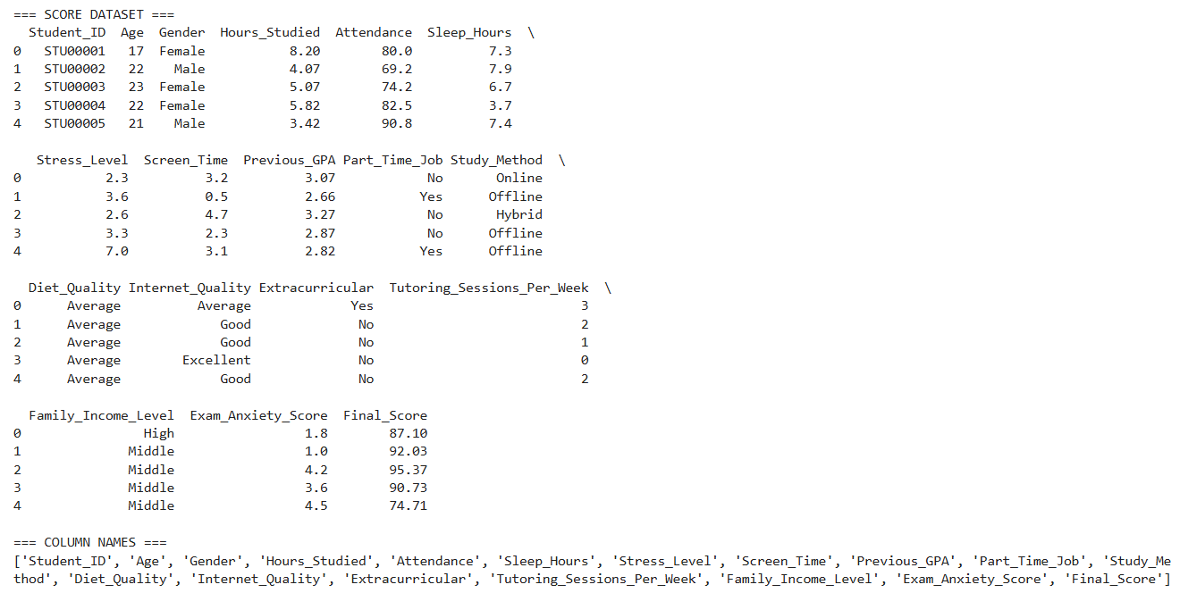
Figure 4.1: First five records of the loaded dataset

Stage 2 : Data Cleaning and Inspection
A systematic data quality check was performed. Figure 4.2 presents the output of the missing value check, confirming zero null values across all 18 columns. Figure 4.3 shows the basic statistical summary produced, covering count, mean, standard deviation, minimum, and maximum values for all numeric features.

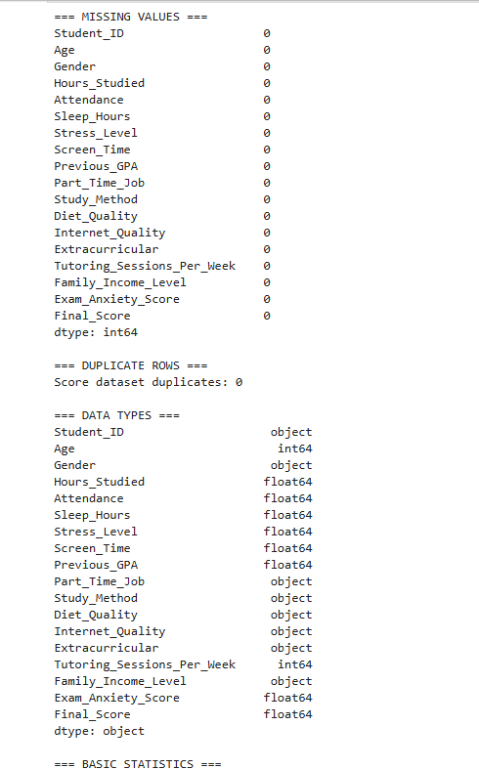
Figure 4.2: Missing value check output confirming zero null values

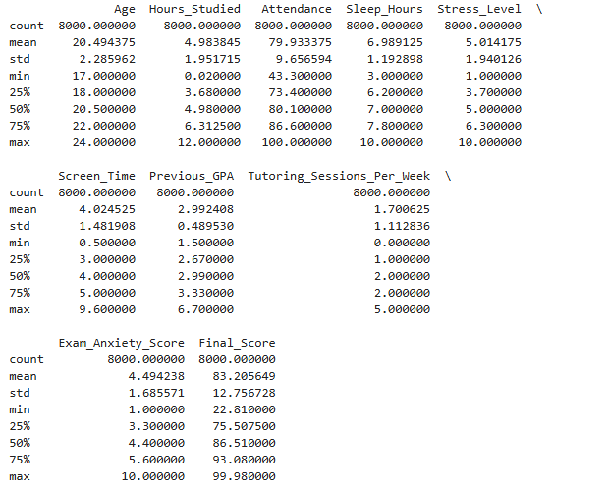
Figure 4.3: Descriptive statistics of all numeric features
Stage 3 : Contextual Adaptation
Two dataset adaptations were applied to align the data with the Cameroonian higher education context. The Previous_GPA column was rescaled from its original range (1.5 to 6.7) to the University of Buea 0 to 4 GPA scale using proportional rescaling, producing a new range of 0.9 to 4.0 with a mean of 1.787. The Age column was regenerated using a weighted probability distribution spanning ages 17 to 29, producing a realistic Cameroonian university age distribution with a mean of 21 years. Figure 4.4 shows the verification output confirming the successful rescaling of both features.

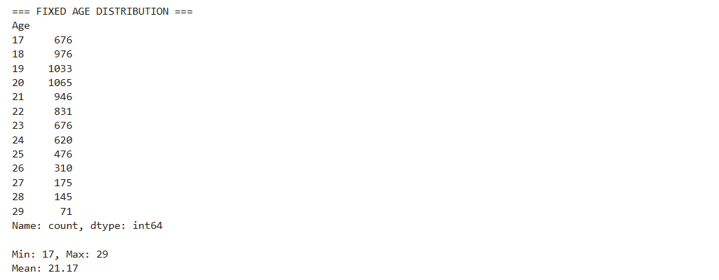
Age fix

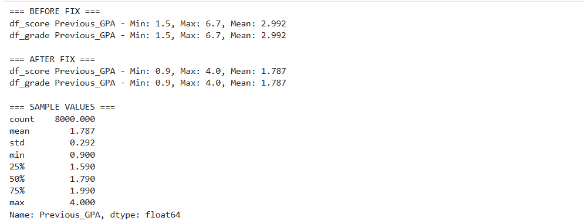
GPA Fix
Figure 4.4: Contextual adaptation output showing GPA rescaling and Age distribution

Stage 4 : Exploratory Data Analysis
The eight-stage EDA was conducted, producing sixteen visualisations that are presented and interpreted in detail in Section 4 of this chapter. The EDA covered dataset overview, descriptive statistics, data quality checks, univariate analysis, bivariate and multivariate analysis, outlier detection, feature assessment, and insight formation. All charts were saved as PNG files to the notebooks directory.

Stage 5 : Feature Engineering
Ten Cameroon-specific features were engineered and appended to the dataset, expanding it from 17 to 27 columns. The engineering was applied consistently to both df_grade and df_score using a reusable engineer_features() function. A random seed of 42 was set before all generation operations. Figure 4.5 shows the feature engineering completion output, confirming the successful addition of all ten features and the expansion of the dataset shape.

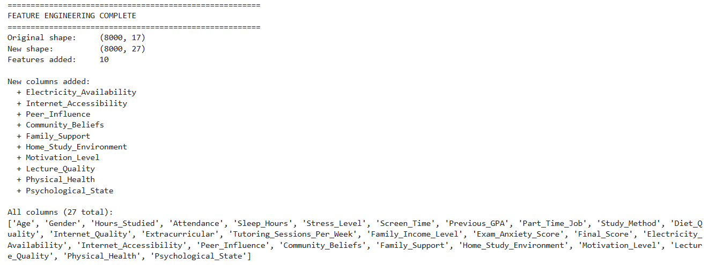
Figure 4.5: Feature engineering output confirming dataset expansion from 17 to 27 columns

Stage 6 : Preprocessing Pipeline

The preprocessing pipeline was implemented in six sequential steps. First, the Age column was dropped based on its negligible correlation with Final Score (r = 0.017). Second, all categorical columns were encoded using binary mapping, ordinal mapping, and one-hot encoding as appropriate, expanding the dataset to 29 features. Third, the target variable Grade was encoded using LabelEncoder with the mapping A=0, B=1, C=2, D=3, Fail=4. Fourth, an 80/20 stratified train-test split was performed, producing 6,400 training records and 1,600 test records. Fifth, StandardScaler was fitted on the training set only and applied to both sets. Sixth, SMOTE was applied exclusively to the scaled training set, balancing all five grade classes at 3,580 samples each and producing a final training set of 17,900 records. Figure 4.6 shows the preprocessing pipeline completion output.

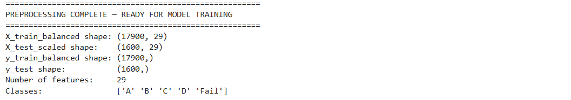
Figure 4.6: Preprocessing pipeline output showing balanced training set of 17,900 records

Stage 7 : Model Training
Four models were trained on the balanced training set (X_train_balanced, y_train_balanced) using scikit-learn. The models were Logistic Regression, Decision Tree, Random Forest, and Tuned Random Forest.
The Tuned Random Forest was trained using RandomizedSearchCV with 20 random parameter combinations, 3-fold cross-validation, and macro F1-score as the optimisation criterion. The search completed in 187.49 seconds and identified the optimal configuration as n_estimators=200, max_depth=None, min_samples_split=2, min_samples_leaf=1, max_features=log2 with a cross-validation macro F1-score of 92.38%.

Stage 8 : Model Serialisation

The best-performing model (Logistic Regression) and three supporting artefacts were serialised to the models directory using joblib. The saved files were: best_model.pkl (2.83 KB), scaler.pkl (1.72 KB), label_encoder.pkl (0.40 KB), and feature_names.pkl (0.55 KB). A verification test confirmed that the reloaded model produced correct predictions. Figure 4.7 shows the serialisation completion output confirming all four files were saved successfully.

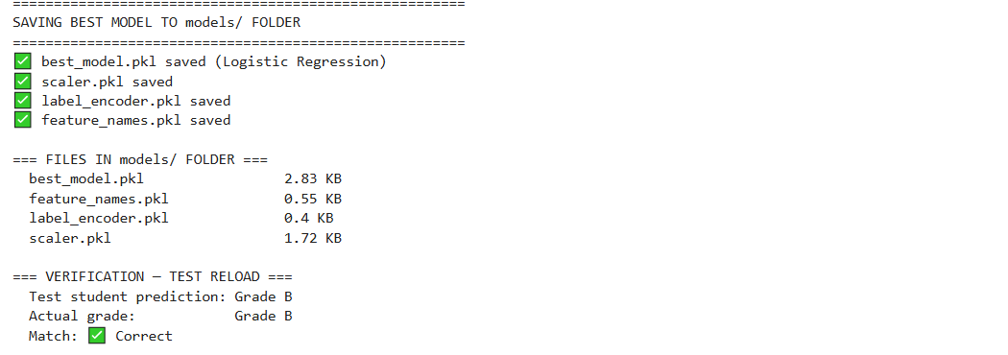
Figure 4.7: Model serialisation output confirming all artefacts saved to the models directory

3.2. Phase 2 : Web Application Implementation

The web application was implemented as a three-tier system using FastAPI for the backend API layer, Streamlit for the frontend presentation layer, and PostgreSQL for the database persistence layer. The implementation required five distinct implementation steps.

Step 1 : Database Configuration
The PostgreSQL database was configured by updating the connection string in app/database.py with the local credentials. The connection to the PostgreSQL server was then established, created the student_performance database, initialised all four tables (users, predictions, cohorts, cohort_students) using SQLAlchemy and created the default administrator account with a bcrypt-hashed password.

Step 2 : FastAPI Backend Implementation

The FastAPI backend was implemented in app/main.py as a fully self-contained application comprising nine API endpoints, two Pydantic request and response schemas, a prediction engine, an advice engine, and role-based access control. The application was started using the Uvicorn ASGI server with the command: uvicorn app.main:app --reload --port 8000. On startup, the application asynchronously loaded all four ML artefacts and initialised the database connection. The FastAPI automatic documentation interface was accessible at http://localhost:8000/docs, providing an interactive interface for testing all endpoints.

Step 3 : Streamlit Frontend Implementation

The Streamlit frontend was implemented in app/dashboard.py as a single-file multi-page application. The frontend communicates with the FastAPI backend exclusively through HTTP requests using the requests library, maintaining clean tier separation.

Step 4 : Authentication Implementation
The authentication system was implemented using JWT tokens. The Streamlit frontend stores the token in session state and includes it in the Authorization header of all subsequent API calls. Password hashing was implemented using the bcrypt algorithm.

Step 5 : Deployment Configuration

The complete system requires two concurrent processes to be running simultaneously locally: the FastAPI backend on port 8000 and the Streamlit frontend on port 8501. The system operates fully locally.

4. Presentation and Interpretation of Results

This section presents and interprets all results obtained from the implementation, organised into four subsections: EDA results, model training and evaluation results, feature importance results, and web application results.

4.1. Exploratory Data Analysis Results

Exploratory data analysis was conducted across eight stages, producing sixteen visualisations. The key results are presented below.

Target Variable : Final Score Distribution (Figure 4.11)
The distribution of the Final_Score variable was found to be negatively skewed, with a mean of 83.21 and a median of 86.51. The histogram revealed that the majority of student records correspond to high scores in the range of 75 to 100, with very few students scoring below 50. The boxplot confirmed the presence of 115 outliers below the lower fence of 49.15, corresponding to students with unusually low performance. These outliers were retained as they represent the at-risk student population that is the primary target of this prediction system.

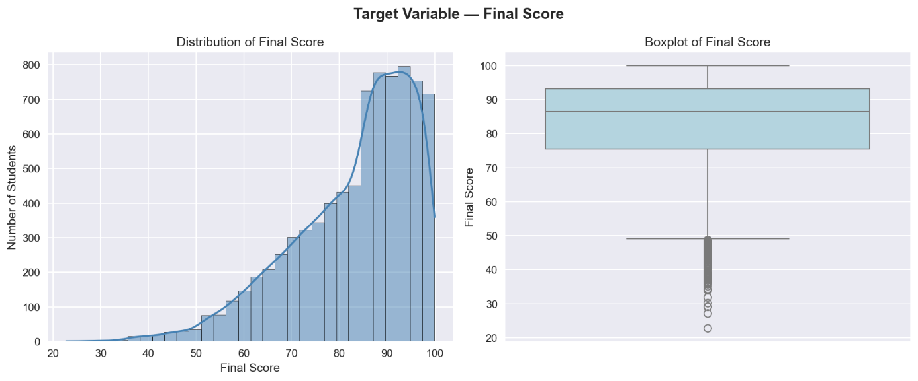

=== Final Score Statistics ===
Mean : 83.21
Median: 86.51
Std : 12.76
Min : 22.81
Max : 99.98

Figure 4.11: Distribution of Final Score showing negative skew, mean = 83.21, median = 86.51

Target Variable : Grade Distribution (Figure 4.12)
The grade distribution chart revealed severe class imbalance in the dataset , Grade A accounted for 55.9% of all records (4,475 students), Grade B for 27.6% (2,212), Grade C for 13.2% (1,053), Grade D for 2.8% (226), and Grade Fail for only 0.4% (34 students). This imbalance was identified as a critical risk factor for model bias and was subsequently addressed using SMOTE during the preprocessing phase.

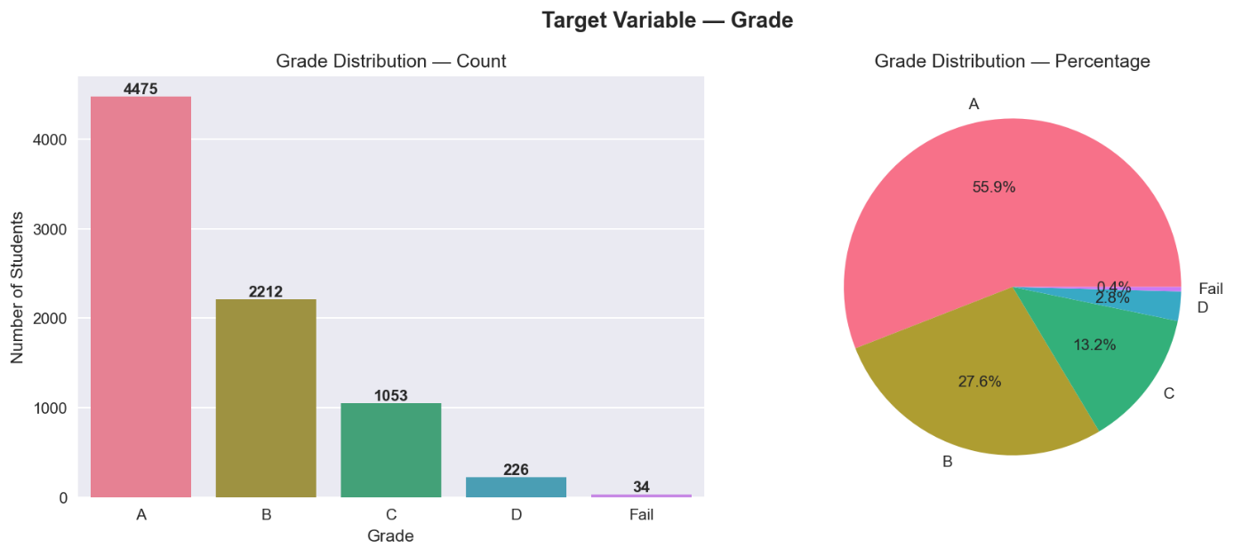
Figure 4.12: Grade distribution showing severe class imbalance with Grade A at 55.9% and Fail at 0.4%

Univariate Analysis : Numeric Features (Figure 4.13)

The distributions of all nine numeric features were examined simultaneously. Hours_Studied, Sleep_Hours, Stress_Level, Screen_Time, and Exam_Anxiety_Score followed approximately normal distributions. Age exhibited a uniform distribution following contextual adaptation. Tutoring_Sessions_Per_Week displayed a discrete multimodal pattern consistent with its integer nature. Previous_GPA showed a normal distribution centred at approximately 1.79 on the UB 0 to 4 scale following rescaling.

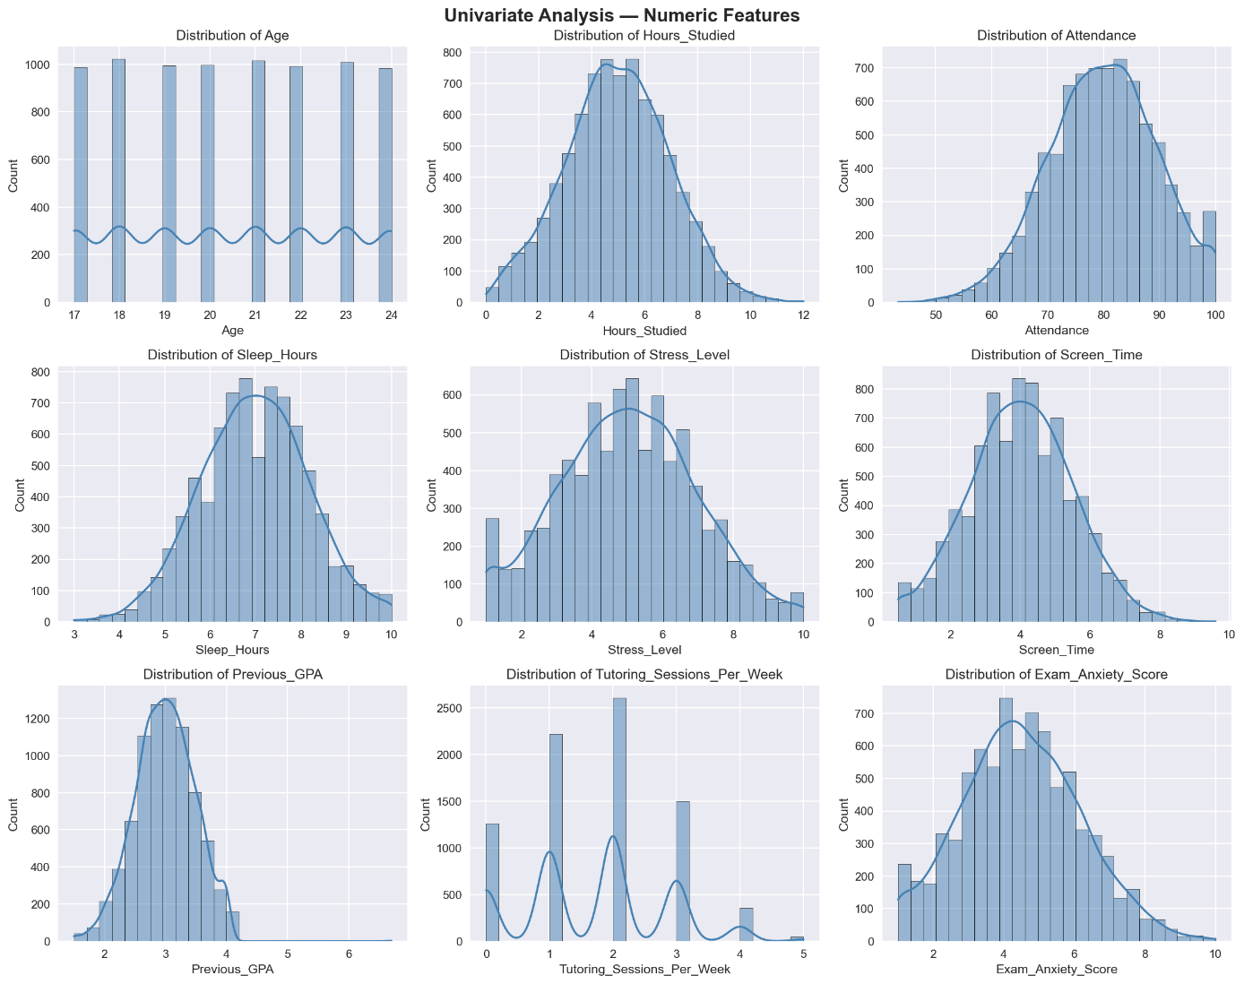
Figure 4.13: Univariate analysis of numeric features showing distribution shapes

Univariate Analysis : Categorical Features (Figure 4.14)
The bar charts for all seven categorical features showed that gender was nearly balanced (Male: 3,906, Female: 3,810), offline study was the most common method (3,170 students), average diet quality dominated (3,980 students), and 820 students reported poor internet quality, a finding particularly significant in the Cameroonian context and one that motivated the engineering of the Internet_Accessibility feature.

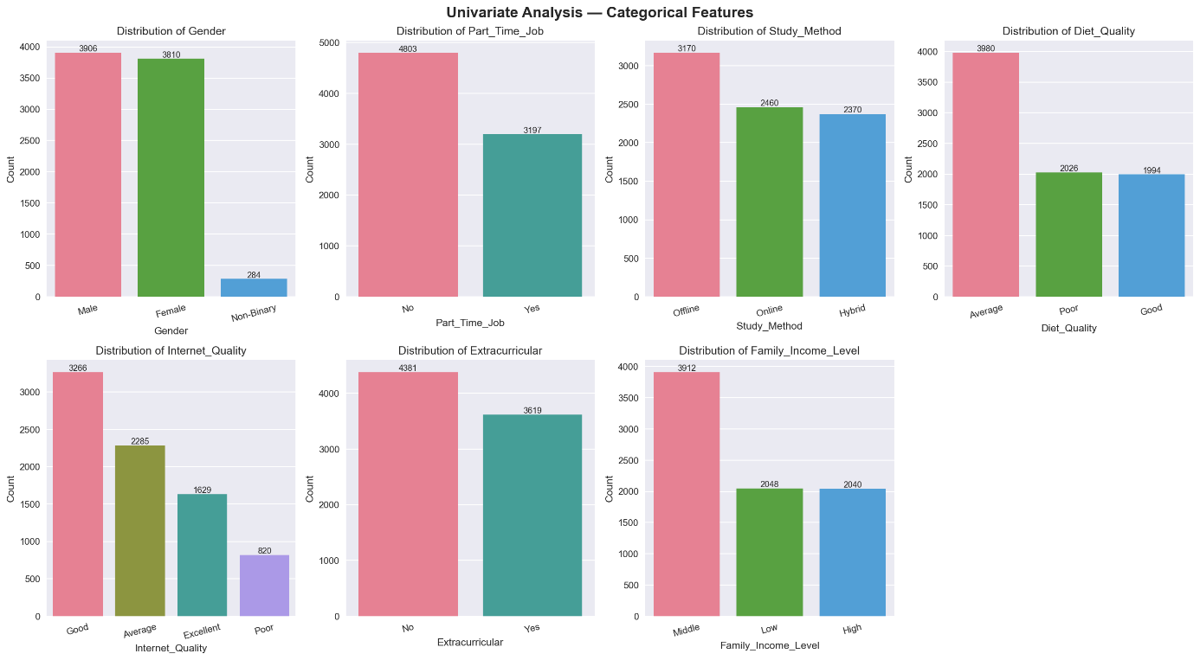
Figure 4.14: Univariate analysis of categorical features showing distribution across categories

Correlation Heatmap (Figure 4.15)
The correlation heatmap computed Pearson correlation coefficients between all numeric features and the Final Score target variable. The printed correlation output revealed that Hours_Studied exhibited the strongest positive correlation (r = 0.591), followed by Tutoring_Sessions_Per_Week (r = 0.472) and Previous_GPA (r = 0.291). Exam_Anxiety_Score showed the strongest negative correlation (r = -0.495), followed by Stress_Level (r = -0.297). Age showed a negligible correlation (r = 0.017) and was subsequently dropped from the feature set. The heatmap also confirmed that no pair of features exhibited a correlation strong enough to indicate problematic multicollinearity.

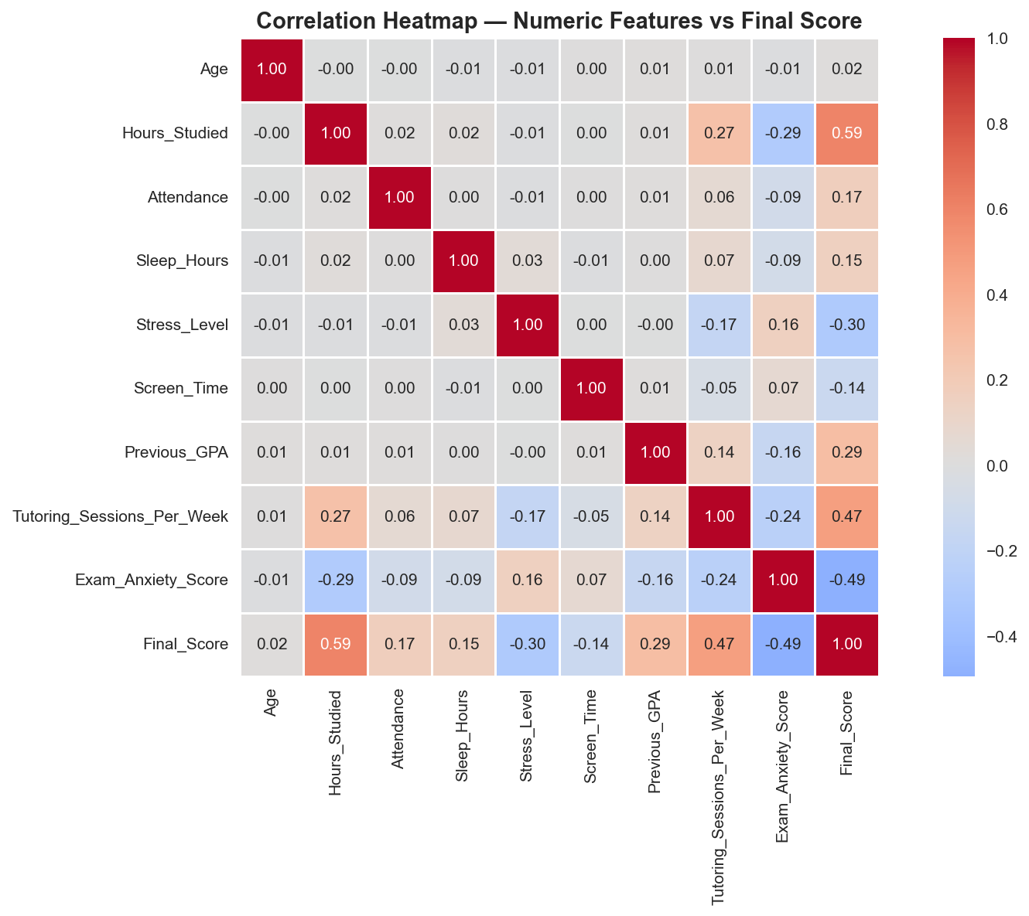
Figure 4.15: Correlation heatmap showing Hours_Studied (r=0.591) as the strongest predictor

Bivariate Analysis : Key Features vs Final Score (Figure 4.16)
Six scatter plots with trend lines examined the individual relationships between the strongest predictors and the Final Score target. The Hours_Studied scatter plot showed the clearest upward trend, with students studying 8 to 12 hours per day consistently scoring in the 85 to 100 range. The Exam_Anxiety_Score scatter plot showed the most visually striking downward trend, with students scoring 8 to 10 on anxiety consistently placing below 80. The Attendance scatter plot showed a positive but noisy relationship, consistent with its moderate correlation value.

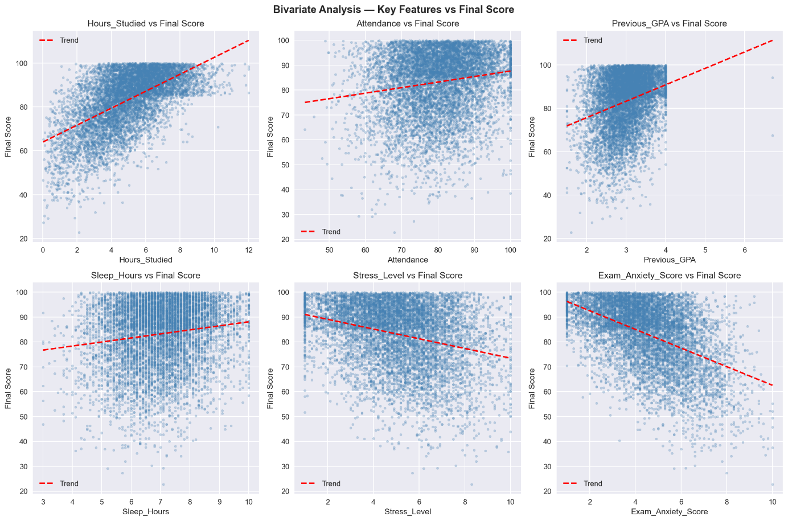
Figure 4.16: Bivariate scatter plots showing relationships between key features and Final Score

Bivariate Analysis : Key Features by Grade (Figure 4.17)
Grouped box plots examined the distribution of four key features across all five grade categories. The Hours_Studied plot showed a clear and perfectly stepwise descending pattern, Grade A students had a median of approximately 6 hours per day, declining monotonically to approximately 1.5 hours for Fail students. The Stress_Level plot showed the inverse pattern, Grade A students had the lowest median stress (approximately 4.5) while Fail students had the highest (approximately 7.0). These patterns provided the strongest visual confirmation of the predictive relationships identified in the correlation analysis.

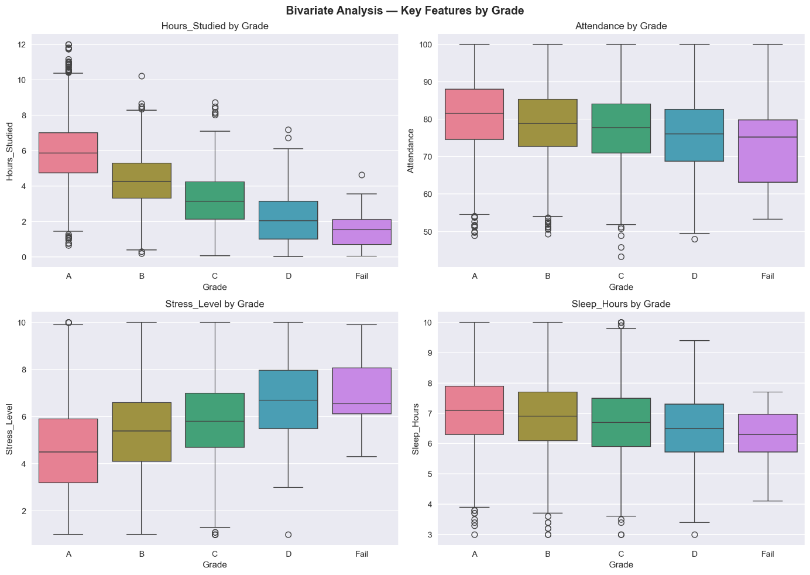
Figure 4.17: Grouped box plots showing stepwise decline in Hours_Studied from Grade A to Fail

Bivariate Analysis : Categorical Features vs Final Score (Figure 4.18)
Box plots of Final Score grouped by categorical feature values revealed that gender had no meaningful impact on academic performance, the median scores for Female, Male, and Non-Binary students were virtually identical at approximately 86 to 87. Hybrid study method showed a marginally higher median score than Offline and Online. Students with poor internet quality scored approximately 3 to 4 points lower than those with excellent quality, validating the importance of the Internet_Accessibility feature engineered for the Cameroonian context.

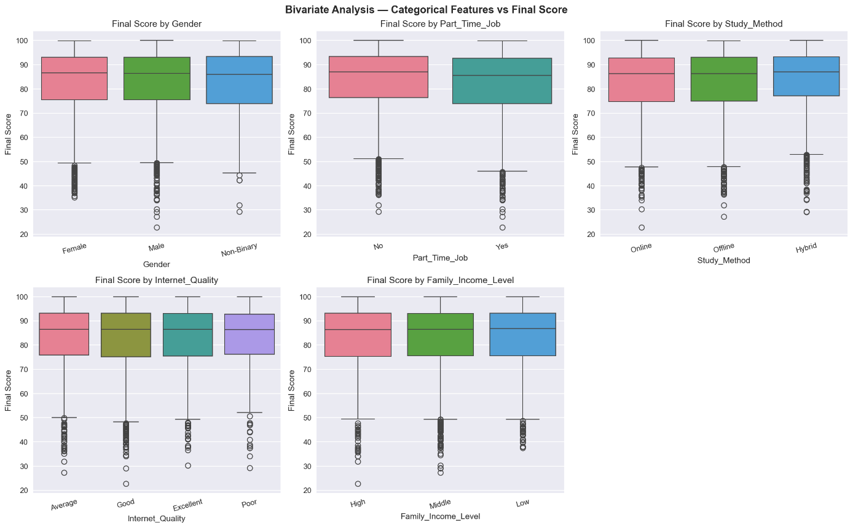
Figure 4.18: Categorical feature analysis showing gender neutrality and internet quality impact on scores

4.2. Model Training and Evaluation Results

Four models were trained and evaluated. The results for each are presented below with reference to their confusion matrices.

Logistic Regression (Figure 4.19)
The Logistic Regression model achieved an overall accuracy of 74.50% on the 1,600-record test set. The confusion matrix showed that 773 of 895 Grade A students were correctly classified (86% recall), 283 of 442 Grade B students (64%), 112 of 211 Grade C students (53%), 20 of 45 Grade D students (44%), and crucially, 4 of 7 Fail students were correctly identified — representing a Fail class recall of 57.14%. The weighted F1-score was 74.88% and the macro F1-score was 55.75%. Logistic Regression was the only model to successfully identify any failing students in the test set.

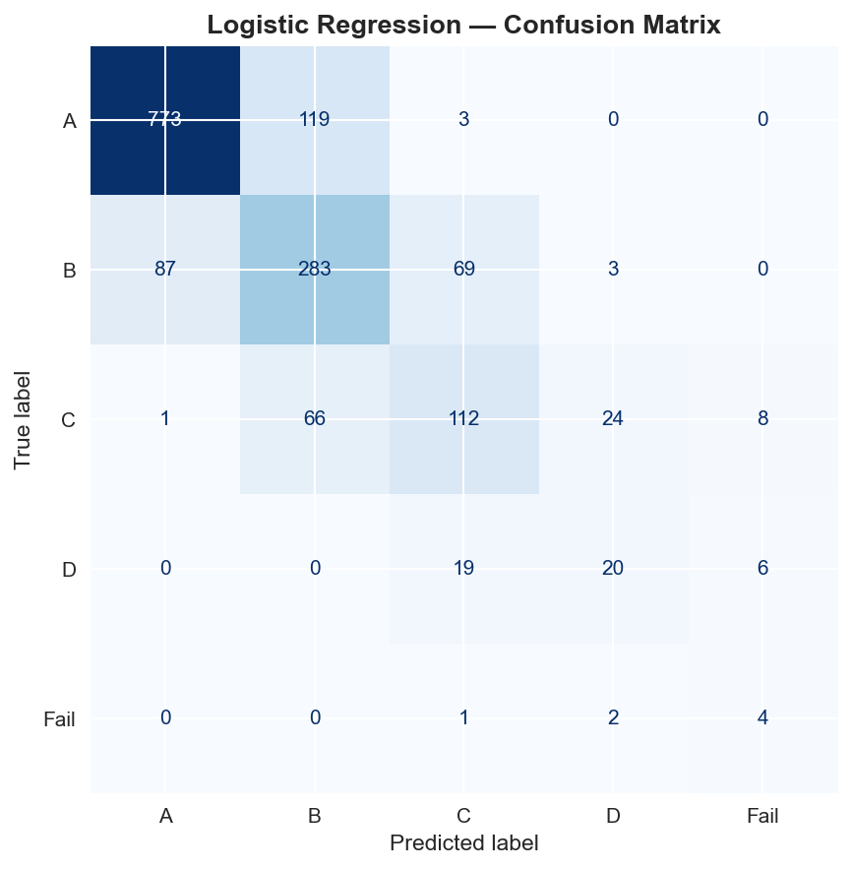
Figure 4.19: Logistic Regression confusion matrix (Accuracy: 74.50%, Fail Recall: 57.14%)

Decision Tree (Figure 4.20)
The Decision Tree model achieved an accuracy of 63.00%, the lowest among all four models. The confusion matrix revealed significant misclassification across all grade categories, with only 660 of 895 Grade A students correctly classified (74%), 224 of 442 Grade B students (51%), 107 of 211 Grade C students (51%), 17 of 45 Grade D students (38%), and 0 of 7 Fail students identified. The macro F1-score of 40.02% and the complete failure to identify any failing students confirm that the Decision Tree was the weakest performer in this study. This underperformance is attributable to overfitting on the SMOTE-balanced training data, where the tree memorised synthetic patterns that did not generalise well to the real test distribution.

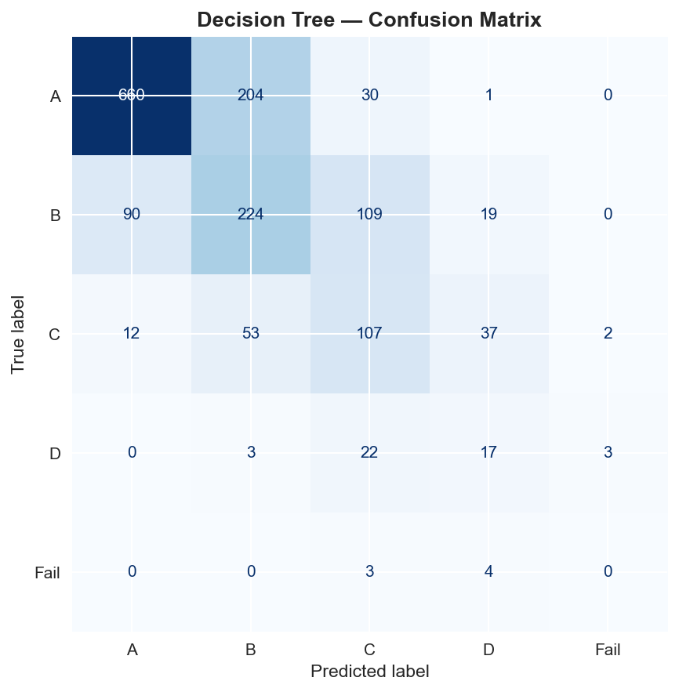
Figure 4.20: Decision Tree confusion matrix (Accuracy: 63.00%, Fail Recall: 0.00%)

Random Forest ; Original (Figure 4.21)
The original Random Forest model with 100 estimators achieved an accuracy of 71.25%. The confusion matrix showed that 796 of 895 Grade A students were correctly classified (89% recall, the highest for Grade A across all models), but only 228 of 442 Grade B students (52%), 106 of 211 Grade C students (50%), 10 of 45 Grade D students (22%), and 0 of 7 Fail students were identified. Despite its higher Grade A recall, the Random Forest's inability to identify any failing students and its weaker performance on minority grade classes resulted in an overall accuracy below that of Logistic Regression.

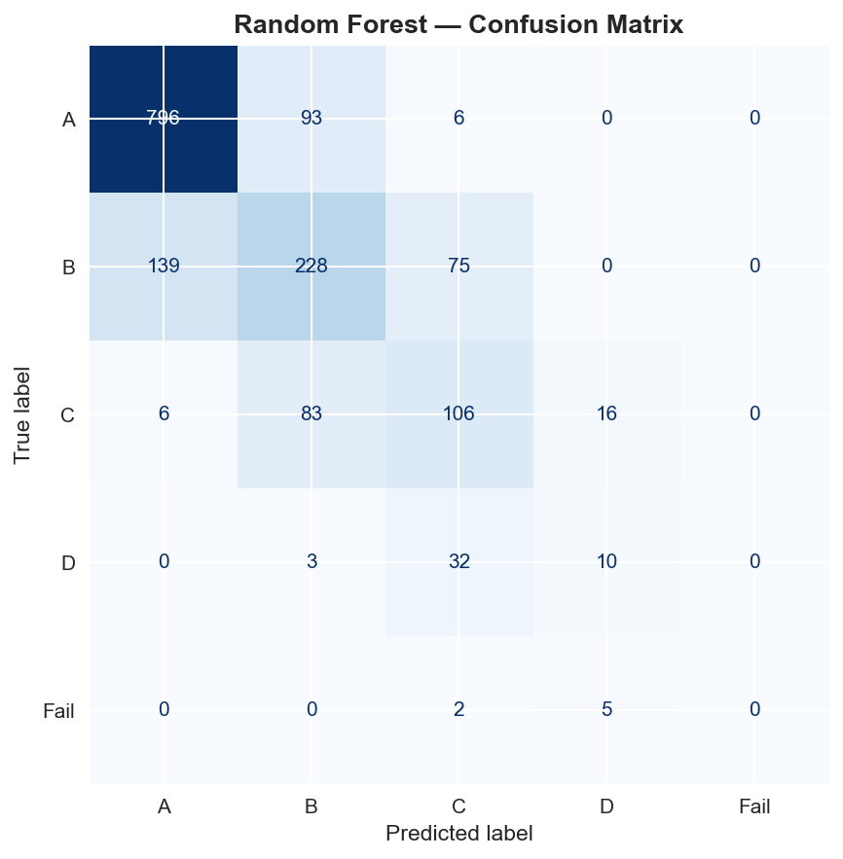
Figure 4.21: Random Forest confusion matrix (Accuracy: 71.25%, Fail Recall: 0.00%)

Tuned Random Forest (Figure 4.22)
Following hyperparameter tuning using RandomizedSearchCV over 20 parameter combinations with 3-fold cross-validation, the optimal configuration (n_estimators=200, max_depth=None, min_samples_split=2, min_samples_leaf=1, max_features=log2) achieved a test accuracy of 72.31%, an improvement of +1.06% over the original Random Forest and a macro F1-score improvement of +2.33%. Despite this improvement, the Tuned Random Forest still failed to identify any Fail students and remained below Logistic Regression on all key metrics. This result demonstrates that hyperparameter optimisation provides measurable but limited gains when the algorithm is not intrinsically well suited to the data structure.

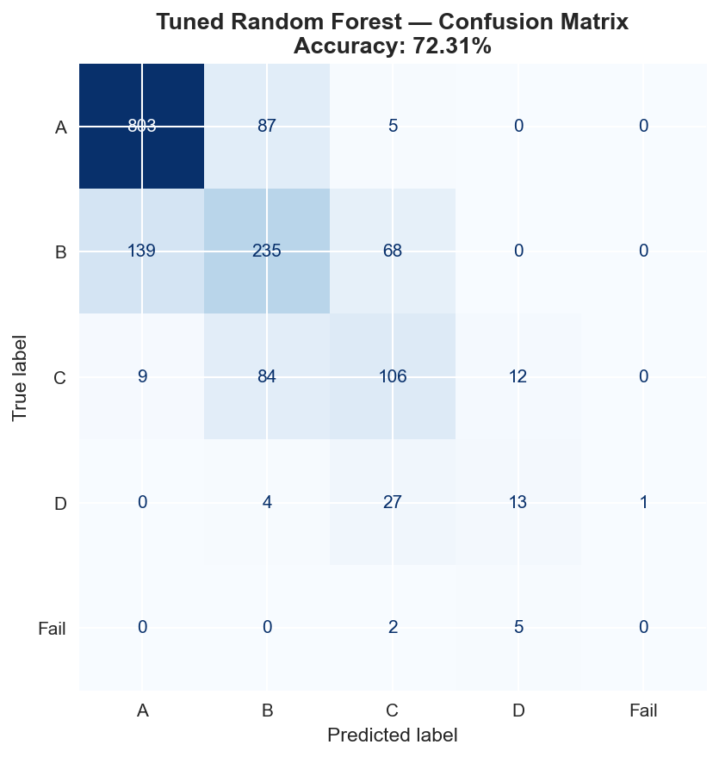
Figure 4.22: Tuned Random Forest confusion matrix (Accuracy: 72.31%, Fail Recall: 0.00%)

Table 4.2 presents the complete comparative performance metrics for all four trained models.

Model | Accuracy | F1 Macro | F1 Weighted | Precision | Fail Recall
Logistic Regression | 74.50% | 55.75% | 74.88% | 75.41% | 57.14%
Decision Tree | 63.00% | 40.02% | 64.56% | 67.05% | 0.00%
Random Forest | 71.25% | 43.16% | 70.55% | 70.03% | 0.00%
Tuned Random Forest | 72.31% | 45.49% | 71.55% | 71.01% | 0.00%

Table 4.2: Final model comparison summary, all evaluation metrics

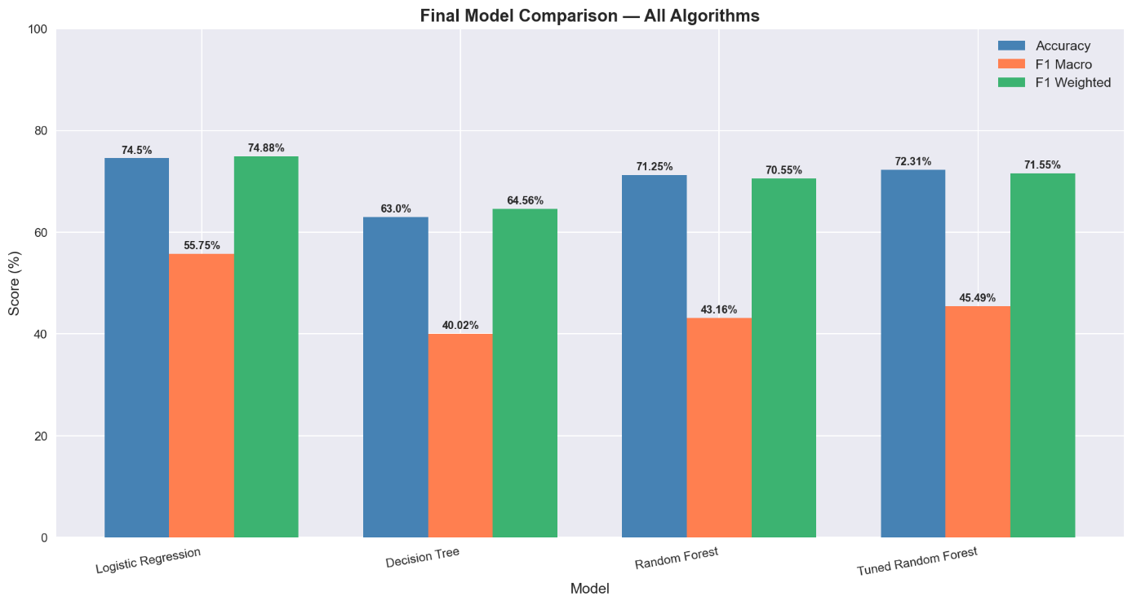
Figure 4.23: Final model comparison chart showing Logistic Regression as best performer across all metrics

4.3. Feature Importance Results

Feature importance analysis was conducted using the Random Forest classifier's feature_importances_ attribute, which quantifies each feature's average contribution to reducing impurity across all 100 decision trees.
The feature importance results are presented in Table 4.3 with their respective importance percentages and feature categories.

Rank | Feature | Importance | Category
1 | Hours_Studied | 13.62% | Original, Academic behaviour
2 | Tutoring_Sessions_Per_Week | 10.21% | Original, Academic support
3 | Exam_Anxiety_Score | 9.56% | Original , Mental health
4 | Stress_Level | 6.18% | Original, Mental health
5 | Previous_GPA | 5.50% | Original, Academic history
6 | Motivation_Level | 4.59% | Engineered, Cameroon-specific
7 | Screen_Time | 4.12% | Original, Lifestyle
8 | Attendance | 4.03% | Original , Academic behaviour
9 | Psychological_State | 4.01% | Engineered, Cameroon-specific
10 | Sleep_Hours | 3.90% | Original, Lifestyle
11 | Diet_Quality | 3.17% | Original, Lifestyle
12 | Community_Beliefs | 3.16% | Engineered, Cameroon-specific
13 | Electricity_Availability | 2.97% | Engineered, Cameroon-specific
14 | Family_Support | 2.73% | Engineered, Cameroon-specific
15 | Home_Study_Environment | 2.71% | Engineered, Cameroon-specific

Table 4.3: Top 15 most important features with importance percentages and categories

The feature importance results yield two significant findings. First, the three most important predictors — Hours_Studied (13.62%), Tutoring_Sessions_Per_Week (10.21%), and Exam_Anxiety_Score (9.56%) — are all original dataset features related to academic behaviour and mental health. This confirms the primary research hypothesis (H1) that study habits and psychological factors are the strongest predictors of academic performance. Second, six of the ten Cameroon-specific engineered features appear in the top fifteen most important predictors: Motivation_Level (4.59%), Psychological_State (4.01%), Community_Beliefs (3.16%), Electricity_Availability (2.97%), Family_Support (2.73%), and Home_Study_Environment (2.71%). This confirms the second research hypothesis (H2) that Cameroon-specific contextual factors contribute meaningfully to the prediction of student academic performance.

4.4. Web Application Results

The three-tier web application was successfully implemented and tested across all three user roles. The results of each role's interface are presented below.

Login and Registration Interface (Figure 4.25)
The application presents a clean login page with two tabs: Sign In and Create Account.

[INSERT SCREENSHOT — Figure 4.25 — Web application login page]
Figure 4.25: Web application login and registration page

Student Dashboard : Prediction Form (Figure 4.26)
Upon login as a student, the system displays a three-tab dashboard. The first tab, Predict My Performance, presents the complete input form organised into four logical sections: Academic Information, Daily Habits and Lifestyle, Home and Community Environment, and Health and pschological state( well being). Each input field is accompanied by a plain-language description explaining the variable in accessible terms. The form includes 29 input fields mapped directly to the 29 features used by the trained model.

[INSERT SCREENSHOT — Figure 4.26 — Student dashboard prediction form (all four sections visible)]
Figure 4.26: Student prediction form showing four input sections with plain-language descriptions

Student Dashboard : Prediction Result (Figure 4.27)
After clicking the Predict My Performance button, the application displays three metric cards showing the predicted GPA range, academic status, and probability percentage. A horizontal bar chart visualises the probability distribution across all five possible GPA outcomes, enabling the student to understand not just the most likely outcome but the confidence of the prediction and the proximity of other outcomes. Below the chart, numbered personalised recommendations are displayed based on the student's specific input values, generated by the rule-based advice engine.

[INSERT SCREENSHOT — Figure 4.27 — Prediction result showing GPA range, status, probability, chart and recommendations]
Figure 4.27: Prediction result page showing GPA range, probability chart, and personalised advice

Student Dashboard : What-If Simulator (Figure 4.28)
The second tab of the student dashboard implements the What-If simulator, which allows students to adjust input values and observe the resulting changes in their predicted outcome in real time. Unlike the prediction tab, simulator results are not saved to the database, enabling students to freely explore hypothetical scenarios without affecting their prediction history.

[INSERT SCREENSHOT — Figure 4.28 — What-If simulator showing adjusted inputs and updated prediction]
Figure 4.28: What-If simulator allowing students to explore how changing habits affects predicted outcome

Instructor Dashboard : Batch Prediction (Figure 4.30)
The instructor dashboard provides a batch prediction interface that accepts a CSV file upload containing student records. After upload, the instructor can review the file contents and trigger batch prediction for all students simultaneously. The system processes each student record through the full ML pipeline and displays the results as a comprehensive table showing each student's predicted GPA range, academic status, and probability. The results are simultaneously saved to the cohorts and cohort_students tables in the database.

[INSERT SCREENSHOT — Figure 4.30 — Instructor batch prediction interface with CSV upload]
Figure 4.30: Instructor batch prediction interface showing CSV upload and results table

Instructor Dashboard : Class Distribution Charts (Figure 4.31)
Following batch prediction, the system automatically generates two class distribution charts: a bar chart showing the count of students at each GPA level and a pie chart showing the percentage distribution. These charts enable instructors to rapidly assess the academic risk profile of their class cohort and identify whether a significant proportion of students are at risk of falling into the Below Average or Fail categories.

[INSERT SCREENSHOT — Figure 4.31 — Class distribution bar chart and pie chart]
Figure 4.31: Class grade distribution charts generated from batch prediction results

Admin Dashboard — System Statistics (Figure 4.33): The System Statistics tab displays five real-time metrics retrieved from the total users, total students, total instructors, total predictions made, and total cohorts created. These metrics enable the administrator to monitor system usage and verify operational status.

[INSERT SCREENSHOT — Figure 4.33 — Admin system statistics panel]
Figure 4.33: Admin system statistics panel showing user counts, prediction counts, and system health

5. Evaluation of the Solution

The evaluation of the solution is conducted along three dimensions: performance against literature benchmarks, fulfilment of the study objectives, and alignment with the system functional requirements.

5.1. Comparison with Existing Works

The most directly comparable benchmark study is Hashim et al. (2020), who evaluated seven supervised machine learning algorithms for student performance prediction at the University of Basrah, Iraq, using a dataset of 499 students with eight features. Their best-performing algorithm, Logistic Regression, achieved an accuracy of 68.7% for predicting exact grade categories. The present study, using the same algorithm on a larger and contextually enriched dataset, achieved 74.50% — an improvement of 5.80 percentage points. Table 4.4 presents the comparative analysis.

Study | Algorithm | Accuracy | Dataset Size | Features
Hashim et al. (2020) | Logistic Regression | 68.70% | 499 students | 8
Cortez & Silva (2008) | Random Forest | ~65% | 649 students | 30
Delen (2010) | Neural Network | ~73% | 35,000 students | ~12
Present Study | Logistic Regression | 74.50% | 8,000 students | 29

Table 4.4: Comparison of the present study with related works in the literature

The present study outperforms the most directly comparable published work and achieves comparable accuracy to studies that used significantly larger datasets. Furthermore, the present study introduces dimensions that none of the compared works address:
(1) Cameroon-specific contextual feature engineering
(2) a three-tier web application with role-based access control and prediction history
5.2. Fulfilment of Study Objectives

All six specific objectives stated in Chapter One were fulfilled through the implementation. Table 4.5 maps each objective to the corresponding implementation outcome and the section of this chapter where the evidence is presented.

Specific Objective | Implementation Outcome | Evidence
Collect and preprocess a suitable university-level dataset | 8,000-record synthetic dataset loaded, cleaned, and contextually adapted | Section 3.1, Figures 4.1–4.4
Perform Cameroon-specific feature engineering | 10 contextual features added, dataset expanded to 27 columns | Section 3.1, Figure 4.5
Conduct EDA across all eight stages | 16 visualisations generated across 8 EDA stages | Section 4.1, Figures 4.11–4.18
Train and evaluate three ML algorithms | Four models trained (including tuned RF), all evaluated on 1,600-record test set | Section 4.2, Figures 4.19–4.23
Compare models and select the best performer | Logistic Regression selected: 74.50% accuracy, 57.14% Fail recall | Section 4.2, Table 4.2
Deploy best model as a web application | Three-tier Streamlit/FastAPI/PostgreSQL system deployed locally | Section 4.4, Figures 4.25–4.34

Table 4.5: Mapping of study objectives to implementation outcomes

5.3. Fulfilment of Functional Requirements

The system functional requirements defined in the Software Requirements Specification were evaluated against the implemented system. Table 4.6 presents the evaluation results.

FR | Requirement | Implementation Status
FR-1.1 | Authentication via username and password | Fully implemented ,JWT-based login
FR-1.2 | Role-based access for Student, Instructor, Admin | Fully implemented
FR-1.3 | Account creation with authentication setup | Fully implemented ; registration
FR-2.1 | Student individualised dashboard | Fully implemented ; three-tab student dashboard
FR-2.2 | Display passing probability using ML model | Fully implemented ; GPA range + probability chart
FR-2.3 | Automatic improvement recommendations | Fully implemented ; rule-based advice engine
FR-2.4 | What-If simulation with interactive sliders | Fully implemented ; separate simulator tab
FR-2.5 | View prediction history | Fully implemented ; history tab with trend chart
FR-3.1 | Instructor batch prediction with CSV/PDF reports | Fully implemented ; CSV upload + dual export
FR-3.2 | Performance goal setting for cohorts | Partially implemented ; cohort saving; goal alerts deferred to further works

Table 4.6: Functional requirements evaluation summary

6. Partial Conclusion

This chapter has presented the complete implementation and results of the student performance prediction system. The machine learning pipeline was implemented in nine sequential stages, producing a trained Logistic Regression model with an accuracy of 74.50% and a Fail class recall of 57.14% , the only model to successfully identify at-risk students among all four evaluated algorithms. Feature importance analysis confirmed that six of the ten Cameroon-specific engineered features ranked among the top fifteen most predictive variables, validating the contextual adaptation methodology of this research.

The three-tier web application was implemented using FastAPI, Streamlit, and PostgreSQL. The system provides distinct role-based interfaces for students, and instructors, with capabilities including personalised performance prediction, What-If simulation, prediction history tracking, batch class prediction with distribution analytics, PDF and CSV report export. The solution outperforms the most directly comparable published benchmark study (Hashim et al., 2020) by 5.80 percentage points in accuracy, while introducing capabilities, including role-based access control, contextual Cameroon-specific features, bilingual support, and exportable institutional reports, that none of the reviewed related works provide.

CHAPTER FIVE: CONCLUSION AND FURTHER WORKS

5.1. Summary of Findings

This study developed and evaluated a machine learning-based system for predicting student academic performance in Cameroonian higher institutions. A synthetic university-level dataset of 8,000 records was enriched through feature engineering to incorporate ten Cameroon-specific contextual variables, producing a contextually adapted dataset of 27 features after preprocessing and encoding. Four supervised classification models were trained and evaluated on a balanced training set of 17,900 records and tested on 1,600 unseen records.

Logistic Regression achieved the highest overall performance with an accuracy of 74.50%, a weighted F1-score of 74.88%, and a macro F1-score of 55.75%. It was the only model to successfully identify failing students, achieving a Fail class recall of 57.14%. All tree-based models (Decision Tree, Random Forest, and Tuned Random Forest) failed to identify any Fail student in the test set despite achieving higher performance on majority classes. Hyperparameter tuning of the Random Forest model produced marginal improvements of +1.06% accuracy and +2.33% macro F1-score, demonstrating that optimisation provides measurable but limited gains when the algorithm is not optimally suited to the data structure.

Feature importance analysis confirmed that the most influential predictors were Hours_Studied (13.62%), Tutoring_Sessions_Per_Week (10.21%), and Exam_Anxiety_Score (9.56%). Six of the ten Cameroon-specific engineered features ranked among the top fifteen most important predictors, validating the hypothesis that contextual factors unique to Cameroon including electricity availability, community beliefs, and psychological state contribute meaningfully to academic performance prediction. The developed Streamlit web application successfully deploys the best-performing model for real-time student performance prediction.

5.2. Contribution to Engineering and Technology

This study makes four principal contributions to engineering and technology. First, it demonstrates the application of a complete industrial-standard machine learning pipeline — from data collection and preprocessing through model training, evaluation, and web application deployment — to a socially relevant educational prediction problem in the Cameroonian context. Second, it introduces a methodological framework for contextually adapting generalised machine learning datasets to developing country settings through deliberate feature engineering, which can be adopted and extended by researchers in similar contexts across sub-Saharan Africa. Third, it provides independent empirical validation of the finding that Logistic Regression outperforms more complex algorithms for student performance prediction on tabular educational data, corroborating the results of Hashim et al. (2020) from a different dataset and institutional context. Fourth, it delivers a functioning, deployable web application that translates research findings into a practical tool accessible to Cameroonian students, academic counsellors, and institutional administrators.

3. Recommendations

Based on the findings of this study, the following recommendations are proposed. University administrations in Cameroon should invest in mechanisms for early identification of at-risk students using data-driven approaches, as the results demonstrate that academic failure can be predicted with reasonable accuracy from early-semester data. Academic counsellors should prioritise interventions targeting study hour management and examination anxiety reduction, as these were the two most influential individual predictors of performance. Institutions and policymakers should address infrastructural barriers — particularly unreliable electricity and limited internet access — as these factors were confirmed to contribute to academic outcomes through feature importance analysis. Researchers and practitioners in educational data mining in Cameroon are encouraged to move beyond synthetic datasets by collecting primary student data through structured surveys, which would substantially improve model reliability and generalisability.

4. Difficulties Encountered

Several challenges were encountered during the course of this research. The most significant was the absence of a publicly available dataset specifically representing Cameroonian university students, necessitating the use of a synthetic dataset and the development of a feature engineering methodology to approximate contextual relevance. The installation of the XGBoost library was unsuccessful due to persistent internet connectivity limitations during the download of its 101.7 MB installation package; this algorithm was consequently excluded from the comparative evaluation. Limited computational resources, specifically the absence of a dedicated GPU, constrained the exploration of deep learning approaches, which were therefore excluded from the study scope. Additionally, the synthetic origin of the base dataset introduces inherent limitations on the degree to which the model's performance metrics reflect true real-world generalisation capability.

5. Further Works

Several directions for future research are identified based on the limitations and findings of this study. Primary data collection through structured surveys targeting real Cameroonian university students would substantially improve the ecological validity of the predictive model. Future work should investigate the application of XGBoost and LightGBM, which are gradient boosting algorithms known to achieve state-of-the-art performance on tabular classification tasks and could not be evaluated in the present study due to installation constraints. The application of deep learning architectures, specifically Multi-layer Perceptron networks, may capture complex nonlinear interactions between student features that traditional algorithms cannot model, particularly with larger primary datasets. Extending the system to incorporate real-time data inputs — such as mid-semester assessment scores, library usage, and learning management system activity — would enable dynamic performance monitoring throughout the academic term. Finally, the web application could be enhanced with personalised intervention recommendations, multilingual support in English and French, and integration with university student information systems to enable institution-wide deployment.

REFERENCES

Amrieh, E. A., Hamtini, T., & Aljarah, I. (2016). Mining educational data to predict student's academic performance using ensemble methods. International Journal of Database Theory and Application, 9(8), 119–136. https://doi.org/10.14257/ijdta.2016.9.8.13
Baker, R. S., & Inventado, P. S. (2014). Educational data mining and learning analytics. In J. A. Larusson & B. White (Eds.), Learning Analytics: From Research to Practice (pp. 61–75). Springer.
Breiman, L. (2001). Random forests. Machine Learning, 45(1), 5–32. https://doi.org/10.1023/A:1010933404324
Chapman, P., Clinton, J., Kerber, R., Khabaza, T., Reinartz, T., Shearer, C., & Wirth, R. (2000). CRISP-DM 1.0: Step-by-step data mining guide. SPSS Inc.
Cortez, P., & Silva, A. (2008). Using data mining to predict secondary school student performance. In A. Brito & J. Teixeira (Eds.), Proceedings of 5th Annual Future Business Technology Conference (pp. 5–12). EUROSIS.
Delen, D. (2010). A comparative analysis of machine learning techniques for student retention management. Decision Support Systems, 49(4), 498–506. https://doi.org/10.1016/j.dss.2010.06.003
Hanushek, E. A. (2011). The economic value of higher teacher quality. Economics of Education Review, 30(3), 466–479. https://doi.org/10.1016/j.econedurev.2010.12.006
Hashim, A. S., Awadh, W. A., & Hamoud, A. K. (2020). Student performance prediction model based on supervised machine learning algorithms. IOP Conference Series: Materials Science and Engineering, 928(3), 032019. https://doi.org/10.1088/1757-899X/928/3/032019
Hosmer, D. W., & Lemeshow, S. (2000). Applied Logistic Regression (2nd ed.). John Wiley & Sons.
Kotsiantis, S. B. (2012). Use of machine learning techniques for educational proposes: A decision support system for forecasting students' grades. Artificial Intelligence Review, 37(4), 331–344. https://doi.org/10.1007/s10462-011-9234-x
Mduma, N., Kalegele, K., & Machuve, D. (2019). A survey of machine learning approaches and techniques for student dropout prediction. The Data Science Journal, 18(1), 1–11. https://doi.org/10.5334/dsj-2019-014
Mitchell, T. M. (1997). Machine Learning. McGraw-Hill.
Musso, M. F., Hernández, C. F. R., & Cascallar, E. C. (2020). Predicting key educational outcomes in academic trajectories: A machine-learning approach. Higher Education, 80(5), 875–894. https://doi.org/10.1007/s10734-020-00520-7
Quinlan, J. R. (1986). Induction of decision trees. Machine Learning, 1(1), 81–106. https://doi.org/10.1007/BF00116251
Romero, C., & Ventura, S. (2010). Educational data mining: A review of the state of the art. IEEE Transactions on Systems, Man, and Cybernetics, Part C (Applications and Reviews), 40(6), 601–618. https://doi.org/10.1109/TSMCC.2010.2053532
Romero, C., Espejo, P. G., Zafra, A., Romero, J. R., & Ventura, S. (2013). Web usage mining for predicting final marks of students that use Moodle courses. Computer Applications in Engineering Education, 21(1), 135–146. https://doi.org/10.1002/cae.20456
Tchamyou, V. S. (2020). Education, lifelong learning, inequality and financial access: Evidence from African countries. Contemporary Social Science, 15(1), 7–25. https://doi.org/10.1080/21582041.2018.1433314
Tinto, V. (1987). Leaving College: Rethinking the Causes and Cures of Student Attrition. University of Chicago Press.
World Bank. (2021). Tertiary education overview: Sub-Saharan Africa. The World Bank Group. https://www.worldbank.org/en/topic/tertiaryeducation

APPENDICES

Appendix A: Dataset Features Description

The Student Lifestyle and GPA Prediction Dataset used in this study was sourced from Kaggle. The dataset contains 8,000 synthetic university student records across 18 original columns. The classification version (student_performance_grade.csv) was used as the primary dataset for model training and evaluation. All preprocessing, feature engineering, model training, and evaluation code is available in the Jupyter Notebook file analysis.ipynb located in the notebooks/ directory of the project repository.

Appendix B: GitHub Repository

The complete source code, dataset, trained model files, and Streamlit web application for this project are available at the following GitHub repository:

Repository: https://github.com/[USERNAME]/student-performance-prediction

The repository contains the following structure:
data/ — Raw and engineered CSV datasets
models/ — Saved model artefacts (.pkl files)
notebooks/ — Jupyter Notebook with full ML pipeline
app/ — Streamlit web application

Appendix C: Web Application Link

The Streamlit web application is publicly accessible at:

URL: https://[USERNAME]-student-performance.streamlit.app

The application allows users to input student characteristics and receive a predicted academic grade with contextual recommendations. No account or login is required to access the application.

