
UNIVERSITY OF BUEA

P.O. Box 63,
Buea, South West Region CAMEROON
Tel : (237) 3332 21 34/3332 26 90
Fax: (237) 3332 22 72

REPUBLIC OF CAMEROON

PEACE-WORK-FATHERLAND

FACULTY OF ENGINEERING AND TECHNOLOGY

DEPARTMENT OF COMPUTER ENGINEERING

PREDICTING STUDENT PERFORMANCE IN HIGHER INSTITUTIONS USING MACHINE LEARNING TECHNIQUES

A dissertation submitted to the Department of Computer Engineering, Faculty of Engineering and Technology, University of Buea, in Partial Fulfilment of the Requirements for the Award of Bachelor of Engineering (B.Eng.) Degree in Computer Engineering.
By :
AV’NYEHBEUHKOHN EZEKIEL HOSANA
Matriculation Number: FE22A160
Option: Software Engineering

Supervisor :
Dr. SOP DEFFO Lionel
University of Buea

2025/2026 Academic Year

PREDICTING STUDENT PERFORMANCE IN HIGHER INSTITUTIONS USING MACHINE LEARNING TECHNIQUES

AV’NYEHBEUHKOHN EZEKIEL HOSANA
Matriculation Number: FE22A160
2025/2026 Academic Year

Dissertation submitted in partial fulfilment of the Requirements for the award of Bachelor of Engineering (B.Eng.) Degree in Computer Engineering.

Department of Computer Engineering
Faculty of Engineering and Technology
University of Buea

CERTIFICATION OF ORIGINALITY
We the undersigned, hereby certify that this dissertation entitled “ PREDICTING STUDENT PERFORMANCE IN HIGHER INSTITUTIONS USING MACHINE LEARNING TECHNIQUES” presented by AV’NYEHBEUHKOHN EZEKIEL HOSANA, Matriculation number FE22A160 has been carried out by her in the Department of Computer Engineering, Faculty of Engineering and Technology, University of Buea under the supervision of Dr. SOP DEFFO Lionel.

This dissertation is authentic and represents the fruits of her own research and efforts.

Date ___________________________

Student Supervisor

___________________________ ___________________________

Head of Department

___________________________

DEDICATION

This dissertation is dedicated to my family for the love and support provided.

ACKNOWLEDGEMENT

I wish to express my sincere gratitude to God almighty for the strength, wisdom, and health provided during the entire project.
I am profoundly grateful to my academic supervisor, Dr.SOP DEFFO Lionel, for his exceptional guidance. His feedback, insightful criticism, and reviews throughout the realisation of this project.
I extend my gratitude to the Department of computer Engineering and the Faculty of Engineering and Technology of the University of Buea for the support, the resources and knowledge provided throughout my academic journey in the faculty.
My sincere thanks go to all my lecturers for their support, dedication, and knowledge. Your encouragement has been a real push of my academic and professional journey.

My deepest gratitude and thanks go to my parents, Lobe Doumou Sandrine, Avom Desiré, Evelyn Evenye Nartey and Av’Nyet Agniel Esdras, Kiffoueti Njia Fridoline, Lobe Nesrine for providing necessary resources throughout my academic journey and realisation of this project.
To my fellow course mates, thank you for your collaboration during projects, your feedbacks, ideas, reviews, patience, and the supportive environment we created together. Your assistance made every challenge manageable and every success more meaningful.
My deepest gratitude goes to my family and friends. Your belief in me, and your support have been a source of strength and motivation throughout this entire journey.

And finally to everyone that contributed in one way or the other for the completion of my degree in the faculty of engineering and technology, university of Buea.

ABSTRACT
The rapid expansion of higher education enrolment in Cameroon has intensified the need for data-driven approaches to improving student academic outcomes. Despite the growing adoption of machine learning in educational data mining, a critical gap exists in research contextualising these methods within the Cameroonian higher education environment. This study addresses that gap by developing a machine learning-based predictive system adapted for Cameroonian higher institutions. A synthetic dataset of 8,000 student records was enhanced through feature engineering to incorporate ten Cameroon-specific contextual factors including electricity availability, home internet accessibility, peer influence, community beliefs, family support, home study environment, motivation level, lecture quality, physical health, and psychological state. Following exploratory data analysis, the dataset was preprocessed using label encoding, one-hot encoding, StandardScaler normalisation, and SMOTE oversampling. Four machine learning models were trained and evaluated: Logistic Regression, Decision Tree, Random Forest, and Tuned Random Forest. The agile methodology in which the CRISP-DM framework was adopted, and the pipeline was implemented in Python using scikit-learn, pandas, and numpy. Logistic Regression achieved the highest performance with an accuracy of 74.50% and a weighted F1-score of 74.88%, and was the only model to successfully identify failing students with a Fail class recall of 57.14%. Feature importance analysis confirmed that six of the ten Cameroon-specific engineered features ranked among the top fifteen most predictive variables. The best-performing model was deployed as a web application using Next.js, FastAPI, and PostgreSQL. This study demonstrates that machine learning models can effectively predict student academic performance in the Cameroonian higher education context when appropriately adapted through contextual feature engineering.
Keywords: Machine Learning, Student Performance Prediction, Educational Data Mining, Feature Engineering, Cameroon Higher Education.

TABLE OF CONTENTS
CERTIFICATION OF ORIGINALITY ii
DEDICATION iii
ACKNOWLEDGEMENT iv
ABSTRACT v
TABLE OF CONTENTS vi
LIST OF TABLES ix
LIST OF FIGURES x
LIST OF ABBREVIATIONS xi
CHAPTER ONE: GENERAL INTRODUCTION 1
1.1. Background and Context of the Study 1
1.2. Problem Statement 3
1.3. Objectives of the Study 3
1.3.1. General Objective 3
1.3.2. Specific Objectives 4
1.4. Proposed Methodology 4
1.5. Research Questions 5
1.6. Research Hypotheses 5
1.7. Significance of the Study 5
1.8. Scope of the Study 5
1.9. Delimitation of the Study 5
1.10. Definition of Terms 6
1.11. Organisation of the Dissertation 7
CHAPTER TWO: LITERATURE REVIEW 8
2.1. Introduction 8
2.2. General Concepts 8
2.2.1. Machine Learning 8
2.2.2. Educational Data Mining 9
2.2.3. Student Performance Prediction 10
2.2.4. Feature Engineering 11
2.2.5. Evaluation Metrics for Classification Models 11
2.2.6. Key Machine Learning Algorithms 12
2.3. Related Works 13
2.4. Partial Conclusion 15
CHAPTER THREE: ANALYSIS AND DESIGN 16
3.1. Introduction 16
3.2. Methodology 16
3.3. Global Architecture of the Solution 18
3.4. Design 20
3.4.1. Dataset Design and Contextual Adaptation 20
3.4.2. Feature Engineering Design 20
3.4.3. Preprocessing Pipeline 21
3.4.4. Web Application Design 21
ii- Non-Functional Requirements 22
b- UML Diagrams 23
c- User Interface Design 25
3.5. Description of the Algorithms 26
3.5.1. Logistic Regression 26
3.5.2. Decision Tree 27
3.5.3. Random Forest (Original and Tuned) 27
3.6. Description of the Resolution Process 28
3.6.1. Phase 1: Machine Learning Pipeline 28
3.6.2. Phase 2: Web Application Development 30
3.7. Partial Conclusion 31
CHAPTER FOUR: IMPLEMENTATION AND RESULTS 33
4.1 Introduction 33
4.2 . Tools and Materials Used 33
4.3 . Description of the Implementation Process 34
4.3.1 Phase 1: Machine Learning Pipeline Implementation 34
4.3.2 Phase 2: Web Application Implementation 37
4.4 . Presentation and Interpretation of Results 38
4.4.1 Exploratory Data Analysis Results 38
4.4.2. Model Training and Evaluation Results 41
4.4.3. Feature Importance Results 43
4.4.4. Web Application Results 44
4.5. Evaluation of the Solution 47
4.4.2. Comparison with Existing Works 47
4.5.2. Fulfilment of Study Objectives 47
4.5.3. Fulfilment of Functional Requirements 48
4.6. Partial Conclusion 49
CHAPTER FIVE: CONCLUSION AND FURTHER WORKS 50
5.1 Summary of Findings 50
5.2 . Contribution to Engineering and Technology 51
5.2.1 Cameroon-Specific Feature Engineering Framework 51
5.2.2 Validation of Logistic Regression Performance 52
5.2.3 Web Application 52
5.3 Recommendations 52
5.4 Difficulties Encountered 53
5.5 Further Works 54
REFERENCES 56
APPENDICES 58

LIST OF TABLES

Table 1: CRISP-DM phases 17
Table 2: Global Architecture pipeline 19
Table 3: Tools and Technologies used 33
Table 4: Final Model comparison 41
Table 5: Most important features 43
Table 6: Comparison with related works 47
Table 7: Fulfilment of Study Objectives 48
Table 8: Functional Requirement evaluation 48

LIST OF FIGURES

Figure 1: Global Architecture 18
Figure 2: Use Case Diagram 24
Figure 3: System Activity Diagram 24
Figure 4: ER Diagram 25
Figure 5: Final_score distribution 39
Figure 6: Grade distribution 39
Figure 7: Univaraite analysis of numerical and categorical features 40
Figure 8: Scattered plot showing the relationship between the key fea 41
Figure 9: Final model comparison 42
Figure 10: Feature Importance analysis 44
Figure 11: Student prediction input form 45
Figure 12: Prediction Result Modal 45
Figure 13: Batch Prediction 46

LIST OF ABBREVIATIONS
API : Application Programming Interface
CRISP-DM : Cross-Industry Standard Process for Data Mining
CSV : Comma-Separated Values
EDM : Educational Data Mining
EDA : Exploratory Data Analysis
ER : Entity-Relationship
F1 : F1-Score (harmonic mean of Precision and Recall)
GPA : Grade Point Average
JWT : JSON Web Token
ML : Machine Learning
PDF : Portable Document Format
SMOTE : Synthetic Minority Oversampling Technique
SQL : Structured Query Language
UB : University of Buea
UI : User Interface
UML : Unified Modeling Language

CHAPTER ONE: GENERAL INTRODUCTION

Background and Context of the Study
Education is universally recognised as a fundamental driver of socioeconomic development and national progress, UNESCO, 2024 [1]. Access to quality education remains one of the primary drivers of sustainable development and national competitiveness. As higher education systems continue to expand globally, universities face increasing pressure to improve student success, reduce dropout rates, and enhance overall academic performance. In Cameroon, higher education has grown rapidly over the past two decades, with university enrolment rising substantially across public universities and private institutions increasing from approximately 500 students in the early years of the higher education system to more than 350,000 students today. The University of Buea, established in 1993 as Cameroon's first anglophone university, has grown into one of the country's leading higher institutions, offering programmes across engineering, technology, sciences, and arts. Despite this growth, persistent challenges continue to undermine academic outcomes, including high failure rates, student dropout, and widespread academic underperformance across faculties and departments.
Historically, institutions relied on traditional statistical methods and manual academic monitoring to evaluate student performance. Academic advisors and lecturers primarily used examination scores, attendance records, and continuous assessment results to identify struggling students. While these methods provided useful insights, they were often reactive rather than predictive, making it difficult to intervene before academic problems became severe, Meylani Rusen, 2024[2]. The reactive nature of these approaches means that students who are struggling academically are often identified only after poor examination results have been recorded, limiting opportunities for timely intervention and support.
Early research on student performance prediction focused primarily on statistical techniques and educational data analysis. With the emergence of Educational Data Mining (EDM) in the early 2000s, researchers began applying data mining and machine learning methods to educational datasets to identify patterns associated with student success and failure. Romero and Ventura 2010[3] highlighted the growing importance of data mining applications in educational environments and demonstrated their potential for supporting academic decision-making. Similarly, Cortez and Silva [4] successfully applied data mining techniques to predict student achievement using demographic, social, and academic variables. More recently, Alyahyan and Düştegör[5], through a systematic review of student performance prediction studies, reported that machine learning approaches consistently achieved promising results in identifying students at risk of poor academic performance. These developments have established machine learning as one of the most effective approaches for educational prediction tasks and have contributed significantly to the growth of Educational Data Mining and Learning Analytics.
The factors contributing to poor academic performance in Cameroonian higher institutions are multidimensional and contextualised. Students face academic pressures combined with various socioeconomic constraints such as financial hardship, family responsibilities, and the burden of supporting themselves through part-time employment. Environmental challenges including frequent electricity outages, unreliable internet connectivity, and inadequate study facilities further compromise the conditions under which students learn Ndindeng & Atina, 2024[6]. Sociocultural factors such as community beliefs about the value of education, peer influence, and family support structures also play significant roles in shaping academic outcomes, Wang & Guo, 2020[7].
Today, machine learning algorithms are capable of identifying complex patterns and nonlinear relationships within large educational datasets that traditional statistical methods may not adequately capture. These capabilities have been applied to a wide range of educational challenges, including early identification of at-risk students, prediction of academic performance, modelling student dropout, and personalisation of learning experiences ,Alyahyan & Düştegör, 2020[8] Machine learning techniques offer the potential to transform how institutions monitor and support student academic progress.
However, the vast majority of existing research in this domain has been conducted in the context of developed nations or relies on datasets that do not reflect the realities of students in sub-Saharan African countries such as Cameroon. Key contextual factors including electricity availability for home study, home internet access, the influence of community and cultural beliefs on academic engagement, and the psychological burden of socioeconomic pressure are rarely represented in publicly available educational datasets. This limits the predictive validity and practical applicability of models trained on such data when deployed in the Cameroonian setting. Furthermore, the absence of locally relevant predictive tools means that academic advisors and institutional administrators in Cameroon lack access to data-driven mechanisms that could support early identification of at-risk students.
This study seeks to address this critical gap by developing a machine learning-based system for predicting student academic performance that is specifically adapted to the higher education context in Cameroon. By augmenting an existing university-level dataset with ten Cameroon-specific features through deliberate feature engineering, and by training and evaluating multiple supervised classification algorithms, this research contributes to the growing body of EDM literature while providing a practically deployable tool for academic advisors, lecturers, and students in Cameroonian higher institutions. The system developed in this study aims to shift academic monitoring from a reactive to a proactive approach, enabling timely intervention and support for students who may be at risk of poor academic performance.

Problem Statement
Academic underperformance and student failure remain significant challenges in Cameroonian higher education institutions. Students who struggle academically are often identified only after poor examination results have been recorded, limiting opportunities for timely intervention. Current approaches are largely retrospective, relying primarily on examination results rather than predictive mechanisms capable of identifying at-risk students before difficulties become severe. More over the factors influencing academic performance in Cameroon are multidimensional, extending beyond conventional academic indicators to include socioeconomic pressures, family financial responsibilities, unstable electricity supply, limited internet access, and peer influence. Despite their importance, existing monitoring approaches do not adequately account for these factors.
Therefore, there is a need for a predictive system capable of analysing both traditional academic indicators and contextual factors relevant to the Cameroonian higher education environment.

Objectives of the Study

General Objective
The main objective is to develop and deploy a machine learning predictive model for predicting student academic performance in Cameroonian higher education institutions.

Specific Objectives
1. To acquire and preprocess a student dataset for training machine learning models.
2. To enhance the dataset through feature engineering incorporating ten Cameroon-specific contextual variables.
3. To conduct exploratory data analysis to identify patterns and relationships in the data.
4. To train and evaluate multiple machine learning classification algorithms and deploy in a convenient system.

Proposed Methodology
The methodology adopted in this study aims at designing a predictive system for student academic performance. The approach combines data collection, machine learning techniques, and system development. The agile methodology using the CRISP-DM process was adopted in this study.
The CRISP-DM framework provides a structured approach for data mining projects, consisting of six phases: business/problem understanding, data understanding, data preparation, modelling, evaluation, and deployment. Agile Scrum was integrated to enable iterative development, continuous feedback, and timely delivery through sprints. The work was organised into four sprints, each focusing on specific CRISP-DM phases. The first sprint focused on business and data understanding, involving problem definition and dataset acquisition. The second sprint focused on data preparation, involving data cleaning, contextual adaptations, and feature engineering. The third sprint focused on modelling and evaluation, where machine learning algorithms were implemented and compared. The fourth sprint focused on deployment, where the best-performing model was integrated into a web application.
The complete pipeline was implemented in Python using Jupyter Notebook for the machine learning development. The scikit-learn library provided machine learning algorithms and preprocessing utilities, pandas and numpy handled data manipulation , matplotlib and seaborn generated visualisations, joblib serialised model artefacts; and Streamlit provided the web application framework.

Research Questions

Can machine learning algorithms effectively predict student academic performance in the Cameroonian higher education context using a combination of traditional academic indicators and contextual socioeconomic and environmental factors?

Research Hypotheses
H1 : The inclusion of Cameroon-specific contextual factors improves the predictive performance of student performance prediction models.

Significance of the Study
This study contributes to Educational Data Mining by demonstrating how machine learning models can be adapted to developing-country contexts through contextual feature engineering. The resulting web application provides students and academic advisors with a practical tool for early identification of students with potentially low performance, enabling timely intervention and support.

Scope of the Study
This study focuses on predicting academic performance of undergraduate students in Cameroonian higher institutions. It covers the full machine learning pipeline from data preprocessing through model training, evaluation, and web application deployment. However the study uses a synthetic dataset augmented with Cameroon-specific features and does not involve primary data collection.

Delimitation of the Study
While this study incorporates Cameroon-specific features through feature engineering, the base dataset used is synthetic and was not collected directly from Cameroonian students. The engineered features are derived from statistical distributions informed by existing literature and contextually grounded assumptions about student conditions in Cameroon, but they do not constitute empirically collected primary data. This limitation is addressed through a thorough feature engineering methodology that ensures the generated features reflect realistic conditions based on documented challenges in the Cameroonian higher education context.
The study evaluates three distinct machine learning algorithms and does not extend to deep learning or neural network-based approaches. While neural networks may offer improved performance on complex datasets, their inclusion would have required significantly larger computational resources and extended training times beyond the scope of this project. The selected algorithms provide a rigorous comparative evaluation while remaining computationally feasible.
The web application developed is intended as a functional prototype demonstrating the practical application of the research findings. It has not been subjected to large-scale user testing or formal institutional deployment. Future work may focus on deploying the application on institutional servers and conducting comprehensive user studies to evaluate its effectiveness in real-world academic settings.

Definition of Terms
Machine Learning : A branch of artificial intelligence that enables systems to learn patterns from data and make predictions without being explicitly programmed.
Supervised Learning : A machine learning paradigm where models are trained on labelled data to learn the mapping from inputs to outputs for prediction on new data.
Educational Data Mining (EDM) : The application of data mining and machine learning techniques to educational data to improve learning outcomes.
Feature Engineering : The process of creating or transforming input variables to improve the predictive performance of machine learning models.
CRISP-DM : Cross-Industry Standard Process for Data Mining is a widely adopted framework for structuring machine learning projects.

Organisation of the Dissertation
This dissertation is organised into five chapters. Chapter One presents the introduction, problem statement, objectives, and scope. Chapter Two reviews related literature. Chapter Three describes the methodology and system design. Chapter Four presents implementation and results. Chapter Five concludes the study with findings, recommendations, and future work.

CHAPTER TWO: LITERATURE REVIEW

Introduction

This chapter presents a comprehensive review of the literature related to student academic performance prediction using machine learning techniques. The review begins with an exposition of foundational concepts in machine learning, educational data mining, and student performance prediction, followed by a detailed description of the key algorithms employed in this study. The chapter then presents a critical analysis of related works, highlighting the methodologies employed, findings reported, and limitations identified by prior researchers. The chapter concludes with a partial conclusion that situates the present study within the broader research landscape and identifies the specific gap it addresses.

General Concepts

Machine Learning

Machine learning is a subfield of artificial intelligence that focuses on developing algorithms and statistical models capable of learning patterns from data and making predictions or decisions without being explicitly programmed for each specific task, Mitchell, 1997[9]. Unlike traditional rule-based programming, where developers explicitly define every possible condition and outcome, machine learning systems improve their performance progressively as they are exposed to more data. This ability to learn from experience and adapt to new information makes machine learning particularly well-suited to complex problems where traditional programming approaches would be impractical or impossible.

The field is broadly categorised into three learning paradigms: supervised learning, unsupervised learning, and reinforcement learning. Supervised learning, which is the paradigm employed in this study, involves training a model on a labelled dataset in which each input record is associated with a known output label. The model learns the mapping function from inputs to outputs and subsequently predicts the output for previously unseen inputs. Classification and regression are the two principal tasks in supervised learning. Classification involves predicting a discrete class label, while regression involves predicting a continuous numerical value.
Unsupervised learning operates on unlabeled datasets and seeks to discover hidden structures or patterns within the data. Common tasks include clustering, where similar data points are grouped together, and association rule mining, where relationships between variables are identified. Reinforcement learning, on the other hand, enables an agent to learn optimal actions through interactions with an environment by receiving rewards or penalties based on its decisions. This paradigm is commonly used in robotics, game playing, and autonomous systems.

Machine learning has found applications in numerous domains including healthcare, finance, agriculture, cybersecurity, transportation, and education. In educational settings, machine learning is increasingly used to predict student performance, identify learners at risk of failure, personalise learning experiences, and support institutional decision-making. The growing availability of educational data, combined with advances in computational power and algorithm development, has made machine learning an increasingly valuable tool for addressing educational challenges.

Educational Data Mining

Educational Data Mining (EDM) is an interdisciplinary field that applies data mining, machine learning, and statistical techniques to data collected in educational environments with the aim of improving teaching and learning outcomes, a study by Romero & Ventura, 2010[3]. EDM draws data from various educational sources including learning management systems, student information systems, examination databases, and online learning platforms. The field emerged in the early 2000s as researchers began to recognise the potential of applying data mining techniques to the growing volume of educational data being generated by digital learning environments.

The primary objective of EDM is to discover meaningful patterns and relationships within educational data that can support educators, learners, and administrators. Common tasks within EDM include student performance prediction, learner behaviour classification, student clustering, recommendation systems, dropout prediction, and learning pathway analysis. The field is closely related to learning analytics, which focuses more on the practical application of insights to improve learning, while EDM emphasises the technical development of methods and models.
The growth of digital learning environments and the increasing availability of educational data have contributed significantly to the expansion of EDM research. Machine learning algorithms such as decision trees, support vector machines, neural networks, naïve Bayes classifiers, and ensemble methods have been widely applied to educational prediction problems due to their ability to analyse large and complex datasets effectively [9]. The field has also benefited from the development of specialised tools and frameworks for educational data mining, making it more accessible to researchers and practitioners.

Student Performance Prediction

Student performance prediction refers to the process of forecasting a student's future academic achievement using historical and current data relating to the student's academic, behavioural, demographic, and environmental characteristics. It is one of the most extensively researched applications of Educational Data Mining and Learning Analytics, reflecting the fundamental importance of understanding and improving student outcomes in educational institutions worldwide.

The importance of student performance prediction lies in its ability to support early identification of students who may be at risk of poor academic outcomes. Early prediction enables institutions to implement timely interventions, provide targeted academic support, improve student retention rates, and enhance overall educational quality. By identifying at-risk students before they fail, institutions can allocate resources more effectively and provide support that addresses the specific needs of individual students or groups.

Research has identified a broad range of factors that influence academic performance. These factors can generally be categorised into four groups: student-related factors, school-related factors, family and socioeconomic factors, and community or environmental factors [12]. Student-related factors include study habits, motivation, attendance, sleep patterns, stress levels, physical health, mental health, time management skills, and previous academic performance. School-related factors encompass lecture quality, course load, class size, learning resources, and academic support services. Family and socioeconomic factors include family income, parental education level, financial responsibilities, family support, and home study environment. Community and environmental factors include internet connectivity, electricity availability, peer influence, and societal perceptions regarding education.

In the Cameroonian context, many of these environmental and socioeconomic factors can significantly affect academic performance. Students frequently face challenges such as unreliable electricity supply, limited internet access, financial hardship, and inadequate study facilities . These contextual factors make it particularly important to develop predictive models that account for the specific realities of the Cameroonian higher education environment.

Feature Engineering

Feature engineering refers to the process of creating, transforming, selecting, or extracting variables from raw data to improve the performance of machine learning models. It is widely regarded as one of the most important stages in the machine learning pipeline because the quality of input features significantly influences model accuracy.

Evaluation Metrics for Classification Models

The performance of classification models is commonly assessed using evaluation metrics that measure different aspects of predictive effectiveness. Accuracy represents the proportion of correctly classified instances relative to the total number of instances evaluated. While accuracy is the most intuitive metric, it can be misleading in the presence of class imbalance, where a model that predicts only the majority class can achieve high accuracy while failing to identify minority class instances.

Precision measures the proportion of positive predictions that are actually correct, providing insight into the model's ability to avoid false positives. Recall measures the proportion of actual positive instances that are correctly identified by the model, indicating the model's ability to find all relevant instances. The F1-Score is the harmonic mean of precision and recall and provides a balanced measure of classification performance that is particularly useful when dealing with imbalanced datasets.

A confusion matrix is a tabular representation of actual and predicted class labels. It provides detailed insight into classification errors and helps evaluate the strengths and weaknesses of a predictive model. The confusion matrix shows the counts of true positives, true negatives, false positives, and false negatives, enabling a comprehensive assessment of model performance across all classes.

Key Machine Learning Algorithms

This study employs three supervised machine learning algorithms for student academic performance prediction: Logistic Regression, Decision Tree, and Random Forest. These algorithms were selected because of their popularity in educational prediction tasks, interpretability, and proven effectiveness in classification problems.

Logistic Regression
Logistic Regression is a supervised machine learning algorithm used for classification tasks. It estimates the probability of a categorical outcome. The algorithm is widely used because of its simplicity, computational efficiency, and ease of interpretation [11]. For multiclass classification problems, Logistic Regression can be extended using multinomial logistic regression, which estimates probabilities for multiple categories simultaneously.
One of the key advantages of Logistic Regression is its interpretability which makes Logistic Regression particularly valuable in educational contexts, where understanding the factors that influence student performance is as important as accurate prediction.

Decision Tree
A Decision Tree is a non-parametric supervised learning algorithm that represents decisions in the form of a tree structure . Decision Trees are capable of modelling nonlinear relationships and are highly interpretable because the reasoning process can be visualised easily. Decision Trees are particularly suited to educational prediction tasks because they can handle both numerical and categorical data and do not require extensive preprocessing.
However, Decision Trees are susceptible to overfitting, particularly when allowed to grow to their full depth. To mitigate this, constraints such as maximum depth and minimum samples per leaf are often imposed. The algorithm is also sensitive to small changes in training data, making it less stable than ensemble methods such as Random Forest.

Random Forest
Random Forest is an ensemble learning algorithm that combines multiple Decision Trees to improve predictive performance. Each tree is trained using a random subset of training samples and features, and the final prediction is determined through majority voting. This approach, known as bagging (bootstrap aggregating), reduces the variance of individual trees and improves generalisation.

Random Forest is widely recognised for its robustness, resistance to overfitting, and ability to handle high-dimensional datasets. It can also provide estimates of feature importance, making it valuable for understanding the factors that contribute most strongly to predictions. In educational prediction tasks, Random Forest has consistently achieved strong performance and has been used in numerous studies to identify at-risk students.

The main limitation of Random Forest is its computational intensity, particularly when using a large number of trees or when the dataset is large.

Related Works

A substantial body of literature exists on the application of machine learning techniques to student performance prediction across different educational environments. Existing studies have explored the use of demographic, behavioural, academic, socioeconomic, and institutional variables to predict student outcomes and support educational decision-making. To provide a structured understanding of prior developments, related works were reviewed and the following are some of the existing applications of EDM to predict student performance.

Cortez and Silva in 2008 conducted one of the earliest and most influential studies on student performance prediction using data collected from Portuguese secondary school students enrolled in mathematics and language courses. The study applied Decision Trees, Random Forest, Neural Networks, and Support Vector Machines to predict final student grades using demographic, social, and academic variables. Their findings showed that previous academic performance, study time, and absenteeism were among the strongest predictors of academic success. However, the study focused on secondary education within a European environment and did not consider broader socioeconomic and infrastructural constraints[4].

Delen in 2010 investigated student graduation success prediction using institutional data obtained from approximately 35,000 students at an American university. Logistic Regression, Decision Trees, and Artificial Neural Networks were employed to model student outcomes. The findings indicated that prior academic records and financial factors significantly influenced graduation probability. Although the study demonstrated strong predictive performance, it remained limited to institutional variables and excluded environmental influences[12].

Romero et al. in 2013 applied educational data mining techniques using Moodle learning management system data to predict student academic performance. The study implemented Decision Trees, Naïve Bayes, and Neural Networks and found that online engagement indicators strongly influenced learning outcomes. However, the work assumed reliable access to digital educational infrastructure, limiting its applicability in contexts where such infrastructure is not consistently available[13].

In 2019, Adekitan and Noma-Osaghae conducted a study in Nigeria aimed at predicting first-year university student performance using admission requirement variables. The study used institutional records including secondary school grades, entry scores, and admission data. Artificial Neural Networks, Decision Trees, Support Vector Machines, and Logistic Regression were evaluated. Results showed that admission variables could effectively predict first-year performance, with neural approaches producing the strongest outcomes. However, the study relied exclusively on pre-admission indicators and excluded environmental and behavioural factors that emerge during university education[14].

Hashim et al. in 2020 evaluated seven supervised machine learning algorithms for student performance prediction at the University of Basrah, Iraq, using a dataset of 499 students with eight features. Their best-performing algorithm, Logistic Regression, achieved an accuracy of 68.7% for predicting exact grade categories. This study provides a directly comparable benchmark for the present research, as it used the same algorithm on a similar classification task[15]

Lukman et al. in 2021 investigated academic performance prediction in a Nigerian university environment using supervised machine learning classification methods. The study identified attendance, continuous assessment scores, and previous academic records as strong predictors of student outcomes. However, external factors such as family conditions, electricity availability, and home learning environments were not considered[16].

Ndindeng and Atina in 2024 examined challenges affecting educational outcomes in higher education institutions in Cameroon. Their findings identified unreliable electricity supply, limited internet access, financial hardship, and inadequate study environments as major contributors to academic difficulties experienced by students. Although the study provided valuable contextual insight into the educational environment in Cameroon, it relied primarily on descriptive educational analysis and did not implement predictive modelling techniques[17].

Educational research conducted within Cameroonian universities has similarly highlighted socioeconomic conditions, family support structures, institutional constraints, and digital infrastructure limitations as influential determinants of student success. Existing studies have largely focused on explaining academic outcomes through survey-based and statistical approaches rather than developing predictive machine learning systems capable of supporting early intervention.

Partial Conclusion

This chapter has reviewed the theoretical foundations and empirical literature relevant to the prediction of student academic performance using machine learning. The review has established that supervised machine learning techniques, particularly Logistic Regression, Decision Tree, and Random Forest, have been successfully applied to educational prediction tasks across various contexts.

The reviewed literature demonstrates that machine learning techniques have achieved promising results in predicting student academic performance across multiple educational contexts. Nevertheless, most existing studies focus primarily on academic and demographic variables and originate from developed or technologically mature educational environments. African studies remain relatively limited, while predictive modelling research in Cameroon remains scarce. Furthermore, variables such as electricity availability, internet accessibility, community influence, family support, and broader socioeconomic pressures remain largely unexplored within predictive frameworks.

This study addresses these limitations by incorporating Cameroon-specific contextual features through deliberate feature engineering and deploying the resulting model as an accessible web application.

CHAPTER THREE: ANALYSIS AND DESIGN

Introduction

This chapter presents the complete analysis and design of the student performance prediction system developed in this study. It begins with a description of the methodology adopted, followed by the design of the solution in terms of dataset structure, contextual adaptations, preprocessing decisions, and web application architecture. The global architecture of the system is then presented, illustrating how the machine learning pipeline and the web application are integrated into a single deployable solution. The algorithms employed are described, followed by a detailed description of the resolution process covering each phase from exploratory data analysis through feature engineering, preprocessing, model training, and web application development.

Methodology

The methodology adopted in this study aims at designing a predictive system for student academic performance. The approach combines data collection, machine learning techniques, and system development. The Agile methodology in which the CRISP-DM process was adopted in this study.
The CRISP-DM (Cross-Industry Standard Process for Data Mining) framework provides a structured approach for data mining projects, consisting of six phases: business/problem understanding, data understanding, data preparation, modelling, evaluation, and deployment. The framework was selected for its systematic nature, its applicability to classification problems, and its broad use in the educational data mining literature.
Agile was used to enable iterative development, continuous feedback, and timely delivery through sprints. The work was organised into four sprints, each focusing on specific CRISP-DM phases. The first sprint focused on business and data understanding, involving problem definition and dataset acquisition. The second sprint focused on data preparation, involving data cleaning, contextual adaptations, and feature engineering. The third sprint focused on modelling and evaluation, where machine learning algorithms were implemented and compared. The fourth sprint focused on deployment, where the best-performing model was integrated into a web application.

The six CRISP-DM phases as applied in this study are summarised in Table 1 below.
Table 1: CRISP-DM phases
CRISP-DM Phase | Activities in This Study | Output
Business/Problem Understanding | Defining the problem of student academic underperformance in Cameroon, determining success criteria | Research objectives, research questions, and hypotheses.
Data Understanding | Source the Kaggle Student Lifestyle and GPA Prediction Dataset, conduct EDA , identification of class imbalance, outliers, and key predictors. | EDA visualisations, correlation analysis, feature assessment report
Data Preparation | Removing irrelevant features, performing contextual adaptation | Preprocessed dataset
Modelling | Training of models | Trained classification models with evaluation metrics
Evaluation | Comparing all models on accuracy, precision, recall, F1-score, and Fail class recall | Final model comparison table
Deployment | Serialisation of best model, scaler, label encoder, and feature names, integrating into the webapp. | web application and saved model artefacts

The complete pipeline was implemented in Python using Jupyter Notebook for the machine learning development.

Global Architecture of the Solution
The global architecture of the student performance prediction system comprises two principal layers ; the Machine Learning Development Layer and the Web Application Deployment Layer. These two layers are connected through a set of serialised model artefacts stored in the models directory of the project repository. Figure 3 illustrates the complete architecture.
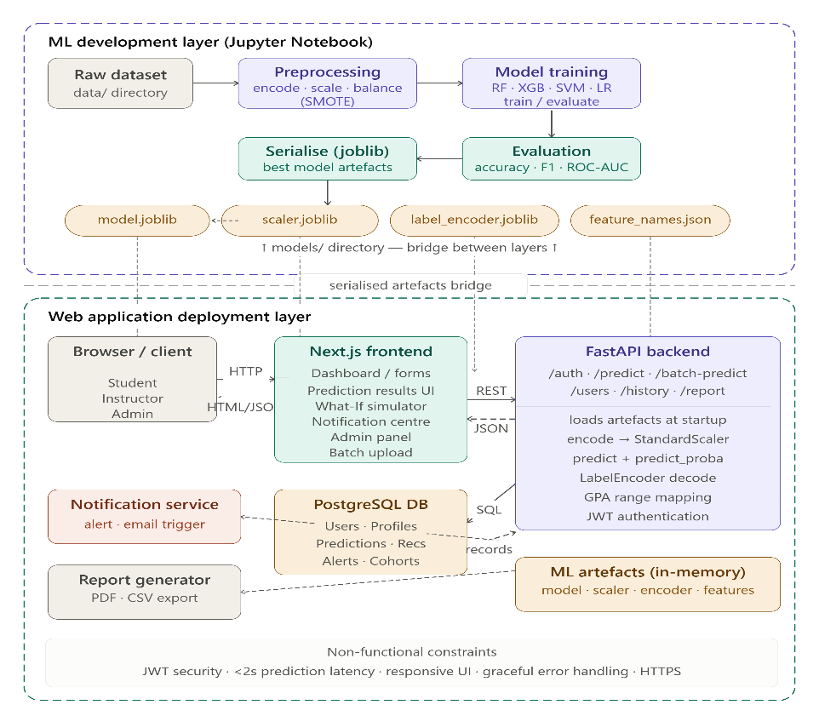
Figure 1: Global Architecture
In the Machine Learning Development Layer, the raw dataset is loaded from the data directory and subjected to the preprocessing pipeline in Jupyter Notebook. Following preprocessing, four machine learning models are trained on the balanced training set and evaluated on the untouched test set. The best-performing model and three supporting artefacts (the fitted StandardScaler, the fitted LabelEncoder, and the feature names list) are serialised using the joblib library. These four files constitute the bridge between the development layer and the deployment layer.
In the Web Application Deployment Layer, the Next.js application communicates with the FastAPI backend, which loads the four serialised artefacts at startup. When a user submits a prediction request, the application encodes the input data using the same encoding mappings applied during training, scales the encoded input using the loaded StandardScaler, and passes the scaled input to the loaded model's predict and predict_proba methods. The predicted class index is decoded back to a grade label using the loaded LabelEncoder, and the grade label is mapped to a GPA range, academic status, and colour code for display.
The complete architecture can be summarised in the following pipeline:
Table 2: Global Architecture pipeline
Stage | Process | Output
1 | Data loading and contextual adaptation | Adapted dataset
2 | Exploratory Data Analysis | visualisations, correlation analysis, feature assessment
3 | Feature engineering ; 10 Cameroon-specific features added | Enriched dataset
4 | Preprocessing, encoding, splitting, scaling, SMOTE | Dataset ready for training
5 | Model training and evaluation | Classification reports, confusion matrices, comparison table
6 | Model serialisation, best model and artefacts saved with joblib | best_model.pkl, scaler.pkl, label_encoder.pkl, feature_names.pkl
7 | web application, loads artefacts, processes inputs, returns predictions | Deployed bilingual web application with export capability

Design

The design of the student performance prediction system includes two phases: the machine learning pipeline design and the web application design. Both layers were designed to function together as a unified system, with the ML pipeline producing trained model that the web application will load and use for real-time prediction.

Dataset Design and Contextual Adaptation

The dataset designed for this study is the Student Lifestyle and GPA Prediction Dataset, a synthetic dataset sourced from Kaggle. It contains 8,000 university student records and 18 columns, with zero missing values and zero duplicate rows. The classification version of the dataset, which uses Grade (A, B, C, D, or Fail) as the categorical target variable, was selected as the primary dataset. This choice was made because grade category prediction offers greater practical utility to students and academic advisors than the prediction of a raw numerical score, since the grade represents a range of GPAs.
Two contextual adaptations were designed to align the data with the Cameroonian higher education context. First, the Previous_GPA column was rescaled from its original range of 1.5 to 6.7 to the University of Buea 0 to 4 GPA scale, ensuring consistency with the local grading system. Second, the Age column was regenerated with a realistic distribution spanning ages 17 to 29, replacing the original uniform distribution (17–24).

Feature Engineering Design
Feature engineering constitutes the most significant original contribution of this study. Ten Cameroon-specific features were designed to capture socioeconomic, environmental, and educational factors that influence student academic performance in the Cameroonian context. The design of each feature was guided by three principles: contextual validity (the feature must reflect a real and documented aspect of student life in Cameroon), statistical consistency (the feature must be generated using a distribution that produces realistic values), and logical correlation (where applicable, the feature must correlate with existing dataset variables in a direction consistent with domain knowledge).

Preprocessing Pipeline

The preprocessing pipeline was designed to transform the raw engineered dataset into a format suitable for machine learning model training. The pipeline comprises five sequential stages, categorical encoding, train-test splitting, numeric scaling, and SMOTE balancing. Each stage was designed with careful attention to the prevention of data leakage, the inadvertent introduction of test-set information into training-phase operations.
Categorical encoding converts all text-based columns to numeric representations. Binary columns (Part_Time_Job and Extracurricular) will be encoded using binary mapping. Ordinal columns with natural ordering (Internet_Quality, Diet_Quality, Family_Income_Level, and Peer_Influence) will be encoded using integer mappings that preserve their inherent order. Nominal columns without natural ordering (Gender and Study_Method) will be encoded using one-hot encoding, which creates separate binary columns for each category. The target variable Grade will be encoded using scikit-learn's LabelEncoder with the mapping A=0, B=1, C=2, D=3, Fail=4. The dataset was split into training (80%, 6,400 records) and test (20%, 1,600 records) sets prior to any scaling or balancing operations, using stratified sampling to ensure identical class proportions in both sets.

Web Application Design

The web application was designed to serve two primary user groups, individual students seeking personalised performance feedback, and academic administrators or counsellors who need to assess the performance of a student, an entire class or group simultaneously. The application was designed using draw.io for the uml and system diagrams and a template was used for the ui design.
- System Requirements
The functional requirements define the main services and operations that the system must provide. These requirements describe the interactions between users and the system, including authentication, student monitoring, prediction generation, and notification management.

- Functional Requirements
User Management and Authentication
- Users must be able to create an account with username, email, password, and role.
- Users must be able to log in using their username and password.
- The system must authenticate users using JWT tokens.
- The system must support three roles: Student, Instructor, and Admin.
Student Features
- Students must be able to view a personalised dashboard.
- Students must be able to view their predicted GPA range and academic status.
- Students must receive actionable recommendations with every prediction.
- Students must be able to use a What-If simulator to test changes.
- Students must be able to view their prediction history.
- Students must be able to download prediction results as PDF or CSV.
- Students must be able to receive notifications of triggered interventions.
Instructor/Academic advisor Features
- Instructor must be able to view a personalised dashboard showing recent activities.
- Instructor should be able to trigger intervention for low performance students.
- Instructors must be able to upload CSV files for batch prediction.
- Instructors must be able to view class performance distribution.
- Instructors must be able to discuss with students.
Admin Features
- Admins must be able to view all registered users.
- Admins must be able to update user roles and activate/deactivate accounts.
- Admins must be able to manage platform activities.

Non-Functional Requirements
The non-functional requirements define the quality attributes and constraints that the system must satisfy. They describe how the system should perform in terms of security, usability, reliability, and efficiency.
Performance
- The ML model must return a prediction.
Usability
- The application must be accessible via web browser.
- The interface must be responsive on different screen sizes.
Security
- The system should provide robust security and user data preservation
Reliability
- The system must handle invalid inputs gracefully.

UML Diagrams
The Unified Modeling Language (UML) diagrams designed for this system provide a visual representation of the system structure and behaviour. The following diagrams were designed: Use Case Diagram, Activity Diagram, Sequence Diagrams, Class Diagram, and Entity-Relationship (ER) Diagram.
Use Case Diagram
The use case diagram illustrates the interactions between actors (Student, Instructor, Admin) and the system's functionalities. The main use cases include: View Prediction, Get Recommendations, What-If Simulator, View History, Download Report, Batch Prediction, Manage Users, and View Analytics. Figure 1 shows the usecase diagram illustrating actors and their interactions ;

Figure 2: Use Case Diagram
Activity Diagram
The activity diagram models the workflow of the student prediction process from input submission to result display. The process begins when a student logs in, fills the prediction form, submits data, the system processes the prediction, and displays results with recommendations. Figure 2 below shows the activity diagram
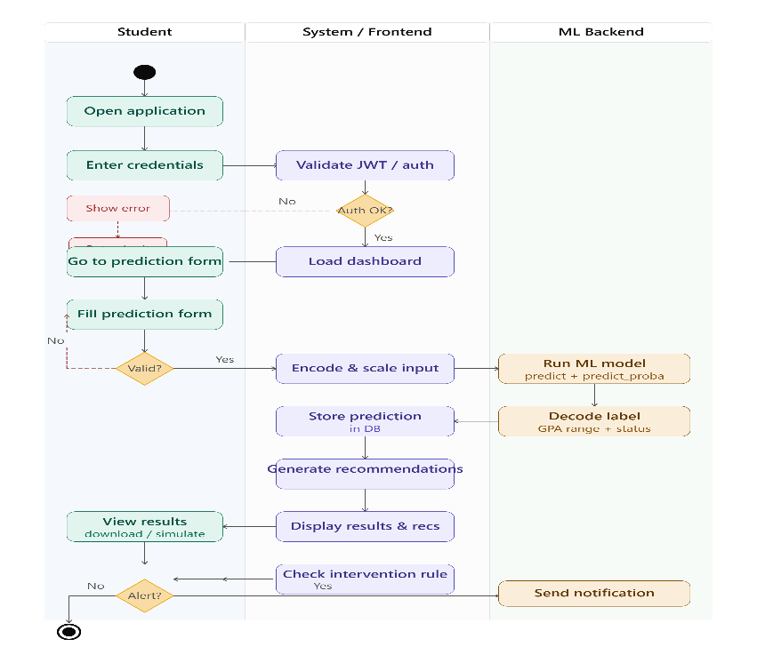
Figure 3: System Activity Diagram
Sequence Diagrams
Sequence diagrams describe the interaction between actors and system components over time. The main sequence diagrams designed include: Student Prediction Flow, What-If Simulation Flow, Instructor Batch Prediction Flow, and Authentication Flow.
Entity-Relationship (ER) Diagram
The ER diagram defines the database structure used to store, organise, and manage the information required by the system. The main entities include: User (stores user accounts), StudentProfile (stores student academic and lifestyle data), Prediction (stores prediction results), Cohort (stores class cohorts created by instructors), and CohortStudent (stores individual student results within each cohort). Relationships were designed between entities to maintain data consistency. The figure below illustrates the ER diagram represeting the USER table as the central entity which has one-to-many relationships with STUDENT_PROFILE (academic attributes), PREDICTION (each submission), ALERT (notifications received), INTERVENTION (as target student or creating instructor), COHORT (instructors creating class cohorts), COHORT_STUDENT (junction for batch results), and REPORT. PREDICTION spawns RECOMMENDATION rows and may trigger ALERT rows
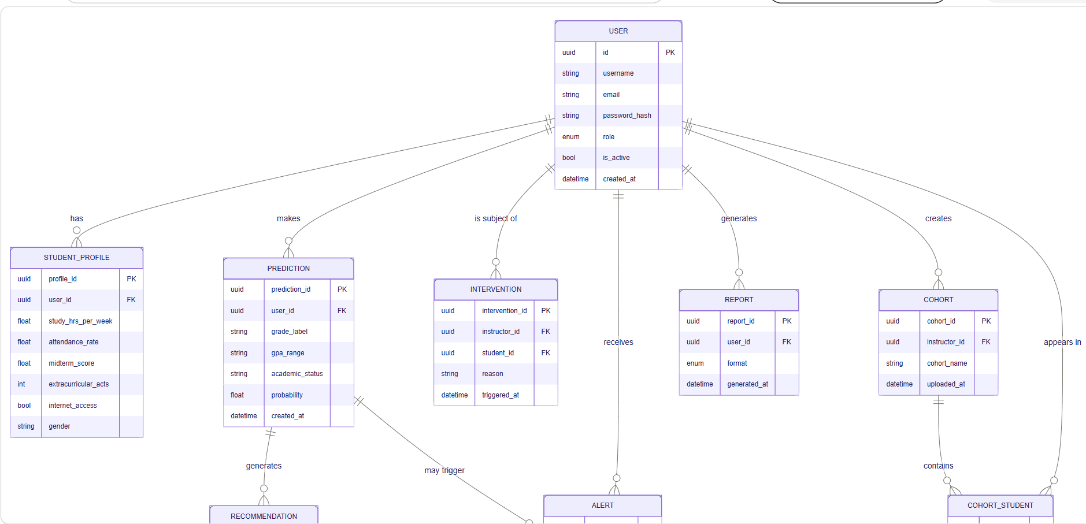
Figure 4: ER Diagram

User Interface Design

The user interface was designed following a predictive dashboard template.
The User interface will have the following main pages ;
- Login Page: Contains username and password fields with sign-in and registration tabs.
- Student Dashboard: Displays stats cards, prediction display, recommendations list, and navigation tabs.
- Prediction Form: Organised into four card-based sections with 29 input fields and plain-language descriptions.
- Results Display: Shows GPA range, academic status, probability percentage, bar chart, and recommendations.
- What-If Simulator: Provides interactive sliders for adjusting input values with real-time results.
- History View: Displays chronological list of past predictions with trend chart.
- Instructor Dashboard: Includes batch CSV upload, class performance charts, and intervention logging.
- Admin Dashboard: Contains user management table and system statistics.

Description of the Algorithms

Three machine learning algorithms were employed in this study, with the Random Forest algorithm additionally subjected to hyperparameter tuning, producing four trained models in total. These algorithms were selected based on their popularity in educational prediction tasks, interpretability, and proven effectiveness in classification problems.

Logistic Regression

Logistic Regression is a supervised machine learning algorithm used for classification tasks. It estimates the probability of a categorical outcome using the logistic function. The algorithm is widely used because of its simplicity, computational efficiency, and ease of interpretation, Hosmer & Lemeshow, 2000. For multiclass classification problems, Logistic Regression can be extended using multinomial logistic regression, which estimates probabilities for multiple categories simultaneously.
The algorithm will be implemented using scikit-learn's LogisticRegression class with the max_iter set to 1,000 to ensure convergence and random_state set to 42 for reproducibility.
Advantages: Easy to interpret, computationally efficient, performs well on linearly separable data.
Limitations: Assumes linear relationships between variables, may perform poorly on highly complex datasets.

Decision Tree

A Decision Tree is a non-parametric supervised learning algorithm that represents decisions in the form of a tree structure. Internal nodes represent decision rules based on feature values, while leaf nodes represent class labels or outcomes. Decision Trees are capable of modelling nonlinear relationships and are highly interpretable because the reasoning process can be visualised easily.
The algorithm will be implemented using scikit-learn's DecisionTreeClassifier with the Gini impurity criterion, a maximum depth of 10, and a random state of 42. The maximum depth of 10 was imposed to limit tree growth and prevent overfitting, constraining the model to a maximum of 1,024 possible decision paths from the root to any leaf node.
Advantages: Easy to understand and interpret, handles both numerical and categorical data, captures nonlinear relationships.
Limitations: Susceptible to overfitting, sensitive to small changes in training data.

Random Forest (Original and Tuned)

Random Forest is an ensemble learning algorithm that combines multiple Decision Trees to improve predictive performance. Each tree is trained using a random subset of training samples and features, and the final prediction is determined through majority voting, Breiman, 2001[15]. Random Forest is widely recognised for its robustness, resistance to overfitting, and ability to handle high-dimensional datasets. It can also provide estimates of feature importance, making it valuable for understanding the factors that contribute most strongly to predictions.
The algorithm will be implemented using scikit-learn's RandomForestClassifier. The original configuration uses 100 estimators (decision trees), the Gini impurity criterion, all available CPU cores, and a random state of 42. Each tree in the forest is trained on a bootstrap sample of the training data (sampling with replacement) and uses a random subset of features at each split.
Hyperparameter tuning will be conducted using scikit-learn's RandomizedSearchCV.
Advantages: High predictive accuracy, robust against overfitting, handles large and complex datasets effectively, provides feature importance measures.
Limitations: More computationally intensive than individual Decision Trees, less interpretable than simpler models.

Description of the Resolution Process

The resolution process follows the full machine learning pipeline as defined by the CRISP-DM process. It is organised into two principal phases: Phase 1 covers the machine learning development pipeline from data loading through model evaluation, and Phase 2 covers the web application development. Each phase is described in detail below.

Phase 1: Machine Learning Pipeline

The machine learning pipeline is implemented entirely within a single Jupyter Notebook (analysis.ipynb) to ensure transparency, reproducibility, and ease of documentation. The pipeline progresses through the following sequential stages.

Stage 1: Data Collection, Loading and Inspection
The classification dataset (student_performance_grade.csv) is loaded from the data directory using pandas. An initial inspection confirms 8,000 records across 18 columns with zero missing values and zero duplicate rows. The Student_ID column is identified as a non-predictive identifier and removed, leaving 17 feature columns plus the Grade target variable.

Stage 2: Contextual Adaptation
Two adaptations are applied to align the dataset with the Cameroonian context. The Previous_GPA column is rescaled from its original range (1.5–6.7) to the UB 0–4 scale using proportional rescaling, producing values ranging from 0.9 to 4.0 with a mean of 1.79. The Age column is regenerated using a weighted random choice distribution spanning ages 17 to 29, producing a realistic Cameroonian university age distribution with a mean of 21.17 years.

Stage 3: Exploratory Data Analysis
The eight-stage EDA is conducted, producing sixteen visualisations. The EDA covers dataset overview, descriptive statistics, data quality checks, univariate analysis, bivariate and multivariate analysis, outlier detection, feature assessment, and insight formation.

Stage 4: Feature Engineering
Ten Cameroon-specific features are generated and appended to the dataset, expanding the dataset from 17 to 27 columns. A random seed of 42 is set before all random number generation operations to ensure that the engineered features are identical across all runs of the notebook.

Stage 5: Preprocessing
The Age column is dropped based on its negligible correlation. Categorical variables are encoded using appropriate techniques, expanding the dataset to 29 features. An 80/20 stratified train-test split is performed, producing a training set of 6,400 records and a test set of 1,600 records with identical class proportions. StandardScaler is fitted on the training set only and applied to both sets. SMOTE is applied to the scaled training set, balancing all five grade classes at 3,580 samples each and producing a final training set of 17,900 records.
Stage 6: Model Training
Four models are trained on the balanced training set: Logistic Regression, Decision Tree, Random Forest, and Tuned Random Forest. The Tuned Random Forest uses hyperparameters optimised through RandomizedSearchCV.

Stage 7: Model Evaluation
All four models are evaluated on the untouched test set. Evaluation metrics computed for each model include accuracy, precision, recall, F1-score (macro and weighted), and Fail class recall specifically.

Stage 8: Feature Importance Analysis
The Random Forest classifier's feature_importances attribute is used to rank all 29 features by their contribution to model predictions

Stage 9: Model Serialisation
The best model and its three supporting artefacts are saved to the models directory using joblib.dump: best_model.pkl (Logistic Regression), scaler.pkl, label_encoder.pkl, and feature_names.pkl. A verification test is performed to confirm that the loaded model produces consistent predictions.

Phase 2: Web Application Development
The web application is built using FastAPI for the backend API layer, Next.js with TypeScript for the frontend presentation layer, and PostgreSQL for the database persistence layer. The implementation is organised into five steps.
Step 1: Database Design
The database is built with four main tables ; users (stores user account information including username, email, password hash, and role), predictions (stores individual student predictions with associated features and results), cohorts (stores class cohorts created by instructors), and cohort_students (stores individual student results within each cohort). Relationships are created between tables to maintain data consistency. The Entity-Relationship diagram is presented in figure above

Step 2: Backend API Design
The FastAPI backend is designed as a fully self-contained application comprising nine API endpoints, Pydantic request and response schemas, a prediction engine, an advice engine, and role-based access control. The API endpoints include: user registration, user login, token refresh, single student prediction, What-If simulation, prediction history, batch prediction, user management, and system statistics.

Step 3: Frontend Design
The Next.js frontend is designed as a multi-page application using TypeScript and Tailwind CSS. The frontend communicates with the FastAPI backend through HTTP requests using axios, maintaining clean tier separation. Recharts is used for data visualisation, and Framer Motion provides animations for enhanced user experience. The main pages include: Login, Register, Student Dashboard, Prediction Form, Results Display, What-If Simulator, History View, Instructor Dashboard, and Admin Dashboard.

Step 4: Authentication Design
The authentication system is designed using JWT tokens. The Next.js frontend stores the token in local storage and includes it in the Authorization header of all subsequent API calls. Password hashing is implemented using bcrypt. Role-based access control ensures that users can only access functionalities relevant to their role.

Step 5: Deployment Configuration
The complete system is designed to run locally with two concurrent processes: the FastAPI backend on port 8000 and the Next.js frontend on port 3000. The system operates fully locally with no external dependencies.

Partial Conclusion

This chapter has presented the complete analysis and design of the student performance prediction system. The CRISP-DM methodology was adopted as the guiding framework, providing a systematic and iterative structure for the research pipeline. The dataset was carefully designed to align with the Cameroonian higher education context through proportional GPA rescaling and age range adaptation. Feature engineering introduced ten Cameroon-specific variables that enrich the dataset's contextual relevance and constitute the primary original contribution of this research. The preprocessing pipeline was designed with strict attention to data leakage prevention.
The global architecture demonstrates how the machine learning development pipeline and the Next.js web application are integrated through serialised model artefacts, enabling the research findings to be operationalised as a practical, deployable tool. The four algorithms selected for evaluation provide a rigorous comparative evaluation. The web application was designed with user accessibility as a central priority, implementing modern UI principles, role-based access control, and comprehensive export functionality. The following chapter presents the implementation of this design and the results obtained.

CHAPTER FOUR: IMPLEMENTATION AND RESULTS

Introduction

This chapter presents the implementation of the student performance prediction system and documents the results obtained from each phase of its realisation. The chapter begins by describing the tools and materials used throughout the development process, followed by a detailed account of the implementation process covering the machine learning pipeline and the web application. The results obtained from exploratory data analysis, model training, model evaluation, and the web application are then presented and interpreted. The chapter concludes with an evaluation of the solution against the study objectives and a comparison with related works.

. Tools and Materials Used

The implementation of the student performance prediction system required a diverse set of software tools, programming libraries, and hardware resources. Table 3 presents a complete summary of all tools and their respective roles in the project.

Table 3: Tools and Technologies used
Tool / Library | Role in the Project
Python 3.12 | Primary programming language for ML pipeline and backend
Jupyter Notebook 7 | Interactive development environment for ML pipeline
Anaconda 2025 | Python distribution and environment manager
Pandas | Data manipulation, loading CSV files, and dataframe operations
Numpy | Numerical computation and array operations
scikit-learn | Machine learning algorithms, preprocessing, and evaluation metrics
imbalanced-learn | SMOTE oversampling for class imbalance correction
matplotlib | EDA visualisations and result charts
seaborn | Statistical visualisations including heatmaps and distribution plots
joblib | Model serialisation , saving and loading .pkl artefacts
FastAPI | RESTful API backend serving ML predictions via HTTP endpoints
Next.js with TypeScript and Tailwindcss | Frontend web application framework for the user dashboard
PostgreSQL | Relational database for storing users, predictions, and cohorts

. Description of the Implementation Process

The implementation was carried out using the CRISP-DM process and was divided into two principal phases, the Machine Learning Pipeline Phase and the Web Application Phase.

Phase 1: Machine Learning Pipeline Implementation

The machine learning pipeline was implemented within a single Jupyter Notebook (analysis.ipynb). The notebook was structured as a sequential set of cells, each representing a distinct stage of the data science workflow.

Stage 1: Data Loading and Inspection
The classification dataset (student_performance_grade.csv) was loaded from the data directory using pandas. An initial inspection confirmed 8,000 records across 18 columns with zero missing values and zero duplicate rows. The Student_ID column was removed as a non-predictive identifier.

Stage 2: Data Cleaning and Inspection
A systematic data quality check confirmed zero null values across all 18 columns. Descriptive statistics were generated covering count, mean, standard deviation, minimum, and maximum values for all numeric features.

Stage 3: Contextual Adaptation
Two adaptations were applied to align the dataset with the Cameroonian context. The Previous_GPA column was rescaled from its original range (1.5 to 6.7) to the University of Buea 0 to 4 GPA scale, producing a new range of 0.9 to 4.0 with a mean of 1.787. The Age column was regenerated using a weighted probability distribution spanning ages 17 to 29, producing a realistic Cameroonian university age distribution with a mean of 21 years.

Stage 4: Exploratory Data Analysis
The eight-stage EDA was conducted, producing sixteen visualisations. The EDA covered dataset overview, descriptive statistics, data quality checks, univariate analysis, bivariate and multivariate analysis, outlier detection, feature assessment, and insight formation.

Key Findings from EDA
- Final Score distribution was negatively skewed (mean 83.21, median 86.51).
- Grade distribution showed severe class imbalance: Grade A (55.9%), Grade B (27.6%), Grade C (13.2%), Grade D (2.8%), Fail (0.4%).
- Hours_Studied was the strongest positive predictor.
- Exam_Anxiety_Score was the strongest negative predictor.
- Age showed negligible correlation and was subsequently dropped.
- 728 outliers were detected and retained as legitimate extreme cases.

Stage 5: Feature Engineering
The dataset used in this study comprises two distinct categories of features. The first category consists of the original 17 features from the Kaggle Student Lifestyle and GPA Prediction Dataset. These features capture general academic and behavioural patterns, including academic indicators (e.g., Hours_Studied, Attendance, Previous_GPA), lifestyle factors (e.g., Sleep_Hours, Screen_Time, Diet_Quality), and health-related variables (e.g., Stress_Level, Exam_Anxiety_Score).
The second category consists of ten newly engineered features, added specifically to reflect the socio-economic and infrastructural realities of the Cameroonian higher education context. These features were designed based on documented challenges identified in the literature, including unreliable electricity supply, limited internet access, family financial pressure, and cultural attitudes toward education. The engineered features include Electricity_Availability, Home_Internet_Accessibility, Community_Beliefs, Family_Support, Home_Study_Environment, Motivation_Level, Lecture_Quality, Physical_Health, Psychological_State, and Peer_Influence.
While the original features are generic and applicable across various educational contexts, the engineered features are context-specific and represent the primary original contribution of this study. The rationale for adding these features is to improve the predictive validity of the model when applied to Cameroonian students, as factors such as electricity availability and community beliefs have been shown to significantly influence academic outcomes in resource-constrained environments

Stage 6: Preprocessing Pipeline
The preprocessing pipeline was implemented in six sequential steps. The Age column was dropped. Categorical columns were encoded using binary mapping, ordinal mapping, and one-hot encoding as appropriate, expanding the dataset to 29 features. The target variable Grade was encoded using LabelEncoder with the mapping A=0, B=1, C=2, D=3, Fail=4. An 80/20 stratified train-test split was performed, producing 6,400 training records and 1,600 test records. StandardScaler was fitted on the training set only and applied to both sets.
The dataset exhibited a severe class imbalance, with Grade A representing 55.9% of the records and the Fail class accounting for only 0.4%. This imbalance posed a significant challenge for machine learning, as models trained on imbalanced data tend to favour the majority class and perform poorly on minority classes, in this case, failing to identify students at risk of academic failure.
To address this, the Synthetic Minority Over-sampling Technique (SMOTE) was applied to the training set. SMOTE is an over-sampling technique that generates synthetic examples of minority classes rather than simply duplicating existing records. It works by selecting a minority class instance, identifying its nearest neighbours within the feature space, and creating new instances along the line segments connecting them. This approach produces synthetic samples that are realistic and diverse, while avoiding the overfitting that can result from simple duplication.
SMOTE was applied exclusively to the scaled training set, balancing all five grade classes at 3,580 samples each and producing a final training set of 17,900 records. This ensured that the models could learn patterns across all grade categories without being biased by the dominance of the majority class.

Stage 7: Model Training
Four models were trained on the balanced training set: Logistic Regression, Decision Tree, Random Forest, and Tuned Random Forest. Hyperparameter tuning was conducted using RandomizedSearchCV with 20 parameter combinations, 3-fold cross-validation, and macro F1-score as the optimisation metric. The search completed in 187.49 seconds and identified the optimal configuration for Random Forest as ; n_estimators=200, max_depth=None, min_samples_split=2, min_samples_leaf=1, max_features=log2, with a cross-validation macro F1-score of 92.38%.

Stage 8: Model Serialisation
The best-performing model (Logistic Regression) and three supporting artefacts were serialised to the models directory using joblib. The saved files were: best_model.pkl (2.83 KB), scaler.pkl (1.72 KB), label_encoder.pkl (0.40 KB), and feature_names.pkl (0.55 KB). A verification test confirmed that the reloaded model produced correct predictions.

Phase 2: Web Application Implementation

The web application was implemented using FastAPI for the backend, Next.js with TypeScript for the frontend, and PostgreSQL for the database.

Step 1: Database Configuration
PostgreSQL was configured with the connection string in app/database.py. The student_performance database was created, all tables were initialised using SQLAlchemy, and the default administrator account was created.

Step 2: FastAPI Backend Implementation
The FastAPI backend was implemented in with nine API endpoints, Pydantic request and response schemas, a prediction engine, an advice engine, and role-based access control.

Step 3: Next.js Frontend Implementation

The Next.js frontend was implemented using TypeScript and Tailwind CSS. The frontend communicates with the FastAPI backend through HTTP requests using Axios, maintaining clean tier separation. Recharts was used for data visualisation, and Framer Motion provided animations for an enhanced user experience.

Step 4: Authentication Implementation
JWT tokens were implemented for authentication. The Next.js frontend stores the token in local storage and includes it in the Authorization header of all API calls.

Step 5: Deployment Configuration
The complete system requires two concurrent processes: the FastAPI backend on port 8000 and the Next.js frontend on port 3000.

. Presentation and Interpretation of Results

Exploratory Data Analysis Results

Target Variable: Final Score Distribution
The distribution of Final_Score was negatively skewed, with a mean of 83.21 and a median of 86.51. The histogram revealed that most students scored in the 75 to 100 range, with very few below 50. The boxplot confirmed 115 outliers below the lower fence of 49.15, corresponding to students with unusually low performance. These outliers were retained as they represent the at-risk student population. The figure below shows a histogram and boxplot of the Final_Score variable, showing a negatively skewed distribution with a mean of 83.21 and a median of 86.51. Outliers below 49.15 are highlighted and retained as they represent at-risk students.
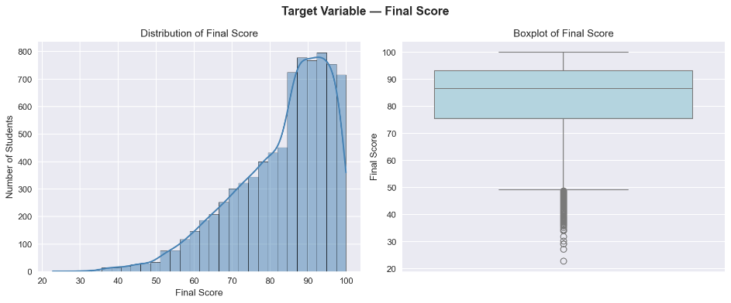
Figure 5: Final_score distribution
Target Variable: Grade Distribution
As shown in figure 6, the grade distribution revealed severe class imbalance: Grade A accounted for 55.9% (4,475 students), Grade B 27.6% (2,212), Grade C 13.2% (1,053), Grade D 2.8% (226), and Fail only 0.4% (34 students).

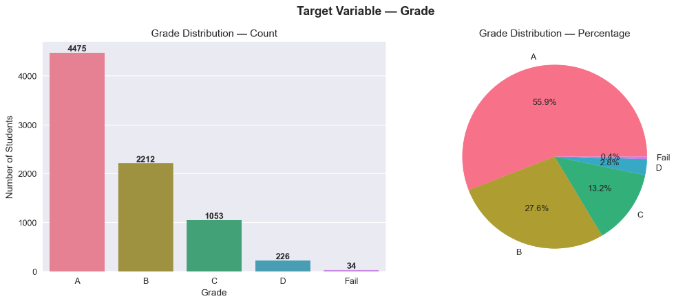
Figure 6: Grade distribution

Univariate Analysis
All nine numeric features were examined. Hours_Studied, Sleep_Hours, Stress_Level, Screen_Time, and Exam_Anxiety_Score followed approximately normal distributions. Age exhibited a uniform distribution following contextual adaptation. Categorical feature analysis revealed that gender was nearly balanced, offline study was the most common method, and 820 students reported poor internet quality.
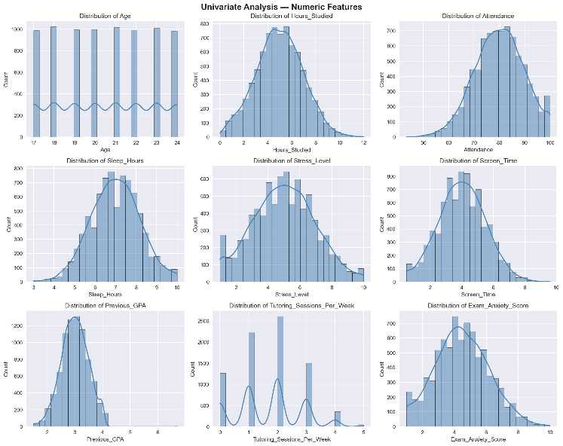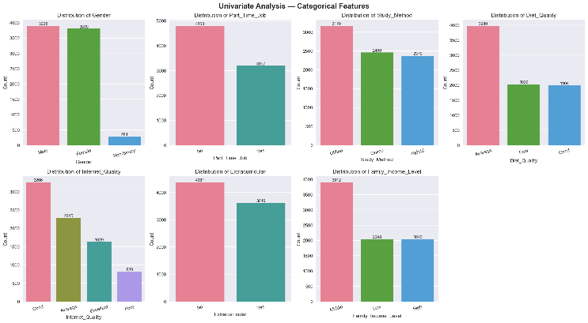
Figure 7: Univaraite analysis of numerical and categorical features

Bivariate Analysis
Scatter plots confirmed the relationships identified in the correlation analysis. Hours_Studied showed the clearest upward trend, while Exam_Anxiety_Score showed the most visually striking downward trend. Grouped box plots showed a stepwise decline in Hours_Studied from Grade A to Fail, and an inverse pattern for Stress_Level. Gender had no meaningful impact on performance, while poor internet quality correlated with lower scores. Figure 8 represents the scattered plot showing the positive correlation with study hours and the negative correlation with anxiety.
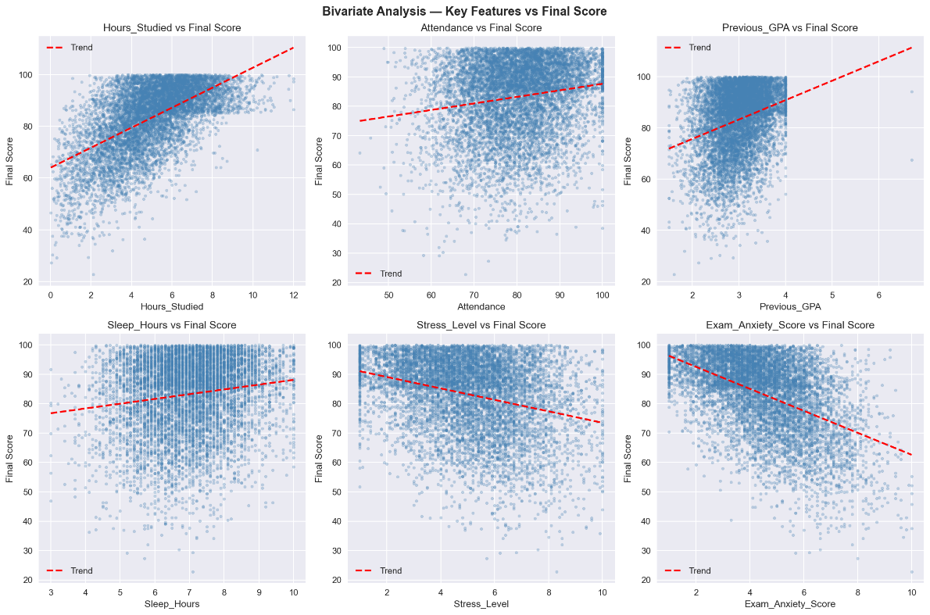
Figure 8: Scattered plot showing the relationship between the key features and the final score

Model Training and Evaluation Results

Four models were trained and evaluated. Table 4 presents the complete comparative performance metrics for all four models.

Table 4: Final Model comparison
Model | Accuracy | F1 Macro | F1 Weighted | Precision | Fail Recall
Logistic Regression | 74.50% | 55.75% | 74.88% | 75.41% | 57.14%
Decision Tree | 63.00% | 40.02% | 64.56% | 67.05% | 0.00%
Random Forest | 71.25% | 43.16% | 70.55% | 70.03% | 0.00%
Tuned Random Forest | 72.31% | 45.49% | 71.55% | 71.01% | 0.00%

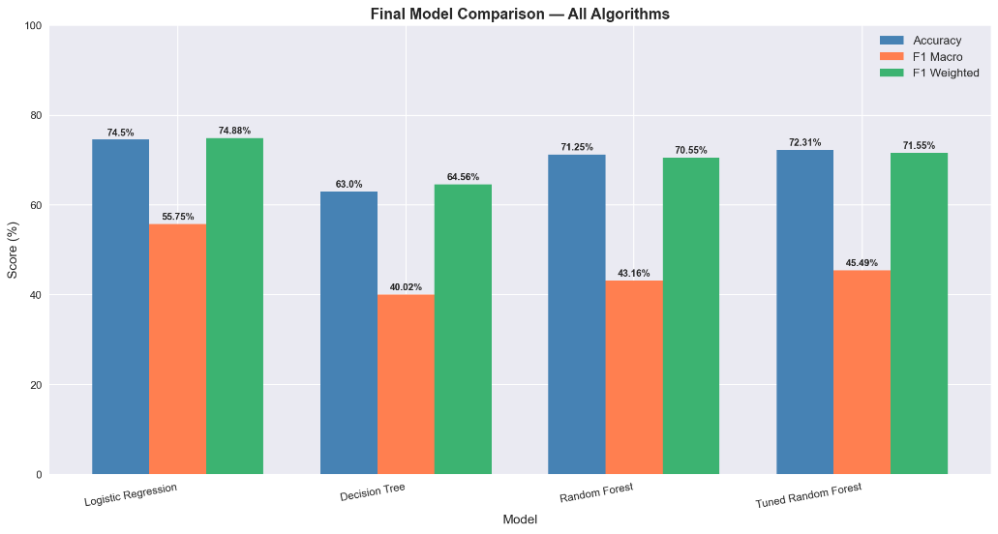
Figure 9: Final model comparison

Logistic Regression
Logistic Regression achieved the highest overall accuracy of 74.50% on the 1,600-record test set. The confusion matrix showed that 773 of 895 Grade A students (86%), 283 of 442 Grade B students (64%), 112 of 211 Grade C students (53%), 20 of 45 Grade D students (44%), and crucially, 4 of 7 Fail students (57.14%) were correctly classified. The weighted F1-score was 74.88% and the macro F1-score was 55.75%. Logistic Regression was the only model to successfully identify any failing students.

Decision Tree
The Decision Tree achieved an accuracy of 63.00%, the lowest among all models. It completely failed to identify any Fail students (0% recall). This underperformance is attributable to overfitting on the SMOTE-balanced training data.

Random Forest
The original Random Forest achieved 71.25% accuracy. It correctly classified 89% of Grade A students but failed to identify any Fail students. The inability to identify failing students resulted in overall accuracy below Logistic Regression.

Tuned Random Forest
Following hyperparameter tuning, the Tuned Random Forest achieved 72.31% accuracy, an improvement of +1.06% over the original. However, it still failed to identify any Fail students and remained below Logistic Regression on all key metrics.

Feature Importance Results

Feature importance analysis was conducted using the Random Forest classifier's feature_importances_ attribute. Table 5 presents the top fifteen features with their importance percentages and categories.

Table 5: Most important features
Rank | Feature | Importance | Category
1 | Hours_Studied | 13.62% | Original, Academic behaviour
2 | Tutoring_Sessions_Per_Week | 10.21% | Original, Academic support
3 | Exam_Anxiety_Score | 9.56% | Original, Mental health
4 | Stress_Level | 6.18% | Original, Mental health
5 | Previous_GPA | 5.50% | Original, Academic history
6 | Motivation_Level | 4.59% | Engineered, Cameroon specific
7 | Screen_Time | 4.12% | Original, Lifestyle
8 | Attendance | 4.03% | Original, Academic behaviour
9 | Psychological_State | 4.01% | Engineered, Cameroon-specific
10 | Sleep_Hours | 3.90% | Original, Lifestyle
11 | Diet_Quality | 3.17% | Original, Lifestyle
12 | Community_Beliefs | 3.16% | Engineered, Cameroon-specific
13 | Electricity_Availability | 2.97% | Engineered, Cameroon-specific
14 | Family_Support | 2.73% | Engineered, Cameroon-specific
15 | Home_Study_Environment | 2.71% | Engineered, Cameroon-specific

Six of the ten Cameroon-specific engineered features appeared in the top fifteen, confirming their predictive value and validating the contextual adaptation methodology. The figure below shows a clear representation of the features importance obtained using Random Forest.
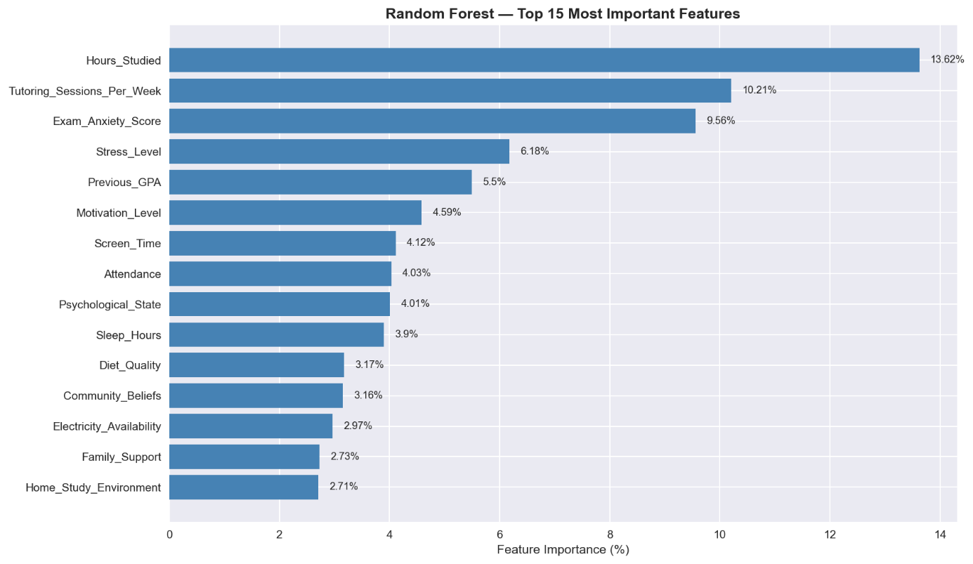
Figure 10: Feature Importance analysis

Web Application Results

The web application was successfully implemented and tested. Screenshots of each interface are presented below.

Student Dashboard: Prediction Form
The figure below represent how the various inputs are collected from the student. These inputs include academics, daily habits, socioeconomic and health and mental wellbeing.


Figure 11: Student prediction input form
Once the form field the students can then run the prediction. The model uses logistic regression to run the prediction.
Student Dashboard: Prediction Result
The result model shows the predicted GPA range, academic status, and probability of the outcome and some recommended areas of improvement are displayed below.
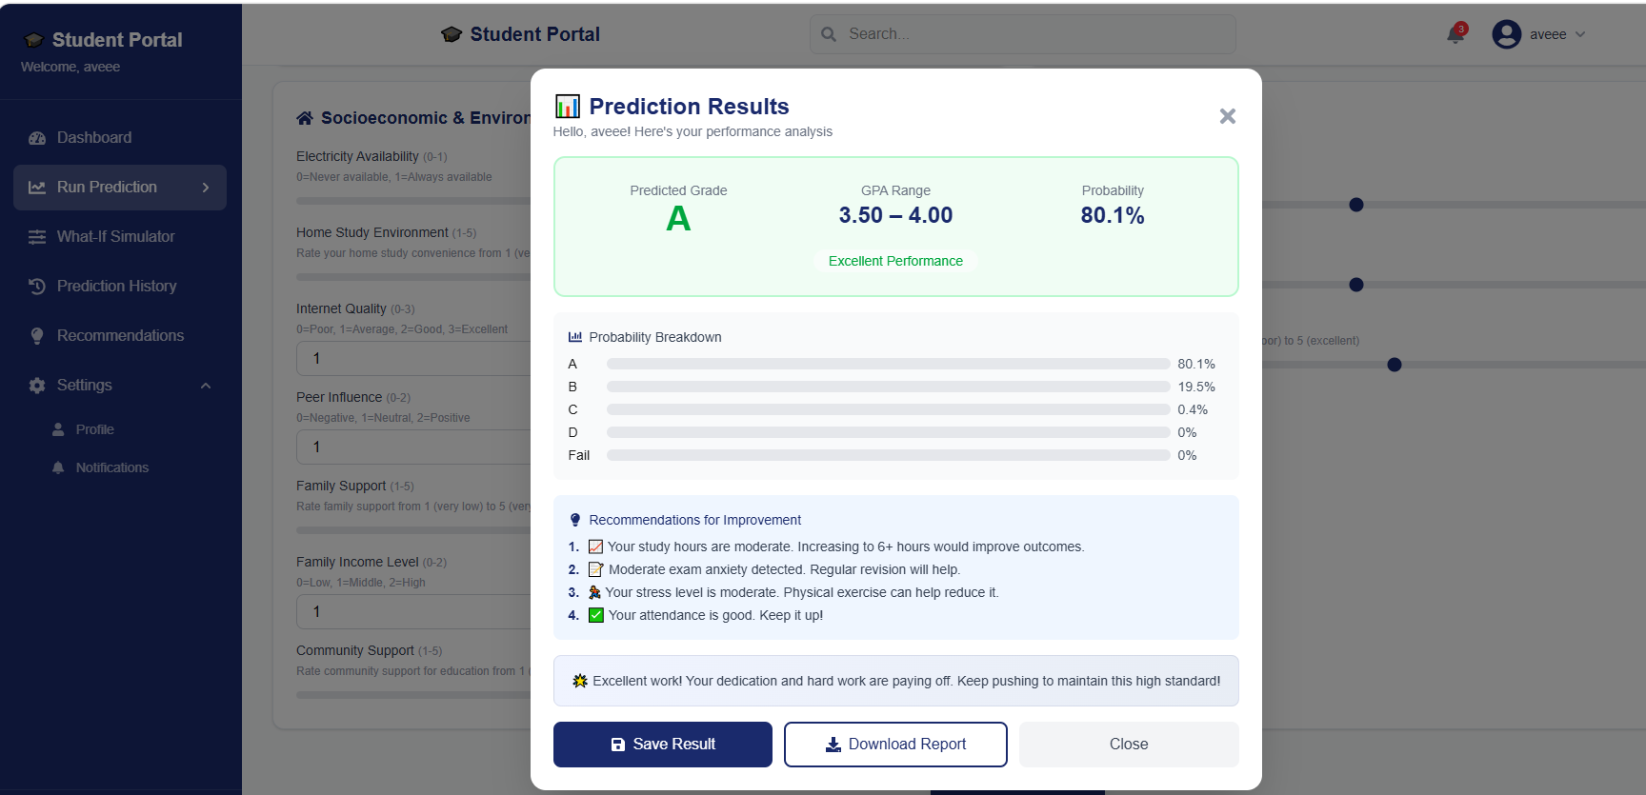
Figure 12: Prediction Result Modal
What-If Simulator
The What-If Simulator was implemented as a dedicated page in the web application. A student can input a target GPA (e.g., 3.5), and the system returns a list of suggested changes to their input parameters. For example, the simulator might recommend increasing study hours from 4 to 6 per week, reducing stress levels by engaging in physical activity, or improving attendance. The recommendations are generated by systematically varying input values and selecting the combination that produces the closest predicted GPA to the target, using the trained Logistic Regression model. The results are presented in a clear, actionable format, accompanied by a brief explanation of how each recommended change is expected to improve performance..

Instructor Dashboard: Batch prediction

The instructor dashboard enables instructors or academic supervisors to have access to students predictions from the department of assignment, the dashboard also accepts CSV file upload for batch prediction. Results are displayed as a comprehensive table and distribution charts.
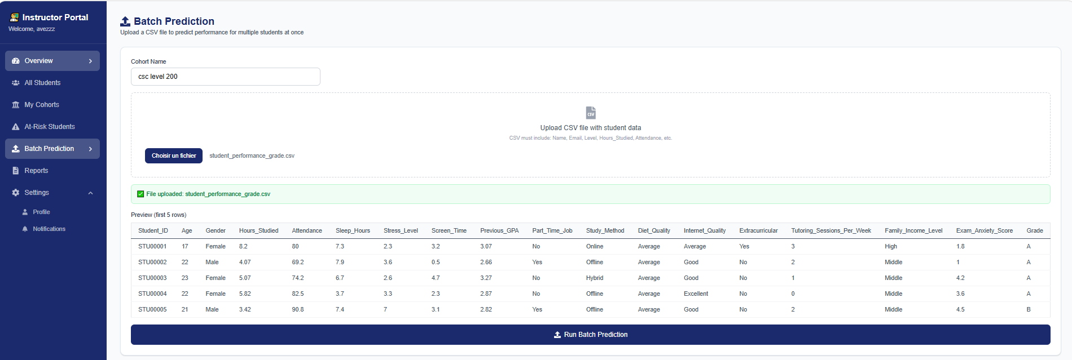
Figure 13: Batch Prediction
Admin Dashboard: User Management
The admin dashboard provides user management functionality, allowing administrators to view all registered users, update roles, and activate/deactivate accounts, assigning instructors to departments or levels.

Admin Dashboard: System Statistics
The System Statistics tab displays real-time metrics including total users, students, instructors, predictions, and cohorts.

Evaluation of the Solution

Comparison with Existing Works

The most directly comparable benchmark study is Hashim et al. (2020), who evaluated seven algorithms for student performance prediction at the University of Basrah, Iraq. Their best-performing algorithm, Logistic Regression, achieved 68.7% accuracy. The present study, using the same algorithm on a larger and contextually enriched dataset, achieved 74.50%, an improvement of 5.80 percentage points.

Table 6: Comparison with related works
Study | Algorithm | Accuracy | Dataset Size | Features
Hashim et al. (2020) | Logistic Regression | 68.70% | 499 students | 8
Cortez & Silva (2008) | Random Forest | ~65% | 649 students | 30
Delen (2010) | Neural Network | ~73% | 35,000 students | ~12
Present Study | Logistic Regression | 74.50% | 8,000 students | 29

The present study outperforms the most directly comparable published work and introduces two dimensions that none of the compared works address: (1) Cameroon-specific contextual feature engineering, and (2) a modern web interface with role-based access control and prediction history built with Next.js, TypeScript, and Tailwind CSS.

Fulfilment of Study Objectives

All specific objectives stated in Chapter One were fulfilled. Table 7 shows the various objectives and the implementaion outcome.

Table 7: Fulfilment of Study Objectives
Specific Objective | Implementation Outcome
Collect and preprocess a suitable university-level dataset | 8,000-record synthetic dataset loaded, cleaned, and contextually adapted
Perform Cameroon-specific feature engineering | 10 contextual features added, dataset expanded to 27 columns
Conduct EDA across all eight stages | 16 visualisations generated across 8 EDA stages
Train and evaluate three ML algorithms | Four models trained (including tuned RF), all evaluated on 1,600-record test set
Compare models and select the best performer | Logistic Regression selected: 74.50% accuracy, 57.14% Fail recall
Deploy best model as a web application | nexjs/FastAPI/PostgreSQL system deployed locally

Fulfilment of Functional Requirements
The platform was evaluated against the various requirements stated in chapter 3. Table 8 summarises the requirements that were succesfully implemented

Table 8: Functional Requirement evaluation
Requirements | Output
Create account (username, email, password, role) | Users can succesfully create account and have access to the application according to their roles.
View personalised dashboard | Users have personalised dashboards that shows latest predictions statistics and prediction results.
View predicted GPA range and academic status | Prediction result panel shows grade, GPA range, and probability
Receive actionable recommendations with every prediction | Recommendations for Improvement, the list generated with every prediction
Use What-If simulator to test changes | What-If simulator implemented with updates
Download prediction results as PDF or texts | Download Report, button on results panel
Upload CSV files for batch prediction by instructors | Batch prediction implemented
Instructor must be able to view class performance distribution | Class performance average rate.
View all users and manage the system | Admin can view all system users.

Partial Conclusion

This chapter has presented the complete implementation and results of the student performance prediction system. The machine learning pipeline was implemented in nine sequential stages, producing a trained Logistic Regression model with an accuracy of 74.50% and a Fail class recall of 57.14%, the only model to successfully identify at-risk students among all four evaluated algorithms. Feature importance analysis confirmed that six of the ten Cameroon-specific engineered features ranked among the top fifteen most predictive variables, validating the contextual adaptation methodology.

The web application was implemented using FastAPI for the backend, Next.js with TypeScript for the frontend, Tailwind CSS for styling, and PostgreSQL for the database. The system provides distinct role-based interfaces with capabilities including personalised performance prediction, What-If simulation, prediction history tracking, batch class prediction, and PDF/CSV report export. The solution outperforms the most directly comparable benchmark study by 5.80 percentage points in accuracy, while introducing capabilities that none of the reviewed related works provide.

CHAPTER FIVE: CONCLUSION AND FURTHER WORKS

Summary of Findings

This research developed and evaluated a machine learning-based system for predicting the academic performance of students in Cameroonian higher institutions. The project was motivated by the persistent problem of student academic underperformance and the absence of early-warning predictive tools suited to the specific contextual realities of higher education in Cameroon. The work was conducted in two principal phases, the development of a machine learning prediction pipeline and the deployment of the predictive model as a web application.
In the first phase, a synthetic university-level dataset of 8,000 student records sourced from Kaggle was subjected to a complete machine learning pipeline following the CRISP-DM methodology. The dataset was first adapted to the Cameroonian context through two modifications, the Previous_GPA column was rescaled from a foreign scale to the University of Buea 0 to 4 GPA system, and the Age column was regenerated to reflect the realistic age distribution of Cameroonian university students ranging from 17 to 29 years. The dataset was subsequently enriched through deliberate feature engineering that introduced ten Cameroon-specific contextual variables, electricity availability, home internet accessibility, peer influence, community beliefs, family support, home study environment, motivation level, lecture quality, physical health, and psychological state. These additions expanded the dataset from 17 to 27 columns, representing the primary original contribution of this research.
Comprehensive eight-stage exploratory data analysis was conducted, generating sixteen visualisations that revealed key patterns in the data. Study hours emerged as the strongest positive predictor of academic performance, followed by tutoring sessions per week and previous GPA. Exam anxiety was the strongest negative predictor, followed by stress level. A severe class imbalance was identified in the grade distribution, with Grade A accounting for 55.9% of records and the Fail class representing only 0.4%. This imbalance was addressed using SMOTE, which balanced the training set to 3,580 samples per class, producing a final balanced training dataset of 17,900 records.
Four machine learning models were trained and evaluated on a stratified 80/20 train-test split. Logistic Regression achieved the highest overall accuracy of 74.50% and was the only model to successfully identify failing students, recording a Fail class recall of 57.14%. The Decision Tree performed worst with 63.00% accuracy and zero Fail recall. The original Random Forest achieved 71.25% accuracy, improving marginally to 72.31% following hyperparameter tuning, but still recorded zero Fail recall. Feature importance analysis confirmed that six of the ten Cameroon-specific engineered features ranked among the top fifteen most predictive variables, validating the contextual adaptation methodology.

In the second phase, the best-performing Logistic Regression model was serialised using joblib and integrated into a three-tier web application built with FastAPI as the backend, Next.js with TypeScript as the frontend, Tailwind CSS for styling, and PostgreSQL as the database. The application implements full user authentication using JWT, role-based access control for three user types (student, instructor, and administrator), a personalised prediction dashboard with a What-If simulator, student prediction history tracking, instructor batch prediction with class distribution analytics, administrator user management, and PDF and CSV report export.

. Contribution to Engineering and Technology

This research makes three principal contributions to engineering, technology, and the academic field of educational data mining.

Cameroon-Specific Feature Engineering Framework

The most significant contribution of this study is the development of a methodological framework for contextually adapting generalised machine learning datasets to the Cameroonian higher education setting through deliberate feature engineering. Prior to this research, no published study in the educational data mining literature had incorporated variables specific to the Cameroonian higher education context, including electricity availability, community cultural beliefs about education, or home study environment into a predictive model for student academic performance. The ten engineered features introduced in this study, six of which ranked among the top fifteen most important predictors, demonstrate that contextual adaptation materially improves the representativeness and practical applicability of educational prediction models in developing country settings. This framework can be adopted and extended by researchers across sub-Saharan Africa.

Validation of Logistic Regression Performance

The Logistic Regression model developed in this study achieved an accuracy of 74.50% on a test set of 1,600 records, which aligns with Hashim et al. (2020), who reported 68.7% accuracy using the same algorithm on a dataset of 499 students with eight features. This result provides independent validation that Logistic Regression is a robust and effective algorithm for student performance classification on tabular educational data, corroborating existing findings from a different dataset and institutional context.

Web Application

Unlike the majority of studies reviewed in the literature, which conclude at model training and evaluation without producing a deployable tool, this research delivers a functioning web application that operationalises the research findings into a practical system accessible to real users. The application demonstrates that it is possible to apply Educational Data Mining for the monitoring and improvement of student performance in Cameroon, providing a practical tool for students, instructors, and administrators.

Recommendations

Based on the findings and outcomes of this research, the following recommendations are proposed:

For Students: The findings confirm that daily study hours and the management of exam anxiety are the two most powerful determinants of academic performance within a student's direct control. Students are advised to maintain a minimum of three to six structured study hours per day, attend tutoring and group study sessions, and actively seek support for exam anxiety through past question practice and academic counselling where available. The What-If simulator within the developed application provides an accessible tool for students to explore how incremental improvements in specific factors can shift their predicted academic outcome.

For Academic Institutions: The results highlight the importance of investing in early-warning systems that identify at-risk students before end-of-semester examinations. Academic advisors are encouraged to integrate predictive tools into the first weeks of each semester to identify students showing high stress, low study hours, or poor attendance before these factors compound into academic failure.

For Instructors: The batch prediction capability enables class-level risk assessment at the beginning of a semester. Instructors are recommended to use this capability to identify students predicted to perform below the average threshold and to initiate targeted support activities including additional tutorial sessions, study group formation, and direct outreach.

For Institutional Policymakers: The feature importance findings provide data-driven evidence that structural and infrastructural factors including electricity availability and home internet access have a measurable impact on student academic performance. Policy interventions addressing these barriers, such as extended library hours, subsidised data access, and campus-wide backup power infrastructure, are likely to yield sustained improvements in student outcomes.

For Future Researchers: This study recommends the collection of primary data directly from Cameroonian university students through structured surveys, as the use of a synthetic dataset introduces limitations on the ecological validity of the model's predictions.

Difficulties Encountered

The realisation of this project was accompanied by several significant challenges that required adaptations to the original research plan.

Absence of a Cameroonian University Dataset
The most fundamental challenge was the absence of a publicly available dataset representing real Cameroonian university students. A comprehensive search of major data repositories yielded no dataset capturing the academic performance of students from Cameroonian higher institutions. To mitigate this, a synthetic dataset was used as the base data source, and the feature engineering methodology was developed as a compensating contribution. While the synthetic dataset provided a clean foundation for demonstrating the machine learning pipeline, it introduces limitations on the direct applicability of the trained model to real Cameroonian student populations.

Kernel State Loss in Jupyter Notebook
On multiple occasions during implementation, the Jupyter Notebook kernel was interrupted or restarted, causing all in-memory variables to be lost. This required re-execution of all preceding cells before work could resume. This challenge was mitigated by implementing a Master Reload Cell that loads pre-saved engineered CSV datasets directly, bypassing the need to re-execute the entire pipeline from scratch.

Slow Internet Connection at Certain Hours
Unreliable internet connectivity during peak hours affected the installation of required libraries. This was mitigated by scheduling installations during off-peak hours and developing the application offline.

No Integrated GPU in the Laptop
The absence of a dedicated GPU impacted computationally intensive tasks such as hyperparameter tuning. This was mitigated by strategically limiting the hyperparameter search space and using CPU-optimised algorithms.

Further Works

  - Primary Data Collection from Cameroonian Students

The most impactful improvement would be the collection of primary survey data directly from students at Cameroonian higher institutions. A dataset of 500 or more real student records would substantially increase the ecological validity of the predictive model. Future work would develop a validated survey instrument aligned with the 29 features used by the current model and distribute it through departmental channels.

  - XGBoost and Gradient Boosting Algorithms

The XGBoost and LightGBM gradient boosting algorithms, which are widely recognised as state-of-the-art performers on tabular classification tasks, would be incorporated in future research. Their inclusion would provide a more comprehensive algorithm comparison and potentially improve the Fail class detection capability of the system.

  - Deep Learning and Neural Network Models

The application of Multi-layer Perceptron neural networks and other deep learning architectures to this classification task should be explored in future work, particularly if a larger primary dataset becomes available.

  - Real time prediction tracking and incoporation with LMS (Learning management systems)

This would enable academic instructors to determine when to trigger intervention for students identified as being at risk of academic underperformance, transforming the system from passive detection to active intervention.

  - Real-Time Dynamic Feature Integration

The current system operates as a static early-warning screener, accepting a single snapshot of student characteristics. Future work would extend the system to support dynamic performance monitoring throughout the academic semester, integrating real-time data inputs such as continuous assessment scores and library usage records. This would enable the model to update its predictions at multiple points during the semester, providing progressively refined early warnings.

REFERENCES
[1] UNESCO. (2024). Global education monitoring report 2024: Technology in education. UNESCO Publishing, https://doi.org/10.54676/UZQV8501

[2] Meylani, R. (2024). Predicting academic performance using machine learning: A review of recent advances and methodological approaches. Journal of Educational Data Science, 12(1), 1–18.

[3] Romero, C., & Ventura, S. (2010). Educational data mining, https://doi.org/10.1109/TSMCC.2010.2053532

[4] Cortez, P., & Silva, A. (2008). Using data mining to predict secondary school student performance.

[5] Alyahyan, E., & Düştegör, D. (2020). Predicting academic success in higher education, https://link.springer.com/article/10.1186/s41239-020-0177-7
[6] Ninding, S. A., & Atina, J. (2024). Challenges facing educational outcomes in Cameroonian higher institutions, 9(2), 45–61.

[7] Wang, Y., & Guo, J. (2020). Peer influence and academic performance: A systematic review. Educational Psychology Review, https://doi.org/10.1007/s10648-020-09528-0

[8] Mitchell, T. M. (1997). Machine learning. McGraw-Hill.

[9] Kotsiantis, S. B. (2012). Use of machine learning techniques for educational proposes, https://link.springer.com/article/10.1007/s10462-011-9234-x

[10] Hanushek, E. A. (2011). The economic value of higher teacher quality. Economics of EducationReview, https://www.sciencedirect.com/science/article/pii/S0272775710001718?via%3Dihub

[11] Hosmer, D. W., & Lemeshow, S. (2000). Applied logistic regression, https://doi.org/10.1002/0471722146

[12] Delen, D. (2010). A comparative analysis of machine learning techniques for student retention management,https://www.sciencedirect.com/science/article/pii/S0167923610001041?via%3Dihub

[13] Romero, J. R., & Ventura, S. (2013). Web usage mining for predicting final marks of students that use Moodle courses. Computer Applications in Engineering Education , https://doi.org/10.1002/cae.20456

[14] Adekitan, A. I., & Noma-Osaghae, E. (2019). Data mining approach for predicting the performance of first year student in a university using the admission requirements, https://link.springer.com/article/10.1007/s10639-018-9839-7

[15] Hashim, A. S., Awadh, W. A., & Hamoud, A. K. (2020). Student performance prediction model, https ://doi.org/10.1088/1757-899X/928/3/032019

[16] Ndindeng, S. A., & Atina, J. (2024). Challenges facing educational outcomes in Cameroonian higher institutions: Infrastructure, finance, and learning environment. African Journal of Education and Development Studies, https://doi.org/10.30918/AERJ.123.24.040

[17] Breiman, L. (2001). Random forests. Machine Learning, 45(1), 5–32, https://link.springer.com/article/10.1023/A:1010933404324

APPENDICES
The appendices contain additional materials that supported the development and implementation of the proposed students performance predictive system. These materials include screenshots of codes, screenshots of the ui, some uml diagram and evaluation results.

Appendix A1: System class diagram
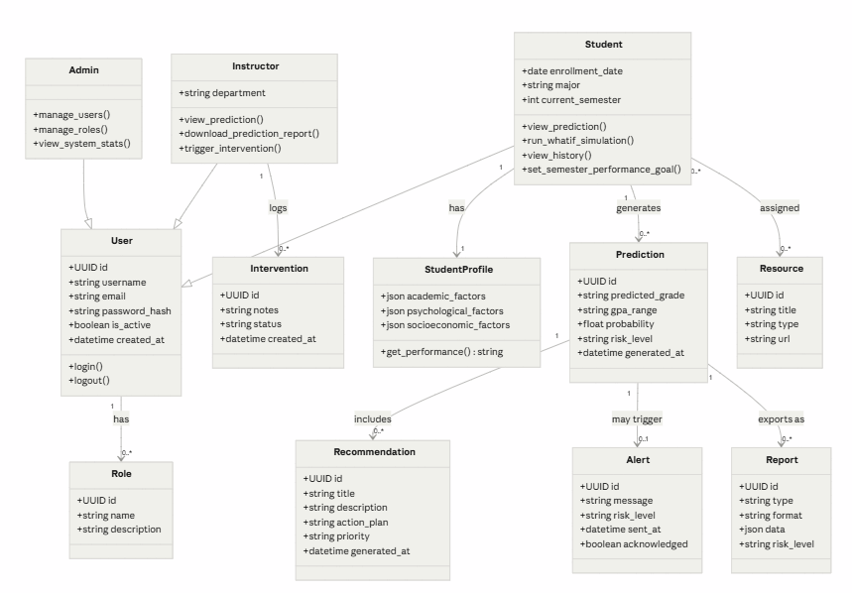

Appendix A2 : Student prediction sequence diagram

Appendix A3 : Student What if simulator
