1. How to choose weights : Gradient Descent Back propagation
2. Activation Functions

$$Activation Functions$$

$$In Neural network Neuron=Summation+Activation$$

$$If we have only summation :Linear combination of inputs=Regression problem$$

$$It will not able to identify complex solutions$$

$$Complex solutions requires Non-linearity$$

$$To provide the Non-linearity in the NN we use activation functions$$

$$Non-linear functions are called Activation functions$$

$Sigmoid$

$Softmax$

$Tanh$

$ReLU \left(Rectified Linear Unit\right)$

$Leaky ReLU$

$$Sigmoid$$

$what is the Equation$

$what is the range$

$On which layer will use$

$$sigmoid= σ\left(x\right)=\frac{1}{1+e^{-x}}$$

$$Graph:$$

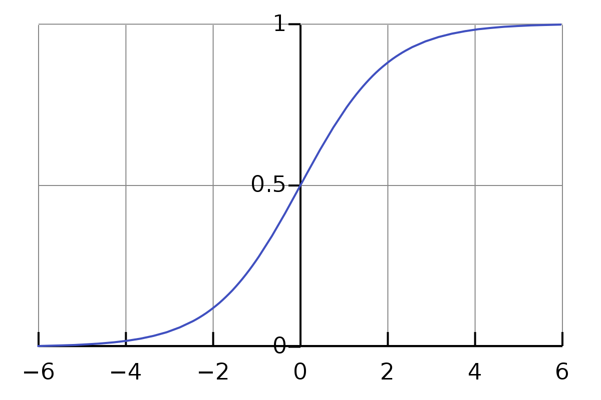

$Range= 0 to 1$

$$Sigmoid activation function use at Output layer only$$

$$and only for Binary classification$$

$$If you have output lables 0 and 1 then use Sigmoid function$$

$$Why Sigmoid function will not use at hidden layers$$

$$Vanishing Gradients or Explode Gradients$$

$$w_{new}=w_{old}-α*{\left(\frac{dJ}{dw}\right)}_{w=w_{old}}$$

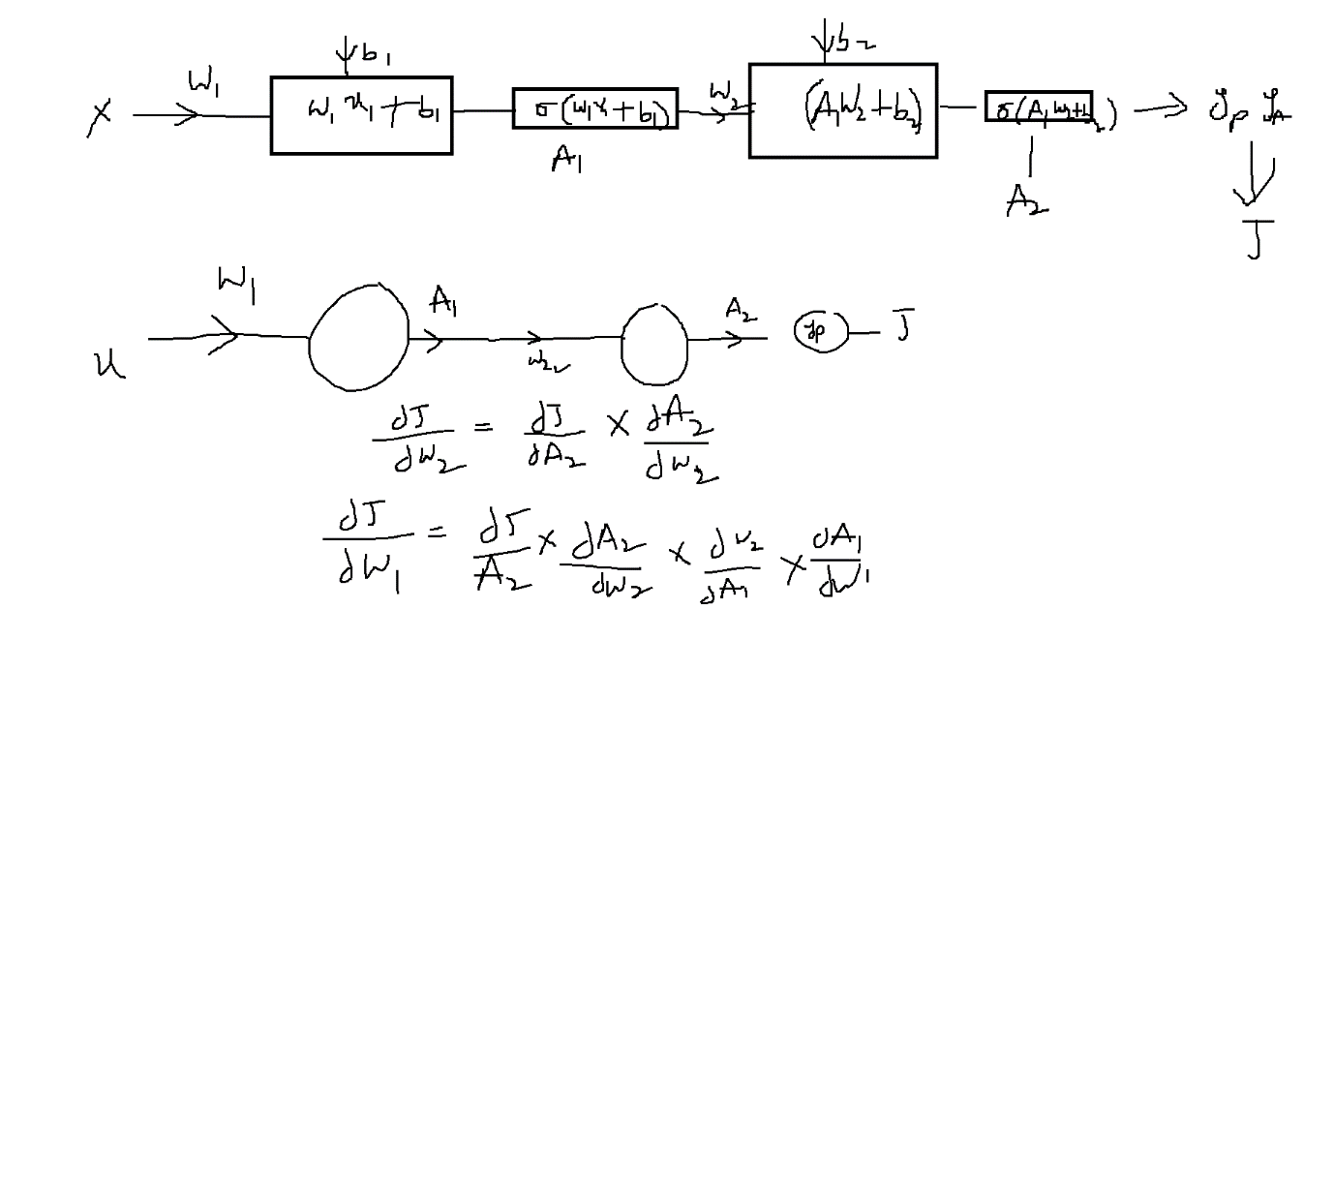

$\frac{dJ}{dw_{2}}=\frac{dJ}{dA_{2}}*\frac{dA_{2}}{dw_{2}}$

$$\frac{dJ}{dw_{2}}=\frac{dJ}{dA_{2}}*\frac{dA_{2}}{dw_{2}}$$

$$\frac{dJ}{dw_{1}}=\frac{dJ}{dA_{2}}*\frac{dA_{2}}{dw_{2}}*\frac{dw_{2}}{dA_{1}}*\frac{dA_{1}}{dw_{1}}$$

$$\frac{dA_{2}}{dw_{2}}=we are differentaiting activation function$$

$$σ\left(w_{1}*x+b_{1}\right)=\frac{1}{1+e^{-(w_{1}*x+b_{1})}}$$

$$differentiation of sigmoid=$$

$$diff\left(σ\left(x\right)\right)=diff\left(\frac{1}{1+e^{-x}}\right)$$

$$diff\left(\frac{1}{1+e^{-x}}\right)=\frac{e^{-x}}{{\left(1+e^{-x}\right)}^{2}}$$

$$\frac{e^{-x}}{{\left(1+e^{-x}\right)}^{2}}=\frac{e^{-x}}{\left(1+e^{-x}\right)}*\frac{1}{\left(1+e^{-x}\right)}$$

$$\frac{e^{-x}}{\left(1+e^{-x}\right)}=\frac{1+e^{-x}-1}{\left(1+e^{-x}\right)}=\frac{1+e^{-x}}{\left(1+e^{-x}\right)}-\frac{1}{\left(1+e^{-x}\right)}=1-\frac{1}{\left(1+e^{-x}\right)}$$

$$\frac{e^{-x}}{{\left(1+e^{-x}\right)}^{2}}=\left(1-\frac{1}{\left(1+e^{-x}\right)}\right)*\frac{1}{\left(1+e^{-x}\right)}$$

$sigmoid=\frac{1}{\left(1+e^{-x}\right)}=Z$

$$sigmoid^{'}=\left(1-Z\right)*Z$$

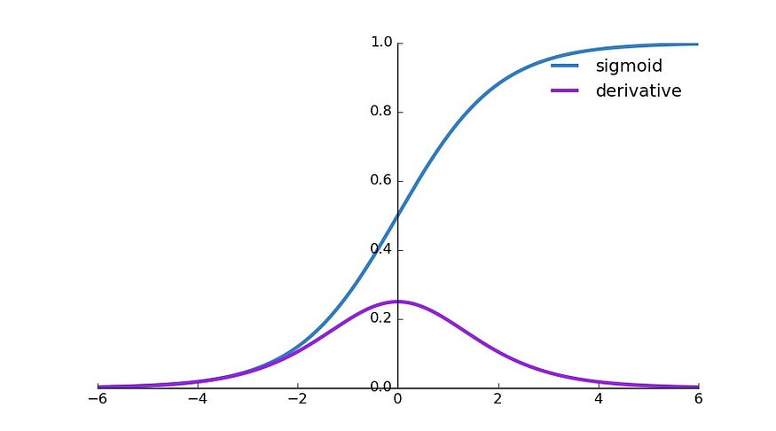

$Imagine Sigmoid activation function using in hidden layer$

$$For w very very small value , the differentiation at that particular w value$$

$$become zero$$

$${\left(\frac{dJ}{dw}\right)}_{w=w_{old}}=0 Vanishing gradients$$

$$w_{new}=w_{old}-α*0= W_{new}=W_{old}$$

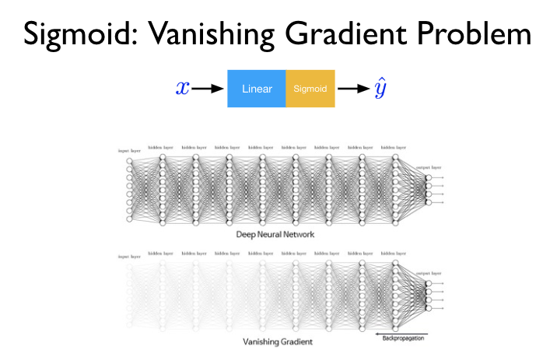

$$Vanishing gradients:$$

$$If you use sigoid function in hiddebn layers, at some point$$

$$for low w value the gradient becomes zero$$

$$Due to gradients become zero, the weight updation not happend$$

$$w_{new}=w_{old}-α*0= W_{new}=W_{old}$$

$$, the weight updation not happend===No pattern learning$$

$$====== >High error$$

$$If you use sigoid function in hiddebn layers, at some point$$

$$for high w value the gradient becomes zero$$

$Sigmoid$

$Softmax$

$Tanh$

$ReLU \left(Rectified Linear Unit\right)$

$Leaky ReLU$

$what is the Equation$

$what is the range$

$On which layer will use$

$Graph$

$$Softmax$$

$$the Equation:$$

$$sigmoid=\frac{1}{1+e^{-x}}=Bi classification$$

$$Softmax is for multi classification$$

$$c_{1} c_{2} c_{3}$$

$p(c1)=\frac{e^{c1_{output}}}{e^{c1_{output}}+e^{c2_{output}}+e^{c3_{output}}}$ $$p(c2)=\frac{e^{c2_{output}}}{e^{c1_{output}}+e^{c2_{output}}+e^{c3_{output}}}$$

$$p(c3)=\frac{e^{c3_{output}}}{e^{c1_{output}}+e^{c2_{output}}+e^{c3_{output}}}$$

$$\max\left(c1,c2,c3\right)is your final answer$$

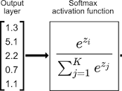

*Getting 1 out of 6= 1/6*

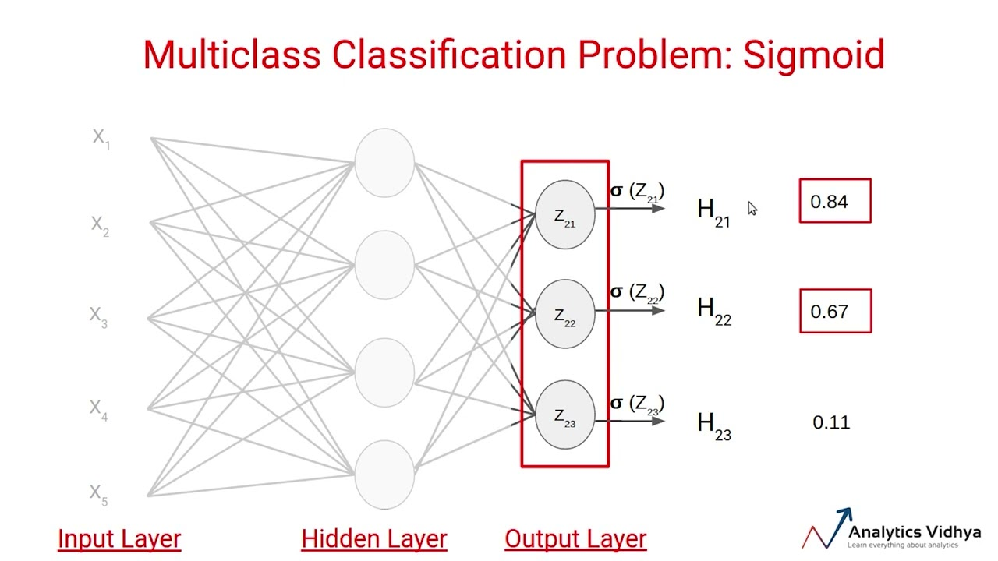

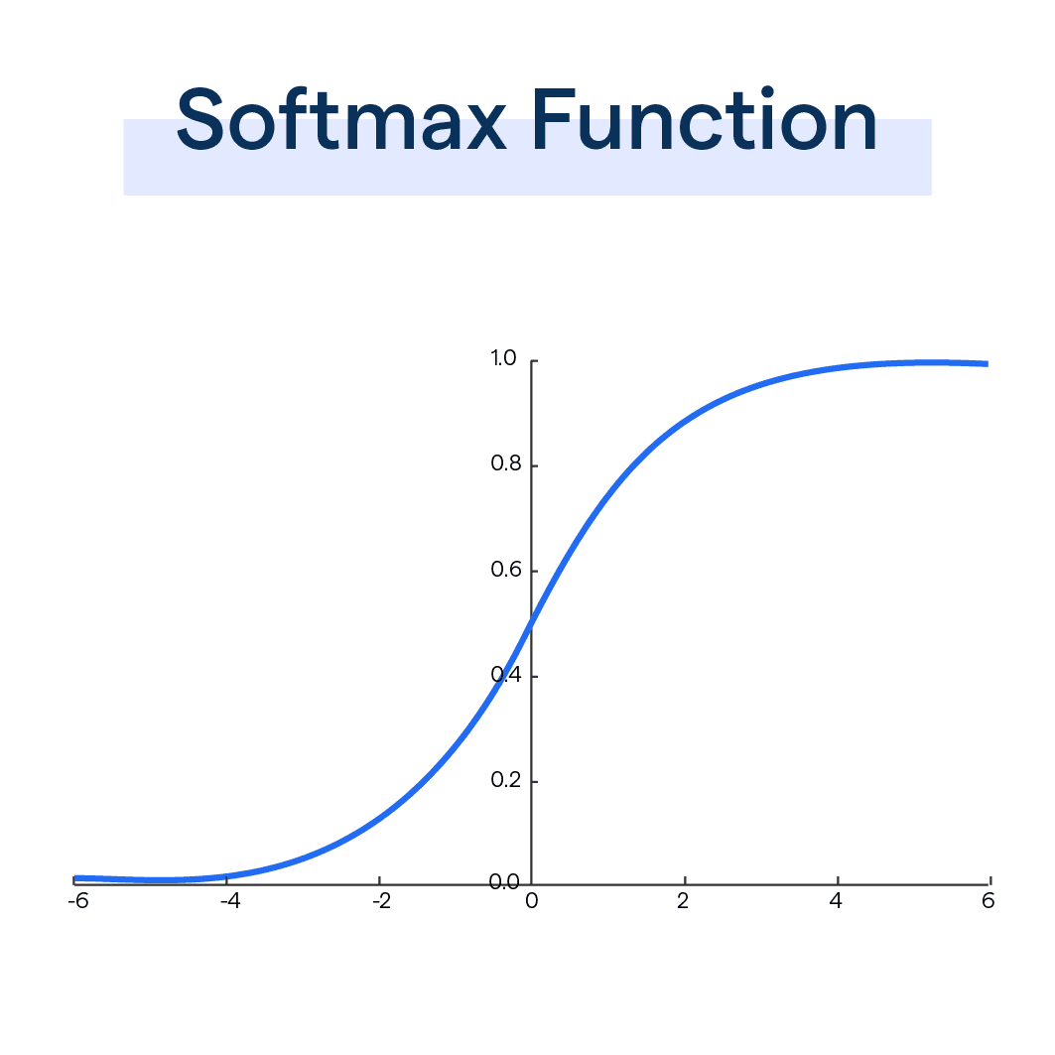

Softmax used for Multiclassification at output layer

Why not at Hidden layer:

Vanishing gradients problem

1. Equation
2. Which problem
3. Vanishing gradients happens in both cases
4. Graph also look like same

$$Tanh$$

$$1) Equation: \frac{e^{x}-e^{-x}}{e^{x}+e^{-x}}=$$

$$2) -1 to 1$$

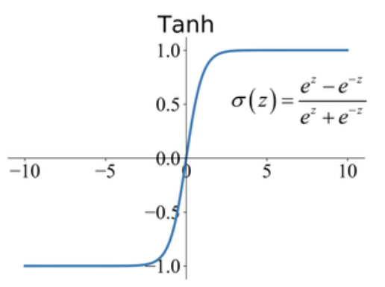

$3) output layer: +1 -1$

$$Sigmoid -Softmax-tanh$$

$$ReLU:Rectified Linear unit$$

$$It avoids vanish gradients problem$$

$$max⁡(0,x)$$

$$x===diff\left(x\right)=constant$$

$$diff\left(x\right) is not giving the zero , avoid vanishing gradients problem$$

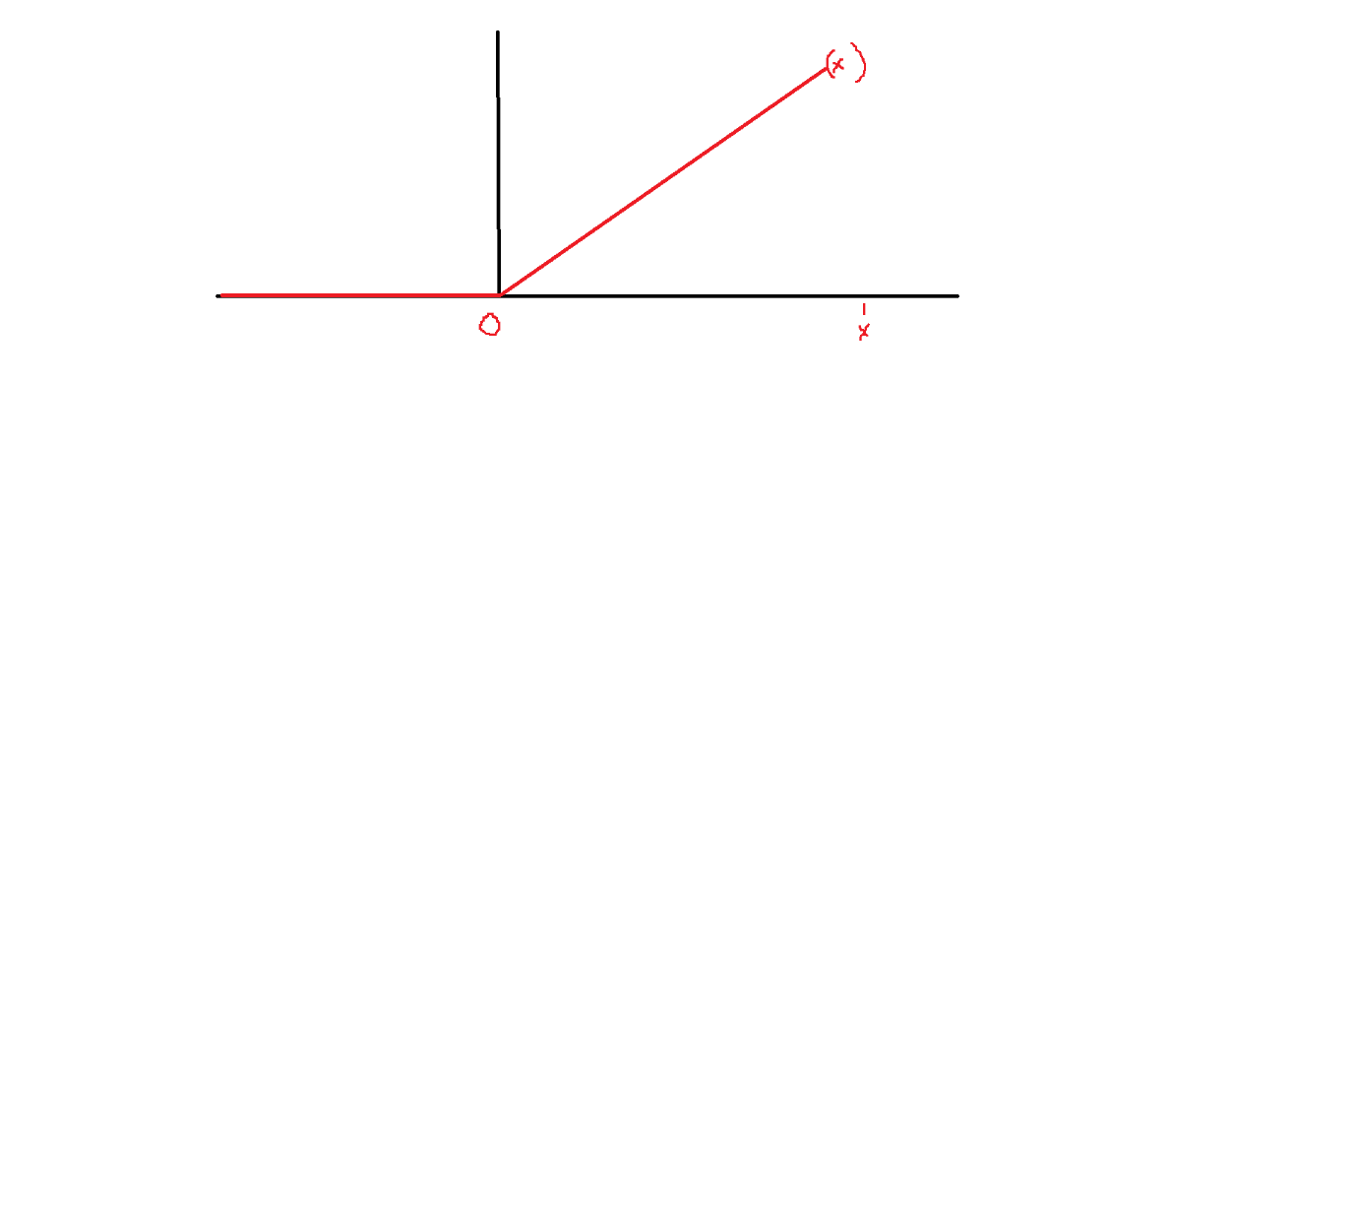Activations is used to provide Non linearity in the Neurons

ReLU looks like Linear curve only

Linear curve will never

$$ReLU is a Non linear curve only, It assumes all the negative values$$

$$as zero$$

$$Psuedo code:$$

$$\max\left(0,x\right)$$

$$if input>0$$

$$x=input$$

$$else$$

$$x=0$$

$$It is used in Hidden layers$$

$$What is the problem:$$

$$supose inputs are all the negative values , it assume as zero$$

$$Then total network will fail$$

to calculate gradients, is reLU differentiable at 0?

$$Leaky ReLU:$$

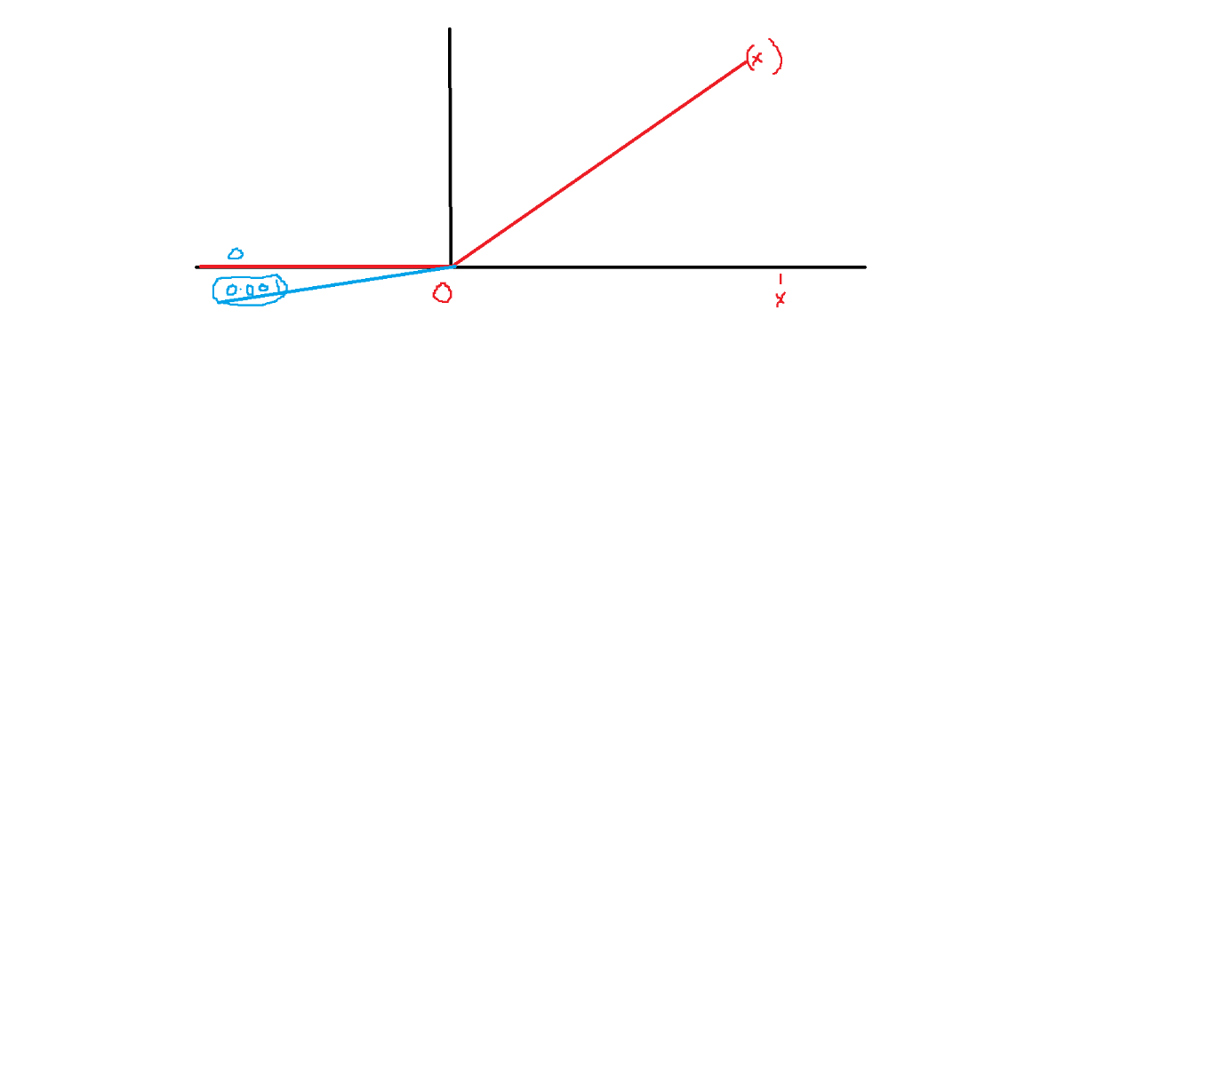

$$\max\left(0,x\right)=====max⁡(ax,x)$$

$$x is input suppose this input is -ve value : 0$$

$$x is input suppose this input is -ve value : 0.05*x$$

$$x=-2.5 ==== > 0.05*\left(-2.5\right)= -0.125$$

$$a=\left(0,1\right) learning rate=\left(0,1\right) hyper parameters$$

$$x is input suppose this input is+ve value : x$$

$Sigmoid$

$Softmax multiclass$

$Tanh -1 1$

$ReLU \left(Rectified Linear Unit\right)$

$Leaky ReLU$

$Equation$

$Range$

$Graph$

$Use case$

$Vanish gradinets$

$Inputs-ve values$

$$For the Regression NO activation Functions$$

$$Y=bo+w1*x1+w2*x2$$

EWA : Forecasting

Over optimisa

Wed === Python implement

CNN