$How to find the weigts : GD$

$Activation functions: sig sof\tanh{ and relu}$

$If you use more hidden layers:Model become overfit$

$$How to avoid overfit$$

$$Overfit: low train error and High test error$$

$Low bias and High variance$

$$Model complexity increases==analogy==Depth of Tree$$

$$Model complexity increases==analogy==Adding more features$$

$$Model complexity increases==analogy==Adding more hidden layers also more neurons$$

$$This all leads to Overfit$$

$$Now we need to avoid the overfit : Regualrization$$

$$Model overfit happens$$

$$1) Model complexity increases$$

$$2) Less training data avialable$$

$Ridge and Lasso regression technique$

$$Generally in Regression our main aim is to reduce Cost function$$

$J= ∑{(y}_{a}-y_{p})^2$

$$Suppose model become overfit : J becomes zero J=0$$

$$as a developer I assume, train error is less I can good to go$$

$$I started working on test data, it gives so high error$$

$$Then I realised model overfitted$$

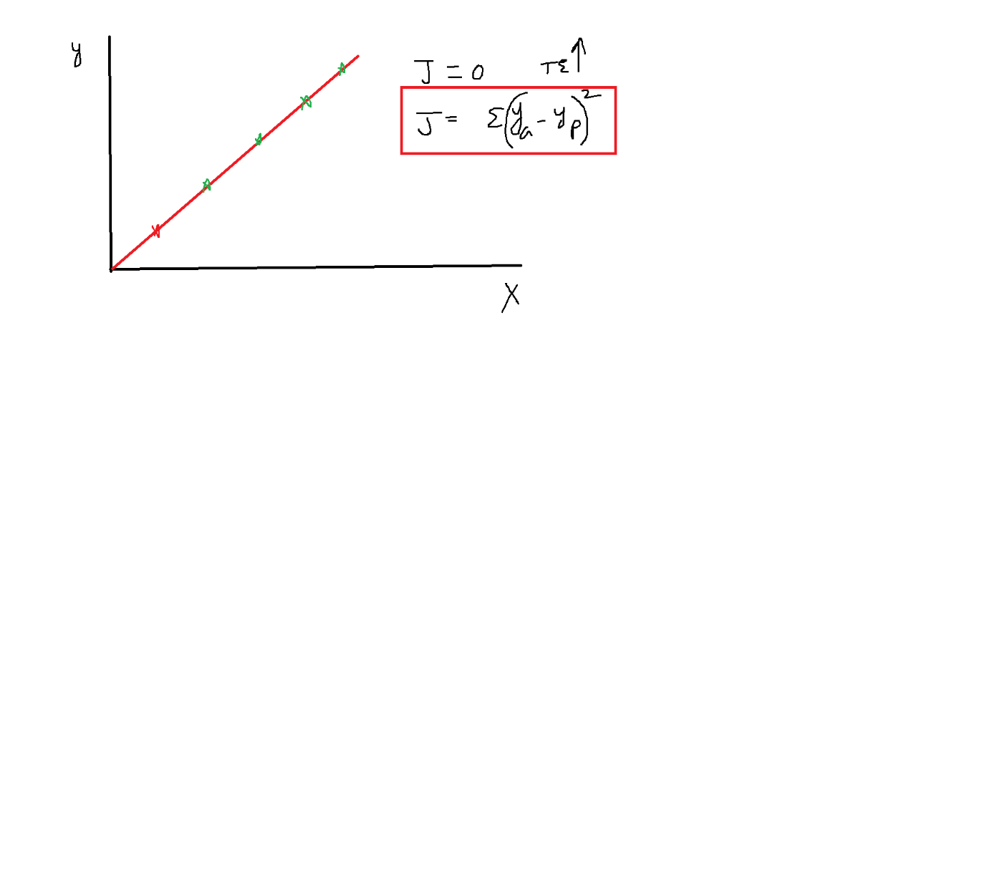

$y=b+wx$

$J= Cost function+ λ*{\left(slope\right)}^{2}$

$before our main concentration to reduce cost function$

$Now our main concentation is not only cost function one extra term:{\left(slope\right)}^{2}$

$Assume that model overfitted: y=1.2+1.3*x$

$$1.3=slope ; λ=1$$

$cost function=0$

$$J= 0+ λ*{\left(1.3\right)}^{2}$$

$$J=1.69$$

$$because of the extra term J not equal to zero even thogh model overfitted$$

$$we will feel like:error is not equal to zero, this migh not be a good model$$

$$will try to get another equation$$

$$Step-1: We want to find the weights : OLS and GD$$

$$Step-2:we will form equation: y=1.5+1.4*x$$

$$Step-3: Will pass train data , y_{predictions}$$

$$Step-4: J=cost functions$$

$$Step-5: J=0 \left(very happy\right)$$

$$Step-6: Pass the test data , Test error huge====BAAAM$$

$$Step-7: We realized model is overfitted$$

$$Step-1: We want to find the weights : OLS and GD$$

$$Step-2:we will form equation: y=1.5+1.4*x$$

$$Step-3: Will pass train data , y_{predictions}$$

$$Step-4: J= Cost function+ λ*{\left(slope\right)}^{2}$$

$$Step-5: J=0+ λ*{\left(slope\right)}^{2}$$

$$step-6: You will feel we have still some J$$

$$step-7:will try to create a another equation :$$

how many times we have to iterate ridge regression to attain actual equation?

Manual calculation will not do

Less error

Fp + Bw

that might not be the best fit line right...when will the gradient descent stop then if cost function is never 0?

J=0

$$y=b+wx$$

$J= Cost function+ λ*{\left(w\right)}^{2}$

$$y=b+w_{1}x_{1}+w_{2}x_{2}$$

$J= Cost function+ λ*{\left(w_{1}+w_{2}\right)}^{2}$

$$λ=0 to inf$$

$$Best use of this is , suppose model complexiy increases model overfitted$$

$$you want reduce your features$$

$$You dont want reduce your features and you want avoid overfit \left( Ridge regression\right)$$

$$In ridge regression slope values will never=0$$

$$Lasso Regression$$

$$J= Cost function+ λ*|slope|$$

$$lasso regression makes weights=0 after so many iterations$$

$$Huge maths research paper$$

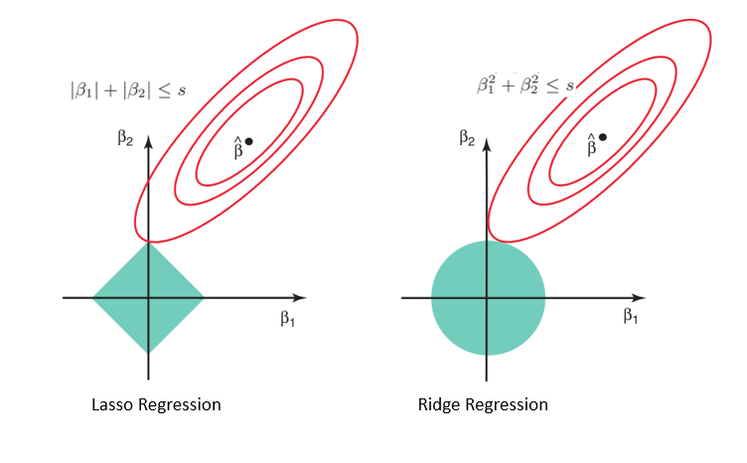

$$Ridge regression and Lasso regresson both are used to avoid Overfitting$$

$$Ridge regression and Lasso regression comes under Regularization methods$$

$$Ridge regression: L2 : J= Cost function+ λ*{\left(w\right)}^{2}$$

$$Lasso regression:L1 : J= Cost function+ λ*|w|$$

$$if you want all thefeatures go for Ridge$$

$$if you want less feature then go for Lasso$$

$$Lasso is not only Regualrization method it is also feature selection method$$

$$λ create the bias from the original line$$

$$original line:Regression line$$

$$λ=0 Regression line an Ridge line bot are same$$

$$Choose λ is very critical : Penalise$$

$$Ridge regression: L2 : J= Cost function+ λ*{\left(w\right)}^{2}$$

$$Lasso regression:L1 : J= Cost function+ alpha*|w|$$

$$L1norm :Lasso \left(alpha\right) L2Norm: Ridge \left(lambda\right)==== >Elastic Net(alpha,lambda)$$

$Drop Out$

$$for every iteration drop the neurons randomly$$

$$Cross valdation:Train and test$$

$$for every iteration will drop neurons randomly as well as we include neurons in training$$

$$when you drop the neurons the model becomes less complex$$

$$while develop NN ,$$

$$Drop out=0.3 \left(assume\right)$$

$$suppose in hidden layer we have 10 neurons$$

$$every time randomly 3 neurons will drop , 7 neurons are present$$

include neurons in training means? I didn't get here

NN

$Data augmentation$

$Early stopping: Forward vs Backward$

Tree pre- pruning post pruning

Hiddn layer 100 overfitted

$$EWA:$$

1. GD
2. GD with Momentum
3. Adaptive GD
4. RMS Prop
5. ADAM