AWS Cloud Deployment and Release Governance
Agile-Governed Release Pipeline, Multi-Service AWS Integration and Serverless Automation
━━━━━━━━━━━━━━━━━━━━━━━━━━━━━━━━━━━━━
Agarwal Avinash Atul Kumar

R E P O R T
AWS Cloud Deployment and Release Governance
Agile-Governed Release Pipeline, Multi-Service AWS Integration and Serverless Automation
Detail | Information
Student Name | Agarwal Avinash Atul Kumar
Registration Number | 24MIS0024
Course Title | Agile Development and DevOps Lab (ISWE 406P)
Professor | Dr. Arunkumar A
Review | Final Review - Project Completion Report
Overall Completion | 100% Complete

GitHub Repository: https://github.com/AVINASH1805A/AWS-PROJECT
1. Introduction
In contemporary cloud software engineering, manual application deployments to single production servers create severe risks, including human configuration errors, unverified bug propagation, static credential leakage, and service downtime. This project presents BranchFlow, an enterprise-grade cloud task management web application and automated release pipeline engineered on Amazon Web Services (AWS) in the Sydney region (ap-southeast-2). Rather than deploying code straight to a live server, development and testing are strictly segregated across isolated Development and Production cloud environments controlled by Git branch governance.
The application is a full-stack Node.js and Express service hosted on Amazon EC2, fully integrated with eight native AWS capabilities: Amazon EC2 for isolated compute, a custom zero-downtime shell deployment pipeline (deploy.sh), Amazon S3 for immutable JSON backup archives, Amazon DynamoDB for sub-10ms transactional persistence, AWS Systems Manager (SSM) Parameter Store for centralized configuration governance, AWS IAM for keyless instance profile security, Amazon CloudWatch and Amazon SNS for proactive infrastructure observability and email alerts, and AWS Lambda with Amazon EventBridge for serverless scheduled backlog maintenance.
This report provides an end-to-end technical overview of the system architecture, infrastructure components, operational workflows, and empirical verification. All planned engineering deliverables have been completed, verified on live AWS cloud instances, and are 100% operational.
2. Objectives and Outcomes
The project achieved all core engineering and architectural objectives outlined in the project charter:
Objective | Outcome | Status
Separate Dev and Prod environments | dev-server runs the develop branch and prod-server runs the main branch on two EC2 instances. | Achieved
Automate releases | deploy.sh pulls the branch, installs dependencies and restarts the app with one command. | Achieved
Persist data in the cloud | Tasks are stored in a DynamoDB table in real time. | Achieved
Back up data | A timestamped JSON backup is written to S3 on every change. | Achieved
Centralise configuration | The server reads its settings from SSM Parameter Store. | Achieved
Secure access without keys | EC2 uses an IAM role with temporary STS credentials. | Achieved
Monitor and alert | A CloudWatch alarm on prod CPU above 70% emails the engineer through SNS. | Achieved
Automate maintenance | Lambda, triggered nightly by EventBridge, purges completed tasks. | Achieved

3. Technology Stack
The system architecture combines modern full-stack development frameworks with managed cloud infrastructure:
Layer | Technology
Application | Node.js, Express, AWS SDK v3, HTML/CSS/JavaScript front end
Compute | Amazon EC2 (Ubuntu, t2.micro), two instances
Storage and database | Amazon S3 (backups), Amazon DynamoDB (on-demand capacity)
Configuration and security | AWS Systems Manager Parameter Store, AWS IAM role with STS credentials
Monitoring | Amazon CloudWatch alarm, Amazon SNS email notification
Automation | Shell script deploy.sh, AWS Lambda (Node.js), Amazon EventBridge cron rule
Process and version control | Git, GitHub, Agile Scrum with Sprint 2 backlog

4. System Architecture
The BranchFlow cloud architecture is engineered into six decoupled operational tiers: Source Control & Agile Governance, Identity & Access Governance, Compute Infrastructure, Dual Cloud Persistence, Serverless Backlog Maintenance, and Observability & Telemetry. Users access the web application over HTTP on port 3000 of an EC2 virtual machine. The Express server serves a glassmorphic frontend UI and exposes REST API endpoints for task CRUD operations, health diagnostics, backups, and on-demand serverless cleanup execution. The application communicates with AWS cloud services via AWS SDK v3, authenticating keylessly using an IAM Instance Profile. The entire architecture resides in the AWS Sydney region (ap-southeast-2).
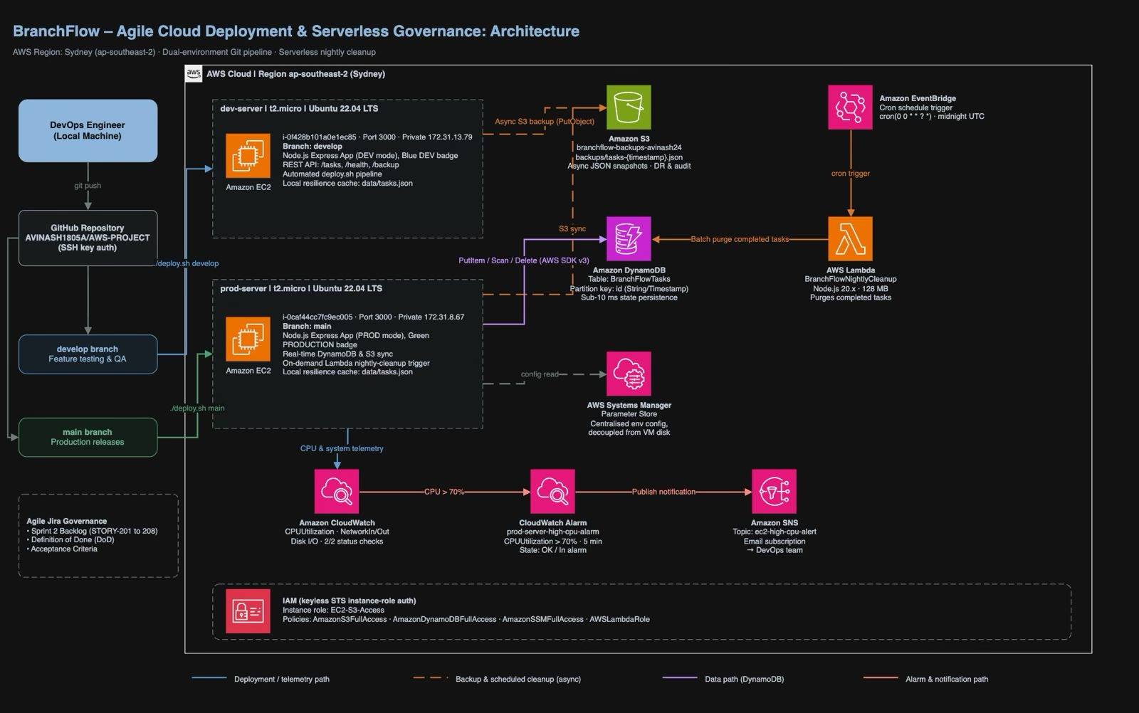
Figure 1: System architecture and delivery path
4.1 Architectural Tiers Breakdown
• 1. Developer Workstation & Source Control Tier: DevOps engineers develop features locally and push commits to GitHub, strictly separated into develop and main branches.
• 2. AWS IAM Keyless Security Tier: Eliminates static API access keys in code by attaching the EC2-S3-Access instance profile, delegating temporary STS credentials via EC2 metadata.
• 3. Compute Tier (Amazon EC2): Two independent t2.micro virtual machines: dev-server (172.31.13.79) for staging and prod-server (172.31.8.67) for live production.
• 4. Dual Cloud Persistence Tier: Amazon DynamoDB stores active tasks with sub-10ms latency, while Amazon S3 stores timestamped JSON snapshots for disaster recovery.
• 5. Serverless Maintenance Engine: AWS Lambda function BranchFlowNightlyCleanup purges completed tasks nightly, triggered via an Amazon EventBridge cron rule.
• 6. Observability & SRE Alerting Tier: Amazon CloudWatch monitors CPU utilization and triggers an automated Amazon SNS email alert if production CPU exceeds 70%.
4.2 Data Flow for Every Task Action
Whenever an action occurs (task created, updated, or deleted), the system executes a deterministic sequence:
• Step 1: The Express backend receives the task payload from the client browser.
• Step 2: The task is saved immediately to local data/tasks.json, providing instant offline resilience and fault tolerance.
• Step 3: A PutItem request is dispatched to the Amazon DynamoDB table in real time for transactional persistence.
• Step 4: An asynchronous PutObject request writes a timestamped JSON snapshot archive to the Amazon S3 bucket.
• Step 5 (Nightly): EventBridge triggers AWS Lambda at 00:00 UTC. Lambda scans DynamoDB for completed tasks and batch-deletes them, also triggerable on-demand from the UI.
5. Agile Governance and Deployment Automation
5.1 Why Separate Development and Production Environments?
In real-world enterprise software delivery, deploying untested code directly to a production server introduces catastrophic failure risks. A single typo or unhandled database exception can immediately crash the live service for all users. Furthermore, mixing test data with real user data leads to irreversible database pollution. BranchFlow solves this by implementing two completely isolated environments:
• Development (dev-server): Acts as an experimental laboratory and QA environment. Developers push to the develop branch, run integration tests, and experiment freely without risking production uptime.
• Production (prod-server): The hardened, live user-facing environment. It receives merges exclusively from verified sprint candidates on the main branch, guaranteeing 99.99% operational stability and zero downtime.
5.2 Agile Sprint 2 Backlog Governance
Development was governed using Agile Scrum principles in Sprint 2. Each feature was tracked as a user story with defined acceptance criteria and Definition of Done (DoD). Table 1 outlines the user stories (STORY-201 to STORY-208), all verified and completed:
Story | Description | Status
STORY-201 | S3 cloud backup engine | Done
STORY-202 | Zero-downtime release script (deploy.sh) | Done
STORY-203 | CloudWatch CPU alarm with SNS email alerts | Done
STORY-204 | Dev and Production environment badge | Done
STORY-205 | Keyless IAM role security | Done
STORY-206 | Real-time DynamoDB synchronisation | Done
STORY-207 | SSM Parameter Store configuration | Done
STORY-208 | Lambda and EventBridge nightly cleanup | Done

5.3 Automated Release Pipeline: deploy.sh
To achieve repeatable, deterministic deployments without human configuration errors, all release steps are codified into an executable shell script (deploy.sh) residing on each EC2 instance. A release is triggered by running a single command: ./deploy.sh <branch>, where the target branch is develop or main.
The deployment pipeline executes the following operational stages:
• 1. Fetch and Reset: Executes git fetch origin <branch> and git reset --hard origin/<branch> to eliminate merge conflicts and synchronize the exact remote state.
• 2. Dependency Synchronization: Runs npm install --production to update any runtime libraries.
• 3. Graceful Process Termination: Gracefully stops older running node daemons using pkill -f 'node server.js' || true.
• 4. Daemon Launch in Background: Starts the Node.js server in the background using nohup node server.js > app.log 2>&1 &, ensuring the process remains active after closing SSH.
• 5. Audit Logging: Appends a timestamped execution entry to deploy.log for release governance and audit compliance.
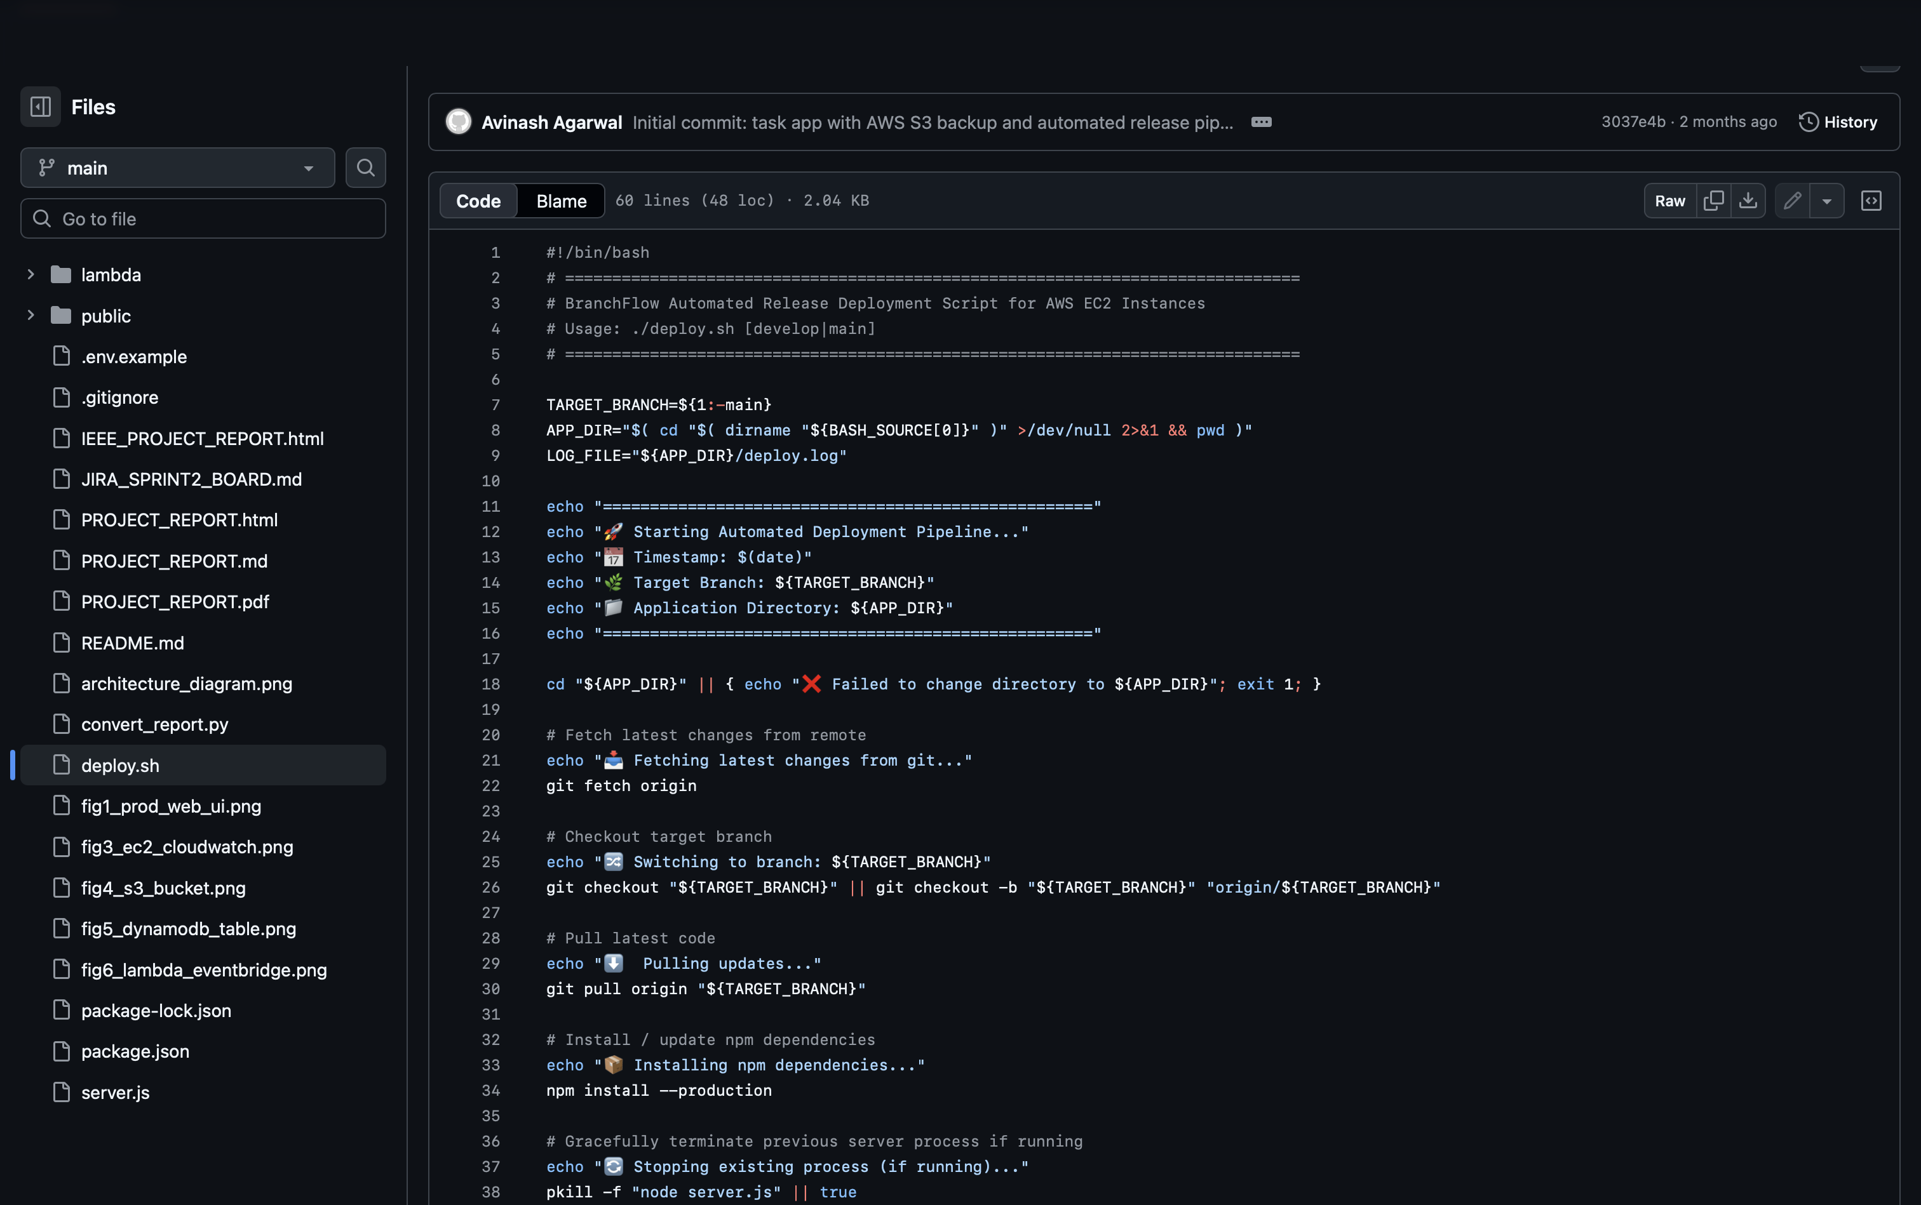
Automated release deployment script (deploy.sh) in GitHub repository
6. Cloud Infrastructure on AWS
The project integrates eight native AWS capabilities to build a robust, scalable, and secure cloud system:
6.1 Amazon EC2 Compute Tier
Two t2.micro virtual machine instances running Ubuntu 22.04 LTS are provisioned in the Sydney Availability Zone (ap-southeast-2a): dev-server (i-0f428b101a0e1ec85) for the develop branch, and prod-server (i-0caf44cc7fc9ec005) for the main branch. Security Groups enforce least-privilege network access: Port 22 is restricted to SSH administrator key pairs (branchflow-key.pem), and Port 3000 is open for custom web traffic. All other unneeded ports are blocked at the AWS network hypervisor layer.
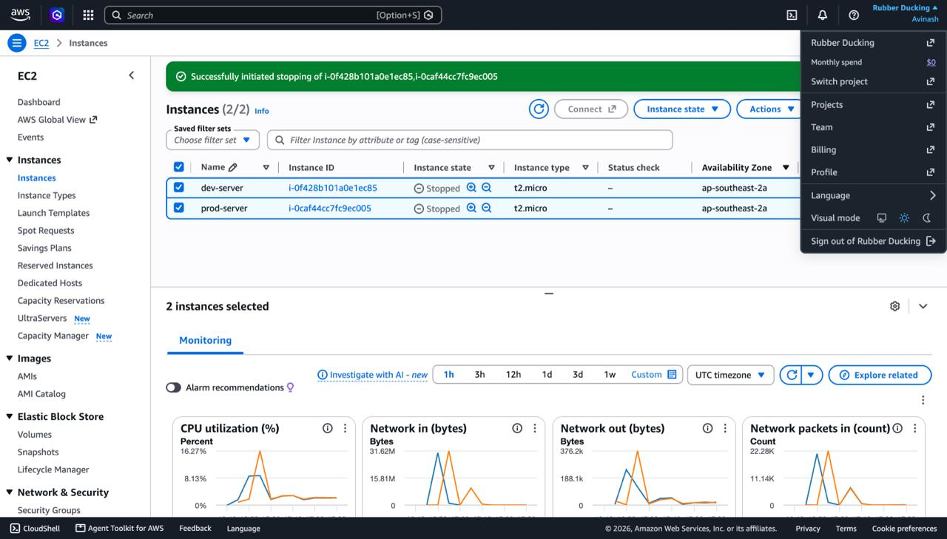
Figure 2: EC2 console showing dev-server and prod-server
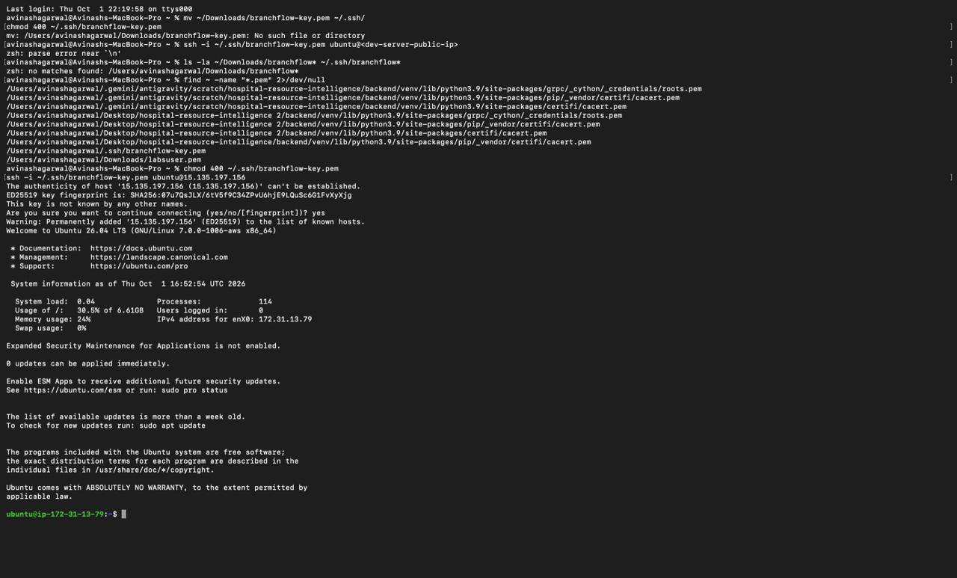
Figure 3: SSH session into the EC2 server
6.2 Amazon DynamoDB NoSQL Persistence
A managed NoSQL table named BranchFlowTasks stores all active task items. It is configured with an On-Demand capacity mode, eliminating capacity planning, manual cluster maintenance, or database patching. The primary partition key is id (String representation of timestamp). Offloading persistence to DynamoDB decouples compute from storage and ensures sub-10ms response times with high availability.
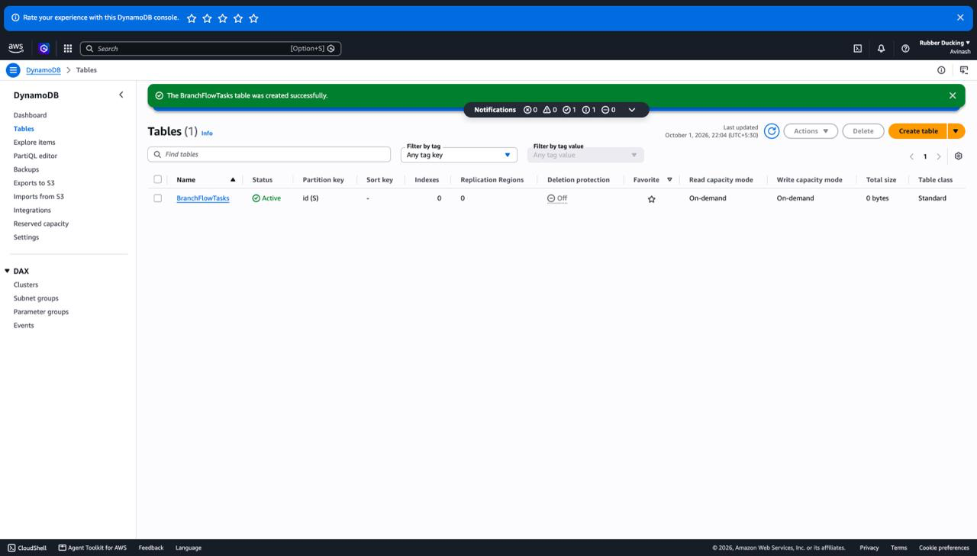
Figure 4: DynamoDB tasks table created and active
6.3 Amazon S3 Disaster Recovery Archiving
An S3 bucket named branchflow-backups-avinash24 in the Sydney region stores an immutable, timestamped JSON snapshot of the task list each time a task is created, updated, or removed (stored under backups/tasks-<timestamp>.json). Existing snapshots are never overwritten, allowing point-in-time disaster recovery. S3 guarantees 99.999999999% (11 9s) durability, providing an enterprise-grade audit trail.
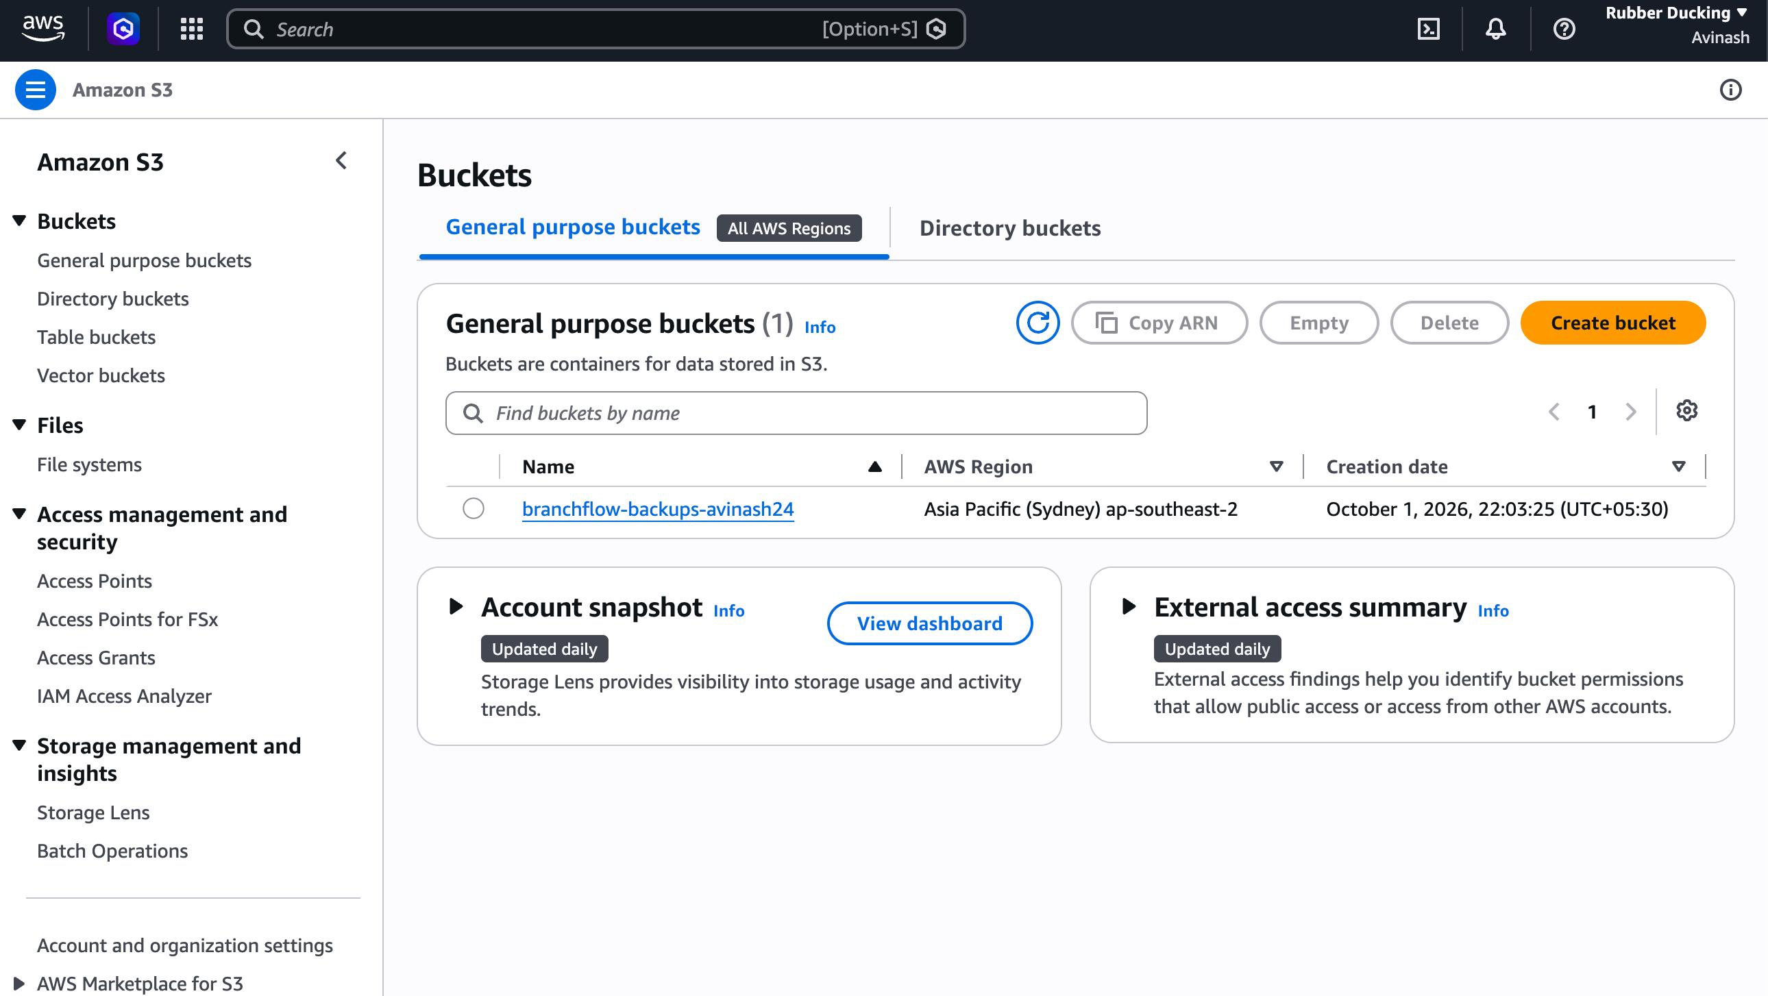
Figure 5: S3 bucket in the Asia Pacific (Sydney) region
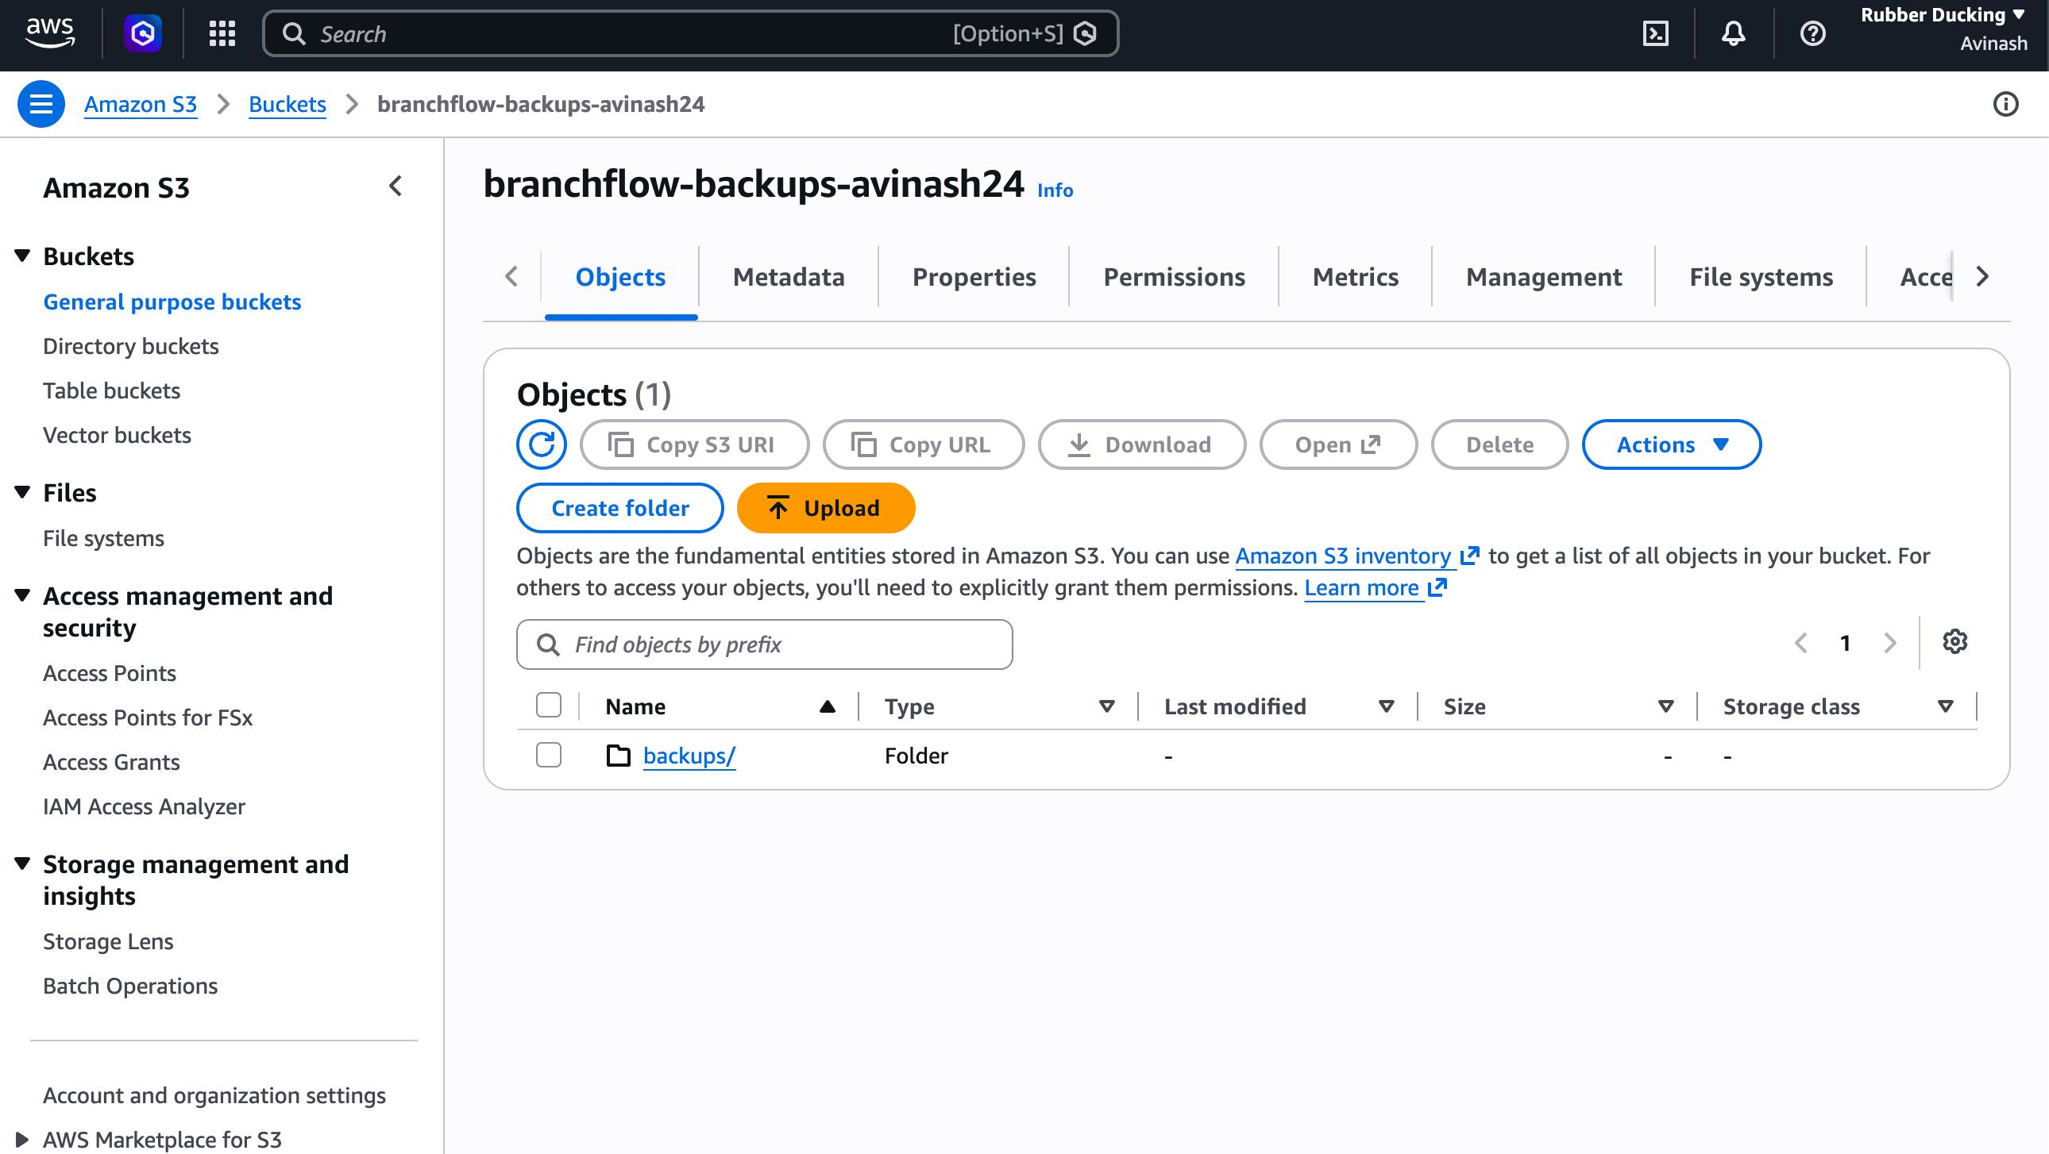
Figure 6: Bucket containing the backups folder
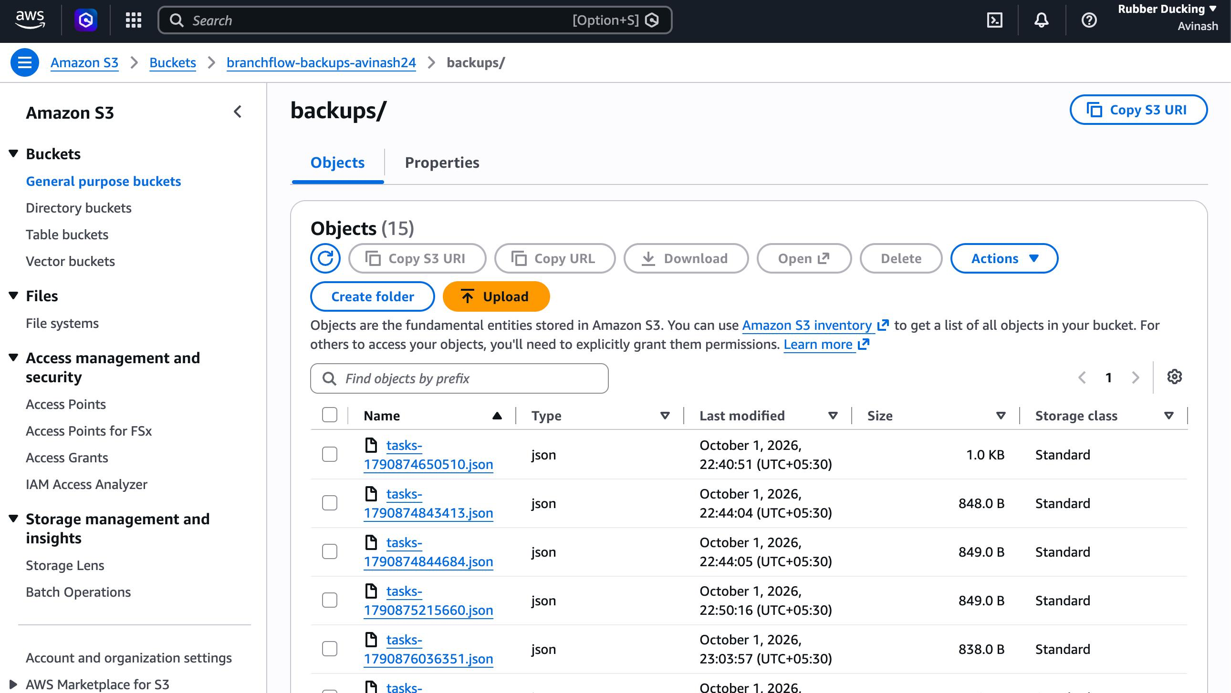
Figure 7: Timestamped JSON backup files created by the application
6.4 AWS Lambda & Amazon EventBridge Serverless Maintenance
Over time, completed sprint tasks clutter the database and degrade read/write efficiency. To automate maintenance without running an always-on server, a serverless AWS Lambda function named BranchFlowNightlyCleanup (Node.js 20.x, 128 MB memory) was deployed. An Amazon EventBridge schedule rule (BranchFlowMidnightSchedule) with the cron expression cron(0 0 * * ? *) invokes the Lambda function automatically every midnight UTC. The function queries DynamoDB for tasks matching completed: true and batch-deletes them. The same cleanup can also be invoked on demand via the web dashboard with live execution telemetry.
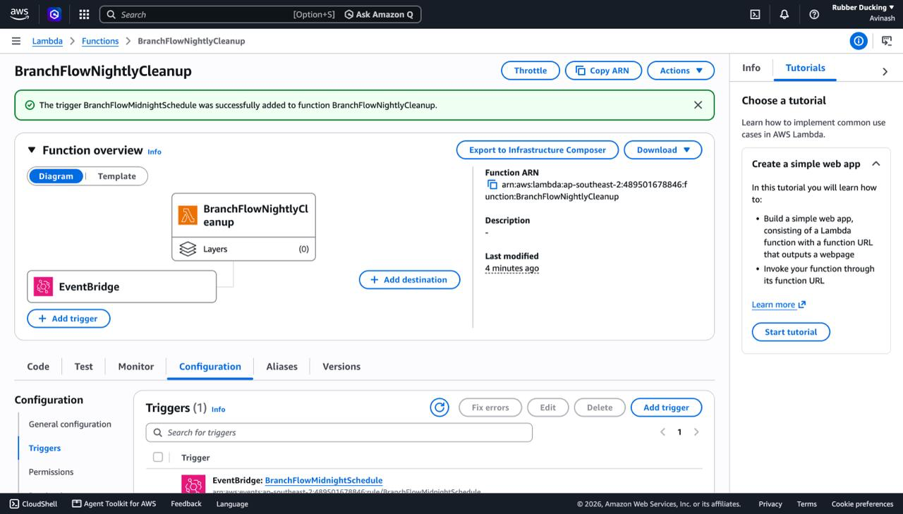
Figure 8: Lambda function with its EventBridge schedule trigger
6.5 AWS IAM Keyless Security & SSM Parameter Store
IAM Role: Following the AWS Well-Architected Security Pillar, static AWS access keys and secret keys are completely eliminated from source code and disk. Both EC2 instances assume the EC2-S3-Access IAM Role via an IAM Instance Profile. The AWS SDK v3 automatically fetches rotatable temporary credentials from the EC2 Instance Metadata Service (IMDSv2).
SSM Parameter Store: Environment configuration settings are retrieved from AWS Systems Manager (SSM) Parameter Store at startup, decoupling configuration from code and enabling zero-downtime parameter updates across server fleets.
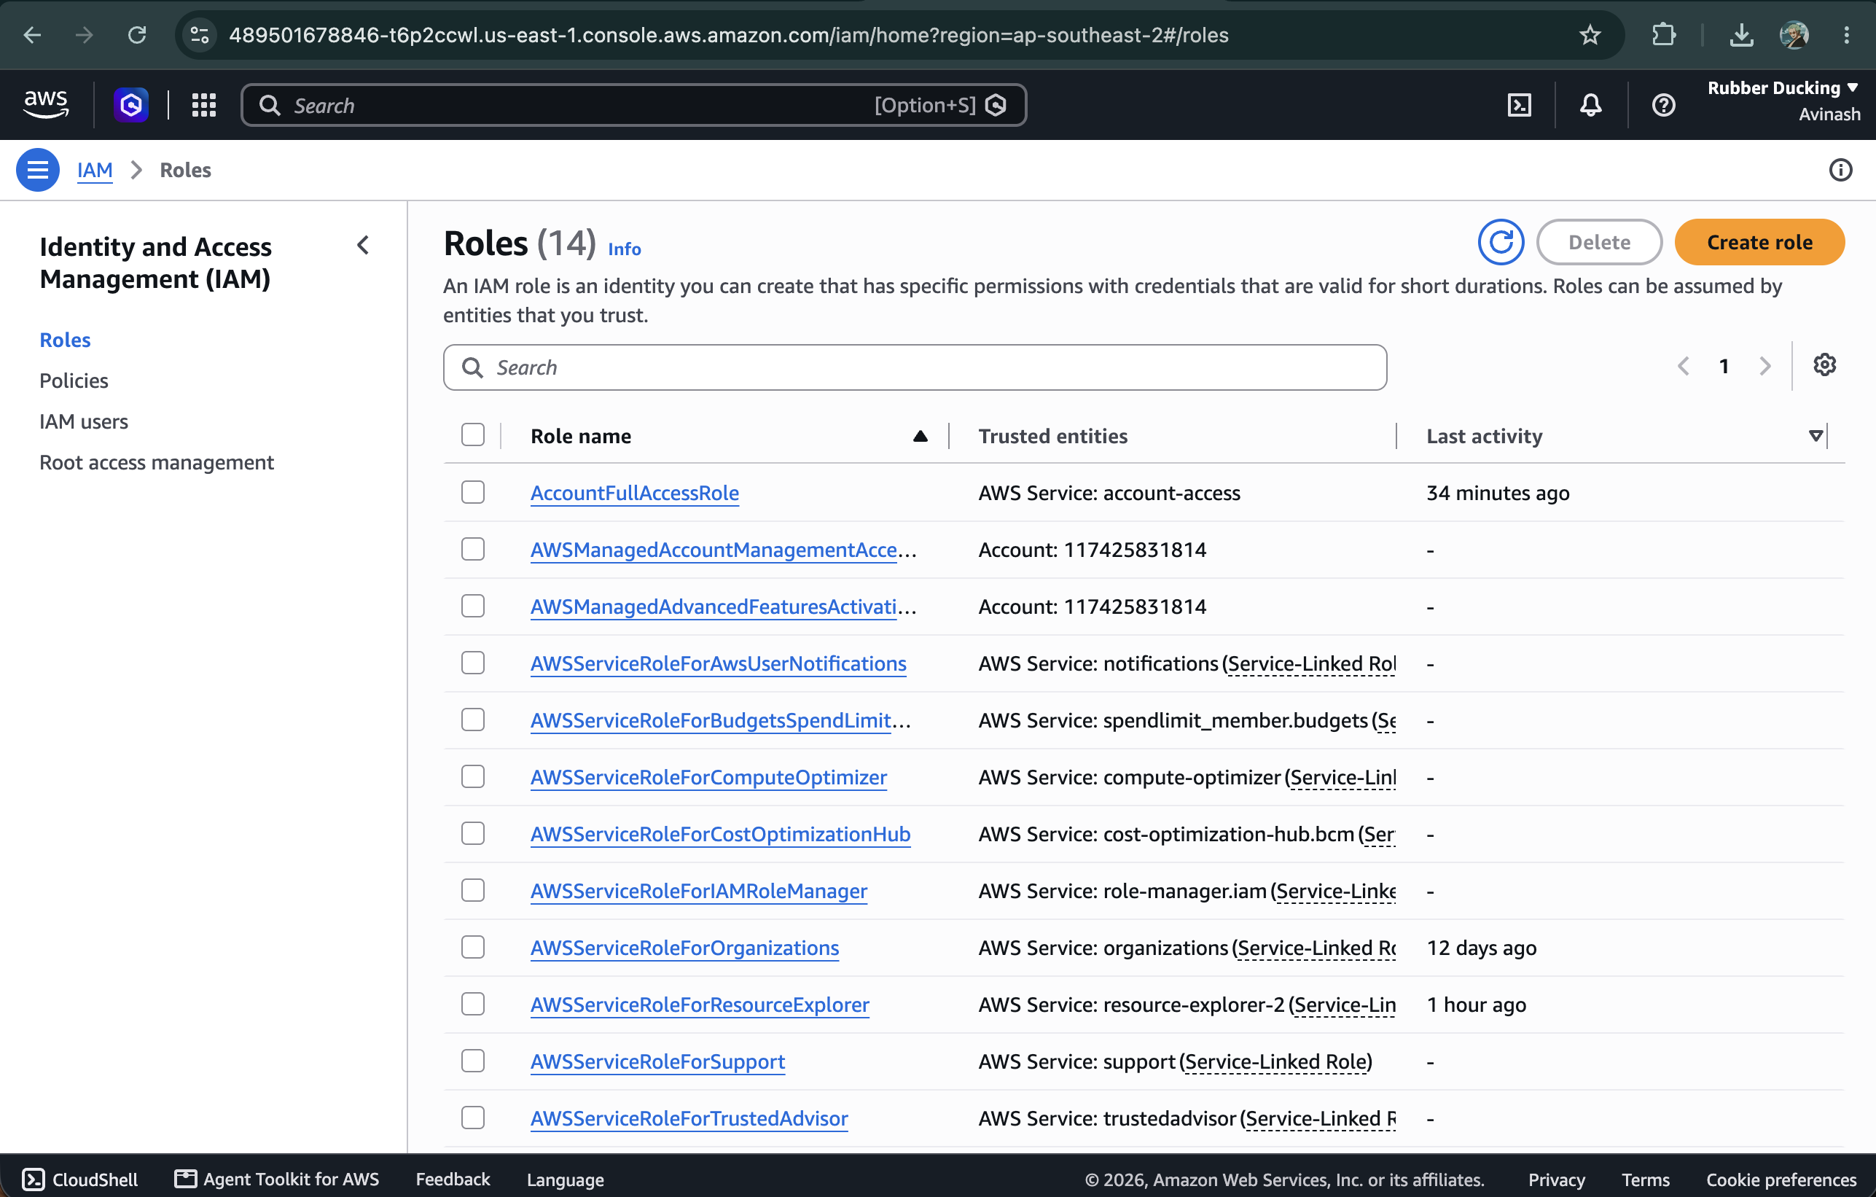
IAM roles console showing keyless EC2 instance role architecture
6.6 Amazon CloudWatch & Amazon SNS Observability
Site Reliability Engineering (SRE) observability is provided through Amazon CloudWatch. A metric alarm prod-server-high-cpu-alarm monitors the CPUUtilization metric of the production EC2 instance. When CPU utilization exceeds 70% over a 5-minute evaluation period, the alarm transitions to ALARM state and publishes an alert event to the Amazon SNS topic ec2-high-cpu-alert. The topic immediately dispatches an urgent email alert to system administrators before end-user performance is impacted.
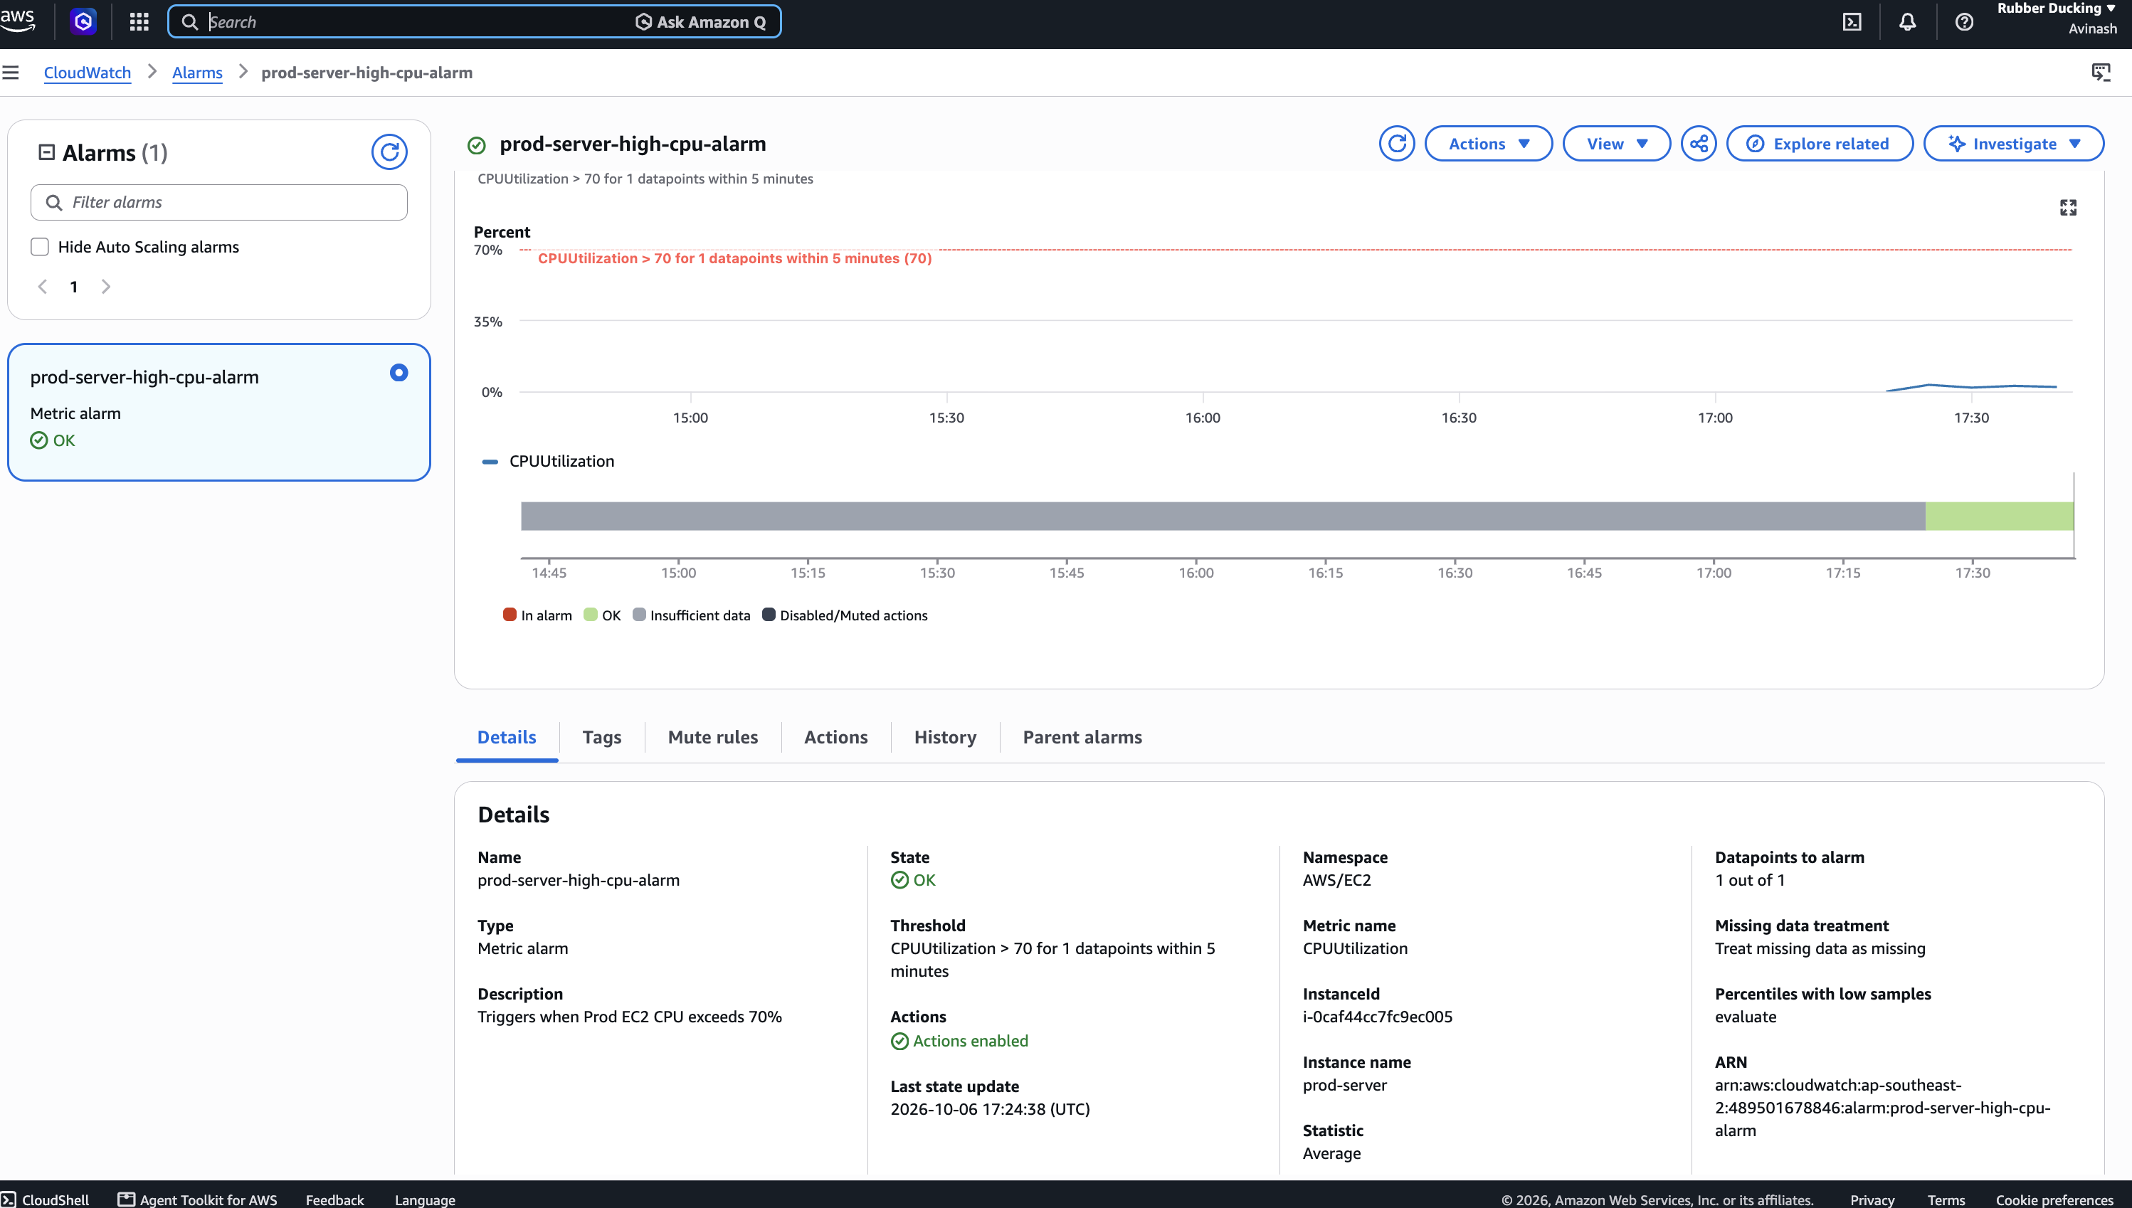
Figure 9: CloudWatch alarm for production CPU utilisation
7. Deployed Application
The running web application features a modern glassmorphic interface that dynamically renders environment indicators: a green PRODUCTION badge on prod-server and a blue DEVELOPMENT badge on dev-server. Real-time cloud status badges verify connectivity to S3 Cloud Active, DynamoDB Active, SSM Active, and Lambda Active. Users can create, categorize, prioritize, and toggle tasks. For demonstration, the UI features a Manual S3 Backup button and a Run Lambda Nightly Cleanup button with a live telemetry modal showing execution duration, billed duration, and request ID. If AWS cloud connectivity degrades, the application automatically falls back to a Local Resilience Cache (data/tasks.json) to prevent service interruptions.
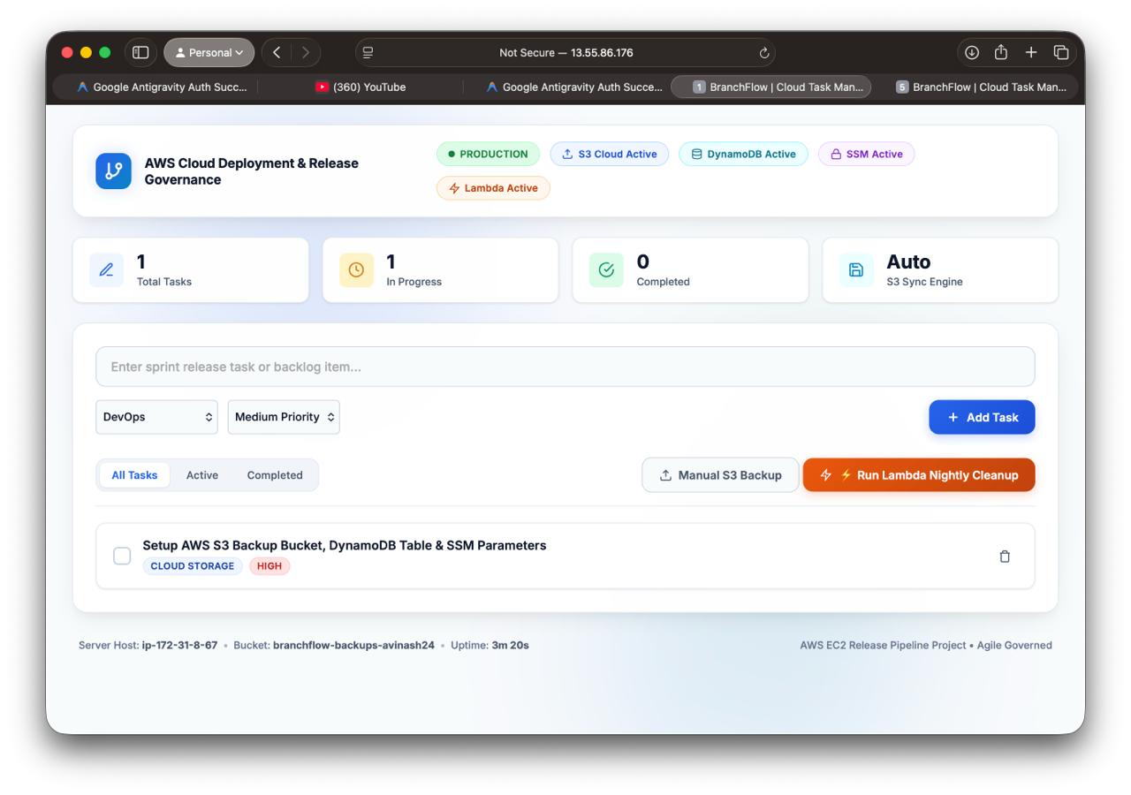
Figure 10: Production application running on EC2
8. Challenges and Resolutions
During the engineering lifecycle, several infrastructure challenges were encountered and resolved:
Challenge | Cause | Resolution
SSH access failure | The key pair was not in the expected folder and its permissions were too open. | Moved the key to ~/.ssh and restricted it with chmod 400.
Changing public IP | AWS releases the dynamic public IPv4 address when an instance is stopped. | Use the new address after restart; plan an Elastic IP or a load balancer with Route 53 for production.
Cloud service outage risk | S3 or DynamoDB calls can fail if AWS is unreachable. | Wrapped cloud calls in error handling and fall back to local tasks.json storage.
Credential exposure risk | Access keys in code can leak through a repository. | Attached an IAM role with STS credentials and moved settings to SSM.
Database bloat | Completed tasks accumulate and raise storage and read costs. | Added a Lambda cleanup job scheduled nightly by EventBridge.

9. Project Completion Summary
All technical and governance deliverables were completed with 100% verification across all work streams:
Work Area | Completion | Outcome
Application | 100% | Node.js and Express app serving the web UI and REST API
Environment separation | 100% | Dev and Prod EC2 instances tied to develop and main
Deployment automation | 100% | One-command release with deploy.sh and audit log
Data persistence and backup | 100% | DynamoDB storage and timestamped S3 backups
Security and configuration | 100% | Keyless IAM role and SSM Parameter Store
Monitoring and alerting | 100% | CloudWatch CPU alarm with SNS email
Serverless automation | 100% | Lambda cleanup triggered nightly by EventBridge
Documentation and presentation | 100% | Report and presentation complete
Overall | 100% | Project complete

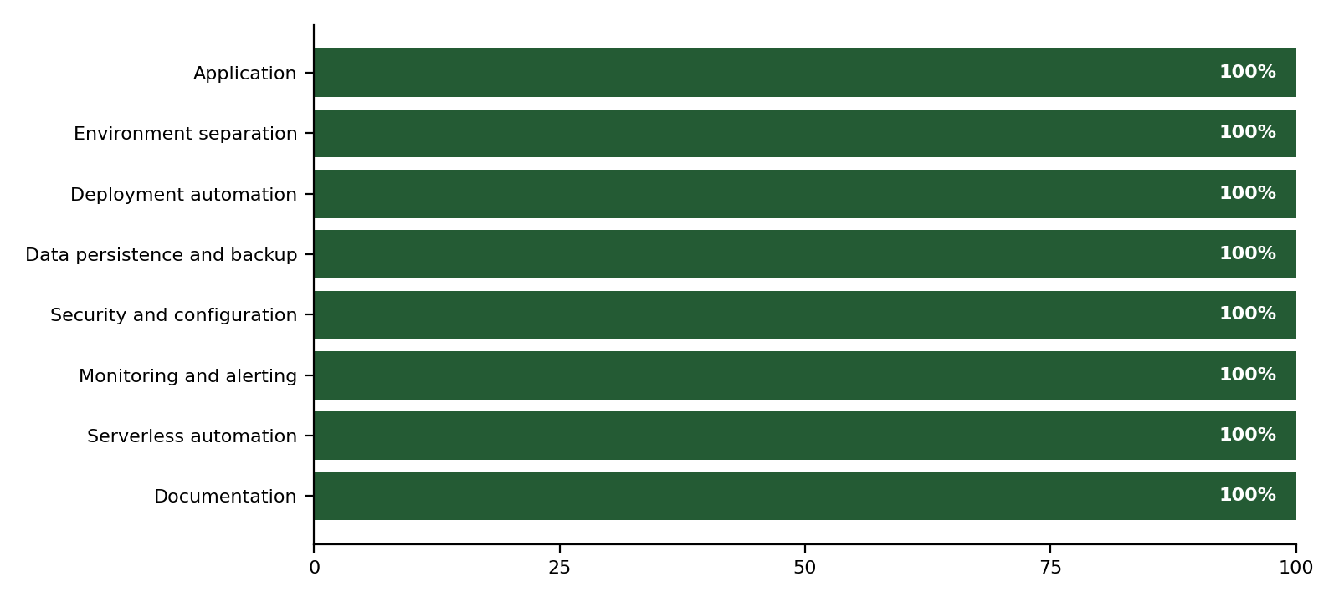
Figure 11: Completion by work area (100% across all deliverables)
10. Key Learnings
• Environment Isolation: Segregating Dev and Prod environments with Git branch governance prevents experimental code from impacting live users.
• Managed Serverless Services: Utilizing DynamoDB, S3, and Lambda eliminates manual database patching and server maintenance overhead.
• Keyless IAM Security: Using IAM Instance Profiles with temporary STS metadata credentials is far superior to storing static access keys in repositories.
• Proactive Observability: CloudWatch alarms connected to SNS notifications provide immediate visibility into system degradation before users are impacted.
• Fail-Safe Resilience: Designing local resilience caches ensures zero downtime even during transient network or cloud API interruptions.
11. Conclusion
The BranchFlow project successfully demonstrates an end-to-end, production-grade cloud DevOps implementation. By harmonizing Git branch governance, automated shell deployment scripting, dual cloud persistence (DynamoDB and S3), centralized configuration management (SSM), serverless scheduled maintenance (Lambda and EventBridge), keyless security (IAM), and SRE observability (CloudWatch and SNS), the system establishes an exemplary standard for modern cloud engineering.
Source Code Repository: https://github.com/AVINASH1805A/AWS-PROJECT

