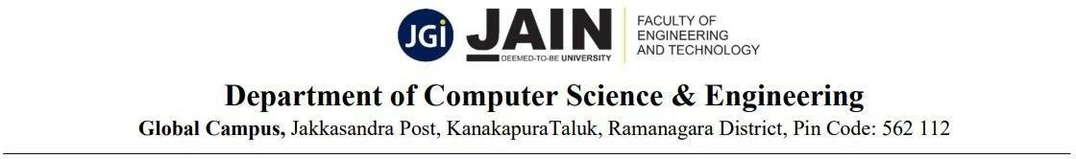
PROJECT CENTRIC LEARNING (PCL) PHASE 2
PROJECT TITLE | Multimodal Deepfake and Synthetic Media Detector
PROJECT TEAM NO. | 19

TEAM MEMBERS
S.No. | USN No. | Name of Student | Class | Mobile No.
1. | 23BTRCL244 | AKSHS M | CSE-AIML 'A' | +91 7483076172
2. | 23BTRCL248 | AVINASH G K | CSE-AIML 'A' | +91 7975936940
3. | 23BTRCL127 | ADITYA K | CSE-AIML 'A' | +91 9148543434
4. | 23BTRCL131 | ARYANA GRAWAL | CSE-AIML 'A' | +91 9479552454
5. | 23BTRCL135 | DEVANSH GUPTA M | CSE-AIML 'A' | +91 6363599332
6. | 23BTRCL137 | DHRUVRAJ | CSE-AIML 'A' | +91 6362011088

DETAILS OF THE PROJECT GUIDE
Name | Dr. Renuka Devi
Designation | Assistant Professor
Department | AIML
Email ID | renukadevi.p@jainuniversity.ac.in
Phone No. | 9865154751

DOMAIN OF THE PROJECT
Multimedia Forensics | Deep Learning | Explainable AI

SCOPE OF THE PROJECT
- The design of a multimodal deep fake detector from videos and audio, to detect modifications of facial features and artificial speech features along with disconnections of lip movements and voice.
- To use an advanced deep learning framework and different feature fusion approaches for detection in a more accurate and effective way by combining visual artifacts, audio features, and temporal anomaly.
- The function X-AI strategy needs to be added, which by providing the user with an easy interactive interface in uploading video clips and showing the impacted segment by their heatmap and to get an accurate detection.
- The system needs to be efficient and scalable for application-specific areas like verification on social media, digital forensics, cyber security, media authentication etc. to counter dissemination of false information and fraud.

EXISTING SYSTEM
Detection of deep fakes has become important as AI methods are more and more applied to generation of contents. While several detectors are proposed, most of them are unimodal.
Visual-Based Detection Systems
These systems match up facial features by using deep learning models, and search for signs of manipulation. They look for abnormalities in:
- Skin type, pattern, and texture
- The sides of the face and blinking patterns
- Lights and shadows
- Pixel-level distortion
Auditory-Based Detection Systems
These systems analyze voice signals to detect synthetic audio by examining:
- The tone of the language
- Mel-spectrogram features
- Voice cloning artifacts
Limitations of Existing Systems
- Single-modality limitation: The majority of systems only consider video or audio individually and therefore do not detect multimodal deep fakes.
- Lack of synchronization analysis: The system has not incorporated alignment of lip trajectory to speech.
- Poor generalization: Deep fake models fine-tuned on a particular dataset do not classify entirely different types of deep fakes.
- Black-box models: Lack of transparency when detection fails.
- Real-time challenges: Computationally expensive, limiting real-time use.
- Dataset imbalance: The availability of real audio with fake video affects model accuracy.
- Growing realism of deep fakes: GANs and diffusion models can now generate highly photorealistic outputs.

PROBLEM IDENTIFICATION
The velocity of development of generative AI has already led to the formation of deepfake videos through nearly every platform on the internet, posing significant threats to society in terms of digital manipulation, fake news, and identity theft.
Key Problems Identified
- Spread of false information — reducing comprehension of actual events and changing cognitive representation of the public.
- Embedding fabricated content within real information, for example deepfake political speeches.
- Identity theft and fraud — people being defrauded using cloned faces and voices (e.g., credit card fraud using AI-generated impersonation).
- Face swapping and voice cloning — single modality detection methods are unable to identify sophisticated multimodal manipulations.
- No explainability: Users require explanations to trust detection results.
- Generation algorithm evolution: Deep fake generation technology advances at a rate far exceeding that of detection technology.
- Security and privacy: Continuous cross-modal analysis must be done securely.

PROPOSED SYSTEM
The proposed system is a robust multimodal deepfake detector that processes both visual and audio modalities simultaneously to identify and explain AI-generated or manipulated media. The architecture combines Xception-based visual feature extraction, an Audio CNN for spectrogram analysis, and a novel Cross-Modal Attention mechanism that learns which modality to trust — producing a weighted fused prediction. Explainable AI (XAI) using Grad-CAM heatmaps is integrated to provide users with visual explanations of detected manipulations.

System Architecture
The system uses a dual-stream architecture:
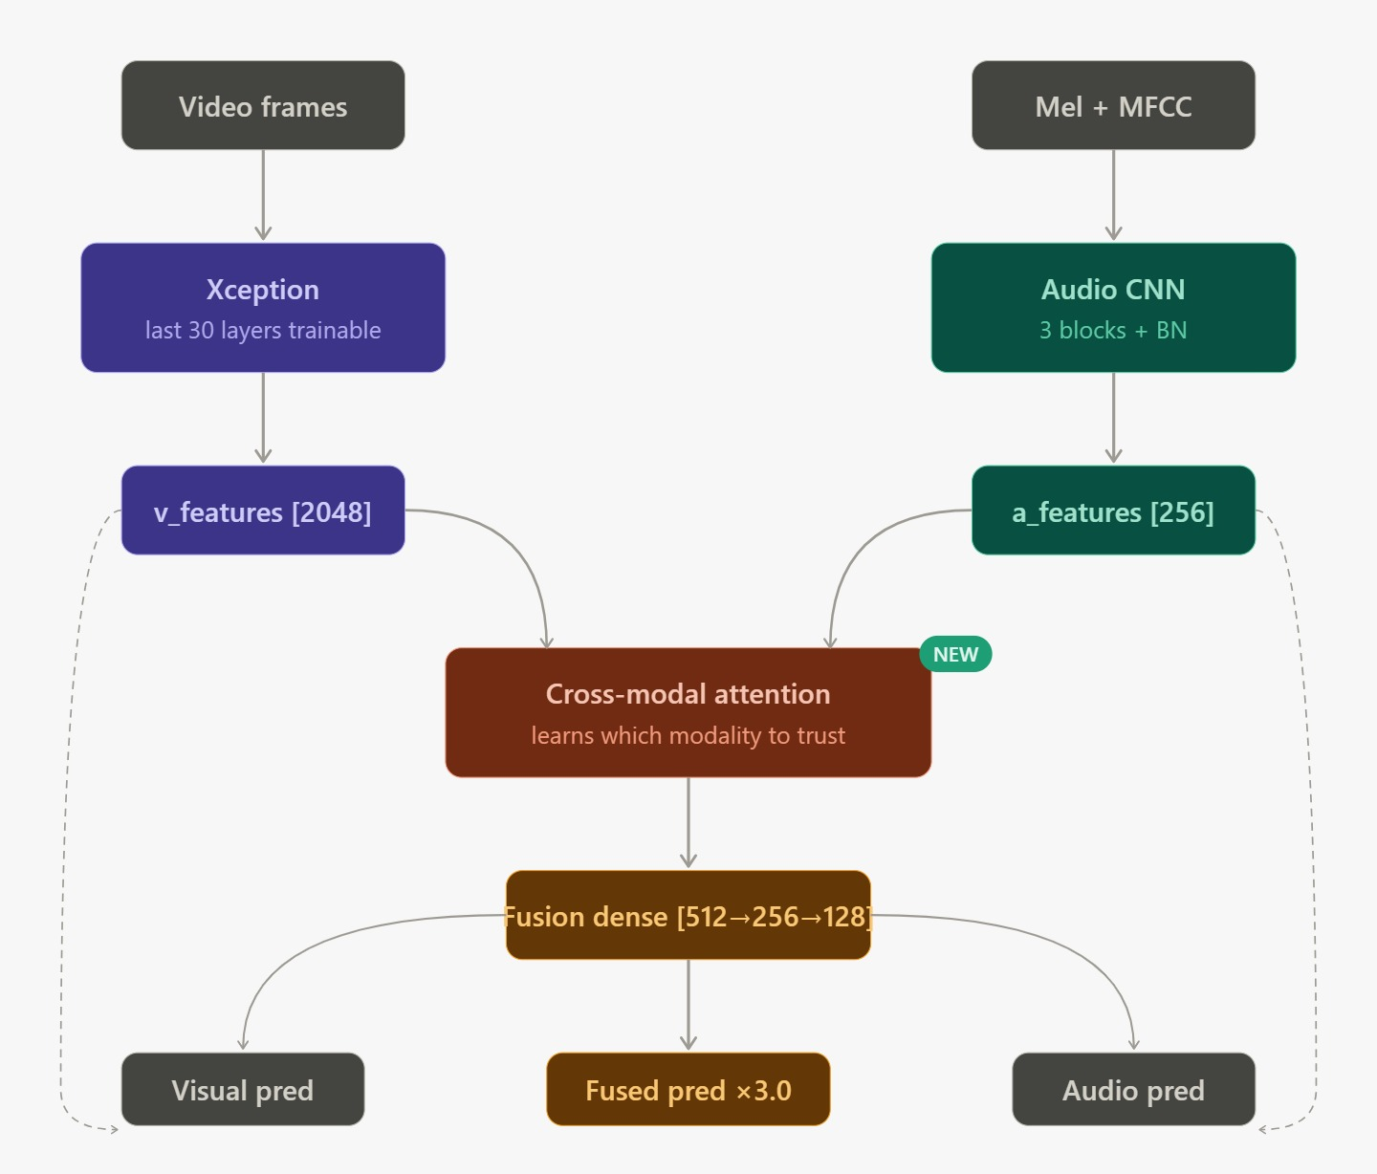
- Visual Stream: Video frames are processed through Xception (last 30 layers trainable), producing a 2048-dimensional feature vector (v_features).
- Audio Stream: Mel-spectrograms and MFCCs are processed through an Audio CNN (3 blocks + Batch Normalization), producing a 256-dimensional feature vector (a_features).
- Cross-Modal Attention (NEW): Learns which modality to trust dynamically, combining both feature vectors.
- Fusion Dense Layer [512→256→128]: Combines the attention-weighted features.
- Output: Three predictions — Visual pred, Audio pred, and Fused pred (×3.0 weighted).

MODULES
Sl. No. | Name of the Module | Remarks
1. | Video Input Module | Receives video input from the user for analysis.
2. | Pre-processing Module | Extracts frames and audio from the uploaded video and prepares data for processing.
3. | Face Detection Module | Detects and isolates the facial region from video frames.
4. | Audio Processing Module | Converts extracted audio into spectrogram format for analysis.
5. | Visual Feature Extraction Module | Uses CNN models to analyze spatial visual features and facial patterns.
6. | Audio Feature Extraction Module | Uses CNN-LSTM architecture to analyze temporal audio patterns.
7. | Fusion Module | Combines audio and visual features using fusion techniques to improve detection performance.
8. | Classification Module | Classifies the input as real or fake based on extracted features.
9. | Explainable AI Module | Generates heatmaps highlighting manipulated regions in the video.
10. | User Interface Module | Displays detection results to the user through the application interface.

LITERATURE PAPER – 01

Project Title | AI Powered Multimodal Deepfake Detection: A Systematic Review
Source | International Journal of Scientific Research in Engineering and Management (IJSREM), Feb 2026
Author(s) | Anamika Suresh, Jayalakshmi M, Krishnapriya R, Sandra Sabu, Rekha K S — College of Engineering Kidangoor, Kerala

What They Did
A detailed survey on video and audio based multimodal deepfake detection methods via audio-video synchronism. Reviewed CNN, LSTM, transformers, and multimodal fusion networks. Analyzed feature extraction via CNN for visual artifacts, Mel-spectrogram and LSTM-based audio analysis, early/late/hybrid fusion strategies, and explainability using Grad-CAM and LIME. Evaluated on benchmark datasets including DFDC, FakeAVCeleb, and Celeb-DF.
Problems Identified
- Deepfakes are becoming increasingly realistic due to GANs and diffusion models.
- Single modality detection is hindered by the lack of audio-visual synchronization analysis.
- Lack of interpretability and transparency in existing models.
- Poor generalization on external datasets.
- Computational cost prohibitive for real-time detection.
Key Contributions
- Demonstrated the superiority of multimodal detectors with cross-modal contradiction analysis.
- Provided an elaborated significance of feature fusion and temporal modeling.
- Summarized benchmark datasets and evaluation metrics.
- Identified research gaps and future directions in the field.
- Proved multimodal deepfake detection systems outperform classical single-modal methods in real-life cybersecurity and digital forensics contexts.

LITERATURE PAPER – 02

Project Title | Deep Fake Detection: A Multimodal Survey
Source | ITM Web of Conferences 78, 02027 (2025) — CSEIT 2025 Conference Proceedings. DOI: https://doi.org/10.1051/itmconf/20257802027
Author(s) | Meng Wang — School of Intelligent Science and Technology, Geely University of China, Chengdu, China

What They Did
Proposed a multimodal deep fake detection approach through audio-video synchronism. Reviewed CNN, LSTM, transformer and fusion networks. Analyzed unimodal to multimodal transition, cross-modal discrepancy (lip-sync mismatch, emotion mismatch, temporal mismatch), CNN feature extraction, Mel-spectrogram LSTM audio analysis, and XAI methods such as Grad-CAM and LIME. Evaluated on DFDC, FakeAVCeleb, and Celeb-DF.
Problems Identified
- GANs and diffusion models allow increasingly realistic deepfakes to be generated.
- Fake audio-video synchronization prevents single modality detection from succeeding.
- Lack of explainability and transparency in detection decisions.
- Poor generalization to external or out-of-distribution data.
- High computational cost prevents real-time deployment.
Key Contributions
- Showed that multimodal detectors are superior to single-modal detectors in cross-modal contradiction scenarios.
- Provided detailed comparison of deep learning network architectures for deepfake detection.
- Highlighted the critical role of feature fusion and temporal modeling.
- Demonstrated the indispensability of multimodal systems in content security, public monitoring, and digital forensics.

LITERATURE PAPER – 03

Project Title | From Single-Modal to Multi-Modal Facial Deep Fake Detection
Source | ARXIV Research Survey (Computer Vision — 2025)
Author(s) | Ping Liu, Qiqi Tao, Joey Tianyi Zhou — University of Nevada, Reno & A*STAR Research Institutes, Singapore

What They Did
Surveyed the evolution of face deep fake detectors from single-modal to multimodal (text, video, audio). Categorized detection approaches as passive vs. active/proactive. Compared single-modal and multimodal detection frameworks (CNNs, transformers, vision-language models, and multimodal LLMs). Summarized datasets including FaceForensics++, DFDC, Celeb-DF, and FakeAVCeleb. Evaluated metrics including classification accuracy, localization, and cross-domain performance.
Problems Identified
- AI-generated faces look increasingly real with fewer detectable artifacts.
- Each modality has its own manipulation artifacts, reducing cross-modal utility.
- Models trained on one dataset may fail to generalize to others.
- Dataset bias and lack of diversity in ethnicity, theme, and fairness.
- Performance degrades significantly under compression and real-world conditions.
- Complex attacks simultaneously integrate video, audio, and text manipulation.
Key Contributions
- Developed a comprehensive taxonomy for deepfake identification modes (passive, active, unimodal, multimodal).
- Referenced transformer vision-language models and large multimodal AI architectures.
- Emphasized cross-modal inconsistency detection as a key differentiator.
- Suggested new datasets and evaluation metrics for real-world assessment.
- Highlighted proactive defense, multimodal reasoning, and interpretability as future research directions.

LITERATURE PAPER – 04

Project Title | Deep Fake Media Generation and Detection in the Generative AI Era
Source | IEEE Transactions on Pattern Analysis and Machine Intelligence (TPAMI), 2024
Author(s) | Florinel-Alin Croitoru, Andrei-Iulian Hîji, Vlad Hondru, Nicolae Cătălin Ristea, Paul Irofti, Marius Popescu, Cristian Rusu, Radu Tudor Ionescu, Fahad Shahbaz Khan, Mubarak Shah

What They Did
Presented a comprehensive high-level overview of both generation and detection techniques in the AI-driven deep fake era. Covered all forms of deep fake media (image, video, audio, multimodal). Reviewed latest generation methods including GANs, diffusion models, transformers, NeRF and VAEs. Introduced a new taxonomy classifying generation and detection techniques. Compared state-of-the-art deep fake detection algorithms on benchmark datasets. Proposed a new multi-modal benchmark for novel deep fake detection.
Problems Identified
- Deep fake creation is becoming faster, easier, and more realistic.
- Existing detectors must be retrained with every new generation method.
- Difficult to generalize detection knowledge across domains.
- Diffusion models make artifact-based detection increasingly ineffective.
- New AI-generated deep fakes cannot be accurately detected by existing detectors — a significant research gap.
Key Contributions
- Conducted the largest survey study on image, video, audio, and multimodal deep fake generation and detection.
- Developed a full taxonomy categorizing deep fake methods by task, architecture, modality, application, and time.
- Gathered and compared benchmark data and performance results of state-of-the-art models.
- Tested generalization of deep fake detectors on unseen and out-of-distribution deep fake sources.
- Identified new AI models as generating deep fakes that existing detectors cannot accurately flag — a critical open problem.

PROJECT GUIDE | PROJECT COORDINATOR

