1 Design the following Time table using HTML5 and CSS3 a.Use “logo” at left side of header b.Write college name and change the font and font size and color of text. And display at center. c.Change color of footer and write given text. d.Change the font size , font name and color of MCA-1 Class Time Table.

Code:

<!DOCTYPE html>

<html lang="en">

<head>

<title>MCA Time Table</title>

<style>

table, th, td{

border: 1px solid black; text-align: center;

}

h2{

color: crimson; text-align: center;

}

footer{

color: white; background-color: black;

}

</style>

</head>

<body>

<header>

<h3><img src="C:\Users\HARISH\Downloads\dy_mca _logo.png" height="75" width="75"> D.Y.PATIL INSTITUTE OF MASTER OF COMPUTER APPLICATION AND MANAGEMENT, Akurdi, Pune</h3>

</header>

<div class="table">

<h2>MCA I Time Table</h2>

<table style="width: 100%;">

<tr>

<th>Time/Day</th>

<th>09:45-10:45</th>

<th>10:45-11:45</th>

<th>11:45-12:00</th>

<th>12:00-01:00</th>

<th>01:00-02:00</th>

<th>02:00-02:45</th>

<th>02:45-03:45</th>

<th>03:45-04:45</th>

</tr>

<tr>

<td>Monday</td>

<td>AIT</td>

<td>OT</td>

<td rowspan="6">S<br>h<br>o<br>r<br>t<br>B<br>r<br>e<br>a<br>k<br></td>

<td>ADBMS</td>

<td>SPM</td>

<td rowspan="6">L<br>o<br>n<br>g<br>B<br>r<br>e<br>a<br>k<br></td>

<td colspan="2">Python Lab</td>

</tr>

<tr>

<td>Tuesday</td>

<td>Python Prog</td>

<td>OT</td>

<td>AIT</td>

<td>SPM</td>

<td colspan="2">AIT Lab</td>

</tr>

<tr>

<td>Wednesday</td>

<td colspan="2">Language Lab/SS</td>

<td colspan="2">Python Lab</td>

<td>Python Prog</td>

<td>AIT</td>

</tr>

<tr>

<td>Thursday</td>

<td colspan="2">Mini Project</td>

<td >OC3</td>

<td>ADBMS</td>

<td>Python Prog</td>

<td>SPM</td>

</tr>

<tr>

<td>Friday</td>

<td colspan="2">AIT Lab</td>

<td >OC4</td>

<td>OT</td>

<td>ADBMS</td>

<td>Add on session/HRDP</td>

</tr>

<tr>

<td>Saturday<br>(Online)</td>

<td colspan="2">Mini Project</td>

<td colspan="2">Pytho/AIT Lab</td>

<td colspan="2">Academin activity tutorialjki</td>

</tr>

</table>

<footer>

<h3>Copyright @2023 Dr.D.Y.Patil Educational Complex, Akurdi, Pune</h3>

</footer>

</div>

</body>

</html>

Output:



1. Design the following RESUME using HTML5 and CSS3. a. Change the background color, font and font size and color of text. And display at center in header. b.Change color of footer and write given text.

Code:

<!DOCTYPE html>

<html lang="en">

<head>

    <meta charset="UTF-8">

    <meta http-equiv="X-UA-Compatible" content="IE=edge">

    <meta name="viewport" content="width=device-width, initial-scale=1.0">

    <title>Resume</title>

    <style>

        * {

            padding: 0;

            margin: 0;

        }

        .mbody {

            margin: 0 auto;

        }

        H3 {

            text-align: center;

            border: 10%;

            width: 100%;

            background-color: grey;

        }

        table td {

            padding: 10px;

            margin: 10%;

            align-items: center;

        }

        header {

            display: flex;

            justify-content: center;

            border: 1px solid;

            align-items: center;

            background-color: #2f343f;

            color: lightcoral;

            font-family: Verdana, Geneva, Tahoma, sans-serif;

        }

        h1 {

            text-align: center;

        }

        .container {

            display: flex;

        }

        .headSec {

            display: flex;

            align-items: flex-start;

        }

        .first {

            flex: 1;

            display: flex;

            flex-direction: column;

            align-items: flex-start;

        }

        .second {

            flex: 1;

            display: flex;

            justify-content: flex-end;

            align-items: center;

        }

        .second img {

            max-width: 30%;

            height: auto;

        }

        footer {

            background-color: black;

            color: rgb(3, 156, 161);

            display: flex;

            justify-content: center;

            align-items: center;

            padding-bottom: 10px;

            font-family: Verdana, Geneva, Tahoma, sans-serif;

        }

    </style>

</head>

<body>

    <table class="mbody">

        <tr>

        <tr>

            <td>

                <header>

                    <h1>Find Jobs</h1>

                </header>

            </td>

        </tr>

        <td>

            <div class="headSec">

                <div class="first">

                    <h1>Rahul Gadekar</h1>

                    <h2>Software Developer </h2>

                </div>

                <div class="second">

                    <img src="rahul.jpeg" alt="my photocopy">

                </div>

            </div>

            <br>

            <div>

                <h3>

                    CONTACT INFORMATION

                </h3>

                <table>

                    <tr>

                        <th>Address</th>

                        <td>: At.Post - Akurdi Tal - Haveli Dist - Pune</td>

                    </tr>

                    <tr>

                        <th>Mobile No</th>

                        <td>: 8265075994</td>

                    </tr>

                    <tr>

                        <th>Email</th>

                        <td>: rahulgade520@gmail.com</td>

                    </tr>

                </table>

            </div>

            <div>

                <h3>PERSONAL PARTICULARS</h3>

                <table>

                    <tr>

                        <td>Age </td>

                        <td>: 22</td>

                    </tr>

                    <tr>

                        <td>Date of Birth</td>

                        <td>: 16 June 2001</td>

                    </tr>

                    <tr>

                        <td>Marital Status </td>

                        <td>: Unmarried</td>

                    </tr>

                    <tr>

                        <td>Nationality</td>

                        <td>: Indian</td>

                    </tr>

                    <tr>

                        <td>Gender</td>

                        <td>: Male</td>

                    </tr>

                </table>

            </div>

            <div>

                <h3>EDUCATIONAL DETAILS</h3>

                <br>

                <b>Masters Degree :</b> Master of Computer Application

                <p>Savitribai Phule Pune University</p>

                <p>D. Y. Patil Institute Of Master Of Computer Applications And Management, Akurdi, Pune</p>

                <br>

                <b>Bachelor Science :</b>

                <p>Shivaji University kolhapur</p>

                <p>Yashwantrao Chavan Institute of Science, Satara.</p>

                <br>

                <b>Hsc Science :</b>

                <p>Savitribai Phule Pune University</p>

                <p>Mahatma Gandhi Junior College, Pravaranagar</p>

            </div>

            <br>

            <div>

                <table>

                    <h3>SKILLS</h3>

                    <tr>

                        <td>Adobe Photoshop </td>

                        <td>: 40%</td>

                    </tr>

                    <tr>

                        <td>Java</td>

                        <td>: 60%</td>

                    </tr>

                    <tr>

                        <td>Python</td>

                        <td>: 40%</td>

                    </tr>

                    <tr>

                        <td>Html</td>

                        <td>: 44%</td>

                    </tr>

                    <tr>

                        <td>Dbms</td>

                        <td>: 43%</td>

                    </tr>

                </table>

            </div>

            <footer>

                <div>

                    <br>

                    <p id="foot">Copyright @Copy 2023 DR. D.Y.Patil Educational Complex,Akurdi,Pune</p>

                </div>

            </footer>

        </td>

        </tr>

    </table>

</body>

</html>

Output:

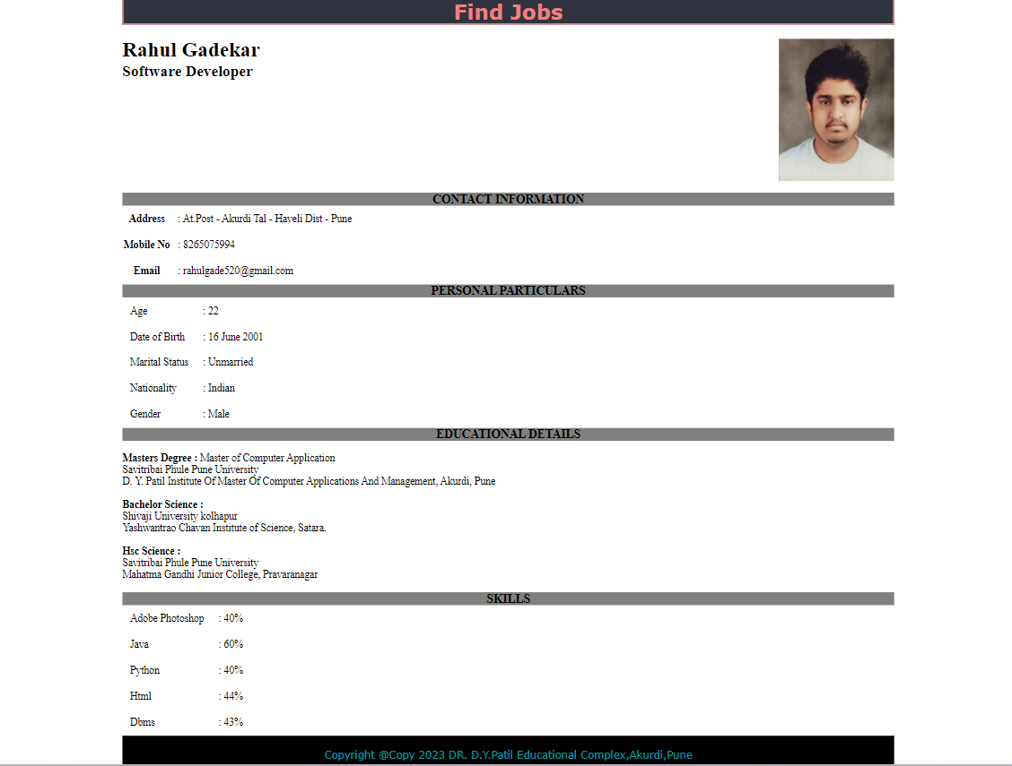

1. Design Student Registration form using HTML5 and CSS3form new elements. (Use all new form input controls). a. Add proper header and footer to web page. Display “Student Registration Form” in header and use CSS3 to change background color. b. apply background-image to web page

Code:

<html>

<head>

<title>Student Registration Form</title>

<style>

body {

background-image: url("student.jpg");

}

header { display: flex;

justify-content: center; border: 1px solid;

align-items: center; height: 40px;

background-color: #a9cbb3;

font-family: Verdana, Geneva, Tahoma, sans-serif;

}

h2 {

color: rgb(255, 255, 255);

}

body {

background-color: #919ba1;

}

table {

border: 1px solid black; border-radius: 10px; text-align: center; margin-left: auto; margin-right: auto;

}

tr,

td {

border: 1px solid black; text-align: center; margin-left: auto; margin-right: auto; padding: 10px;

background-color: #e6ebf0;

}

footer { display: flex;

justify-content: center; border: 1px solid; height: 40px;

align-items: center; background-color: #a9cbb3;

font-family: Verdana, Geneva, Tahoma, sans-serif;

}

</style>

</head>

<body>

<header>

<h2>Student Registration Form</h2>

</header>

<form action="#">

<table>

<div class="tb">

<tr>

<td colspan="2">

</td>

</tr>

<tr>

<td>

Enter Your Name:

</td>

<td>

<input type="text" placeholder="Enter your name">

</td>

</tr>

<tr>

<td>

Enter Your Email:

</td>

<td>

<input type="email" placeholder="[abc@gmail.com"](mailto:abc@gmail.com)>

</td>

</tr>

<tr>

<td>

Enter Your Moble No:

</td>

<td>

<input type="number">

</td>

</tr>

<tr>

<td>

Choose Your Favourite Color:

</td>

<td>

<input type="color">

</td>

</tr>

<tr>

<td>

Enter Your BirthDate:

</td>

<td>

<input type="date">

</td>

</tr>

<tr>

<td>

Enter Your BirthTime:

</td>

<td>

<input type="time">

</td>

</tr>

<tr>

<td>

Enter Your Addmission month:

</td>

<td>

<input type="month" min="2022-10" max="2022-11">

</td>

</tr>

<tr>

<td>

Rate Your College:

</td>

<td>

<input type="range" max=100 min=0 step=2>

</td>

</tr>

<tr>

<td>

Insert Your Aadhar Card:

</td>

<td>

<input type="file">

</td>

</tr>

<tr>

<td>

<button>Clear</button>

</td>

<td>

<button>Submit </button>

</td>

</tr>

</div>

</table>

</form>

<footer>

Thank You🙂

</footer>

</body>

</html>

Output:

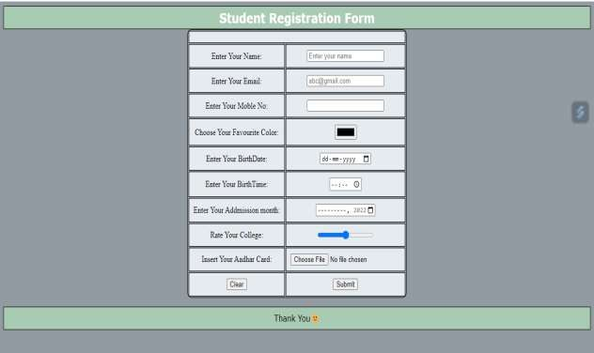

1. Design the web page using HTML5 and CSS3 semantic elements Code:
2. <!DOCTYPE html>
3. <html>
4. <head>
5. <title>My HTML5 Page</title>
6. <style>
7. .logosection {
8. display: flex;
9. justify-content: space-between;
10. }
11. li {
12. display: flex;
13. background-color: rgb(0, 0, 0);
14. }
15. .img1 {
16. float: right;
17. height: 60px;
18. width: 60px;
19. margin: 5px;
20. }
21. a {
22. text-decoration: none;
23. color: white;
24. }
25. body {
26. font-family: Arial, sans-serif;
27. margin: 0;
28. padding: 0;
29. }
30. footer {
31. background-color: #333;
32. color: #fff;
33. padding: 10px;
34. text-align: center;
35. }
36. section {
37. padding: 20px;
38. width: 1000px;
39. }
40. article {
41. margin-bottom: 20px;
42. padding: 10px;
43. border: 1px solid #ccc;
44. width: 700px;
45. }
46. .tulipimg{
47. display: flex;
48. }
49. .tulipside{
51. }
52. aside {
53. float: right;
54. width: 300px;
55. padding: 10px;
56. background-color: #f1f1f1;
57. border: 1px solid #ccc;
59. float: right;
60. }
61. .spotlight {
62. margin: 20px;
63. background-color: #f9f9f9;
64. text-align: left;
65. align-items: normal;
66. display: flex;
67. }
68. .spotlight img {
69. max-width: 100%;
70. height: auto;
71. margin-bottom: 10px;
72. }
73. .spot1 {
74. width: 250px;
75. }
76. </style>
77. </head>
78. <body>
79. <header>
80. <div class="logosection">
81. <div>
82. <img src="DYPLogo.png" alt="" class="logo" width="40px" height="50px" margin="10px">
83. </div>
84. <div>
85. <img src="flag logo.jpg" alt="" class="img1">
86. </div>
87. </div>
88. <div>
89. <li>
90. <ul><a href=""> Item 1</a></ul>
91. <ul><a href=""> Item 2</a></ul>
92. <ul><a href=""> Item 3</a></ul>
93. <ul><a href=""> Item 4</a></ul>
94. <ul><a href=""> Item 5</a></ul>
95. <ul><a href=""> Item 6</a></ul>
96. </li>
97. </div>
98. </header>
99. <section>
100. <div class="tulipimg">
101. <image src="tulip.jpg" width="1000" height="250"></image>
102. <aside class="tulipside">
103. <h1>Hot Items</h1>
104. <p>-Lorem ipsum dolor sit amet,<br><br>
105. -consectetur adipiscing elit.<br><br>
106. -Sed auctor leo tortor, <br><br>
107. -Lorem ipsum dolor sit amet,<br><br>
108. -consectetur adipiscing elit.<br><br>
109. -sed posuere erat dictum et.</p>
110. </aside>
111. </div>
112. </section>
113. <section>
114. <aside>
115. <h1>New Items</h1>
116. <p>- Lorem ipsum dolor sit amet.<br><br>
117. - consectetur adipiscing elit.<br><br>
118. - Sed auctor leo tortor.<br><br>
119. - consectetur adipiscing elit.<br><br>
120. - Sed auctor leo tortor.<br><br>
121. - sed posuere erat dictum et.</p>
122. </aside>
123. <article>
124. <h2>Article 1</h2>
125. <p>A flower, sometimes known as a bloom or blossom, is the reproductive structure found in flowering plants
126. (plants of the division Angiospermae).
127. Flowers produce gametophytes, which in flowering plants consist of a few haploid cells which produce
128. gametes. The "male" gametophyte, which
129. produces non-motile sperm, is enclosed within pollen grains; the "female" gametophyte is contained
130. within the ovule. When pollen from the
131. same plant, but others have mechanisms to prevent self-pollination and rely on cross-pollination,
132. when pollen is transferred from the anther of one flower to the stigma of another flower on a different
133. individual of the same species.</p>
134. </article>
136. </section>
137. <section>
138. <article>
139. <p>A flower, sometimes known as a bloom or blossom, is the reproductive structure found in flowering plants
140. (plants of the division Angiospermae). Flowers produce gametophytes, which in flowering plants consist
141. of a few haploid cells which produce gametes. The "male" gametophyte, which produces non-motile sperm,
142. is enclosed within pollen grains; the "female" gametophyte is contained within the ovule. When pollen
143. from the anther of a flower is deposited on the stigma, this is called pollination. Some flowers may
144. self-pollinate, producing seed using pollen from the same flower or a different flower of the same
145. plant.</p>
146. </article>
147. </section>
148. <section>
149. <article>
150. <p>A flower, sometimes known as a bloom or blossom, is the reproductive structure found in flowering plants
151. (plants of the division Angiospermae). Flowers produce gametophytes, which in flowering plants consist
152. of a few haploid cells which produce gametes. The "male" gametophyte, which produces non-motile sperm,
153. is enclosed within pollen grains; the "female" gametophyte is contained within the ovule. When pollen
154. from the anther of a flower is deposited on the stigma, this is called pollination. Some flowers may
155. self-pollinate, producing seed using pollen from the same flower or a different flower of the same
156. plant.</p>
157. </article>
158. </section>
159. <h2>In The spotlight</h2>
160. <section class="spotlight">
161. <section>
162. <article class="spot1">
163. <img src="tulip.jpg" width="300" height="200"></img>
164. <p>Lorem ipsum dolor sit amet, consectetur adipiscing elit. Phasellus in turpis sed magna dignissim
165. accumsan. Nullam eleifend vestibulum tortor id fermentum.</p>
166. </article>
167. </section>
168. <section>
169. <article class="spot1">
170. <img src="tulip.jpg" alt="Image 3">
171. <p>Lorem ipsum dolor sit amet, consectetur adipiscing elit. Phasellus in turpis sed magna dignissim
172. accumsan. Nullam eleifend vestibulum tortor id fermentum.</p>
173. </article>
174. </section>
175. <section>
176. <article class="spot1">
177. <img src="tulip.jpg" alt="Image 3">
178. <p>Lorem ipsum dolor sit amet, consectetur adipiscing elit. Phasellus in turpis sed magna dignissim
179. accumsan. Nullam eleifend vestibulum tortor id fermentum.</p>
180. </article>
181. </section>
182. </section>
183. <footer>
184. <p>&copy; 2023 My HTML5 Page. All rights reserved.</p>
185. </footer>
186. </body>
187. </html>

Output:

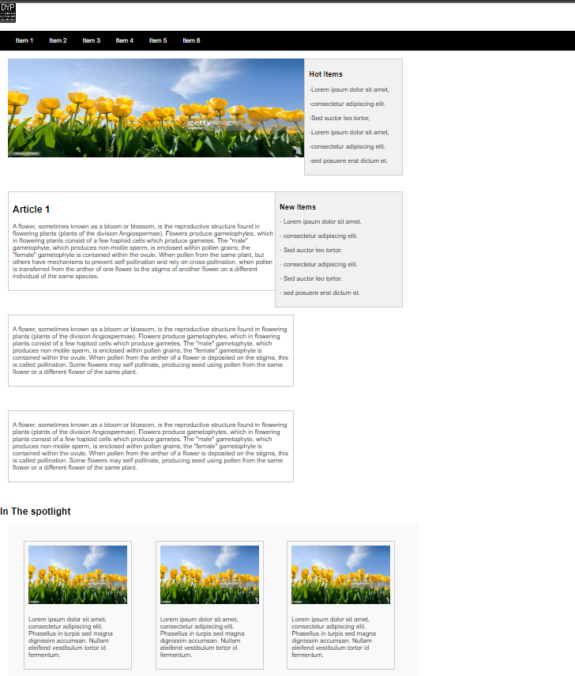

5 Design the following web page using HTML5 and CSS3. a. Change the background color, font and font size and color of text. And display at center in header b.Change color of footer and write given text.

Code:

<!DOCTYPE html>

<html lang="en">

<head>

<title>Document</title>

<style>

table, th, td {

border: 1px solid black; border-collapse: collapse;

}

</style>

</head>

<body bgcolor=" lightblue">

<header style="border: 2px solid black;">

<marquee behavior="scroll" direction="left" scrollamount="15">Welcome to Dr D Y Patil College of Education</marquee>

</header>

<div style="border: 2px solid black;padding: 10px;">

<div style=" margin: 0; padding: 0; line-height: 1.2;">

<h1 style="text-align: center;"> DPU </h1>

<h3 style="text-align: center;">Dr.D.Y.Patil University Society's</h3>

<h2 style="text-align: center;">Dr.D.Y.Patil college of Education(B.Ed..M.Ed.)</h2>

</div>

<div style="text-align: center; background-color: black; color: aliceblue;">

<style> p {

margin: 0;

padding: 0;

line-height: 1.2;

}

</style>

<p>Behind YCM.Hospital,sant Tukarram Nagar,pimpri,pune-411 015</p>

<p>Phone no:-9120-27805893 </p>

<p>E-mail: [info.coed@dypvp.edu.in,](mailto:info.coed@dypvp.edu.in) Web site: [WWW.coed.dypvp.edu.in](http://WWW.coed.dypvp.edu.in/)</p>

</div>

<div>

<h2 style="text-align: center;">(Affiliated to Savitribai Phule Pune University & recognized by N.C.TE.)

</h2>

<hr>

<p style="text-align: center;">Applications are invited from eligible candidates for the academic year

2021-2022 for the

following posts fulfilling the necessary qualifications & experience as follows. The <br>

applications should reached within Seven days from the date of publication of

advertisement through Mail/Post on the above Address:</p>

</div>

<div>

<style> table {

margin: auto;

}

</style>

<table>

<thead>

<tr>

<th width="40%">Name of the Post</th>

<th width="20%">No.Of.Post</th>

<th width="50%">Qualifiaction and experience <br> according to NCTE,SPPU</th>

</tr>

</thead>

<tbody>

<tr>

<td>Professor M.Ed</td>

<td> 01</td>

<td>Master Degree & M.Ed/M.A. Education with 55% & SET/NET. Ph.D in Education, 10yrs experience

</td>

</tr>

<tr>

<td>Associate Professor M.Ed.</td>

<td>02</td>

<td>Master Degree & M.Ed/M.A. Education with 55% & SET/NET. Ph.D in Education, approved.

exp in B.Ed. 5yrs. & 3 yrs. in M.Ed.</td>

</tr>

<tr>

<td>Assistant Professors M.Ed.</td>

<td>03</td>

<td rowspan="2">MA/M.Com/M.Sc/M.CS & M.Ed. <br> /M.A.Edu.with 55% & SET/NET</td>

</tr>

<tr>

<td>

Assistant Professors B.Ed. Mathematics,<br>

History Geography, English, Hindi, Science, Economics.

<br> Psychology. Political Science, Commerce</td>

<td>10</td>

<td></td>

</tr>

<tr>

<td>Part Time Teacher

<br> Physical Education</td>

<td>01</td>

<td>M.PEd.</td>

</tr>

<tr>

<td> Librana</td>

<td>01</td>

<td>M.Lib, SET/NET</td>

</tr>

</tbody>

</table>

</div >

<div style="text-align: right;">

<h1>(Dr.P.D.Patil) <br>

Chairman

</h1>

</div>

</div>

<footer>

<marquee behavior="scroll" direction="left" scrollamount="15">&copy; 2023 My Website Terms of Service Privacy Policy Contact Us</marquee>

</footer>

</body>

</html>

Output:

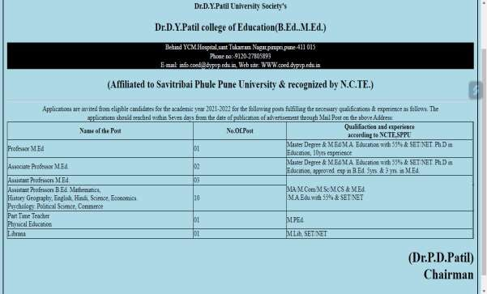

1. Design the following web page by using HTML5 and CSS3 a.Change the background color, font and font size and color of text. And display at centre in header b. Change color of footer and write given text. c.audio and video tag. d. Use tag and apply css.

Code:

<!DOCTYPE html>

<html lang="en">

<head>

<title>Player</title>

<style>

table,tr,td{

border: 1px solid black; margin-left: auto; margin-right: auto;

}

h1{

color: brown; text-align: center;

}

</style>

</head>

<body>

<h1>Movie Hub</h1>

<table>

<tr>

<td>Movie Name</td>

<td>

<figure>

<img src="C:\Users\HARISH\Downloads\one_piece_red.png" height="150" width="240">

<figcaption>One Piece Red</figcaption>

</figure>

</td>

</tr>

<tr>

<td>Song</td>

<td>

<audio controls>

<source src="C:\Users\HARISH\Downloads\one_piece_song.m4a" type="audio/mpeg">

</audio>

</td>

</tr>

<tr>

<td>Movie Trailer</td>

<td>

<video height="320" width="320" controls>

<source src="C:\Users\HARISH\Downloads\one_piece_trailer.mp4" type="video/mp4">

</video>

</td>

</tr>

</table>

</body>

</html>

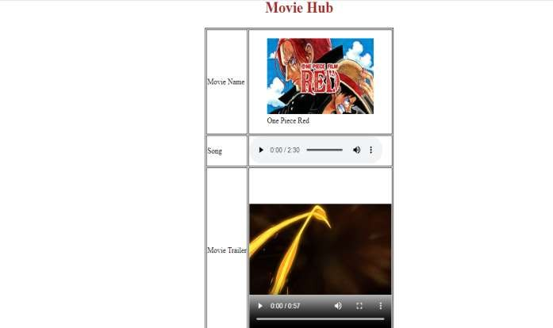Output:

1. Design the following web page by using HTML5 and CSS3.Using Client side image mapping display following Output. After image click show the health benefits of fruits page respectively. a.Change the background color, font and font size and color of text. And display at center in header b. Change color of footer and write given text.

Code:

<!DOCTYPE html>

<html lang="en">

<head>

<title>Image Mapping</title>

<style> h2{

color: crimson; background-color: aqua; text-align: center;

}

footer{

color: white; background-color: black;

}

</style>

</head>

<body bgcolor="pink">

<header>

<h2>FRUIT BASKET</h2>

</header>

<img src="C:\Users\HARISH\Downloads\Fruits.jpg" usemap="#fruits1">

<map name="fruits1">

<area shape="circle" coords="113,83,61" href="coconut.html">

<area shape="circle" coords="269,92,66" href="orange.html">

<area shape="circle" coords="109,224,54" href="watermelon.html">

<area shape="circle" coords="269,257,60" href="lemon.html">

</map>

<footer><h3>click the above picture to know information about fruits.</h3></footer>

</body>

</html>

Output:

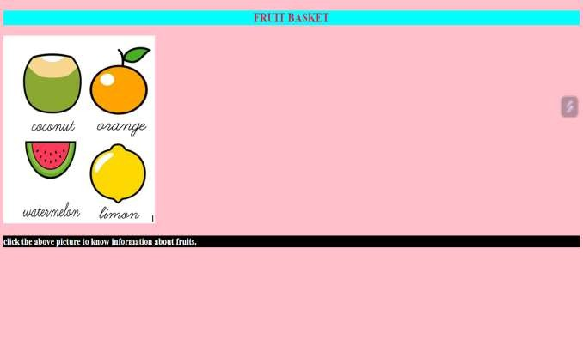

1. Design the website using HTML5 and CSS3. Use music any instrument images. a. Change the background color, font and font size and color of text. And display at centre in header b.Change color of footer and write given text.

Code:

<!DOCTYPE html>

<html lang="en">

<head>

<title>Music</title>

<style> h1{

text-align: center; border: 1px solid black;

} #m1{

color: rgb(58, 149, 230); font-size: 25px;

} #m2{

color: crimson; font-size: 25px;

}

table,tr,td{

border: 1px solid black;

}

img{

border: 2px solid black;

}

footer{

background-color: darkorange;

}

</style>

</head>

<body>

<header><h1>Musical Instruments</h1></header>

<p id="m1">Music has a language which everyone understands. It gives a soothing effect to the listeners.</p>

<p id="m2">Write the names if the given musical instruments using clue corner.</p>

<table>

<tr><td><h3>You press my keyboard<br>to play me.</h3><br>

<img src="C:\Users\HARISH\Downloads\piano.png" height="75" width="75"><br>1

<input type="text"></td>

<td><h3>I am stick. Hold me close to your lips<br>and blow.I will play for you.</h3><br>

<img src="C:\Users\HARISH\Downloads\flute.png" height="75" width="75"><br>2

<input type="text"></td>

<td><h3>I play when you press my keys.<br>I can give many different sounds.</h3><br>

<img src="C:\Users\HARISH\Downloads\harmonium.png" height="75" width="75"><br>3

<input type="text"></td>

</tr>

<tr><td><h3>We come in pair.you have to<br>use your hands to play us</h3><br>

<img src="C:\Users\HARISH\Downloads\tabla.png" height="75" width="75"><br>4

<input type="text"></td>

<td><h3>When you beat me with sticks.<br>I will play for you</h3><br>

<img src="C:\Users\HARISH\Downloads\drum.png" height="75" width="75"><br>5

<input type="text"></td>

<td><h3>When you pluck my strings.<br>I will play for you.</h3><br>

<img src="C:\Users\HARISH\Downloads\guitar.png" height="75" width="75"><br>6

<input type="text"></td>

</tr>

</table>

<footer><h3>Clue Corner</h3>

<p id="m3">a] Harmonium b] Tabla c] Guitar d] Piano e] Drum f] Flute</p></footer>

</body>

</html>

Output:

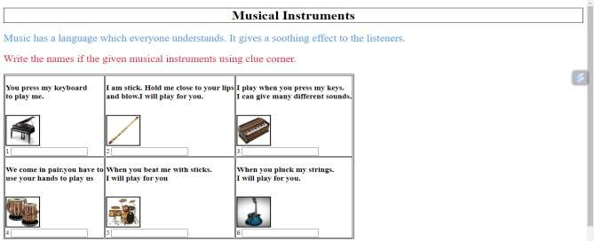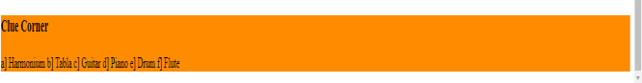

1. Programs using web using Canvas. Use Radial Gradient on Text and Linear Gradient on smile face. (use HTML5 and CSS3) a. Change the background color, font and font size and color of text. And display at center in header

b. Change color of footer and write given text. Code:

<!DOCTYPE html>

<html lang="en">

<head>

<title>Smile</title>

</head>

<style> h1{

font-size: 70px;

background: -webkit-radial-gradient(#2915db,skyblue,#25bb18,lightgreen,#cf23cf,#d60c0c);

-webkit-background-clip: text; color: transparent;

}

h2{

text-align: center; color: #d60c0c; font-size: 40px;

}

</style>

<body>

<header><h2>Keep Smiling!</h2></header>

<h1>Smile! </h1>

<canvas id="mycanvas" height="800" width="500"></canvas>

<script>

var c = document.getElementById("mycanvas"); var ctx = c.getContext("2d");

ctx.beginPath();

ctx.arc(100, 100, 80, 0, 2 * Math.PI); ctx.stroke();

ctx.fillStyle = "Yellow"; ctx.fill();

ctx.beginPath();

ctx.arc(60, 75, 15, 0, 2 * Math.PI); ctx.stroke();

ctx.fillStyle = "red"; ctx.fill();

ctx.beginPath();

ctx.arc(140, 75, 15, 0, 2 * Math.PI); ctx.stroke();

ctx.fillStyle = "red"; ctx.fill();

ctx.beginPath();

ctx.arc(100, 105, 40, 0, 1 * Math.PI); ctx.strokeStyle="black"

ctx.stroke();

</script>

</body>

</html>

Output:



1. Design the following web page using HTML5 SVG and CSS3. a. Change background color of header b. Write the text in header “Welcome to My Sweet Home” and change the font and font size and color of text. And display at center. c. Change color of footer and write some text.

Code:

<!DOCTYPE html>

<html>

<head>

<title>My SVG House</title>

<style>

header, footer { background-color: #333; color: #fff;

padding: 10px;

}

rect, polygon, circle { stroke-width: 3; stroke: black;

}

h1{

font-size: 50;

font-family: sans-serif; color: blue;

text-align: center;

}

</style>

</head>

<body>

<header>

<h1>Welcome to My Sweet House</h1>

</header>

<svg width="1000" height="600">

<rect x="300" y="150" width="200" height="100" fill="#ffcc66" />

<polygon points="300,150 500,150 400,50" fill="#8ecae6" />

<rect x="380" y="190" width="40" height="60" fill="#555" />

<circle cx="400" cy="120" r="9" fill="#555" />

<polygon points="165,210 209,210 190,170" fill="green" />

<rect x="180" y="210" width="15" height="35" fill="#555" />

<polygon points="565,210 610,210 590,170" fill="green" />

<rect x="580" y="210" width="15" height="35" fill="#555" />

</svg>

<footer>

<p>14 may 2022</p>

</footer>

</body>

</html>

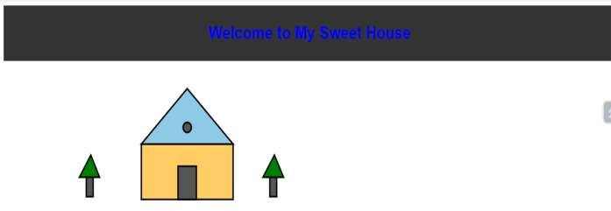Output: