MCA — Software Engineering / DevOps
Continuous Integration with Jenkins
Unit 1.1 — Jenkins Setup & Jenkins Pipelines

1.1 Jenkins Setup

1.1.1 What is Jenkins?
Jenkins is a free, open-source automation server written in Java that helps automate the parts of software development related to building, testing, and deploying, facilitating Continuous Integration (CI) and Continuous Delivery/Deployment (CD). It was originally created as the "Hudson" project and later renamed Jenkins in 2011.
Continuous Integration is a development practice in which developers frequently merge their code changes into a shared repository (several times a day). Every merge triggers an automated build and test sequence, which allows teams to detect integration problems early.
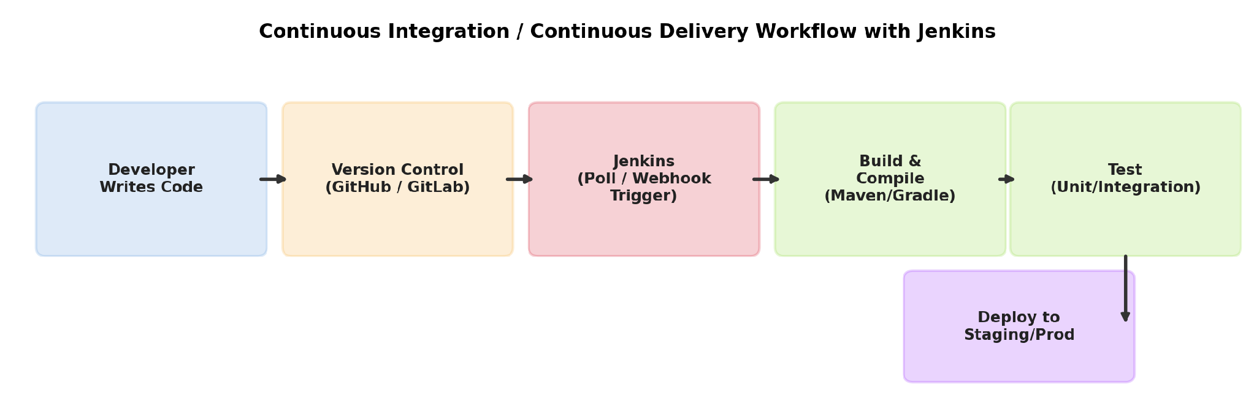
Fig 1.1 — CI/CD workflow: code commit triggers Jenkins to build, test and deploy automatically
Key Benefits of Jenkins
- Automation — eliminates repetitive manual build/test/deploy tasks.
- Early bug detection — integration errors surface quickly because builds run on every commit.
- Extensibility — 1800+ plugins integrate Jenkins with almost any tool (Git, Maven, Docker, Kubernetes, Slack, etc.).
- Distributed builds — work can be spread across multiple machines (master/agent) for speed and platform coverage.
- Free and open source — large community support, cross-platform (Windows, Linux, macOS).

1.1.2 Installation
Jenkins can be installed in several ways depending on the operating system and use-case. The most common methods are described below.
(a) Installing on Windows
- Download the Windows installer (.msi) from jenkins.io/download.
- Run the installer; it installs Jenkins as a Windows Service (auto-starts on boot).
- Choose an installation directory (default: C:\Program Files\Jenkins).
- The installer opens the browser at http://localhost:8080.
- Unlock Jenkins using the initial admin password shown in the console / found at the path `C:\Program Files\Jenkins\secrets\initialAdminPassword`.
(b) Installing on Linux (Debian/Ubuntu)
# Add Jenkins repository key and source
curl -fsSL https://pkg.jenkins.io/debian-stable/jenkins.io-2023.key | \
sudo tee /usr/share/keyrings/jenkins-keyring.asc > /dev/null
echo "deb [signed-by=/usr/share/keyrings/jenkins-keyring.asc] \
https://pkg.jenkins.io/debian-stable binary/" | \
sudo tee /etc/apt/sources.list.d/jenkins.list > /dev/null

# Install Java (Jenkins requires JDK 11/17) and Jenkins
sudo apt-get update
sudo apt-get install -y fontconfig openjdk-17-jre jenkins

# Start and enable the service
sudo systemctl start jenkins
sudo systemctl enable jenkins
(c) Running via WAR file (platform-independent)
# Requires Java installed
java -jar jenkins.war --httpPort=8080
This is useful for quick evaluation on any OS that has a JVM installed, without needing a system service.
(d) Installing via Docker
docker run -d -p 8080:8080 -p 50000:50000 \
-v jenkins_home:/var/jenkins_home \
--name myjenkins jenkins/jenkins:lts
Docker installation is popular in modern DevOps pipelines because it is fast, disposable, and easily reproducible across environments.

1.1.3 Initial Configuration
After installation, Jenkins goes through a first-time setup wizard:
- Unlock Jenkins — paste the auto-generated password from the initial admin password file.
- Customize Jenkins — choose "Install suggested plugins" (recommended for beginners) or "Select plugins to install".
- Create First Admin User — set username, password, full name and email.
- Instance Configuration — confirm the Jenkins URL (default http://localhost:8080/).
Important Configuration Concepts
- JENKINS_HOME — the directory where Jenkins stores all configuration, job data, plugins, and build history (default: `/var/lib/jenkins` on Linux, `C:\Program Files\Jenkins` on Windows).
- Manage Jenkins → System Configuration — set global properties such as JDK/Maven/Git tool paths, number of executors, security realm, and environment variables.
- Global Security — configure authentication (Jenkins own DB, LDAP, SSO) and authorization (Matrix-based security, Role-based strategy) under Manage Jenkins → Security.
- Number of Executors — controls how many builds a node (master or agent) can run in parallel.
Master–Agent (Distributed Build) Architecture
For larger teams, a single Jenkins instance (the Controller/Master) delegates build execution to one or more Agent (Node) machines. This distributes load, allows builds on different OS/architectures, and improves scalability.
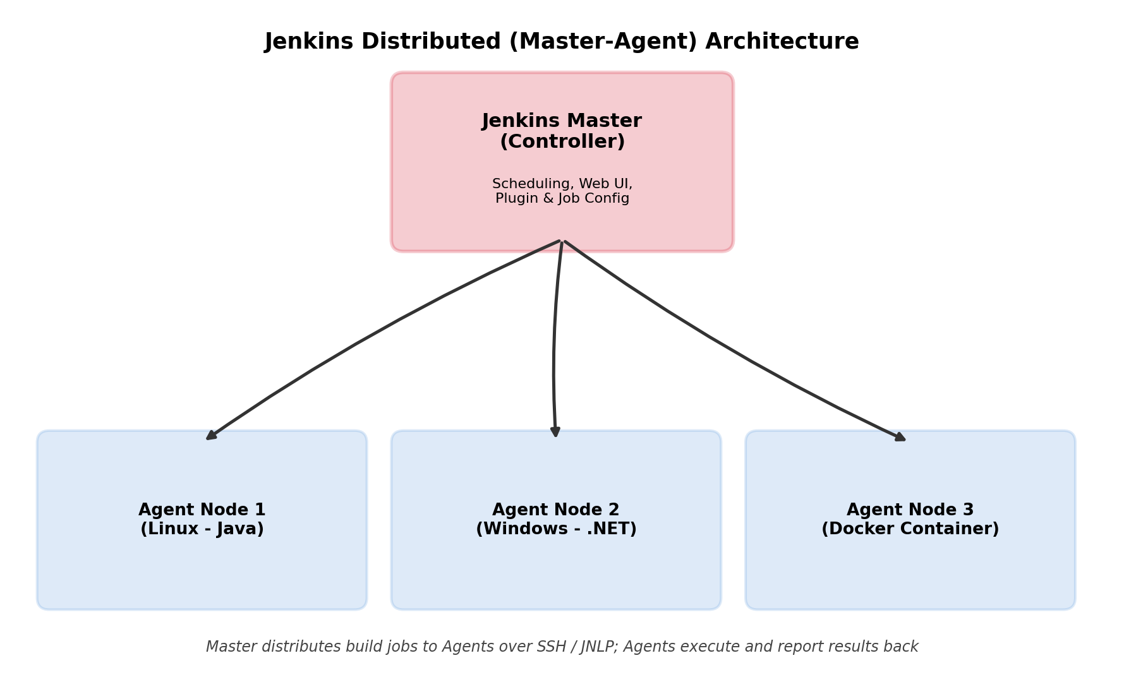
Fig 1.2 — Jenkins Master-Agent distributed architecture

1.1.4 Plugin Management
Plugins are the backbone of Jenkins' extensibility. Almost every integration (Git, Docker, Slack, email, code-quality tools) is delivered as a plugin. Plugins are managed from Manage Jenkins → Plugins.
Plugin Manager Tabs
Tab | Purpose
Updates | Lists installed plugins that have a newer version available
Available plugins | Browse and search the plugin catalog to install new plugins
Installed plugins | View, enable/disable, or uninstall currently installed plugins
Advanced settings | Configure the Update Center URL, HTTP proxy, and upload a plugin (.hpi/.jpi) manually

Commonly Used Plugins
Plugin | Use
Git / GitHub Integration | Fetch source code from Git/GitHub repositories, trigger builds on push
Pipeline | Enables Declarative/Scripted Jenkinsfile-based pipelines
Maven Integration / Gradle | Build Java projects using Maven or Gradle
Docker Pipeline | Build, run and publish Docker images from a pipeline
Blue Ocean | Modern visual UI for pipeline status and stage view
Email Extension | Send customizable build-status email notifications
Credentials Binding | Securely store and inject secrets (passwords/tokens) into jobs

Installing / Updating / Removing a Plugin
- Go to Manage Jenkins → Plugins → Available plugins, search by name, tick the checkbox, and click Install without restart (or Download now and install after restart).
- To update, open the Updates tab, select plugins, and click Download now and install after restart.
- To remove, open Installed plugins, select the plugin and click Uninstall (some plugins require dependent plugins to be removed first).
Good Practice
Always take a backup of the JENKINS_HOME directory before a major plugin upgrade, and upgrade plugins in a test/staging Jenkins instance first, since plugin updates can occasionally break existing pipeline syntax or job configuration.

1.2 Jenkins Pipelines
A Pipeline is a suite of plugins that supports implementing and integrating continuous delivery pipelines into Jenkins. A pipeline defines the entire build/test/deploy process as code, typically stored in a file called a Jenkinsfile that is checked into source control alongside the application.

1.2.1 Freestyle Projects
A Freestyle Project is the simplest and oldest type of Jenkins job. It is configured entirely through the Jenkins web UI (point-and-click forms) rather than through code, making it easy for beginners but harder to version, review, or reuse.
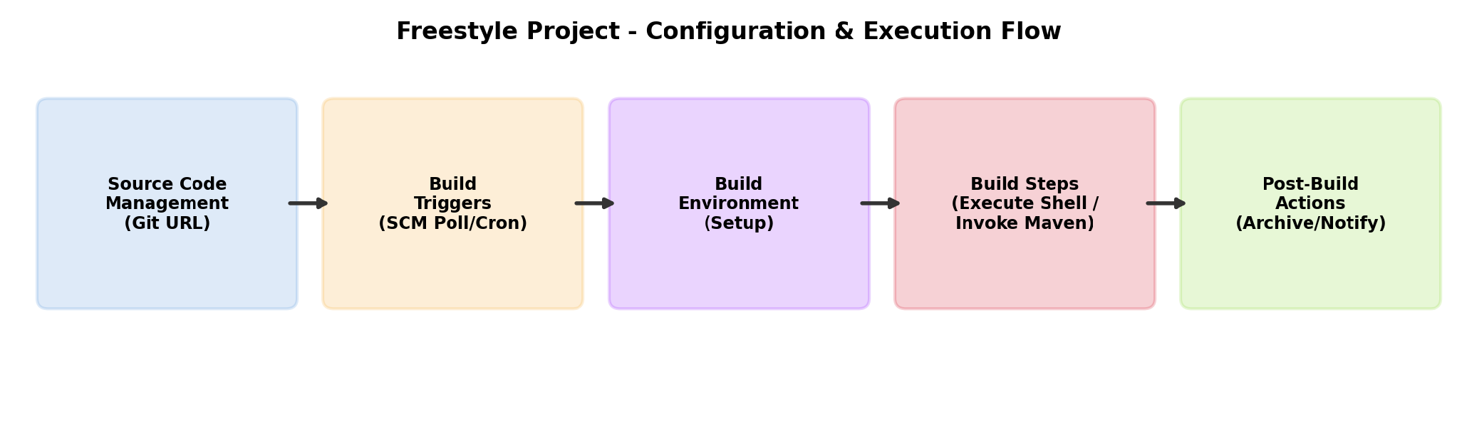
Fig 1.3 — Freestyle project configuration & execution flow
Freestyle Configuration Sections
- General — job description, discard old builds, parameterization.
- Source Code Management — connect to Git/SVN, specify repository URL and branch.
- Build Triggers — Poll SCM, Build periodically (cron), Trigger remotely, GitHub webhook.
- Build Environment — delete workspace before build, add timestamps, inject environment variables.
- Build Steps — Execute shell/batch command, Invoke Maven/Gradle/Ant target.
- Post-build Actions — archive artifacts, publish JUnit test results, send email notifications, trigger downstream jobs.
Limitations of Freestyle Projects
- Configuration lives only inside Jenkins (not version-controlled with the source code) — hard to track history or review changes.
- Complex logic (conditionals, loops, parallel stages) is difficult or impossible to express through the UI.
- Not easily reusable/portable across Jenkins instances; duplicating a job means re-clicking through the UI.

1.2.2 Pipeline as Code — the Jenkinsfile
To overcome Freestyle's limitations, Jenkins introduced the Pipeline plugin, which lets the entire build process be described in a text file called a Jenkinsfile, written in Groovy-based DSL. It supports two syntaxes: Declarative and Scripted.
(a) Declarative Pipeline
Declarative Pipeline is the newer, more structured and opinionated syntax. It uses a fixed, predefined block structure (`pipeline { agent { } stages { } post { } }`) that is easier to read, validate, and is recommended for most users, including beginners.
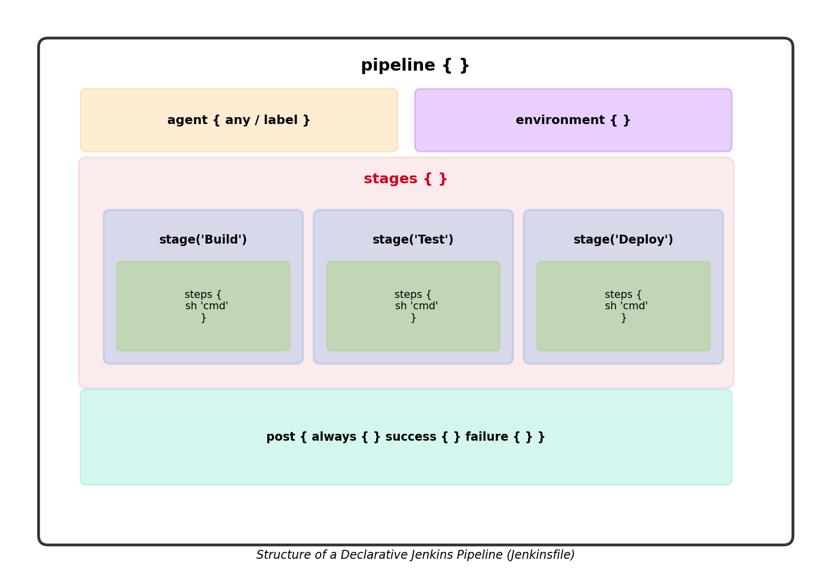
Fig 1.4 — Structure of a Declarative Jenkins Pipeline
Example — Declarative Jenkinsfile
pipeline {
agent any

environment {
MVN_HOME = tool 'Maven3'
}

stages {
stage('Checkout') {
steps {
git branch: 'main',
url: 'https://github.com/example/demo-app.git'
}
}
stage('Build') {
steps {
sh "${MVN_HOME}/bin/mvn clean package"
}
}
stage('Test') {
steps {
sh "${MVN_HOME}/bin/mvn test"
}
}
stage('Deploy') {
steps {
sh 'echo Deploying application...'
}
}
}

post {
always { echo 'Pipeline finished.' }
success { echo 'Build succeeded!' }
failure { echo 'Build failed.' }
}
}
(b) Scripted Pipeline
Scripted Pipeline is the older syntax, built on top of the Groovy programming language itself. It runs inside a single `node { }` block and gives full programmatic control (loops, conditionals, try/catch) at the cost of being more complex and less readable for beginners.
Example — Scripted Jenkinsfile
node {
stage('Checkout') {
git branch: 'main',
url: 'https://github.com/example/demo-app.git'
}
stage('Build') {
sh 'mvn clean package'
}
stage('Test') {
try {
sh 'mvn test'
} catch (err) {
currentBuild.result = 'UNSTABLE'
}
}
stage('Deploy') {
if (env.BRANCH_NAME == 'main') {
sh 'echo Deploying to production...'
}
}
}
Declarative vs Scripted vs Freestyle — Comparison
Aspect | Freestyle | Declarative Pipeline | Scripted Pipeline
Definition method | Web UI (point & click) | Jenkinsfile (Groovy DSL, structured) | Jenkinsfile (pure Groovy)
Version control | Not versioned by default | Versioned with source code | Versioned with source code
Syntax structure | N/A (forms) | Fixed blocks: pipeline/agent/stages | Flexible, imperative Groovy code
Learning curve | Easiest | Moderate | Steepest (needs Groovy knowledge)
Flow control (if/loops) | Not supported natively | Limited (via `script{}` step) | Full support
Best suited for | Simple, one-off jobs | Most real-world CI/CD pipelines | Complex, highly dynamic pipelines

1.2.3 Pipeline Parameters
Pipelines can be parameterized so that users supply input values (text, choices, booleans, credentials) each time a build is triggered — for example, choosing which environment to deploy to, or which branch to build. Parameters are declared in the `parameters { }` block (Declarative) and accessed anywhere in the pipeline using `params.PARAMETER_NAME`.
Common Parameter Types
Type | Directive | Example Use
String | string(name, defaultValue, description) | Version tag, commit ID
Choice | choice(name, choices, description) | Select environment: dev/staging/prod
Boolean | booleanParam(name, defaultValue, description) | Run tests? Skip deployment?
Password/Credentials | credentials(name) | Inject a secret (API key, DB password)
Text | text(name, defaultValue, description) | Multi-line release notes

Example — Parameterized Declarative Pipeline
pipeline {
agent any

parameters {
string(name: 'BRANCH', defaultValue: 'main',
description: 'Git branch to build')
choice(name: 'ENVIRONMENT', choices: ['dev','staging','prod'],
description: 'Target deployment environment')
booleanParam(name: 'RUN_TESTS', defaultValue: true,
description: 'Run unit tests?')
}

stages {
stage('Checkout') {
steps {
git branch: "${params.BRANCH}",
url: 'https://github.com/example/demo-app.git'
}
}
stage('Test') {
when { expression { params.RUN_TESTS == true } }
steps { sh 'mvn test' }
}
stage('Deploy') {
steps {
echo "Deploying to ${params.ENVIRONMENT}"
}
}
}
}
When this pipeline is run manually, Jenkins presents a "Build with Parameters" form; on subsequent builds triggered by webhooks/SCM polling, the last-used or default parameter values are applied.
Note
Parameters declared in a Jenkinsfile only appear in the "Build with Parameters" UI after the pipeline has been run (or the Jenkinsfile scanned) at least once, because Jenkins needs to parse the file first to discover the parameters block.

Assignment — Based on Bloom's Taxonomy
Answer the following questions. Each question targets a specific cognitive level of Bloom's Taxonomy as indicated.
Q.No | Bloom's Level | Question
1 | Remember | List any five plugins commonly used in Jenkins and state one purpose of each.
2 | Remember | Define Continuous Integration (CI) and Continuous Delivery (CD). State the default port on which Jenkins runs.
3 | Understand | Explain the difference between a Freestyle Project and a Pipeline job in Jenkins. Why is "Pipeline as Code" considered a better practice?
4 | Understand | Describe, with the help of a diagram, the Jenkins Master-Agent architecture and explain why distributed builds are useful for large projects.
5 | Apply | Install Jenkins on a Linux/Windows machine, install the Git and Pipeline plugins, and configure the JDK/Maven tool paths under Manage Jenkins → Global Tool Configuration. Submit screenshots of each step.
6 | Apply | Write a Declarative Jenkinsfile that checks out code from a Git repository, builds it using Maven, and archives the resulting JAR file as a build artifact.
7 | Analyze | Compare Declarative and Scripted pipelines on the basis of syntax, flexibility, readability and error handling. Identify two real-world scenarios where a Scripted pipeline would be preferable over Declarative.
8 | Analyze | A Freestyle job's build fails intermittently and its configuration cannot be tracked in version control. Analyze the root causes of this problem and identify which Jenkins feature(s) would resolve it.
9 | Evaluate | A team is deciding between using Freestyle Projects and Declarative Pipelines for a microservices project with 15 services. Evaluate both options against criteria such as maintainability, scalability, and auditability, and justify which approach you would recommend.
10 | Create | Design and implement a parameterized Declarative Jenkinsfile for a project that lets the user choose the deployment environment (dev/staging/prod) via a choice parameter and optionally skip tests via a boolean parameter, with a post block that sends different messages on success and failure.

Bloom's Taxonomy Levels Used
Remember (recall facts) → Understand (explain concepts) → Apply (use in a new situation) → Analyze (break down / compare) → Evaluate (justify a decision) → Create (design a new artifact). Questions progress from lower-order to higher-order thinking skills.

