🐳
Docker Volumes &
Data Persistence
A Complete Hands-On Lab
Environment | Duration | Level
Docker Desktop on Windows | 2 hours | Beginner → Intermediate

Containers are replaceable. Data should not be.

Contents
▸ 1. Learning Objectives
▸ 2. The Problem We Are Solving
▸ 3. Storage Options in Docker
▸ 4. Prerequisites
▸ Step 1 — Data Loss Without Persistent Storage
▸ Step 2 — Create a Docker Volume
▸ Step 3 — Inspect the Docker Volume
▸ Step 4 — Attach a Volume to a Container
▸ Step 5 — Verify Data Persistence
▸ Step 6 — Share One Volume Between Two Containers
▸ Step 7 — The --mount Syntax
▸ Step 8 — Configure a Read-Only Volume
▸ 9. Volumes vs. Bind Mounts
▸ Step 9–10 — Bind Mounts on Windows
▸ Step 11–12 — Build a Persistent Nginx Website
▸ Step 13 — MongoDB with Persistent Storage
▸ Step 14–15 — Backup and Restore a Volume
▸ 18. Essential Docker Volume Commands
▸ 19. Named vs. Anonymous Volumes
▸ 20. Using --volumes-from
▸ 22. Final Assessment — Persistent Student Records
▸ 23. Troubleshooting on Docker Desktop for Windows
▸ 24. Final Comparison & Mental Model
▸ 25. Suggested Lab Timing (2 Hours)

1. Learning Objectives
By the end of this lab, students will be able to:
- Explain why containers lose data by default.
- Differentiate the four storage types: writable layer, Docker volumes, bind mounts, and tmpfs mounts.
- Create, inspect, and delete Docker volumes.
- Attach a volume to a container and store files in it.
- Delete and recreate containers without losing data.
- Share a single volume across multiple containers.
- Back up and restore a volume.
- Apply volumes to a real database (MongoDB).
- Perform every activity using Docker Desktop on Windows.

2. The Problem We Are Solving
Suppose you create an Nginx container and write a file inside it:
docker exec -it mycontainer sh
echo "Hello Docker" > /data/test.txt
The file exists — until you remove the container:
docker rm -f mycontainer
The container is gone, and so is the data that lived in its writable layer.
NOTE The fundamental problem: containers are designed to be disposable, but application data often needs to survive. Docker's storage mechanisms solve this.
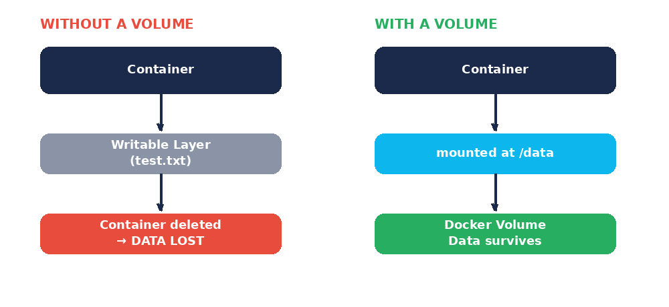
Figure 1 — Without a volume, data dies with the container. With a volume, it survives.

3. Storage Options in Docker
Storage | Managed by | Typical use
Volume | Docker | Databases, application data
Bind mount | User / host | Development, source code
tmpfs | Memory | Temporary, sensitive data

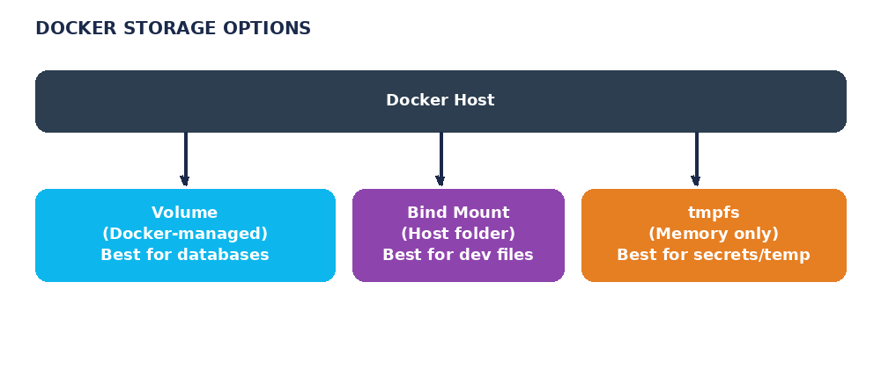
Figure 2 — The three storage options available to a Docker container.
This lab focuses mainly on volumes and bind mounts.

4. Prerequisites
- Make sure Docker Desktop is running.
- Open Command Prompt or PowerShell.
- Confirm your Docker version: docker --version
- Check general Docker status: docker info
- Run a quick sanity check: docker run hello-world — you should see a "Hello from Docker!" message.

Step 1 — Observe Data Loss Without Persistent Storage

1. Create a container
docker run -dit --name data-test ubuntu
Option | Meaning
docker run | Create and start a container
-d | Detached mode
-i | Interactive
-t | Allocate a terminal
--name data-test | Container name
ubuntu | Image to use

2. Enter the container and create a file
docker exec -it data-test bash
mkdir /mydata
echo "This is my important data" > /mydata/student.txt
cat /mydata/student.txt

3. Exit, delete the container, and try again with a new one
exit
docker rm -f data-test
docker run -dit --name data-test2 ubuntu
docker exec -it data-test2 bash
ls /mydata
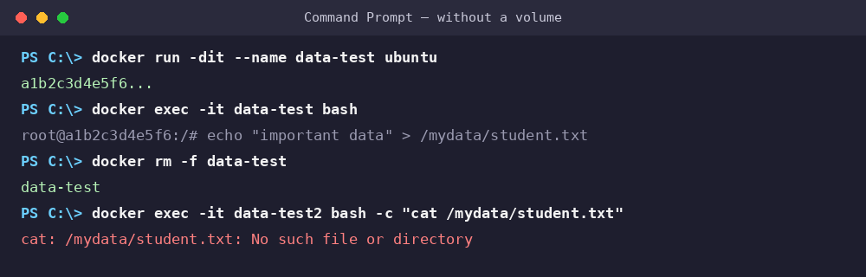
Figure 3 — The file is gone: data stored only in a container's writable layer does not survive deletion.
What happened? The data lived only in data-test's writable layer. When the container was deleted, that layer — and everything in it — was deleted too.
exit
docker rm -f data-test2

Step 2 — Create a Docker Volume
docker volume create student-data
docker volume ls
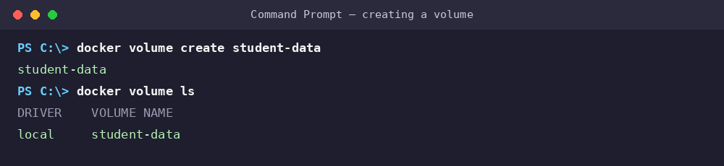
Figure 4 — A named volume, created and confirmed with docker volume ls.
A Docker volume is storage that Docker manages independently of any single container. Because it exists outside the container's lifecycle, deleting the container that used it does not delete the volume.

Step 3 — Inspect the Docker Volume
docker volume inspect student-data
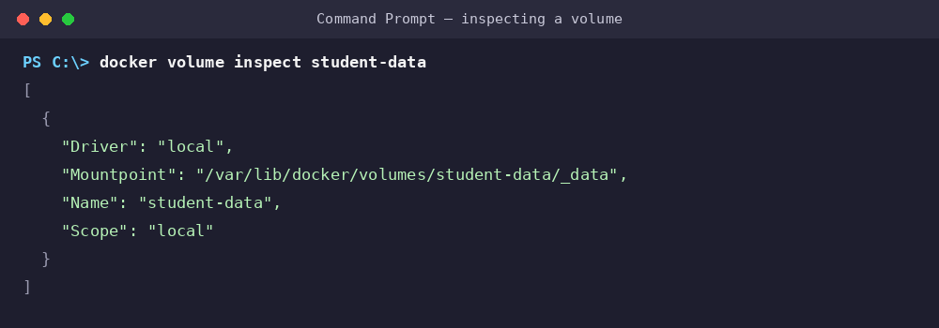
Figure 5 — Inspecting a volume shows its driver, name, and internal mount point.
- Name — student-data, the volume's identifier.
- Driver — local, Docker's default local volume driver.
- Mountpoint — where Docker internally stores the volume's data.
NOTE Docker Desktop runs Linux containers inside a Linux virtualization layer. The Mountpoint path is not an ordinary Windows folder you should edit directly — always use Docker commands or a temporary container to access volume data.

Step 4 — Attach a Volume to a Container
docker run -dit --name volume-test -v student-data:/data ubuntu
docker exec -it volume-test bash
cd /data
echo "Docker Volume Practical" > notes.txt
echo "Student Name: Sharon" > student.txt
ls
exit
-v student-data:/data maps the volume student-data to the /data path inside the container.

Step 5 — Verify Data Persistence
This is the core demonstration of the lab.
docker rm -f volume-test
docker volume ls
docker run -dit --name volume-test2 -v student-data:/data ubuntu
docker exec volume-test2 cat /data/notes.txt
docker exec volume-test2 cat /data/student.txt
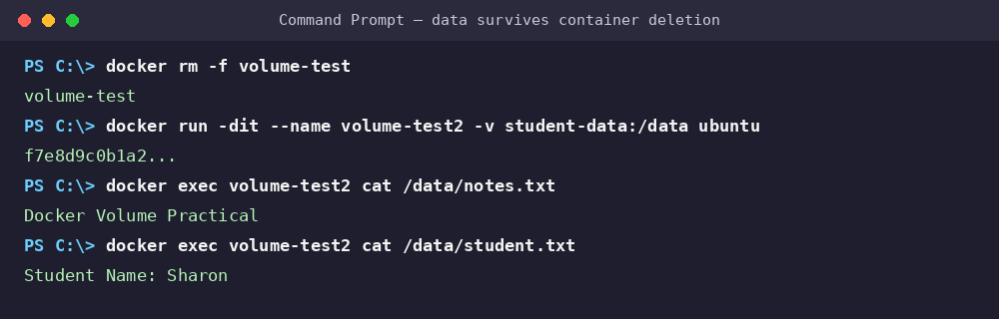
Figure 6 — volume-test was deleted, yet its files reappear instantly in a brand-new container.
Conclusion: volume-test was deleted, but student-data survived and was reattached to volume-test2 — proving the data persisted independently of any single container.

Step 6 — Share One Volume Between Two Containers
docker rm -f volume-test2
docker run -dit --name container1 -v student-data:/data ubuntu
docker run -dit --name container2 -v student-data:/data ubuntu
docker exec container1 bash -c "echo 'Created by Container 1' > /data/container1.txt"
docker exec container2 cat /data/container1.txt
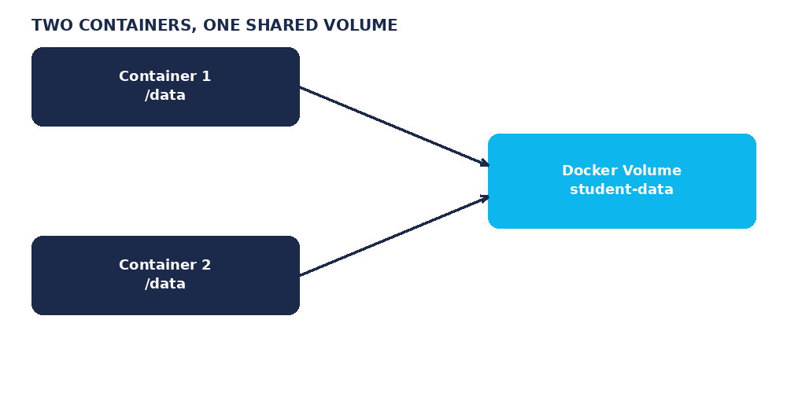
Figure 7 — Two independent containers reading and writing the same volume.
Both containers see the same data — this is how shared, persistent storage between containers works in practice (e.g., an app container and a backup container).

Step 7 — The --mount Syntax
docker run -dit --name mount-test --mount source=student-data,target=/data ubuntu
Syntax | Best for
-v | Beginners — short and quick
--mount | Production/documentation — explicit, self-describing parameters

Step 8 — Configure a Read-Only Volume
docker run -dit --name readonly-test -v student-data:/data:ro ubuntu
docker exec -it readonly-test bash
cd /data
echo "new data" > newfile.txt # permission denied
Appending :ro mounts the volume as read-only, so writes from inside the container fail.

9. Volumes vs. Bind Mounts
Docker volume — Docker manages the storage location for you:
docker run -v student-data:/data ubuntu
Bind mount — you point directly to a folder on your Windows machine:
docker run -dit --name bind-test -v C:\DockerLabs\data:/data ubuntu
Feature | Volume | Bind Mount
Managed by | Docker | User / OS
Location | Docker-managed | Specific host path
Example | student-data:/data | C:\DockerLabs\data:/data
Good for | Database / app data | Development
Requires a host path | No | Yes
Docker manages lifecycle | Yes | No

NOTE Simple rule for students — Volume: "Docker, manage my storage." Bind mount: "Docker, use this specific folder from my computer."

Step 9–10 — Bind Mounts on Windows
mkdir C:\DockerLabs\data
echo Hello from Windows > C:\DockerLabs\data\windows.txt
docker run -dit --name bind-test -v C:\DockerLabs\data:/data ubuntu
docker exec -it bind-test bash
cat /data/windows.txt
echo "Modified from Docker" > /data/docker.txt
exit
Check C:\DockerLabs\data on Windows — you'll now see both windows.txt and docker.txt. This two-way visibility is the defining feature of a bind mount.

Step 11–12 — Build a Persistent Nginx Website
docker volume create website-data
docker run -d --name nginx-volume -p 8080:80 -v website-data:/usr/share/nginx/html nginx
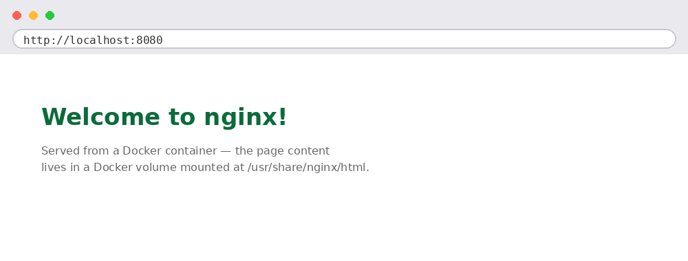
Figure 8 — The default Nginx welcome page at localhost:8080.
docker run --rm -v website-data:/data ubuntu bash -c "echo '<h1>Hello from Docker Volume</h1>' > /data/index.html"
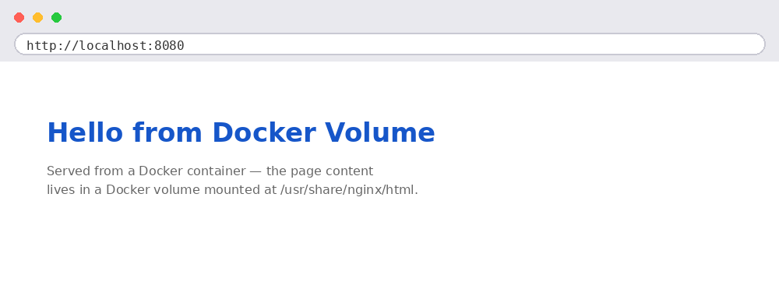
Figure 9 — The page content now comes from the volume, not the container.
docker rm -f nginx-volume
docker volume ls
docker run -d --name nginx-new -p 8080:80 -v website-data:/usr/share/nginx/html nginx
Reload the page — the custom heading still appears, even though nginx-volume no longer exists.

Step 13 — MongoDB with Persistent Storage
One of the most important real-world use cases for volumes: databases.
docker volume create mongo-data
docker run -d --name mongodb -p 27017:27017 -v mongo-data:/data/db mongo
Add data via MongoDB Compass (mongodb://localhost:27017): create database CollegeDB, collection Students, and insert { "name": "Rahul", "course": "BCA" }.
docker rm -f mongodb
docker run -d --name mongodb-new -p 27017:27017 -v mongo-data:/data/db mongo
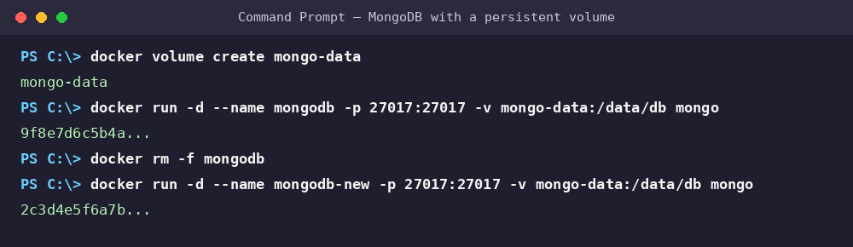
Figure 10 — MongoDB recreated on the same volume; CollegeDB → Students → Rahul is still there.
This is exactly why volumes matter for production databases — MongoDB, MySQL, PostgreSQL, MariaDB, Redis, and Elasticsearch all rely on the same pattern.

Step 14–15 — Backup and Restore a Volume

Backing up
mkdir C:\DockerLabs\backup
docker run --rm -v student-data:/data -v C:\DockerLabs\backup:/backup ubuntu tar czf /backup/student-data.tar.gz -C /data .

Restoring
docker volume create restored-data
docker run --rm -v restored-data:/data -v C:\DockerLabs\backup:/backup ubuntu tar xzf /backup/student-data.tar.gz -C /data
docker run --rm -v restored-data:/data ubuntu ls -l /data

18. Essential Docker Volume Commands
Action | Command
List volumes | docker volume ls
Create a volume | docker volume create myvolume
Inspect a volume | docker volume inspect myvolume
Remove a volume | docker volume rm myvolume
Remove all unused volumes | docker volume prune

NOTE Container removal ≠ volume removal. docker rm mycontainer deletes the container but does not touch a separately named volume. Only docker volume rm myvolume deletes the persistent data.

19. Named vs. Anonymous Volumes
Named volume — you choose the name, so it's easy to reference and manage:
docker volume create student-data
docker run -v student-data:/data ubuntu
Anonymous volume — Docker creates and names it for you:
docker run -v /data ubuntu
Named volumes are recommended for learning and for most production scenarios.

20. Using --volumes-from
docker run -dit --name container1 -v student-data:/data ubuntu
docker run -dit --name container2 --volumes-from container1 ubuntu
Container 2 automatically receives the same volume mounts as Container 1. Less common in modern designs, but still seen in older Docker tutorials.

22. Final Assessment — Persistent Student Records
Task: build a persistent student-record application using Docker.
docker volume create student-records
docker run -dit --name student-app -v student-records:/data ubuntu
docker exec -it student-app bash
echo "101, Rahul, BCA" > /data/students.csv
echo "102, Priya, BCA" >> /data/students.csv
cat /data/students.csv
exit
docker rm -f student-app
docker run -dit --name student-app-new -v student-records:/data ubuntu
docker exec student-app-new cat /data/students.csv
Expected output (unchanged after the container is replaced):
101, Rahul, BCA
102, Priya, BCA
NOTE Learning outcome — Container 1 → persistent volume → Container 1 deleted → Container 2 → same data.

23. Troubleshooting on Docker Desktop for Windows

Docker isn't running
docker info
If you get a connection error, start Docker Desktop and try again.

Port already in use
docker run -p 8081:80 nginx
Then browse to http://localhost:8081.

Volume doesn't show expected data
docker volume inspect student-data
docker inspect container-name
Look for the "Mounts" section and confirm the Type, Name, and Destination match what you expect.

24. Final Comparison & Mental Model
Feature | Container Storage | Volume | Bind Mount
Persists after container deletion | No | Yes | Yes
Managed by Docker | Partially | Yes | No
Uses a Windows folder directly | No | No | Yes
Good for databases | No | Yes | Possible
Easy to back up | Difficult | Yes | Easy

Containers are replaceable. Data should not be.

25. Suggested Lab Timing (2 Hours)
Time | Activity
10 min | Container storage concept
15 min | Demonstrate data loss
20 min | Create and use named volumes
15 min | Delete/recreate container and prove persistence
15 min | Two containers sharing one volume
15 min | Bind mounts on Windows
15 min | MongoDB + persistent volume
15 min | Backup/restore + final student assessment

