Individual Assignment 1a:   
Proposal of WebXR Application

TypeVritter  
05111740000078 – Mhd Fadly Hasan

## Application Overview

Typevritter name came from typewriter and VR, It’s Basically twitter in VR environment with basic function like posting status and real-time chatting. What makes it different from other social media is, user have to interact in created VR environment to do some function like follows people, make statuses, and deleting stuffs.

The world is going to be build in vr environment for browser that supports pc and mobile users

## Sketch of XR World

 

Neon blue with side of magenta is chosen to be the theme / layout of the vr world

It has 3 walls, status wall to show statuses, chat wall to show chat history, and follow wall that shows follow-able users based on the result of user search

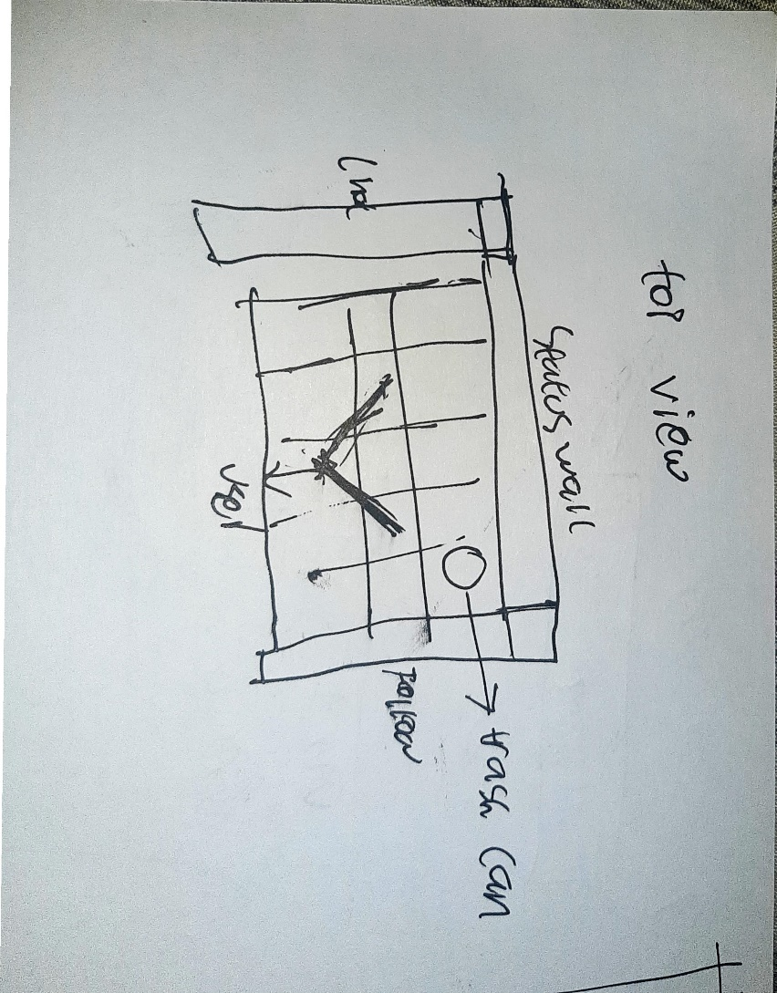

Top view of the world, user can interact with three walls in left, front, and right.

Front wall, status wall

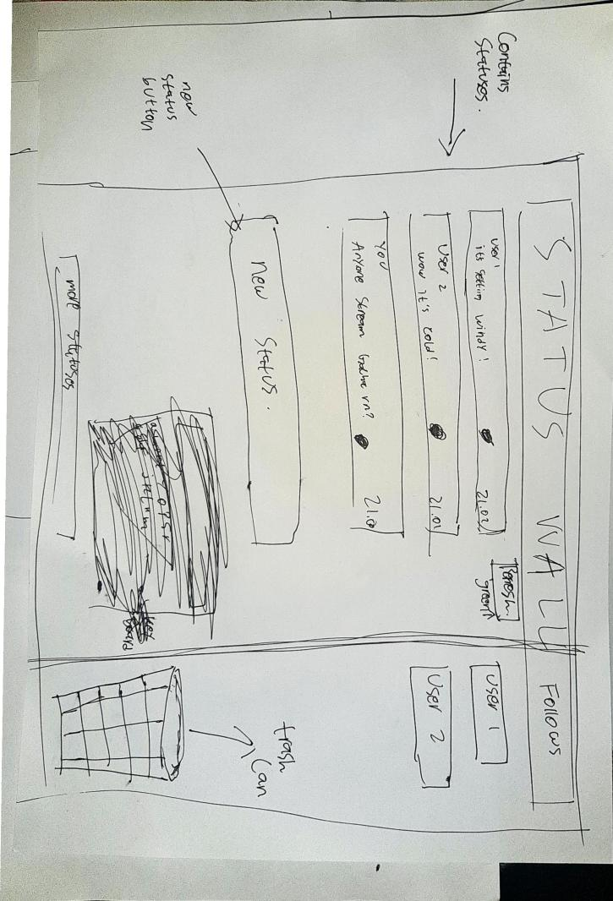

Status wall will embedded status stamp which contains the status

Thrash can is an object not embedded to the wall

Right wall

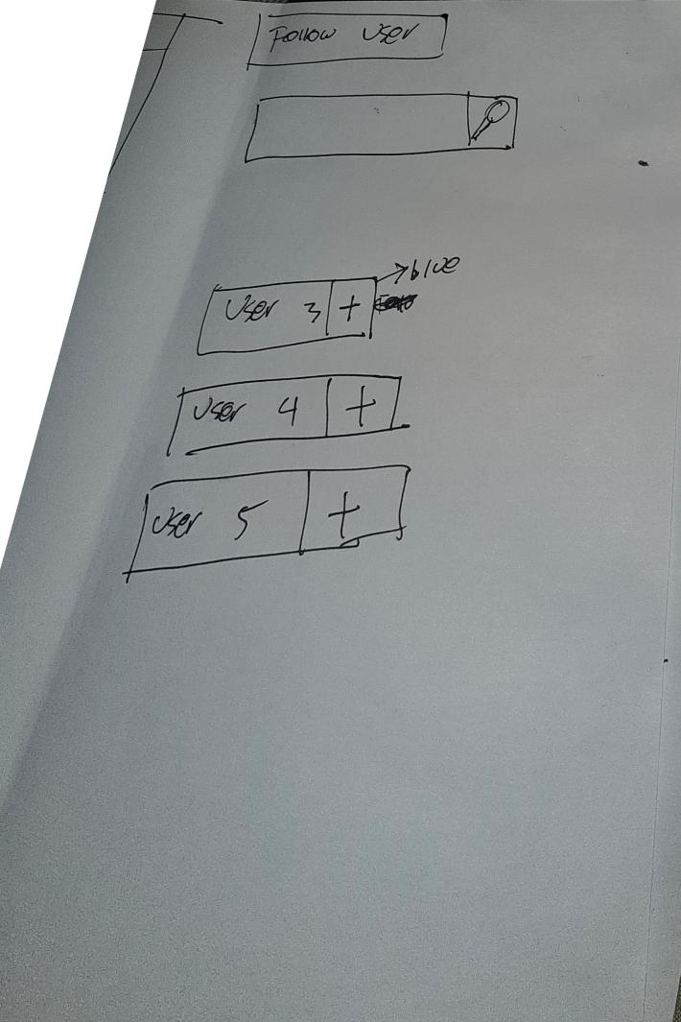

Shows what user to follow and search bar to follow users.

Left wall

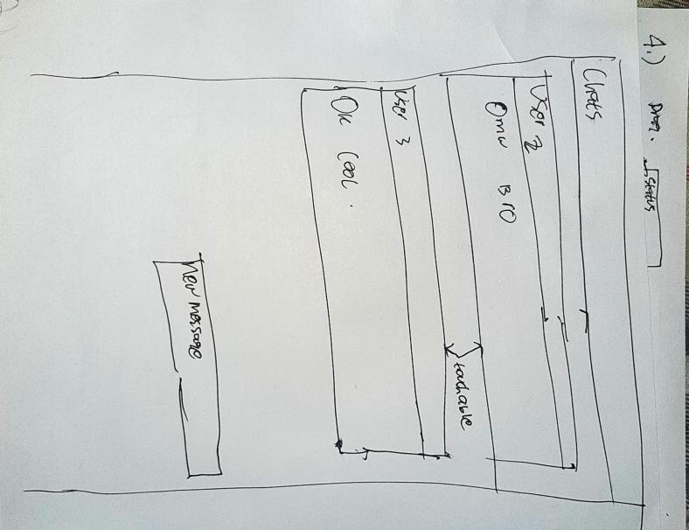

Shows chat history

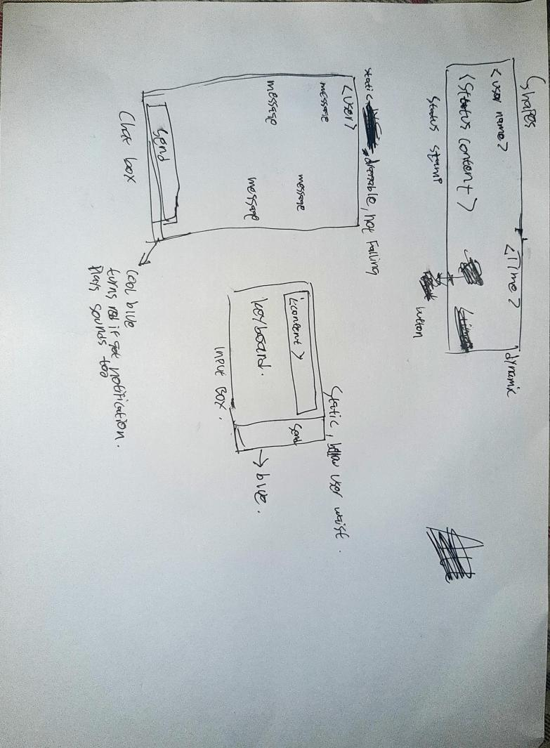

Status stamp is posted status, chat box is chat form, input box is keyboard and input box to input text.

## Sketch of Interaction

The controller is the camera pointer, defined interactions will be touch, drag (touch first then touch again to drop), typing with keyboard.

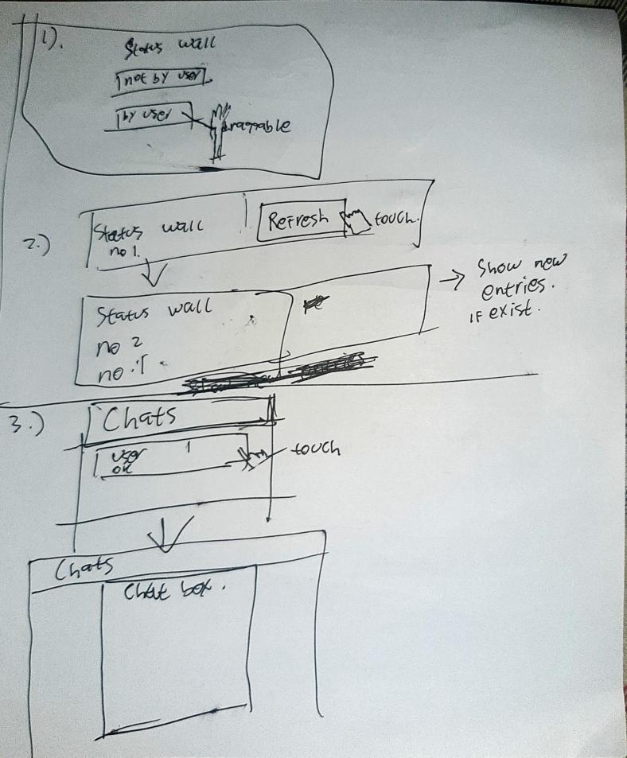

1. Status wall stamp that made by user can be dragged will be useful for delete functions.
2. Refresh button on status wall will fetch new status.
3. In chat wall, when item touched, vr environment will show chatbox between user and target, draggable useful for delete functions.

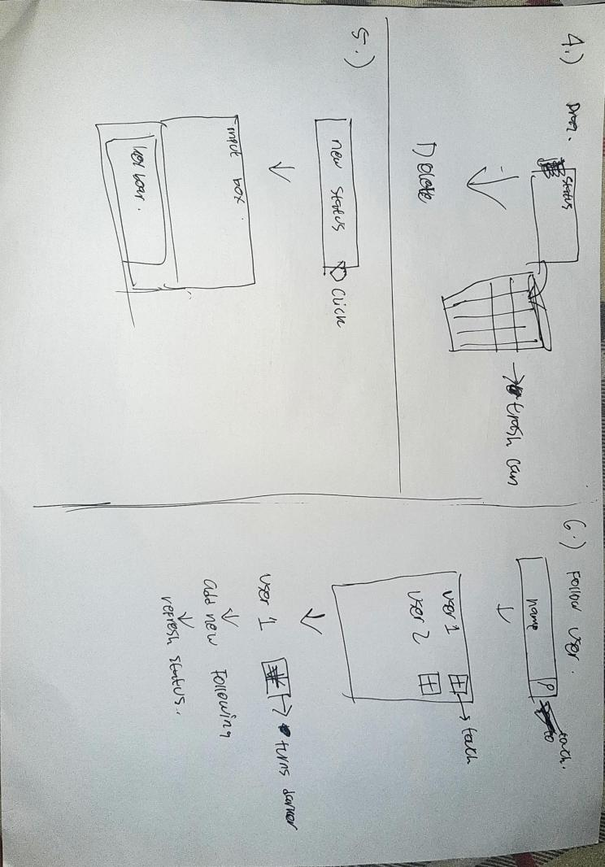4. Any item that dragged into trash can will be deleted,

5. if user click new status and other input interaction, an keyboard will be shown

6. to follow another user, user will search its username and touch the button to follow it. Improvement may occur.

## Object Dynamics

### Local Variables

#### Functionalities

* Login
* Register
* See statuses.
* Follow user.
* Unfollow user.
* Chat user to user, no group chat

#### Shapes

* Form (using a-frame material) for:
  + Login
  + Make status
  + Input chat content to chat box
  + Input username to search bar
* chat box, different for each user, draggable, doesn’t has physics.
* status wall, a wall that show’s followed status stamps
  + if status stamp was send by this user, stamps object is interactable, draggable and has physics.
  + if not, it’s not interactable.
  + Object may have animate
* trash can, to delete status or chat, or unfollow user, throw its object to the junk and it will be deleted, thrash can interactable so user could move it around.

#### Other decoration objects.

Library used:

* A-FRAME
* Three js to render object
* A-Frame Material <https://github.com/etiennepinchon/aframe-material>
* Look at library
* Physics library
* Hitbox / impulse
* Click drag component <https://github.com/jesstelford/aframe-click-drag-component>

### External Variables

In order to fulfill these functionalities, this project will implement these external stacks:

* Node js for server
* Socket io for real-time chat notifications
* Express.js for API request
* Postgresql for database

#### Search user:

* User input search api request
* Server show’s results / closest result
* Shows in following wall

#### Follow User

* User click or interact with the shown result
* Send request to server
* Server add new ‘following’ table entry
* Give respond

#### Unfollow user

* User drag followed user object to trash
* Send request to server
* Server delete ‘following’ table entry
* Give respond

#### Send Chat

* User input chat
* Server gets it
* Server puts to ‘conversation’ db
* Check in socket, if targeted user online, send notification to them

#### See statuses

* User request with api to server
* Server show’s paged entry (10 message for each time)
* VR worlds show’s the result

#### Make statuses

* User request with api to server
* Server add to ‘statuses’ database
* Give response

#### Delete statuses

* User request with api to server
* Delete an entry of ‘statuses’ in database
* Give response