Name: Aakash Valliyil Roll No: 763 Division: A | DOP: 03/10/2026 DOS: 06/10/2026 Score: _____
Project Title: MapPulse AI – Google Maps Competitor Update Intelligence Platform
• Live Application URL: https://google-maps-competitor-intelligence-c7ga.onrender.com
• GitHub Repository: https://github.com/AVR003/google-maps-competitor-intelligence • Demo Subject: ABC Salon, Kharghar (vs 4 Competitors)
1. Approach & Methodology
MapPulse AI is an automated intelligence tool engineered to monitor competitor Google Maps updates, analyze promotional topics, detect gaps, and generate non-repetitive, ready-to-publish Google Maps posts.
1. Multi-Project Setup: Groups local business profiles, competitors, and keywords. Pre-loaded with a realistic demo dataset for 100% evaluation reliability.
2. Automated Scraping & Anti-Automation: Headless Python Selenium engine with stealth headers extracts post copy, timestamps, images, and CTAs. If Google presents a CAPTCHA challenge, the system halts gracefully, prompts the user via a modal, and logs manual intervention.
3. SHA-256 Duplicate Detection: Fingerprints posts via SHA256(competitor + text + date). Re-scraping identifies and skips existing posts to maintain clean data.
4. AI Trend & Gap Analysis: Computes the Topic Occurrence Matrix (% occurrence, competitor usage count), analyzes publishing frequency, and identifies untapped market gaps.
5. Content & Update Generator: Allows users to control idea batch size (3, 10, 50). Employs duplicate prevention against SQLite history and generates complete copy with location keywords, CTAs, and AI image concepts.
2. Technologies Used
Backend & DB: Python 3.14, FastAPI, Uvicorn, SQLite. Scraping: Selenium WebDriver, BeautifulSoup4.
Frontend: HTML5, Tailwind CSS, Chart.js, Lucide Icons. AI Layer: Google Gemini 2.5 Flash, Groq LLaMA 3.3, Built-in Offline NLP. Hosting: Render.com (Procfile).
3. Key Screenshots (Part 1: Ingestion & Duplicate Auditing)
Fig 1: Dashboard & Analytics Overview  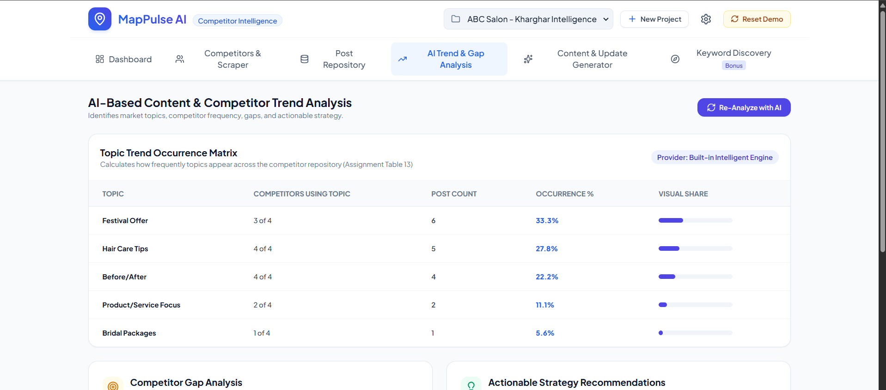  Monitors 4 competitors, 29 stored posts, and 13 duplicates skipped. | Fig 2: Competitor Management & Scraper Console  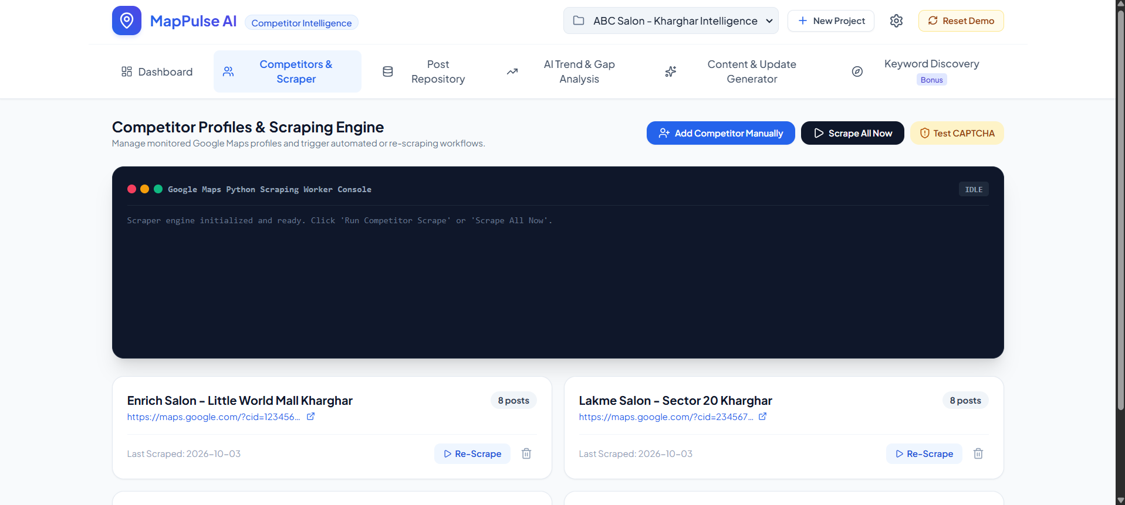  Live Selenium console with SHA-256 duplicate detection.

3. Key Screenshots (Part 2: Trend Intelligence & Content Generation)
Fig 3: AI Trend Matrix & Strategic Gap Analysis  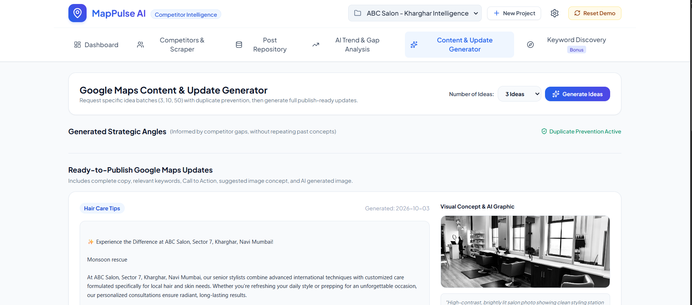  Assignment Table 13 matrix (Festival Offer 33%, Hair Care Tips 28%). | Fig 4: Content Generator & Ready-to-Publish Update  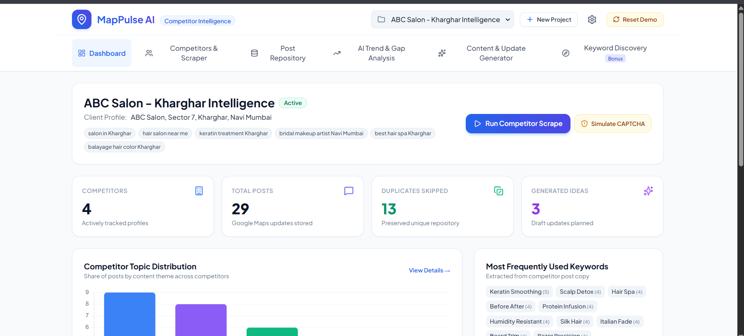  Controlled batch size generator drafting full copy and photo concepts.
4. Key Results & Findings from Competitor Research
• Topic Saturation: Competitors heavily emphasize Festival Offers (33.3%) and Hair Care Tips (27.8%), reflecting strong local demand for discount bundles and seasonal hair damage prevention.
• Identified Market Gap: Visual Before/After transformations (22.2%) and specialized Bridal Packages (5.6%) are underutilized by 50% of competitors, presenting a primary opportunity for ABC Salon to capture local search visibility.
• Publishing Patterns: Competitors post primarily mid-week (Tuesday–Thursday) leading into weekend walk-in traffic, with CTA distributions concentrated on 'Book Online' (34%) and 'Call Now' (28%).
5. Bonus Features Implemented
• Keyword-Based Competitor Discovery: Discovers candidate businesses from search keywords (e.g., 'salon in Kharghar') and adds them directly to the scraping queue without duplicates.
• Strategic Gap Analysis & Recommendations: Automatically prescribes content strategies based on what competitors have missed.
• Offline Resilience: The integrated heuristic NLP engine guarantees full functionality even without external AI API keys or internet access.

