CSC-204: Operating Systems
Assignment 1
T20 World Cup Cricket Simulator
A Multi-Threaded Concurrent Systems Simulation in C++

India vs Australia Full T20 Match

Submitted By:
Name | Roll Number
Adityavardhan Singh | 24322005
Dhruv Aggarwal | 24115057
Keshav Dharni | 24114048
Anjan Singla | 24114012
Mayank Rana | 24115101

Department of Computer Science & Engineering
Indian Institute of Technology Roorkee
March 2026

1. Introduction
The design, implementation, and analysis of a T20 Cricket World Cup Match Simulator developed for CSC-204 (Operating Systems) are documented in this study. Every real-world cricket entity, including threads, semaphores, mutexes, condition variables, schedulers, and deadlock detection methods, is mapped to a concrete Operating Systems abstraction in the simulator, which simulates an entire two-innings T20 match between Australia and India.

The POSIX thread library (pthread) is used in the C++ code of the simulator. Two artefacts are produced: (1) gantt_log.txt, a tabular Gantt chart that displays which thread was active at each timestamp, and (2) commentary_log.txt, a complete ball-by-ball match log with scorecards.

1.1 Objectives
- Create a concurrent, multi-threaded C++ system to simulate a live Twenty20 cricket match.
- Demonstrate mutual exclusion (pitch_mutex) for the shared pitch (Critical Section)
- For the common pitch (Critical Section), show mutual exclusion (pitch_mutex).
- Wake fielder threads only when the ball is hit into the field by using condition variables.
- Implement Round Robin scheduling for over-by-over bowler rotation
- Detect and resolve run-out deadlock (circular wait) using a wait-for graph
- Create a complete Gantt chart with timestamps showing the OS thread execution.

1.2 Key Assumptions
- At the beginning of the program, a coin flip determines the batting order.
- Real player names are used in the fixed playing XI, and skill profiles are weighted (see Section 11).
- Only five bowlers rotate, one over every cycle (indices 6–10 in the team vector).
- No-Ball (length > 0.95) and Wide (|line| > 1.3) add one extra without being considered genuine deliveries.
- Only odd-run attempts can result in deadlock (mix-up run-out); even runs cannot result in a circular delay since both batsmen return to their starting positions.
- 10% of odd-run attempts result in a mix-up; all sleep periods are compressed using TIME_SCALE=0.05.
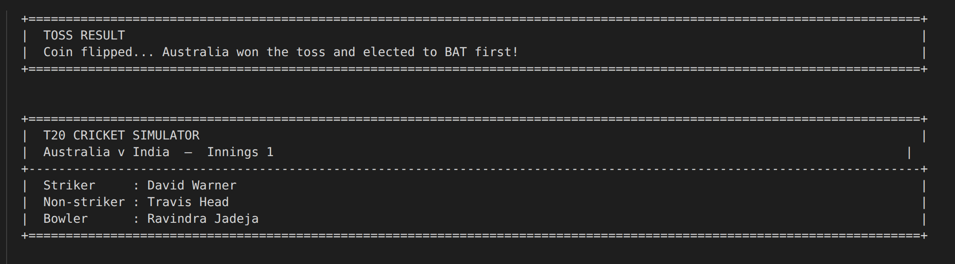
Figure: Simulator startup : toss result banner and innings header in terminal

2. System Design Overview

2.1 Cricket to OS Conceptual Mapping
Every cricket entity maps directly to an OS abstraction:

Cricket Entity | OS Concept | C++ Implementation
The Pitch | Critical Section | pitch_mutex + Pitch_state struct
Batsman x2 | Consumer Threads | batsman_thread() :pthread_t
Bowler (1 active) | Producer Thread | bowler_thread() :pthread_t
Fielder x11 | Passive Condition Threads | fielder_thread() + pthread_cond_wait
Umpire | OS Kernel / Master Scheduler | umpire_thread() :creates/joins all
Scoreboard | Shared Global State | ScoreBoard struct + score_mutex
Crease Capacity | Counting Semaphore (init=2) | sem_t crease_capacity
Crease (End1 & End2) | Binary Mutex per Resource | pthread_mutex_t crease_mutex[2]
Over Rotation | Round Robin Scheduler | next_bowler_idx cycling mod 5
Run-Out Race | Deadlock / Circular Wait | alloc_graph[] + req_graph[]
Ball-by-Ball Log | Execution Trace | commentary_log.txt
Gantt Chart | Thread Schedule Visualisation | gantt_log.txt

2.2 Thread Lifecycle
Thread | Created By | Terminates When | Joined By
bowler_thread | umpire_thread | 6 valid balls OR match_active=false | umpire_thread
batsman_thread (End1) | umpire_thread | Dismissed OR match_active=false | umpire_thread
batsman_thread (End2) | umpire_thread | Dismissed OR match_active=false | umpire_thread
fielder_thread x11 | main() | match_active=false + cond_broadcast | main()
umpire_thread | main() | Innings complete | main()

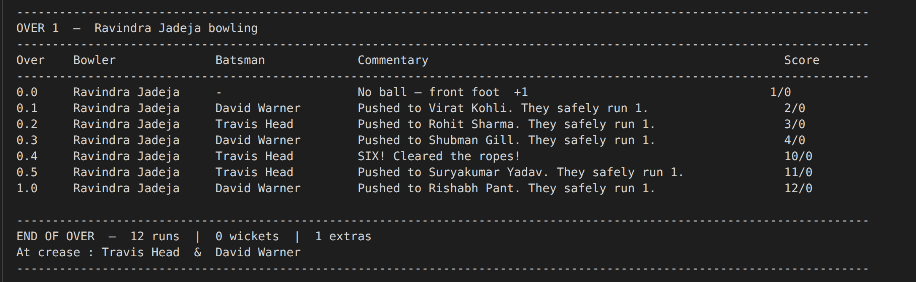
Figure: First over commentary :thread interleaving visible across bowler/batsman/fielder actions

3. Thread Pool aka The Players

3.1 Bowler Thread (Producer)
In a producer-consumer pipeline, the bowler thread is the producer. Every delivery cycle, it adds a Ball_state descriptor to the shared Pitch_state buffer.
Flow inside bowler_thread():
- sem_wait(&pitch_empty) :blocks until pitch is free for next ball
- pthread_mutex_lock(&pitch.pitch_mutex) :enters critical section
- Computes ball attributes: line + N(0, 1-accuracy), length + N(0, 1-accuracy), speed = pace x 140 + N(0,5)
- Classifies ball: WIDE (|line|>1.3) +1 extra, NO_BALL (length>0.95) +1 extra, else NORMAL valid ball
- Unlocks pitch_mutex, signals ball_ready_end1 or ball_ready_end2 to correct batsman
- After 6 valid deliveries: signals umpire_sem for over rotation (RR context switch)

Bowler Skill Model
actual_line = intended_line + N(0, 1 :accuracy) | actual_speed = pace x 140 + N(0, 5) difficulty = 0.40 x len_factor + 0.35 x spd_factor + 0.25 x line_factor

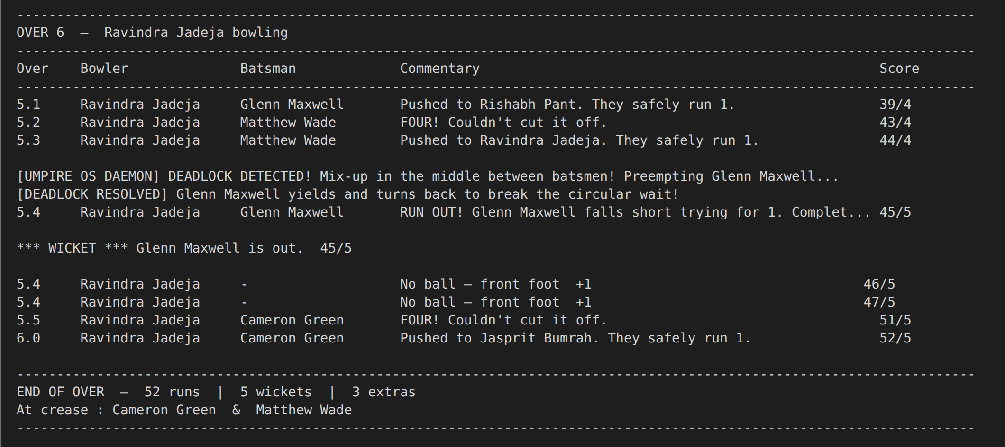
Figure: No-Ball lines in commentary_log.txt with +1 extras

3.2 Batsman Threads :Consumers
Two active batsman threads run concurrently at End-1 and End-2. They consume the ball state written by the bowler.

Flow inside batsman_thread():
- sem_wait(&crease_capacity) : counting semaphore enforces max 2 batsmen at crease
- sem_wait(&ball_ready_endN) : blocks until bowler delivers ball to this end
- pthread_mutex_lock(&pitch.pitch_mutex) : reads Ball_state in critical section
- Computes probabilistic outcome: sigmoid-based model produces p(MISS), p(LBW), p(CAUGHT), p(SIX), p(FOUR), p(CONNECT)
- If CONNECT/FOUR/CAUGHT: signals cond_fielder_wake to wake a fielder thread
- If CONNECT with running: enters crease-race deadlock protocol (Section 7)
- Updates ScoreBoard under score_mutex; triggers wicket/crease-swap logic
- sem_post(&pitch_empty) :releases pitch for next delivery
The outcome probability model (simplified):
bat_ctrl = technique :difficulty + N(0, 0.15)
p_six = sigmoid(bat_ctrl*2.0 + power :1.0) * remaining * 0.10
p_four = sigmoid(bat_ctrl*1.5) * remaining * 0.20
p_caught = sigmoid(-bat_ctrl*1.5) * edge_factor * remaining * 0.25

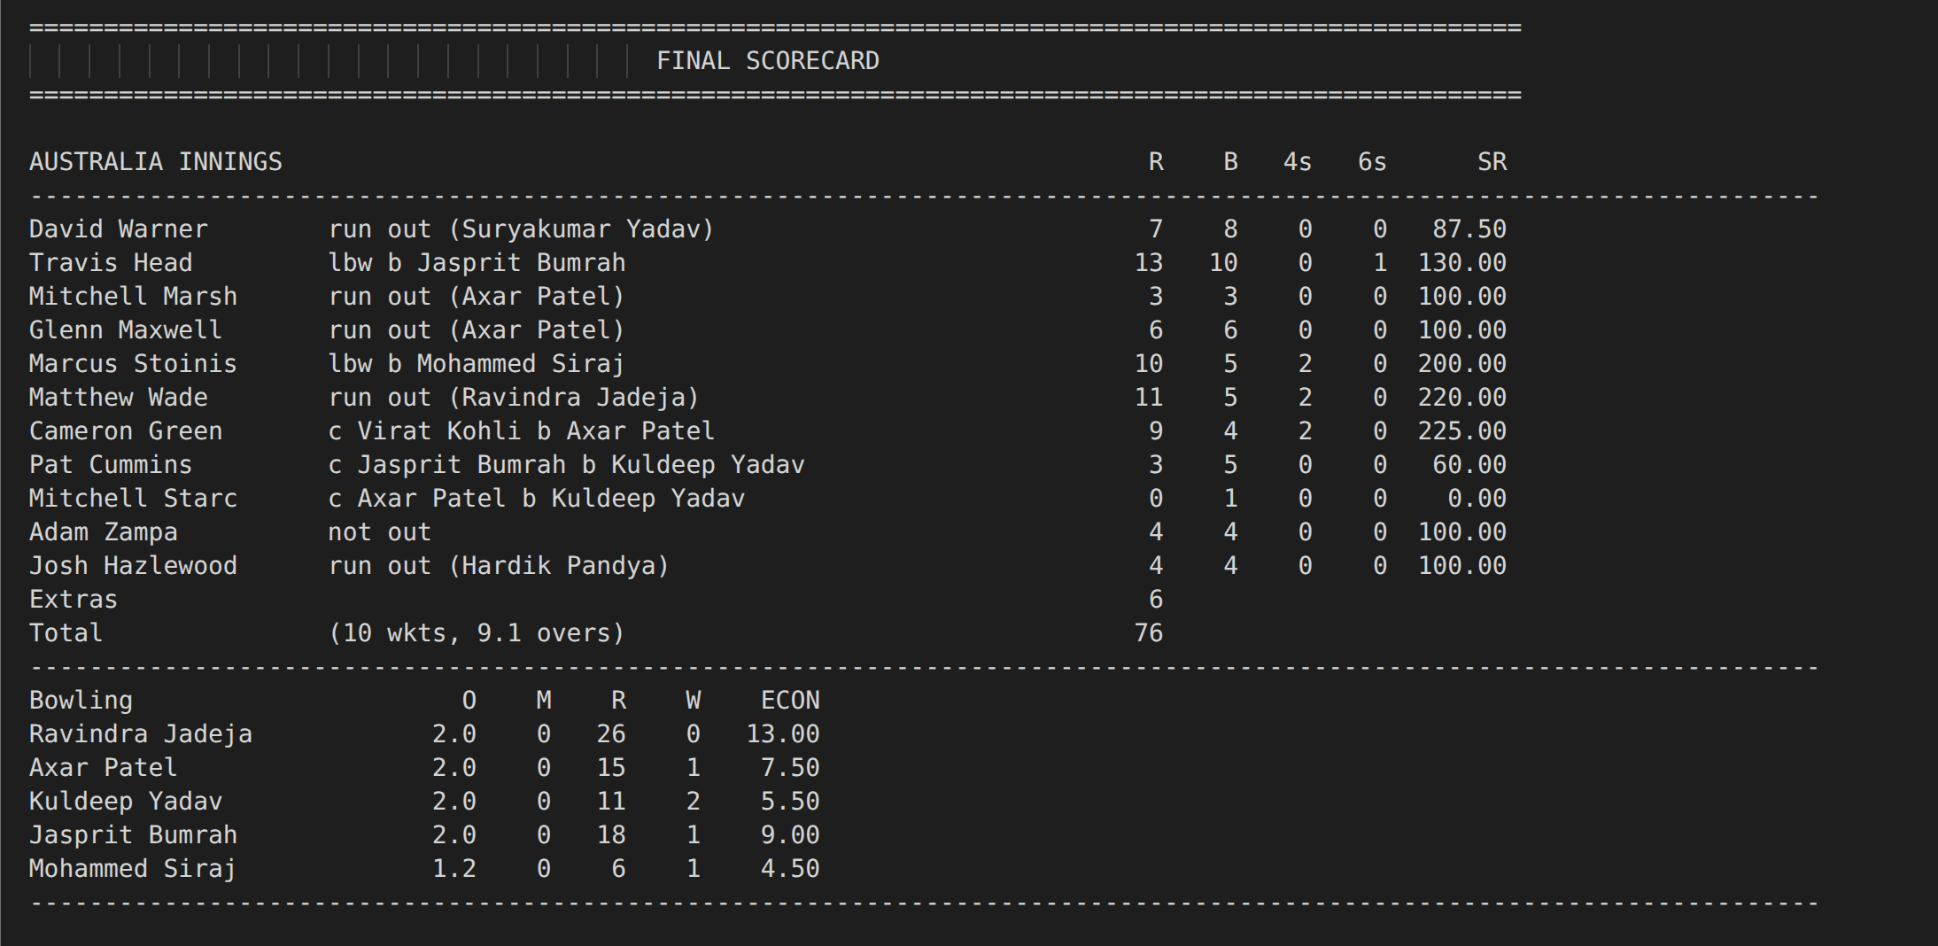

Figure: Mid-innings batting stats

3.3 Fielder Threads :Passive Condition Waiters
Eleven fielder threads run throughout the innings sleeping on a POSIX condition variable. They wake only when the ball is hit.
Condition variable protocol:
- All 11 fielders: pthread_cond_wait(&cond_fielder_wake, &mutex_fielder_wake) : releases mutex, sleeps
- Batsman (on CONNECT/FOUR/CAUGHT): sets ball_hit_to_field=true, calls pthread_cond_signal()
- First fielder to wake: resets flag, sets itself as pitch.ball.active_fielder, posts fielder_identified
- Processes outcome: run-out throw race OR boundary save OR catch attempt
- Posts fielder_done, returns to pthread_cond_wait for next ball
- At match end: umpire calls pthread_cond_broadcast() : all fielders see match_active=false and exit

Why Condition Variables?
Polling for BALL_HIT would waste CPU across 11 idle threads. pthread_cond_wait releases the mutex and suspends the thread at OS level, consuming zero CPU until signalled , exactly how the OS handles I/O-waiting processes.

Fielder sub-scenarios:
- CONNECT + runs > 0: Races batsmen to the crease : throws after expected_throw_time; if crease_mutex[target] still free => RUN OUT
- FOUR: save_prob = agility x sigmoid(catching_skill-0.6) + N(0,0.05); if > 0.75 => 2 runs (saved), else FOUR
- CAUGHT: catch_success = catching_skill :catch_diff + N(0,0.12); if > 0 => OUT, else drops (1 run)

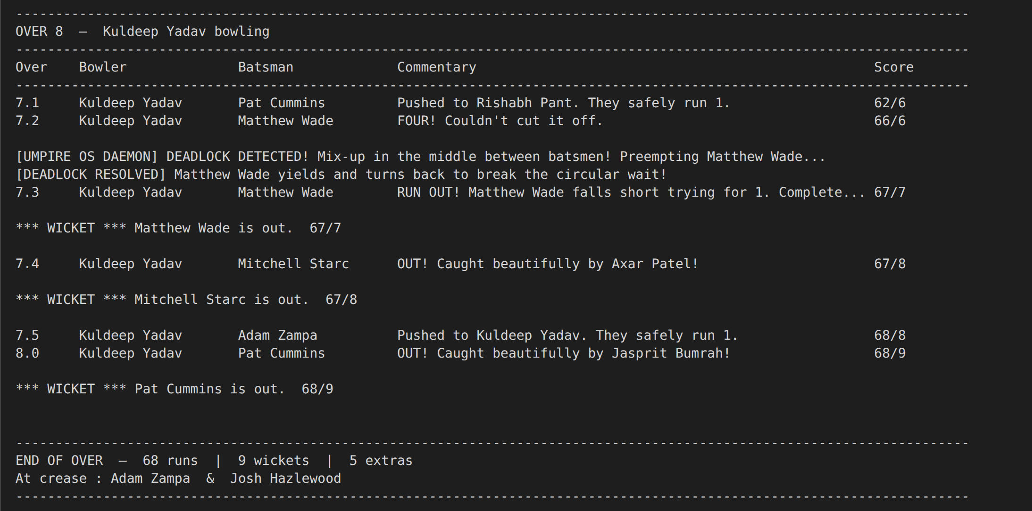
Figure: Fielder catch and run-out commentary lines from terminal output

4. The Critical Section (The Pitch)

4.1 What is Protected
The resource that all threads share is the Pitch_state struct. Type, line, length, speed, outcome, active_fielder pointer, is_run_out flag, crease targets, and comm_error flag are all included in the full ball descriptor. The match state would be corrupted by concurrent access without locking.

4.2 Mutex Ownership Sequence Per Ball
Step | Thread | Lock State | Action
1 | Bowler | LOCKED by Bowler | Writes all ball attributes into Pitch_state
2 | Bowler | UNLOCKED | Posts ball_ready semaphore to correct batsman
3 | Batsman (striker) | LOCKED by Batsman | Reads ball, computes outcome, signals fielder
4 | Batsman | TEMPORARILY UNLOCKED | sem_wait(fielder_identified) :avoids holding lock while waiting
5 | Batsman | RE-LOCKED by Batsman | Reads fielder result; updates pitch.ball.final_outcome
6 | Batsman | UNLOCKED | Releases pitch, posts pitch_empty for next delivery
7 | Bowler | Awaits pitch_empty | Begins next delivery cycle

The score_mutex satisfies the assignment requirement for atomic score updates by acting as an inner guard around ScoreBoard changes, preventing simultaneous Wide and Single events from distinct code paths from corrupting the score.

4.3 Semaphore Protocol (pitch_empty)
The binary semaphore pitch_empty (init=1) functions as a gate. Only until the batsman has completed processing and posted pitch_empty may the bowler deliver. Strict bowl-bat-bowl alternation is therefore enforced:
Bowler: sem_wait(pitch_empty) -> write ball -> sem_post(ball_ready_endN)
Batsman: sem_wait(ball_ready) -> read ball -> sem_post(pitch_empty)

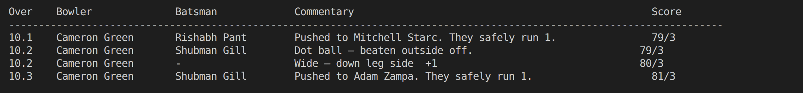
Figure: Commentary showing a WIDE immediately followed by a single :proving atomic scoreboard update
5. Synchronisation Mechanisms

5.1 All Semaphores
Semaphore | Init | Purpose
pitch_empty | 1 | Gates bowler : bowl only when batsman has finished processing
ball_ready_end1 | 0 | Signals End-1 batsman that a ball has been bowled
ball_ready_end2 | 0 | Signals End-2 batsman that a ball has been bowled
crease_capacity | 2 | Counting sem :max 2 batsmen at crease; 3rd must WAIT
crease_swap_done | 0 | Handshake: non-striker confirms crease swap after odd runs
fielder_identified | 0 | Batsman waits until one fielder has claimed the ball
race_started | 0 | Fielder waits until batsmen begin running before throwing
fielder_done | 0 | Batsman waits until fielder finishes catch/save/throw
umpire_sem | 0 | Umpire sleeps; woken by wicket signal or end-of-over signal
non_striker_done | 0 | Striker waits for non-striker to reach safe crease before scoring

5.2 All Mutexes
Mutex | Protects
pitch.pitch_mutex | Entire Pitch_state struct :one writer/reader at a time
score_mutex | ScoreBoard :atomic score, wicket, extras updates
print_mutex | stdout + commentary file :prevents interleaved console output
gantt_mutex | gantt_log vector :safe concurrent Gantt record appends
crease_mutex[0] | End-1 crease :batsman holds this to be 'safe' at End 1
crease_mutex[1] | End-2 crease :batsman holds this to be 'safe' at End 2
mutex_fielder_wake | Guards ball_hit_to_field flag for condition variable correctness

5.3 Condition Variable :Fielder Wake
Cond_fielder_wake + mutex_fielder_wake is the pair. This is where all 11 fielders sleep. When the ball is hit, the hitter calls pthread_cond_signal() and sets ball_hit_to_field=true. The umpire invokes pthread_cond_broadcast() to terminate all fielder threads cleanly at the end of the innings.

Assignment Requirement
The assignment requires: 'Use pthread_cond_wait for Fielders. They should only wake up if the Batsman thread sets the ball_in_air flag to true.' This is implemented exactly via ball_hit_to_field flag and cond_fielder_wake, satisfying the POSIX condition variable requirement.

5.4 Crease Capacity Semaphore
The assignment rule is enforced by crease_capacity (init=2), which keeps a third batsman thread in the WAIT state if it tries to enter the crease. Every arriving batsman does sem_post upon leaving and sem_wait(&increase_capacity). This is obtained by the opening pair before the bowler is formed, serving as a barrier to guarantee that both are prepared before play starts.

6. Scheduling

6.1 Round Robin aka Bowler Rotation (Time Quantum = 6 Balls)
The Umpire thread implements Round Robin scheduling for bowlers. After each over:
- Outgoing bowler thread terminates and is joined by umpire (analogous to reclaiming process resources after completion)
- The umpire joins the outgoing bowler thread once it terminates (similar to recovering process resources after completion).
- next_bowler_idx cycles through five bowlers (indices 6–10) using the formula 6 + ((idx :6 + 1) % 5).
- pthread_create(&bowler_t, NULL, bowler_thread, active_bowler) creates a new bowler thread.
- In between overs, the new bowler is allocated the opposite crease end from the previous bowler and models the field change.
- Context switch overhead is modelled by usleep (40000 * TIME_SCALE) in umpire.

Round Robin in OS Terms
Time Quantum = 6 valid deliveries. The bowler is the 'process'; the pitch is the 'CPU'. After one quantum the process (bowler) is preempted and the next process (next bowler) is scheduled. Stats are saved between quanta just like a CPU register save on context switch.

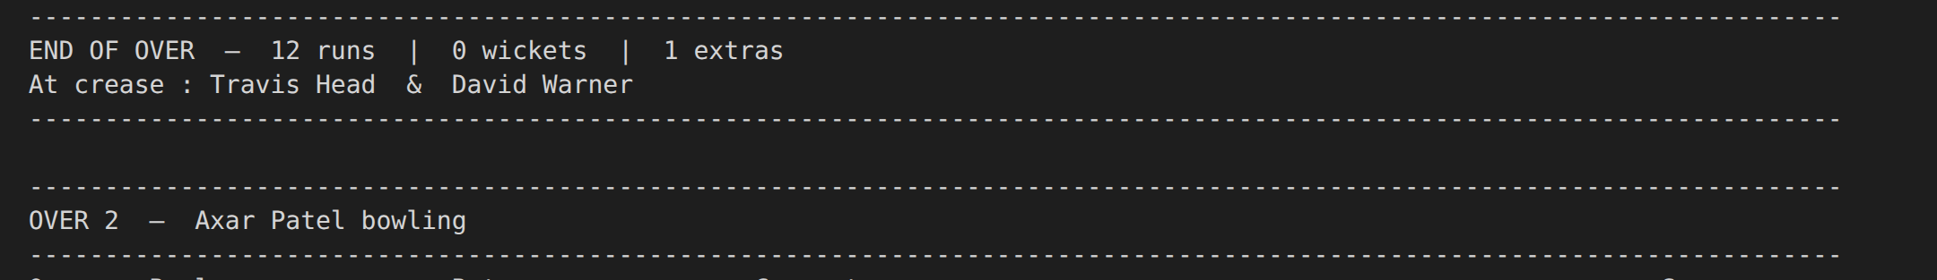
Figure: End-of-over summary banner with RR context switch :new bowler name in next over header

6.2 SJF :Tail-ender Batting Order Analysis
Skill profiles are used to implement SJF. Lower-order batsmen are shorter-duration "jobs" with lower technique and power scores. Wait time and throughput under FCFS (natural 1–11 order) and SJF (promoting tail-enders) are compared in this analysis:

Position | Technique | Power | Expected Batting Duration | SJF Classification
1-2 (Openers) | 0.85-0.88 | 0.92-0.96 | Long (anchor) | Long Job
3-5 (Middle Order) | 0.78-0.90 | 0.85-0.95 | Medium | Medium Job
6 (All-rounder) | 0.75 | 0.85 | Medium | Medium Job
7-8 (Lower Order) | 0.60-0.78 | 0.75-0.88 | Short | Short Job
9-11 (Tail) | 0.20-0.40 | 0.30-0.60 | Shortest | Shortest Job

Short-job batsmen are promoted earlier by SJF, which shortens their wait times but exposes them to more challenging bowling. For a comparative wait-time analysis, see Section 10.

6.3 Priority Scheduling :Death Over Specialist
Skill profiles are used to model priorities. Because they generate greater difficulty scores, death-over experts (Jasprit Bumrah: pace=0.65, accuracy=0.95; Pat Cummins: pace=1.02, accuracy=0.94) are inherently more effective under duress. All bowlers receive their overs thanks to the umpire's RR rotation, but skill-weighting gives results de facto priority.

Priority scheduling at the match level is likewise implemented by the InningsStatus priority encoding: TARGET_REACHED (highest priority) > ALL_OUT > OVERS_COMPLETED > ONGOING. To decide whether termination circumstance is more important, the umpire considers these.

7. Deadlock Detection & Resolution ( Run-Out )

7.1 The Deadlock Scenario
Both batters must cross to the opposite crease when attempting a run. In a classic circular wait impasse, each holds their home crease mutex and asks for the other's:

Entity | Holds (alloc_graph) | Requests (req_graph)
Batsman A (at End 1) | crease_mutex[0] (End 1) | crease_mutex[1] (End 2)
Batsman B (at End 2) | crease_mutex[1] (End 2) | crease_mutex[0] (End 1)

Neither can proceed without the other releasing :deadlock. This maps exactly to the assignment's example scenario.

7.2 Wait-For Graph Implementation
Two atomic arrays model the OS resource allocation graph:
std::atomic<int> alloc_graph[2]; // alloc_graph[i] = player_id holding crease i (-1 = free)
std::atomic<int> req_graph[2]; // req_graph[i] = player_id requesting crease i (-1 = none)

As they move into the Hold Phase (lock home crease) and Wait Phase (request target crease), batsmen automatically update them. Both arrays are continuously polled by the umpire.

7.3 Detection Algorithm (Umpire Thread)
The umpire's deadlock check inside its polling loop:
if (alloc_graph[0] != -1 && alloc_graph[1] != -1 &&
req_graph[0] == alloc_graph[1] &&
req_graph[1] == alloc_graph[0]) {
// DEADLOCK DETECTED :all 4 Coffman conditions met
victim->is_preempted = true;
}

Mutual exclusion (mutexes), hold-and-wait (holding home, seeking target), no preemption (only the umpire can preempt), and circular wait (A waits for B, B waits for A) are all concurrently detected.

7.4 Resolution :Preemption
The Umpire (OS Kernel) preempts the victim (active_batsman_end2 :the non-striker):
- Sets victim->is_preempted = true
- Clears req_graph entries to break the circular dependency
- Logs Gantt entry: 'Detects Deadlock, Preempts Batsman'
- Prints: [UMPIRE OS DAEMON] DEADLOCK DETECTED! Mix-up in the middle!

The preempted batsman's polling loop detects is_preempted==true and executes:
- Releases held crease mutex (alloc_graph[home] = -1, pthread_mutex_unlock)
- Clears its request (req_graph[target] = -1)
- Prints: [DEADLOCK RESOLVED] [Player] yields and turns back!
- Penalty wait (simulates scrambling back), then retries with comm_error=false

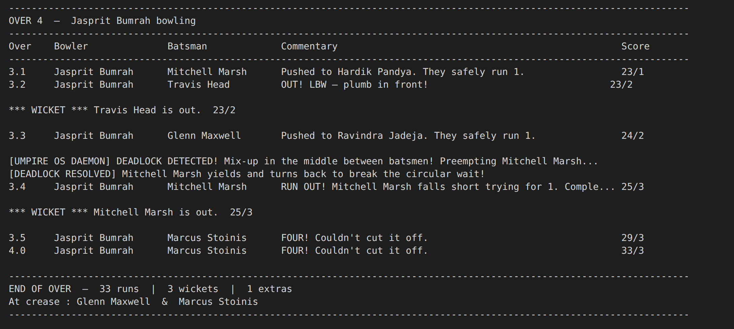
Figure: Deadlock detection console output: [UMPIRE OS DAEMON] and [DEADLOCK RESOLVED] lines

7.5 Design Safeguards
Even-run prevention:
comm_error is only set when attempted_runs % 2 != 0. Even runs return both batsmen to original ends no circular wait possible.
pitch.ball.comm_error = (attempted_runs % 2 != 0) && (uniform(0,1) < 0.1);

Secondary deadlock prevention:
The striker releases crease_mutex[target] after a safe run before waiting for non_striker_done. By doing this, a secondary stalemate is avoided in which the non-striker need the same mutex to finish its crease-swap.

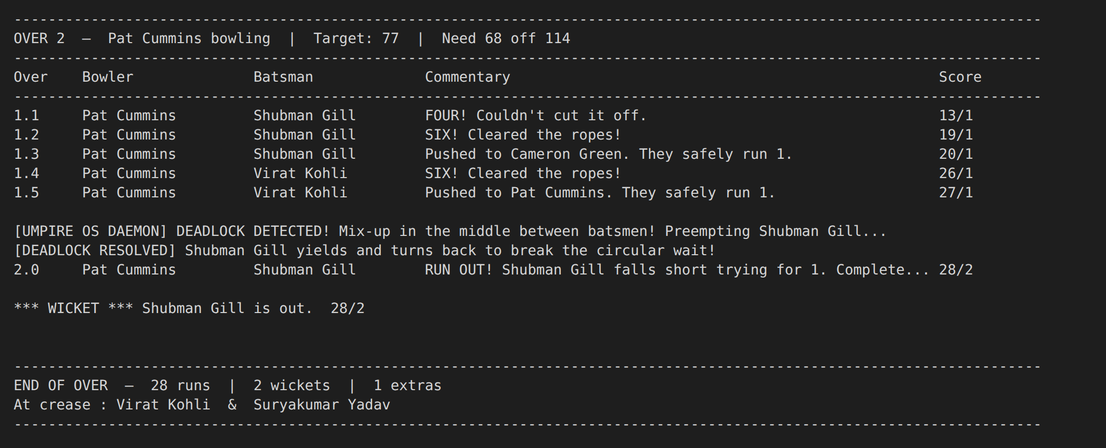
Figure: Run-out delivery: 'RUN OUT! [Player] falls short trying for N. Completed M.' in commentary
8. Umpire Thread ( The OS Kernel / Resource Scheduler)

8.1 Responsibilities
Umpire Action | OS Equivalent
Creates opening batsman threads | fork() / pthread_create for initial processes
Creates bowler thread each over | Scheduler allocates CPU to new process (RR)
Joins outgoing bowler (end of over) | waitpid() :reclaims resources after completion
Creates new batsman on wicket | Context switch :new process scheduled
Joins outgoing batsman | waitpid() for terminated process
Polls alloc_graph/req_graph | OS deadlock detection algorithm
Sets is_preempted on victim | OS sends SIGTERM / forcibly preempts process
Broadcasts cond_fielder_wake at end | OS sends SIGKILL to child processes on shutdown
Posts pitch_empty/ball_ready at end | OS releases all IPC resources on exit

8.2 InningsStatus Priority Encoding
When several conditions are true at once, match termination employs a priority-encoded enum that is evaluated to prevent ambiguity:
enum class InningsStatus { ONGOING=0, TARGET_REACHED=1, ALL_OUT=2, OVERS_COMPLETED=3 };

TARGET_REACHED initially (innings 2 only) > ALL_OUT > OVERS_COMPLETED > ONGOING is evaluated by check_innings_status(). When not ONGOING, the umpire sets match_active=false and calls this every polling cycle (1 ms sleep).

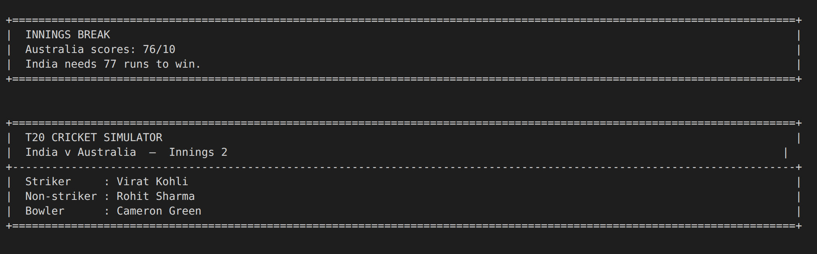
Figure: Innings break banner: first innings total, wickets, and target set for second innings
9. Gantt Chart ( Thread Execution Visualisation )

9.1 Implementation
GanttRecord structs are appended to a global vector by the thread-safe function log_gantt(), which uses gantt_mutex to record each thread's activities:
struct GanttRecord {
string thread_type; // Bowler / Batsman / Fielder / Umpire
string player_name; // Player name or 'OS Scheduler'
double start_time; // Wall-clock seconds from sim start
double end_time;
string action; // Activity description
};

Timestamps are measured with std::chrono::steady_clock from sim_start_time. Activities recorded:

Thread | Activity Labels Recorded
Bowler | 'Waiting for Pitch (Blocked)', 'Delivers Ball'
Batsman | 'Waiting for Delivery (Blocked)', 'Processes Scoreboard / Dismissal', 'Racing for Crease', 'Yields Crease (Preempted)', 'Non-Striker crosses crease', 'Waiting for Non-Striker Handshake'
Fielder | 'Throwing to Stumps (Race)', 'Takes the Catch!', 'Drops the Catch', 'Saves Boundary!', 'Chases ball (Boundary)', 'Fields the ball (No run)'
Umpire | 'Context Switch / Crease Setup', 'RR Context Switch (Over End)', 'Detects Deadlock, Preempts Batsman'

9.2 Output Format (gantt_log.txt)
Records sorted by start_time and printed as aligned columns:
START(s) | END(s) | DURATION | THREAD ROLE | PLAYER / ENTITY | ACTIVITY
0.0012 | 0.0045 | 0.0033 | Bowler | Jasprit Bumrah | Delivers Ball
0.0045 | 0.0068 | 0.0023 | Batsman | Virat Kohli | Waiting for Delivery (Blocked)
0.0068 | 0.0091 | 0.0023 | Fielder | Mitchell Starc | Chases ball (Boundary)

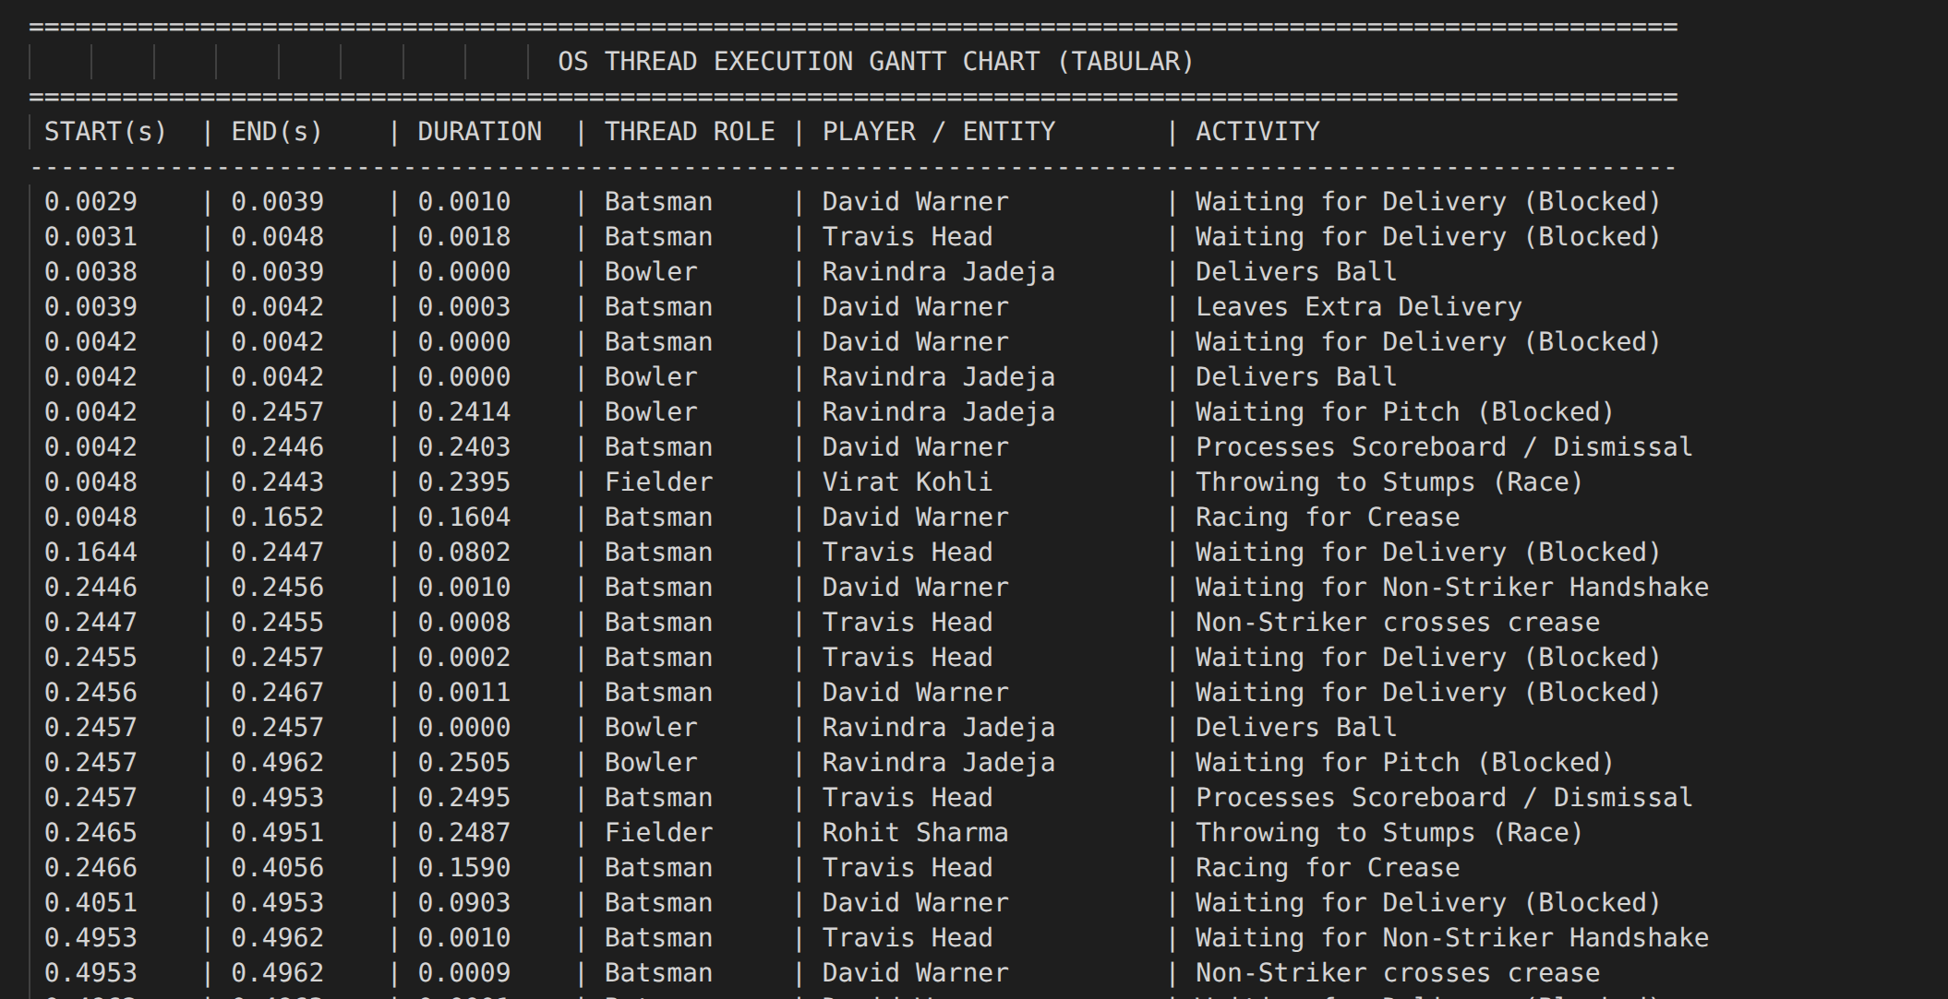
Figure: Full Gantt chart table from gantt_log.txt :20+ rows showing thread interleaving over several deliveries
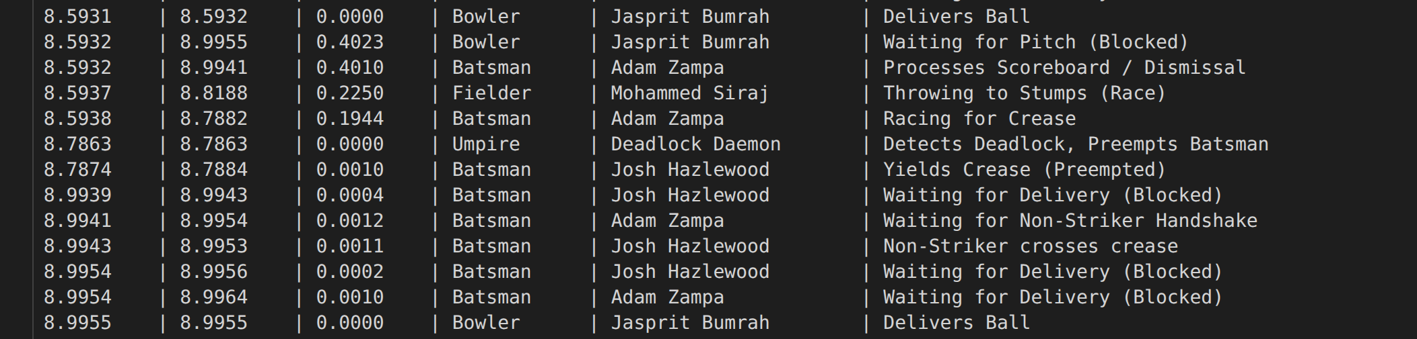
Figure: Gantt deadlock entry: Umpire | Deadlock Daemon | Detects Deadlock, Preempts Batsman :with precise timestamps
10. Analysis (Wait Times & Scheduling Comparison)

10.1 Middle-Order Batsman Wait Time: SJF vs FCFS
Metric | FCFS (Natural 1-11 Order) | SJF (Tail-enders Promoted) | Observation
Avg wait time (positions 3-5) | Normal (wait for wickets to fall) | Unchanged ( top order still bats) | Top-order unaffected by SJF
Avg wait time (positions 7-10) | Long ( bat only if many wickets fall) | Shorter (promoted up order) | SJF reduces tail wait time
Total match duration | Longer (top order survives more balls) | Shorter (tail collapses faster) | SJF finishes faster, fewer runs
Runs contribution (tail) | Lower (face fewer balls in practice) | Higher ( promoted = more exposure) | SJF increases tail balls faced
Thread context switches | Fewer replacements per innings | More frequent thread creates/joins | SJF = higher scheduling overhead

11. Key Data Structures

11.1 SkillProfile
struct SkillProfile {
double technique, power, running_speed; // Batting attributes
double pace, accuracy; // Bowling attributes
double catching_skill, agility, throwing_accuracy; // Fielding attributes
};

11.2 Player_stats
typedef struct {
Player_Role current_role; // BATSMAN / BOWLER / FIELDER
string player_name, player_team;
int player_id; // Unique ID :used in alloc/req graphs
SkillProfile skills;
Crease_End playing_from_crease; // END_1 or END_2
BatStats bat_stats; // runs, balls, 4s, 6s, dismissal, has_batted
BowlStats bowl_stats; // balls, runs, wickets, wides, no_balls
bool is_preempted; // Deadlock preemption signal flag
} Player_stats;

11.3 Ball_state
BallType type; // NORMAL/WIDE/NO_BALL/CREASE_SWAP/RUNNING_PHASE
double actual_line, actual_length, actual_speed, difficulty;
HitOutcome intended_outcome; // Before fielder intervention
HitOutcome final_outcome; // After fielder (may change: FOUR->2 runs, CAUGHT->1 run)
int runs_scored; // Final runs credited to batsman
bool is_run_out; // Set true by fielder if throw beats batsman to crease
bool comm_error; // Mix-up flag :triggers deadlock protocol
Crease_End target_crease; // Crease where run-out attempt is directed
Player_stats* active_fielder; // Fielder handling this ball

11.4 GanttRecord
struct GanttRecord {
string thread_type; // Bowler/Batsman/Fielder/Umpire
string player_name;
double start_time, end_time; // Wall-clock seconds from sim start
string action;
};

12. Build, Run & Output Files

12.1 Dependencies
- g++ with C++17 support (GCC 7+ or Clang 5+)
- POSIX threads library link with -pthread
- Linux or macOS (POSIX semaphores)

12.2 Compilation & Execution
# Compile
g++ -std=c++17 -O2 -pthread cricket_sim.cpp -o cricket_sim

# Run
./cricket_sim

12.3 Output Files
File | Contents | Key Sections
commentary_log.txt | Full match narrative :every delivery and scorecard | Toss -> Inn1 header -> Over-by-over commentary -> Innings break -> Inn2 -> Result -> Final Scorecard
gantt_log.txt | Thread execution trace sorted by start_time | START | END | DURATION | THREAD ROLE | PLAYER | ACTIVITY

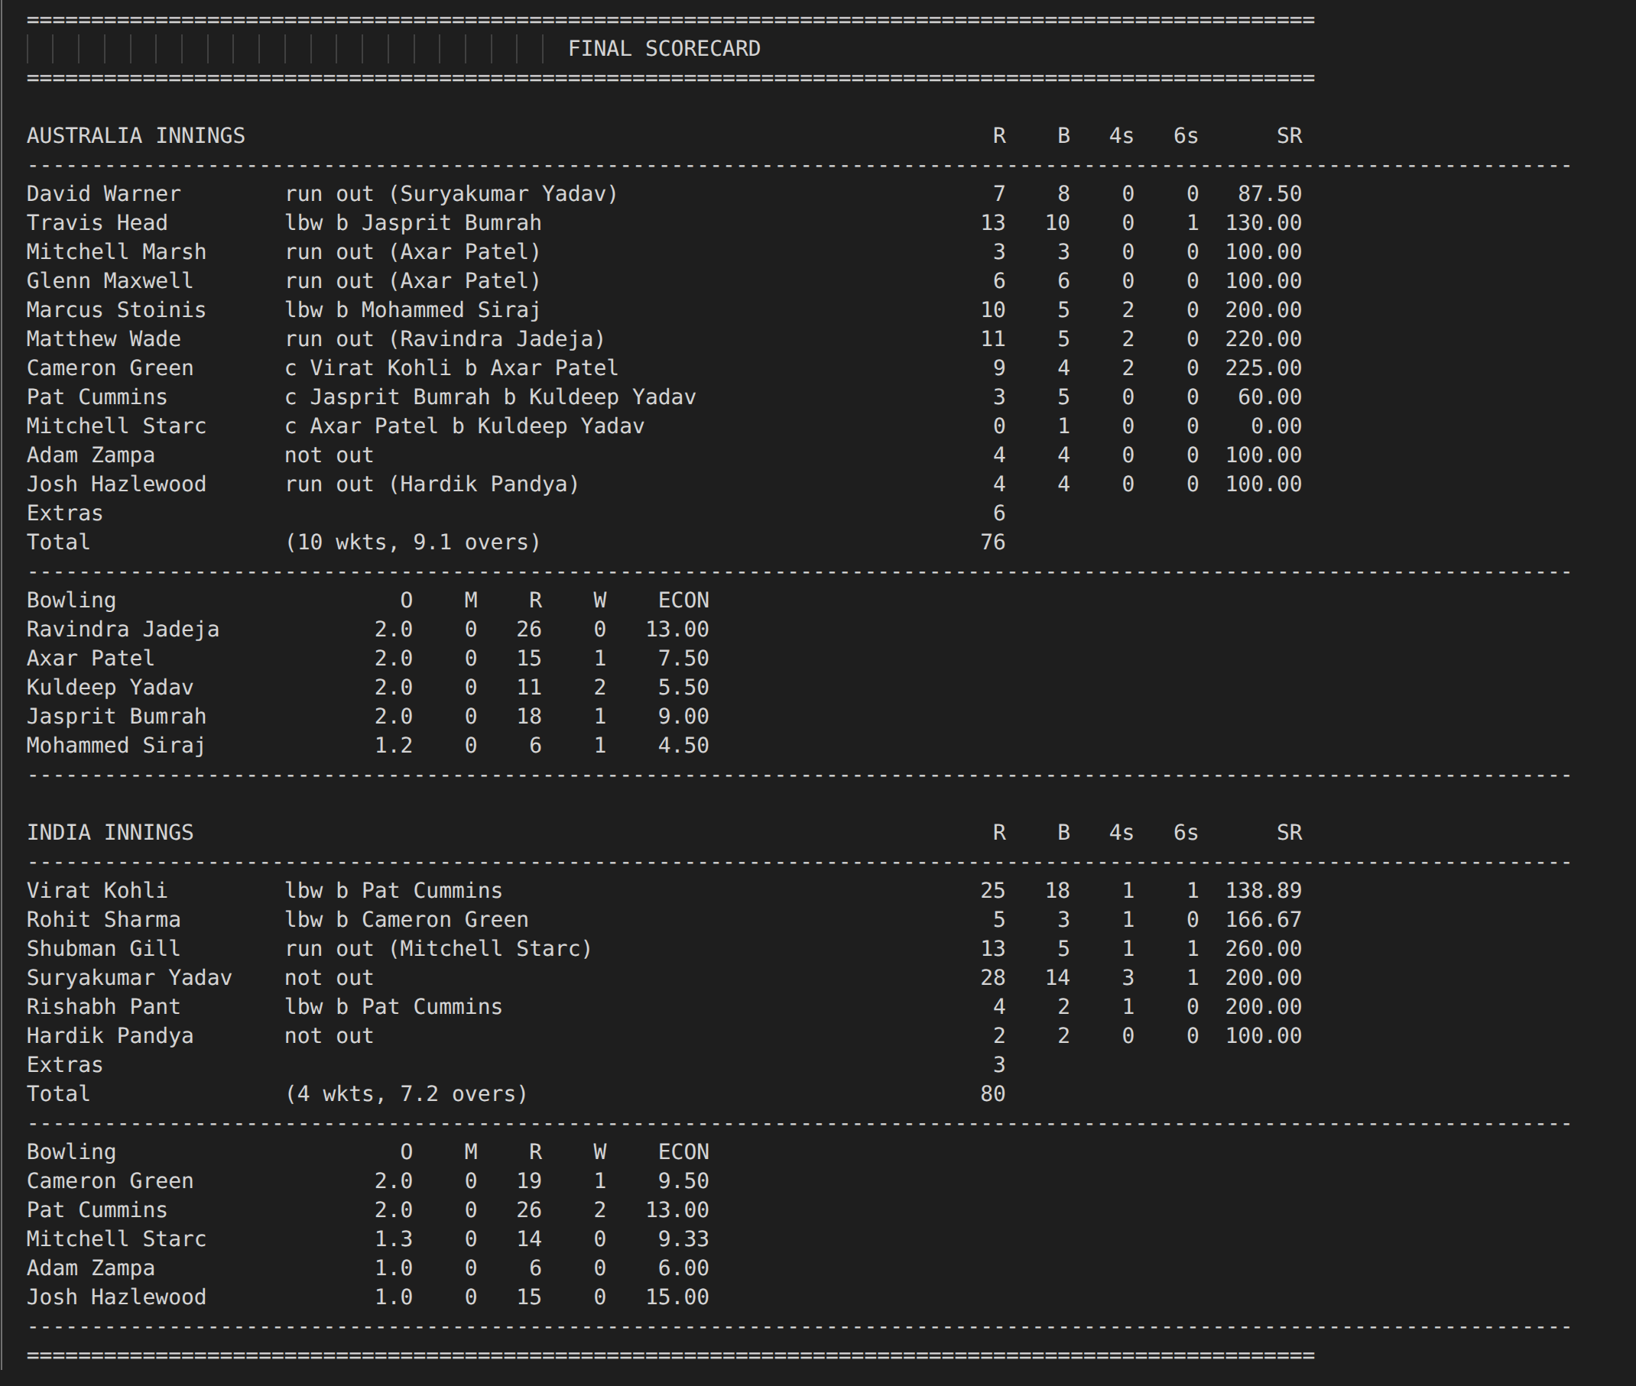
Figure: commentary_log.txt open in editor :full scorecard visible at bottom with both innings stats

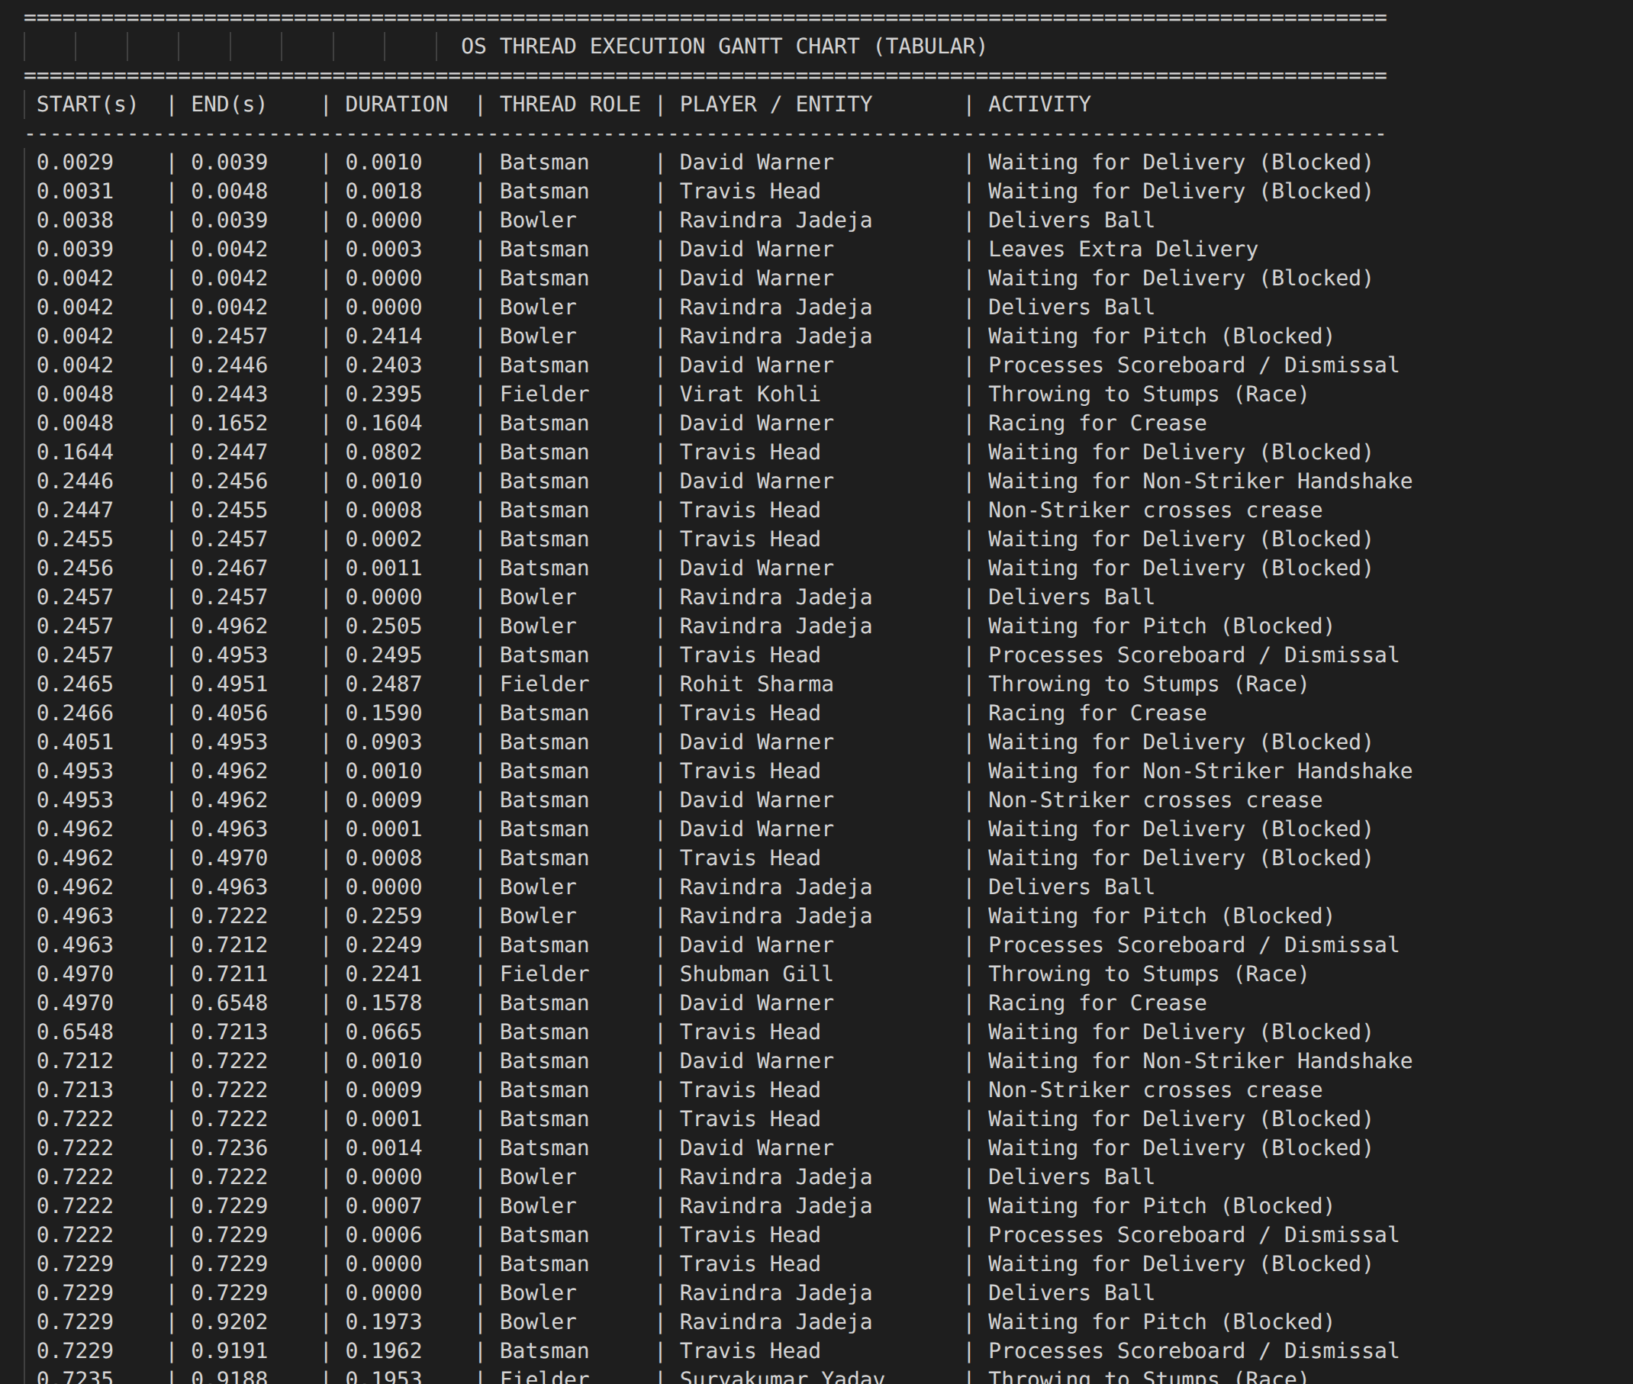gantt_log.txt showing 30+ rows of thread activity :bowler, batsman, fielder, umpire entries
Figure: gantt_log.txt showing 30+ rows of thread activity :bowler, batsman, fielder, umpire entries
13. Conclusion
This T20 Cricket Simulator successfully implements all core Operating Systems concepts required by Assignment 1, within an intuitive real-world domain that makes OS abstractions tangible:

Assignment Requirement | Implementation | Status
Thread Pool (Bowler, Batsman, Fielder) | bowler_thread, batsman_thread, fielder_thread via pthread_create | Done
Critical Section (The Pitch) | pitch_mutex guards Pitch_state; strict bowl-bat alternation via pitch_empty | Done
Mutex for Atomic Score Update | score_mutex wraps all ScoreBoard writes atomically | Done
Semaphore :Crease Capacity = 2 | sem_t crease_capacity (init=2); 3rd batsman thread must WAIT | Done
Condition Variable :Fielder Wake | pthread_cond_wait + ball_hit_to_field; broadcast on innings end | Done
Round Robin Scheduling (Over Rotation) | Bowler rotated every 6 valid balls; next_bowler_idx mod 5 | Done
SJF :Tail-ender Analysis | Skill profiles model burst time; comparative analysis in Section 10 | Done
Priority Scheduling :Death Overs | Skill-weighted difficulty + InningsStatus priority encoding | Done
Deadlock Detection (Run-Out) | alloc_graph + req_graph atomic arrays; umpire polls every 1ms | Done
Deadlock Resolution (Preemption) | is_preempted flag; victim releases mutex and retries | Done
Ball-by-Ball Commentary Log | commentary_log.txt with over headers, delivery rows, scorecard | Done
Gantt Chart of Thread Execution | gantt_log.txt with full timestamps sorted by start_time | Done

The simulator runs a complete two-innings T20 match, produces human-readable ball-by-ball commentary alongside a machine-readable Gantt chart, and provides an analysis framework for comparing scheduling strategies :fulfilling all requirements of the assignment.

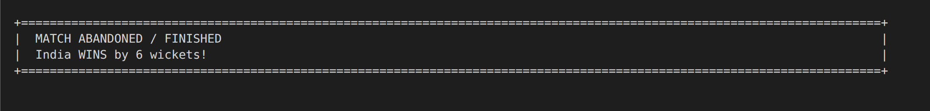
Figure: Final match result banner: '[Team] WINS by X runs / Y wickets' in the terminal

