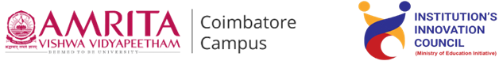

**Live-in-Labs® : Field Visit to Kolundurai, Ramanathapuram**

**Activity Category :** Self – Driven Activities

**Event Title :** Live-in-Labs : Field Visit

**Dates :**04/06/2025 – 13/06/2025

**Occasion/Theme :** Experiential Learning

**Organized by :** Live-in-Labs, Amrita Vishwa Vidyapeetham

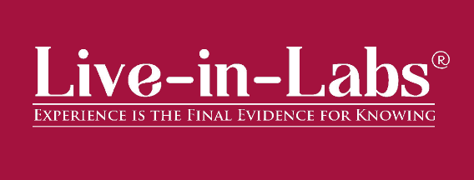

**Overview**

The Live-in-Labs® project in **Kolundurai** was carried out by a team of Amrita students and international students under the mentorship of **Dr. Lalithamani N** Department of Computer Science and Engineering . The focus of the visit was to address the challenge of Unavailability of free drinking water, through innovative, sustainable, and community-driven solutions.

The team interacted with villagers, conducted surveys, and studied the socio-economic conditions to identify root causes of the problem. Based on this, solutions such as a robust low-power modular purifier for accessible dinking water within village is proposed. These interventions combine scientific knowledge with frugal innovation, making them both cost-effective and scalable.

The visit provided the team with hands-on exposure to applying classroom concepts in real-world contexts. Students gained valuable knowledge on design thinking, grassroots innovation, and community engagement. The collaboration between Amrita and international students enriched the process with diverse perspectives, ensuring that the solutions were both technically sound and socially acceptable.

Overall, the project demonstrated how grassroots challenges can be transformed into opportunities for innovation and entrepreneurship. The solutions identified have the potential for further prototyping, incubation, and replication in other rural contexts, aligning with the vision of IIC to foster innovation-driven impact.

**Planning & Execution**

The project was planned in advance based on the schedule prepared and submitted during the Live-in-Labs® workshop. The schedule served as a roadmap, outlining each stage of the work from preliminary study to field immersion and final reporting. In the initial phase, the team conducted a background study of the village and gathered secondary data to understand the broader context of the problem. This was followed by structured planning of surveys, community interactions, and technical assessments, all aligned with the timelines agreed upon.

Day-wise schedule:

1. 04-06-2025: Meeting with village head, Exploration of the village, Government School interview, Building rapport, AEIOU/6 Senses observation.
2. 05-06-2025: PHC interview, Interview with - MGNREGA union head, meeting with Anganwadi teachers, Resource map(North), Building rapport, Household interviews.
3. 06-06-2025:Meeting with government school for World environment day, Resource map(South) , Resource Map(East).
4. 07-06-2025:Brainstorming(North), Meeting Mr.Yuvraj, a soldier who took part in 1999 Kargil War and Operation Sindhoor, Household Interviews/Empowering App
5. 08-06-2025:Transect walk, Remaining resource map(South).
6. 09-06-2025:Brainstorming(South), Focused Group Discussion with SHG’s, Meeting E-seva collecting village statistics, Transect Walk(North).
7. 10-06-2025: Household Interviews/Empowering App.
8. 11-06-2025: Brainstorming(East), Household Interviews/Empowering App.
9. 12-06-2025: Household Interviews/Empowering App.
10. 13-06-2025: Water Sample Collection, Farewell to villagers.

**Impact & Outcomes**

* **Innovation :** The project demonstrated how grassroots challenges can inspire innovative, frugal solutions. By integrating scientific concepts with local knowledge, the team is planning to design interventions such as a robust low-power modular water purifier that will be low-cost, adaptable, and scalable. This process highlighted the power of student-led innovation to create practical and impactful models in rural development.
* **Design Thinking :** The outcomes of the project were achieved by following a design-thinking approach. Students empathized with villagers through surveys and discussions, defined the root problems, ideated possible solutions, and tested their feasibility with the community. This systematic method ensured that the solutions were not only technically feasible but also socially acceptable and context-specific.
* **Entrepreneurship Potential :** Several proposed solutions have the potential to evolve into entrepreneurial models or startups. For example, robust low-power modular water purifier can be further developed into a product or service that benefits multiple villages, creating employment opportunities while addressing community needs. This outcome aligns with IIC’s vision of nurturing student entrepreneurship and translating innovation into scalable ventures.
* **Sustainability :** The solutions emphasized long-term sustainability by making use of locally available resources and building capacity within the community. As a result, the interventions can be maintained by villagers themselves without heavy dependence on external support. This ensures that the outcomes continue to create impact even after the project phase ends.
* **Societal Impact :** The immediate impact of the project was raising awareness among community members about alternative and innovative practices. In the long run, the solutions are expected to improve living standards, reduce resource-related hardships, and strengthen the resilience of the village. The project also encouraged local youth to view innovation as a tool for solving their own challenges.
* **Collaboration and Knowledge Sharing :** A significant outcome of the project was the knowledge exchange that took place between Amrita students, international peers, and the local community. This cross-cultural collaboration enriched the learning experience, allowed multiple perspectives to be considered, and helped design solutions that were technically sound, socially relevant, and globally informed.

**Participation**

1. **Student Members** : Conducted Surveys, Identified the Problem and Designed Solutions.

* Akhil S (CB.SC.U4CSE24105)–Computer Science and Engineering
* Anuja R S (CB.SC.U4CSE24107) - Computer Science and Engineering
* Bhirugu Dev V R (CB.EN.U4ELC24156)–Electrical and Computer Engineering
* Pabolu Amrutha Sai Spandana (CB.SC.U4CSE24336)- Computer Science and Engineering
* Subhalakshmi Balakrishnan (CB.EN.U4CCE24053)–Computer and Communication Engineering

1. **Faculty Member (Mentor)** : **Dr. Lalithamani N** Department of Computer Science and Engineering - Provided continuous guidance and supervision.

**Contribution to SDGs**

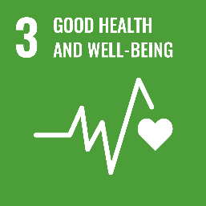The project contributes to several United Nations Sustainable Development Goals (SDGs): **SDG**

By addressing clean drinking water , the project improves health outcomes for the community.

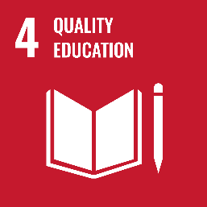

Knowledge sharing, awareness programs, and cross-cultural learning enhanced educational opportunities for both villagers and students.

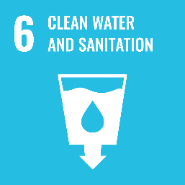

Proposed solutions such as water purification units directly improve access to safe water and sanitation facilities.

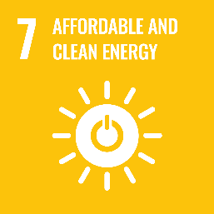

Interventions like solar-powered systems, waste-to-energy solutions promote clean and sustainable energy alternatives.

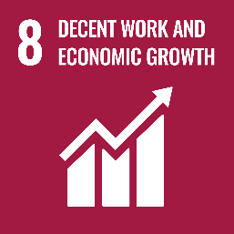

Entrepreneurial potential of the solutions encourages community-based enterprises and livelihood opportunities.

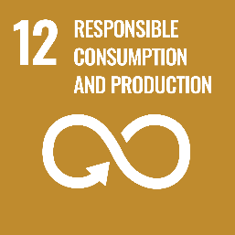

The solutions emphasize frugal innovation, waste reduction, and sustainable use of resources.

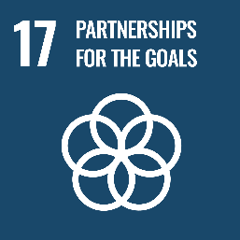

Collaboration between Amrita students, international peers, and the village community reflects strong global partnerships for sustainable development.

**Publicity**

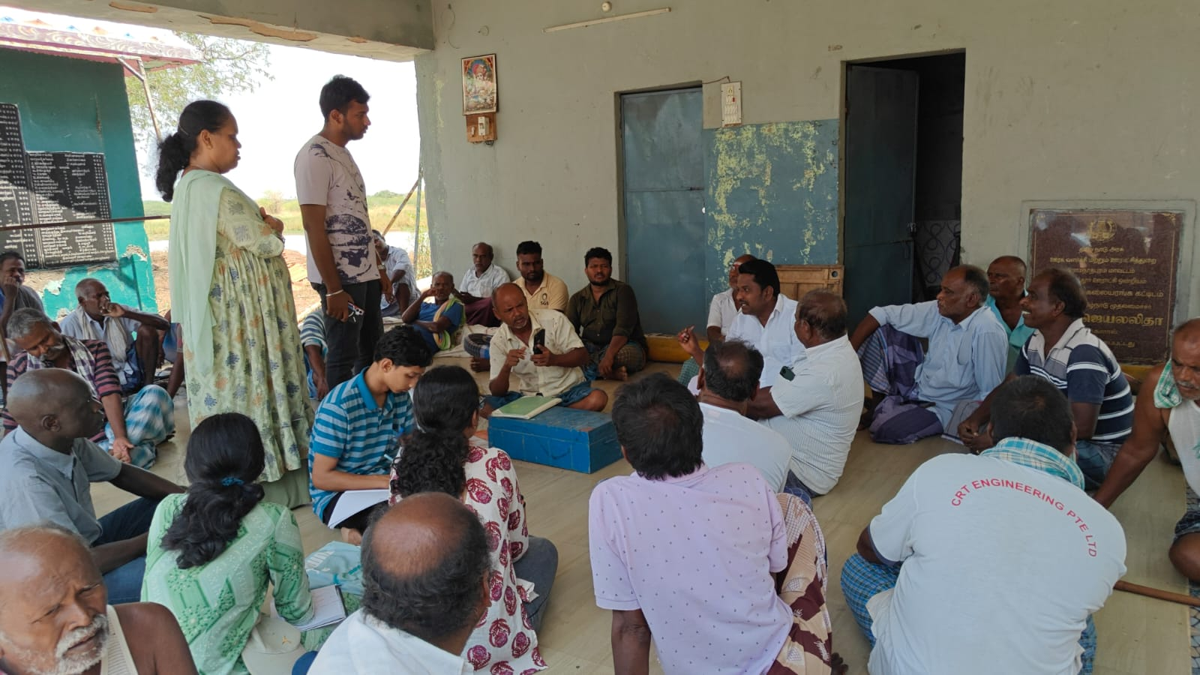

Fig 1: North brainstorming

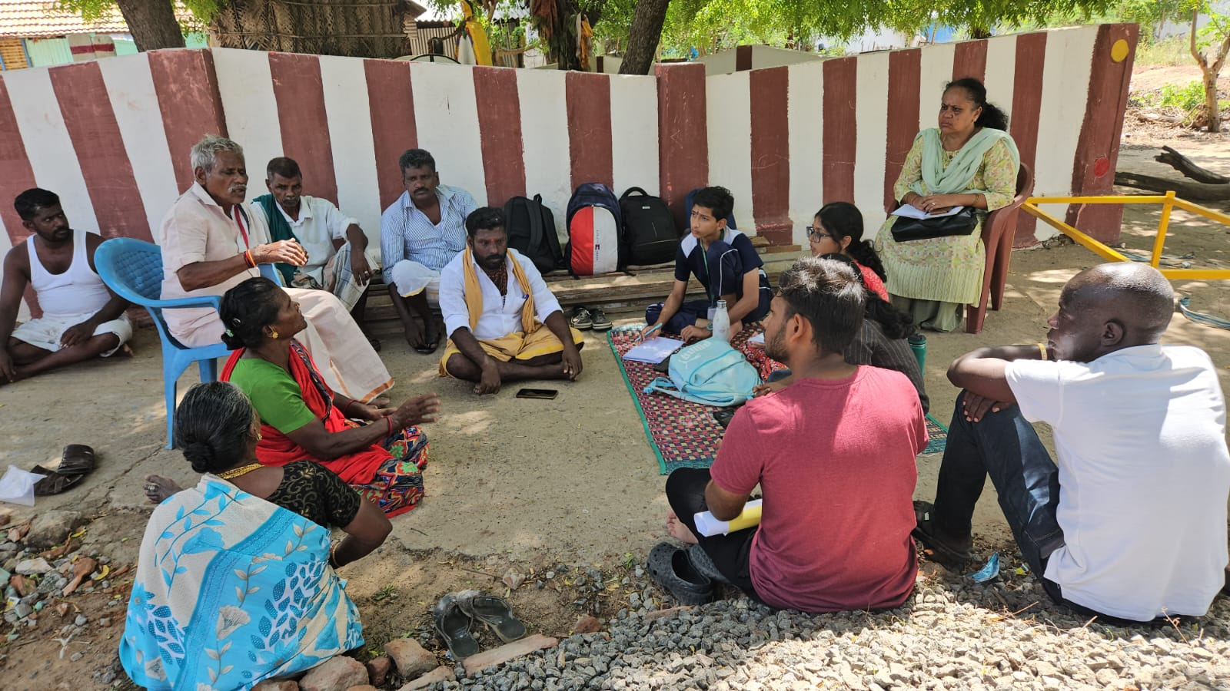Fig 2: South brainstorming

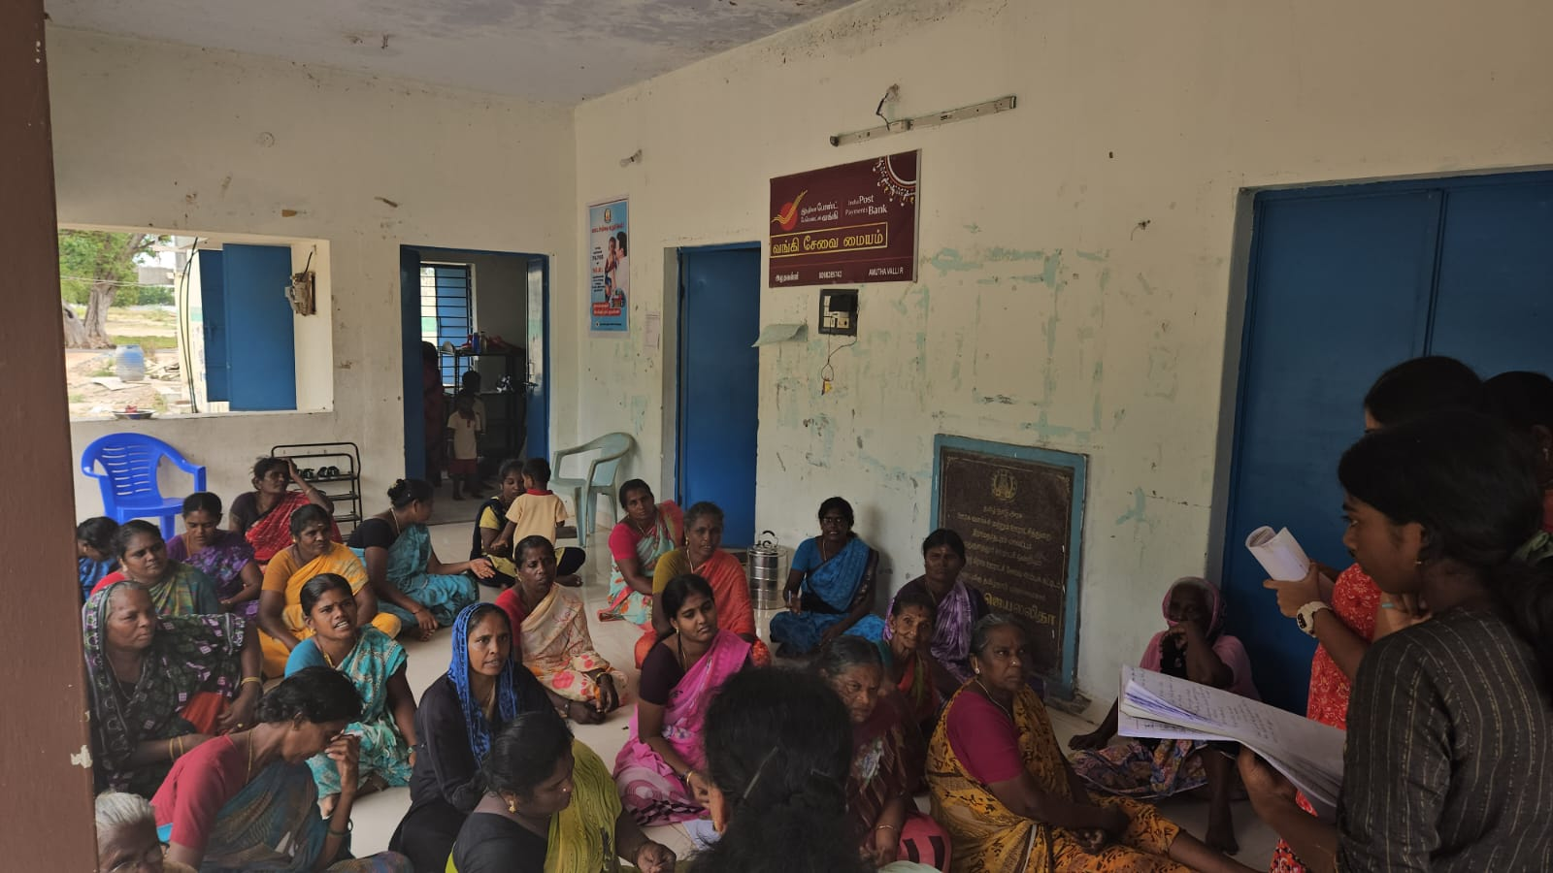

Fig 3: SHG Focus group discussion

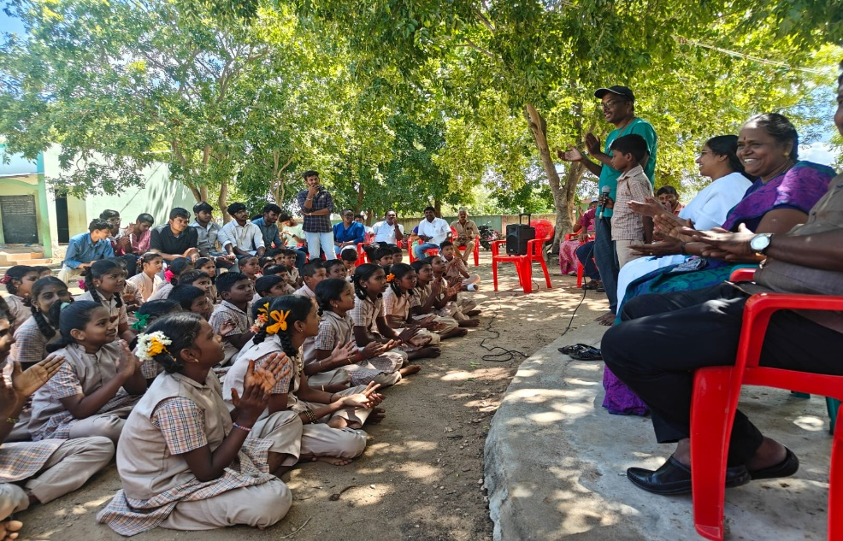

Fig 4: Tree plantation drive conducted at the local government primary school

