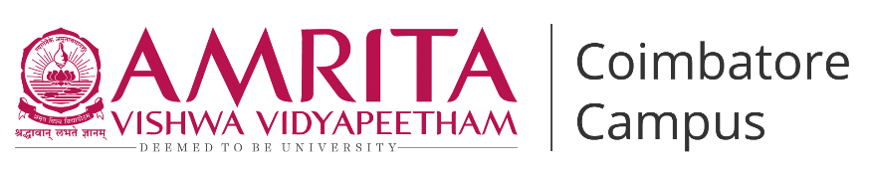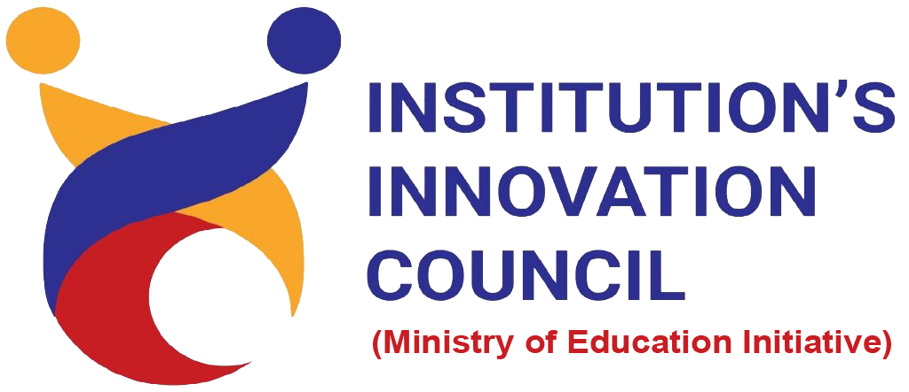

**Live-in-Labs® : Field Visit to Annai Sathya Nagar, Ramanathapuram**

**Activity Category :** Self – Driven Activities

**Event Title :** Live-in-Labs : Field Visit

**Dates :** Phase 1 (23/12/2024 to 29-12-2024) & Phase 2 (25-04-2025 to 02-05-2025)

**Occasion/Theme :** Experiential Learning

**Organized by :** Live-in-Labs, Amrita Vishwa Vidyapeetham

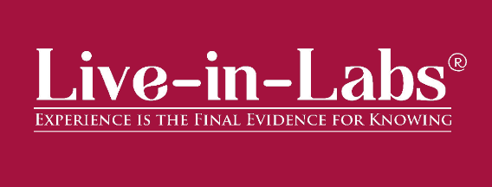

**Overview**

The Live-in-Labs® project in ***Annai Sathya Nagar***was carried out by a team of Amrita students and international students under the mentorship of***Dr. Geetha P***. The focus of the visit was to address the challenge of *Open Defecation* through innovative, sustainable, and community-driven solutions.

The team interacted with villagers, conducted surveys, and studied the socio-economic conditions to identify root causes of the problem. Based on this, solutions such as *Public Toilet Renovation(well desilting, pipeline repair, lighting upgrades)* and *Community Awareness Campaign* were proposed. These interventions combine scientific knowledge with frugal innovation, making them both cost-effective and scalable.

The visit provided the team with hands-on exposure to applying classroom concepts in real-world contexts. Students gained valuable knowledge on design thinking, grassroots innovation, and community engagement. The collaboration between Amrita and international students enriched the process with diverse perspectives, ensuring that the solutions were both technically sound and socially acceptable.

Overall, the project demonstrated how grassroots challenges can be transformed into opportunities for innovation and entrepreneurship. The solutions identified have the potential for further prototyping, incubation, and replication in other rural contexts, aligning with the vision of IIC to foster innovation-driven impact.

**Planning & Execution**

The project was planned in advance based on the schedule prepared and submitted during the Live-in-Labs® workshop. The schedule served as a roadmap, outlining each stage of the work from preliminary study to field immersion and final reporting. In the initial phase, the team conducted a background study of the village and gathered secondary data to understand the broader context of the problem. This was followed by structured planning of surveys, community interactions, and technical assessments, all aligned with the timelines agreed upon.

**Daywise Schedule:**

**Phase 1:**

* **Day 1 (23/12/2024):** Team traveled to the village, met the coordinator and Thalaivar, and conducted a village walk for initial mapping.
* **Day 2 (24/12/2024):** Conducted community interviews, seasonal calendar exercise, and resource mapping with villagers.
* **Day 3 (25/12/2024):** Visited the health centre, and updated resource maps while identifying key challenges.
* **Day 4 (26/12/2024):** Carried out household surveys, and prepared stakeholder mapping using Venn diagrams.
* **Day 5 (27/12/2024):** Facilitated focus group discussions, cross-checked resource maps, and created the problem tree.
* **Day 6 (28/12/2024):** Performed inflow–outflow checks, updated PRA tools, validated the problem tree with the community, conducted brainstorming sessions and developed personas and scenarios.
* **Day 7 (29/12/2024):** Completed pending works, cross-verified data with villagers and faculty, and evaluated all tasks for final documentation.

**Design Thinking (Bridge to Phase 2):**

* Between the two visits, the team conducted solution co-design sessions in discussion with the mentor, faculty members and villagers.
* This helped analyze findings from Phase 1, validate the problem tree, and converge on the most practical solution: revamping the abandoned public toilet.
* Brainstorming, feasibility checks, and faculty and community consultations shaped the phased renovation plan that was implemented in Phase 2.

**Phase 2:**

* **Day 1 (25/04/2025):** Met the village coordinator and stakeholders, visited the abandoned public toilet, and discussed the phased renovation plan with the community.
* **Day 2 (26/04/2025):** Conducted awareness sessions on sanitation and responsible toilet use, distributed pamphlets, and involved residents in planning.
* **Day 3 (27/04/2025):** Drained, desilted, disinfected, and secured the contaminated well with a protective mesh cover.
* **Day 4 (28/04/2025):** Flushed, repaired, and tested the pipelines to ensure safe water supply for the toilet facility.
* **Day 5 (29/04/2025):** Carried out fixture upgrades, deep cleaning of the blocks, and installed new lighting to improve safety and usability.
* **Day 6 (30/04/2025):** Facilitated community participation in cleaning, minor repairs, and maintenance training to build local ownership.
* **Day 7 (01/05/2025):** Conducted a final awareness drive covering all 105 households, reinforced hygiene practices, and wrapped up with stakeholder feedback and sustainability planning.

**Impact & Outcomes**

* **Innovation :** The project demonstrated how grassroots challenges can inspire innovative, frugal solutions. By integrating scientific concepts with local knowledge, the team designed interventions such as *public toilet renovation (well desilting, pipeline repair, lighting)* that were low-cost, adaptable, and scalable. This process highlighted the power of student-led innovation to create practical and impactful models in rural development.
* **Design Thinking :** The outcomes of the project were achieved by following a design-thinking approach. Students empathized with villagers through surveys and discussions, defined the root problems, ideated possible solutions, and tested their feasibility with the community. This systematic method ensured that the solutions were not only technically feasible but also socially acceptable and context-specific.
* **Entrepreneurship Potential :** Several proposed solutions have the potential to evolve into entrepreneurial models or startups. For example, the proposed solution of *Anaerobic Upflow Domestic Septic Tank (AUDST) with operation and maintenance (O&M) modeling* can be further developed into a product or service that benefits multiple villages, creating employment opportunities while addressing community needs. This outcome aligns with IIC’s vision of nurturing student entrepreneurship and translating innovation into scalable ventures.
* **Sustainability :** The solutions emphasized long-term sustainability by making use of locally available resources and building capacity within the community. As a result, the interventions can be maintained by villagers themselves without heavy dependence on external support. This ensures that the outcomes continue to create impact even after the project phase ends.
* **Societal Impact :** The immediate impact of the project was raising awareness among community members about alternative and innovative practices. In the long run, the solutions are expected to improve living standards, reduce resource-related hardships, and strengthen the resilience of the village. The project also encouraged local youth to view innovation as a tool for solving their own challenges.
* **Collaboration and Knowledge Sharing :** A significant outcome of the project was the knowledge exchange that took place between Amrita students, international peers, and the local community. This cross-cultural collaboration enriched the learning experience, allowed multiple perspectives to be considered, and helped design solutions that were technically sound, socially relevant, and globally informed.

**Participation**

1. **Student Members** : Conducted Surveys, Identified the Problem and Designed Solutions.

* Pinjala Thrinadh (CB.EN.U4CSE22141) – Department of Computer Science and Engineering
* Nithyashree Marichamy (CB.EN.U4ECE22036)- Department of Electronics and Communication Engineering
* Sabbella Manoj Subba Reddy (CB.EN.U4CSE22359)- Department of Computer Science and Engineering
* Vinuga V M (CB.EN.U4CCE22059) - Department of Electronics and Communication Engineering
* R. Sheshanth (CB.EN.U4MEE23032)– Department of Mechanical Engineering
* Pranav P S (CB.EN.U4CSE22536) – Department of Computer Science and Engineering
* Aniruth Sriram K S (CB.EN.U4EEE22004) – Department of Electrical and Electronics Engineering

**Contribution to SDGs**

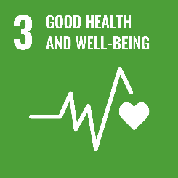The project contributes to several United Nations Sustainable Development Goals (SDGs):

By addressing sanitation behaviour-change and community health awareness, the project improves health outcomes.

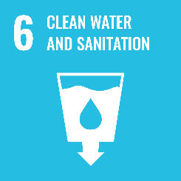

Proposed solutions such as septic tank upgrades, public toilet rehabilitation, and sanitation awareness drives directly enhance access to safe sanitation and clean water facilities.

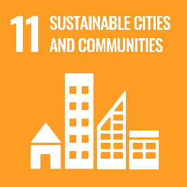

Through community-driven toilet renovations and active youth participation in awareness drives, the project promotes sustainable infrastructure, resilient communities, and improved living conditions.

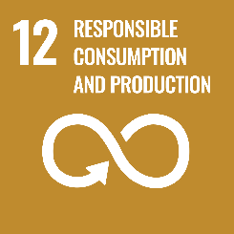

The solutions emphasize frugal innovation, waste reduction, and sustainable use of resources.

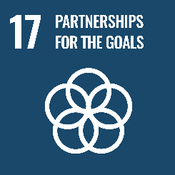

Collaboration between Amrita students, international peers, and the village community reflects strong global partnerships for sustainable development.

**Publicity**

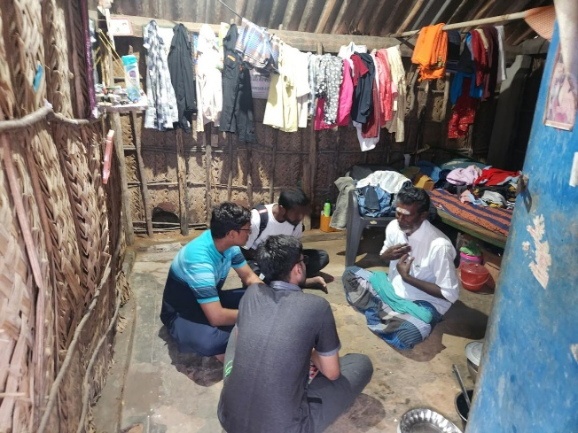 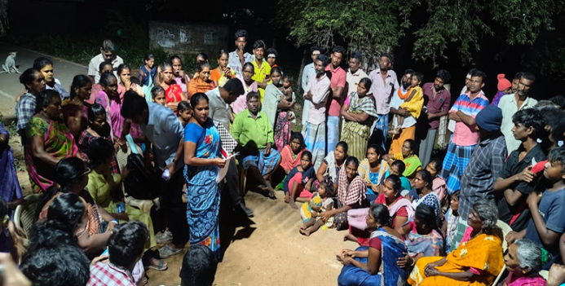

Figure 1: Personal Interview Figure 2: Brainstorming Session

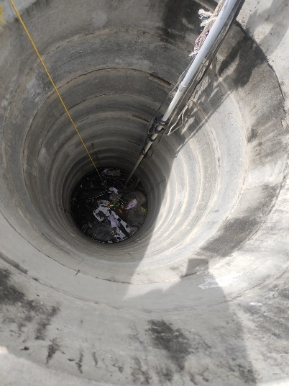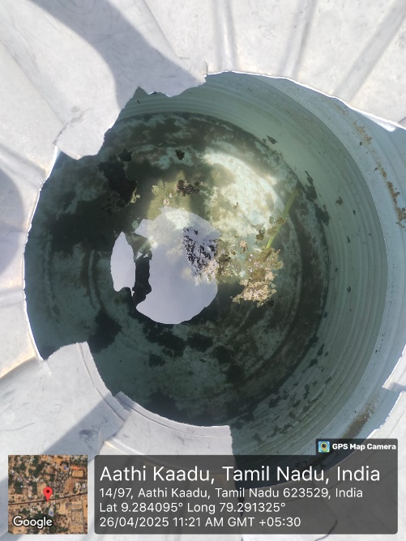 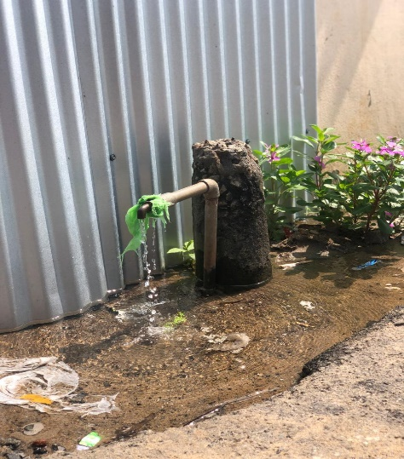

* 1. (b) (c)

Figure 3 (a), (b), (c) : Visual Insights from PRA Exercises

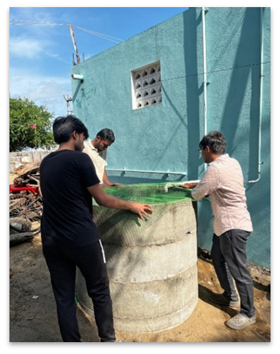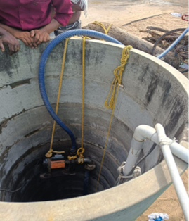

Figure 4: Cleaning the Well Figure 5: Covering the Well with a Green Net

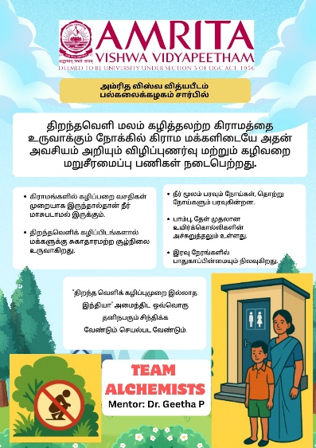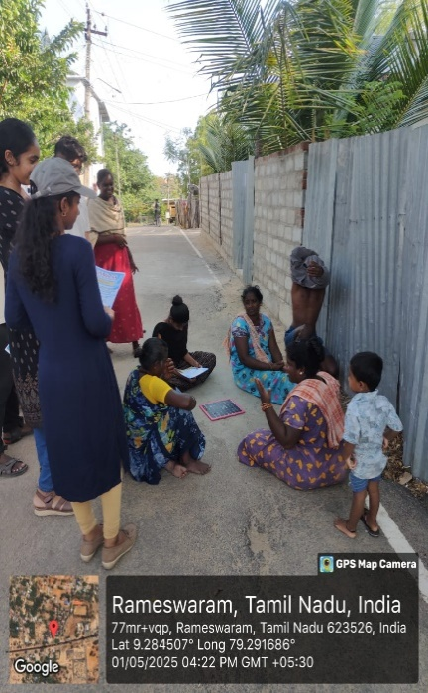

Figure 6: Community Awareness Pamphlet Figure 7: Awareness Interaction

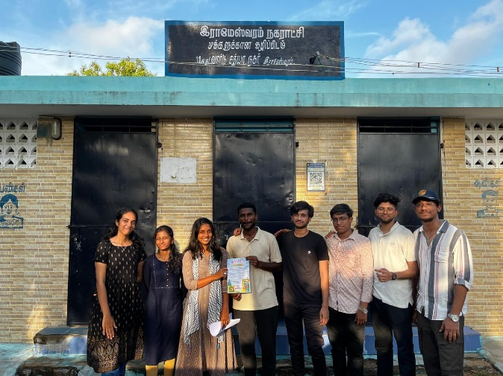

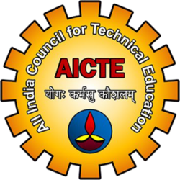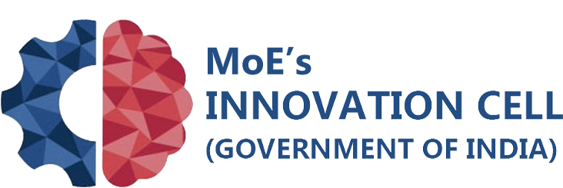

Figure 8: Team Alchemists’ Successful Implementation Intervention