
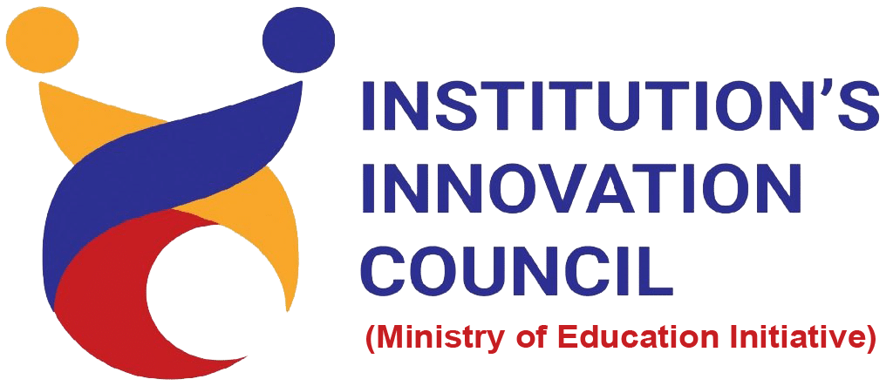
Title of the Session

Session Details
Date | Xx - <JAN, FEB, MAR, APR, MAY, JUN, JUL, AUG, SEPT, OCT, NOV, DEC> - 20xx
Duration | x Hours y Mins (X:xx AM/PM – X:xx AM/PM)
Level | refer attendance
Mode | Hybrid/Offline/Online (either one)
Venue / Platform  (choose appropriately) | Name of the Venue/ Virtual platform – MS Teams  Meeting Link : (in case Online/ Hybrid)
Activity Category | Calendar Activity/ MIC Driven Activity/ Self-Driven Activity/ Celebration Activity/ R&D Cell Activity  (specify either of these)
Activity Led by | Institute Council / Student Council (either one)
Theme | IPR & Technology Transfer / Innovation & Design Thinking / Entrepreneurship & Startup / Pre-Incubation & Incubation Management / Safe and Trusted AI / Human Capital / Science / Resilience, Innovation & Efficiency / Inclusion for Social Empowerment / Democratizing AI Resources / Economic Growth & Social Good (either one)

Objective
Briefly explain the (a) Purpose of the activity, (b) Why it was organized, (max 4–5 lines).

Expert/Speaker Details
(In case of single speaker)
Name of the Speaker: | Keep First Letter Caps in All Parts of Name and Include Dr/Mr/Ms Where Necessary
Designation | Of The Speaker
Organization/Institution | Of the speaker
Brief about Expert/Speaker | Include his/ her achievements/ awards and his life work etc

(In case of multiple speaker… accordingly number of speakers can be added or removed)
Name of the Speaker | Designation | Organization/Institution | Brief about Expert/Speaker
Speaker 1 -
<name>
Speaker 2 -
<name>
Speaker 3 -
<name>

Activity Description
(150 – 200 words) Include important aspects of the activity like (a) How the session started, (b) Key topics covered, (c) Key points used while interaction with participants, (d) Demonstrations / examples shared, (e) Q&A session, (f) Any activity conducted (quiz, brainstorming, ideation exercise etc.).
All these are to be in points and not separate sub topics.
Participant details
No. of Student Participation | No. of Staff Participation | No. of External Participation

Key Highlights

Briefly mention the most important moments, insights, and engagement points of the activity (in short bullet points (5–8 points) that help to understand what made the session meaningful).

Activity Outcome

Clearly mention what participants gained. The outcome should align with and reflect the KPIs mentioned in the activity details on the IIC portal.

Feedback / Reflection
Include 2–3 participants’ feedback.

Organizing Team Members

Role in Activity | Full Name
Faculty Coordinator
Student Coordinator
Event Manager
Social Media Coordinator

Photographs/Screenshots (Screenshots in case of Hybrid Sessions)
(one of the photos should be geo tagged)

[Insert Photograph ]  Banner used for the activity | [ Insert Photograph ]  Common viewing – dais / screen with banner
[ Insert Photograph ]  Students & staff participation | [ Insert Photograph ]  Candid / unique activity moment

Media Coverage and Pre & Post Activity Social Media Post screenshot
[ Attach screenshots of the pre-activity announcement and the post-activity update shared on the Institute’s official social media handles, tagging AICTE, MIC and MoE. Attach any newspaper or newsletter coverage, if available ]
Contact Lohitha M, in case the social media posts is not having these tags, or not having IIC logo

Attendance details
[ Attach a scanned copy of the signed attendance sheet as an annexure ]
Contact Dhaniksha to ensure attendance for the event is available.

