**Hyperloop**



**It's 2020 and it's time to invent something that will be really useful and ecological!** 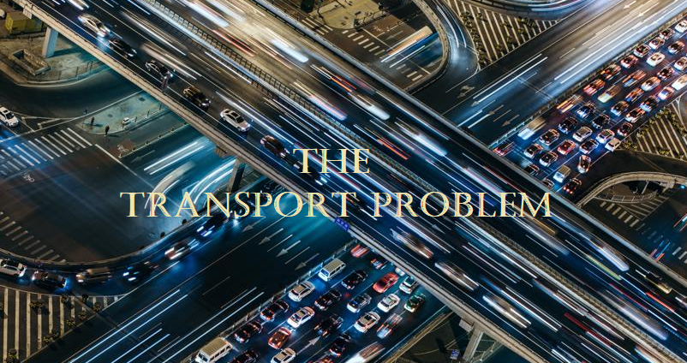

As we know transport is a worldwide global problem. There is a lot of traffic congestion, crashes, noise, air pollution, landscape destruction, or greenhouse gas emissions and.. The costs from our current forms of transport are dangerously high and getting worse.

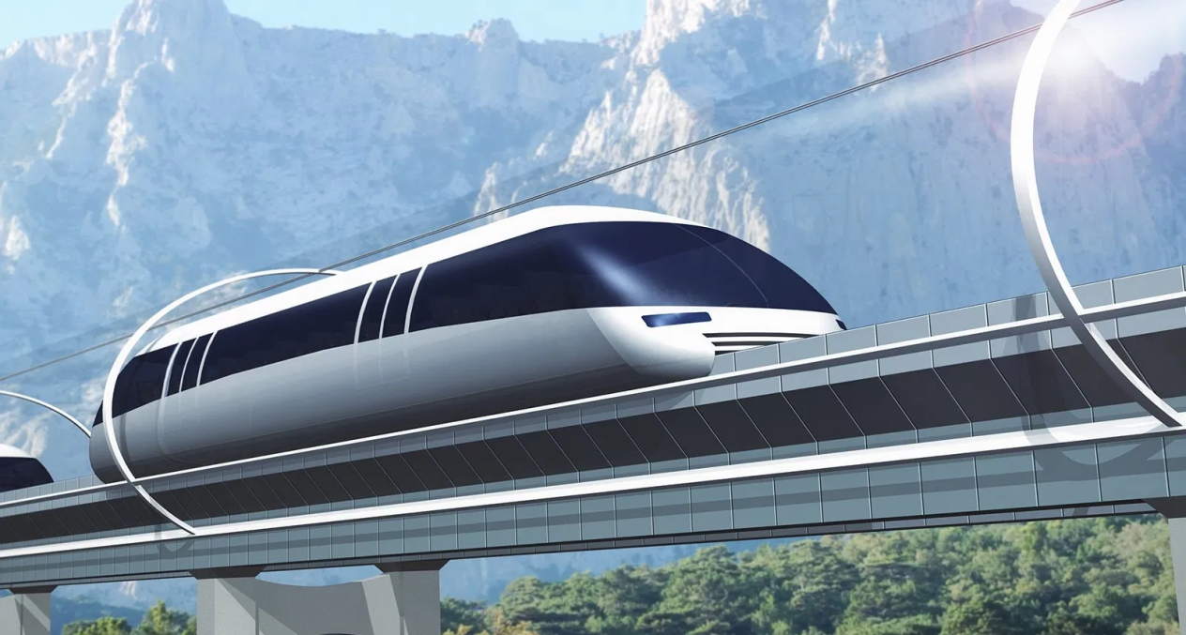

Luckily our team “Future Technology” is delighted to present you The Hyperloop! It's a transport capsule or system of capsules through which a pod may travel free of [air resistance](https://en.wikipedia.org/wiki/Air_resistance) or friction conveying people or objects at high speed while being very efficient, thereby drastically reducing travel times over medium and big-range distances.

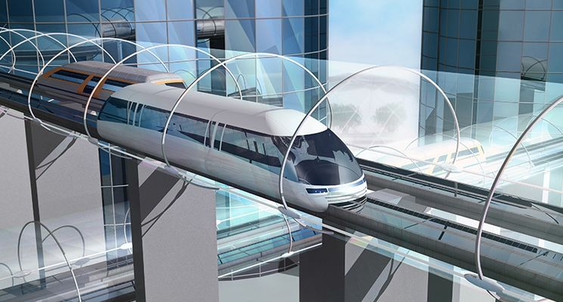

Instead of slowly and uncomfortable city’s busses we will be using the “HyperLoop”. We won’t be waiting for it for a long time, because it will be travelling with 1200km/h. About the amenities It will be more comfortable, because there are more than 20 self-warming seats in one capsule. Of the fully natural movement, the costs will be cheaper and really decreased .

**Изготвили:**

Име: Атанас Бурмов

Клас: 9А

E-mail: AABurmov18@codingburgas.bg

Име: Ангел Желязков

Клас: 9Б

E-mail: AVZhelyazkov18@codingburgas.bg

**Credits**

Video: Tesla

Photos: Arguma