
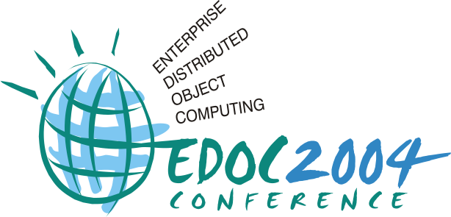


Workshop on Model-driven Web Engineering
(MDWE 2005)

Nora Koch, Antonio Vallecillo, Gustavo Rossi

Sydney (Australia), July 26, 2005
http://www.lcc.uma.es/~av/mdwe2005/

Proceedings


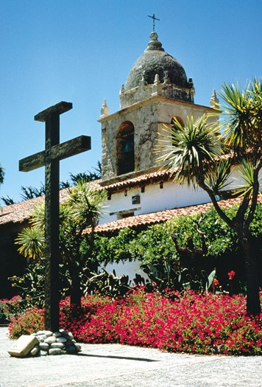




In conjunction with:

ICWE 2005. 5th International Conference on Web Engineering

http://www.icwe2005.org

Editors

Nora Koch
Institute for Informatics,
Ludwig-Maximilians-Universität München and FAST GmbH,
Oettingenstr. 67, 80538 München, Germany

kochn@pst.informatik.uni-muenchen.de
http://www.pst.informatik.uni-muenchen.de/~kochn/

Antonio Vallecillo
University of Málaga
ETSI Informática
Campus Teatinos
29071 Málaga (Spain)
av@lcc.uma.es
http://www.lcc.uma.es/~av

Gustavo Rossi
Lifia. Facultad de Informática. UNLP
50 y 115, La Plata, Buenos Aires, Argentina

gustavo@sol.info.unlp.edu.ar
http://www-lifia.info.unlp.edu.ar

Table of Contents

Preface ............................................................................………………………………………. vii
A Model Driven Approach for the Integration of External Functionality in Web Applications. The Travel Agency System
Victoria Torres, V. Pelechano, M. Ruíz, P. Valderas
……………..………..………...... 1
The PIM to Servlet-Based PSM Transformation with OOHDMDA
Hans Albrecht Schmid, Oliver Donnerhak
……………………………….………….... 12
Model Integration through Mega Operations
T. Reiter, E. Kapsammer, W. Retschitzegger, W. Schwinger
….................................. 20
Applying WebSA to a Case Study: A Travel Agency System
Santiago Meliá, Jaime Gómez ...
…………………………………………………......... 30
Web Engineering does Profit from a Functional Approach
Torsten Gipp, Jürgen Ebert
..........................................……………………................... 40
How to Model Aspect-Oriented Web Services
Guadalupe Ortíz, Juan Hernández, Pedro Clemente, Pablo Amaya
………………...… 50
Integrating Web Systems Design and Business Process Modeling
Mario A. Bochicchio, Antonella Longo
.............................................………………… 60
Incorporating Cooperative Portlets in Web Application Development
Nathalie Moreno, Raul Romero, Antonio Vallecillo
……………………...................... 70
Conceptualization of Navigational Maps for Web Applications
A. Navarro, J.L. Sierra, A. Fernandez-Valmayor, B. Fernández-Manjón
…………….. 80
Atomic Use Case as a Concept to Support the MDE Approach to Web Application Development
Kinh Nguyen, Tharam Dillon
…………………………………………………………. 89

List of Authors

Amaya, P. 50
Bochicchio, M.A. 60
Clemente, P. 50
Dillon, T. 89
Donnerhak, O. 12
Ebert, J. 40
Fernández-Manjón, B. 80
Fernández-Valmayor, A. 80
Gipp, T. 40
Gómez, J. 30
Hernández, J. 50
Kapsammer, E. 20
Longo, A. 60
Meliá, S. 30
Moreno, N. 70
Navarro, A. 80
Nguyen, K. 89
Ortíz, G. 50
Pelechano, V. 1
Reiter, T. 20
Retschitzegger, W. 20
Romero, R. 70
Ruíz, M. 1
Schmid, H. A. 12
Schwinger, W. 20
Sierra, J. L. 80
Torres, V. 1
Valderas, P. 1
Vallecillo, A. 70

Program Committee

Luciano Baresi, Politecnico di Milano, Italy
Jean Bézivin, University of Nantes, France
Olga De Troyer, Vrije Universiteit Brussel, Belgium
Peter Dolog, Universität Hannover, Germany
Robert France, Colorado State University, USA
George Fernandez, RMIT Melbourne, Australia
Jesús García Molina, Universidad de Murcia, Spain
Jaime Gómez, Universidad de Alicante, Spain
Reiko Heckel, Universität Paderborn, Germany
Geert-Jan Houben, Technische Universiteit Eindhoven, The Netherlands
Gerti Kappel, Technische Universität Wien, Austria
Nora Koch, Ludwig-Maximilians-Universität, and FAST GmbH, Germany
David Lowe, University of Technology of Sydney, Australia
Maristella Matera, Politecnico di Milano, Italy
Emilia Mendez, University of Auckland, New Zealand
Ana Moreira, Universidade Nova de Lisboa, Portugal
Vicente Pelechano, Universidad Politécnica de Valencia, Spain
Gustavo Rossi, Universidad Nacional de La Plata, Argentina
Hans-Albrecht Schmid, FH Konstanz, Germany
Daniel Schwabe, PUC-Rio de Janeiro, Brazil
Wieland Schwinger, Johannes Kepler Universität Linz, Austria
Jean Vanderdonckt, Université Catholique de Louvain, Belgium
Antonio Vallecillo, University of Málaga, Spain

Preface

Model-Driven Software Engineering (MDE) is becoming a widely accepted approach for developing complex distributed applications. MDE advocates the use of models as the key artifacts in all phases of development, from system specification and analysis, to design and testing. Each model usually addresses one concern, independently from the rest of the issues involved in the construction of the system. Thus, the basic functionality of the system can be separated from its final implementation; the business logic can be separated from the underlying platform technology, etc. The transformations between models provide a chain that enables the automated implementation of a system right from the different models defined for it.
The development of Web applications is a specific domain in which MDE can be successfully applied, due to its particular characteristics. In fact, existing model-based Web engineering approaches currently provide excellent methodologies and tools for the design and development of Web applications. They address different concerns using separate models (navigation, presentation, data, etc.), and count with model compilers that produce most of the application’s web pages based on these models. However, these proposals also present some limitations, especially when it comes to modeling further concerns, such as architectural styles, or distribution. Furthermore, current Web applications need to interoperate with other external systems, which require their integration with third party web-services, portals, portlets, and also with legacy systems.
Recently, the MDA initiative has provided a new approach for organizing the design of an application into (yet another set of) separate models so portability, interoperability and reusability can be obtained through architectural separation of concerns. MDA covers a wide spectrum of topics and issues (MOF-based meta-models, UML profiles, model transformations, modeling languages, tools, etc.) that need to be yet solved.
The Model-Driven Web Engineering (MDWE) Workshop provided a discussion forum where researchers and practitioners on these topics met, disseminated and exchanged ideas and problems, identified some of the key issues related to the model-driven development of Web applications, and explored together possible solutions and future works.
All papers submitted to MDWE 2005 were formally peer reviewed by at least by two referees. This volume contains the 10 papers finally selected for presentation at the workshop. They deal with different issues of Model-Driven Web Engineering, both theoretical and practical, focused in general aspects and in specific sub-domains such as Web Services, Portlets and Business Processes. We feature papers devoted to specific methodologies or methodological issues and to formal approaches to Model-Driven development.

We would like to thank to the ICWE 2005 organization for giving us the opportunity to organize the workshop. Many thanks to all the authors for their submissions, and particularly to the contributing authors. Our gratitude also goes to the paper reviewers and the members of the Program Committee for their help in the selection of the papers.

.

Sydney, Australia, July 2005

Nora Koch, Antonio Vallecillo, Gustavo Rossi
MDWE2005 Organizers

