Integrating Web Systems Design and Business Process Modeling

Prof. Mario A. Bochicchio, Eng. Antonella Longo
SET-Lab, Dipartimento di Ingegneria dell’Innovazione - University of Lecce - Italy
mario.bochicchio@unile.it, antonella.longo@unile.it

Abstract
Business processes models and methodologies are effectively adopted by business process engineer, organization experts and bureaucrats, to describe important aspects peculiar of many modern organizations (banks, government, utilities and, generally, service organizations). The expressive power of these models is desirable to design and deliver Web Applications and Web-enabled services for these organizations. On the other hands, models and methodologies for the design of Web systems, primarily focused on software engineering and technical aspects, may fail in capturing important business aspects of the services to be delivered.
In the paper we propose a framework which extends a specific methodology for modeling Web applications with concepts of business process design, to bridge the gap between the business process modelers and the Web system designers.

1. Introduction

In last years the growth of digital communication networks and of distributed systems permitted the development of new business-to-consumer, business-to-business and government-to-citizen relationships. The current trend is to exploit the Web to provide services in such an unexplored fashion, driving organizations to rethink continuously the ways in which they do business and the type of business they do. In this scenario, an organization needs to be flexible enough so that it can cope with the complexity of the new technologies and its business systems while not disregarding all the opportunities created by internal or external changes of context.
Therefore, an organization should be aware about how it operates at both business and information system levels, and should constantly assess their reciprocal dependencies. These dependencies are twofold:
• the design of Web systems should reflect the model of business processes, where with a business process we mean a sequence of activities that take one or more inputs and create an output that gives value to a customer. Business process modeling includes the description of the structure and behavior of an organizational activity, such as process activities flow, the role of its actors, the rules actors use, the information needs actors have;
• Web systems should enable innovation in business processes and business models, providing the process customer with new services. In other words, Web technologies provide significant strategic leverage to businesses, with a strong impact on business models and consequently on business processes.
The first dependency requires a reasonably seamless modeling chain from business process modeling to web system design. The latter dependency requires Web system architects to have a clear vision of what technology can do for business.
The necessity to unify these areas is a hot research topic today [21-23, 28]; it derives from the fact that existing methodologies to design business processes are naive in modeling Web system aspects (like information, transactions, navigation patterns). Conversely current frameworks to design Web applications are still basic in treating business processes which must be supported by Web applications.
In the paper we propose a conceptual framework, referred to as UWA+, for describing, linking and tracing these concepts at multiple levels of detail merging two separate areas of concerns: business processes and Web systems. UWA+ extends UWA (Ubiquitous Web Application) conceptual framework [19], developed by a joint effort of European researchers, with concepts from the Information System research area, in order to cope with an UWA’s lack about the modeling of business processes. The adoption of standard (in a broad sense) models and tools from the business process research scenario facilitates to linkage between business process models and Web systems design – a characteristic that is crucial in Web-development, where the systems under development often lead to fundamental changes in business processes and models.
The proposed framework has been built and tested referring to real cases of business processes typical of local public administrations, like the “building permit” released by Local Governmental Agencies [26] and the real-estate tax management process [27].
This paper is structured as follows. Next section provides the context for our approach; section 3 presents the requirements of the new framework; section 4 presents the main concepts of UWA+ referring to a sample application. Finally, in section 5 we discuss our conclusions and work directions.

2. Background

Although business modeling has been a significant challenge for business and IS practitioners for more than one decade, relatively little has been written about how to express interdependencies among business processes, information system components and actually adopted technologies. In net-enhanced organizations these dependencies are even more stressed because the introduction of a Web system has a fundamental role on the nature of business processes and the business models which are being supported. This section provides background on business process modeling and Web system modeling and on linkages between them.

2.1 Web Information System and Web applications Modeling

More and more, information systems (IS) relies on system architecture models. The system architecture describes the relationship among components and the guidelines governing their design and evolution. The associations between the business concepts and the systems are usually embedded in the architecture’s development process [6]. This implies that identifying which parts of business are supported by which parts of the system is not a straightforward task. One major issue that enterprises face today is ensuring that the IS architecture is business-driven and can be adjusted so that changing business needs are satisfied [8]. Nonetheless Web Information Systems (WIS) single components, consisting of the integration of complex functionality with rich information handling, must be designed with the focus on users in order to maintain their experience effective and satisfactory.
To model these systems there are a number of elements that we would like to represent.
In terms of modeling the information design, typically we wish to model not only the information itself, but also the relationship between the underlying content and the user-perceived views of that content, the interactions with those views (such as behavioral and navigational aspects), and the ways in which the information is represented and presented to the users. This modelling tends to be much more complex than traditional “data modelling” (e.g. E-R models and data flows). Whilst existing modeling languages (such as UML) can be used to represent the functional aspects, they are not as effective at representing these informational aspects. Although some attempts have been made to adapt UML to support information models (e.g. the interesting work by Conallen [7]), these are still relatively simplistic and suffer from a notational confusion. For example classes, normally adopted to represents data structures and related methods, are now proposed to represent information elements and/or other modelling constructs, that is incorrect or inconsistent [24]. Further, some other approaches based on UML (such as [9,10]) and software engineering methods (such as WebOPEN [11]) tend to focus only on modelling lower level constructs.
Actually the problem to explicitly include business processes in Web Systems design, treating them as “first class citizens” along with navigational and informational aspects, is emerging insistently [20,21]. Usually these approaches are based on the definition of business processes which reminds the concept of database transactions; in [25] business processes are regarded as heavy-weighted flows of control consisting of activities and transitions. These definitions add functional aspects to the informational and navigational design and they treat business processes as a single user perspective’s workflow related to a chosen interaction channel. On the other hand business processes, as defined in Organizations and Information Systems literature [1-6], are a sequence of activities that take one or more inputs and create an output that gives value to a customer. This definition involves several user types with different points of view, each accomplishing different activities with specific communication style.
In our experience processes are fundamental for the design of WIS in complex organizations, because they add contextual information to the further design of operations and business transactions. Hence we consider business process design an essential portion of WIS requirement analysis.
More recently a number of approaches has been developed to design Web applications that utilize and adapt software modelling design, and in particular UML [12-15]. Of particular interest in this paper, as an example of these modeling approaches, is UWA (Ubiquitous Web Applications) conceptual framework [19]. UWA is a requirements-driven, user-focused approach, incorporating a graphical notation based on UML.
Whilst these kinds of framework (like many other modern approaches) claim to address the full development spectrum – from the requirements to the detailed design of websites -, we contend that their focus is primarily on the design and development of hypermedia aspects (like for navigational sites, which mainly allow access to huge amount of information) of Web applications. Moreover in the requirement elicitation step UWA’s authors describe organization context through goal-stakeholders diagrams and textual constraints. This approach is acceptable in the design of small Web systems, but it is less effective for the conceptual modeling of Web applications to be set up in complex organizations (like banks, e-government services, utilities, …), where more formal contemplation of the scenario (made up of organizational structures, processes, constraints, rules and norms) is required. Thus models like UWA’s requirement elicitation, describing the organization by semiformal rules and textual constrains need to be improved.

2.2 Business Modeling: Processes and Goals

In current competitive global economy, the demand of high quality, low costs and fast delivered products is forcing organizations to become process-focused in order to maximize the performance of their value chain and business process engineering.
Countless research studies have underlined that in designing a new process, one should investigate the interaction between the “systems” that drive business performance and condition organizational change. Business and organizational view and systems view have been variously integrated ([2], [3], [4]). In particular with the advent of Business Process Reengineering (BPR) the necessity of a systemic view has required analysts to document, understand, manage and efficiently model business processes. Numberless modelling languages describe at various extents these aspects of processes (e.g. IDEF0 highlights activities and DFD is centered on the information flow). However, their stereotypes and their abstract types are rather far from the one used to model web systems. Bridging the gap between these business and systems models is a hard task, because they use proprietary types and lack systems modelling notations and concepts necessary to conceptual modelling Web systems.
On the other side UML provides a standard, non-proprietary, general purpose modelling language, currently used to model business processes.
There are currently two mainstream directions to extend UML for business modeling in order to bridge the gap with the system design. One direction is proposed and standardized into the UML by OMG [5]. This approach tends to preserve existing UML diagram elements, duplicating the user view layer and the structural view layer into the business modelling domain and broadening the scope to the business analysis domain. This results into an approach which is comfortable for system analysts, but it is rarely used by business analysts. The latter approach, Eriksson-Penker’s Business Process Extended Modelling (BPEM) [6], is wider and more process oriented, but twists somehow the UML pre-ordered arrangement and diagrams to adapt them better to the way business analysts think about processes and business process redesign. By this extension one can describe both statically and dynamically a variety of process elements. BPEM also proposes a new diagram, the assembly line diagram, which is the core tool to bridge the business process analysis and IS design. Through assembly line diagrams the analyst captures both the domain of functionality and the domain of information and connects the two through use cases in object-oriented modeling. The relationship between assembly line packages (describing the information aspect) and swimlanes (describing the functional part) shows the information necessary to each user type during the process activities, while the reference to the assembly line packages comprises the information flow to and from the information system.
Even if this view is very helpful to link informational resources to the user type through the swimlanes, in general this functional approach, appropriate for some traditional information systems, is not valid in Web system design because
• Informational resources are modeled with classes, which are a construct normally associated with functional elements and usually used in the system detailed design. They show little emphasis on the structure of information, which is very complex in WIS design as in all hypermedia applications.
• Web systems handle richer information than traditional data systems, with additional informational navigational issues to the traditional business process workflow;
• Assembly lines link process activities to their required informational resources, not showing any semantic association among the informational resources. This last feature provides the “infrastructure” for possible informational navigation;
• By its nature and purpose conceptual modeling of hypermedia applications is different from business process modeling and, in particular, navigational aspects cannot be straight derived from business process models, without considering the user experience and other communication aspects ;
• Business informational resources are at higher level of abstraction than information objects composing software systems and a straight match to software components or classes is too coarse.
Moreover the relationship between business goals and business processes are expressed in a semiformal language with no reference to systemic properties [17], like process performances or properties concerning the impact of Web technologies on business goals and processes.
An interesting attempt to exceed this lack is BPEMS (Business Process Extended Model enhanced by a Systemic view) model, a further extension of Erikkson-Penker’s BPEM, developed at the Business Engineering of Politecnico of Milan. The systemic aspect [17] is modeled through Key Performance Indicators (KPI) a concept used in a management landmark, the Balanced Scorecard [1]. In this model, generally used in BPR projects, business goals are quantified, planned and controlled through Business Process KPIs, which measure both internal performances and the performance of customers from different standpoints - quality levels, service level, efficiency and cost. Therefore, the analyst selects the appropriate KPIs to describe the performance of the process being modeled, and uses these KPIs to benchmark the actual performance and/or the performance expected by management and/or the best practice.
In net-enhanced organizations, where the link between business goals, business models and Web systems models is even more crucial than in the past, KPIs are fundamental to satisfy the user expectations, to monitor business performances and to trace requirements and changes from goals to Web systems and viceversa.

3. Integrating Web Systems Design and Business Process Design: Requirements
The background, depicted in the previous section, shows that existing methodologies to design business processes are naive in modeling Web application aspects (like information, transactions, navigation patterns etc.). Conversely current frameworks to design Web applications are still basic in treating business processes and goals. A conceptual framework integrating these views is not just the union of two tasks performed in isolation. It sums up the complexity of the two activities with the additional task of designing their coupling. As such, extending conceptual modeling of web applications cannot simply pile up existing techniques of hypermedia design (borrowed from the hypermedia/web communities) with methods and notations for “traditional” business process modeling (borrowed from the information systems or organization communities). The crucial point is to integrate and extend models, design methodologies and techniques to meet the new design challenge. Given the goals, defined in order to exploit the potential of Web technologies, the integration aims at providing a formal way of design processes and Web information systems and the relationships between them.
Although the new framework is based on a clear separation of concerns (business processes designers and Web systems designers), necessary to handle the complexity of the Web System design, the dependencies and relationships between the different views are evident. The research literature and the previous discussion has shown that a conceptual framework aiming at bridging the gap between the two perspectives requires the following properties:
- Req. 1: Ability to design business processes “per se” (i.e. not just as artifacts to design the corresponding Web sites, like dynamic diagrams in UML);
Business processes are essential to describe several key aspects of a given business context: they are useful to define the key performance indicators (KPI), to optimize the workflow, to solve possible conflicts etc. Therefore, they are not just design artifact to better define some navigation step or some page details of the Web site supporting that process. Business processes have the responsibility to support all the key aspects of the organization's business model. These crucial business functions can be implemented either through Web interfaces to existing legacy applications, or through new Web-based systems. Therefore the new framework, must enable the representation of these functions and the related design artifacts. Examples include the modelling of business workflows, information and order tracking, transaction processing etc.
- Req. 2: Traceability between the business process model and the WIS model.
The traceability problem can be expressed as an extension of the same issue in software engineering. Paraphrasing Palmer’s assertion [16] the traceability between processes and WIS gives essential assistance in understanding the relationships existing within and across Web system requirements and design, and within and across the business process modeling. Therefore, for example, all transactions and operations on Web pages should be mapped to the corresponding business process (or subprocess, or activity); the relationships between workflows and navigation structures should be captured and the correspondence between business processes models and Web information models should be established.
By definition, net-enhanced organizations are constantly evolving, so that the traceability requirement is essential to continuously evolving the model, adapting it (and the related Web System) to the changing context, without restarting a whole new design/implementation cycle. The requirement is that the framework must support the modelling of both information and functional architecture and, more important, their integration in a cohesive and consistent manner. Once understood and documented, the business process model needs to be effectively mapped and integrated into a Web Systems design, enabling the implementation and delivering of the system functionality. To support this requirement, the framework must provide the ability to identify the linkage between the business model and the technical aspects, and between the model elements in the business model and the model elements in the technical architecture. This interconnection needs to be represented at various abstraction levels.
- Req. 3. Skill hiding;
Business-related development and modelling artifacts are usually created and used by developers from both IT and business backgrounds. As a result, the modelling of business domain concepts must be designed considering a wide range of users; in this way the modelling artifacts can be easily understood, communicated and modified within and across development teams and business units. It can be very helpful to customize the modelling artifacts from different perspectives, so that concepts and methods are used by people with different background. Paraphrasing the well–know “information hiding” concept, the new framework must enable teams with homogeneous skills (i.e. process designers, Web system designers) to encapsulate their work, with an interface that only provides access to concepts and diagrams useful to the other teams. The requirement aims at allowing Web system engineers and business analysts to work together in a common environment, each preserving the specific focus on either processes or Web system design respectively. In this way the communication gap between business process and Web systems designers is bridged. The skill hiding requirement is also important because in a continuously changing scenario, like that of Web Information Systems, both process modelers and Web application designers need to manage the “in-progress” aspects, and to continuously review the design, each from his/her own perspective.
- Req. 4. A user centered rationale;
The common trend in Web Systems approaches is “user-centered”. Instead, business designers usually define their methodologies, and handle the supporting Web Information Systems design, according to a “process-based” approach. Actually the definition of Web Information System is at higher level of abstraction than Web application and the characterization of the first as business driven doesn’t exclude the latter to be user centered. Moreover the definition of the process focuses on the characterization of its customer. Hence, to support this requirement, the methodology must be based on a user centered rationale.
- Req. 5. A unique modelling language;
Several modern Web design methodologies adhere to the semantics and notation provided by UML. The scenario is less uniform in business process modelling, even if the use of UML is already increasing. UML is also the standard modelling language in both research and industry environments and it is already applied to different domains through its extensibility mechanism. In this perspective, the new framework must be based on UML, assuming that business process aspects and Web system aspects must be supported with the proper notation and tools.

4. UWA+

The requirements depicted in the previous sections are contemplated in the framework briefly presented in this section. UWA+ (Figure 1) extends the UWA framework [19] with business for business process design coming (Req. 1) from BPEMS methodology [17].
The choice has been guided by the characteristics of these methodologies, which match some requirements of those described in the previous section.
We adopted UWA framework among other "hypermedia-based" conceptual models, because of both its strength in user-centered modeling (Req. 4) and its UML-based notation (Req. 5). On the other side BPEMS is a process–driven methodology (Req. 4), based on UML primitives (Req. 5). Both these approaches have been successfully tested in real life projects, and they are, at the moment, some of the most convincing frameworks for designing web-applications and Business processes.
In agreement with Req. 4, UWA+ has the common rationale in the user satisfaction/process focus, but the conceptual component that models the process performances, and drives a part of the requirement design of the Web system, is based on KPIs (Key Performance Indicators). It helps in improving the overall performance of the process and, simultaneously, complies with the objectives of users.
UWA+ is focused on net-enhanced organizations with a systemic approach, so it assumes goals and KPIs are defined considering the use of Web technologies. The methodology supposes a heterogeneous teamwork of business-process analysts and Web-application engineers collaborating on complementary parts of the same framework and sharing some relevant aspects (Req. 2).
The starting point of the overall approach is the definition of strategic goals and KPIs, applicable to the process and to the customer to be achieved by the support of the Web system. In UWA+ we distinguish between procedural and communication goals, which correspond to organization’s critical success factors. Procedural goals describe time dependencies and logical steps, in a process-driven fashion, while communication goals define the user experience and the content aims.

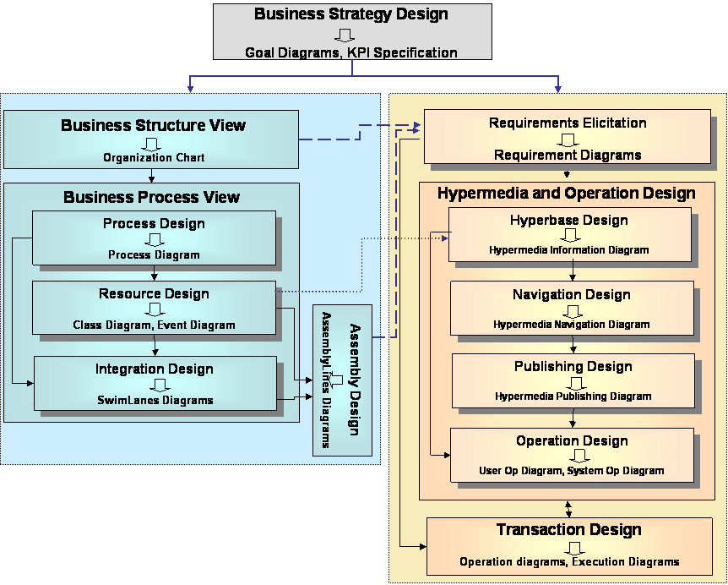

Figure 1: UWA+ framework

In order to integrate the two perspectives, a process engineer must provide the Web system designer with models describing the organization where the application is going to be set up, namely the organizational chart, business process models (showing the process flow, input and output, actors, constraints), models of resources and structured constraints drawn during the organizational analysis. Special diagrams, like swimlanes and assembly lines [6], are very effective to define the scenario and are a useful input to the requirement elicitation of the Web system. Conversely these models are used to trace potential changes of the Web system requirements back to the business process perspective. The conceptual modelling of the Web system follows the main steps of UWA, with some integration described in the following.
The elicitation of the Web system requirements starts from the identification of stakeholders (anyone who has interest in the application), goals, i.e., objectives that the application must satisfy in the stakeholder desires, and scenarios. Through the goal-stakeholder diagram goals are linked to the corresponding stakeholders, who are also responsible of their performances. Hence procedural goals, the corresponding KPIs, detailed with the support of swimlanes, elicit operation and transaction requirements, while Contents, Structure-of-Content, Navigation, Presentation, Customization requirements are derived from communication goals.
Swimlanes, assembly lines diagrams and organization chart contribute to the identification of the Web System’s stakeholders. In particular swimlanes and assembly lines diagrams define internal users (clerks and employees), customer profiles and external organizations dealing with the Web system, while the Organization chart helps to identify stakeholders who are hierarchically superior to the system’s internal users and interested in the system for strategic and advisory purposes. The stakeholders so located are a subset of those a requirement engineer must take into account. The relationships among goals, stakeholders, process structure and system requirements enable the traceability (Req. 2) among business strategy, business processes and Web system architecture.
To model goals and derived sub-goals coming from the business process analysis we use an arrow shape, whose content is the process phase at the top and the child’s activity at the bottom, while communication goals are still represented by oval shapes.
Resources diagrams and assembly lines diagrams are input of the Information design, where the main purpose is the identification of the relevant information to be handled by the application, and the provision of an overall organization of the information structures, independently from any specific intended usage. Assembly line packages [6] are evaluated for the design of entity types in the hyperbase in the large [19], while Resources Diagrams [6] are an input of the hyperbase in the small. The hyperbase model is designed at a high level of abstraction and it is independent from the single user perspective and the specific interaction channel. This lets the model be persistent along the time and the different user views.
Navigation, Publishing, Operation and Transaction Design are common to UWA’s framework. They gather inputs and information from the requirement elicitation and the information design.
As shown, in UWA+ the traceability requirement (Req. 2) between the two views is satisfied, thanks to the formal definition of the steps and the integration diagrams existing between the views.
Moreover business process design and Web systems design remain separated and are made by people with different backgrounds, according to the “skill hiding” requirement (Req.3).

4.1. A sample case
In the Travel Agency sample we will consider the point of view of the Personal Travel Assistant. According to the definition we can single out two business processes, the purchase of the travel by the customer and the monthly payment of the external Broker Agents.
Let’s consider the first process. Figure 2 shows the πDiagram representing the business process of selling a travel to a customer and the corresponding candidate information entity types. The upper part of the πDiagram shows the process and the swimlanes representing the involved stakeholders (the Customer, the Personal Travel Assistant of the Travel Agency, the Broker Agent -which can be internal or external to the Travel Agency-, the Financial Companies) and the corresponding activities.
When the Customer needs to buy a trip, he/she enter the travel agency and describes it, sometimes establishing constraints and conditions on it.
The Travel Agency’s Personal Travel Assistant receives the requests from the Customer, checks that it is well formed, and selects the Broker Agents that work with them and that can service the trip. The Personal Travel Assistant interacts with each Broker Agent, asking them for an offer that fulfils the Customer’s requested trip.
Each Broker Agent asks the Transportation Companies to provide an offer for the requested service. If the offer matches the customer requirements, the Broker Agent will pass the offer (with the corresponding overhead in case of external Brokers) to the Personal Travel Assistant of the Travel Agency. The Personal Travel Assistant will then sort the list of all suitable trips and quotations received from all the Broker Agents, according to the Customer preferences, and provide that sorted list to the Customer for him or her to choose one. The Customer may either select one of the offered trips, reject them all and quit, or refine his or her requirements and start the process again. If the Customer selects one of the arranged trips, the Customer will provide the credit card details to the Personal Travel Assistant, who will process the payment through the corresponding Financial Company. Once the payment is correct, the Personal Travel Assistant will notify the corresponding Broker Agent to confirm the booking(s). If the Personal Travel Assistant cannot process the payment (not enough credit, invalid or expired card, etc.), the Customer will be asked to either re-enter his payment details, or quit. In any case, the Personal Travel Assistant will notify those Broker Agents whose offers have not been selected to cancel their bookings.
The bottom of the πDiagram shows the information packages and the candidate semantic relationships among them. In our sample the Customer package includes demographical information, his/her preferences, his/her purchase history, the broker agent package consists of information about his/her specialty, his/her overhead, the Cities package says about the airports and other travel facilities, the Travel package expresses information about the specific trip of a customer from the departure city to the arrival town, offered by a Broker Agent.
For clearness of the diagram we show only a few relationships between the swimlanes and the information packages; the most suitable Broker Agent for a giver travel is derived from the Broker Agent descriptions stored in the corresponding information package; once the payment is accepted the travel information and the customer information are stored in the corresponding information packages.

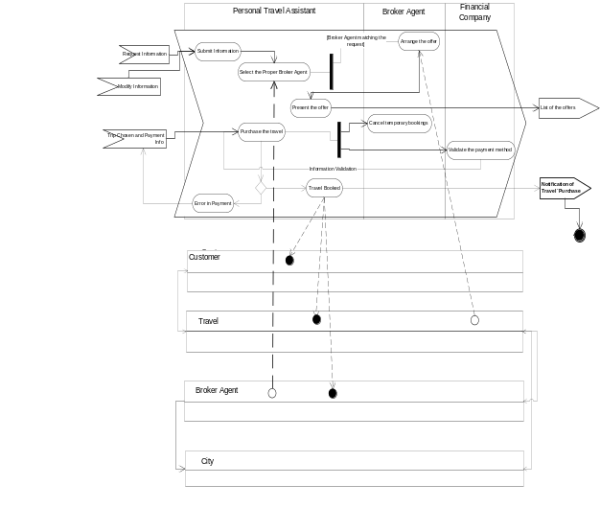 Figure 2: πDiagram

Figure 3 shows a partial view of the goal/stakeholders diagram. It represents the goals of the Customer who wants to Buy a travel, which corresponds to the goal of the Personal Travel Assistant to “Sell a travel”. The Customer also wants to Get Information about the arrival city and Access his/her previous trips.
From the customer’s perspective, the “Buy a travel” goal can be specialized into a few sub-goals: Submit a Request goal, Refine/Update request, Choose among travel alternatives. The shape used for these goals are similar to those used in the process diagram in order to trace the process activities in the Web application design perspective. The label in the upper part of the diagram is the process to which the activity belongs.
These subgoals are also the specialization of Personal Travel Assistant’s “Sell a travel” goal, together with the “Selection of the broker”, the “arrangement of the trip” and the “Presentation of the different offers” to the Customer. The last subgoal can be “operationalized” into requirements: the description of each single alternative and the sort of the offers according to the customer’s requests.
The shape used for the requirements is a rectangle with a label indicating its nature (in our sample they are Content and system requirements, respectively)

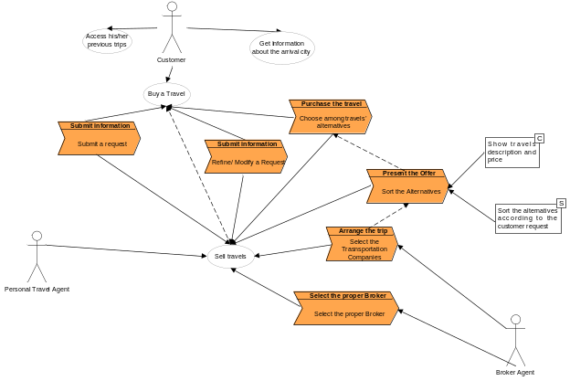Figure 3: Goal / Stakeholder diagram

It is evident that the whole set of requirements to design the Personal Travel Assistant Web system comes both from the specialization of the business processes into transactions and operations and from content and navigation features, derived from the context and from other interviews wit the users.
UWA+ is more efficient and effective with respect to UWA because:
• The modeling of business processes has reduced the time of requirement elicitation to define the Web systems requirements
• The documentation quality has been improved due to the use of a common modeling language based on UML,
• The design documentation has been reduced and harmonized between the business process and the Web system designers because of the use of a common framework
• Web system and documentation maintenance is easier due to the traceability between the two views

5. Conclusions and Further Works

The framework proposed in this paper aims at solving some of the problems haunting the relationship between business process modeling and Web systems design. Having a unique and standard language to describe different aspects of business and systems is fundamental to create a common ground for discussing both business and the supporting Web system. The emphasis of UWA+ is on providing the basis for creating such a common representation and simultaneously providing a way for addressing the traceability between the different views. The first view of the framework is about business goals and business processes. The relations between the process and Web system view allow the representation of how Web information systems support business, which is one of the main issues in today’s organizations. Web system modeling is based on a user centered approach, which is the cornerstone of today’s Web system architecture.
UWA+ overcomes the main shortcomings of the parent methodologies, BPEMS and UWA. In fact BPEMS is very effective in designing business processes, it is less successful in the steps toward the design of the information system. For instance, it designs information systems from business processes models and models informational resources as classes, using activity diagrams to model the behavioral aspect of business processes. This approach is information systems - oriented, whilst the key viewpoint should be process oriented. On the other hand in the requirement elicitation step UWA’s authors describe organization context through goal-stakeholders diagrams and textual constraints. This approach is acceptable in the design of small Web systems, but the conceptual modeling of Web systems in complex organizations (like banks, e-government services, utilities, …) require the contemplation of the scenario (made up of organizational structures, processes, constraints, rules and norms), thus models like UWA’s requirement elicitation, describing the organization by semiformal rules and textual constrains are little effective. In one word the first flattens the user communication and interaction design, the latter needs to extend the requirement to hook up the organization.
UWA+ framework integrates these views and manage the complexity of the two activities with the additional task of designing their coupling.
The framework has been sampled in the e-government scenario, with a sample developed during the UWA+ approach tuning.
Future lines of work are planned to include a methodology for better capturing the evolving needs of real organization into evolving business models, and a development process that leads from business to systems (of which the matching between different layers is a starting point).

6. References

[1] Kaplan R.S., Norton D.P., Balanced Scorecard, HBS Press, Boston, 1996
[2] IBM, Business Systems Planning, GE 20-0257-1, 1975
[3] Martin J., Information Systems Engineering, Prentice Hall, 1990
[4] Scheer A.-W., ARIS - Business Process Modelling, Springer, 2000
[5] Object Management Group, UML Extensions for Business Modelling, v.1.1, September 1997
[6] Eriksson H-E., Penker M., Business Modelling with UML: Business Patterns at Work, Addison Wesley, 1999
[7] J. Conallen. Building Web Applications with UML. Addison Wesley Object Technology Series. Addison-Wesley, 2nd edition, 2003.
[8] Sims, D., “EA Best Practices”, 2000. http://www.eacommunity.com/articles/art28.asp
[9] P. Dolog and M. Bieliková, "Hypermedia Modelling Using UML," presented at ISM 2002 - Information Systems Modelling - ISM'2002, Czech Republic, 2002.
[10] L. Mandel, N. Koch, and C. Maier, "Extending UML to Model Hypermedia and Distributed Systems," 1999
[11] B. Henderson-Sellers, A. J. H. Simons, and H. Younessi, The OPEN Toolbok of Techniques. UK: Addison-Wesley, 1998.
[12] L. Baresi, F. Garzotto, and P. Paolini, "Extending UML for Modeling Web Applications," presented at 34th Hawaii International Conference on System Sciences, Hawaii, USA, 2001.
[13] [J. Conallen, Building Web Applications with UML. Reading, Mass: Addison-Wesley, 1999
[14] R. Hennicker and N. Koch, "Systematic Design of Web Applications with UML," in Unified Modeling Language: Systems Analysis, Design and Development Issues, K. Siau and T. Halpin, Eds.: IDEA Group Publishing, 2001.
[15] N. Koch and A. Kraus, "The expressive Power of UML-based Web Engineering," presented at Second International Workshop on Web-oriented Software Technology (IWWOST2), Malaga, Spain, 2002
[16] J. D. Palmer. Traceability. In R. H. Thayer and M. Dorfman, editors, Software Requirements Engineering, Second Edition, pages 412.422. IEEE Computer Society Press, 2000.
[17] R. Vidgen, D. Avison, B. Wood, T. Wood-Harper, Developing Web Information Systems, 2002 Elsevier Science
[18] G. Rossi, H. A. Schmid, F. Lyardet: Customizing Business Processes in Web Applications. EC-Web 2003: 359-368
[19] http://www.uwaproject.org/
[20] L. Baresi, F. Garzotto, P. Paolini, “From Web Sites to Web Applications: News Issues for Conceptual Modeling”, Proc. Int’l Workshop on the World Wide Web and Conceptual Modeling, LNCS 1921, S.W. Liddle, H.C. Mayr, B. Thalheim, eds., Springer, 2000, pp. 89-100
[21] H. A. Schmidt, G. Rossi, “Modeling and Designing Processes in E-Commerce Applications”, IEEE Internet Computing, Vol. 8, Number 1, 2004, pp. 19-27
[22] W. Lam, V. Shankararaman, “An Enterprise Integration Metholodogy”, IEEE IT Professional, March/ April 2004, pp. 40-48
[23] AA. VV. “Business processes on the Web”, Special Issue of IEEE Internet Computing, Vol. 8, Number 1, 2004, pp. 28-54
[24] Tongrungrojana, R. and Lowe, D., 2003, WebML+: connecting business models to information designs, SEKE: Fifteenth International Conference on Software Engineering and Knowledge Engineering, (San Francisco, USA, 2003), Knowledge Systems Institute, Skokie, IL, USA, 17-24
[25] Koch N., Kraus A., Cachero C., Meliá S.,. Modelling Web Business Processes with OO-H and UWE. In Third International Workshop on Web-oriented Software Technology (IWWOST03). D. Schwabe, O. Pastor, G. Rossi, and L. Olsina, editors, 27-50, July 2003
[26] Longo A., Bochicchio M. A., “UWA+: bridging Web systems design and Business process modeling”, in Web Engineering Workshop, Hypertext ‘04, Santa Cruz, August ‘04
[27] Longo A., Bochicchio M. A., “Public-Private Partnership to manage Local Taxes: Information Models and Software Tools”, in EGOV 2002, Aix-en-Provence, sept. 2002
[28] Booch G., Brown A., Sridhar I., Rumbaugh J. Selic B.: “An MDA Manifesto”, MDA Journal (www.bptrends.com), May 2004

