The ∆-Categorisation: Evaluating development strategies for technology-enhanced organizations

David Lowe
University of Technology
Sydney - Australia
David.Lowe@uts.edu.au
Mario A. Bochicchio
Sw Engineering & Telemedia Lab
Department of Innovation Engineering
University of Lecce, Italy
mario.bochicchio@unile.it
Antonella Longo
Sw Engineering & Telemedia Lab
Department of Innovation Engineering
University of Lecce, Italy
antonella.longo@unile.it

ABSTRACT
A key characteristic of many online and Web-based systems is that there is an increased impact of the technological solutions on the business processes and ultimately even on the business strategy. This arises both from the pervasive nature of these applications, but also the way in which they change the way in which stakeholders interact with (and within) organisations. Conventional software engineering and information systems development processes typically do not handle this characteristics particularly well - partly because they tend to focus on system construction rather than business evolution. Similarly, business process re-engineering tends to focus on process change and not technological inter-dependencies. In this paper we propose a categorisation (which we call the ∆-Categorisation both since ∆ traditionally represents incremental change, but also graphically shows the three key components of our categorisation). We argue that this categorisation can be used to evaluate, and hence highlight, the strengths and weaknesses of different development approaches and methods. This allows approaches to be more appropriately selected to suit particularly development problems.
Categories and Subject Descriptors
D.2.9 [Software]: Software Engineering – Lifecycle, Software Process Models.
General Terms
Management, Design, Human Factors.
Keywords
Co-evolution, impact assessment, web development.

Permission to make digital or hard copies of all or part of this work for personal or classroom use is granted without fee provided that copies are not made or distributed for profit or commercial advantage and that copies bear this notice and the full citation on the first page. To copy otherwise, or republish, to post on servers or to redistribute to lists, requires prior specific permission and/or a fee.
Conference’04, Month 1–2, 2004, City, State, Country.
Copyright 2004 ACM 1-58113-000-0/00/0004…$5.00.

INTRODUCTION
In the span of a decade, the Web has transformed entire industries and entered the mass culture. Complex online Web-enabled systems have become increasingly crucial to both business success and to the provision of social and government services. They typically employ Web technologies to provide a complex distributed front-end combined with high-performance back-end software systems that integrate new components with existing legacy applications to support critical business processes.
One key characteristic of many of these systems (as well as various other software systems) is that the introduction of the system has a fundamental impact on the nature of the business processes and business models which are being supported by the system. In other words, the business domain not only drives the definition of the system needs, but is in turn fundamentally changed by the system. This arises both from the pervasive nature of these applications, but also how they change the way in which stakeholders interact with (and within) organisations. Conventional software engineering and information systems development processes typically do not handle this characteristics particularly well - primarily because they tend to focus on system construction rather than business evolution. Similarly, business process re-engineering tends to focus on process change and not technological inter-dependencies. In this paper we consider these issues and propose a categorisation which can be used to evaluate, and hence highlight, the strengths and weaknesses of different development approaches and methods. This allows approaches to be more appropriately selected to suit particularly development problems.

BACKGROUND
A typical business analysis / systems development process moves from an understanding of the business strategy, to the design of the business operations (including aspects such as business processes and associated workflows), and then from these to a set of requirements and subsequent design for a system (or systems) which supports these business processes (i.e. BS → BO → SD).
There has been considerable work on understanding the relationships between business models and strategies, and the design of suitable business operations (BS → BO) [1, 2]. Similarly, there has been considerable research on how given business operations can be supported by the design of appropriate IT systems (BO → SD). Indeed, these has even been some considerable work considering how IT systems lead to necessary changes in business processes (BO ← SD) and business strategies (BS ← SD) – mainly in the area of business process re-engineering [3].
In general, the methods for designing systems that support given business processes (BO ← SD) will be quite different from the methods for understanding how a system impacts upon those business processes (BO → SD). An analogy may highlight some of the difficulties which can exist in understanding some of these relationships. Consider the provision of directions from one location to another (see Figure 1: leave the house and turn left; drive until a fork is reached and veer right; continue to the end and then turn right; continue until you reach the station). The directions to go in the opposite direction will not typically just be the reverse of the original directions (leave the station and take the first turn left; continue following this road until you reach the third right turn, and then turn right and progress to the house). This is primarily because the perspective is different when travelling in the reverse direction. Similarly, the perspective of methods for designing business models that exploit a novel technology (BS→ SD) is different from those considering the strategic changes led by the introduction of IT systems in an organization (BS ← SD).

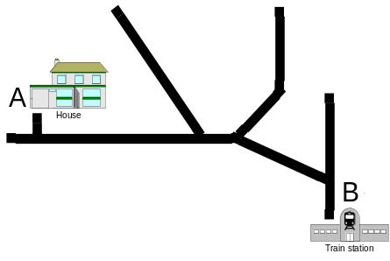
Figure 1: Navigating from point A to to Point B
So, this raises questions about the differences between developing business processes and subsequently systems, and understanding how these systems impact on processes, and how the processes affect business strategies – i.e. How do we integrate BS → BO → SD and BS ← BO ← SD, to achieve a development processes which supports BS ↔ BS ↔ SD.
But, the situation is more complex than this. Again, let us use an analogy. The phase change diagram (see Figure 2a) shows the phases of a substance (solid, liquid, vapor) under different conditions of pressure and temperature. As the pressure or temperature (or both) changes the substance changes between the three phases. The triple point (point A in Figure 2a) is the point where the gaseous, liquid, and solid forms of a substance can exist in equilibrium. By analogy, we can have system development phase diagram, which represents the methods for designing an organizational system (see Figure 2b) where we can locate different situations of business/technology integration and modeling abstraction. Different situations correspond to consideration of the different approaches/“phases” of business strategy, business operations, and system design. However, as we increase the business/technology integration, the gap between business strategy and system design decreases and the design focus moves from business processes to IT systems. Indeed there has been much written about the tighter coupling of business model and technology within web systems [4-6]. We could even speculate that there will exist an approach perfectly balancing business strategy, business operations and systems design (the triple point of the Organization design phase diagram) and as in chemistry the triple point is distinctive of a substance so we could consider the triple point in fig. 2b specific of an organization.
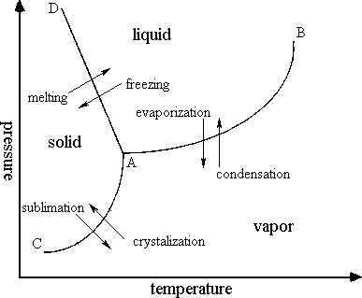
Figure 2a: Chemistry phase diagram
(from http://members.tripod.com/~EppE/phases.htm)
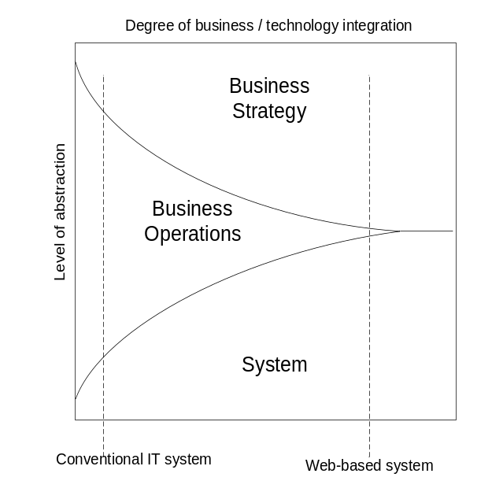
Figure 2b: System development phase diagram
One of the key observations arising from this analogy is that it becomes important to not only consider the relationship between the business strategy and the business operations, and between the business operations and the system design, but also directly between the business strategy and the system design itself. In effect we need a model of this triple relationship – the ∆-Categorisation which we will now discuss.

CATEGORISATION DESCRIPTION
The thesis which underpins the ∆-Categorisation is that development is much more complex than a simple linear process which moves from business models to business processes to system specifications to system design to implementations. Even incremental or iterative development typically still sees the development as moving primarily in this forward direction. Existing methods, in an attempt to guide the development, over-simplify reality and can mislead the development process. This is particularly true in Web development, where the systems typically have a greater impact on the organization.
Given this thesis, it becomes important to understand the extent to which different approaches support elements of the development cycle, and the limitations of these various approaches. Such an understanding should allow a much more effective selection of development approaches.
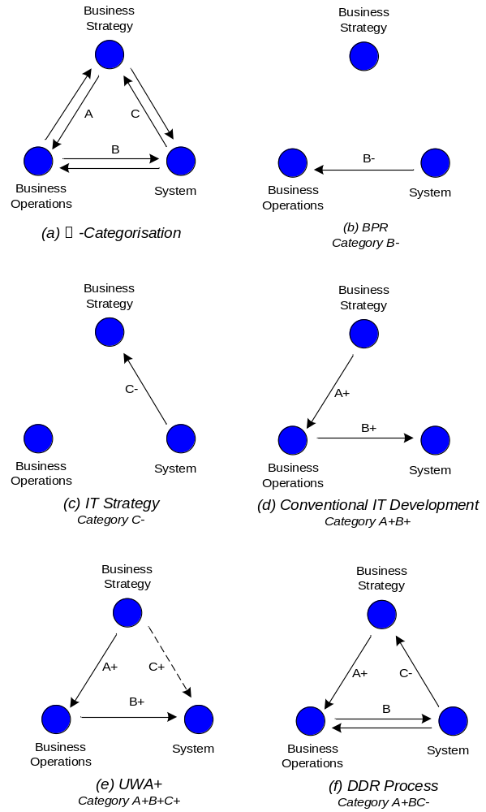
Figure 3: ∆-Categorisation Diagram
The basis of the ∆-Categorisation is shown in Figure 3a. This shows the three core domains of business strategy, business operations, and system development. Business strategy includes the overall business goals and models, and the broad approach taken in supporting a business. The business operations encompass the business processes, workflows, and other operational activities. The system encompasses the system specification, design and implementation.
A given development paradigm, process or approach can be categorised based on the transformations between these three domains which are the focus and which are actively supported. For example, BPR activities (business process reengineering) is predominantly focused on understanding how to change business processes in response to the introduction of, or changes to, systems which support the business. As such BPR processes can be categorised as type B- approaches.
By categorising different approaches it allows us to highlight the focus of the approach and therefore identify the types (and stages) of development which are supported. For example, where a business and its associated systems falls into the region at the right-hand side of Figure 2b, then approaches which include support for type C- development become more crucial.

DISCUSSION AND EVALUATION

Discussion
A categorisation such as the one we are proposing allows a clearer expression of the domain of support of different techniques and approaches, and hence the limitations of these approaches. For example, we would argue that most conventional approaches to the development of IT systems would be categorised as B+ or A+B+. In other words, it supports the effective creation of the systems, but does not explicitly support the development of an understanding of how the creation of these systems impact upon or change the underlying business process or especially the business strategy. Whilst this may not be of concern in many cases, it is likely to be a significant issue in the development of many web-based applications where the system itself leads to changes in the way an organisation interacts with its stakeholders, and consequently the whole business model can be affected.
We will consider two specific issues which arise out this type of consideration: predictive development; and disruptive development.
Let is begin by considering predictive development. We have already argued that systems which exist towards the right-hand side of Figure 2b are likely to be such that there is a mutual interdependence between the system, the business operations and the business strategies. One consequence of this is that the introduction of a system (i.e. solution) changes the nature of the business (i.e. problem) which defined the need for the system in the first place. It has been argued [7] that for these types of applications, the system design needs to be carried out in conjunction with (or indeed, can even drive) the formulation of the system and/or business requirements. Whilst iterative development can address this to a limited extent (i.e. develop and implement a prototype system, then understand the impacts on the business, then redevelop the system, and continually repeat) this creates interim solutions which are suboptimal. A much more effective approach would be to adopt approaches which are able to predict, as early as possible, the impacts which a proposed system is likely to have on the organisation. These impacts can then be used to understand the business changes which will occur and hence how the solution should actually be formulated to take direct account of the changes. An example of an approach which supports this view is given in [8].
As an example, consider a traditional bank which is developing an online banking presence to support typical banking activities for the bank’s account holders. An initial design of the system might focus on support for existing business activities – e.g. transferral of funds between linked accounts. However, it should be possible to predict that the introduction of the system will be likely to change customers’ expectations with regard to the time taken to action such transfers, and so the underlying business processes will need to be adapted.
The second issue mentioned was disruptive development. Given the interdependence between business strategies, business operations, and supporting systems, development processes will endeavour to attempt to achieve an effective optimisation of these three. It is, however, quite feasible (indeed likely) that the optimum which is found in a particular case will only be a local optimum. To illustrate this, consider the example of bookstores. As the Web emerged, numerous existing bookstores have developed online presences which support their business. The combined business strategy, business operations and supporting systems for, for example, Barnes and Noble are likely to be locally optimal, but quite different from those for Amazon. This raises the question of how the development process can support the identification of alternative possibilities. There is some emerging literature which discusses this issue from the perspective of disruptive technologies [9]. In particular, various approaches may be taken to considering the potential impact on a business and a currently acceptable system of the introduction of new technologies – i.e. whether this introduction will trigger new business opportunities and hence necessary changes to the system which result in a totally new (and hopefully improved) balance of business strategy, business operations, and supporting systems. Such an approach would require strong B-, and especially C-, categories of development approaches.

Application
We will show how the categorisation can be used to understand the nature of existing approaches by considering two examples from the Web development literature: UWA+ and DDR.
UWA+ [10] is a framework for modeling Web applications which includes concepts drawn from business process design. It is based on a combination of web design using UWA (the Ubiquitous Web Application framework) and business modelling using BPEMS (Business Process Extended Model enhanced by Systemic views). The result is a framework which much more clearly links specific issues of business strategy with the technical issues within the system design. As such, we could view UWA+ as being a category A+B+C+ approach (as shown in Figure 3e). In particular, the explicit connection between the BPEMS components of the framework and the UWA components of the framework contribute to the C+ component of the categorisation. It does, however quickly become clear that UWA+ does not provide any of the A-B-C- categories, and is hence not fully sufficient for the effective development of applications where the system has an immediate impact on the nature of the business.
Another example is work on DDR (Design Driven Requirements) [7, 11]. This work describes a perspective on the Web development process where designs are jointly used by the developers and clients to develop an understanding of the required system and the way in which is may change business models and processes, and hence clarify the requirements of the system. The result is an approach which can be classified as A+BC- (see Figure 3f). In this case the explicit consideration of the role of the designs, and the way in which consideration is given to the nature of the impacts on the business provides the B- and C- components of the categorisation. The approach however lacks the clear understanding of the business strategies impact on the system (i.e. C+ component of the categorisation) provided by UWA+.

CONCLUSIONS AND FURTHER WORK
We argue that the categorisation we have described provides a useful tool in understanding the relative strengths and limitations of existing development approaches – particularly those that relate to the development of web-enabled systems where there is a tighter coupling to the business strategy and operations. This in turn allows the more effective selection of methods, based on an understanding of the particular characteristics of the project.
Further work is looking at extending the categorisation into a full reference model which allows a finer degree of granularity of the evaluation. We are also looking at how we can use this categorisation to support the more effective integration of existing approaches (such as UWA+ and DDR) by identifying the key strengths of these methods and linking them together.

REFERENCES
[1] H. Smith and P. Fingar, Business Process Management (BPM): The Third Wave: Meghan-Kiffer Press, 2003.
[2] U. J. Gelinas, S. G. Sutton, and J. Fedorowicz, Business Processes and Information Technology: South-Western College Pub, 2003.
[3] P. Harmon, Business Process Change: A Manager's Guide to Improving, Redesigning, and Automating Processes: Morgan Kaufmann, 2002.
[4] E. Angelique, "A Lightweight Development Process for Implementing Business Functions on the Web," presented at WebNet'99, Honolulu, Hawaii, USA, 1999.
[5] J. Gordijn, J. M. Akkermans, and J. C. v. Vliet, "Business Modelling is not Process Modelling," presented at ECOMO 2000: published as Conceptual Modeling for E-Business and the Web, LNCS 1921, Salt Lake City, USA, 2000.
[6] S. Overmyer, "What's Different about Requirements Engineering for Web Sites?," Requirements Engineerng Journal, vol. 5, pp. 62-65, 2000.
[7] D. Lowe and J. Eklund, "Client Needs and the Design Process in Web Projects," Journal of Web Engineering, vol. 1, pp. 23-36, 2003.
[8] D. Lowe, N. Yusop, and D. Zowghi, "Using Prototypes to Understand Business Impacts of Web Systems," presented at AusWeb'03: The Ninth Australian World Wide Web Conference, Sanctuary Cove, Gold Coast, Australia, 2003.
[9] C. M. Christensen, The Innovator's Dilemma: HarperBusiness, 2003.
[10] M. Bochicchio and A. Longo, "UWA+: bridging Web systems design and Business process modeling," presented at International Workshop on Web Engineering, in conjunction with ACM Hypertext 2004, Santa Cruz, USA, 2004.
[11] D. Lowe, "Web Requirements: An Overview," Requirements Engineering Journal, vol. 8, pp. 102-113, 2003.

http://www.barnesandnoble.com/
http://www.amazon.com

