An Approach to Model-Driven Portlet Development

Yuriy Taranovych, Andreas Schweiger, Helmut Krcmar

Chair for Information Systems
Technische Universitaet Muenchen

Abstract
In recent years, enterprise portals become more and more popular among organisations as a technology of web front-end integration of various information systems (Klaene 2004). The decision to introduce a portal environment within an organization is usually made after users become frustrated with using a huge number of applications which are not integrated and not immediately reachable (Linwood/Minter 2004, 1). A portal provides a solution for aggregating content and applications from various systems for presentation to the end user. The users are not interested to know how the content or functionality is provided and where they are hosted. They just want to enjoy the benefit of the single point of access via a web interface to the information and applications they need and use (Linwood/Minter 2004, 2) (Abdelnur/Hepper 2003, 13). Due to the fact that all people are different they need and use different information and applications. To fulfil this requirement a portal typically provides the personalized content for individual users or groups of users and allows them to customize their user interface by including or removing information or applications to be displayed on their portal page (Klaene 2004).

These information and applications are plugged in the portal in a form of so called portlets or portlet applications. Portlets are individual Java classes, managed by a portlet container, that process requests from a user and generate dynamic content for display inside a portal. (Abdelnur/Hepper 2003, 13; Linwood/Minter 2004, 11). Portlet applications are standard J2EE web applications or web components that include portlet classes, business logic in form of Java Beans or Enterprise Java Beans (EJBs), the portlet.xml portlet deployment descriptor, the web.xml web application deployment descriptor and other requires resources such as additional Java libraries, images, etc. The terms portlet and portlet application are often used as synonyms. Portlets are used by portals as pluggable user interface components that provide a presentation layer to information systems and enable modular and user-centric web applications.

Due to proprietary APIs for portlets in the past years the interoperability between portals and portlets was very limited. In order to overcome this disadvantage the JSR (Java Specification Request) 168 standard was introduced by the Java Community Process (JCP) group within Sun Microsystems (JCP 2005). The JSR 168 standard is specified in the Java Portlet Specification in order to enable interoperability between portlets and portals (Abdelnur/Hepper 2003; Hepper/Hesmer 2003). The IT industry has broadly accepted JSR 168. All major companies in the portal space are part of the JSR 168 expert group. Among them are such companies and organisations as Apache, BEA, Fujistu, IBM, Oracle, SAP, Sun Microsystems to name some of them (Hepper/Hesmer 2003). All these facts underline the importance of portlet development as a part of web engineering nowadays.

Requirements to software systems become more and more complex. In order to deal with increasing complexity and to develop software more efficiently sophisticated means and processes are introduced. One example is the paradigm Model Driven Architecture (MDA) (MDA, OMG 2000, 2001, 2003). MDA distinguishes between the elements Platform Independent Model (PIM), Platform Specific Model (PSM), code and transformation rules. The PIM is mapped to a PSM by user defined transformation rules. As a final step “Code” is generated from the PSM.

In our paper we present an approach of applying MDA for the portlet development – an approach to Model-Driven Portlet Development (MDPD). Software architecture is defined as a set of components and interactions among these components (Shaw/Garlan 1996, 1). Software architecture describes the overall system structure and its behaviour. In addition to that, the behaviour of the single components is also to be specified. The MDPD approach consists therefore of two parts focusing on structural and behavioural description.

The Entity-Relationship-Model (ERM, Chen 1976) is used as a PIM for the structural part of the MDPD. It reflects single entities of the business logic and relationships between them. The entities are represented in the portlet application through corresponding EJBs (DeMichiel/Yalçinalp/Krishnan 2001) which are used as a “Model” within the MVC pattern (Singh/Stearns/Johnson 2004) of the portlet. In the next step the ERM is transformed into a Java/EJB-Model (PSM) that is denoted by XML description (ejb.xml). The latter one is converted to an EJB implementation.

A graphical automaton model is used as a PIM for the behavioural part. The automaton reflects the behaviour of a single EJB. The following step transforms the automaton model to a corresponding XML representation as PSM. The XML representation is used to generate the business logic of the structural EJB skeleton as constructed in the previous structural part.

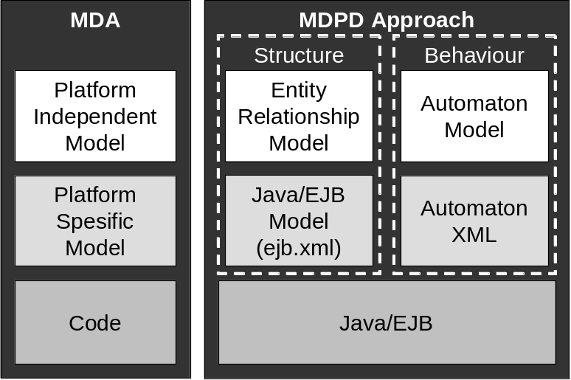

Figure 1: Model-Driven Architecture and Approach to Model-Driven Portlet Development

The MDPD supports the development process for portlets by generating business logic skeletons (EJBs) for the portlet implementation from Entity-Relationship and Automaton models.

The structural part of the MDPD approach was successfully applied for development of the cooperation platform (WebCo@ch platform) within the research project WebCo@ch. The WebCo@ch platform is based on the open source JSR-168 compliant Liferay Enterprise Portal (Liferay 2005) and consists of over 30 portlets for supporting communication, collaboration and cooperation between users. Most of the portlets were developed and implemented using the structural part of the MDPD.

The integration of the behavioural part of the MDPD is not supported by any technical frameworks up to now, but provides a room for further research. The mapping from ERM to an XML description has to be conducted manually at this point of time. Automated transformation would also simplify this development step.

References

WebCo@ch (Code: FKZ 01HW0205) is a research project sponsored by the Federal Ministry for Education and Research/Germany. The project is carried out by the Chair for Information Systems at the Technical University of Munich. The project goal is to develop and to implement web based coaching services in the project management of digital production. Under the term digital production we understand the development of multi media content and application-oriented enterprise software. More information about the research project can be found at: http://www.project-webcoach.de.

