An Approach to Model-Driven Portlet Development

Yuriy Taranovych, Andreas Schweiger, Helmut Krcmar
Technische Universitaet Muenchen
yuriy.taranovych | andreas.schweiger | krcmar @in.tum.de

Abstract

This paper presents an approach of applying Model-Driven Architecture (MDA) for portlet development – an approach to Model-Driven Portlet Development (MDPD). We describe how the development of the portlet business logic represented by EJBs can be partly automated using Entity-Relationship (ER) and automaton models which represent the structure and the behavior of the portlet business logic respectively. These models are transformed into XML descriptions which serve as input for the code generation. The MDPD approach is explained by means of a travel agency system example. For this purpose we present an extract of this example as ER and automaton model and corresponding representation as XML descriptions and finally the Java implementation.

1. Introduction

In recent years, enterprise portals became more and more popular among organizations as a technology of web front-end integration of various information systems [1]. The decision to introduce a portal environment within an organization is usually made after users become frustrated with using a huge number of applications which are not integrated and not immediately reachable [2]. This fact results a rising interest to portlet development intensified with the appearance of the JSR 168 portlet standard [3]. The methods and approaches for improving development process are searched also in the portlet development world. MDA is one of the methods for realizing these improvement potentials.

In our paper we present an approach of applying MDA for the portlet development – an approach to Model-Driven Portlet Development (MDPD). Using MDA the developer can concentrate on modeling business logic since the generation of code can be partly automated. In this way the software development process can be improved in terms of quality and time.

The paper is structured as follows. Section 2 gives a short overview of portal technology, its components and benefits. Section 3 presents a concept of MDA. The central part of the paper deals with the presentation of the MDPD approach as describes in section 4. We conclude in section 5 by presenting further research areas.

2. Portal technology

A portal provides a solution for aggregating content and applications from various systems for presentation to the user. The users are not interested in knowing how the content or functionality is provided and where they are hosted. They just want to enjoy the benefit of the single point of access via a web interface to the information and applications they need and use [2] [3]. Due to the fact that people and their tasks are different they need and use different information and applications. To fulfill this requirement a portal typically provides the personalized content for individual users or groups of users and allows them to customize their user interface by including or removing information or applications to be displayed on their portal page [1].

These information and applications are plugged into the portal as so called portlets or portlet applications. Portlets are individual Java classes, managed by a portlet container, that process requests from a user and generate dynamic content for display inside a portal [2, 3]. Portlet applications are standard J2EE web applications or web components that include portlet classes, templates (JSPs, Velocity templates, etc.), business logic in form of Java Beans or Enterprise Java Beans (EJBs), the portlet.xml portlet deployment descriptor, the web.xml web application deployment descriptor and other required resources such as additional Java libraries, images, etc. The terms portlet and portlet application are often used as synonyms. Portlets are used by portals as pluggable user interface components that provide a presentation layer to information systems and enable modular and user-centric web applications.

Typically, a single portlet generates only a markup fragment of the portal page that the user views in the browser. A portal usually adds a title, control buttons and other decorations to the markup fragment generated by the portlet. This new fragment is called a portlet window. The portal aggregates portlet windows into a complete portal page [3]. Elements of a portal page are depicted in Figure 1.

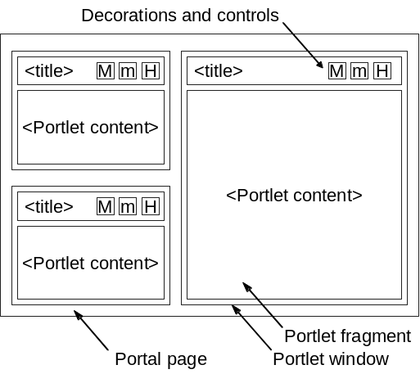

Figure 1: Elements of a portal page [3]

Figure 2 illustrates the sequence of events for a portal page creation. Users access a portal by using a client device such as a web browser or a web-enabled mobile phone. Upon receiving the request, the portal determines the list of portlets that need to be executed to satisfy the request. The portal invokes the portlets through the portlet container. The portal creates the portal page with the fragments generated by the portlets and the page is returned to the client where it is presented to the user [3]. Portlets run within a portlet container which provides the run-time environment to portlets. The portlet container is responsible for sending user requests from the portal server to the appropriate portlet and then passing the portlet response back to the portal server. It also manages the initialization of portlets, along with other lifecycle [1, 3] events. The portal server is responsible for taking the content from the portal container, building a portal page with the content generated by the portlets and sending it to the client device (e.g. a web browser) where it is displayed to the user. The portal server handles also the layout, aggregation of portlets, personalization and security [2, 3]. It should be noted that the distinction between a portal server and a portal container is logical. These may be implemented as a single physical component [1].

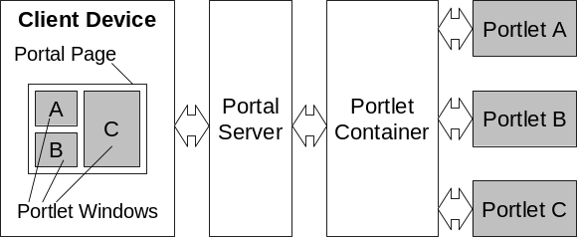

Figure 2: Portal page creation [3]

illustrates an interface of a calendar portlet. It can be used either as a personal or group calendar to coordinate personal/group events and tasks. The calendar portlet could be also synchronized with other calendar systems (e.g. MS Outlook or Lotus Notes) and be used as a presentation layer of these.

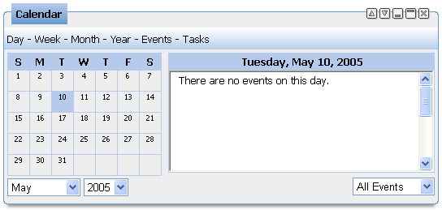

Figure 3: Calender portlet

Due to proprietary APIs for portlets in the past years the interoperability between portals and portlets was very limited. In order to overcome this disadvantage the JSR (Java Specification Request) 168 standard was introduced by the Java Community Process (JCP) group within Sun Microsystems [4]. The JSR 168 standard is specified in the Java Portlet Specification in order to enable interoperability between portlets and portals [3, 5]. The IT industry has broadly accepted JSR 168. All major companies in the portal space are part of the JSR 168 expert group. Among them are companies and organizations such as Apache, BEA, Fujistu, IBM, Oracle, SAP, Sun Microsystems to name some of them [5]. All these facts underline the importance of portlet development as a part of web engineering nowadays.

3. Model-Driven Architecture

Requirements to software systems become more and more complex. In order to deal with increasing complexity and to develop software more efficiently sophisticated means and processes are introduced. One example is the paradigm Model Driven Architecture (MDA) [6-8]. It introduces an additional abstraction layer to conventional software development approaches. MDA distinguishes between the elements Platform Independent Model (PIM), Platform Specific Model (PSM), code and transformation rules. A PIM is independent of the implementation concept and describes a business system. A PSM describes technology specific aspects. These models can be mapped through previously defined transformation rules to another model, which is closer to implementation and takes into account technological aspects. This model needs not necessarily be a PSM, but can also be a PIM. What is considered to be a PIM or PSM depends heavily on the point of view. Finally, a model is generated, which is considered to be categorized as a PSM. The last transformation yields the implementation code. The crucial point in deploying MDA and its benefits is defining adequate transformation rules between the mentioned models. Once these rules are defined, the software developer is capable of modeling business concepts. Thus, the domain models are the focus of the development work. The implementation is generated by transformation steps. If requirements are changing, the corresponding implementation can be generated automatically and thus the MDA reduces implementation effort. To conclude, the MDA raises the abstraction layer and therefore allows the development of increasingly complex systems and their more efficient implementation [9].

4. Model-Driven Portlet Development approach

Firstly, the concept of the MDPD approach will be presented. It focuses on the development of the portlets’ business logic driven by models. The development of portlets’ presentation layer is not considered in the paper. In the next step this approach will be exemplified by building a part of the travel agency system example.

Software architecture is defined as a set of components and interactions among these components [10]. It describes the overall system structure and its behavior. In addition to that, the behavior of the single components is also to be specified. The MDPD approach consists therefore of two parts focusing on structural and behavioral description.

The Entity-Relationship-Model (ERM) [11] is used as a PIM for the structural part of the MDPD. It reflects static entities of the business logic and relationships between them. The entities are represented in the portlet application through corresponding EJBs [12] which are used as a “Model” of the MVC patterns [13] of the portlet. In the next step the ERM is transformed into a Java/EJB-Model (PSM) that is denoted by XML description (ejb.xml). The latter one is converted to an EJB skeleton implementation which reflects the entities’ structure.

An automaton model is used as a PIM for the behavioral part. It consists of graphical and XML descriptions. The XML description at the PIM level is equivalent to the graphical representation of the automaton and is provided by e.g. an UML state transition diagram. The automaton reflects the behavior of a method within an EJB. This model needs to be transformed into a corresponding EJB automaton XML description which represents the PSM of our approach. The EJB automaton XML description is used to generate methods of EJBs which represent the behavior of the business logic. These methods are inserted into the EJB skeleton as constructed in the previous structural part of the approach.

The MDPD supports the development process for portlets by generating business logic skeletons (EJBs) for the portlet implementation from Entity-Relationship and automaton models (Figure 4).

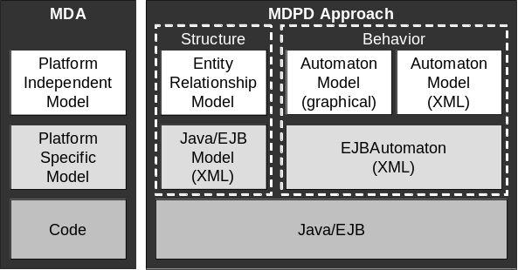

Figure 4: The concept of the MDPD approach

To illustrate the idea of the MDPD let us take a look at a procedure of building a part of a travel agency system using the portal technology and the MDPD approach. The travel agency system is a web application that provides electronic services to customers for searching for and buying travels. For simplicity reasons our travel agency system concentrates just on transportation services and provides functionality for a customer registration (including the input of the first and second name), submitting a travel request (including the input of the travel departure and destination) and getting a response with available travels (including the information about the travel departure, destination and price). All this information is stored in a relational database. For implementing our travel agency system we need to build two portlets: one for the customer (user) registration and another for the entering the travel request and displaying the travel response – available trips. The latter one plays the role of a personal travel assistant that receives a travel request from a customer and tries to find a trip that matches the customer requirements. The personal travel assistant contains no searching functionally. It only delegates a request to different broker agents (e.g. software agent or web services), receives their response and displays it to the customer. The following example demonstrates the procedure of developing a small part of the business logic required for the customer registration portlet using the MDPD approach.

illustrates the ERM of the travel agency system described above. It contains three entities:
- User (attributes UserID, LastName and FirstName) representing the customer;
- Request (attributes RequestID, Dest and Departure) representing the travel request of the customer;
- Response (attributes ResponseID, Dest, Departure and Price) representing the travel information for the customer received from broker agents.

A customer (User) may submit n travel requests (Request) and gets for each request n responses (Response).

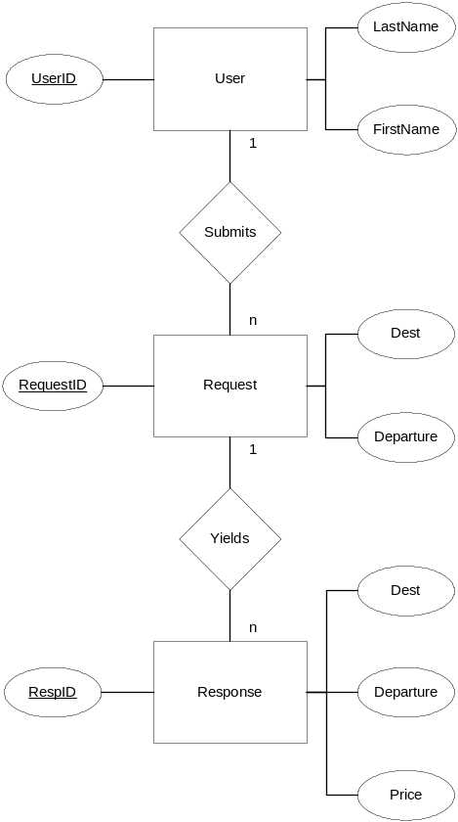

Figure 5: ERM of the travel agency system

An extract of a corresponding Java/EJB model (ejb.xml) in XML format is shown in Figure 6. It is used for generating a Java representation of the entities shown above in Figure 5 which reside in the package “de.winfobase.portlet.travelagency”:
- TravelAgencyUser,
- TravelAgencyRequest and
- TravelAgencyResponse.

The Java representation includes an entity model (e.g. Java class TravelAgencyUser.java), EJB skeletons for further implementation of the behavioral business logic, utility and exception classes. The entity model contains methods to instantiate a Java entity object, to make simple CRUD (create, read, update, delete) operations on the entity attributes and to search for the data stored in the database. These methods can be accessed only from EJBs.

<?xml version="1.0"?>
<build-ejb root-dir=".." package-dir="de.winfobase.portlet">
<portlet name="TravelAgency" short-name="TravelAgency" />

<ejb name="TravelAgencyUser" local-manager="false"
persistence-class="de.winfobase.portlet.travelagency.ejb.
TravelAgencyUserPersistence">

<column name="UserId" type="String" primary="true" />
<column name="LastName" type="String" />
<column name="FirstName" type="String" />

<order by="asc">
<column name="LastName" />
</order>

<finder name="UserId" return-type="TravelAgencyUser">
<column name="UserId" />
</finder>
</ejb>

…

<exceptions>
<exception>NoTravelAgencyUserFoundException</exception>

…

</exceptions>
</build-ejb>

Figure 6: Java/EJB model (ejb.xml) in accordance with the ERM of Figure 5

The EJBBuilder (part of the Liferay Enterprise Portal [14]) performs the code generation by parsing the XML description of the Java/EJB model. Besides entity models and EJB skeletons the EJBBuilder generates EJB deployment descriptors for a number of J2EE application servers (e.g. JBoss, Weblogic AS, Sun AS, JRun AS, etc.).

The generated code reflects only the structure of the ERM and presents a static implementation of its entities, but describes no behavioral business logic yet. The latter has to be implemented as Java methods within the class “[EntityName]Impl.java”. As soon as the behavioral business logic is implemented the EJBBuilder has to be started again in order to update all corresponding interfaces and utility classes of the EJB.

In our example we implement the method addNewUser(String firstName, String lastName) using the automaton for generating business logic (Figure 7). Each automaton represents a single method of an EJB. The method addNewUser(…) creates a new object of the entity “User” (TravelAgencyUser), sets its attributes (FirstName, LastName) and saves it in a relational database. The behavior of the method is illustrated in Figure 7. The automaton notation is based on the UML state transition diagram [15]. The particularity of our representation is the transitions’ annotation in form “?x/!y”, where x defines the automaton’s input and y the transition’s output.

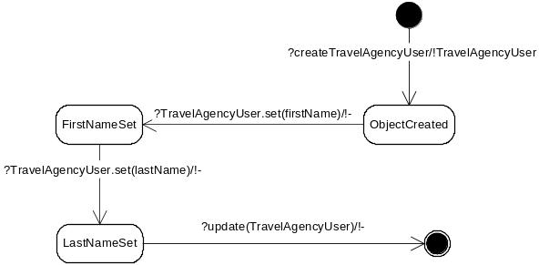

Figure 7: Automaton for generation business logic

Figure 8 illustrates the XML description equivalent to the graphical representation of the automaton. It could be used for the implementation of a graphical automaton editor and for the integration of further transformation tools.

<?xml version="1.0"?>
<automaton xmlns="http://www.winfobase.de"
xmlns:xsi="http://www.w3.org/2001/XMLSchema-instance"
xsi:schemaLocation="http://www.winfobase.de automaton.xsd" name="addNewUser">
<states>
<state name="start" type="start"/>
<state name="ObjectCreated" type="regular"/>
<state name="FirstNameSet" type="regular"/>
<state name="LastNameSet" type="regular"/>
<state name="end" type="end"/>
</states>
<transitions>
<transition name="?createTravelAgencyUser/!TravelAgencyUser"
start="start" destination="ObjectCreated"/>
<transition name="?TravelAgencyUser.set(firstName)/!-"
start="ObjectCreated" destination="FirstNameSet"/>
<transition name="?TravelAgencyUser.set(lastName)/!-"
start="FirstNameSet" destination="LastNameSet"/>
<transition name="?update(TravelAgencyUser)/!-"
start="LastNameSet" destination="end"/>
</transitions>
</automaton>

Figure 8: XML description of the automaton in Figure 7

The XML description of the automaton is constructed in accordance with the XML schema depicted in Figure 9.

<?xml version="1.0"?>
<xs:schema xmlns:xs="http://www.w3.org/2001/XMLSchema"
targetNamespace="http://www.winfobase.de"
xmlns="http://www.winfobase.de"
elementFormDefault="qualified">

<xs:element name="automaton">
<xs:complexType>
<xs:attribute name="name" type="xs:string"/>
<xs:sequence>
<xs:element name="states" type="xs:statessequence"/>
<xs:element name="transitions"
type="xs:transitionssequence"/>
</xs:sequence>
</xs:complexType>
</xs:element>

<xs:complexType name="statessequence">
<xs:sequence>
<xs:element name="state" type="state"/>
</xs:sequence>
</xs:complexType>

<xs:complexType name="state">
<xs:attribute name="name" type="xs:string"/>
<xs:attribute name="type" type="statetype"/>
</xs:complexType>

<xs:simpleType name="statetype">
<xs:restriction base="xs:string">
<xs:enumeratoin value="start"/>
<xs:enumeratoin value="end"/>
<xs:enumeratoin value="regular"/>
</xs:restriction>
</xs:simpleType>

<xs:complexType name="transitionssequence">
<xs:sequence>
<xs:element name="transition" type="transition"/>
</xs:sequence>
</xs:complexType>

<xs:complexType name="transition">
<xs:attribute name="name" type="xs:string"/>
<xs:attribute name="start" type="xs:string"/>
<xs:attribute name="destination" type="xs:string"/>
</xs:complexType>

</xs:schema>

Figure 9: Schema of the XML description of the automaton

The XML description of the automaton has to be converted to an EJB specific XML description which is used for the final generation of EJB methods (Figure 10). The transformation between the automaton model and the EJB automaton model can be described as follows. The name of the method that has to be implemented can be taken over from the automaton XML description. Additionally the EJB name and the EJB package have to be defined manually. The names of the method parameters can be derived from the automaton XML description, but the parameter types have to be inserted manually. By parsing the XML description we can filter out the method parameters since they are defined within brackets. The transitions are represented by the method calls. The names of the method calls reflect simple CRUD operations. Dependent on the name of the method call (e.g. create, set or update) its behavior can be also different. For example by calling the method “create” the object defined in the transition output is initialized. By calling the method “set” a value is assigned to the object. And by calling the method “update” the object properties are stored in a relational database. Due to this distinction we can differ whether we are dealing with a method parameter or other objects. If methods need to be called on objects the attribute “item” has to be introduced. The return value of the method calls are denoted by the transitions’ output by the automaton.

<?xml version="1.0"?>
<EJBAutomaton xmlns="http://www.winfobase.de"
xmlns:xsi="http://www.w3.org/2001/XMLSchema-instance"
xsi:schemaLocation="http://www.winfobase.de EJBAutomaton.xsd"
name="addNewUser"
root-dir=".."
type="void"
package-dir="de.winfobase.portlet.travelagency"
ejb="TravelAgencyUser">

<params>
<param name="firstName" type="String"/>
<param name="lastName" type="String"/>
</params>
<methodcalls>
<call name="create" input="" type="TravelAgencyUser"/>
<call name="set" item="TravelAgencyUser"
input="firstName" type="void"/>
<call name="set" item="TravelAgencyUser"
input="lastName" type="void"/>
<call name="update" input="TravelAgencyUser" type="void"/>
</methodcalls>
</EJBAutomaton>

Figure 10: XML description of the EJB automaton

The code of the method addNewUser(…) generated with the help of the EJB automaton XML description is illustrated in Figure 11. The EJBBuilder has to be started again in order to add the generated method to all corresponding interfaces and utility classes of the EJB. The portlet can then access this method through the TravelAgencyUserUtil class of the EJB after the EJB is deployed inside the J2EE application server.

package de.winfobase.portlet.travelagency.ejb;

import com.liferay.portal.PortalException;
import com.liferay.portal.SystemException;
import com.liferay.counter.ejb.CounterManagerUtil;
import de.winfobase.portlet.travelagency.model.TravelAgencyUser;

public class TravelAgencyUserImpl
implements TravelAgencyUserManager {

public void addNewUser(String firstName, String lastName)
throws PortalException, SystemException {

TravelAgencyUser item = TravelAgencyUserUtil.create(
CounterManagerUtil.increment(
TravelAgencyUser.class.getName()));
item.setFirstName(firstName);
item.setLastName(lastName);
TravelAgencyUserUtil.update(item);
}
}

Figure 11: EJB implementation according to EJB automaton

The structural part of the MDPD approach was successfully applied for the development of the cooperation platform (WebCo@ch platform) within the research project WebCo@ch. The WebCo@ch platform is based on the open source JSR 168 compliant Liferay Enterprise Portal [14] and consists of over 30 portlets for supporting communication, collaboration and cooperation between users. Most of the portlets were developed and implemented using the structural part of the MDPD approach.

5. Conclusion

We presented the MDPD approach that supports the model-driven development of the portlet’s business logic represented by EJBs. We distinguish between the behavioral and structural part of EJBs constructed by ER and automaton models, respectively.

The structural part of the approach is realized by Liferay’s EJBBuilder and was successfully applied for the development of a number of portlets. The mapping from ERM to an XML description has to be conducted manually at this point of time. Automated transformation would simplify this development step.

We also presented a concept of the behavioral part of the MDPD approach that is not supported by any technical frameworks up to now, but provides a room for further research.

6. References

[1] M. Klaene, "Understanding the Java Portlet Specification," developer.com, 2004.
[2] J. Linwood and D. Minter, Building Portals with the Java Portlet API. New York: Apress, 2004.
[3] A. Abdelnur and S. Hepper, "Java Portlet Specification," Sun Microsystems, Inc. 1, 2003.
[4] JCP, "Java Community Process Group," 2005.
[5] S. Hepper and S. Hesmer, "Introducing the Portlet Specification. Get your feet wet with the specification's underlying terms and concepts," Java World, vol. August 2003, 2003.
[6] OMG, "Model Driven Architecture, White Paper, Draft 3.2, November 27, 2000," vol. 2004, 2000.
[7] OMG, "Developing in OMG's Model-Driven Architecture, White Paper, November 2001, Revision 2.6," vol. 2004, 2001.
[8] OMG, "MDA Guide Version 1.0.1, Document Number omg/2003-06-01," vol. 2004, 2003.
[9] A. Kleppe, J. Warmer, and W. Bast, MDA Explained: Addison-Wesley Professional, 2003.
[10] M. Shaw and D. Garlan, Software Architecture: Perspectives on an Emerging Discipline. Upper Saddle River, New Jersey: Prentice Hall, Inc., 1996.
[11] P. P.-S. Chen, "The Entity-Relationship Model-Toward a Unified View of Data," Massachusetts Institute of Technology 1976.
[12] L. DeMichiel, Ü. Yalçinalp, and S. Krishnan, "Enterprise JavaBeans(TM) Specification 2.0 Final Release 2," Sun Microsystems, Inc., Palo Alto 2001.
[13] G. Krasner and S. Pope, "A cookbook for using the model-view controller user interface paradigm in Smalltalk-80," Journal of Object-Oriented Programming, vol. 1, pp. 26-49, 1988.
[14] Liferay, "Liferay Documentation," 2005.
[15] OMG, "OMG Unified Modeling Language Specification," Object Management Group Inc., Needham Version 1.5, formal/03-03-01, 2003.

WebCo@ch (Code: FKZ 01HW0205) is a research project sponsored by the Federal Ministry for Education and Research/Germany. The project is carried out by the Chair for Information Systems at the Technical University of Munich. The project goal is to develop and to implement web based coaching services in the project management of digital production. We relate the term digital production with the development of multi media content and application-oriented enterprise software. More information about the research project can be found at: http://www.project-webcoach.de.

