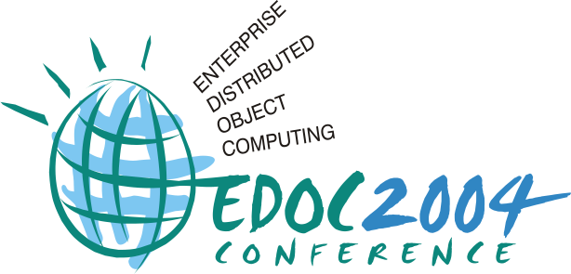



Workshop on ODP for Enterprise Computing
(WODPEC 2005)

P. Linington, A. Tanaka, S. Tyndale-Biscoe, and A. Vallecillo (Eds.)

Enschede, The Netherlands, September 19, 2005
http://www.lcc.uma.es/~av/wodpec2005/

Proceedings

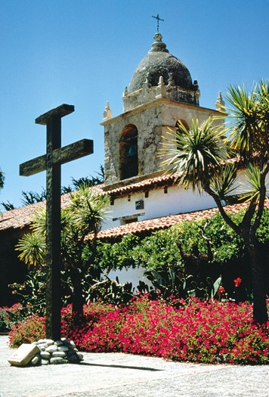


In conjunction with:

The 9th International IEEE Enterprise
Distributed Object Computing Conference
19-25 September 2005, Enschede, The Netherlands
http://www.edocconference.org

Editors

Peter F. Linington
Computing Laboratory
University of Kent
Canterbury
Kent, CT2 7NF (UK)
P.F.Linington@kent.ac.uk
http://www.cs.kent.ac.uk/people/staff/pfl/

Akira Tanaka
Hitachi Ltd.
Open Standards and Architecture
Software Division
…..(Japan)
tanakaak@itg.hitachi.co.jp

Sandy Tyndale-Biscoe
Open-IT Limited
Cedarcroft, Sunnyway, Bosham,
Chichester, W. Sussex, PO18 8HQ (UK)
sandy@Open-IT.co.uk
http://www.open-it.co.uk

Antonio Vallecillo
University of Málaga
ETSI Informática
Campus Teatinos
29071 Málaga (Spain)
av@lcc.uma.es
http://www.lcc.uma.es/~av

© The authors
September 2005

Table of Contents

Preface ………………………………………………………………………………………… vii

Change Management in Multi-view Systems
Nesrine Yahiaoui, Bruno Traverson, Nicole Levy............................................................ 1

An RM-ODP Based Ontology and a CAD Tool for Modeling Hierarchical
Systems in Enterprise Architecture
Lam-Son Lê, Alain Wegmann …………………............................................................. 1

On Interactions in the RM-ODP
Guy Genilloud, Gonzalo Génova ..................................................................................... 1

Modeling the ODP Computational Viewpoint with UML 2.0: The Templeman
Library Example
Raul Romero, Antonio Vallecillo .................................................................................... 1

UML 2 Models for ODP Engineering/Technology Viewpoints
Daisuke Hashimoto, Hiroshi Miyazaki, Akira Tanaka .................................................... 1

Modeling the Engineering Viewpoint of ODP systems with MODERN
Hai-Quan Nguyen. ………………………………............................................................ 1

Adopting the Practice of Enterprise Analysis in a Mid-Sized Company
Mary Burns Furr ............................................................................................................... 1

Generic model for services: health domain study
Zoran Milosevic ............................................................................................................... 1

Services, contracts, policies and eCommunities – Relationship to ODP framework
Lea Kutvonen and and Janne Metso ................................................................................. 1

List of Authors

Furr, M. B. 1
Genilloud, G. 1
Génova, G. 1
Hashimoto, D. 1
Kutvonen, L. 1
Lê, L.S. 1
Levy, N. 1
Metso, J. 1
Milosevic, Z. 1
Miyazaki, H. 1
Nguyen, H.Q. 1
Romero, R. 1
Tanaka, A. 1
Traverson, B. 1
Vallecillo, A. 1
Wegmann, A. 1
Yahiaoui, N. 1

Program Committee

David Akehurst University of Kent (UK)
Joao P. Almeida University of Twente (The Netherlands)
Jean Bérubé Idigenic (Canada)
Jonathan Billington University of South Australia (Australia)
Celso González IBM (Canada)
Haim Kilov Stevens Institute of Technology (US)
Lea Kutvonen University of Helsinki (Finland)
Peter F. Linington University of Kent (UK)
Arve Meisingset Telenor (Norway)
Joaquin Miller X-Change Technologies (US)
Akira Tanaka Hitachi (Japan)
Sandy Tyndale-Biscoe Open-IT (UK)
Antonio Vallecillo University of Málaga (Spain)
Bryan Wood Open-IT (UK)

Preface

The present volume contains the papers selected for presentation at the EDOC 2005 Workshop on ODP for Enterprise Computing (WODPEC 2005), that aims to provide a venue where researchers and practitioners on the use of the RM-ODP in the realm of Enterprise Distributed Computing can meet, disseminate and exchange ideas and problems, identify some of the key issues related to these topics, and explore together possible solutions and future work.

As stated in the Call for Papers (www.lcc.uma.es/~av/wodpec2005/wodpec2005-CFP.pdf), the Workshop tried to focus this year on problems and ideas related to the use of UML for ODP system specifications, and its relationship with other architectural practices and approaches (e.g., MDA, SOA, CBA, EDA), in the realm of Enterprise Distributed Computing.

All papers submitted to WODPEC 2005 were formally peer reviewed by two referees, and 9 papers were finally accepted for presentation at the workshop. These contributions cover a wide range of topics related to the RM-ODP, from general issues of the reference Model, to modelling approaches for specific ODP viewpoints.

We would like to thank the EDOC 2005 organization for giving us the opportunity to organize the workshop, especially to the General Chairs, Marten J. van Sinderen, Maarten W.A. Steen and Marc M. Lankhorst, and to the Workshop Chair, Bryan Wood, for their assistance and support. Many thanks to all those that submitted papers, and particularly to the contributing authors. Our gratitude also goes to the paper reviewers and the members of the WODPEC 2005 Program Committee, who helped in choosing and improving the selected papers. Finally, we want to acknowledge the Department of Lenguajes y Ciencias de la Computación of the University of Málaga for supporting the production and distribution of this volume, and the Spanish CICYT research project TIC2002-04309-C02 for funding some of its costs.

Enschede, The Netherlands, September 2005

Peter Linington, Akira Tanaka, Sandy Tyndale-Biscoe and Antonio Vallecillo
WODPEC 2005 Organizers

