Generic model for services: health domain study
Zoran Milosevic

CRC for EDST,
University of Queensland,
Brisbane, QLD 4072, Australia.
zoran@dstc.edu.au

Abstract
This paper provides a broader view on services than current Service Oriented Architecture (SOA) approaches. We analyse a generic concept of service from economic, legal and business perspectives and discuss the implications for the health domain. This enables us to develop an ODP enterprise viewpoint of the service concept and its relationship with other ODP viewpoints. In particular we consider the computational viewpoint, closely linked with the SOA concepts. The health domain provides a rich base for developing a comprehensive view on services. This is because of the inherent complexity of the domain with many actors, policies and dynamics involved in an increasingly multi-organisational and multi-jurisdictional context. The paper also provides a contribution in positioning services as part of an overall enterprise architecture for the health domain.
Keywords: Service Model, RM-ODP, SOA, Health Domain

Introduction
The recent popularity of Service Oriented Architecture (SOA) approaches can be explained by their capability to develop and structure IT applications in a way that more closely reflects the business logic of the enterprise. This is an attractive alternative to the monolithic applications of the past, many of which do not directly reflect end-user business needs. Such monolithic applications, offered by different vendors and deployed in a fragmented way, have resulted in IT systems that often provide duplicated and inconsistent views on data and functionality. This situation has resulted in many difficulties in managing IT systems, including change management in response to new requirements. This state of affairs is evident in many industry domains including health care.
The SOA allows decoupling of ICT applications into the logical units of business functionality, namely the components that can be configured and composed to create new or changed business function with minimal impact on the rest of the system. These components offer their functionality through their interfaces and are often referred to as services in the SOA speak. Web Services are one special case of SOA.
However, the SOA paradigm has also raised a number of questions regarding the meaning of the term ‘service’, in particular for the business stakeholders used to thinking in terms of economic or business perspectives. If the concept of service is to be used by both the IT and business domain experts, then there needs to be a clear separation of concerns pertinent to this concept.
This paper provides such a separation, by considering not only the computational and engineering aspects of service, as in the SOA approaches, but also their enterprise aspects. The value of this broader scope is in the capability to provide a unified view of service, so that both business and IT stakeholders establish a common foundation for communicating among themselves. This also ensures architectural alignment between business and IT aspects of an overall enterprise architecture of a system in broader sense.
We discuss the ideas in the paper by considering the pervasiveness of the service concept in the health domain. This is a highly complex domain, involving many different actors that must effectively collaborate in a service delivery while increasingly relying on the IT capabilities to do so. The service concept in the health domain needs to cover activities of, and policies to apply to health professionals, some of which are increasingly relying on the underlying IT services.
The next section provides a background discussion on the generic considerations for the concept of services, illustrated with examples from health domain. Section 3 considers the concept of service from various architectural perspectives of an overall enterprise architecture. Section 4 proposes an ODP enterprise viewpoint on service. This is followed by an ODP computational viewpoint of service, which is mapped onto the SOA approaches. Section 7 summarises our approach and outlines direction for our future work.

Service: generic aspects and health examples
This section outlines key aspects of the service concept, in particular from the economic, legal and business perspectives and reflects on their corresponding characteristics in the health domain.
In general, a service can be defined as ‘something done to benefit others’. Service provision is then a process that creates benefits to consumers by facilitating a change in consumers, a change in their physical possessions, or a change in their intangible assets [1].
In the health domain, the benefits to consumers are the improvement of their medical condition, their health and their well-being, through the delivery of health-care services. These are provided by various specialist providers, such as doctors, nurses, and allied health professionals, and usually through coordinated interactions between these professionals, e.g. in the context of the “continuity of care” for individual consumers, or through care packages. The delivery of such a combined care package can be quite complex and often requires synchronised and timely service delivery from all service providers involved. Finally, in the health domain the benefits are increasingly covering a broader range of services for the population in general, including for example preventative care and community services in addition to the acute service delivery. This broader spectrum of service delivery for all citizens during their life time is often referred to as ‘care continuum’.

Economic aspects
When considered from an economic perspective, service is an economic activity through which benefits to the consumer are delivered, in exchange for a payment of some form to those who provide services.
In the health domain, service provision also has an economic aspect because of the cost of service delivery, arising from the labour cost or from the utilisation of necessary resources such as medical equipment and medications. We note that there are various economic models for covering costs associated with service provision ranging from full public subsidies to fully private payment with most of these being a blend of public and private models. This depends on the national health system in question, which may include state jurisdictions.

Legal aspects
In the context of legal frameworks that govern service provision in most economies, including international trade, a promise to deliver service, or service offer, implies certain level of guarantees from the service providers. The guarantees can be in terms of what functionality is provided and also in terms of non-functional variables often referred to as Quality of Service (QoS). These guarantees can be substantiated by various mechanisms such as certification requirements and reputation characteristics of providers. The guarantees can even be taken as given, based on the direct trust in service providers from consumers’ previous experience. The legal frameworks also provide rules and regulations for the measures to be taken in case these guarantees are not met or are violated.
In the case of health care service providers, part of the guarantees are derived from the rules that set prerequisite criteria for permitting delivery of health services, e.g. requirements for passing certification tests typically set by governments or medical boards. An example of such an organisation in Australia is the Australian College of Health Services Executives [9]. These bodies also set rules for the actions to be taken in cases where there is inadequate service delivery. There are various forms of penalties that apply to service providers ranging from financial penalties to the revocation of their licences or certifications for providing services.

Business aspects
In the world of business, services are usually described in terms of service offers, which when accepted by consumers, form the corresponding agreements or a legally binding contract. Contracts can be regarded as a special way of defining guarantees to consumers for the behaviour of service providers. A business contract is constrained by the legal framework of the jurisdiction in which it is made. The contract will specify what the service provider has agreed to deliver and what the service consumer has agreed to accept, i.e. the consideration to be given in exchange for the use of service.
In health, contracts also exist as a way of governing interactions between various actors such as between private and public providers, medical and non-medical providers and so on. They are also subject to standard business contracts law. However, the ‘contracts’ that apply to the interactions between health care providers are consumers have a somewhat different character. The main concerns here are the policies that specify the responsibilities of health providers and the rights that consumers have in case of inadequate service delivery by health professionals. Note that consumers also have certain responsibilities, for example to comply with the therapies prescribed. As opposed to business contract law coverage, the law that applies to the consumer and health providers is mostly common law.
Furthermore, in business, many standard agreement types have been developed over time, reflecting historical patterns of interactions. Examples are real-estate contracts, financial contracts, construction contracts and service level agreements (SLAs).
In the health domain, there are standard agreements too. Some involve commercial providers and others are more within government scope, such as agreements between non-government organisations and health service providers, e.g. Memorandums of Understandings.

Generic aspects: summary
In summary, in addition to the functional aspects to be provided by the service (i.e. ‘something to be done’), there are other characteristics of services such as:
- the benefits or value delivered to consumers and the associated measures; in other words, these are outcomes which in the health domain is an improved health for individual consumers and for the population in general
Figure 1: Different service aspects in an Enterprise Architecture
- policies that apply to those who deliver services and possibly to those who are recipients of services; for example in the health domain the former are quality of care, accountability, delegation and privacy while the latter are patients' responsibility to follow treatment guidelines. Note that a subset of policies come into effect in case of violation of the primary policies, e.g. the measures that need to be taken when there is an unsatisfactory treatment of patients
- costs associated with service delivery

Service concept and enterprise architecture
The term ‘service’ has also been used in the context of IT systems, where in the past it has been primarily used to describe functionality provided by a software component, application or the whole system. In some cases, the term is also linked with the cost aspects of service delivery. However, in IT systems services have rarely addressed their social, legal or economic aspects. These aspects are critical for the health domain and, from the point of view of an enterprise architecture, they belong to the business architecture aspects of an overall architecture.
Considering the importance of enterprise architecture for health systems, as evidenced by many new initiatives in the health domain, such as in the US Federal Enterprise Architecture [10], it is important to take into account a broader definition and model for health care service. This is needed to describe other characteristics of services, such as the policies that apply to health providers and their implication on the underlying IT applications that support coordinated health service delivery.
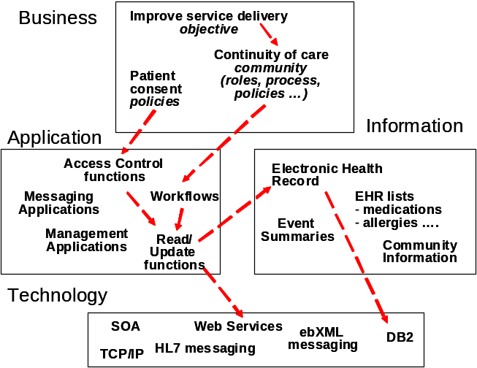
We illustrate this through a simplified example showing some of the modelling concepts in business, information, application and technology architecture of an overall enterprise architecture, Fig.1 Consider patient policy constraints regarding access to and sharing of information in their electronic health records (EHR). These are important aspects for the EHR service provision and they need to be expressed as part of a business architecture on an overall enterprise architecture. This business constraint needs to be propagated to the definition of the access control rules for the read/update functions for the EHR, in the application architecture, as shown with the arrows linking these modelling concepts. This functionality is then specified as part of the technology architecture, for example using Web Services technology. The example also shows links to the information architecture which specifies structure of HER, and which uses a specific database technology, DB2.
Another example is the specification of various roles and processes in the continuity of care community (specified in the business architecture) that can be implemented using a workflow engine which in turn may need to use read/update function to access the EHR system.
In the remainder of this paper, we propose a broader framework for defining services, by adopting the ISO ODP architectural framework. According to this framework, a system or a concept can be defined from various architecture viewpoints reflecting specific concerns of the relevant stakeholders. These viewpoints are enterprise, computational, information, engineering and technology. In this paper we consider only enterprise and computational viewpoints.
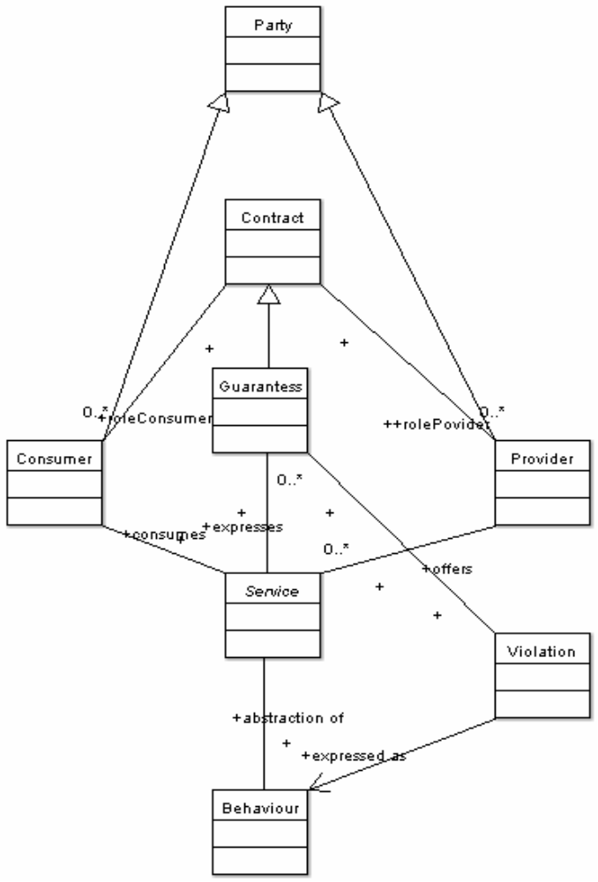
In the ODP standard the concept of service is mentioned in the context of foundational concepts and is defined as ‘a particular abstraction of behaviour expressing guarantees offered by a service provider’ [2]. To a significant extent, this statement reflects the fundamental aspects of service as per their economic, legal and business interpretation discussed above. We will use this definition as a starting point for further refinements. Specifically, we will refine this definition from each of the ODP viewpoint abstractions allowing us to support modelling of services from either the IT or business perspectives. Our intention is to provide a clear separation of concerns associated with service concept while ensuring that its fundamental properties are preserved.
Our aim is to ensure that service becomes a more explicit modelling concept in the ODP specification, in a similar way as the concept of object has the enterprise, information, computation and engineering viewpoints. This can be also seen as a contribution to current revisions within the ODP standards, with the aim to promote a more unified view on service.
We begin by considering service from the enterprise viewpoint in next section, followed by computational viewpoints, presented in following sections.

Enterprise viewpoint considerations
The ODP enterprise viewpoint is about the scope, policies to apply and objectives of the systems to be built. Thus the ODP enterprise specification needs to define the organisational, policy and legal constraints for the IT systems to be built. Accordingly, the concept of service in the enterprise specification deals with a broader set of issues that apply to both, human or social behaviour in the system. Part of this behaviour applies to the behaviour (i.e. functionality) of an underlying IT applications and systems that are used by the human actors. This was discussed in the context of health domain example in the previous section.
Figure 2: Service - ODP enterprise viewpoint
From the ODP enterprise viewpoint, service is an abstraction of behaviour of a service provider in terms of economic and legal activities through which the provider offers services with the corresponding guarantees. This definition includes a number of modelling concepts which we depict using the corresponding meta-classes in the meta-model in Fig. 2. These are the Service, the Provider and the Guarantee meta-classes and the relationships between the Provider and the Service classes, and between the Service and the Guarantees classes. The Service meta-class is an abstract meta-class, as there are many specialised types of services. In the health domain, these can be classified in many different ways [1]. Note that due to space limitation this is not a fully specified meta-model. Rather, it only includes key meta-classes and their relationship, while omitting other detail such as attributes of the meta-classes and full details of their relationships, e.g. their full cardinality and navigability properties.
The service provides some value to potential consumers according to the guarantees associated with the service offer, and this is shown as the relationship between the Service and the Consumer meta-classes.
The guarantees that are offered by the service provider for the provision of service can be regarded as a partially filled business contract (shown as specialisation relationship between the Contract and the Guarantee meta-classes). Such a contract will be instantiated at the point when a consumer of service accepts the service offer of the provider.
Typically, the guarantees specify the capabilities and constraints of a service provider and can be in terms of functional or non-functional properties. It is also possible that, through a form of negotiation, the original guarantees are updated to better reflect needs of consumers. Notice that the Service Provider and Consumer meta-classes have their corresponding roles in the respective contract (shown through the relationships between the Contract and Consumer and Provider classes).
For a contract to be legally valid, and thus the guarantees to be accompanied by the corresponding reparation actions, each of the roles in the contract, i.e. the provider and the consumer must have the legal capacity properties. This is one of the elements of legal contract validity [4]. The ODP enterprise language includes several accountability concepts and we use the concept of party, defined as an enterprise object modelling natural person or any other entity to have some of the rights, powers and duties of a natural person [3]. This is shown as two specialisation relationships between party and consumer and provider meta-classes.
Finally, we include a meta-class that describes violation measures that need to be applied in the case of failure to meet service guarantees. These measures could be defined in terms of the policies that take effect in response to violation events. One possible approach to formally specifying and implementing violations of guarantees stated in business contracts is given in [8].

ODP computational viewpoint considerations
From the ODP computational perspective a service is an abstraction of behaviour of a server object in terms of a function that it makes available to other objects. These guarantees include computational activities such as conveyance of information back to the client object. This transfer of information is initiated in response to the client’s invocation, i.e. their request for a function to be performed by the server object.
It is important to note that the above definition encompasses both the synchronous (e.g. RPC) and asynchronous (e.g. message-oriented or publish-subscribe) styles of interactions. In the latter case, the server object is called producer and the client object is called consumer.
In the following we show how these ODP abstract computational concepts can be mapped onto the specific architecture styles such as SOA and event-driven architectures (EDA). These mappings, coupled with the relationships between the ODP enterprise and computational viewpoints (which will be briefly discussed first), enable us to provide more direct linkages between business and application architectures.

Relationships to enterprise specification
We describe several relationships between the ODP enterprise and computational modelling concepts pertinent to services. These relationships need to be accompanied with the relationships between other enterprise and computational modelling concepts, some of which are described in [3].
The function that the (computational) server object makes available to others implements guarantees of the service provider stated in the enterprise viewpoint. The (computational) client object implements some of the functionality of consumers specified in the enterprise viewpoint.
The basic behaviour specified in terms of computational behaviour above needs to be augmented with the behaviour expressions specifying the policies that apply to the service provider and consumer enterprise objects. These additional behaviour specifications can be implemented using a special kind of computational objects, i.e. policy objects that implement obligation, permission or prohibition expressions. A detail description of policy objects and their behaviour is presented in our earlier work [6].
The use of policy specifications can be either to directly prevent an inadequate service delivery or as part of business activity monitoring. In the latter case certain reparation measures could be applied and these can be implemented through the appropriate set of computational objects. A more detailed description of various enforcement approaches are given in [7, 8].

SOA and mapping to ODP
The principles of SOA have been around for long time, including the early development of open distributed systems and the related standards such as ISO ODP [2,3] and OMG standards. The SOA principles became prominent in recent years with the emergence of the Web Service technologies and specifications. Perhaps the novel features are:
- the more explicit focus on the business logic to be supported, including more direct access to human users via Web-based interfaces
- the capability to link services through various choreography models and
- a more documented-oriented messages (typically defined in XML) in communication between objects.
The use of SOA in the health domain can be seen as an enabler towards replacing monolithic and hard-to-change applications of the past with the components that more directly reflect the needs of various health professionals. This would enable clearer definition of services of each of the health providers and linking them into processes that reflect health-care specific activities. This applies to administrative and procurement activities, but also linking of various service providers in the context of ‘continuity of care’ delivery.
In the following we list key SOA principles, and provide a simplified mapping to the ODP computational architecture framework.
Loose coupling – meaning that services are defined solely in terms of the functionality they provide, without a strong (or with a small and well-known) dependency on other components; in ODP, this decoupling is achieved through the concept of object, which can expose its functionality through one or more interfaces;
Interoperability – meaning the ability of services implemented using different platforms and languages to communicate with each other; in ODP this is achieved through a protocol independent computational interface specification
Composition – meaning a capability for services to be assembled into applications in various ways including the ways which were not anticipated at the time of service definitions. This allows developing more complex business logic and adding new functionality as new business needs require. In ODP there are various mechanisms for composing objects, in particular the computational binding object which allows connecting computational interfaces of various objects. The binding object is an abstract mechanism for linking various objects and some specific styles of binding are orchestration and choreography. An approach based on the refinement of binding object targeting such binding styles are discussed in more detail in [7].

Event-driven architecture and ODP mapping
Event-driven architectures (EDA) are based on the capabilities of components to produce events and of other components to consume events. This is often referred to as publish-subscribe model of interactions. So, rather than through a usual synchronous communication style typical of SOA approaches, components interact by producing and consuming events. This assumes the existence of a message oriented middleware (referred to as message queue) which provides persistent storage for events, after they are produced and consumed by others. The capabilities of EDA, also enable the specification of applications in terms of events and event relationships, i.e. the event patterns, as proposed in [5]. A similar approach was also taken in [6], for the purpose of real-time monitoring of business activities associated with enterprise contract management.
The combined capabilities of SOA and EDA offer many options for developing health applications in an incremental manner, while leveraging the existing applications where possible. For some applications in which there is no need for real-time access to information, the SOA may suffice. For others, the choice may be based solely on the EDA principles or more likely it would be the combination of SOA and EDA solutions.
The use of EDAs and event-pattern specifications in the health domain could be exploited to support real-time checking of the adequacy of service delivery by health providers, or the implementation of medical treatment by the patients.
In terms of the mapping to the ODP computational model, the concept of event in the EDA corresponds to the ODP concept of signal. This is defined as an atomic shared action resulting in an one-way communication from an initiating object to responding object []. As operations in the ODP computational model can be defined in terms of signals, so the messages communicated between components in an EDA can be defined in terms of events.

Conclusions and Future Work
This paper provides an input towards a generic service modelling covering both the business and IT aspects of services. We use the ISO ODP standard as a framework for discussing the ideas. We presented an initial proposal for extending ODP standards to give more prominence to the concept of service. We then discussed relationships between ODP enterprise and computational modelling concepts regarding services. When further consolidated these relationships will allow generic mappings between different viewpoints on service. Further, each of the abstract set of ODP viewpoints can be made more specific. On the technology side we have demonstrated how the ODP computational modelling concepts could be mapped to more concrete architectural styles such as SOA and EDA. These are still abstract models an the respective concrete models would be Web Services architectures and JMS. Our approach is illustrated in Fig. 3. The mappings 2, 3 and 4 show generic mappings from the enterprise language concepts to the underlying technology implementations. For example, the concept of policy in the enterprise language can be mapped onto the policy objects in the computational viewpoint. These can be implemented using both the SOA and EA solutions, such as WSDL and WS-eventing. Finally, the health specific concepts could be used to refine and extend relevant ODP concepts. This mapping (1), with the mappings 2, 3 and 4, thus provides a link from the enterprise language to the underlying implementation options, such as the specific SOA and EDA solutions.

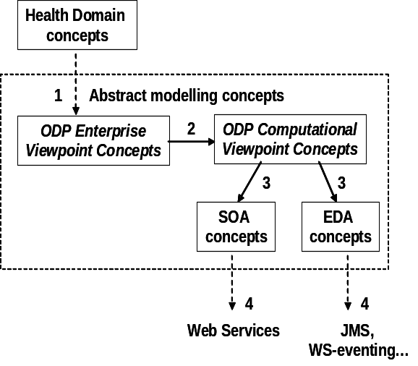
Figure 3: From health domain concepts to concrete technology solutions

The paper was motivated by a recent collaboration between DSTC and Queensland Health regarding the establishment of an enterprise architecture framework for this health organisation. However, the results pertinent to the health domain are not specific to Queensland Health and could be applied to many health jurisdictions.
In future we plan to continue this study by developing more comprehensive business language concepts for the health domain and test this on a number existing and future initiatives within Queensland and Australian health organisations. The concept of service is one, but important modelling concept in this language.
We believe that the maturity of ODP standards (directly, or through other standards that were influenced by ODP), provide a sound basis for developing an enterprise architecture framework for health domain. The precise architecture of ODP, supported by the emerging and future tools, including model-driven engineering, is a promising candidate for developing a business-driven, and sustainable enterprise architecture for the existing and future health applications.

Acknowledgements
The work reported in this paper has been funded in part by the Co-operative Research Centre for Enterprise Distributed Systems Technology (DSTC) through the Australian Federal Government's CRC Programme (Department of Education, Science and Technology). The author would also like to thank Walter Robb, from Queensland Health for providing valuable comments to this paper.

References
- http://en.wikipedia.org/wiki/Service (accessed June 2005)
- ISO/IEC IS 10746-3, Open Distributed Processing Reference Model, Part 2, Foundations, ISO 1994
- ISO\IEC IS 15414, Open Distributed Processing-Enterprise Language, 2002.
- Z. Milosevic. Enterprise Aspects of Open Distributed Systems. PhD thesis, Computer Science Dept. The University of Queensland, October 1995.
- D. Luckham, The Power of Events, Addison-Wesley, 2002
- P. Linington, Z. Milosevic, J. Cole, S. Gibson, S. Kulkarni, S. Neal, A unified behavioural model and a contract for extended enterprise, Data Knowledge and Engineering Journal, Elsevier Science.
- A. Berry, Z. Milosevic, Extending Choreography with Business Contract Constraints, International Journal of Cooperative Information Systems, Vol. 14, Nos. 2 & 3 (2005), p. 131-179, World Scientific Publishing Company.
- G. Governatori, Z. Milosevic, Dealing with contract violations: formalism and a domain specific language, Proc. the 9th IEEE EDOC conference, Holland, Sept. 2005, to appear.
- http://www.achse.org.au/
- http://www.whitehouse.gov/omb/egov/a-3-2-services-health.html
- www.oasis-open.org/committees/legalxml-econtracts/charter.php

