TOOLS-Europe 2010


48th International Conference on Objects, Models, Components, Patterns

ICMT 2010

3rd International Conference on Model Transformation

SC 2010

9th International Conference on Software Composition

TAP 2010

4th International Conference on Tests and Proofs

Conference Programs

Málaga, Spain
28 June – 2 July 2010

Contents
Welcome to TOOLS 2010 Federated Conferences 3
Welcome to TOOLS Europe 2010 4
Welcome to ICMT 2010 5
Welcome to SC 2010 6
Welcome to TAP 2010 7
Organization 8
About Málaga 9
Other useful Information 13
Social Program 15
Technical Information for Presentations 18
Keynote speakers 19
Workshops 26
Overall Schedule 32
Program 33
TOOLS Europe 2010 Committees 44
ICMT 2010 Committees 45
TAP 2010 Committees 47
SC 2010 Committees 48
Sponsors 49

Welcome to TOOLS 2010 Federated Conferences
It is our pleasure to welcome you to TOOLS 2010 Federated Conferences, which this year take place in Málaga, Spain, from Monday June 28 to Friday July 2. The conferences will be held at the premises of the School of Informatics of the University of Málaga.
The TOOLS series of conferences is devoted to all modern approaches to Software Development. This will be the third year that TOOLS happens as a federated event, bringing together a set of conferences that encompass a broad range of topics related to Software Development, while keeping the traditional TOOLS spirit of technical excellence, practicality, combination of theory and applications, and reliance on the best experts from academia and industry.
The 2010 edition is a confederation of four major annual conferences (TOOLS Europe, ICMT, SC and TAP). In addition, a number of satellite Workshops will be held in conjunction with the main conferences, making TOOLS the premier forum for academic and industrial research working on areas related to Software Development, and also the perfect venue for exchanging ideas and experiences around these topics.
The TOOLS 2010 conferences are organized by the Department of Computer Science of the University of Málaga, in co-operation with the ETH, Zurich. The conferences proceedings are all published by Springer under the LNCS series.
In addition, a comprehensive social program has been prepared to help all the participants enjoy the visit as much as possible, and to foster friendly collaboration among the different communities.
This conference would not have been possible without the help and dedication of many people, in particular the Chairs of the four Conferences, the members of the Program Committees that assembled the technical programs, the members of the Organizing Committee that worked for more than one year to make the conference happen, the Workshop Organizers, and of course to this year’s Sponsors..
We would like to warmly welcome you to Málaga for this TOOLS 2010 experience, and hope you have a very fruitful and productive conference.

Bertrand Meyer Antonio Vallecillo
Chair Organizing Chair
TOOLS Conference Series TOOLS 2010 Federated Conferences
Welcome to TOOLS Europe 2010
…

Welcome to ICMT 2010
LAST YEAR’S TEXT:
Modelling is now essential for dealing with the complexity of IT systems during their development and maintenance processes. As models grow in use for developing IT systems, transformations between models grow in importance. Model transformations allow the definition and implementation of operations on models, and also provide a chain that can enable the automated development of a system from its corresponding models.
Model transformations require specialized support in order to realize their full potential; their foundations, semantics, structuring mechanisms, and properties (e.g., modularity, composability, and parameterization) all demand further study. Furthermore, model transformations do not sit in isolation, and require methodological support to integrate into existing software development practices.
ICMT is the premier forum for the presentation of new results in the area of model transformations. As a working conference, ICMT has a strong practical focus, with research papers, industrial reports, tool presentations, panels, and invited talks from renowned speakers.
Topics of interest include, but are not limited to languages, scalability, reuse, semantics, implementation, generation, merging, maintenance, evolution, methodologies, tools, case studies of/for model transformations.
Welcome to SC 2010
LAST YEAR’S TEXT:
The International Conference on Software Composition (SC) is the leading venue that addresses challenges of how composition of software parts may be used to build and maintain large software systems.
SC2010 will be the ninth edition in the series and we invite researchers and practitioners to submit high quality papers. Submissions relating theory and practice of software composition are particularly welcome. Software Composition 2010 is co-located with TOOLS 2010 Federated Conferences.
Proceedings of the conference will be published as a volume in Springer's Lecture Notes in Computer Science.
Welcome to TAP 2010
LAST YEAR’S TEXT:
The TAP conference is devoted to the convergence of proofs and tests. It combines ideas from both sides for the advancement of software quality.
To prove the correctness of a program is to demonstrate, through impeccable mathematical techniques, that it has no bugs; to test a program is to run it with the expectation of discovering bugs. The two techniques seem contradictory: if you have proved your program, it's fruitless to comb it for bugs; and if you are testing it that is surely a sign that you have given up on any hope to prove its correctness.
Accordingly, proofs and tests have, since the onset of software engineering research, been pursued by distinct communities using rather different techniques and tools.
And yet the development of both approaches leads to the discovery of common issues and to the realization that each may need the other. The emergence of model checking has been one of the first signs that contradiction may yield to complementarity, but in the past few years an increasing number of research efforts have encountered the need for combining proofs and tests, dropping earlier dogmatic views of incompatibility and taking instead the best of what each of these software engineering domains has to offer.
The conference will include a mix of invited and submitted presentation, and a generous allocation of panels and informal discussions.
Organization
General Chairs
- Conference Series chair: Bertrand Meyer, ETH Zurich and Eiffel Software, Switzerland
- Organizing chair: Antonio Vallecillo, Universidad de Málaga
TOOLS Europe 2010
- Conference chair: Bertrand Meyer, ETH Zurich and Eiffel Software, Switzerland
- PC chair: Jan Vitek, Purdue University, US
Software Composition 2010
- Conference chair: Judith Bishop, Microsoft, US
- PC co-chairs: Benoit Baudry, IRISA, France, and Eric Wohlstadter, UBC, Canada
ICMT 2010
- Conference chair: Martin Gogolla, University of Bremen, Germany
- PC chair: Laurence Tratt, Bournemouth University, UK
TAP 2010
- Conference chairs: Yuri Gurevich, Microsoft Research, USA, and Bertrand Meyer, ETH Zürich and Eiffel Software,Switzerland
- PC co-chairs: Angelo Gargantini, University of Bergamo, Italy and Gordon Fraser, Saarland University, Germany
Local organizing committee:
- Organizing chair: Antonio Vallecillo, Universidad de Málaga
- Workshop chair: Francisco Durán, Universidad de Málaga
- Registration chair: Carlos Canal, Universidad de Málaga
- Social program chair: José M. Álvarez, Universidad de Málaga
- Finance chair: Ernesto Pimentel, Universidad de Málaga
- Organizing team: José Antonio Martín, Universidad de Málaga
Jose Bautista, Universidad de Málaga
Manuel F. Bertoa, Universidad de Málaga
Fernando López, Universidad de Málaga
Lola López, Universidad de Málaga
Ana Doherty, Universidad de Málaga
Nathalie Moreno, Universidad de Málaga
Eduardo Rivera, Universidad de Málaga
Daniel Ruiz, Universidad de Málaga
Javier Troya, Universidad de Málaga
About Málaga
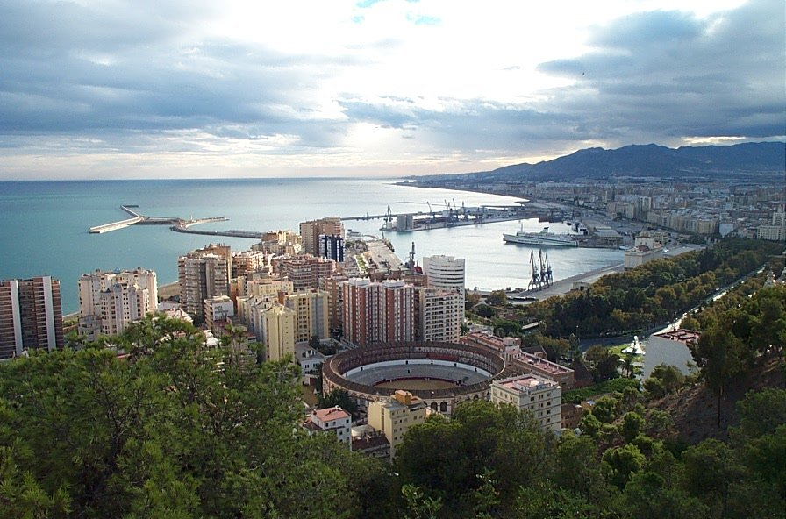
Malaga is located in the South of Spain on the Mediterranean coast in the community of Andalusia. Its province lies between Granada to the East, Cadiz to the West and Cordoba and Seville to the North. Spain's fifth-largest city with a population of about 650,000, Malaga offers an interesting mixture of a cosmopolitan business center and a traditional Andalusian city with a relaxed atmosphere and joyful people.
Malaga has a long and interesting history dating back to its foundation as a Phoenician town 3000 years ago. Thanks to its strategic position next to the Mediterranean Sea, this province has long been a highly disputed territory; in 550 BC the Carthaginians took control from the Phoenicians and in 218 BC the area was invaded by the Romans. The large Roman theatre located in the centre of the city stands as a testament to this period in the city's history. The Moorish rule of Southern Spain (which lasted from 700 AD until the Christian re-conquest in the late 15th Century) also left behind several interesting historical sites - among them the 15th Century Gibralfaro castle and the Alcazaba fortress built in the 11th Century.
In modern times, Malaga has gained international fame for its pleasant year-round weather, which boasts around 320 days of sun per year. Since the 1970's the region has become a preferred tourist destination for thousands of North Europeans who flock each year to the surrounding towns of Marbella, Torremolinos and Benalmadena. Other popular destinations in the Costa del Sol (which is home to a thriving and diverse expatriate community) can also be found just 20 minutes west of Malaga's city center.
Apart from being a popular tourist destination, Malaga is also an important business center for Southern Spain. The city's airport and harbour are among the busiest in the country, and the newly built Technology Park and International Congress Centre in the outskirts of the city have attracted large national and international companies to the city.
Malaga is also a city rich in culture; apart from the numerous historical monuments that grace its streets and plazas, it is home to some of Spain's most interesting museums and theatres. The new Picasso Museum is without doubt the most important of these museums and stands as a fitting tribute to Malaga's most famous native son.

Conference Venue
All events related to TOOLS 2010 Federated Conferences will take place at the premises of the School of Informatics (ETSI Informática) of the University of Málaga, located in the Campus de Teatinos. See http://bit.ly/cbJX8t for detailed information about the location of the campus and how to reach it.

Address: ETSI Informática
Campus Teatinos
Bulevar Louis Pasteur, 35.
29071 - Málaga
The locations of the individual conferences and workshops are detailed on their corresponding pages in this booklet.
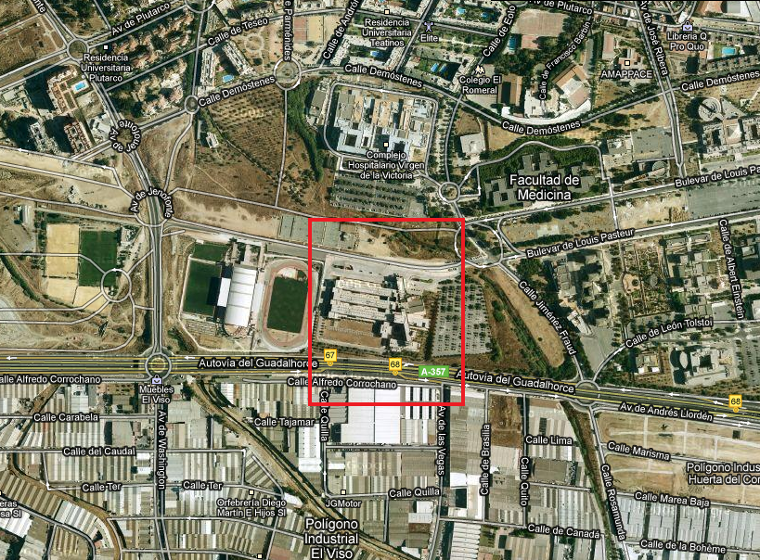

Transportation: From the airport to the city centre
By train
The train station is outside the airport building. You should take the lift in the Arrivals Hall up the Departures Hall, and then walk to the outside, through the upper level parking area, going over the footbridge, which spans the road below. Follow the signs for the train station. Look out for this sign above the station:

It is important to know that you must have a ticket before you board the train, or you will be liable for a fine of around 10 times the cost of the fare. There is an automated ticket machine at the airport train station, which works with Euro coins, bank notes (up to €20), and credit cards. The price of a single is around €1,20 (working days and weekend fares are slightly different).
First train 07:09, then every half an hour. Last train 23.59. Journey time 12 minutes. Take the direction Málaga (not Fuengirola), until the terminus station (Málaga Renfe – “Vialia”). Price of Train Ticket: most one-way journeys are less than 3 Euro depending on destination and day of the week (slightly higher fares on Saturdays and public holidays).
By bus
The Bus stop is located just outside the main arrivals hall (turn right on leaving and walk 40m). Frequent bus Services from the Airport to Málaga City Service No 19. This is an urban bus, it may leave the airport empty but fill with passengers en-route so be prepared if you have a lot of luggage.

- From the Airport to Malaga bus and train station every 1/2 hour: First Bus: 07.00. Last Bus: 24.00
- From Malaga bus and train station to the Airport every 1/2 hour: First Bus: 06.30. Last Bus: 23.30
The cost is around 2 Euro. Note that bus cards are not valid for the trip to the airport. You should buy a separate ticket.
By Taxi
A taxi from the airport to the city centre may cost you between 20 and 25 Eur. Fees are a bit more expensive during the week-end and at night (between 10pm and 6am).

Transportation: From the city centre to the conference venue

By bus
As part of your delegate package you will be given a bus map and a bus card, valid for the whole week of the conference (Monday 28 to Friday 2). The bus card grants you an unlimited number of trips in all city buses.
There are several lines that take you from Málaga city centre to the University, but probably the best one is #20. Buses run every 10-15 min and the duration of the trip is between 15 and 20 min. depending on the traffic.
Coming from Málaga city centre you can take it from the Alameda Ave, very close to where the recommended conference hotels are. The final stop is “Hospital Clínico”, where you should get off to go to the conference venue (the hospital is in front of the ETSI Informática). The ETSI Informática is 50m. away from the bus stop, you will see the building when you get off the bus.
Once you arrive at the ETSI Informática, follow the signs for TOOLS 2010.
Bus#20 is also the bus you can take to go back to the city centre. Be careful not mistaking it with bus #22, because they share stops but it serves a different part of the city. The number of the bus lines are shown both in the displays in the front and the side of the buses.
When you do not need your bus card anymore (for instance, if you are leaving to the airport directly from the University), please return it to the registration desk, since cards can be recycled.
By taxI
An alternative option for going to the conference venue is by taxi. It costs around 8 Euro, and the trip duration is around 10 minutes. There are taxi ranks at the door of most hotels, or very close to them. To go from the conference venue back to the city centre or directly to the airport by taxi, you can either ask somebody at the TOOLS registration desk to order you a taxi, or walk to the taxi rank at the Hospital Clínico (100 m. away from the conference venue).
The duration of the trip by taxi from the ETSI Informática to the city centre is around 10 minutes (it goes up to 15 min. in the afternoon) and around 15-20 minutes to go to the airport. From the city centre to the airport you should allow 20 to 25 minutes to be on the safe side (trip fare is around 20 euros).
IMPORTANT: Please try to be at the airport at least 90 minutes before your flight (60 if it is a domestic flight).
Other useful Information
Registration Desk
The registration desk will be open every day between 28 June and 2 July, from 8:30 to 9:30 and during the morning coffee-breaks (11:00-11:30). If you need to register outside these times, or need any other assistance, please ask somebody from the local organization or to any student volunteer.
Badges
You are kindly requested to wear your name badge at all times. Admittance to the sessions, coffee breaks, lunches, and the evening program is allowed only to badge/pass holders.
Lunch
Lunch will be served every day between 13:00 and 14:30 in the Cafeteria, situated on the lower ground floor of the School. Vegetarian meals will be available. You will receive coupons for the lunches as part of the registration package. Should you require any special food or have any particular dietary restrictions, please indicate them when registering for the conference.
Coffee Breaks
Every day there will be two coffee breaks, one in the morning (11:00-11:30) and one in the afternoon (16:00-16:30). The coffee breaks will be served in the cafeteria.
Weather
Málaga is the capital of the Costa del Sol (the Sun Coast), so warm temperatures are expected during the conference, ranging from 25C to 30C (77F-86F). Bring your swimming suit with you (for your free time!), and of course do not forget some sun cream protection. There are beaches in Málaga close to the hotels (walking through “el Parque” will take you to the nearest ones). From there you can go to the “Pedregalejo” beaches either by walking (3 km) or you can take bus line #11 (destination “Pedregalejo”). Alternatively, you can go to one of the more beautiful nearby beaches along the coast by taking a bus from the Central Bus station to Torremolinos, Fuengirola or Marbella.
Useful telephone numbers
Local police: 092
National police: 091
Health service: 061
Airports: 952 048 804 and Iberia 902 400 500
RENFE (trains): 952 360 202
Taxis: 952 33 33 33 / 952 048 614
Málaga Tourist Office: 952 604 410
Hotels:

Málaga Palacio: (+34) 952 22 51 85
Tryp Alameda: (+34) 952 36 80 20
Don Curro: (+34) 952 22 72 00
Petit Palace: (+34) 952 22 21 32
Problems
Organizational details during the conference will be dealt with at the registration desk. Should you need further assistance, do not hesitate to contact any member of the organization, who will try to help in any way they can.
Outside the conference hours, or if you are away from the conference venue, please dial +34 678998465 for contacting somebody from the conference organization.
Please do not hesitate to ring them if in need of assistance. Málaga is a tourist city used to dealing with tourists and their problems, and normally very friendly to foreigners.
Social Program
For the participants of the TOOLS 2010 Federated Conferences a wide variety of social events have been planned, so that they can meet in a friendly and informal environment. Participants will have the opportunity to visit and explore some of the most interesting and historical parts of the host city, Málaga. The scheduled events are:
Monday, June 28 Welcome Cocktail
A welcome cocktail and finger buffet will be served in the Town Hall. This historic building was built in the early twentieth century, between 1911 and 1919, on an area of land which was originally covered by the sea. It is in a beautiful spot, close to the city harbor and surrounded by the Pedro Luis Alonso and the Puerta Oscura Gardens. It is also positioned at the foot of the old Moorish castle (the Alcazaba) and also the Gibralfaro castle.
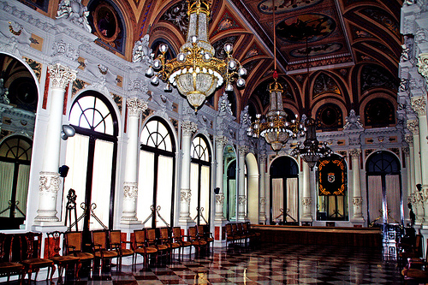
Time: Evening, exact time to be announced.
Tuesday, June 29. Night on the beach
Perhaps one of the best known dishes of the local cuisine is the delicious fried fish, caught fresh daily. This outing will be a very informal dinner in a typical beach restaurant, where a variety of local fried fish and seafood will be served, including the famous "espetos". These are sardines, skewered on a stick, grilled over a fire, in an old fisherman’s boat filled with sand, right on the beach.
Everyone is invited to bring their towels and swimming gear so that they can enjoy an after dinner swim in the sea.
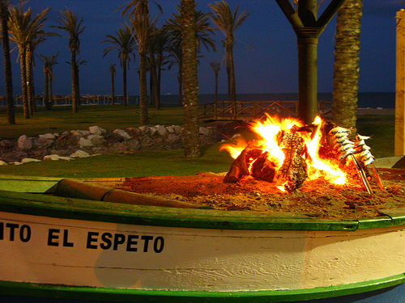
Time: Evening, exact time to be announced.
Wednesday, June 30. Gala banquet
The gala banquet will be served in a wonderful setting, the Castle of Santa Catalina military fortress, which was originally converted into a private palace for one of the wealthiest local families and later converted for use as a top quality restaurant and hotel. The dinner will be served in the beautiful gardens which have outstanding views over the city and the bay of Málaga.
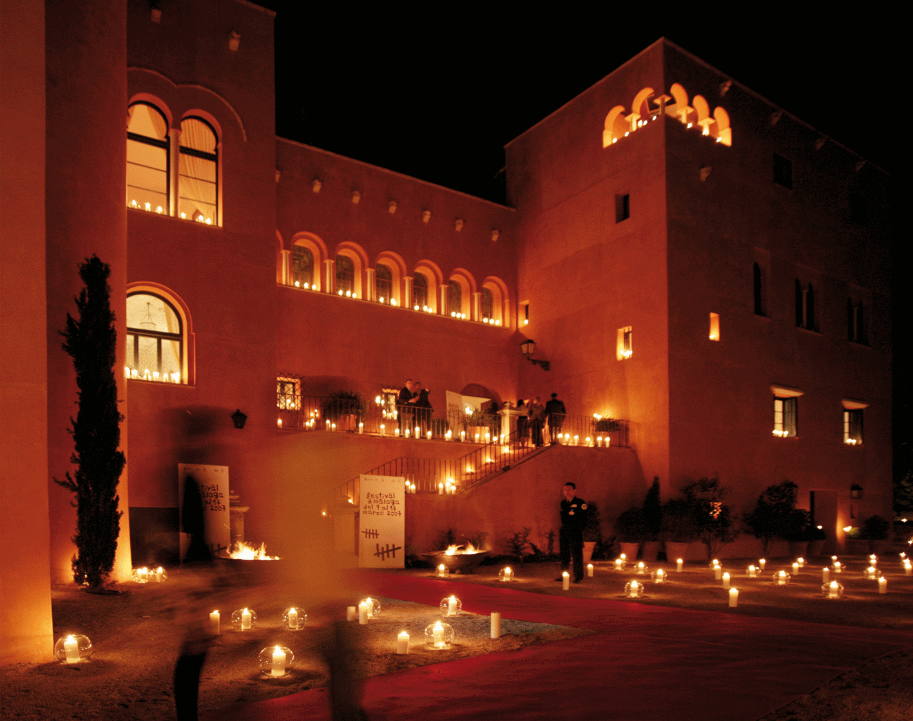
Time: Evening, exact time to be announced.
Thursday, July 1. City walk and "tapas" route
Thursday's events are oriented to help the participants to get to know the city in two different ways. First, a guided walk around the city center streets followed by a “gastronomic” tour. For this, a selection of local restaurants has been chosen so that the participants have the opportunity to taste a variety of well known tapas small, tasty snacks.
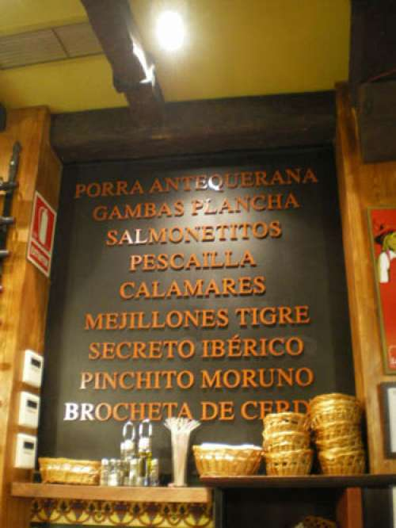
A map with a list of the restaurants on the tour will be given to the participants, along with vouchers which can be used to pay in those restaurants. Some local tour guides will be available to take the visitors around,, but participants are also free to explore on their own and follow their own route based on the restaurants listed.
Further social activities
An extensive social program has been arranged during the conference so that those attending the conference will enjoy thier visit to Málaga as much as possible. Free activities for companions are available as well, since this can be an excellent opportunity to bring your partner and/or family and to enjoy the trip to Spain.
Should you need further assistance on this matter, apart from the excursions and trips already organized, do not hesitate to contact us.
Technical Information for Presentations
All rooms in the ETSI Informática are equipped with a digital projector. The digital projector has a VGA connector on the speaker's desk and should work with a resolution of 1024x768 or below. Although there will be PCs in every room, we recommend all speakers to use their own laptop to avoid potential incompatibility problems with the presentation software or the installed fonts in the computer.
Internet Access
Wireless access should be available everywhere in the building. You will need an IEEE 802.11b compatible wireless adapter. Network configuration uses DHCP. To access the network please the following user name and password:
- User name: Tools2010
- Password: Malaga2010
This connection does not block ports or filter traffic. You will have full access to the Internet, including Web, Telnet, IMAP, IMAPS and SSH. Be advised that the wireless traffic is not encrypted. Authentication is WPA-PSK


Keynote speakers
Monday 28th June
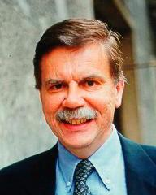 | Stefano Ceri,  Department of Electronics and IT  Polytechnic of Milan, Italy  ICMT keynote speaker
SEARCH COMPUTING - A MODEL-DRIVEN PERSPECTIVE

Abstract
Search Computing (SeCo, www.search-computing.it) is a project funded by the European Research Council (ERC). It focuses on building the answers to complex search queries like "Where can I attend an interesting conference in my field close to a sunny beach?" by interacting with a constellation of cooperating search services, using ranking and joining of results as the dominant factors for service composition.
This talk sketches the main characteristics of search computing and discusses how software engineering and model-driven engineering are challenged by the search computing problems. The talk presents Search Computing applications from a model-driven perspective, in terms of (1) the models describing the objects of interest, (2) the specification of applications through model transformations, and (3) the definition of a domain specific language (DSL) defined for the specification of search query plans.
Bio
Stefano Ceri (http://home.dei.polimi.it/ceri/) is Professor of "Database Systems" at DEI, Politecnico di Milano; his research interests are focused on extending database technology to incorporate data distribution, deductive and active rules, object orientation, XML query languages; recent work is focused on design methods for data-intensive WEB sites, stream reasoning, and search computing. He is vice-chairman (representing Politecnico di Milano) of the Executive board of Alta Scuola Politecnica, a school of excellence for master-level students which is jointly organized by the Politecnico di Milano and the Politecnico di Torino (2007-2010). He is author of about 250 articles on International Journals and Conference Proceedings, and is co-author of 9 international books; he is co-editor in chief of the book series "Data Centric Systems and Applications" (Springer-Verlag).
He is responsible for several EU Projects projects at the Politecnico di Milano, including LarKC "Large Knowledge Collider" (2008-2011). In July 2008 he has been awarded an IDEAS Advanced Grant, funded by the European Research Council (ERC), on "Search Computing" (2008-2013). He is co-inventor of WebML a model for the conceptual design of Web applications (US Patent 6,591,271, July 2003) and co-founder of Web Models, a startup of Politecnico di Milano focused on WebML commercialization by means of the product WebRatio (www.webratio.com).
Tuesday 29th June
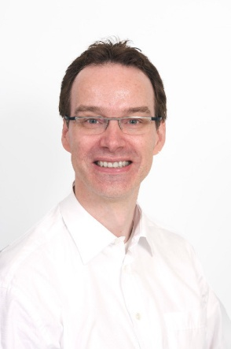 | Professor Oege de Moor  Professor of Computer Science  Tutorial Fellow  Magdalen College Oxford  TOOLS keynote speaker
Analysing OO programs on an OO database

Abstract
Software analysis is searching data, where the data consists of the source code. It's natural, therefore, to try and write analyses as relational database queries, a suggestion first explored by Linton in 1984. Since then, the program analysis community has concluded that while the idea might be attractive, it doesn't work in practice both because the queries quickly become way too complex, and because query execution is too slow.
ODASA is an industrial engine for software analysis that finally realises the vision of program analysis via queries. It overcomes the earlier impediments in two ways: first, by using object-oriented concepts to make writing the queries easier, and second, by applying known techniques for optimising OO programs to optimising OO queries.
In the talk, I shall demonstrate how ODASA facilitates easy construction of new queries, and how those can be used to analyse substantial software systems like Firefox.

Bio
Oege de Moor is a professor of computer science at the University of Oxford, where he leads the Programming Tools research group. He is also the CEO of Semmle Ltd, the company that produces ODASA.
Wednesday 30th June
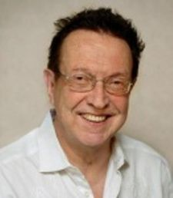 | Ivar Jacobson,  Ivar Jacobson International  Keynote speaker
A SMARTER WAY: The Software Engineering Method And Theory Initiative (Semat)

Abstract:
Semat and its large supporter base believes that software engineering is gravely hampered by immature practices. Specific problems include: The prevalence of fads more typical of the fashion industry than an engineering discipline, lack of a sound, widely accepted theoretical basis, a huge number of methods and method variants, with differences little understood and artificially magnified. SEMAT supports a process to refound software engineering based on a solid theory, proven principles and best practices that include; a kernel of widely-agreed elements, extensible for specific uses, addressing both technology and people issues. We focus on changing the way we deal with methods and processes, which will impact our industry, its education, its research and its developer community. Join this presentation on SEMAT by Ivar Jacobson to identify how we can change how we work today, as well as influence larger changes required to operate more successfully tomorrow.

Bio
Dr. Ivar Jacobson is a father of components and component architecture, use cases, the Unified Modelling Language and the Rational Unified Process. He has contributed to modern business modelling and aspect-oriented software development.Thus, Ivar is a legend in his own lifetime. However, all of this is history. Now he is together with Bertrand Meyer and Richard Soley leading a worldwide network Semat, which has agreed to revolutionize software development.
Wednesday 30th June
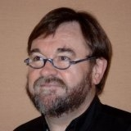 | Jean Bézivin,  Professor of Computer Science  University of Nantes, France  Talk at the TOOLS 2010 Banquet Dinner
Bio
Jean Bézivin is a professor of Computer Science at the University of Nantes, France, and lead of AtlanMod a joint research team between INRIA and Ecole des Mines of Nantes. He got his Master degree from the University of Grenoble and Ph.D. from the University of Rennes . Since 1980 he has been very active in Europe in the object-oriented community, starting the ECOOP series of conference, the TOOLS series of conferences, the MoDELS/UML series of conferences and more recently the ICMT (International Conference on Model Transformation) series of conferences.
He founded in 1979, at the University of Nantes, one of the first Master programs in Software Engineering entirely devoted to Object Technology (Data Bases, Concurrency, Languages and Programming, Analysis and Design, etc.). His present research interests include legacy reverse engineering, general model engineering and, in particular, model-transformation languages and frameworks, and the building of model-engineering platforms. He has published many papers and organized tutorials and workshops in the domains of concurrency, simulation, object-oriented programming, and model-driven engineering.
On the subjects of model-driven engineering and MDA, he has been leading the OFTA industrial group in France, co-animating a CNRS specific action and the Dagstuhl seminar #04101. He is a member of the ECOOP, MoDELS, TOOLS and ICMT steering committees. He was co-chair of the ECOOP'2006 conference organized in Nantes. He can be reached at JBezivin@gmail.com
Thursday 1st July
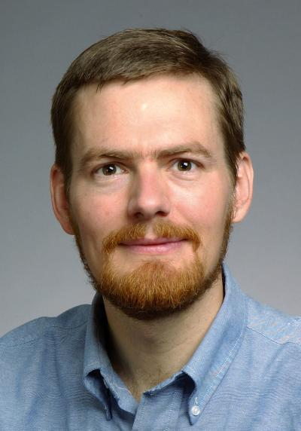 | Mike Ernst,  Computer Science & Engineering  University of Washington  TAP keynote speaker
How tests and proofs impede one another: The need for always-on static and dynamic feedback

Abstract:
Dynamic and static feedback provide complementary benefits, and neither one dominates the other. Sometimes, sound global static checking is most useful. At other times, running tests is most useful. Unfortunately, current languages impose too rigid a model of the development process: they favor either static or dynamic tools, which prevents the programmer from freely using the other variety. I propose a new approach, in which the developer always has access to immediate execution feedback, and always has access to sound static feedback.
The aim is to permit developers to work the way they find most natural and effective, which will improve reliability and reduce cost. Developers will create software that is more reliable than that created in an environment that favors dynamic analysis. Developers will work faster than they can in an environment that favors static analysis.

Bio
Michael D. Ernst is an Associate Professor in the Computer Science and Engineering department at the University of Washington. His research aims to make software more reliable, more secure, and easier (and more fun!) to produce. His primary technical interests are in software engineering and related areas, including programming languages, type theory, security, program analysis, bug prediction, testing, and verification. Ernst's research combines strong theoretical foundations with realistic experimentation, with an eye to changing the way that software developers work. Dr. Ernst was previously a tenured professor at MIT, and before that a researcher at Microsoft Research.
Friday 2nd July
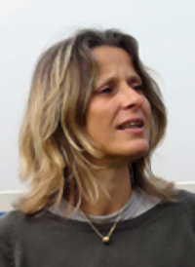 | Valérie Issarny,  Director of Research INRIA  Paris Rocquencourt, France  SC keynote speaker

From Middleware To On The Fly Connector Synthesis For The Dynamic Composition Of Pervasive Software Intensive Networked Systems

Abstract:
Our everyday activities are increasingly dependent upon the assistance of digital systems that pervade our living environment. However, the current ubiquity of digital systems is technology-dependent. The efficacy of integrating and composing networked systems is proportional to the level of interoperability of the systems' respective underlying technologies. This leads to a landscape of technological islands of networked systems, although interoperability bridges may possibly be deployed among them. Further, the fast pace at which technology evolves at all abstraction layers increasingly challenges the lifetime of networked systems in the digital environment.
The CONNECT European project aims at dropping the heterogeneity barriers that prevent networked systems from being eternal, thus enabling the continuous composition of networked systems to respond to the evolution of functionalities provided to and/or required from the networked environment, independently of the embedded software technologies. CONNECT specifically targets the dynamic synthesis of connectors via which networked systems communicate. The resulting CONNECTors then compose and further adapt the interaction protocols run by the connected systems, which realize application- down to middleware-layer protocols.
In this talk, I will discuss why and how CONNECT revisits the middleware paradigm so as to enable the dynamic composition of networked systems in the now pervasive digital environments. I will then highlight the research challenges faced by CONNECT in order to enable on the fly CONNECTor synthesis. I will in particular concentrate on the elicitation of a theory of connectors that shall allow reasoning about and adapting the interaction behavior of networked systems at run-time, from the application down to the middleware-layer.
The presentation is on joint work with colleagues at INRIA (Amel Bennaceur, Nikolaos Georgantas, Animesh Pathak) and University of L'Aquila (Paola Inverardi, Romina Spalazzese, Massimo Tivoli) as part of the FP7 ICT FET CONNECT project.

Bio

Dr. Valérie Issarny is "Directrice de recherche" at INRIA. Since 2002, she is the head of the ARLES INRIA research project-team at INRIA-Rocquencourt. Her research interests relate to distributed systems, software engineering, pervasive computing/ambient intelligence systems and middleware. She has (co)authored over 100 technical papers in the area of distributed systems and software engineering, and has been involved in a number of European and industrial projects. She has been and is serving as PC member, including as PC chair, of leading international events in the area of distributed systems, middleware, software engineering and trust management. She was the coordinator of the FP6 IST STREP PLASTIC project, and is currently the coordinator of the FP7 FET CONNECT project.
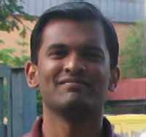 | Nachi Nagappan,  Empirical Software Engineering and Measurement Research Group  Microsoft Research  TAP keynote speaker

Myths in Software Engineering: From the other side

Abstract:
In this talk I will broadly discuss certain myths and assumptions in Software Engineering related to software quality. Presenting a complementary view to the TAP community, the empirical software engineering community adopts the viewpoint that “software engineering is a relatively new and immature discipline. In order to mature, we need to adopt an experimental view of research allowing us to observe and experiment with technologies, understand their weaknesses and strengths, tailor technologies to the goals and characteristics of particular projects, and package them together with empirically gained experience to enhance their reuse potential in future projects... (From ISERN Purpose)”.
In this regard my talk specifically addresses issues relating to static analysis, code coverage, distributed development, minor contributors, unit testing, spec inspections, test driven development, organizational metrics and software assertions. I will also highlight the impact of these results in practice with examples.
Bio
Nachiappan Nagappan is a Senior Researcher in the Empirical Software Engineering and Measurement Research Group (ESM) at Microsoft Research. His research interests are in the field of software measurement focusing on software metrics, software reliability, failure analysis/prediction and empirical software engineering processes. Prior to his current position he earned his PhD from North Carolina State University in 2005.
Workshops
BSME 2010
Business System Management and Engineering
Date: Monday 28th June
Location: Room 4.1.1
The next-generation of Business Process Management (BPM) will serve as a means of developing mission-critical service-enabled applications based on strategic technology capable of creating and executing collaborative end-to-end business processes. The trend will be to move from relatively stable, organization-specific applications to more dynamic, high-value ones where business process interactions and trends are examined closely to understand more accurately application dynamics. Such collaborative, complex end-to-end service interactions give rise to the concept of Service Networks (SNs).
The BSME workshop offers a forum for researchers and practitioners to present and discuss research towards this next generation of Business Process Management for service networks that will require a unification of concepts, methods and techniques from the field of Service Oriented Architecture, “traditional” BPM, Transaction Management, Business Activity Monitoring and Cloud Computing.
Workshop Organizers
- Mike Papazoglou (Tilburg University, Netherlands)
- Willem-Jan Van den Heuvel (Tilburg University, Netherlands)
- Frank Leymann (IAAS, Germany)
- Dimka Karastoyanova (IAAS, Germany)

DYLA
Fourth Workshop on Dynamic Languages and Applications
Date: Monday 28th June
Location: Room 4.0.1
The DYLA Workshop series is focused on the revival of dynamic languages. The goal of this workshop is to act as a forum where we can discuss new advances in the design, implementation and application of dynamically typed languages. The workshop will have a demo-oriented style. The idea is to allow participants to demonstrate new and interesting features and discuss what they feel is relevant for the dynamic language community.
Workshop Organizers
- Alexandre Bergel, University of Chile, Santiago, Chile
- Carl Friedrich Bolz, Heinrich-Heine-Universität, Düsseldorf, Germany
- Simon Denier, RMoD Research group, INRIA Lille-Nord Europe, France
- Michael Haupt, Hasso-Plattner-Institut, Potsdam, Germany
- Adrian Kuhn, University of Bern, Switzerland
IWMCP
International Workshop on Model Comparison in Practise
Date: Thursday 1st July
Location: Room 4.1.1
Model Driven Engineering elevates models to first class artefacts of the software development process. To facilitate multi-user collaboration and enable version management and seamless evolution of models and metamodels, support for robust and performant model comparison and differencing mechanisms is essential. Previous research has demonstrated that mechanisms used for comparison and differencing of text-based artefacts (e.g. source code) are not sufficient for comparing models, as they are unaware of the structure and the semantics of the compared artefacts. To date, several model-specific model comparison approaches have been proposed, each demonstrating different characteristics and focusing on particular sub-problems. For instance, model comparison techniques have been adopted for software refactoring, for transformation testing, to support the coupled evolution of metamodel and models, or to analyse existing artefacts with respect to some criteria. However the consensus is that this research area is still young and more research is required in order to achieve the full potential of model comparison.
The goal of the workshop is to gather together both researchers in the area of model comparison and differencing to report novel results, and especially adopters of existing approaches to present their experiences and provide insights on issues encountered when applying these approaches in practice.
Workshop Organizers
- Davide Di Ruscio (University of L'Aquila, Italy)
- Dimitrios S. Kolovos (University of York, United Kingdom)

MoSE
2nd International Workshop on Model-Driven Service Engineering
Date: Tuesday 20th June
Location: Room 4.0.1
Model-Driven Engineering (MDE) deals with the provision of models, transformations between them and code generators to address software development. One of the main advantages of model-driven approaches is the provision of a conceptual structure where the models used by business managers and analysts can be traced towards more detailed models used by software developers. This kind of alignment between high level business specifications and the lower level Service Oriented Architectures (SOA) is a crucial aspect in the field of Service-Oriented Development (SOD) where meaningful business services and business process specifications are those that can give support to real business environment usually changing with increasing speed.
SOD has become currently in one of the major research topics in the field of software engineering, leading the appearance of a novel and emerging discipline called Service Engineering (SE), which aim to bring together benefits of SOA and Business Process Management (BPM). SE focuses on the identification of service (a client-provider interaction that creates value for the client) as first class elements for the software construction. The convergence of SE with MDE can holds out the promise of rapid, accurate development of software that serves software users' goals.
In this context, MoSE workshop aims to provide a forum to discuss different issues related to SE in conjunction with MDE, boarding open research problems in this area as well as practical experiences. Particular interests include methods, modelling languages, development methodologies and techniques in the field of SOD.
Workshop Organizers
- Mike Papazoglou (Tilburg University, Netherlands)
- Esperanza Marcos (Rey Juan Carlos University, Spain)
- Willem-Jan Van den Heuvel (Tilburg University, Netherlands)
- Valeria De Castro (Rey Juan Carlos University, Spain)
- Juan Manuel Vara (Rey Juan Carlos University, Spain)

MtATL
2nd International Workshop on Model Transformations with ATL
Date: Wednesday 30th June
Location: Room 4.1.1
Model transformation is an essential operation in Model-Driven Engineering. It may be used to generate lower-level code from higher-level models, but its application scope has now gone beyond Model-Driven Engineering. After the success of the 1st International Workshop on Model Transformations with ATL (AtlanMod Transformation Language), this 2nd event of the series aims at showing new applications for model transformations using ATL, as well as at improving the technology.
Although the experience of using ATL is very positive, ATL is an evolving technology that is still a subject of research. Feedback from the ATL users and researchers is crucial for identifying potential language extensions and incorporating research results into the language. The connection between the language designers and the language users guarantees that ATL stays adequate to the real needs for model transformations encountered in non-trivial industrial and academic applications.
The topics of interest to the workshop are typically about applying ATL model transformations to new problems, and extending ATL with new features. They notably include, for instance: performance, industrial applications, higher-order transformations, verification, or ATL language/tools extensions. The main purpose of this workshop is to get together users and researchers in the domain of model transformations both from the academia and the industry in order to share experience.
Workshop Organizers
- Marcos Didonet Del Fabro (IBM Software Group, France)
- Frédéric Jouault (Université de Nantes, France)
- Ivan Kurtev (University of Twente, The Netherlands)

QAOOSE
13th Workshop on Quantitative Approaches on Object-Oriented Software Engineering and Related Paradigms
Date: Friday 2nd July
Location: Room 4.1.1
QAOOSE+ 2010 is a direct continuation of twelve successful workshops held during previous editions of ECOOP in Paphos (2008), Berlin (2007), Nantes (2006), Glasgow (2005), Oslo (2004), Darmstadt (2003), Malaga (2002), Budapest (2001), Cannes (2000), Lisbon (1999), Brussels (1998) and Aarhus (1995).
Quantitative approaches in the field of object-oriented software engineering form a broad and active research area that develops and/or evaluates methods, practical guidelines, techniques, and tools to improve the quality of software products and the efficiency and effectiveness of software processes. The workshop is open to other technologies related to objects, such as component-based systems, aspect-oriented programming, Web-based systems, and agent-based systems.
Relevant research topics are diverse, but should strongly focus on applying empirical software engineering techniques. Position papers are invited in, but not limited to, the areas of measure collection, quality assessment, measure validation, and process management.
Workshop Organizers
- Manual F. Bertoa (University of Málaga, Spain)
- Coral Calero (University of Castilla-La Mancha, Spain)
- Houari A. Sahraoui (Université de Montréal, Canada)
- Stephane Vaucher (Université de Montréal, Canada)

R2oSE
1st International Workshop on Research 2.0 and Software Engineering
Date: Monday 28th June
Location: Room 4.1.4

Workshop Organizers
- Jean-Marie Favre (OneTree Technologies, Luxembourg)
- Dragan Gaševic (Athabasca University, Canada)
TTC
Transformation Tool Contest
Date: Thursday 1st July
Location: Room 3.1.1
Tools are crucial for the promotion of graph and model transformation in industry. Currently, a variety of tool environments exist for different graph and model transformation approaches. However, for potential users, working in application domains where transformation techniques may be useful, it is difficult to select the right tool for their purpose. Moreover, even for most of the tool experts it is true that they know about one or two tools but little about others. Finally, and maybe most importantly, the tool developers themselves can also be inspired by a more detailed understanding of related approaches.
The aim of this event is to compare the expressiveness, the usability and the performance of graph and model transformation tools along a number of selected case studies. That is, we want to learn about the pros and cons of each tool considering different applications. A deeper understanding of the relative merits of different tool features will help to further improve graph and model transformation tools and to indicate open problems.
Workshop Organizers
- Pieter Van Gorp (Eindhoven University of Technology, The Netherlands)
- Arend Rensink (University of Twente, The Netherlands)
- Steffen Mazanek (Bundeswehr Transformation Centre, Germany)

TWOMDE
3rd Workshop on Transforming and Weaving Ontologies and Model Driven Engineering
Date: Wednesday 30th June
Location: Room 4.0.1
The interest in integrating Ontologies and Software Engineering has gained more attention with commercial and scientific initiatives. The Semantic Web Best Practice and Deployment Working Group (SWBPD) in W3C included a Software Engineering Task Force (SETF) to explore how Semantic Web and Software Engineering can cooperate. The Object Management Group (OMG) has an Ontology Platform Special Interest Group (PSIG) aiming at formalizing semantics in software by knowledge representation and related technologies. The concrete results of such initiatives are the specification of the OMG Ontology Definition Metamodel, the OWL2 Metamodel, the introduction to Ontology Driven Architectures and a guideline for software developers.
Nevertheless, as MDE spreads, disciplines like model transformation, domain specific languages (DSLs) and traceability become essential in order to support different kinds of models in an model driven environment. Understanding the role of ontology technologies like knowledge representation, automated reasoning, dynamic classification and consistence checking in these fields is crucial to leverage the development of such disciplines. Thus, we highlight the following open questions: How can the scientific and technical results around ontologies, ontology languages and their corresponding reasoning technologies be used fruitfully in MDE? What is the role of ontologies in supporting model transformation or traceability? How can ontologies improve designing DSLs? Are current query languages able to query both kinds of models?
Discussions about these and related questions will be supported by the proposed workshop.
Workshop Organizers
- Jeff Z. Pan (University of Aberdeen, Great Britain)
- Uwe Assmann (University of Dresden, Germany)
- Fernando Parreiras (University of Koblenz, Germany)

WCSI
International Workshop on Component and Service Interoperability
Date: Tuesday 29thJune
Location: Room 4.1.1
The development of software systems requires mechanisms to structure them in order to tackle their complexity. This has led to the appearance of different kinds of abstractions to encapsulate system functionality, e.g., modules, objects, components, and more recently, services. Systems are then built as assemblies of these smaller and reusable entities, which are commonly developed by third parties, and that often present interoperability issues when assembled. Hence, interoperability is one of the key aspects related to the construction of large software systems, and can be defined as the ability of two or more entities to communicate and cooperate despite interface mismatch.
Several levels of interoperability, and accordingly of interface description languages (IDL), have been described: the signature level deals with the static aspects of component interoperability; the behaviour or protocol level specifies the order in which the operations described in the signature interface should be invoked; the service level includes the description of non-functional properties like temporal requirements, security, cost, etc; finally, the functional or conceptual level concerns the functional or semantic specification of the component or service. Interoperability problems may arise at any of the interface levels above. Detecting mismatch and providing the means to solve it is crucial for building systems out of components or services, enabling real third-party composition. Objectives are twofold: (i) discovering interoperability issues, and (ii) controlling and ensuring correct interactions among the entities that form the system. Furthermore, extended interface description and analysis is the key to predict global system properties based on the features of its constituent parts.
Workshop Organizers
- Javier Cámara (INRIA Grenoble – Rhône-Alpes, France)
- Carlos Canal (University of Málaga, Spain)
- Gwen Salaün (INRIA Grenoble – Rhône-Alpes, France)
Overall Schedule
Monday  (Jun 28) | Tuesday  (Jun 29) | Wednesday  (Jun 30) | Thursday  (Jul 1) | Friday  (Jul 2)
ICMT |  |  | SC
 | TOOLS
DYLA | IFIP WS |  | TAP
BSME | MoSE | MtATL | TCC
R2oSE | WCSI | TWOMDE | IWMCP | QAOOSE

Program
Monday, 28 June 2010

Time | ICMT
09:30-11:00 | Keynote: Stefano Ceri
11:00-11:30 | Coffee Break
11:30-12:00 | Safe Composition of Transformations
12:00-12:30 | From State-to Delta-Based Bidirectional Model Transformations
12:30-13:00 | Surviving the Heterogeneity Jungle with Composite Mapping Operators
13:00-14:30 | Lunch
14:30-15:00 | Meta-model Matching Based on Planar Graph Edit Distance
15:00-15:30 | From Sequence Diagrams to State Machines by Graph Transformation
15:30-16:00 | Synthesis of OCL Pre-Conditions for  Graph Transformation Rules
16:00-16:30 | Coffee Break
16:30-17:00 | Constructing and Navigating Non-Invasive Model Decorations
17:00-17:30 | Implementing Business Process Recovery Patterns through QVT Transformations
17:30-18:00 | Temporal Model-Based Diagnostics Generation  for HVAC Control Systems

Tuesday, 29 June 2010

Time | ICMT | TOOLS Europe
09:30-11:00 | Keynote: Oege de Moor
11:00-11:30 | Coffee Break
11:30-12:00 | Domain-Specific  of Model | Composition  Deltas
12:00-12:30 | Deep  with | Meta-Modelling  MetaDepth
12:30-13:00 | Model-to-Model  by | Transformation  Demonstration
13:00-14:30 | Lunch
14:30-15:00 | Model Migration  with Epsilon Flock | Encoding Ownership Types  in Java
15:00-15:30 | Exceptional Transformations | Revisiting Parametric Types  and Virtual Classes
15:30-16:00 | Towards Incremental Execution  of ATL Transformations | Welterweight Java
16:00-16:30 | Coffee Break
16:30-17:00 | Improving Highter-Order Transformations  Support in ATL | Late Binding of  AspectJ Advice
17:00-17:30 | A Constructive Approach to  Testing Model Transformations | EriLex: An Embedded Domain Specific  Language Generator
17:30-18:00 | Towards a Rewriting Logic  Semantics for ATL | A Generic Meta-Model-based Approach for  Specifying Framework Functionality and Usage

Wednesday, 30 June 2010

Time | TOOLS Europe
09:30-11:00 | Keynote: Bertrand Meyer
11:00-11:30 | Coffee Break
11:30-12:00 | Understanding the Impact of  Collection Contracts on Design
12:00-12:30 | Visualizing Dynamic Metrics  with Profiling Blueprints
12:30-13:00 | Domain-Specific Program Checking
13:00-14:30 | Lunch
14:30-16:00 | Keynote: Ivar Jacobson
16:00-16:30 | Coffee Break
16:30-17:00 | Read-Only Execution for Dynamic Languages
17:00-17:30 | Loosely-coupled Distributed Reactive Programming in Mobile Ad Hoc Networks
17:30-18:00 | Reasoning about Function Objects

Thursday, 1 July 2010

Time | SC | TOOLS Europe | TAP
09:30-11:00 | Keynote: Michael Ernst
11:00-11:30 | Coffee Break
11:30-12:00 | Composing models at two modeling levels to capture heterogeneous concerns in requirements | JSConTest:  of | Contract-Driven Testing JavaScript Code
12:00-12:30 | Managing Variability in Workflow with Feature Model Composition Operators | Moles:  environment isolation | tool-assisted  with closures
12:30-13:00 |  | QuickSpec: Guessing using | Formal Specifications Testing
13:00-14:30 | Lunch
14:30-15:00 | Construction of Asynchronous Communicating Systems | Optimizing Aspect-oriented Mechanisms for Embedded Applications | Testing First-Order Logic Axioms in Program Verification
15:00-15:30 | An advice for advice | composition in AspectJ | Proving OCL Invariant Independence by Automatically Generated Test Cases
15:30-16:00 | The .NET Composition | Primitives | Proof process evaluation with mutation analysis
16:00-16:30 | Coffee Break
16:30-17:00 |  |  | Generating Regression Unit Tests using a Combination of Verification and Capture & Replay
17:00-17:30 |  |  | DyGen: Automatic Generation of High-Coverage Tests via Mining Gigabytes of Dynamic Traces
17:30-18:00 |  |  | Combining Static Analysis and Test Generation for C Program Debugging

Friday, 2 July 2010

Time | SC | TAP
09:30-11:00 | Keynote: Valérie Issarny
11:00-11:30 | Coffee Break
11:30-12:00 | Dynamically Adaptive Systems  through Automated Model Evolution using Service Compositions | Keynote: Nachi Nagappan
12:00-12:30 | Visualizing and Assessing a Compositional Approach of Business Process Design
12:30-13:00
13:00-14:30 | Lunch
14:30-15:00 | Composition and Compositionality for Robotics Components | Generating High Quality Tests for Boolean Circuits by Treating Tests as Proof Encodings
15:00-15:30 | Event-specific Software Composition in Context-oriented Programming | Relational Analysis of (Co)inductive Predicates, (Co)algebraic Datatypes, and (Co)recursive Functions
15:30-16:00 | Predicated Generic Functions: Enabling Context-Dependent Method Dispatch | Combining narrowing and theorem proving for rewriting-logic specifications
16:00-16:30 | Coffee Break
16:30-17:00 |  | Syntactic Abstraction of B Models to Generate Tests
17:00-17:30 |  | Building a test-ready abstraction of a behavioral model using CLP
17:30-18:00

ICMT Program
Monday June 28
ICMT Keynote:
- Stefano Ceri: Search Computing: a Model-Driven Perspective.
ICMT Session 1 "Composition and Bidirectionality":
- Safe Composition of Transformations. Florian Heidenreich, Jan Kopcsek and Uwe Aßmann
- From State-to Delta-Based Bidirectional Model Transformations. Zinovy Diskin, Yingfei Xiong and Krzysztof Czarnecki
- Surviving the Heterogeneity Jungle with Composite Mapping Operators. Manuel Wimmer, Gerti Kappel, Angelika Kusel, Werner Retschitzegger, Johannes Schoenboeck and Wieland Schwinger
ICMT Session 2 "Matching and Execution":
  - Meta-model Matching Based on Planar Graph Edit Distance. Konrad Voigt and Thomas Heinze
  - From Sequence Diagrams to State Machines by Graph Transformation. Roy Grønmo and Birger Møller-Pedersen
  - Synthesis of OCL Pre-Conditions for Graph Transformation Rules. Jordi Cabot, Robert Clarisó, Esther Guerra and Juan de Lara
ICMT Session 3 "Model Management and Applications":
  - Constructing and Navigating Non-Invasive Model Decorations. Dimitrios Kolovos, Louis Rose, Nicholas Drivalos Matragkas, Richard Paige, Fiona Polack and Kiran Fernandes
  - Implementing Business Process Recovery Patterns through QVT Transformations. Ricardo Pérez-Castillo, Ignacio García-Rodríguez de Guzmán and Mario Piattini
  - Temporal Model-Based Diagnostics Generation for HVAC Control Systems. Marion Behrens and Gregory Provan
Tuesday June 29
TOOLS Europe Keynote:
- Oege de Moor: Analysing OO Programs on an OO Database.
ICMT and TOOLS Europe joint Session:
  - Domain-Specific Composition of Model Deltas (ICMT). Maider Azanza, Don Batory, Oscar Díaz and Salvador Trujillo
  - Deep Meta-Modelling with MetaDepth (TOOLS Europe). Juan De Lara and Esther Guerra
  - Model-to-Model Transformations By Demonstration (ICMT). Philip Langer, Manuel Wimmer and Gerti Kappel
ICMT Session 2 "Transformation Systems":
  - Model Migration with Epsilon Flock. Louis Rose, Dimitrios Kolovos, Richard Paige and Fiona Polack
  - Exceptional Transformations. Eugene Syriani, Jörg Kienzle and Hans Vangheluwe
  - Towards Incremental Execution of ATL Transformations. Frédéric Jouault and Massimo Tisi
ICMT Session 3 "Semantics":
  - Improving Higher-Order Transformations Support in ATL. Massimo Tisi, Jordi Cabot and Frédéric Jouault
  - A constructive approach to testing model transformations. Camillo Fiorentini, Alberto Momigliano, Mario Ornaghi and Iman Poernomo
  - Towards a Rewriting Logic Semantics for ATL. Javier Troya and Antonio Vallecillo

TOOLS Europe Program
Tuesday June 29
TOOLS Europe Keynote:
- Oege de Moor: Analysing OO Programs on an OO Database.
TOOLS Europe Session 1:
  - Deep Meta-Modelling with MetaDepth. Juan De Lara, Esther Guerra.
  - A Generic Meta-Model-based Approach for Specifying Framework Functionality and Usage. Fabian Christ, Jan-Christopher Bals, Gregor Engels, Christian Gerth, Markus Luckey.
TOOLS Europe Session 2:
  - Encoding Ownership Types in Java. Nicholas Cameron, James Noble.
  - Revisiting Parametric Types and Virtual Classes. Anders Bach Madsen, Erik Ernst.
  - Welterweight Java. Johan Astlund, Tobias Wrigstad.
TOOLS Europe Session 3:
  - Late Binding of AspectJ Advice. Ryan M Golbeck, Peter Selby, Gregor Kiczales.
  - EriLex: An Embedded Domain Specific Language Generator. Hao Xu.
  - A Generic Meta-Model-based Approach for Specifying Framework Functionality and Usage.Fabian Christ, Jan-Christopher Bals, Gregor Engels, Christian Gerth, Markus Luckey.
Wednesday June 30
TOOLS Europe Keynote:
- Bertrand Meyer.
TOOLS Europe Session 1:
  - Understanding the Impact of Collection Contracts on Design. Stephen F Nelson, David J Pearce, James Noble.
  - Visualizing Dynamic Metrics with Profiling Blueprints. Alexandre Bergel, Romain Robbes, Walter Binder.
  - Domain-Specific Program Checking. Lukas Renggli, Stephane Ducasse, Tudor Girba, Oscar Nierstrasz.
TOOLS Europe Session 2:
- Ivar Jacobson: A Smarter Way: The Software Engineering Method and Theory Initiative (Semat)
TOOLS Europe Session 3:
  - Read-Only Execution for Dynamic Languages. Jean-Baptiste Arnaud, Marcus Denker, Stephane Ducasse, Damien Pollet, Alexandre Bergel, Mathieu Suen.
  - Loosely-coupled Distributed Reactive Programming in Mobile Ad Hoc Networks. Andoni Lombide Carreton, Stijn Mostinckx, Tom Van Cutsem, Wolfgang De Meuter.
  - Reasoning about Function Objects. Martin Nordio, Cristiano Calcagno, Bertrand Meyer, Peter Mueller, Julian Tschannen.
Thursday July 1
TOOLS Europe Keynote:
- Michael Ernest: The Need for Always-On Static and Dynamic Feedback: How Tests and Proofs Impede One Another.
TOOLS Europe Session 1:
  - JSConTest: Contract-Driven Testing of JavaScript Code. Phillip Heidegger, Peter Thiemann.
  - Moles: tool-assisted environment isolation with closures. Jonathan de Halleux, Nikolai Tillmann.
TOOLS Europe Session 2:
  - Optimizing Aspect-oriented Mechanisms for Embedded Applications. Christine Hundt, Daniel Stohr, Sabine Glesner.
  - SC Paper: An advice for advice composition in AspectJ.
  - SC Ppaper: The .NET Composition Primitives: A Common Foundation for Open, Dynamic, and Reflective Component Frameworks.

TAP Program
Thursday July 1
TAP Keynote:
- Michael Ernst: The Need for Always-On Static and Dynamic Feedback: How Tests and Proofs Impede One Another.
TAP and TOOLS Europe joint Session:
  - QuickSpec: Guessing Formal Specifications using Testing. Koen Claessen, Nicholas Smallbone and John Hughes.
  - (TOOLS Europe) JSConTest: Contract-Driven Testing of JavaScript Code. Phillip Heidegger, Peter Thiemann.
  - (TOOLS Europe) Moles: tool-assisted environment isolation with closures. Jonathan de Halleux, Nikolai Tillmann.
TAP Session 2: "Testing Proofs"
  - Testing First-Order Logic Axioms in Program Verification. Ki Yung Ahn and Ewen Denney.
  - Proving OCL Invariant Independence by Automatically Generated Test Cases. Martin Gogolla, Lars Hamann and Mirco Kuhlmann.
  - Proof process evaluation with mutation analysis. Lydie du Bousquet and Michel Levy.
TAP Session 3: "Test Generation using Proof Techniques"
  - Generating Regression Unit Tests using a Combination of Verification and Capture & Replay. Christoph Gladisch, Shmuel Tyszberowicz, Bernhard Beckert and Amiram Yehudai.
  - DyGen: Automatic Generation of High-Coverage Tests via Mining Gigabytes of Dynamic Traces. Suresh Thummalapenta, Jonathan Halleux, Nikolai Tillmann and Scott Wadsworth.
  - Combining Static Analysis and Test Generation for C Program Debugging. Omar Chebaro, Nikolai Kosmatov, Alain Giorgetti and Jacques Julliand.

Friday July 2
TAP & SC Keynote
- Valérie Issarny: From Middleware to on the Fly Connector Synthesis for the Dynamic Composition of Pervasive Software Intensive Networked Systems.
TAP Keynote
- Nachiappan Nagappan: Myths in Software Engineering: From the Other Side.

TAP Session 1: (continued): "Test Generation using Proof Techniques"
  - Generating High Quality Tests for Boolean Circuits by Treating Tests as Proof Encodings. Eugene Goldberg and Panagiotis Manolios.
TAP Session 2: "Theorem Proving and Testing"
  - Relational Analysis of (Co)inductive Predicates, (Co)algebraic Datatypes, and (Co)recursive Functions. Jasmin Christian Blanchette.
  - Combining narrowing and theorem proving for rewriting-logic specifications. Vlad Rusu.
TAP Session 3: "Abstraction"
  - Syntactic Abstraction of B Models to Generate Tests. Jacques Julliand, Nicolas Stouls, BUE Pierre-christophe and Pierre-Alain Masson.
  - Building a test-ready abstraction of a behavioral model using CLP. Pierre-Christophe Bue, Frederic Dadeau, Adrien de Kermadec and Fabrice Bouquet.

SC Program
Thursday July 1
TAP & SC Keynote:
- Michael Ernst: The Need for Always-On Static and Dynamic Feedback: How Tests and Proofs Impede One Another.
SC Session 1: "Model Composition"
  - Composing models at two modeling levels to capture heterogeneous concerns in requirements. Erwan Brottier, Yves Le Traon, Bertrand Nicolas.
  - Managing Variability in Workflow with Feature Model Composition Operators. Mathieu Acher, Philippe Collet, Philippe Lahire, Robert France.
SC Session 2: "Languages"
  - Construction of Asynchronous Communicating Systems: Weak Termination guaranteed!. Kees M. van Hee, Natalia Sidorova, Jan Martijn van der Werf.
  - An advice for advice composition in AspectJ. Fuminobu Takeyama, Shigeru Chiba.
  - The .NET Composition Primitives: A Common Foundation for Open, Dynamic, and Reflective Component Frameworks. Mircea Trofin, Clemens Szyperski, Nicholas Blumhardt.
Friday July 2
TAP & SC Keynote
- Valérie Issarny: From Middleware to on the Fly Connector Synthesis for the Dynamic Composition of Pervasive Software Intensive Networked Systems.
SC Session 1: "Composing Services"
  - Dynamically Adaptive Systems through Automated Model Evolution using Service Compositions. Adina Mosincat, Walter Binder, Mehdi Jazayeri.
  - Visualizing and Assessing a Compositional Approach of Business Process Design. Sebastien Mosser, Alexandre Bergel, Mireille Blay-Fornarino.
SC Session 2: "Context-Orientation and Domain-Specific Composition"
  - Composition and Compositionality for Robotics Components. Olena Rogovchenko, Jacques Malenfant .
  - Event-specific Software Composition in Context-oriented Programming. Malte Appeltauer, Robert Hirschfeld, Hidehiko Masuhara, Michael Haupt, Kazunori Kawauchi.
  - Predicated Generic Functions: Enabling Context-Dependent Method Dispatch. Jorge Vallejos, Sebastian Gonzalez, Pascal Costanza, Wolfgang De Meuter, Theo D'Hondt, Kim Mens.

TOOLS Europe 2010 Committees
Conference Chair
- Bertrand Meyer, ETH Zürich and Eiffel Software, Switzerland
Program Chair
- Jan Vitek, Purdue University, USA
Publicity Chair
- Osmar Santos, University of York, UK
Program Committee
- Uwe Assman, University of Dresden, Germany
- Elisa Baniassad, Chinese University of Hong Kong, Hong Kong
- Alexandre Bergel, University of Chile, Chile
- Lorenzo Bettini, University of Torino, Italy
- Judith Bishop, Microsoft Research, USA
- William Cook, University of Texas Austin, USA
- Sophia Drossopolou, Imperial College London, UK
- Catherine Dubois, ENSIIE, France
- Stéphane Ducasse, INRIA Lille, France
- Manuel Fahndrich, Microsoft Research, USA
- Harald Gall, University of Zurich, Switzerland
- Benoit Garbinato, University of Lausanne, Switzerland
- Angelo Gargantini, University of Bergamo, Italy
- Jeff Gray, University of Alabama Birmingham, USA
- Kathryn Gray, University of Cambridge, UK
- Thomas Gschwind, IBM Research, Switzerland
- Matthias Hauswith, University of Lugano, Switzerland
- Nigel Horspool, University of Victoria, Canada
- Tomas Kalibera, Charles University, Czech Republic
- Gerti Kappel, Vienna University of Technology, Austria
- Doug Lea, State University of New York Oswego, USA
- Shane Markstrum, University of California Los Angeles, USA
- Peter Müller, ETH Zurich, Switzerland
- Oscar Nierstrasz, University of Bern, Switzerland
- James Noble, Victoria University of Wellington, New Zealand
- Nate Nystrom, University of Texas Arlington, USA
- Manuel Oriol, University of York, UK
- Jonathan Ostroff, York University, Canada
- Richard Paige, University of York, UK
- Shaz Qadeer, Microsoft Research, USA
- Awais Rashid, Lancaster University, UK
- Vivek Sarkar, Rice University, USA
- Doug Schmidt,Vanderbilt University, USA
- Manuel Serrano, INRIA Sophia Antipolis, France
- Peter Thiemann, University of Freiburg, Germany
- Dave Thomas, Bedarra Research Labs, Canada
- Laurence Tratt, Bournemouth University, UK
- Mandana Vaziri, IBM Research, USA
- Tian Zhao, University of Wisconsin-Milwau
ICMT 2010 Committees
Conference Chair
- Martin Gogolla, University of Bremen, Germany
Program Chair
- Laurence Tratt, Bournemouth University, UK
Publicity Chair
- Dennis Wagelaar, Vrije Universiteit Brussels, Belgium
Steering Committee
- Jean Bézivin, INRIA and University of Nantes, France
- Jeff Gray, U. Alabama at Birmingham, USA
- Richard Paige, University of York, UK
- Alfonso Pierantonio, University of L’Aquila, Italy
- Antonio Vallecillo, University of Malaga, Spain
Program Committee Members
- Andreas Rummler, SAP, Germany
- Andreas Winter, Koblenz University, Germany
- Andy Schürr, TU Darmstadt, Germany
- Antonio Cicchetti, University Mälardalen, Sweden
- Bernhard Rumpe, TU Braunschweig, Germany
- Bran Selic, Malina Software, Canada
- Charles Consel, INRIA / LaBRI, France
- Daniel Varro, University of Budapest, Hungary
- Davide Di Ruscio, University of L'Aquila, Italy
- Dimitrios Kolovos, University of York, UK
- Eelco Visser, TU Delft, The Netherlands
- Esperanza Marcos, U. Rey Juan Carlos, Spain
- Francesco Parisi-Presicce, University of Rome, Italy
- Frédéric Jouault, INRIA and E.M. Nantes, France
- Gabriele Taentzer, Philipps-U. Marburg, Germany
- Gerti Kappel, TU Vienna, Austria
- Gregor Engels, University of Paderborn, Germany
- Günter Kniesel, University of Bonn, Germany
- Howard Ho, IBM Almaden Research, USA
- Ivan Kurtev, University Twente, The Netherlands
- Ivan Porres, Åbo Akademi, Finland
- Jens Weber, University of Victoria, Canada
- Jesús García-Molina, Universidad de Murcia, Spain
- Jim Steel, Queensland University, Australia
- Jon Whittle, Lancaster University, UK
- Jordi Cabot, University of Toronto, Canada
- Kelly Androutsopoulos, King’s College London, UK
- Luciano Baresi, Politecnico di Milano, Italy
- Marc Pantel, University of Toulouse, France
- Nicolas Rouquette, NASA/JPL, USA
- Orlando Avila-Garcia, Open Canarias, Spain
- Piero Fraternali, Politecnico di Milano, Italy
- Reiko Heckel, University of Leicester, UK
- Stuart Kent, Microsoft, UK
- Thomas Kuehne, V.U. Wellington, New Zealand
- Toni Clark, Thames Valley University, UK
- Vicente Pelechano, U. Politécnica de Valencia, Spain
- Vinay Kulkarni, Tata R&D, India
- Yasemin Topaloglu, Ege University, Turkey
- Zhenjiang Hu, NII Tokyo, Japan
TAP 2010 Committees
Conference Chairs
- Yuri Gurevich, Microsoft Research, USA
- Bertrand Meyer, ETH Zürich, Switzerland
Program Chairs
- Gordon Fraser, Saarland University, Germany
- Angelo Gargantini, University of Bergamo, Italy
Program Committee
- Bernhard K. Aichernig, Graz University of Technology, Austria
- Paul Ammann, George Mason University, USA
- Bernhard Beckert, University of Koblenz, Germany
- Dirk Beyer, Simon Fraser University, Canada
- Koen Claessen, Chalmers University of Technology, Sweden
- John A. Clark, University of York, UK
- Catherine Dubois, ENSIIE, Evry, France
- Carlo Furia, ETH Zürich, Switzerland
- Patrice Godefroid, Microsoft Research, USA
- Martin Gogolla, University of Bremen, Germany
- Arnaud Gotlieb, IRISA, France
- Reiner Haehnle, Chalmers University of Technology, Sweden
- Bart Jacobs, Katholieke Universiteit Leuven, Belgium
- Gregory M. Kapfhammer, Allegheny College, USA
- Victor Kuliamin, Russain Academy of Sciences, Russia
- Karl Meinke, KTH Royal Institute of Technology, Sweden
- Manuel Nunez, Universidad Complutense de Madrid, Spain
- Sam Owre, SRI International, USA
- Doron Peled, Bar Ilan University, Israel
- Wolfram Schulte, Microsoft Research, USA
- Yannis Smaragdakis, University of Massachusetts, USA
- Assia Touil, Supélec, France
- T.H. Tse, University of Hong Kong, China
SC 2010 Committees
General Chair:
- Judith Bishop , Microsoft, US
Program Chairs:
- Benoit Baudry, INRIA Rennes, France
- Eric Wohlstadter, University of British Columbia, Canada
Steering Committee:
- Uwe Assmann, Dresden University of Technology, Germany
- Judith Bishop, University of Pretoria, South Africa
- Thomas Gschwind, IBM Zurich Research Lab, Switzerland
- Oscar Nierstrasz, University of Berne, Switzerland
- Mario Südholt, INRIA - Ecole des Mines de Nantes, France
Program Committee:
- Sven Apel, Univ. of Passau, Germany
- Paul Klint, CWI, the Netherlands
- Yvonne Coady, Univ. of Victoria, Canada
- Simon Denier, INRIA, France
- Theo D'Hondt, Vrije Universiteit Brussels, Belgium
- Rémi Douence, EMN, France
- Laurence Duchien, Univ. Lille, France
- Robert France, Colorado State Univ. USA
- Jeff Gray, Univ. of Alabama, USA
- Volker Gruhn, Univ. of Leipzig, Germany
- Valérie Issarny, INRIA, France
- Wouter Joosen, KU Leuven, Belgium
- Andy Kellens, Vrije Universiteit Brussels, Belgium
- Philippe Lahire, Univ. Nice, France
- Welf Löwe, Växjö University, Sweden
- Markus Lumpe, Swinburne Univ. of Tech., Australia
- Raffaela Mirandola, Politecnico di Milano, Italy
- Johann Oberleitner, bwin Interactive Entertainment AG, Austria
- Cesare Pautasso, Univ. of Lugano, Switzerland
- Mónica Pinto, Univ. of Malaga, Spain
- Awais Rashid, Univ. of Lancaster, England
- Wolfram Schulte, Microsoft, USA
- Clemens Szyperski, Microsoft, USA
Sponsors
We thank the following companies and institutions for their support:


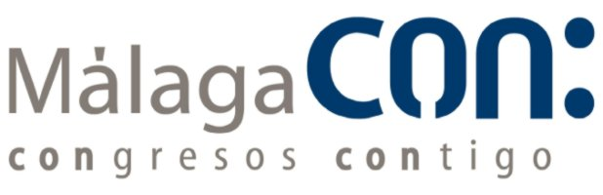

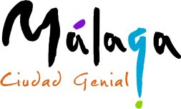




In cooperation with:
