Homework 8 – Aaron Van De Brook

UML Diagram:

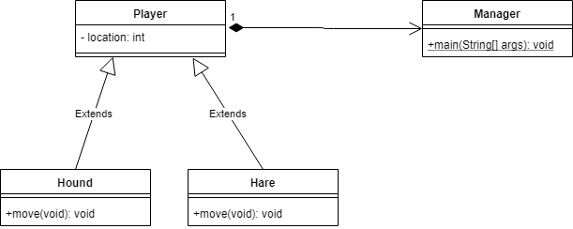

Description: