File Operations

Task Description:

Write a Java program to write data to an Excel file using Apache POI library.

1. Create a new Excel workbook.

2. Create a new sheet with the name "Sheet1".
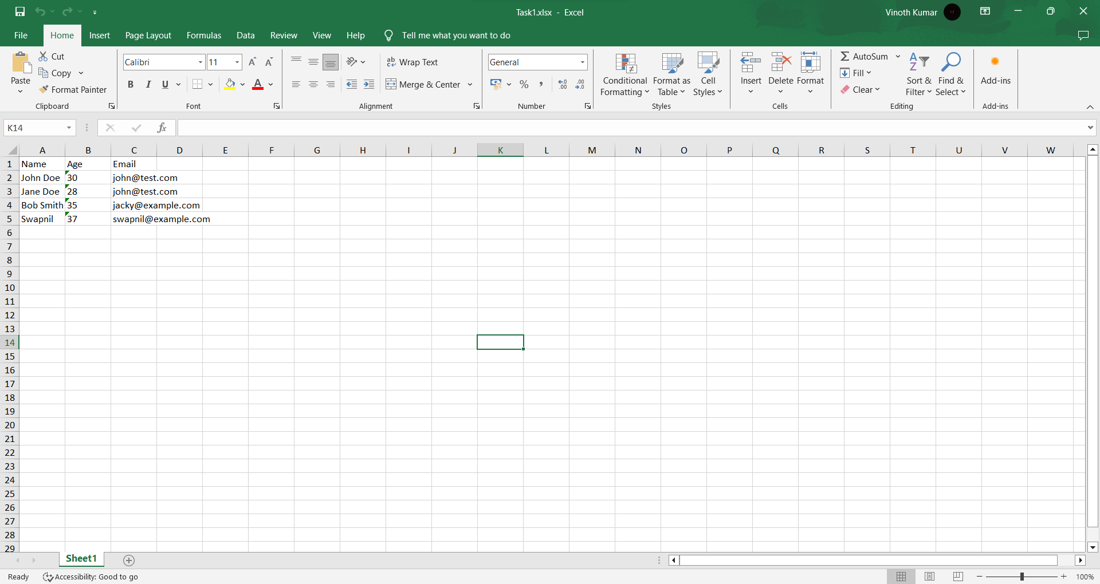

3. Write the following data to the sheet:

Column headers: Name, Age, Email.

Row 1: John Doe, 30, john@test.com.
Row 2: Jane Doe, 28, john@test.com.
Row 3: Bob Smith, 35, jacky@example.com.
Row 4: Swapnil, 37, swapnil@example.com.

4. Write a Java program to write data to an Excel file using Apache POI library.
package pack01;

import java.io.File;
import java.io.FileInputStream;
import java.io.FileNotFoundException;
import java.io.FileOutputStream;
import java.io.IOException;

import org.apache.poi.ss.usermodel.Cell;
import org.apache.poi.ss.usermodel.DataFormatter;
import org.apache.poi.ss.usermodel.Row;
import org.apache.poi.xssf.usermodel.XSSFSheet;
import org.apache.poi.xssf.usermodel.XSSFWorkbook;

public class FileOperations {

public static void main(String[] args) {

FileOperations obj = new FileOperations();

String s1 = null;

try {

s1 = obj.excelRead(0);

} catch (FileNotFoundException e) {

e.printStackTrace();
} catch (IOException e) {

e.printStackTrace();
}

System.out.println(s1);

}

public void excelWrite() throws FileNotFoundException, IOException {

File file = new File(System.getProperty("user.dir") + "\\Task.xlsx");

FileOutputStream output = new FileOutputStream(file);

XSSFWorkbook book = new XSSFWorkbook();

XSSFSheet sheet = book.createSheet();

sheet.createRow(0).createCell(0).setCellValue("Name");
sheet.getRow(0).createCell(1).setCellValue("Age");
sheet.getRow(0).createCell(2).setCellValue("Email");
sheet.createRow(1).createCell(0).setCellValue("John Doe");
sheet.getRow(1).createCell(1).setCellValue("30");
sheet.getRow(1).createCell(2).setCellValue("john@test.com");
sheet.createRow(2).createCell(0).setCellValue("Jane Doe");
sheet.getRow(2).createCell(1).setCellValue("28");
sheet.getRow(2).createCell(2).setCellValue("john@test.com");
sheet.createRow(3).createCell(0).setCellValue("Bob Smith");
sheet.getRow(3).createCell(1).setCellValue("35");
sheet.getRow(3).createCell(2).setCellValue("jacky@example.com");
sheet.createRow(4).createCell(0).setCellValue("Swapnil");
sheet.getRow(4).createCell(1).setCellValue("37");
sheet.getRow(4).createCell(2).setCellValue("swapnil@example.com");

book.write(output);

book.close();

output.close();

}

public String excelRead(int page) throws FileNotFoundException, IOException {

String value = "";

FileInputStream input = new FileInputStream(System.getProperty("user.dir") + "\\Task1.xlsx");

XSSFWorkbook book = new XSSFWorkbook(input);

XSSFSheet sheet = book.getSheetAt(page);

int last = sheet.getLastRowNum();

for (int i = 0; i <= last; i++) {
Row row = sheet.getRow(i);
if (row != null) {
int lastCell = row.getLastCellNum();
for (int j = 0; j < lastCell; j++) {
Cell cell = row.getCell(j);
DataFormatter formatter = new DataFormatter();
String cellValue = formatter.formatCellValue(cell);
value += cellValue + " ";
}
value += "\n"; // Add a newline for better readability
}
}

book.close();

input.close();

return value;
}

}

5. Write a Java program to read data from an Excel file using Apache POI library and print it in the console.
Name Age Email
John Doe 30 john@test.com
Jane Doe 28 john@test.com
Bob Smith 35 jacky@example.com
Swapnil 37 swapnil@example.com

