Selenium Locators

**Task Description:**

1. Write a Selenium script that opens the Firefox browser, maximizes the browser window, navigates to "http://google.com", prints the URL of the current page, reloads the page, and closes the browser.

**Script:**

import org.openqa.selenium.WebDriver;

import org.openqa.selenium.firefox.FirefoxDriver;

public class Firefox {

public static void main(String[] args) {

WebDriver driver = new FirefoxDriver();//Starting a new session with webdriver

driver.manage().window().maximize(); //Maximize the browser window

driver.get("http://google.com");//Navigating to required Url

System.***out***.println(driver.getCurrentUrl());//Printing the current url

driver.navigate().refresh();//Refreshing the page

driver.quit();//Closing the browser

}

}

**Output:**

https://www.google.com/?gws_rd=ssl

2. Write a Selenium script that opens the Chrome browser, navigates to

"https://www.demoblaze.com/", maximizes the browser window, verifies if the title of the page is "STORE", and prints "Page landed on correct website" if the title matches, else prints "Page not landed on correct website".

**Script:**

import org.openqa.selenium.WebDriver;

import org.openqa.selenium.chrome.ChromeDriver;

public class GoogleSearch {

public static void main(String[] args) {

String expectedTitle = "STORE";

WebDriver driver = new ChromeDriver();

driver.manage().window().maximize();

driver.get("https://www.demoblaze.com/");

String actualTitle = driver.getTitle();

if(actualTitle.equals(expectedTitle)) {

System.***out***.println("Page landed on correct website");

} else {

System.***out***.println("Page not landed on correct website");

}

}

}

**Website:**

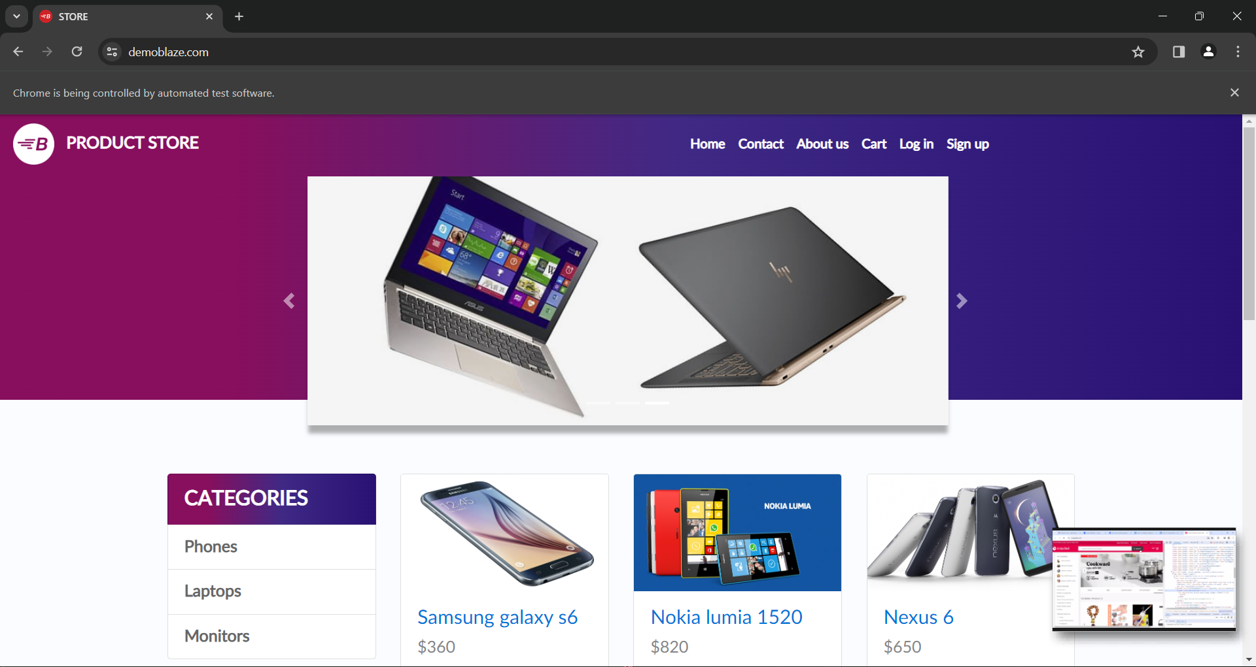

**Output:**

Page landed on correct website

3. Write a Selenium script that opens the chrome browser, navigates to

"https://www.wikipedia.org/", maximizes the browser window, searches for the query "Artificial Intelligence", clicks on the "History" section in the search results, and prints the title of the section.

**Script:**

import org.openqa.selenium.By;

import org.openqa.selenium.Keys;

import org.openqa.selenium.WebDriver;

import org.openqa.selenium.WebElement;

import org.openqa.selenium.chrome.ChromeDriver;

public class WikiSearch {

public static void main(String[] args) {

WebDriver driver = new ChromeDriver();//Starting new chrome session

driver.manage().window().maximize();//Maximizing the window

driver.get("https://www.wikipedia.org/");//Entering the Url

WebElement searchBar = driver.findElement(By.*id*("searchInput"));//Finding search bar element with id

searchBar.sendKeys("Artificial Intelligence");//Search text

searchBar.sendKeys(*Keys*.***RETURN***);//Search key

driver.findElement(By.*xpath*("//a[@href='/wiki/History_of_artificial_intelligence'][normalize-space()='History']")).click();//Finding element of History using xpath

String sectionTitle = driver.getTitle();//Getting title

System.***out***.println("Title of the History section: " + sectionTitle);//Printing the title of History

driver.quit();//Closing the window

}

}

**Output:**

Title of the History section: History of artificial intelligence - Wikipedia