Selenium Method & Actions

Task Description:

1). To Automated Facebook Sign Up Process using Selenium script. Steps to be performed:

1. Open the Chrome/Firefox/Safari browser.

2. Navigate to the Facebook website (https://www.facebook.com/).

3. Verify that the website has been redirected to the Facebook homepage.

4. Click on the "Create new account" button.

5. Enter the first name as "Test" and last name as "User" in the respective fields.

6. Enter a valid email address (for example, testuser@test.com) in the email field.

7. Enter a strong password in the password field.

8. Select the date of birth as "11", month as "May", and year as "1985" using the drop-down

menus.

9. Select the gender as "Male"/ “Female” using the radio button.

10. Click on the "Sign Up" button.

11. Verify that the user is successfully registered on Facebook and redirected to the Facebook homepage.

**Code:**

import java.time.Duration;

import org.openqa.selenium.By;

import org.openqa.selenium.WebDriver;

import org.openqa.selenium.WebElement;

import org.openqa.selenium.chrome.ChromeDriver;

public class Facebook {

public static void main(String[] args) {

WebDriver driver = new ChromeDriver();

driver.manage().window().maximize();

driver.get("https://www.facebook.com/");

driver.manage().timeouts().implicitlyWait(Duration.ofSeconds(20));

driver.findElement(By.xpath("/html/body/div[1]/div[1]/div[1]/div/div/div/div[2]/div/div[1]/form/div[5]/a")).click();

WebElement firstName = driver.findElement(By.name("firstname"));

firstName.sendKeys("Test");

driver.findElement(By.name("lastname")).sendKeys("User");

driver.findElement(By.name("reg_email__")).sendKeys("lorinda95615@phantom-mail.io");

driver.findElement(By.name("reg_passwd__")).sendKeys("@Password123");

driver.findElement(By.name("reg_email_confirmation__")).sendKeys("lorinda95615@phantom-mail.io");

driver.findElement(By.id("day")).sendKeys("11");

driver.findElement(By.id("month")).sendKeys("May");

driver.findElement(By.id("year")).sendKeys("1985");

driver.findElement(By.xpath("/html/body/div[3]/div[2]/div/div/div[2]/div/div/div[1]/form/div[1]/div[7]/span/span[2]/input")).click();

driver.findElement(By.name("websubmit")).click();

}

}

**Result:**

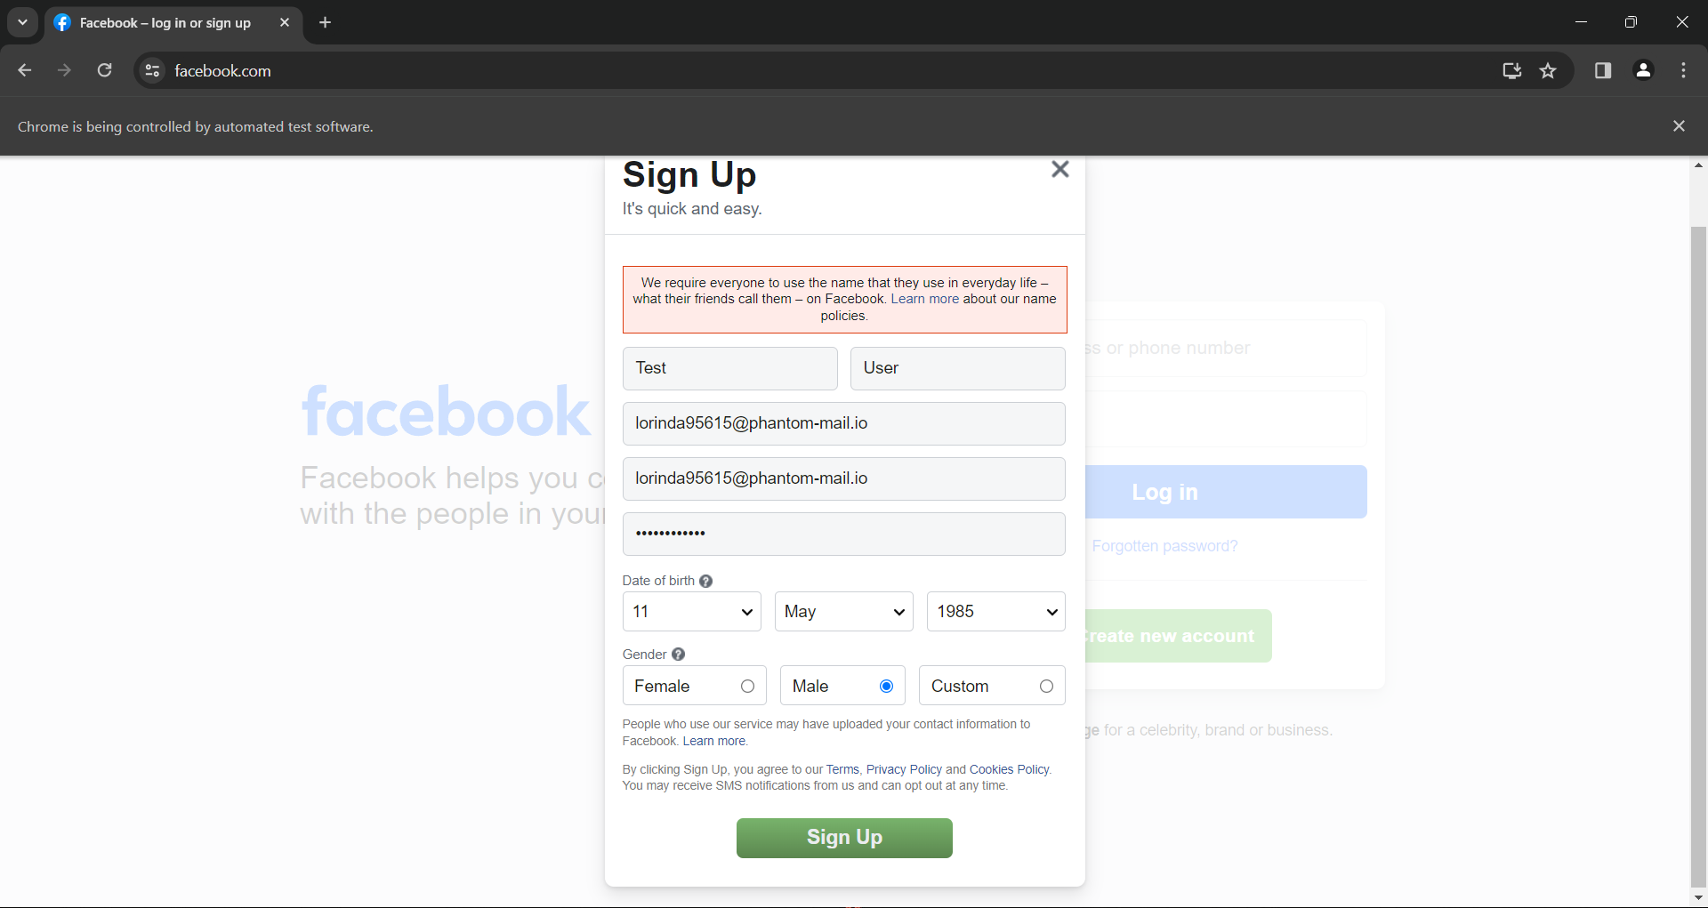

2).To Automated Drag and Drop Operation using Selenium Java.

Steps to be performed:

1. Open the Chrome/Firefox/Safari browser.

2. Navigate to the jQueryUI droppable website (https://jqueryui.com/droppable/).

3. Find the source element with the text "Drag me to my target" and the target element with the text "Drop here".

4. Perform the drag and drop operation from the source element to the target element.

5. Verify that the drag and drop operation is successful by checking the color property of the target element's CSS.

6. Verify that the text of the target element has changed to "Dropped!" after the drop.

**Code:**

import org.openqa.selenium.By;

import org.openqa.selenium.WebDriver;

import org.openqa.selenium.WebElement;

import org.openqa.selenium.edge.EdgeDriver;

import org.openqa.selenium.interactions.Actions;

public class DragandDrop {

public static void main(String[] args) {

WebDriver driver = new EdgeDriver();

driver.manage().window().maximize();

driver.get("https://jqueryui.com/droppable/");

driver.switchTo().frame(0 );

WebElement source = driver.findElement(By.id("draggable"));

WebElement target = driver.findElement(By.id("droppable"));

Actions a = new Actions(driver);

a.dragAndDrop(source, target).perform();

}

}

**Result:**

