Software Design Specification

Smart Glasses App

Project Code:
AUZ-272032

Internal Advisor:
Dr. Fahad Maqbool

Project Manager:
Dr. Muhammad Ilyas

Project Team:
Awais Ahmed | BSCS51F22S027 | Team Lead
Uzair Anwer | BSCS51F21S020RE | Team Member
Zohaib Shehzad | BSCS51F21S032RE | Team Member

Submission Date:
December, 2025

_____________________
Project Manager’s Signature

Document Information

Category | Information
Customer | University of Sargodha (CS Department)
Project | Smart Glasses App – AI-Based Eyewear Recommendation Mobile Application
Document | Software Design Specification
Document Version | 2.0
Identifier | AUZ-272032-DS
Status | Final Draft
Author(s) | Awais Ahmed, Uzair Anwer, Zohaib Shehzad
Approver(s) | Project Manager
Issue Date | May, 2026
Distribution | 1. Dr. Fahad Maqbool 2. Dr. Muhammad Ilyas 3. Project Office

Definition of Terms, Acronyms and Abbreviations

Term | Description
AI | Artificial Intelligence
API | Application Programming Interface
CNN | Convolutional Neural Network
UI | User Interface
Gemini 2.5 | Google's multimodal large language model used for image analysis and text generation
React Native | An open-source framework for building cross-platform mobile applications using JavaScript
Face Shape | Geometric classification of a human face (e.g., oval, round, square, heart, oblong)
VTO | Virtual Try-On: digitally overlaying eyeglass frames on a user's face image
Frame Category | A group of eyeglass frame styles recommended based on classified face shape
SDS | Software Design Specification
FR | Functional Requirement
HTTP/HTTPS | Hypertext Transfer Protocol (Secure): used for API communication
JSON | JavaScript Object Notation: data format used for API responses
OOD | Object-Oriented Design

Table of Contents

1. Introduction 4
1.1 Purpose of Document 4
1.2 Project Overview 4
1.3 Scope 4
2. Design Considerations 4
2.1 Assumptions and Dependencies 4
2.2 Risks and Volatile Areas 4
3. System Architecture 4
3.1 System Level Architecture 4
3.2 Sub-System / Component / Module Level Architecture 5
3.3 Sub-Component / Sub-Module Level Architecture (1…n) 5
4. Design Strategies 5
4.1 Strategy 1…n 5
5. Detailed System Design 5
6. References 6
7. Appendices 6

1. Introduction

1.1 Purpose of Document
This Software Design Specification (SDS) describes the architectural design, system components, and data models for the Smart Glasses App. It translates the requirements from the SRS into a concrete technical blueprint, giving the project team, advisors, and developers a shared understanding of how the system is structured internally, how its components interact, and how data flows through the application. The design follows Object-Oriented Design (OOD) principles within a component-based mobile architecture.

1.2 Project Overview
The Smart Glasses App helps users select eyeglass frames that suit their facial features. When the user opens the app and takes a photo, a face detection module checks that exactly one clear, forward-facing face is present. If the photo contains no face or more than one, an alert prompts the user to try again.
Once a valid image is confirmed, it is base64-encoded and sent to the Google Gemini 2.5 API over a secure HTTPS connection. The API analyzes facial geometry and returns the classified face shape, which can be oval, round, square, heart, or oblong. The app then maps this result to a predefined recommendation ruleset and displays suitable eyeglass frame styles on the results screen. The entire workflow runs on any standard Android smartphone, with no specialized hardware required.

1.3 Scope
This project delivers a functional Android prototype. The scope boundaries are as follows.

In-scope functions include the Android mobile application built in React Native, real-time camera integration with permission handling, face detection and single-face validation with alert pop-ups, Gemini 2.5 API integration for face shape classification, mapping of the classified shape to frame categories, and the recommendation results screen.

Out-of-scope items include physical hardware components such as a two-way mirror, Raspberry Pi, or LED display, e-commerce or purchasing integration, AR virtual try-on, cloud-based user storage or account management, and iOS support in this prototype release.

One key constraint applies: an active internet connection is required for Gemini 2.5 API calls. No offline fallback is provided at this stage.

2. Design Considerations

2.1 Assumptions and Dependencies
The following assumptions were established during requirements analysis and directly shape several design decisions.

- Android Device: The user's device runs Android 10 or above and has a working front or rear camera capable of capturing clear facial images.
- Internet Connectivity: An active 4G or Wi-Fi connection is available at the time of use, since the Gemini 2.5 API requires network access for processing.
- Lighting Conditions: Adequate ambient lighting is assumed in the user's environment. During testing, we found that poorly lit images noticeably reduced face detection confidence, which is why the home screen includes a lighting guidance note.
- Single-User Interaction: The system processes one person at a time. Multi-face scenarios are handled through validation alerts rather than simultaneous processing.
- Gemini API Stability: The Gemini 2.5 free tier is assumed to remain accessible and return structured, parseable text responses containing the face shape classification throughout the project period.
- Face Shape Coverage: The recommendation ruleset covers the five standard categories the Gemini API returns: oval, round, square, heart, and oblong.
- Framework Compatibility: Future updates to React Native and the Gemini API are assumed to remain backward-compatible with this prototype implementation.
- Recommendation Quality: The accuracy of the eyewear recommendations depends directly on how accurately Gemini 2.5 classifies the face shape from the provided image.

2.2 Risks and Volatile Areas
Several risk areas were identified during design that required explicit mitigation strategies.

- API Latency: Network variability may push Gemini 2.5 response times beyond the target threshold. A loading indicator is shown during every API call, and timeout handling with user-friendly error messages is in place.
- Face Detection Accuracy: Blur, poor angle, or dim lighting can reduce detection confidence. The home screen offers guidance on posture and lighting, and alert messages direct the user toward corrective action.
- API Key Security: Embedding the Gemini API key client-side introduces exposure risk. The key is stored in environment configuration files excluded from version control. A server-side proxy should be used in any production release.
- Gemini Response Variability: The model's text response format is not guaranteed to be identical every time. The response parser applies multiple matching strategies and gracefully handles unrecognized outputs with a fallback message. This was one of the more challenging parts to get right during development.
- Android Fragmentation: Camera behavior and permission handling can differ across device models. React Native's camera module abstracts most device-level differences, and testing was conducted across multiple Android versions to catch edge cases.
- Privacy: Transmitting facial images to an external API may raise user concerns. No images or personal data are stored permanently; everything is session-scoped and discarded when the session ends.

3. System Architecture

3.1 System Level Architecture

3.1.1 Package Diagram
The package diagram shows the top-level logical grouping of the application's software components, illustrating how the React Native mobile app, the face detection library, the Gemini 2.5 API integration layer, and the recommendation engine are organized as distinct packages with defined dependencies.
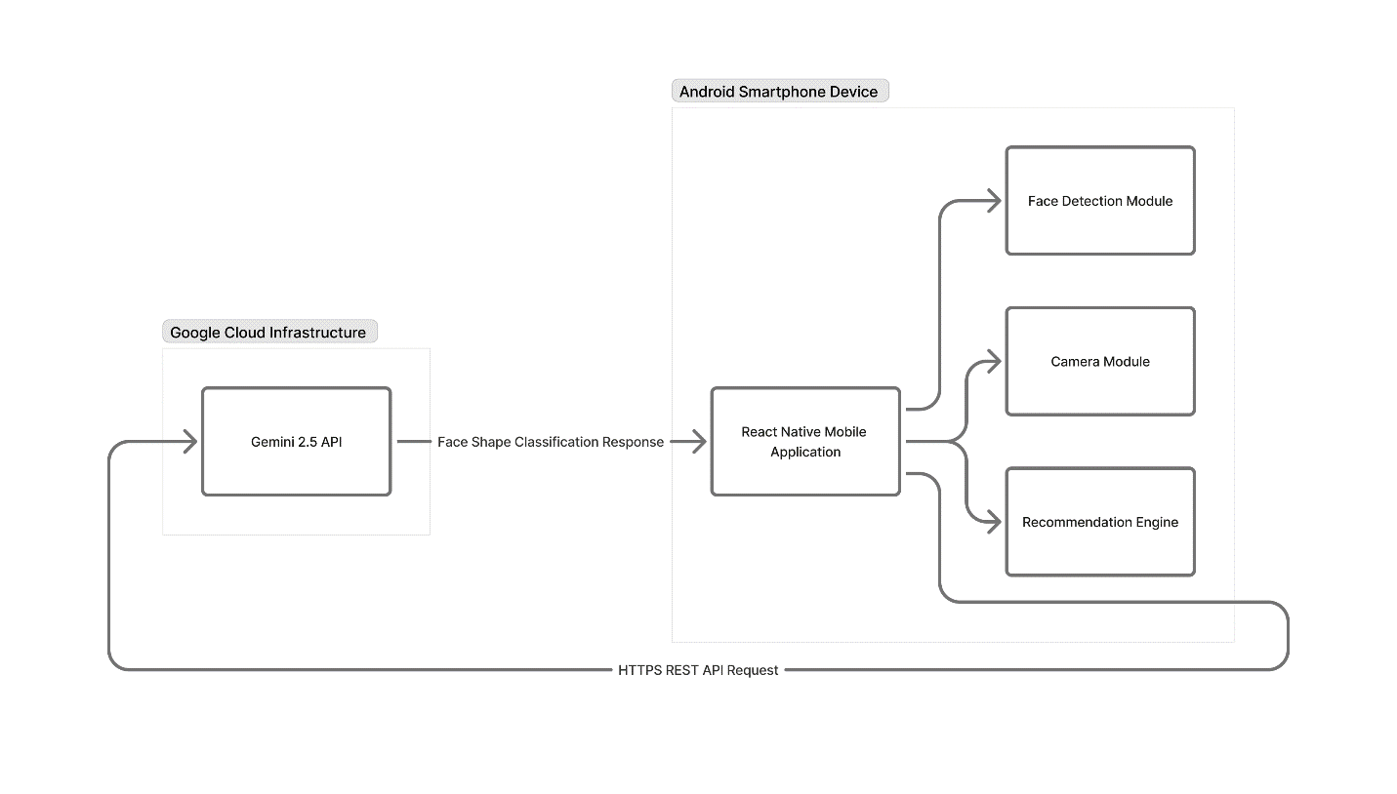
Source: https://www.figma.com/board/VlWA2UpifHwkc6sMLFm2As/Package-Diagram---Smart-Glasses-App?node-id=0-1&p=f&t=cbGI4j53fayKZ1G2-0

3.1.2 Deployment Diagram
The deployment diagram shows how system components are distributed across hardware nodes: the Android smartphone runs the React Native application and local face detection module, while the Gemini 2.5 API is hosted on Google Cloud infrastructure. Communication between the two nodes occurs over a secure HTTPS connection.
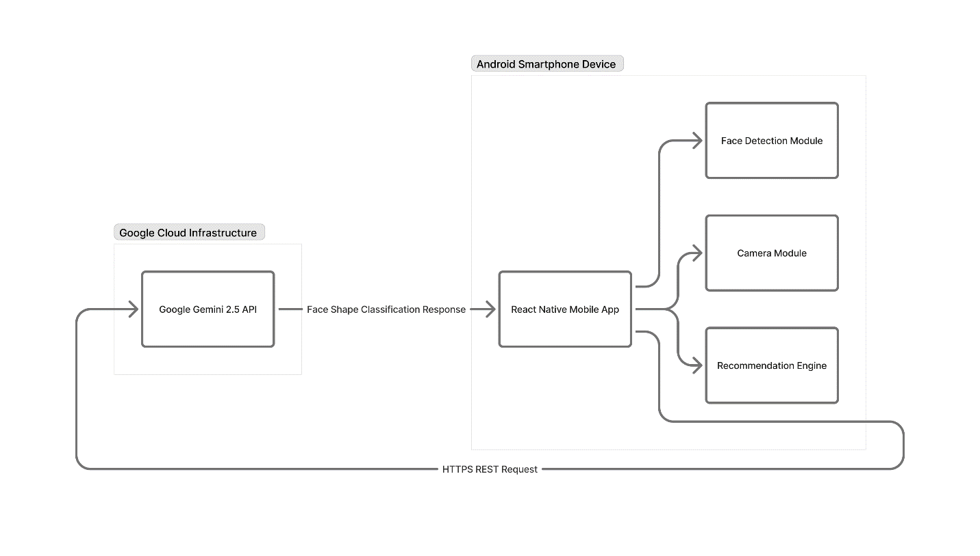
Source: https://www.figma.com/board/uPBkiSSKslkABakjHowRMF/Deployment-Diagram?node-id=0-1&p=f&t=stOvWgI9dQIYfMpc-0

3.2 Sub-System / Component / Module Level Architecture

3.2.1 Component Diagram
The component diagram details the internal architectural components of the application and their interfaces. The key components are the Camera Module (image capture and permission handling), the Face Validation Module (single-face detection logic), the API Integration Module (Gemini 2.5 HTTP communication), the Response Parser Module (text analysis and face shape extraction), the Recommendation Engine (face shape to frame category mapping), and the UI screens covering Home, Camera, Validation Feedback, and Results.
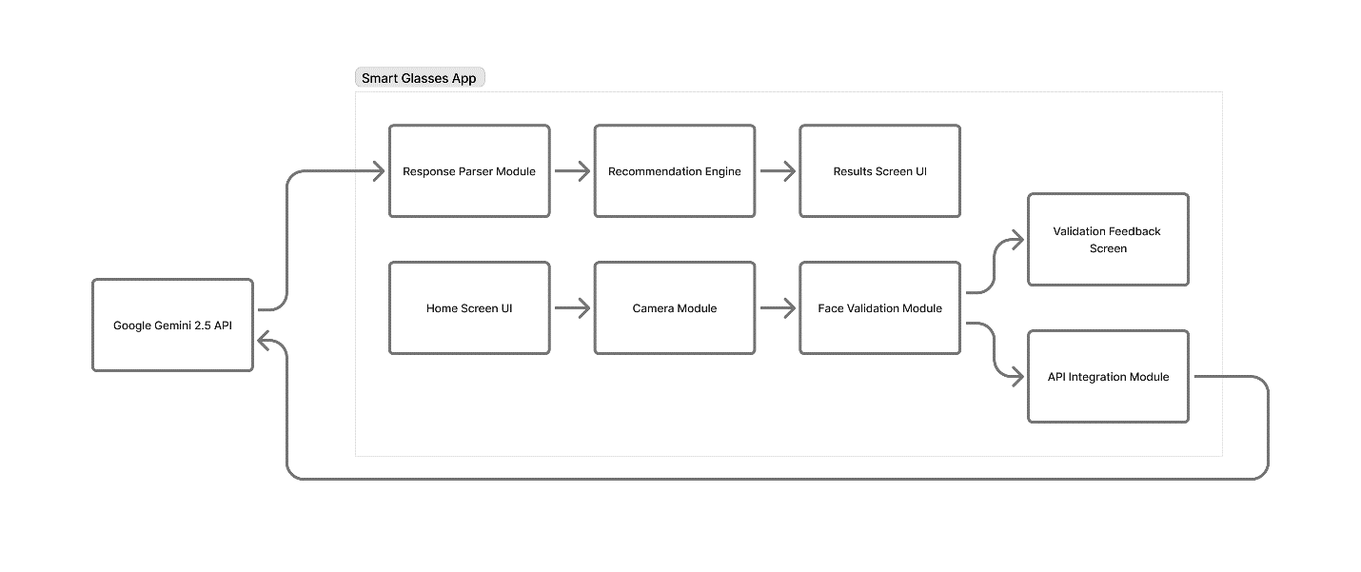
Source: https://www.figma.com/board/O38dxdsJs0WCO52SmPSKjG/Component-Diagram?node-id=0-1&p=f&t=PmVpYJG87QdYKu1E-0

3.2.2 Sub-System / Module level Architecture
This view presents a layered breakdown of the application's subsystems. The Presentation Layer contains the React Native UI screens, the Application Logic Layer handles face validation, response parsing, and recommendation mapping, and the External Services Layer is the Gemini 2.5 API. Data flows unidirectionally from image capture through validation, API transmission, and parsing to the final results display.
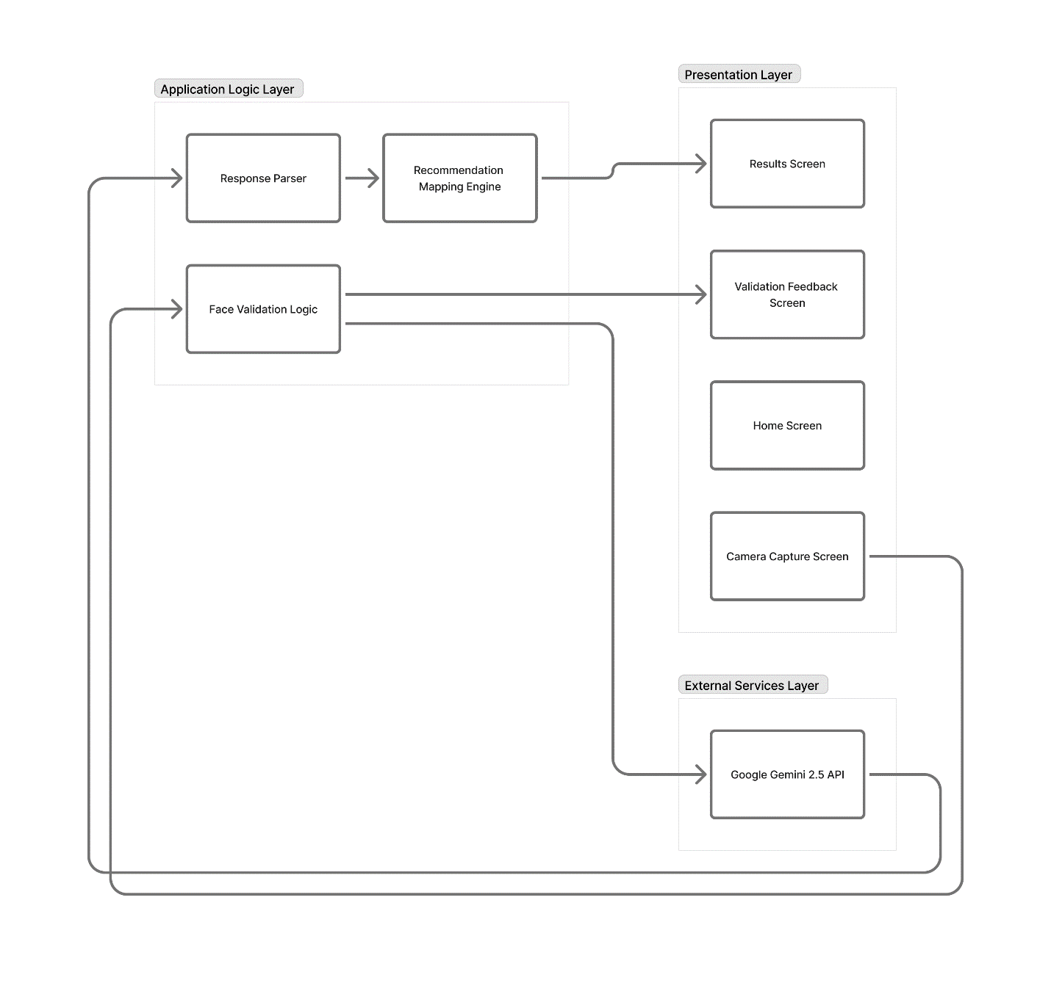
Source: https://www.figma.com/board/dpK2w2yOw4eyOoNG9H6LZe/Subsystem-Module-Architecture?node-id=0-1&p=f&t=3cfEKagRWH2jcWn7-0

3.3 Sub-Component / Sub-Module Level Architecture
This section details the AI Analysis Submodule, which forms the core intelligence pipeline of the application. It includes the Image Encoder (base64 encoding of the validated photo), the Prompt Constructor (building the structured instruction prompt sent to Gemini 2.5), the HTTP Request Handler (HTTPS POST to the Gemini API endpoint with key authentication), the Response Parser (extracting the face shape classification from the returned text), and the Frame Mapper (applying the predefined ruleset to map the classified shape to frame categories).
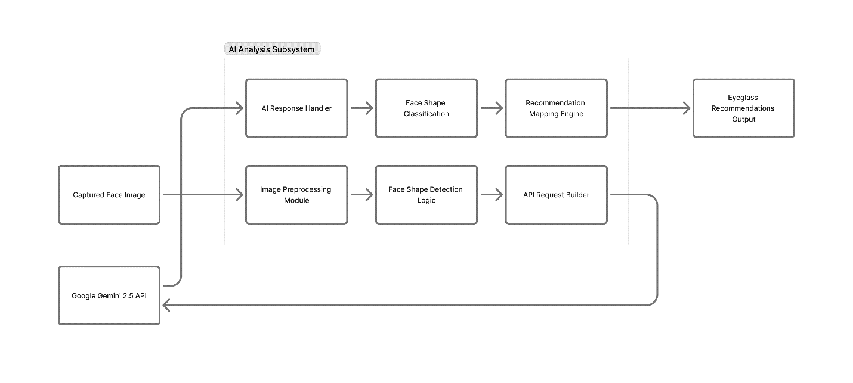

Source: https://www.figma.com/board/mIjMofKmCSSBO1mffIxN0v/AI-Analysis-Submodule-Architecture?node-id=0-1&p=f&t=ExX3xbJaytTtVYy2-0

4. Design Strategies

4.1 API-First Integration Strategy (Connectivity & Scalability)
A core architectural decision was to delegate all AI processing to the Google Gemini 2.5 cloud API rather than running a local model on the device. This differs from the earlier Smart Mirror system that relied on edge computing with TensorFlow Lite on a Raspberry Pi. Two requirements drove this shift.
First, accessibility: using a cloud-based multimodal AI eliminates the need for expensive dedicated hardware, making any Android device with internet access capable of delivering recommendations. Second, scalability: the kind of multimodal facial geometry analysis needed here would be computationally infeasible on consumer smartphone hardware, and offloading it to the API produces far more reliable classifications without device-side model optimization overhead.
The obvious trade-off is the internet dependency. This is addressed through timeout handling, loading state management, and clear error messaging when the API is unavailable.

4.2 AI Prompt Engineering Strategy
The accuracy and consistency of Gemini 2.5's face shape classification depends heavily on how the prompt is structured. A carefully engineered prompt is transmitted alongside the image, and getting this right turned out to be one of the more iterative parts of the project.
The prompt explicitly instructs the model to analyze the facial geometry in the image and classify it into one of five standard categories: oval, round, square, heart, or oblong. It requests a structured text response that includes both the face shape label and a brief rationale, which makes the output reliably parseable by the Response Parser Module. An additional instruction tells the model to respond only if exactly one face is clearly visible, providing a secondary AI-level validation layer on top of the device-side detection. Fallback handling in the parser covers cases where the response is unexpectedly formatted.

4.3 Mobile-First UI Strategy
The interface is designed specifically for Android using React Native, with simplicity as the guiding principle. The application has four screens, each serving a single function: Home, Camera Capture, Face Validation Feedback, and Recommendation Results. Keeping the flow this focused made it easier to test each stage independently and trace issues back to specific components.
Validation outcomes (no face, multiple faces, or a valid single face) are communicated through clear, descriptive alert pop-ups. The app requests only camera access and internet connectivity, minimizing the privacy footprint and reducing friction during installation. Loading indicators are shown throughout API calls so the user knows the app is working rather than frozen.

5. Detailed System Design

5.1 Class Diagram
The class diagram presents the object-oriented design of the application, showing the primary classes, their attributes, methods, and relationships. CameraScreen manages the camera preview, image capture, and permission requests. FaceValidator encapsulates the face detection logic and returns a validation status along with the detected face count. GeminiAPIClient handles image encoding, prompt construction, and the HTTP POST request and response retrieval. ResponseParser extracts the classified face shape from the API text output. FrameRecommender maps the face shape to the predefined frame category ruleset. ResultsScreen renders the face shape and frame recommendations in the UI.
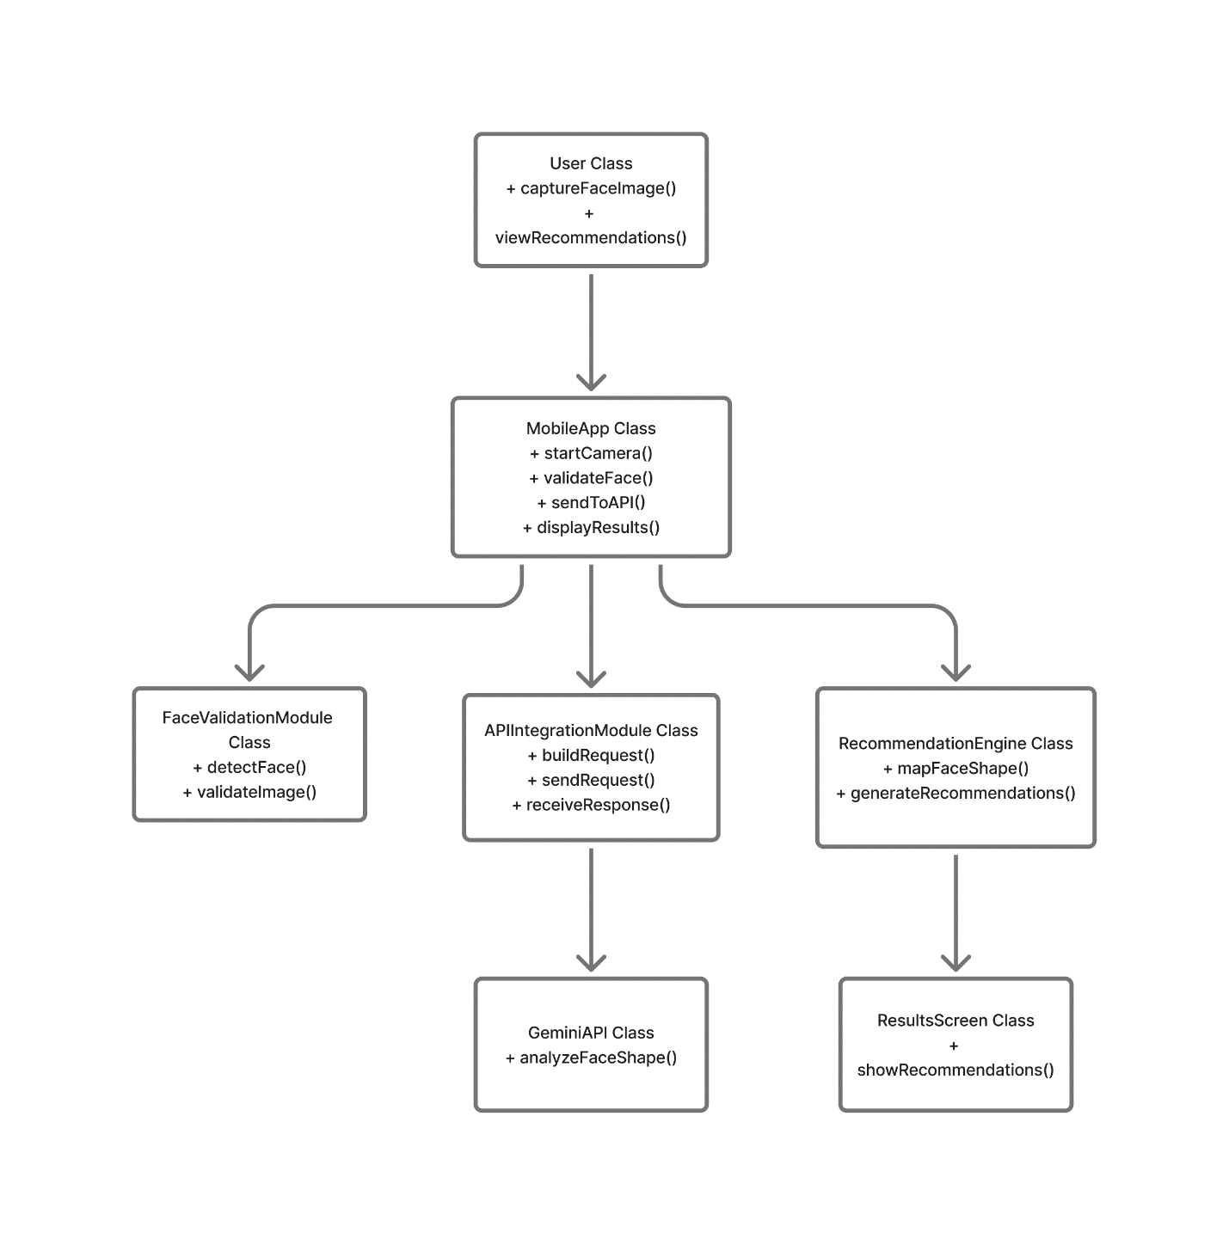
Source: https://www.figma.com/board/8jA5IeoYtPepGehm4aZMPf/Class-Diagram?node-id=0-1&p=f&t=uFHKR3tfYJ2GQ02q-0

5.2 Sequence Diagram
The sequence diagram traces the end-to-end interaction for the primary use case: a successful face shape classification and eyewear recommendation. The flow begins when the user activates the camera from the Home screen, proceeds through image capture, face validation, API transmission, response parsing, and ends with the results screen displaying the frame recommendations. Error branches for both the no-face and multi-face scenarios are also captured in the diagram.
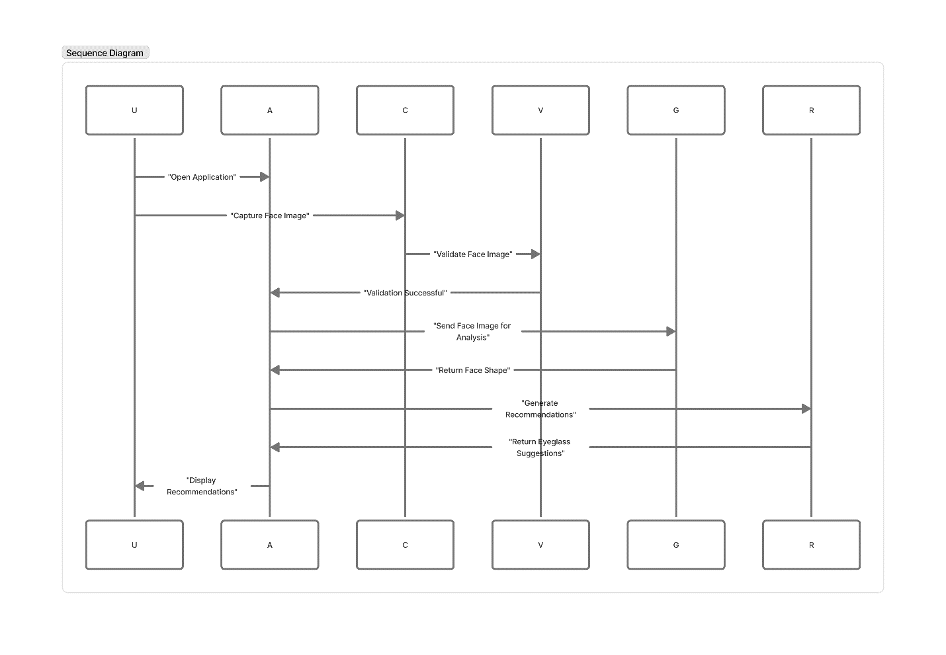
Source: https://www.figma.com/board/PFIVoa0akq2AdQJKelLoTu/Sequence-Diagram?node-id=0-1&p=f&t=K0HviS3P7Mfskjuf-0

5.3 Activity Diagram
The activity diagram maps the complete procedural workflow from application launch to recommendation display. Decision nodes capture all three face validation outcomes: no face detected triggers an alert, multiple faces triggers a different alert, and a single valid face allows the workflow to proceed. The diagram then shows the API call, response parsing, and recommendation mapping steps, giving developers a clear operational reference for implementing the application logic.
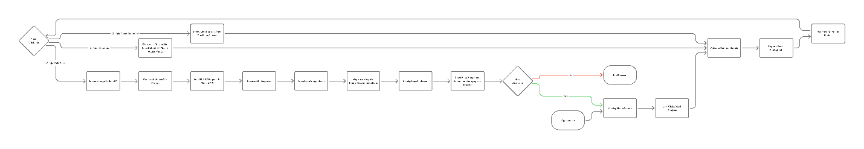
Source: https://www.figma.com/board/uWbfx272CgNjkSmgzfVgeX/Activity-Diagram---Smart-Glasses-App?node-id=0-1&p=f&t=8BOdNdZqwJRb4FAS-0

5.4 Use Case Diagram
The primary actor is the End User, which covers both individuals seeking personal eyewear recommendations and optical shop staff assisting a customer. The use cases include launching the application, capturing a facial photograph, receiving face validation feedback, viewing the face shape classification, and viewing eyeglass frame recommendations. Google Gemini 2.5 API appears as the external system actor participating in the AI Analysis use case.
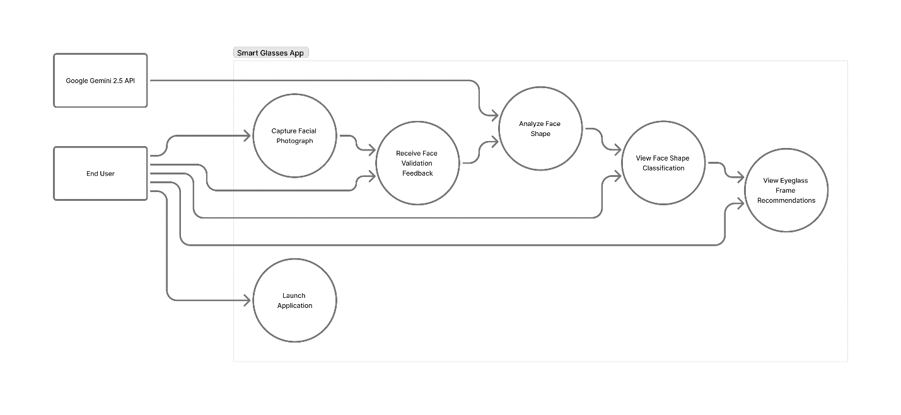
Source: https://www.figma.com/board/YgfL71ai0PVnAUmKOFsRLx/Use-Case-Diagram---Smart-Glasses-App?node-id=0-1&p=f&t=C9ys3pdTTtMyONhG-0

5.5 State Transition Diagram
The state transition diagram models the discrete states of the application during a user session. These include Idle (Home Screen), Camera Active, Image Captured, Face Validation (with sub-states for No Face Detected, Multiple Faces Detected, and Valid Face Confirmed), API Processing, Response Parsed, and Recommendation Displayed. Transitions between states are triggered by both user actions and system events, capturing the complete lifecycle of a recommendation session from start to finish.

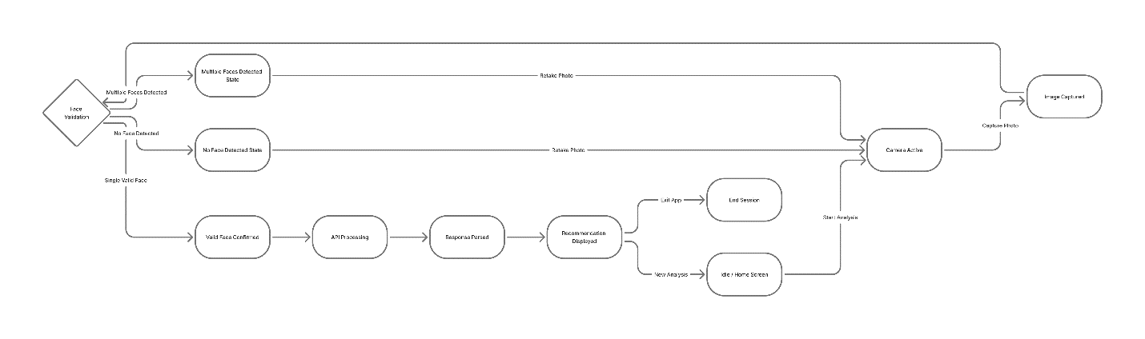
Source: https://www.figma.com/board/khRkgja8XkxV2SslhBTj7V/State-Transition-Diagram---Smart-Glasses-App?node-id=0-1&p=f&t=rvqt7yKoD5fVqjRd-0

6. References
Ref. | Document Title | Year | Source
[1] | H. Fatima et al., "Internet-of-Mirrors (IoM) for connected healthcare and beauty" | 2024 | https://www.sciencedirect.com/science/article/pii/S2542660524003561
[2] | M. Wang et al., "Smart mirror fashion technology for better customer brand experience" | 2025 | https://www.tandfonline.com/doi/full/10.1080/17543266.2023.2243485
[3] | M. Zafar et al., "Facial Shape-Based Eyeglass Recommendation Using CNNs" - IEEE SSCI 2023 | 2023 | https://ieeexplore.ieee.org/document/10371836
[4] | A. Cannavò & G. Pilato, "Interaction Design Patterns for Augmented Reality Fitting Rooms" | 2022 | https://www.ncbi.nlm.nih.gov/pmc/articles/PMC8838181/
[5] | Google, "Gemini API Documentation - Vision and Multimodal Capabilities" | 2025 | https://ai.google.dev/gemini-api/docs/vision
[6] | Google DeepMind, "Gemini 2.5: Our most intelligent AI model" | 2025 | https://blog.google/technology/google-deepmind/gemini-2-5/
[7] | Meta Open Source, "React Native - Learn once, write anywhere" | 2025 | https://reactnative.dev/

7. Appendices

Appendix A: Future Enhancements
The following enhancements are identified as natural extensions beyond the current prototype scope.

- AR Virtual Try-On: An AR module that overlays recommended frames on the user's face in real time through the device camera. This was excluded from the prototype due to scope constraints but remains the most impactful potential next step.
- Expanded Frame Database: A comprehensive inventory database linking face shape recommendations to specific brands, styles, and purchase links, replacing the current static ruleset.
- iOS Platform Support: Extension of the React Native codebase to support iOS devices, enabling full cross-platform availability.
- E-Commerce Integration: Connection to optical shop inventory systems or online marketplaces for direct frame browsing and purchase from within the app.
- Multi-Language Support: Localization of the interface and recommendation descriptions to support non-English-speaking users.
- User History: A local session history feature allowing users to review past face shape classifications and recommendations across sessions.

Appendix B: Tools and Technologies
The following tools and technologies are employed in the design and development of the Smart Glasses App:

Category | Technology / Tool
Programming Language | JavaScript (React Native)
Mobile Framework | React Native (Android)
AI Service | Google Gemini 2.5 API (Multimodal Vision)
Face Detection | React Native Vision Camera / ML Kit Face Detection
Target Platform | Android 10+
Version Control | GitHub Repository
Development Environment | VS Code, Android Studio, Node.js
API Communication | HTTPS / REST (JSON)
Image Encoding | Base64 encoding for API image transmission

