**FRONT-END DOCUMENTS (Version 1)**

**Pre-requirements:**

* Node version: v14.16.x (system files)
* React version: v17.0.x (system files)
* React router dom : v6.0.x (system files) (Latest version)
* React-slick: v0.28.x (Carousel)
  + Slick-carousel: v1.8.x (CSS for carousel)
* Styled-components: v5.3.x (Specific CSS style)
* Antd: v4.16 (UI library)

**Directory structure**

* **Tree directory**

Src:

* + App.js
  + App.module.css
  + (Folder) components
    - Header.js
    - Footer.js
    - **(Folder)** styles ( containing all css files for components with same name, ex: **Header.module.css** is for **Header.js …** )
    - **(Folder)** Modals
      * RegisterModal.js
      * LoginModal.js
    - **(Folder)** Content
      * BigBoard.js
      * Categories.js
      * Category.js
      * Checkout.js
      * Discovery_board.js
      * Error.js
      * Food_Category.js
      * Food.js
      * Index.js
      * Restaurant_board.js
      * Restaurant_menu.js
      * Restaurant.js

Starting from **src** file: small rectangles are as components, big rectangles are as folders which contain components

* **Directory structure by Illustration**

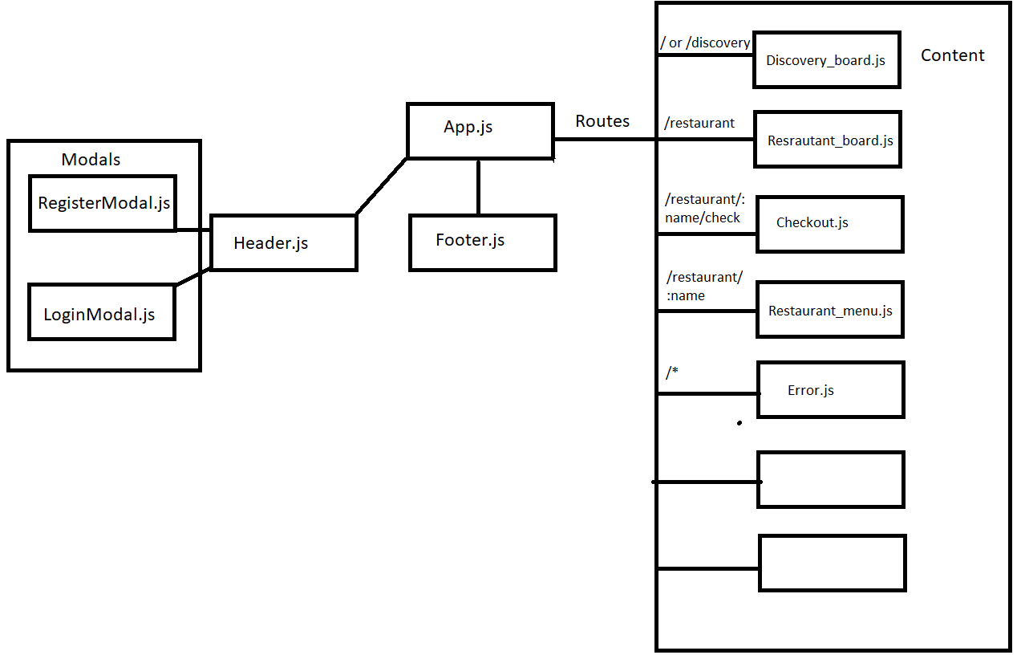

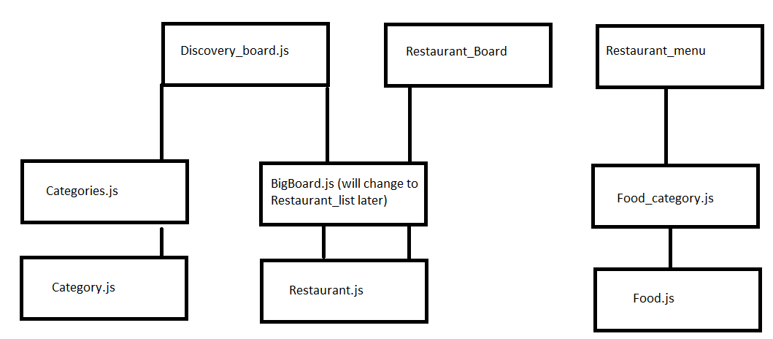

**Functionality:**

* **Header.js:**
  + Login:
    - (Func) **handleLogin(e):** where to handle login with input data. Type of data (e) **is Object**: {username:”value”, password:”value”}
  + Register:
    - (Func) **handleLogin(e)**: where to handle register with input data. Type of data (e) **is Object**: {username:”value”, email:”value”, password:”password”,confirm:”confirm”,phone:”phone”,address:”address”}