DOAB (दोआब) — Competitive & Government Landscape Analysis
Deep-Dive Benchmarking: Global Tech Competitors, Indian Civic Portals & DOAB Value Proposition
Environmental Hacks (Track 02) • Project Whitepaper

1. Executive Summary
Modern climate disasters in India present a paradoxical dual challenge: extreme urban flash floods and underpass waterlogging during the monsoon season, transitioning directly into severe borewell depletion, water tanker delivery deficits, and fatal thermal heatwaves during the pre-monsoon dry season. While multiple platforms operate in disaster management and meteorology, a fundamental gap exists between macro-level forecasting and street-level citizen life-safety.
Existing systems either operate as broad-area meteorological broadcasts (IMD, NDMA Sachet), macro-riverine flood predictions (Google Flood Hub), or closed enterprise GIS tools (Esri, One Concern). None of them provide real-time, digital elevation model (DEM)-grounded street inundation routing, vehicle-clearance underpass passability, crowdsourced ground-truth verification, or dual-climate adaptability.
DOAB (Detect → Order → Alert → Back-check) bridges this critical divide by delivering hyper-local, 60-minute forward predictive hazard intelligence, automated 3-corridor elevation bypass navigation, and emergency dispatch on a resilient AWS Cloud architecture.

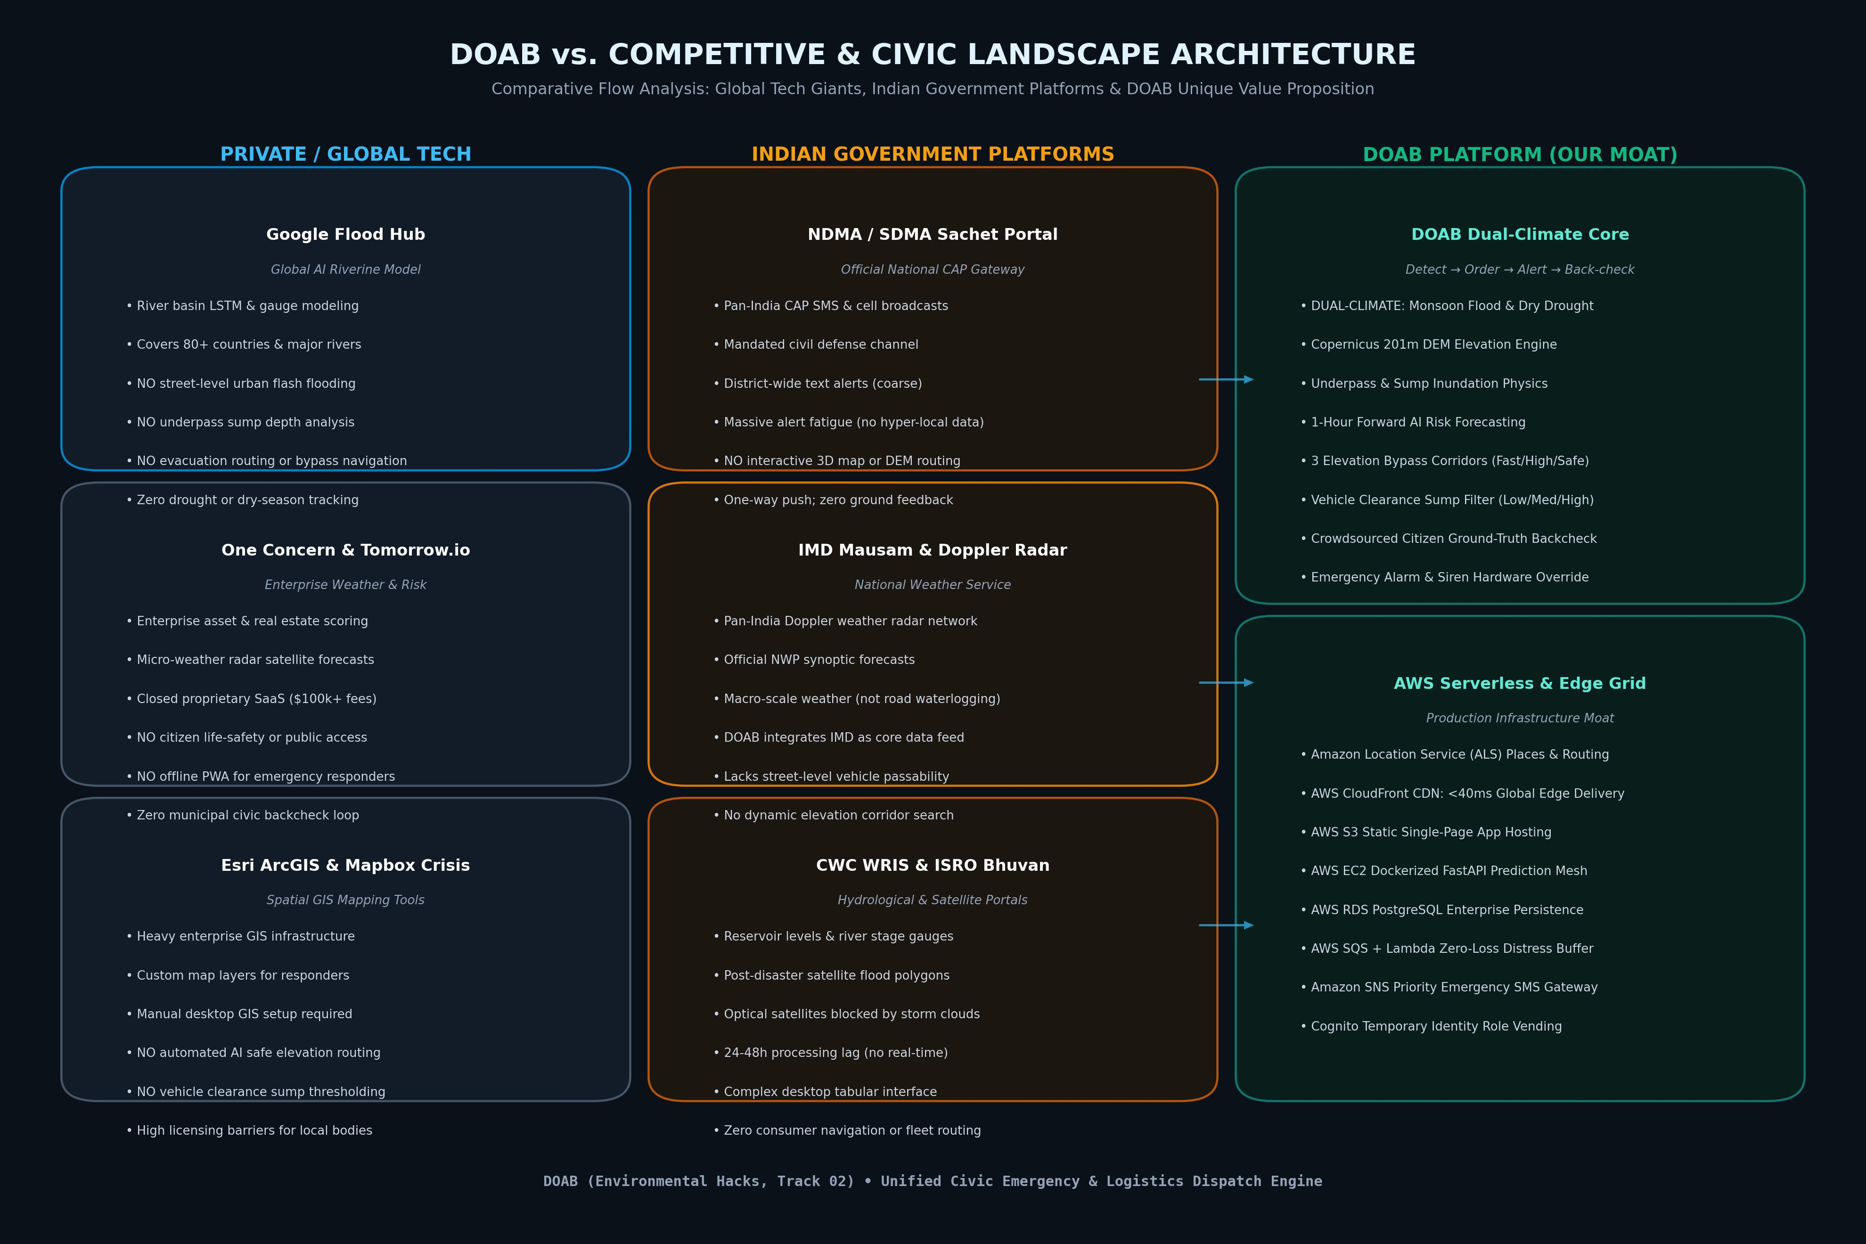
Figure 1: High-level System Topology & Competitor Benchmarking Flowchart

2. Comprehensive Competitor & Platform Feature Matrix
Capability / Dimension | DOAB Platform | Google Flood Hub | NDMA Sachet | IMD Mausam / Radar | CWC India-WRIS | Tomorrow.io / One Concern
Dual-Climate Architecture | YES (Flood + Drought) | NO (River Flood Only) | Partial (SMS Only) | Weather Only | Water Data Only | Weather Only
Street & Sump Inundation Depth | YES (DEM + Sump Physics) | NO (Basin Polygons) | NO (District-wide) | NO (Rainfall Only) | NO (River Gauges) | NO (Enterprise SaaS)
3D Safe Elevation Bypass Routing | YES (3 Corridors: Fast/High/Safe) | NO (Static Map) | NO (Text SMS) | NO (Bulletins) | NO (Tabular) | NO (Enterprise)
Vehicle Clearance Thresholding | YES (Low/Med/High Clearance) | NO | NO | NO | NO | NO
Ground-Truth Citizen Back-Check | YES (Bidirectional Verification) | NO (One-way) | NO (One-way) | NO | NO | NO
Emergency Hardware Siren / SOS | YES (Siren Override + Haptics) | NO | Partial (Cell Broadcast) | NO | NO | NO
Cloud & Edge Latency | AWS CloudFront (<40ms Edge) | Google Cloud Edge | Govt NIC Gateway (Slow) | NIC Data Center (Slow) | NIC Portal (Tabular) | Proprietary Cloud (Paid)
Offline PWA / Field Responder APK | YES (Local Cache + ServiceWorker) | NO | Mobile App (Basic) | Mobile App (Basic) | Desktop Only | Enterprise Web Only

3. Detailed Competitor Profiles: Strengths vs. DOAB Advantages

3.1 Google Flood Hub (Global Tech Competitor)
Where They Excel:
• Massive geographic coverage spanning 80+ countries and 460M+ inhabitants.
• Advanced Long Short-Term Memory (LSTM) machine learning models trained on decades of river discharge records.
• Seamless integration with Google Search and Android system notification hooks.
Key Gaps & Shortcomings:
• Macro-Riverine Focus Only: Models major river catchments (Ganges, Brahmaputra). It cannot predict localized urban flash waterlogging or street sumps where 80% of urban monsoon casualties occur.
• Zero Safe Path Routing: Displays static flood risk polygons on map. Cannot compute alternate bypass navigation routes for ambulances, delivery fleets, or commuting citizens.
• No Sump Clearance Awareness: Unaware of underpasses (e.g. Koramangala 80ft road or Domlur underpasses) where water pools 80cm deep despite zero river proximity.
• Single-Climate Paradigm: Completely idle during dry seasons; provides zero drought, tanker dispatch, or groundwater depletion tracking.
The DOAB Advantage: DOAB fuses Copernicus 201m DEM topography with real-time precipitation and municipal ward reports, delivering 60-minute forward street-level inundation prediction and 3 safe elevation corridors.

3.2 NDMA Sachet (Official Indian Government CAP Portal)
Where They Excel:
• Authorized National Disaster Management Authority mandate with direct access to cellular telecom gateways.
• Multi-hazard coverage including cyclones, landslides, and tsunamis.
Key Gaps & Shortcomings:
• Coarse Geographic Granularity: Sends broad district-level SMS blasts (e.g. 'Heavy rain alert in Bengaluru Urban'). Citizens cannot tell if their route 300 meters ahead is impassable.
• Severe Alert Fatigue: Repeated generic text messages cause citizens to silence notifications.
• One-Way Dissemination: No mechanism for citizens or responders to submit live water depth back-checks or ground-truth confirmations.
• Zero Interactive Mapping: Lacks interactive 3D map views, elevation cross-sections, or automated safe-path calculation.
The DOAB Advantage: DOAB delivers precise street-level hazard pins with exact water depths in centimeters, paired with an emergency siren override and bidirectional ground-truth backcheck loop.

3.3 IMD Mausam & Doppler Radar (Scientific Agency)
Where They Excel:
• Official scientific agency with national network of Doppler Weather Radars (DWR) and automatic weather stations (AWS).
• High-precision atmospheric Nowcast and 7-day Numerical Weather Prediction (NWP) models.
Key Gaps & Shortcomings:
• Atmospheric, Not Hydrological: IMD measures rainfall falling from the sky, not where water collects on the ground. A 50mm rainfall creates 10cm pooling on high ground but 90cm submersion in an underpass.
• No Road Passability Mapping: Does not evaluate vehicle low-clearance thresholds or route accessibility.
The DOAB Advantage: DOAB directly ingests IMD Doppler Radar Nowcasts and AWS telemetry as an upstream data input, combining it with digital elevation models and road networks to translate raw atmospheric rain into actionable vehicle passability.

3.4 CWC Flood Forecast & ISRO Bhuvan (Hydrological & Space)
Where They Excel:
• Central Water Commission monitors hundreds of river gauge stations and reservoir storage levels.
• ISRO Bhuvan provides satellite-derived post-flood spatial inundation extent.
Key Gaps & Shortcomings:
• Delayed Post-Event Telemetry: Optical satellites cannot see through monsoon cloud cover during the event; Bhuvan flood maps take 24-48 hours to compile.
• Non-Intuitive Enterprise Interfaces: Heavy tabular portals designed for irrigation engineers rather than field rescue teams or active dispatchers.
The DOAB Advantage: DOAB provides instant 1-hour forward predictive routing during the storm, utilizing high-speed edge compute on AWS CloudFront with zero satellite cloud-blocking dependencies.

4. DOAB Architectural Moats & Technology Stack
1. Copernicus 201m DEM Baseline + Sump Physics
DOAB calculates local topographic relief using digital elevation models. Combined with soil runoff potential and sub-surface sump geometry, the model accurately predicts street-level pooling depths (e.g. 15cm alert threshold).
2. 3-Corridor Elevation Bypass Engine
Unlike conventional navigation engines that optimize solely for travel duration or traffic congestion, DOAB's routing algorithm computes 3 distinct corridors: Fastest Road, Highest Elevation Ridgeline, and Verified Safe Haven Bypass.
3. Dynamic Vehicle Clearance Filter
Field responders and delivery fleets can toggle between Low Clearance (sedans/scooters, 15cm threshold), Medium Clearance (SUVs/vans, 35cm threshold), and High Clearance (fire engines/trucks, 65cm threshold).
4. Complete AWS Serverless & Life-Safety Mesh
Architected on AWS CloudFront (<40ms global edge delivery), S3 origin hosting, EC2 dockerized FastAPI prediction microservices, Amazon RDS PostgreSQL persistence, and SQS/SNS emergency distress buffers.
5. Dual-Climate Seasonal Flip
Seamless zero-downtime transition between Monsoon Inundation Mode and Scarcity Drought Mode, re-orienting algorithms to monitor groundwater table deficits, tanker dispatch logistics, and heat stress advisories.

