\



**UNIVERSITY OF GHANA**

(All rights reserved)

**DEVELOPING A SMART HOUSE MODEL**

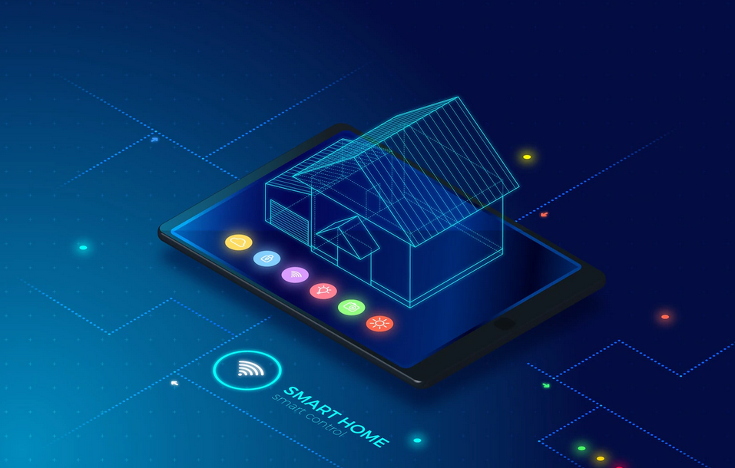

**TABLE OF CONTENTS**

Contents

**Abstract** **1**

**Introduction……………………..……………………………………………………………………………………………………………..…2**

**Research Apparatus………..……………………………………………………………………………………………………………….…3**

**Analysis of the basic concepts of the study………..……………………………………………………………………………….4**

**Designing a Smart Home Model………………………………………………………………………………………………………….5**

**Practical Implementation of the model……………..……………………………………………………………………………….6**

**Conclusions…..……………………………………………………………………………………………………………………………………7**

**References………………..……………………………………………………………………………………………………………………….8**

**ABSTRACT**

This work is devoted to designing a smart house model. It contains the following levels: command, communication and management. The main subsystems of the model include: communication, signaling, control of lighting, temperature and monitoring of sensor data. The hardware components for the implementation of the Mini Smart House were selected in the article. It uses a variety of technologies to conveniently manage it and use a stable energy source to power it. The model was produced independently by students involved in the STEM project. The purpose is to establish the idea of students coming together to work on a project, that we can set our minds to something and actually achieve it.

**Keywords:** Mini Smart House, STEM-projects, Smart technologies, C++, Internet of Things, technology of management.

1. **INTRODUCTION**

Smart House will be the next smartphone. The technology that encompasses a smart house will become the new normal for modern-day homeowners. Smart houses range from basic to advanced depending on the sensors that are installed in the house and the operating system.

The trend of IT development in recent years is Smart-technologies. They are now  
widely implemented in many industries, in the home and in education. As a result, the modern teacher receives many tools that make the learning process interesting and creative. Today, the IoT sphere is one of the major global trends. Almost all devices known in the everyday life become part of the Internet and as a result perform new functions. No wonder this industry is considered the driving force of the 4th Industrial Revolution, which is now underway in the world. Therefore, forming an IoT expert – the person who creates the future – is an important educational task.  
  
Smart home technology embodies all of the above concepts. Smart home can  
be understood as a system that provides security and resource conservation (including comfort) for all users. In the simplest case, it should be able to recognize and respond to specific situations occurring in the home: one of the systems can control the behavior of others using pre-built algorithms. In addition, the automation of several subsystems provides a synergistic effect for the whole complex. With the increasing computing power of gadgets, many smart home technologies and the Internet of Things have been standardized. Also, for them the basic rules and recommendations for the construction of the finished product at the level of both the system as a whole and the individual components were defined

1. **APPARATUS**

The purpose of the project is to develop a smart home model, design and create a Mini Smart House.

Achieving the goal of the research is possible by solving the following tasks:

1. Analysis of the conceptual apparatus in the field of Internet of Things.

2. Designing the smart house model and choosing the hardware components that will implement the model.

3. Project development through programming and assembly of parts.

4. Implementation, testing, debugging of some components of the project.

**III. Designing a Smart Home Model**

Functionality, style, comfort, safety is far from being a complete list of what a smart home can do. IoT technologies are implemented in the concept of the “smart home” training model, which should provide convenient management of basic household appliances. In our model of “smart home” we propose the following components:

* A control center (in the form of a mobile app), which records and interprets data from sensors.
* Motion, smoke, flooding, opening doors, light, humidity, temperature.
* Temperature regulators for batteries.
* Readers of indicators of counters.

All of these components have to receive data from the sensors and  
work according to the developed algorithms. Accordingly, the entire process of their operation will be subject to control and management from mobile devices via the Internet. Our model has three levels: commands, management and communications.

Mini Smart House embodies a combination of technical, engineering, design  
techniques, computer and software engineering (computer networks,  
C programming), and demonstrates practical results. The introduction of such projects into the educational process enables to acquire the skills of modeling the respective processes and to implement similar technologies in real life. Pupils or students will learn a self-created system that ensures the safety, comfort, economy and efficiency of managing their own home and is scaled and customized, ensuring efficiency in managing smart home technology. This integration of academic subjects and the implementation of cross-curricular links will help to prepare the modern specialist.

In our “Smart House” model, we can distinguish the following subsystems:

* Communication
* Alarm system
* Lighting control
* Temperature control
* Monitoring of sensor data

In order to ensure their functioning in practice, appropriate software modules for all components were developed and optimal development tools were based on the selected hardware elements for our model.

**Table 1.** Calculation of the cost of hardware components of the prototype

|  |  |  |  |
| --- | --- | --- | --- |
| Name | Model | Quantity | Price |
| Temperature and humidity sensor | TMP 36 | 1 |  |
| Arduino pin extension module | I2C на PCF8574T |  |  |
| LCD 1602 module for Arduino | 1602 |  |  |
| Buzzer | KY-012 |  |  |
| Ultrasonic distance sensor | HC-SR04 |  |  |
| Jumper Wires |  |  |  |
| LED |  | 5 |  |
| Arduino | Mega 2560 | 1 |  |
| Payless Layout Board | MB-102 |  |  |
| Plastic | 1 |  |  |
| Cart  Accessories for doors and windows |  |  |  |
| Other supplies | 20 |  |  |

* 1. **Practical implementation of the model**

The practical implementation of the model involves the creation of a layout smart  
house. The model is a sketch project of the house, which gives an idea of the artistic and stylistic decisions of the building, features of its planning.  
First of all, we drew a sketch of the house on paper. Then, according to the sketch,  
the house was modelled with ArchiCAD and SketchUp.  
After completing a detailed drawing of the layout, you need to select the material  
for its construction. Many different materials are suitable for making a model of  
the house, but it is most appropriate to use foam, wood or solid cardboard. We have decided that cart box is the most appropriate material for the Mini Smart House prototype. It is easily machined, reliable and durable. So, we chose the cart. Careful quality work made it easy to connect all the details with each other. After preparation of all the details, a prototype of the house was assembled, fixed with PVA glue and with hot gluing. Moving parts are attached to the curtains that are screwed onto the screws. The defining function of any SMART-system is to respond to the environment, the parameters of which are measured using sensors, signals, communications and other integrated elements. The received data is processed through the implementation of program code. C++ programming language is used for programming in the Arduino IDE.

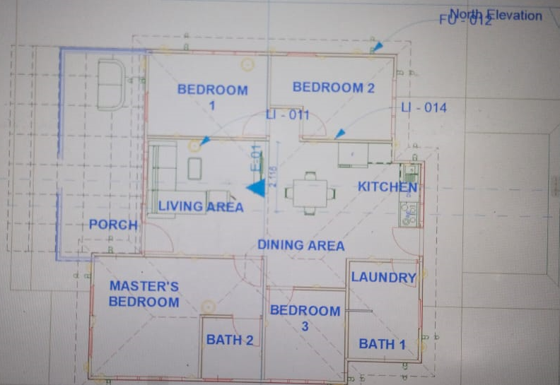 **Fig. 1**

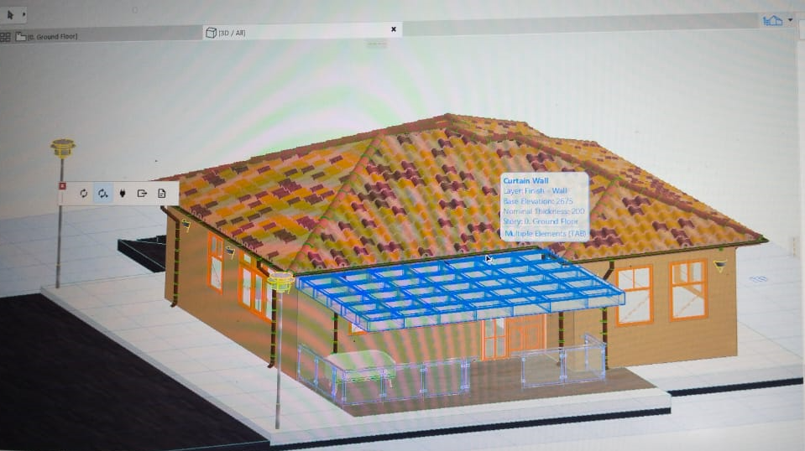 **Fig. 2**

Fig. 1 and Fig. 2 View of the “Mini Smart House” prototype

We created code from the Arduino IDE environment and uploaded it to the Arduino Mega 2560 board. So, we program microcontrollers.

**The Smart Lighting System**

The lighting control subsystem provides convenient switching on and off of the light by using a simple switch. The hardware components of this subsystem are a switch and an LED. An alternative way is to control the lighting from your smartphone. The hardware connection diagram is shown in Fig. 3.

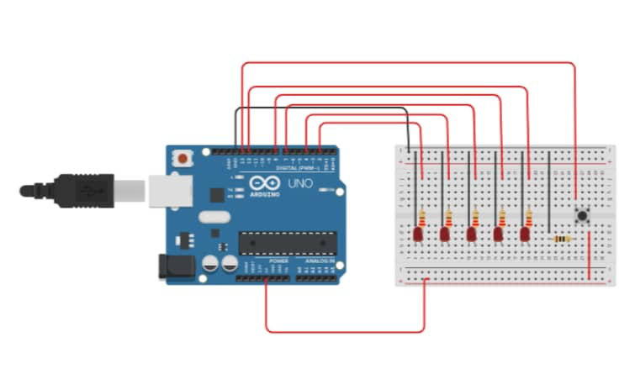Fig 3.

**The Smoke Detection System**

In this subsystem, we have designed **Arduino Smoke Level Detector using MQ-5 Sensor** for measuring the **level of smoke** in the environment. Simply we have interfaced MQ-5 Gas Sensor module with Arduino. Smoke Detectors are very useful in detecting the carbon content of the air in buildings, and so are the important safety parameters.

This circuit triggers the Buzzer when Smoke level becomes higher than the desirable limit, this threshold value can be changed in the code according to the requirement. Instead of MQ-5, you can use **MQ2, MQ3, MQ-135 module** as well. Basically, they all have similar functions.

The hardware connection diagram is shown in Fig. 4.

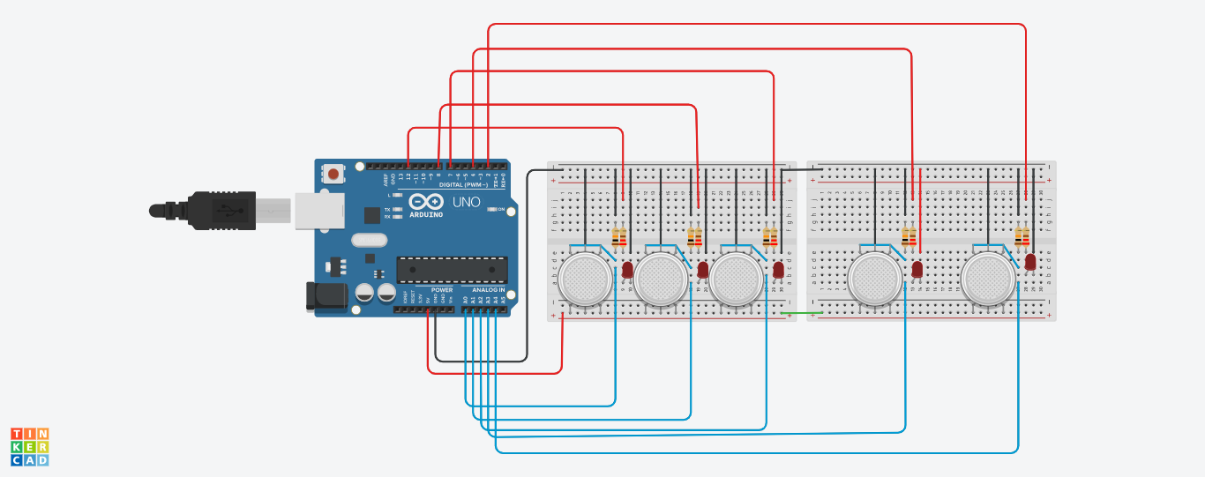 Fig. 4

**The Temperature Sensing and Modulation System**

This subsystem uses a temperature sensor. In our model of smart home implemented the output of sensor data. The corresponding subsystem contains an LCD screen, and a temperature sensor. The scheme of their connection is shown in Fig. 5. Additionally, sensor data is sent in addition to the smartphone.

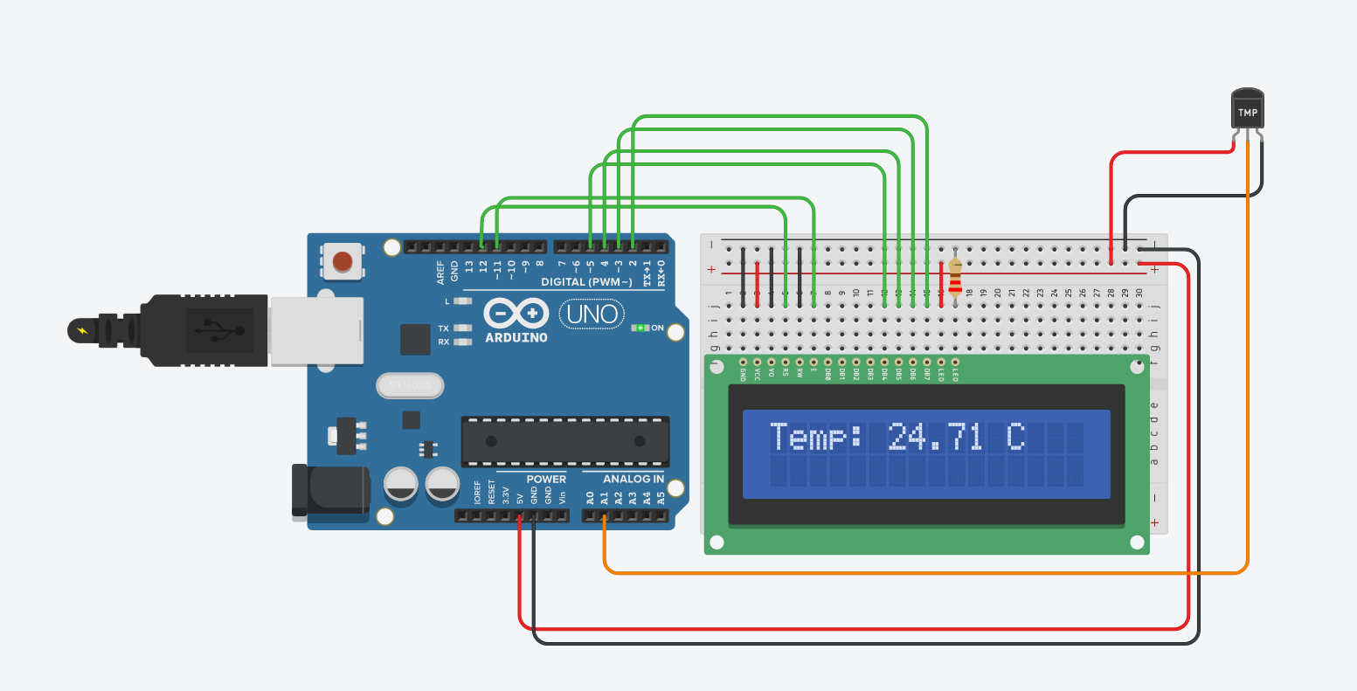Fig. 5

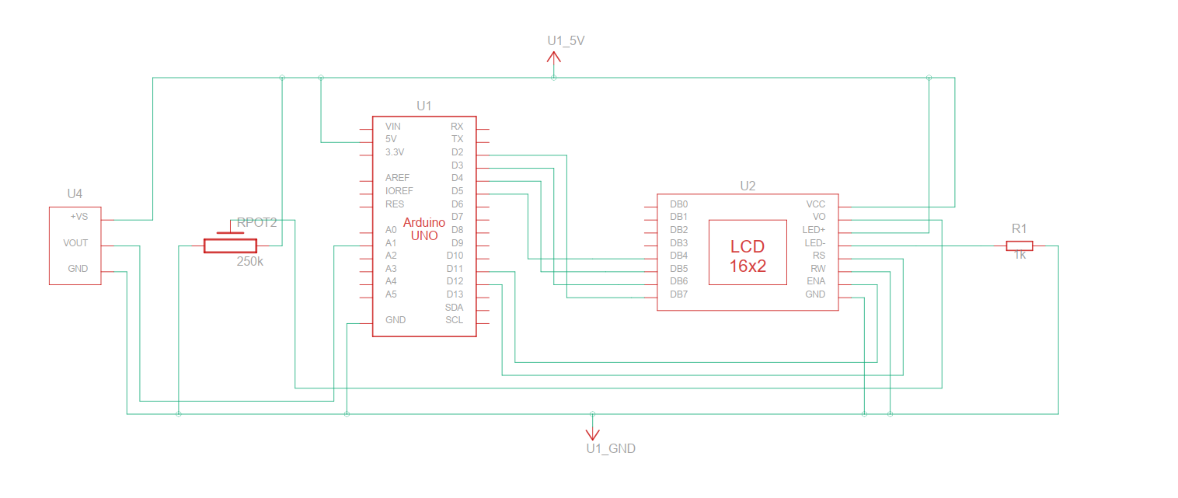Schematic diagram

**The Smart Door System**The objective of this project is to control the opening and closing of a door in a safe and efficient manner. The system utilizes an ultrasonic sensor (HC-SR04) to measure the distance between the door and an individual. The sensor utilizes sound waves to accurately determine this distance. When the distance is within a suitable range, the system sends a signal to a motor to rotate, thereby opening the door. By implementing this system, it will prevent instances of doors being unintentionally left open or closed too forcefully, which can lead to damage. This functionality is achieved through the use of Arduino programming.

The hardware connection diagram is shown in Fig. 6.

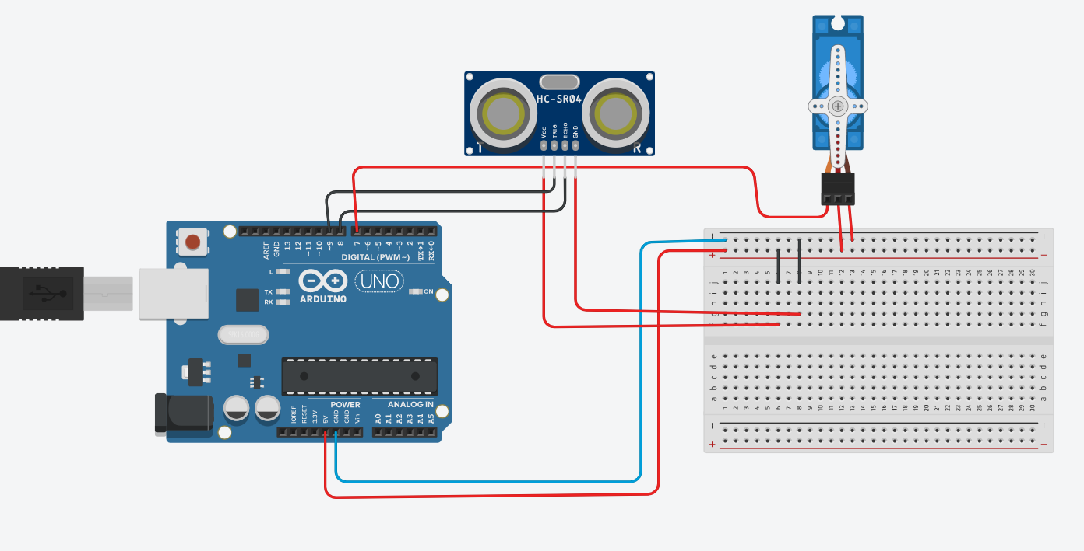

Fig. 6

**FINAL DESIGN**

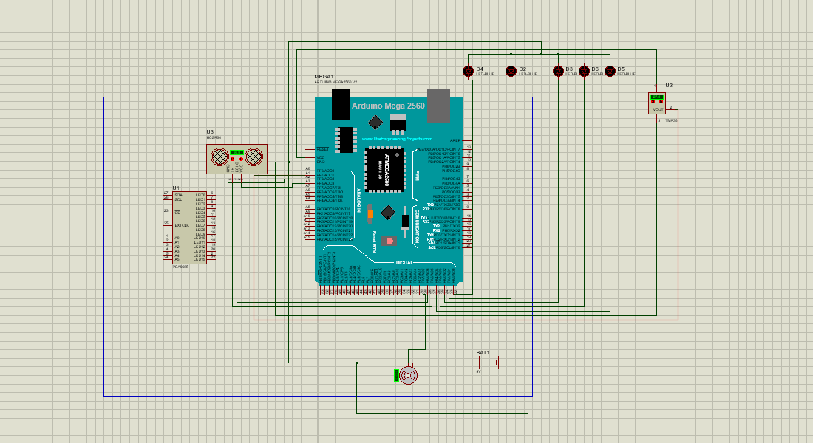

**4. Conclusions**The analysis of the possibilities of modern technologies in education (STEM, Smart, Internet of Things) has given theoretical and methodological basis for the design of the smart home model and development on its basis Mini Smart House.  
We have created a finished product that combines technical, engineering, design  
methods, computer and software engineering (computer networks, C++ programming) and demonstrates practical result. Using the approaches described  
above, we can model relevant processes and implement similar technologies in real  
life. As a result, students can learn a self-created system that provides security,  
comfort, economy and efficiency in managing their own home, scalable and  
customizable, ensuring efficiency in managing smart home technologies.

**REFERENCES**

[1] <https://www.instructables.com/Miniature-Smart-House/> (2015, November 18)

[2] <https://www.electricaltechnology.org/2019/07/smart-home-automation-system.html>

[3] <https://www.mobindustry.net/blog/how-to-build-a-smart-home-app-a-guide-for-developing-a-home-automation-system/> (2022, September 26)

[4] <https://www.makeuseof.com/tag/budget-smart-home-projects/> (2021, July 6)

[5] <https://www.instructables.com/Smart-Home-model/>

[6] <https://all3dp.com/2/arduino-smart-home-project/>

[7] <https://www.instructables.com/How-to-Build-a-Smart-House-Model/> (2016, September 18)