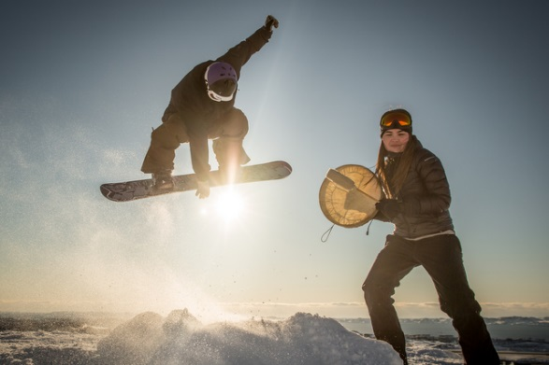
Foreign volunteers
We are happy that so many people from foreign countries wants to volunteer for AWG2016!

Deadline for signing up
Due to the screening procedure, the deadline for registration of foreign volunteer is December 31.

Accommodation
Unfortunately, it is not possible for AWG2016 to provide any financial support to transportation, or cover any costs for living expenses, in connection to voluntary work before, during and after the Games.

Introduction meeting
On March 4 there will be an introduction meeting for volunteers arriving late to AWG2016. At the meeting, important information for volunteers will be shared, and volunteer handbook and volunteer uniform handed out.

Screening procedure
To secure the safety of participants and volunteers, individuals aged 15 years and older who wish to volunteer during the period 29 February – 16 March 2016, must provide written consent for AWG2016 to obtain information regarding child protection certificates and criminal records from the police.
Persons, who want to volunteer in Iqaluit, Kangerlussuaq or Nuuk, who come from other countries than the host countries, and who are not residents in Greenland or Canada (Nunavut), must hand in documents equivalent to child protection certificates and criminal records, from their home countries. It is the responsibility of the foreign volunteer only to hand in records from their home country, and send them to screening@awg2016.gl as soon as possible, and no later than December 31. It is not possible for volunteers from other countries to volunteer for AWG2016 without documenting clean records from their home country.
Processing Personal Data
The AWG2016 secretariat will not proceed the personal data, but only receive a list from an external lawyer with names on persons who can/cannot be recognised as volunteers. Volunteers will only receive feedback on their security clearance if, on the basis of these documents, they are not permitted to take part in the games as a volunteer. Volunteers are considered approved unless they are contacted by the AWG2016 secretariat.

Questions?
Write to volunteer@awg2016.gl.

