REQUEST FOR QUOTATION
1" Scotch-Eye Auger Bit — Custom Manufacturing
PRODUCT SPECIFICATION
Product | 1" Scotch-Eye Auger Bit
Reference | Black Raven Co. design
Material | High Carbon Steel (1075 or equivalent)
Finish | Black Oxide
Type | Single-spur, aggressive lead screw, scotch eye socket
Tolerances | ±0.010" unless otherwise noted
ENGINEERING SCHEMATIC
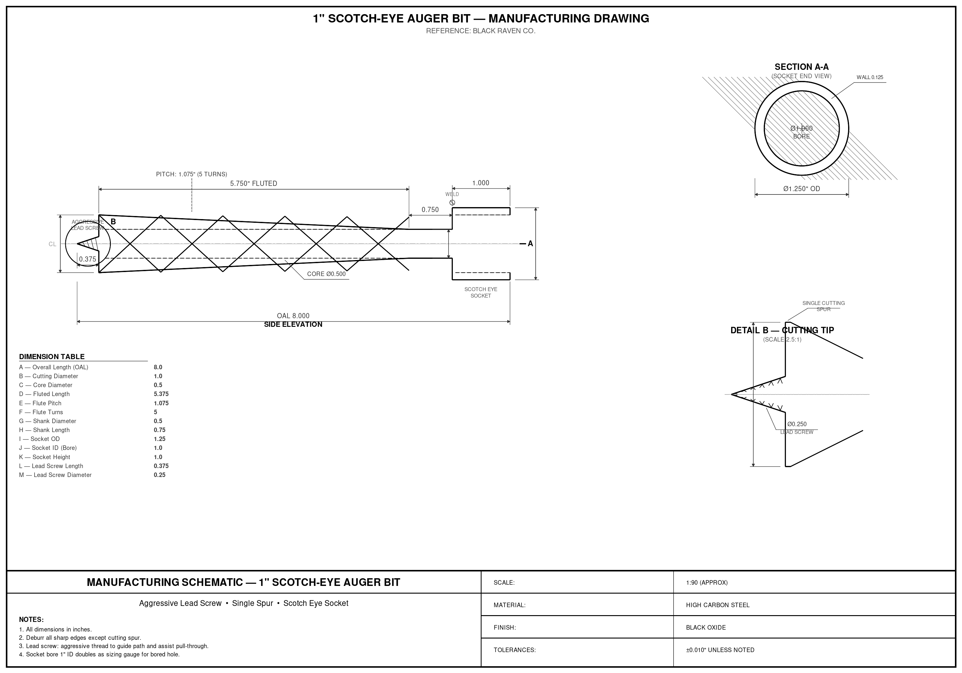
CRITICAL DIMENSIONS
Dimension | Value | Dimension | Value
Overall Length (OAL) | 8.000" | Cutting Diameter | 1.000"
Core Diameter | 0.500" | Fluted Length | 5.375"
Flute Pitch | 1.075" (5 turns) | Shank Diameter | 0.500"
Shank Length | 0.750" | Socket OD | 1.250"
Socket ID (Bore) | 1.000" | Socket Height | 1.000"
Lead Screw Length | 0.375" | Lead Screw Dia. | 0.250"

CONSTRUCTION NOTES
1. Socket (Scotch Eye): Cylindrical hollow socket welded to shank end. 1.250" OD, 1.000" ID bore (0.125" wall). Bore matches cutting diameter so the socket doubles as a sizing gauge for the bored hole. Accepts a hardwood dowel or natural branch for use as a T-handle. Weld must be ground smooth at the shank-to-socket transition.
2. Lead Screw: Aggressive thread at tip. Must guide the auger's path and assist in pulling auger through wood.
3. Cutting Head: Single spur design with one cutting lip. Deburr all edges except the cutting spur and lip, which must remain sharp.
4. Helical Flute: 5 full turns at 1.075" pitch for efficient chip evacuation. Core diameter 0.500" maintained throughout the fluted section.
5. Finish: Black oxide coating on all surfaces for corrosion resistance. No paint or powder coat.
6. Heat Treatment: Through-harden and temper entire piece (excluding socket). Primary use is green/wet wood; optimize for cost of manufacture over maximum edge retention. Socket to be left unhardened or welded on after heat treatment.
REFERENCE PHOTO
Cutting tip and spur detail (1" cutting diameter shown against ruler):
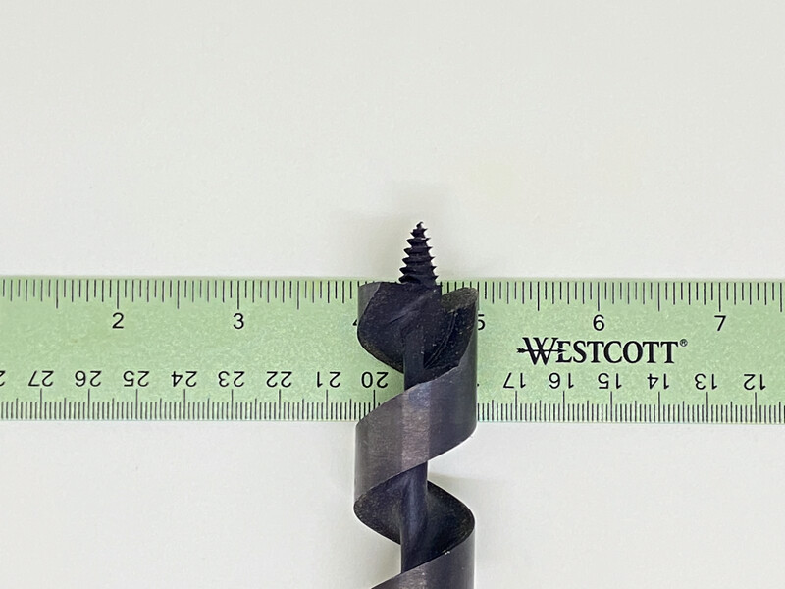
Note: Additional reference photos (full length, oblique view, socket detail) available upon request.
QUOTE REQUESTED FOR
PRICING TIERS
Quantity 1 | Prototype / sample unit
Quantity 50 | Small batch
Quantity 250 | Production run
Quantity 1,000+ | Volume pricing
Lead Time | Please specify per quantity tier
Tooling Costs | If applicable, please itemize separately
Shipping | FOB origin preferred; quote CIF if available

CONTACT INFORMATION
Name | August
Email | claude@kaw.cc
Please include unit pricing, setup/tooling fees, lead times, and any minimum order requirements. Samples may be requested before production order.

