Title | Baseline Radar Menus | Test Case Execution Engineer
Test Case Creation Engineer | William Smith | Test Platform Used
Date Test Case Created | 01/25/2008 | Release Version on Testbed
CI | RD | Logged in User’s Role
Site Specific | N/A | Start Date / Time
TC Updated for Version | AWIPS II | Completion Date/Time
Last Modified By | William Smith 05/28/2015 | Total Test Time
Executable Steps | 35 (unique) + 0 (repeats) = 35 | Pass/Fail/Pending

Test Case: | Baseline Radar Menus
Test Case Description: | Verifies the contents of all of the D-2D radar menus.
Requirements: | N/A
Data Input: | N/A
Prerequisite Conditions: | - This test case also assumes the appropriate radars (e.g., local and terminal) have been added to the D2D menu bar and that data for each radar product has been ingested and is available for display.  It is important that ad hoc testing of the radar products be performed during this test case (i.e. load the products in D-2D and verify that the products auto-update and that the information in the upper left of the main pane are consistent with the displayed product).  NOTE: Go directly to table 1.1-3 to see the results of the radar testing. The table reflects these steps but is broken out.

Table 1.1-1. Test Steps and Expected Results
Step # | Actions / Inputs | Expected Results | P/F | Comments
 | Open a terminal window and log on to the Radar server:  - ssh dx1f | Logged in on the Radar server.
 | On the Radar server verify that the radar processes are running by typing:  - ps –ef | grep -i radar | grep –v grep | The Radar server is running.
 | Verify that log files are being created for the Radar processes.  - cd /awips2/rcm/data/logs  - ls -trl *log | Log files exist for the Radar processes.
 | Exit from the dx1 server and close the terminal window. | User is logged off from dx1.
 | Open a D-2D session in Cave. | Cave is opened.
 | On a D-2D graphics display, select one of the kxxx dedicated radar menus. The menu should look similar to the image below. Verify against Table 1.  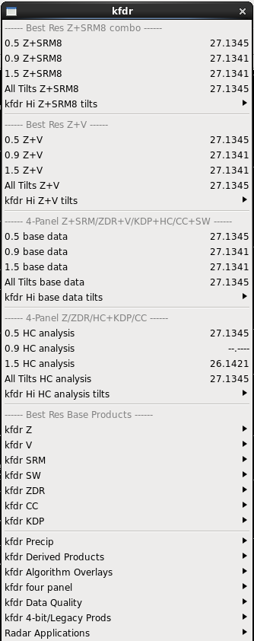 | The menu is as expected.
 | On a D-2D graphics display, select one of the kxxx dedicated radar menus. Then select the kxxx 4 Bit/Legacy Prods menu. The menu should look similar to the image below. Verify against Table 1.  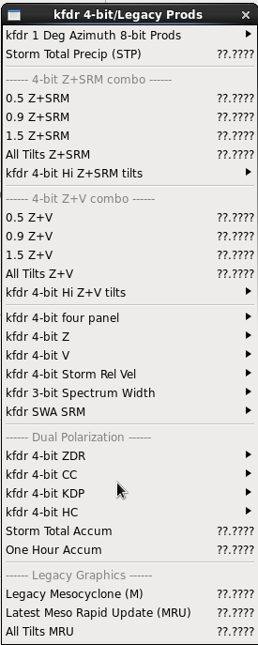 | The menu is as expected.
 | On a D-2D graphics display, select one of the kxxx dedicated radar menus. Then select the kxxx 4 Bit/Legacy Prods menu. Then select the kxxx 4-bit four panel menu. The menu should look similar to the image below. Verify against Table 1.  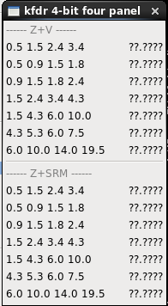 | The menu is as expected.
 | On a D-2D graphics display, select one of the kxxx dedicated radar menus. Then select the kxxx four panel menu. The menu should look similar to the image below. Verify against Table 1.  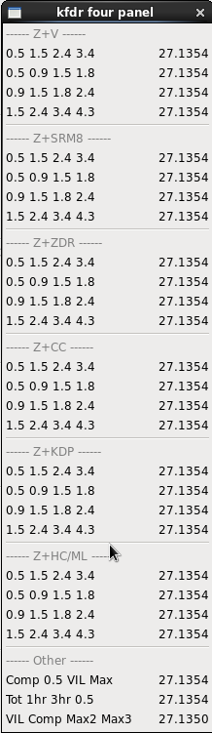 | The menu is as expected.
 | On a D-2D graphics display, select one of the kxxx dedicated radar menus. Then select the kxxx Precip menu. The menu should look similar to the image below. Verify against Table 1.  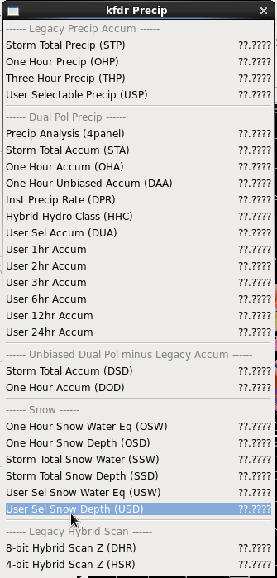 | The menu is as expected.
 | On a D-2D graphics display, select one of the kxxx dedicated radar menus. Then select the kxxx Derived Products menu. The menu should look similar to the image below. Verify against Table 1.  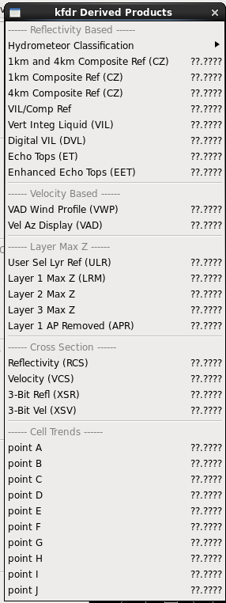 | The menu is as expected.
 | On a D-2D graphics display, select one of the kxxx dedicated radar menus. Then select the kxxx Algorithms Overlays menu. The menu should look similar to the image below. Verify against Table 1.  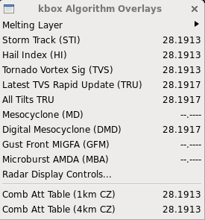 | The menu is as expected.
 | On a D-2D graphics display, select one of the kxxx dedicated radar menus. Then select the kxxx Data Quality menu. The menu should look similar to the image below. Verify against Table 1.  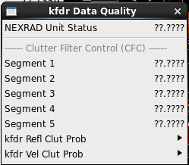 | The menu is as expected.
 | On a D-2D graphics display, select one of the txxx dedicated radar menus. The menu should look similar to the image below. Verify against Table 1.  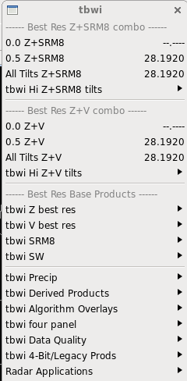 | The menu is as expected.
 | On a D-2D graphics display, select one of the txxx dedicated radar menus. Then select the txxx four panel menu. The menu should look similar to the image below. Verify against Table 1. Note that this table only populates the data that is available so there might be more than what was captured here.  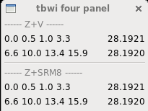 | The menu is as expected.
 | On a D-2D graphics display, select one of the txxx dedicated radar menus. Then select the txxx Derived Products menu. The menu should look similar to the image below. Verify against Table 1.  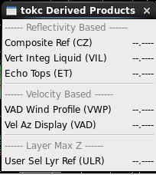 | The menu is as expected.
 | On a D-2D graphics display, select one of the kxxx dedicated radar menus. Then select One Time Request… (under Applications). Click on the Product: pull-down menu. The menu should look similar to the image below. Verify against Table 1.  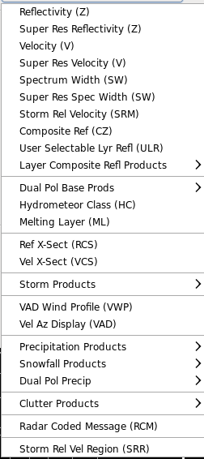 | The menu is as expected.
 | On a D-2D graphics display, select one of the kxxx dedicated radar menus. Then select One Time Request… (under Applications). Click on the Product: pull-down menu and select the Storm Products sub-menu. The menu should look similar to the image below. Verify against Table 1.  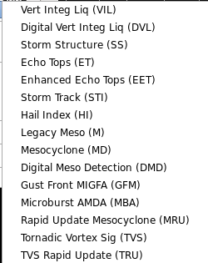 | The menu is as expected.
 | On a D-2D graphics display, select one of the kxxx dedicated radar menus. Then select One Time Request… (under Applications). Click on the Product: pull-down menu and select the Precipitation Products sub-menu. The menu should look similar to the image below. Verify against Table 1.  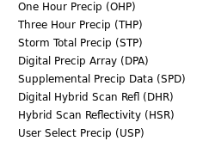 | The menu is as expected.
 | On a D-2D graphics display, select one of the kxxx dedicated radar menus. Then select One Time Request… (under Applications). Click on the Product: pull-down menu and select the Snowfall Products sub-menu. The menu should look similar to the image below. Verify against Table 1.  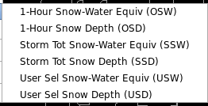 | The menu is as expected.
 | On a D-2D graphics display, select one of the kxxx dedicated radar menus. Then select One Time Request… (under Applications). Click on the Product: pull-down menu and select the Clutter Products sub-menu. The menu should look similar to the image below. Verify against Table 1.  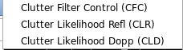 | The menu is as expected.
 | On a D-2D graphics display, select one of the kxxx dedicated radar menus. Then select One Time Request… (under Applications). Select a TDWR radar (e.g. TBWI) from the RPG: pull-down menu. Click on the Product: pull-down menu.The menu should look similar to the image below. Verify against Table 1.  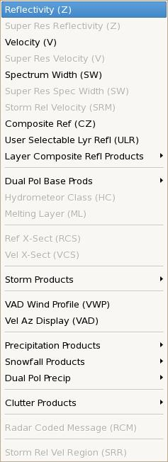 | The menu is as expected.
 | On a D-2D graphics display, select one of the kxxx dedicated radar menus. Then select Radar Multiple Request… (under Applications). Select an existing request or create a new request. Click on the Add Products button. Then click on the Products: pull-down menu. The menu should look similar to the image below. Verify against Table 1.  Note: If an existing request does not exist, create a new request and edit.  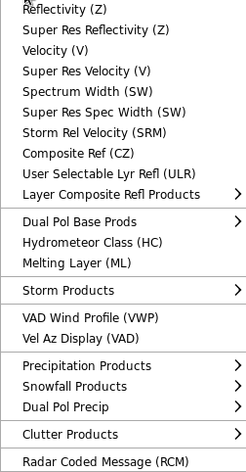 | The menu is as expected.
 | On a D-2D graphics display, select one of the kxxx dedicated radar menus. Then select Radar Multiple Request… (under Applications). Click on the Add Products button. Then click on the Products: pull-down menu. Then click on the Storm Products sub-menu. The menu should look similar to the image below. Verify against Table 1.  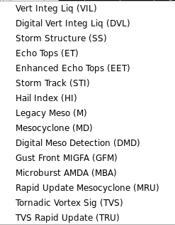 | The menu is as expected.
 | On a D-2D graphics display, select one of the kxxx dedicated radar menus. Then select Radar Multiple Request… (under Applications). Click on the Add Products button. Then click on the Products: pull-down menu. Then click on the Precipitation Products sub-menu. The menu should look similar to the image below. Verify against Table 1.  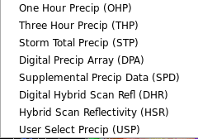 | The menu is as expected.
 | On a D-2D graphics display, select one of the kxxx dedicated radar menus. Then select Radar Multiple Request… (under Applications). Click on the Add Products button. Then click on the Products: pull-down menu. Then click on the Snowfall Products sub-menu. The menu should look similar to the image below. Verify against Table 1.  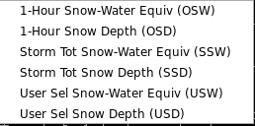 | The menu is as expected.
 | On a D-2D graphics display, select one of the kxxx dedicated radar menus. Then select Radar Multiple Request… (under Applications). Click on the Add Products button. Then click on the Products: pull-down menu. Then click on the Clutter Products sub-menu. The menu should look similar to the image below. Verify against Table 1.  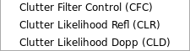 | The menu is as expected.
 | On a D-2D graphics display, select one of the kxxx dedicated radar menus. Then select the RPS List Editor (under Applications). Click on the Add button. Then click on the Products: pull-down menu. The menu should look similar to the image below. Verify against Table 1.  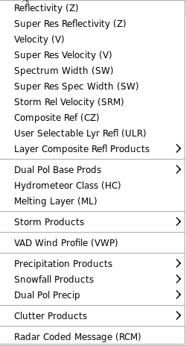 | The menu is as expected.
 | On a D-2D graphics display, select one of the kxxx dedicated radar menus. Then select the RPS List Editor (under Applications). Click on the Add button. Then click on the Products: pull-down menu. Then select the Storm Products submenu. The menu should look similar to the image below. Verify against Table 1.  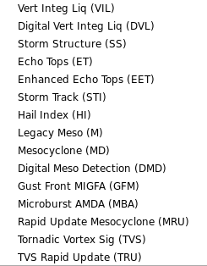 | The menu is as expected.
 | On a D-2D graphics display, select one of the kxxx dedicated radar menus. Then select the RPS List Editor (under Applications). Click on the Add button. Then click on the Products: pull-down menu. Then select the Precipitation Products submenu. The menu should look similar to the image below. Verify against Table 1.  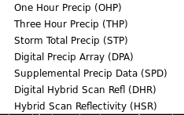 | The menu is as expected.
 | On a D-2D graphics display, select one of the kxxx dedicated radar menus. Then select the RPS List Editor (under Applications). Click on the Add button. Then click on the Products: pull-down menu. Then select the Snowfall Products submenu. The menu should look similar to the image below. Verify against Table 1.  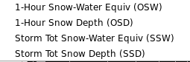 | The menu is as expected.
 | On a D-2D graphics display, select one of the kxxx dedicated radar menus. Then select the RPS List Editor (under Applications). Click on the Add button. Then click on the Products: pull-down menu. Then select the Clutter Products submenu. The menu should look similar to the image below. Verify against Table 1.  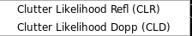 | The menu is as expected.
 | In the D2D perspective, from one of radar menus, load a 4 panel blended product(Such as Z/SRM on multiple tilts)  Toggle the left product off  Sample and verify that values are shown for both products  Change frames and verify that the sampled data updates for both products. | Values are shown for both products, and the sampled data updates for both products.
 | Load each of the products from Table 1.1-3 below, and make sure each product auto-updates and that the information in the upper left of the main D-2D pane is consistent with the loaded product. | All products auto-update and the upper left information (VCP mode and colorbar) are consistent.  NOTE: Some products may not auto-update if they are not on the RPS list. You may need to utilize the OTR or RMR to request any products that are not available. |  | DR 12774
 | Close all windows and log out. | All windows close.
The test case is completed.

- If requirements are attached to the test cases, then maintain them together. A reference can be made to Table 1.1-1.

Table 1.1-2. Requirements Verification Traceability Matrix (RVTM)
Number | Description | Test Step (s)
1 | N/A

Table 1.1-3: List of radar products from the MDM (modified from it’s original version)
Products/Buttons | Available Y/N | Display P/F | Comments
kxxx
kxxx 4 Bit/Legacy Prods
Storm Total Precip (STP)
4 bit Z/SRM Combo
0.5 Z/SRM
0.9 Z/SRM
1.5 Z/SRM
All Tilts Z/SRM
kxxx 4 bit Hi Z/SRM tilts
1.8 Z/SRM
2.4 Z/SRM
3.4 Z/SRM
4.3 Z/SRM
5.3 Z/SRM
6.0 Z/SRM
7.5 Z/SRM
8.7 Z/SRM
10.0 Z/SRM
12.0 Z/SRM
14.0 Z/SRM
16.7 Z/SRM
19.5 Z/SRM
4 bit Z/V Combo
0.5 Z/V
0.9 Z/V
1.5 Z/V
All Tilts Z/V
kxxx 4 bit Hi Z/V tilts
1.8 Z/V
2.4 Z/V
3.4 Z/V
4.3 Z/V
5.3 Z/V
6.0 Z/V
7.5 Z/V
8.7 Z/V
10.0 Z/V
12.0 Z/V
14.0 Z/V
16.7 Z/V
19.5 Z/V
kxxx 4 bit four panel
Z/V
0.5 1.5 2.4 3.4
0.5 0.9 1.5 1.8
0.9 1.5 1.8 2.4
1.5 2.4 3.4 4.3
1.5 4.3 6.0 10.0
4.3 5.3 6.0 7.5
6.0 10.0 14.0 19.5
Z/SRM
0.5 1.5 2.4 3.4
0.5 0.9 1.5 1.8
0.9 1.5 1.8 2.4
1.5 2.4 3.4 4.3
1.5 4.3 6.0 10.0
4.3 5.3 6.0 7.5
6.0 10.0 14.0 19.5
kxxx 4 bit Reflectivity
0.5 Refl
0.9 Refl
1.5 Refl
1.8 Refl
2.4 Refl
3.4 Refl
4.3 Refl
5.3 Refl
6.0 Refl
7.5 Refl
8.7 Refl
10.0 Refl
12.0 Refl
14.0 Refl
16.7 Refl
19.5 Refl
kxxx 4 bit Velocity
0.5 Vel
0.9 Vel
1.5 Vel
1.8 Vel
2.4 Vel
3.4 Vel
4.3 Vel
5.3 Vel
6.0 Vel
7.5 Vel
8.7 Vel
10.0 Vel
12.0 Vel
14.0 Vel
16.7 Vel
19.5 Vel
kxxx 3 bit Spectrum Width
0.5 Spec Width
0.9 Spec Width
1.5 Spec Width
1.8 Spec Width
2.4 Spec Width
3.4 Spec Width
4.3 Spec Width
5.3 Spec Width
6.0 Spec Width
7.5 Spec Width
8.7 Spec Width
10.0 Spec Width
12.0 Spec Width
14.0 Spec Width
16.7 Spec Width
19.5 Spec Width
kxxx 4 bit SWA SRM
0.5 SRM
0.9 SRM
1.5 SRM
1.8 SRM
2.4 SRM
3.4 SRM
4.3 SRM
5.3 SRM
6.0 SRM
7.5 SRM
8.7 SRM
10.0 SRM
12.0 SRM
14.0 SRM
16.7 SRM
19.5 SRM
Legacy Graphics
Legacy Mesocyclone
Latest Meso Rapid Update
All Tilts MRU
Composite Ref (CZ)
Best Res Z/SRM8:
0.5 Z/SRM8
0.9 Z/SRM8
1.5 Z/SRM8
All Tilts Z/SRM8
koax Hi Z/SRM8 tilts
1.8 Z/SRM
2.4 Z/SRM
3.4 Z/SRM
4.3 Z/SRM
5.3 Z/SRM
6.0 Z/SRM
7.5 Z/SRM
8.7 Z/SRM
10.0 Z/SRM
12.0 Z/SRM
14.0 Z/SRM
16.7 Z/SRM
19.5 Z/SRM
Best Res Z/V:
0.5 Z/V
0.9 Z/V
1.5 Z/V
All Tilts Z/V
kxxx Hi Z/V tilts
1.8 Z/V
2.4 Z/V
3.4 Z/V
4.3 Z/V
5.3 Z/V
6.0 Z/V
7.5 Z/V
8.7 Z/V
10.0 Z/V
12.0 Z/V
14.0 Z/V
16.7 Z/V
19.5 Z/V
kxxx four panel
Best Res Z/V
0.5 1.5 2.4 3.4
0.5 0.9 1.5 1.8
0.9 1.5 1.8 2.4
1.5 2.4 3.4 4.3
Best Res Z/SRM8
0.5 1.5 2.4 3.4
0.5 0.9 1.5 1.8
0.9 1.5 1.8 2.4
1.5 2.4 3.4 4.3
Z+ZDR
0.5 1.5 2.4 3.4
0.5 0.9 1.5 1.8
0.9 1.5 1.8 2.4
1.5 2.4 3.4 4.3
Z+CC
0.5 1.5 2.4 3.4
0.5 0.9 1.5 1.8
0.9 1.5 1.8 2.4
1.5 2.4 3.4 4.3
Z+KDP
0.5 1.5 2.4 3.4
0.5 0.9 1.5 1.8
0.9 1.5 1.8 2.4
1.5 2.4 3.4 4.3
Z+HC/ML
0.5 1.5 2.4 3.4
0.5 0.9 1.5 1.8
0.9 1.5 1.8 2.4
1.5 2.4 3.4 4.3
Comp 0.5 Vil Max
Tot 1hr 3hr 0.5
VIL Comp Max2 Max3
kxxx Best Res Refl
0.5 Refl
0.9 Refl
1.5 Refl
1.8 Refl
2.4 Refl
3.4 Refl
4.3 Refl
5.3 Refl
6.0 Refl
7.5 Refl
8.7 Refl
10.0 Refl
12.0 Refl
14.0 Refl
16.7 Refl
19.5 Refl
Refl (All)
kxxx Best Res Vel
0.5 Vel
0.9 Vel
1.5 Vel
1.8 Vel
2.4 Vel
3.4 Vel
4.3 Vel
5.3 Vel
6.0 Vel
7.5 Vel
8.7 Vel
10.0 Vel
12.0 Vel
14.0 Vel
16.7 Vel
19.5 Vel
Vel (All)
kxxx Precip
Storm Total Precip
One Hour Precip
Three Hour Precip
User Selectable Precip
Snow products
One Hour Snow Water Eq (OSW)
One Hour Snow Depth (OSD)
Storm Total Snow Water (SSW)
Storm Total Snow Depth (SSD)
User Select Snow Water Eq (USW)
User Select Snow Depth (USD)
Hybrid Scan products
Hybrid Scan Refl (DHR)
4-bit Hyb Scan Refl (HSR)
kxxx Derived
Layer Max Refl
Layer Max Refl (APR)
User Sel Lyr Ref (ULR)
Layer 1 Max Refl (LRM)
Layer 2 Max Refl
Layer 3 Max Refl
Cross section
Reflectivity (RCS)
Velocity (VCS)
3-bit Refl (XSR)
3-bit Vel (XSV)
Other products
Vert Integ Liquid (VIL)
Digital VIL (DVL)
VIL/Comp Ref
1km Composite Ref (CZ)
4km Composite Ref (CZ)
Echo Tops
Enhanced Echo Tops
kxxx Algorithm Overlays
Storm Track (STI)
Hail Index (HI)
Tornado Vortex Sig (TVS)
TVS Rapid Update (TRU)
All Tilts TRU
Mesocyclone (MD)
Digital Mesocyclone (DMD)
Comb Att Table (1 km CZ)
Comb Att Table (4 km CZ)
Velocity Azimuth Display (VAD)
VWP products
Cell Trends (Points A-J)
kxxx Best Res (8-bit) SRM
0.5 SRM
0.9 SRM
1.5 SRM
1.8 SRM
2.4 SRM
3.4 SRM
4.3 SRM
5.3 SRM
6.0 SRM
7.5 SRM
8.7 SRM
10.0 SRM
12.0 SRM
14.0 SRM
16.7 SRM
19.5 SRM
SRM (All)
kxxx Best Res Spec Width
0.5 Spec Width
0.9 Spec Width
1.5 Spec Width
1.8 Spec Width
2.4 Spec Width
3.4 Spec Width
4.3 Spec Width
5.3 Spec Width
6.0 Spec Width
7.5 Spec Width
8.7 Spec Width
10.0 Spec Width
12.0 Spec Width
14.0 Spec Width
16.7 Spec Width
19.5 Spec Width
Spec Width (All)
kxxx Data Quality
Nexrad Unit Status
Clutter Filter Control (CFC)
Segment 1
Segment 2
Segment 3
Segment 4
Segment 5
kxxx Refl Clut Prob
0.5 (CLR)
0.9 (CLR)
1.5 (CLR)
1.8 (CLR)
2.4 (CLR)
3.4 (CLR)
4.3 (CLR)
5.3 (CLR)
6.0 (CLR)
7.5 (CLR)
8.7 (CLR)
10.0 (CLR)
12.0 (CLR)
14.0 (CLR)
16.7 (CLR)
19.5 (CLR)
kxxx Vel Clut Prob
0.5 (CLD)
0.9 (CLD)
1.5 (CLD)
1.8 (CLD)
2.4 (CLD)
3.4 (CLD)
4.3 (CLD)
5.3 (CLD)
6.0 (CLD)
7.5 (CLD)
8.7 (CLD)
10.0 (CLD)
12.0 (CLD)
14.0 (CLD)
16.7 (CLD)
19.5 (CLD)
Applications:
Alert Request...
Alert Request dialog window
Add
Category: 1 Grid Velocity
Threshold : 1 15kt
Request Product: Yes/No
Remove
RPG:
Clear
Alert Area #1
Alert Area #2
Category, Threshold, Code & Request Product Flag:
Send Request
Revert
Load/Edit Area
Exit
One Time Request...
Repeat count:
RPG:
Product:
Reflectivity (Z)
Super Res Reflectivity (Z)
Velocity (V)
Super Res Velocity (V)
Spectrum Width (SW)
Super Res Spectrum Width (SW)
Storm Rel Velocity (SRM)
Composite Ref (CZ)
User Selectable Lyr Refl (ULR)
Layer Composite Refl Products
Lyr Comp Ref Max (LRM)
Lyr Comp Ref Max (APR)
Dual Base Prods
Differential Refl (ZDR)
Correlation Coeff (CC)
Specific Diff Phase (KDP)
Hydrometeor Class (HC)
Melting Layer (ML)
Ref X-Sect (RCS)
Vel X-Sect (VCS)
Storm Products
Vert Integ Liq (VIL)
Digital Vert Integ Liq (DVL)
Storm Structure (SS)
Echo Tops (ET)
Enhanced Echo Tops (EET)
Severe Wx Prob (SWP)
Storm Track (STI)
Hail Index (HI)
Legacy Meso (M)
Mesocyclone (MD)
Digital Meso Detection (DMD)
Rapid Update Mesocyclone (MRU)
Tornadic Vortex Sig (TVS)
TVS Rapid Update (TRU)
Combined Shear (CS)
VAD Wind Profile (VWP)
Vel Az Display (VAD)
Precipitation Products
One Hour Precip (OHP)
Three Hour Precip (THP)
Storm Total Precip (STP)
Digital Precip Array (DPA)
Supplemental Precip Data (SPD)
Digital Hybrid Scan Refl (DHR)
Hybrid Scan Reflectivity (HSR)
User Select Precip (USP)
Snowfall Products
1-Hour Snow-Water Equiv (OSW)
1-Hour Snow Depth (OSD)
Storm Tot Snow-Water Equiv (SSW)
Storm Tot Snow Depth (SSD)
User Sel Snow-Water Equiv (USW)
User Sel Snow Depth (USD)
Dual Pol Precip
Digital Inst Precip Rate (DPR)
Hybrid Hydrometeor Class (HHC)
One Hour Accum (OHA)
One Hour Unbiased Accum (DAA)
Storm Total Accum (STA)
User Select Accum (DUA)
One Hour Diff (DOD)
Storm Total Diff (DSD)
Clutter Products
Clutter Filter Control (CFC)
Clutter Likelihood Refl (CLR)
Clutter Likelihood Dopp (CLD)
Radar Coded Message (RCM)
Priority
Request Interval:
Elevation:
Data levels:
Resolution:
Baseline:
Load Baselines:
Point:
Load Points:
OTR Dialog Midsection Control Group
OTR Midsection Control Group for Reflectivity
Priority
Request Interval
Elevation(s):
All
All at or below:
Unlabeled selection list
Lowest n
Unlabeled slider
Selected
Unlabeled selection list
Data levels:
Resolution:
OTR Midsection Control Group for User Selectable Lyr Refl
Priority
Request Interval
Top of Layer
Bottom of Layer
OTR Midsection Control Group for Lyr Comp Ref Max
Priority
Request Interval
Layer:
OTR Midsection Control Group for Ref X-Sect
Priority
Request Interval
Data levels
Baseline:
Load Baselines
Length:
Az/Ran:
OTR Midsection Control Group for User Select Precip
Priority
Request Interval
End hour:
Most recent
Selected
Unlabeled slider
Time span (hours):
OTR Midsection Control Group for Storm Rel Vel Region
Priority
Request Interval
Elevation(s):
All
All at or below:
Unlabeled selection list
Lowest n
Unlabeled slider
Selected
Unlabeled selection list
Point
Azimuth
Range
Load Points
Use storm closest to window center
Speed (kt) - Used for Dedicated RPGs Only
Direction (deg) - Used for Dedicated RPGs Only
Time:
Current
Latest
Selected
Selected time:
Change...
Radar Multiple Request...
Radar Multiple Request (RMR)
Existing Requests
New Request
Name:
Single request
Multiple request
Repeat every:
Duration:
OK
Cancel
Copy Request
Add Products
Radar Type:
Dial RPGs:
Dedicated RPGs:
Product::
Request Interval
Elevation:
Resolution:
product parameter controls for User Selectable Lyr Refl
Request Interval
Top of Layer
Bottom of Layer
product parameter controls for User Sel Snow-Water Equiv
Request Interval
Most recent
Selected
Time span (hours):
Edit...
Edit Request
Name:
Single request
Multiple request
Repeat every:
Unlabeled selection list
Duration:
Unlabeled selection list
OK
Cancel
Delete...
Radar Multiple Request
Yes
No
Submit
Active Requests
Cancel
RPS List Editor…
RPS List Editor
File:
New…
Open…
Save
Save as…
Exit
List:
Add Product…
Edit Product
Remove Product
Send List…
Send and Store List…
View:
Current List
Clear Air Lists
Storm Mode Lists
Add:
Edit:
Remove:
Send:
Radar Tools
Estimated Actual Velocity
4-D Storm Investigator
D2D Tools
Radar Display Controls
Num storms to show STI
Type of track to show
HI POH
HI POSH
Show elevated TVS
Show extrapolated Features DMD MD TVS
Min feature strength,
Show overlapping Mesos
Type of track to show
Storm Motion from WarnGen Track
Average Storm Motion from STI
Custom Storm Motion
Dir
Spd
VR-Shear
txxx
Z/SRM8 combo:
0.5 Z/SRM8
1.0 Z/SRM8
All Tilts Z/SRM8
txxx Hi Z/SRM8 tilts
3.3 Z/SRM8
6.6 Z/SRM8
10.0 Z/SRM8
13.4 Z/SRM8
15.9 Z/SRM8
19.4 Z/SRM8
25.7 Z/SRM8
28.1 Z/SRM8
35.5 Z/SRM8
42.0 Z/SRM8
45.3 Z/SRM8
50.2 Z/SRM8
55.1 Z/SRM8
60.0 Z/SRM8
Z/V combo:
0.5 Z/V
1.0 Z/V
All Tilts Z/V
txxx Hi Z/V tilts
3.3 Z/V
6.6 Z/V
10.0 Z/V
13.4 Z/V
15.9 Z/V
19.4 Z/V
25.7 Z/V
28.1 Z/V
35.5 Z/V
42.0 Z/V
45.3 Z/V
50.2 Z/V
55.1 Z/V
60.0 Z/V
txxx four panel
Z/V
0.5 1.0 3.3 6.6
0.5 1.5 2.4 3.3
0.5 1.0 1.5 1.8
1.5 4.3 6.6 10.0
6.6 10.0 13.4 19.4
Z/SRM
0.5 1.0 3.3 6.6
0.5 1.5 2.4 3.3
0.5 1.0 1.5 1.8
1.5 4.3 6.6 10.0
6.6 10.0 13.4 19.4
txxx Refl
Long Rng Refl
0.5 Refl
1.0 Refl
3.3 Refl
6.6 Refl
10.0 Refl
13.4 Refl
15.9 Refl
19.4 Refl
25.7 Refl
28.1 Refl
35.5 Refl
42.0 Refl
45.3 Refl
50.2 Refl
55.1 Refl
60.0 Refl
Refl (All)
txxx Vel
Long Rng Vel
0.5 Vel
1.0 Vel
3.3 Vel
6.6 Vel
10.0 Vel
13.4 Vel
15.9 Vel
19.4 Vel
25.7 Vel
28.1 Vel
35.5 Vel
42.0 Vel
45.3 Vel
50.2 Vel
55.1 Vel
60.0 Vel
Vel (All)
txxx Precip
Precip
Storm Total Precip
4 bit Storm Total Precip (STP)
One Hour Precip (OHD)
Three Hour Precip (THP)
User Selectable Precip (USP)
Hybrid Scan
Hybrid Scan Refl (DHR)
4-bit Hyb Scan Refl (HSR)
txxx Storm Products
Vert Integ Liquid (VIL)
Echo Tops (ET)
Storm Track (STI)
Hail Inded (HI)
Tornado Vortex Sig (TVS)
Mesocyclone (MD)
Digital Mesocyclone (DMD)
Comb Att Table (CZ)
txxx High Res (8-bit) SRM
0.5 SRM8
1.0 SRM8
3.3 SRM8
6.6 SRM8
10.0 SRM8
13.4 SRM8
15.9 SRM8
19.4 SRM8
25.7 SRM8
28.1 SRM8
35.5 SRM8
42.0 SRM8
45.3 SRM8
50.2 SRM8
55.1 SRM8
60.0 SRM8
SRM8 (All)
txxx Spectrum Width
0.5 Spec Width
1.0 Spec Width
3.3 Spec Width
6.6 Spec Width
10.0 Spec Width
13.4 Spec Width
15.9 Spec Width
19.4 Spec Width
25.7 Spec Width
28.1 Spec Width
35.5 Spec Width
42.0 Spec Width
45.3 Spec Width
50.2 Spec Width
55.1 Spec Width
60.0 Spec Width
Composite Ref (CZ)
User Sel Lyr Ref (ULR)
VAD Wind Profile (VWP)
Vel Az Display (VAD)
TDWR SPG Unit Status
Applications:
Alert Request
One Time Request...
Radar Multiple Request...
RPS List Editor...
Radar Server Configuration…
VR Shear
Snapping VR Shear
VR Shear in 4 Panel
Radar
10km Radar Coded Msg
NOWrad
Home/88D
Home
ASR-11 Radars
Reflectivity
ASR-11 Unit Status
ARSR-4 Radars
ARSR-4 Unit Status
Mosaic:
0.5 Reflectivity
Hybrid Scan Refl
Composite Refl
VIL/Composite Refl
Vert Integrated Liquid
Storm Total Precip
One Hour Precip
Three Hour Precip
User Selectable Precip
Layer 1 Max Refl
Layer 2 Max Refl
Layer 3 Max Refl
Echo Tops
Hybrid Hydro Class
Dual Pol Storm Total
Dual Pol 1hr Accum
Dial Radars:
kxxx dial radar
kxxx 4 Bit/Legacy Prods
Comp Ref 4 bit (CZ)
Storm Total Precip (STP)
Applications:
Alert Request...
One Time Request...
Radar Multiple Request...
RPS List Editor...
Radar Tools
Estimated Actual Velocity
4-D Storm Investigator
Radar Display Controls...
VR-Shear

