Title | Baseline NPOESS Preparatory Project | Test Case Execution Engineer
Test Case Creation Engineer | William Smith | Test Platform Used
Date Test Case Created | 12/14/2012 | Release Version on Testbed
CI | D2D | Logged in User’s Role
Site Specific | N/A | Start Date / Time
TC Updated for Version | AWIPS II | Completion Date/Time
Last Modified By | William Smith – 03/27/2015 | Total Test Time
Executable Steps | 119 (unique) + 00 (repeats) = 119 | Pass/Fail/Pending

Test Case: | Baseline NPOESS Preparatory Project
Test Case Description: | This test case demonstrates the ability to process and display NPP test products in the D2D Perspective during the NPP Phase2 tests.
Requirements: | - These objectives are taken from the Environmental Satellite NPP Testing WA 13.1 document.  - Test procedures describe the steps that will be taken in AWIPS II to:  Objective 1: confirm the receipt of NPP imagery  Objective 2: ingest NPP imagery  Objective 3: decode NPP imagery  Objective 4: confirm the receipt of NPP NUCAPS Sounding  Objective 5: ingest NPP NUCAPS Sounding  Objective 6: decode NPP NUCAPS Sounding  Objective 7: store of NPP VIIRS Imagery  Objective 8: store of NPP NUCAPS Sounding  Objective 9: display NPP imagery  Objective 10: display NPP NUCAPS Sounding product  Objective 11: purge NPP imagery  Objectives 1 to 6 objectives are all demonstrated by examining the ingest log file.
Data Input: | - Live NPP data should be flowing into the system within the parameters defined under the Assumptions and Constraints  - If live data is not flowing into the system, drop canned data into the manual end-point.  - Note: This may require modifying the purge rule if the canned data is older than the purge rule limits. If the canned data is greater than 100 days, it may be necessary to disable purging for the duration of the test
Prerequisite Conditions: | - Build 14.2.1 must be installed on the AWIPS II testbed.  - NPP CAVE plugins must be installed.  - EDEX must be running.  - The tester has to have all necessary system and database access permissions implemented prior to executing the test.

Table 1.1-1. Test Steps and Expected Results
Step # | Actions / Inputs | Expected Results | P/F | Comments
 | Launch CAVE. | The CAVE application loads.
 | In a terminal window, ssh to the machine with the location of the edex log files.  - ssh dx3 | The user is logged into the node where the edex logs are located.
 | Change to the edex logs directory.  - cd /awips2/edex/logs | The working directory changes to the location of the log files.
 | Search the EDEX ingest log for the NPP entry:  grep viirs edex-ingest-<yyyymmdd>.log | grep –i processed  where yyyymmdd is the current date.  If no NPP data is available, you will need to manually ingest NPP data into the system and repeat this step. | Entries indicating successful ingest of NPP data display. The grep results have the following form in the lines:  VIIRS_I1_IMG_EDR_TIPB01_KNES_npp_s<dtg>_e<dtg>_c<dtg>.nc.gz.wmo  where <dtg> is the date-time-group in form “yyyymmddhhmmsss” with sss in hundredths of seconds |  | Objectives 1, 2 and 3.
 | Search the EDEX ingest log for the NPP entry for NUCAPS Sounding data:  grep nucaps edex-ingest-<yyyymmdd>.log | grep –i processed  where yyyymmdd is the current date (or the date of the manually ingested data). | The grep results have the following form in the lines:  NUCAPS_EDR_TTAA01_KNES_npp_s<dtg>_e<dtg>_c<dtg>.nc.wmo  where <dtg> is the date-time-group in form “yyyymmddhhmmsss” with sss in hundredths of seconds |  | Objectives 4, 5 and 6.
 | Open the metadata PSQL database:  psql –U awips –d metadata  Note: awips is the pw | PSQL is open for the metadata database.
 | Run the following SQL query:  select * from viirs; | The results of the sql command show that the NPP VIIRS imagery data is stored in the database. |  | Objective 7
 | Run the following SQL query:  select * from nucaps; | The results of the sql command show that the NPP NUCAPS sounding data is stored in the database. |  | Objective 8
 | In D2D, change the scale to North American. | The D2D scale is changed to North American in the main pane.
 | MB1 click on Satellite → NPP Products. | The NPP menu opens.
 | Verify two sections, VIIRS and Soundings, appear in the menu. | The VIIRS and Soundings section headers are included under the NPP Products menu, but grayed out.
 | Under VIIRS, verify CONUS Imagery, Alaska Imagery and Pacific Imagery are available menu options. | CONUS, Alaska and Pacific Imagery are available menu options under the VIIRS header.
 | Under Soundings, verify the NUCAPS Sounding Availability product is listed. | NUCAPS Sounding Availability is available.
 | MB1 click on Satellite → NPP Products → CONUS Imagery. | The CONUS Imagery menu opens.
 | Verify the following products are listed in the CONUS Imagery menu:  Imagery Band 1 (0.64u)  Imagery Band 2 (0.865u)  Imagery Band 3 (1.61u)  Imagery Band 4 (3.74u)  Imagery Band 5 (11.45u)  Moderate Band 6 (0.746u)  Moderate Band 9 (1.378u)  Moderate Band 13 (4.05u)  Moderate Band 15 (10.763u)  Moderate Band 16 (12.013u)  Day/Night Band (0.7u) | All products are listed in the CONUS Imagery menu.  Note: The menu will display “--.----“ if a product is not available or a date.time (dd.hhmm) tag, where dd is the day and hhmm are the hour and minutes in a 24hr clock, if the product is available |  | Objective 9
 | MB1 click on Satellite → NPP Products → Alaska Imagery. | The Alaska Imagery menu opens.
 | Verify the following products are listed in the Alaska Imagery menu:  Imagery Band 1 (0.64u)  Imagery Band 2 (0.865u)  Imagery Band 3 (1.61u)  Imagery Band 4 (3.74u)  Imagery Band 5 (11.45u)  Moderate Band 6 (0.746u)  Moderate Band 9 (1.378u)  Moderate Band 13 (4.05u)  Moderate Band 15 (10.763u)  Moderate Band 16 (12.013u)  Day/Night Band (0.7u) | All products are listed in the Alaska Imagery menu.  Note: The menu will display “--.----“ if a product is not available or a datetime (dd.hhmm) tag, where dd is the day and hhmm are the hour and minutes in a 24hr clock, if the product is available |  | Objective 9
 | MB1 click on Satellite → NPP Products → Pacific Imagery. | The Pacific Imagery menu opens.
 | Verify the following products are listed in the Pacific Imagery menu:  Imagery Band 1 (0.64u)  Imagery Band 2 (0.865u)  Imagery Band 3 (1.61u)  Imagery Band 4 (3.74u)  Imagery Band 5 (11.45u)  Moderate Band 6 (0.746u)  Moderate Band 9 (1.378u)  Moderate Band 13 (4.05u)  Moderate Band 15 (10.763u)  Moderate Band 16 (12.013u)  Day/Night Band (0.7u) | All products are listed in the Pacific Imagery menu.  Note: The menu will display “--.----“ if a product is not available or a datetime (dd.hhmm) tag, where dd is the day and hhmm are the hour and minutes in a 24hr clock, if the product is available |  | Objective 9
 | Change the scale to N. Hemisphere. | The D2D scale is changed to N. Hemisphere.
 | Select the Satellite → NPP Products → Alaska Imagery → Imagery Band 1 (0.64u) product.  Note: A different Imagery region can be selected if Alaska Imagery is not available. | The VIIRS NPP Imagery product loads within the display without error. |  | Objective 9
 | Click and hold the MB3 button in the main D2D display. | A popup menu appears.
 | Select Sample. | Sampling is activated.
 | Move the mouse cursor over the image. Verify the sampled value is unitless. | - Sampling displays the unitless reflective value of the Imagery Band 1 product.  - The color bars for reflective bands do not show any values  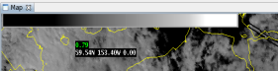 |  | Objective 9
 | Loop the product by selecting the looping  icon on the menu. | Live Data: If using a current data ingest, the product loops and updates.  Canned Data: If using a canned data set, verify that the product loops.
 | Swap the main pane into a side pane by clicking MB3 in the desired side pane. | The product is swapped.
 | Select the Satellite → NPP Products → Alaska Imagery → Imagery Band 4 (3.74u) product.  Note: A different Imagery region can be selected if Alaska Imagery is not available. | The VIIRS NPP Imagery product loads within the display without error. |  | Objective 9
 | Click and hold the MB3 button in the main D2D display. | A popup menu appears.
 | Select Sample. | Sampling is activated.
 | Move the mouse cursor over the image. Verify the sampled value matches the color bar. | - Sampling displays the Brightness Temperature value of the Imagery Band 4 product.  - The color bars for Brightness Temperature products have color-related temperature values.  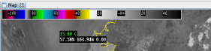 |  | Objective 9
 | Swap the main pane with the product previously moved to a side pane by clicking MB3 in the side pane. | The products are swapped.
 | Turn looping off.  MB1 click the Clear button. | Looping is turned off.  The main display is cleared.
 | Select the Satellite → NPP Products → Alaska Imagery → Imagery Band 5  (11.45u) product.  Note: A different Imagery region can be selected if Alaska Imagery is not available. | The VIIRS NPP Imagery product loads within the display without error. |  | Objective 9
 | Click and hold the MB3 button in the main D2D display. | A popup menu appears.
 | Select Sample (if not already checked). | Sampling is activated.
 | Move the mouse cursor over the image. Verify the sampled value matches the color bar. | - Sampling displays the Brightness Temperature value of the Imagery Band 5 product.  - The color bars for Brightness Temperature products have color-related temperature values. |  | Objective 9
 | Swap the main pane with the product previously moved to a side pane by clicking MB3 in the side pane. | The product in the side pane is now in the main pane.
 | MB1 click the Clear button. | The main display is cleared.
NOTE: Execute steps 39 to 87 ONLY if data are available for these products.
 | Select the Satellite → NPP Products → Alaska Imagery → Imagery Band 2 (0.865u) product. | The VIIRS NPP Imagery product loads within the display without error. |  | Objective 9
 | Click and hold the MB3 button in the main D2D display. | A popup menu appears.
 | Select Sample. | Sampling is activated.
 | Move the mouse cursor over the image. Verify the sampled value is unitless. | - Sampling displays the unitless reflective value of the Imagery Band 2 product.  - The color bars for reflective bands do not show any values |  | Objective 9
 | Swap the main pane with the product previously moved to a side pane by clicking MB3 in the side pane. | The products are swapped.
 | MB1 click the Clear button. | The main display is cleared.
 | Select the Satellite → NPP Products → Alaska Imagery → Imagery Band 3 (1.61u) product. | The VIIRS NPP Imagery product loads within the display without error.
 | Click and hold the MB3 button in the main D2D display. | A popup menu appears.
 | Move the mouse cursor over the image. Verify the sampled value is unitless. | - Sampling displays the unitless reflective value of the Imagery Band 3 product.  - The color bars for reflective bands do not show any values
 | Swap the main pane with the product previously moved to a side pane by clicking MB3 in the side pane. | The products are swapped.
 | MB1 click the Clear button. | The main display is cleared.
 | Select the Satellite → NPP Products → Alaska Imagery → Moderate Band 6 (0.746u) product.  This is a reflective product. | The VIIRS NPP Moderate Band product loads within the display without error. |  | Objective 9
 | Click and hold the MB3 button in the main D2D display. | A popup menu appears.
 | Select Sample. | Sampling is activated.
 | Move the mouse cursor over the image. Verify the sampled value matches the color bar. | - Sampling displays the unitless reflective value of the Moderate Band 9 product  - The color bars for reflective bands do not show any values |  | Objective 9
 | Swap the main pane with the product previously moved to a side pane by clicking MB3 in the side pane. | The products are swapped.
 | MB1 click the Clear button. | The main display is cleared.
 | Select the Satellite → NPP Products → Pacific Imagery → Moderate Band 13 (4.05u) product. | The VIIRS NPP Moderate Band product loads within the display without error. |  | Objective 9
 | Click and hold theMB3 button in the main D2D display. | A popup menu appears.
 | Select Sample. | Sampling is activated.
 | Move the mouse cursor over the image. Verify the sampled value matches the color bar. | - Sampling displays the Brightness Temperature value of the Moderate Band 13 product.  - The color bars for Brightness Temperature products have color-related temperature values. |  | Objective 9
 | Swap the main pane with the product previously moved to a side pane by clicking MB3 in the side pane. | The products are swapped.
 | MB1 click the Clear button. | The main display is cleared.
 | Select the Satellite → NPP Products → Pacific Imagery → Moderate Band 13 (4.05u) product. | The VIIRS NPP Moderate Band product loads within the display without error. |  | Objective 9
 | Click and hold the MB3 button in the main D2D display. | A popup menu appears.
 | Select Sample. | Sampling is activated.
 | Move the mouse cursor over the image. Verify the sampled value matches the color bar. | - Sampling displays the Brightness Temperature value of the Moderate Band 15 product.  - The color bars for Brightness Temperature products have color-related temperature values. |  | Objective 9
 | Swap the main pane with the product previously moved to a side pane by clicking MB3 in the side pane. | The products are swapped.
 | MB1 click the Clear button. | The main display is cleared.
 | Select the Satellite → NPP Products → CONUS Imagery → Moderate Band 15 (10.763u) product.  This is a temperature product. | The VIIRS NPP Moderate Band product loads within the display without error. |  | Objective 9
 | Click and hold the MB3 button in the main D2D display. | A popup menu appears.
 | Select Sample. | Sampling is activated.
 | Move the mouse cursor over the image. Verify the sampled value matches the color bar. | - Sampling displays the Brightness Temperature value of the Moderate Band 16 product.  - The color bars for Brightness Temperature products have color-related temperature values. |  | Objective 9
 | Swap the main pane with the product previously moved to a side pane by clicking MB3 in the side pane. | The products are swapped.
 | MB1 click the Clear button. | The main display is cleared.
 | Select the Satellite → NPP Products → CONUS Imagery → Moderate Band 16 (12.013u) product.  This is a temperature product. | The VIIRS NPP Day/Night Band product loads within the display without error. |  | Objective 9
 | Click and hold the MB3 button in the main D2D display. | A popup menu appears.
 | Select Sample. | Sampling is activated.
 | Move the mouse cursor over the image. Verify the sampled value matches the color bar. | - Sampling displays the Reflectivity value of the Day/Night Band product.  - The color bars for reflective bands do not show any values |  | Objective 9
 | Loop the product by selecting the looping icon on the menu. | Current Data: If using a current data ingest, the product loops and updates.  Canned Data: If using a canned data set, verify that the product loops.
 | Swap the main pane with the product previously moved to a side pane by clicking MB3 in the side pane. | The products are swapped.
 | MB1 click the Clear button. | The main display is cleared.
 | Select the Satellite → NPP Products → CONUS Imagery → Day/Night Band (0.7u) product. | The VIIRS NPP Day/Night Band product loads within the display without error.
 | Click and hold the MB3 button in the main D2D display. | A popup menu appears.
 | Select Sample. | Sampling is activated.
 | Move the mouse cursor over the image. Verify the sampled value matches the color bar. | - Sampling displays the Reflectivity value of the Day/Night Band product.  - The color bars for reflective bands do not show any values
 | Loop the product by selecting the looping icon on the menu. | Current Data: If using a current data ingest, the product loops and updates.  Canned Data: If using a canned data set, verify that the product loops.
 | Swap the main pane with the product previously moved to a side pane by clicking MB3 in the side pane. | The products are swapped.
 | MB1 click the Clear button. | The main display is cleared.
NOTE: Execute steps 88 to 100 ONLY if Sounding Availability data is available in the Satellite → NPP Products menu.
 | MB1 click on Satellite → NPP Products, if data is available, select NUCAPS Sounding Availability. | The NUCAPS Sounding Availability product is loaded in the main D2D pane without error.  The image will look like a large solid green bar (On the N. Hemisphere scale).  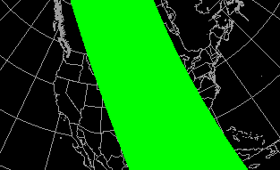 |  | Objective 10
 | Zoom into the image or change to a smaller scale | Several rows of green points appear.
 | MB1 click on one of the points. This will be designated as Point 1. | An NSHARP Skew-T tab opens. The sounding information displays for that particular Lat/Lon point.  The date/time and the lat/lon (located in the Station ID field) are in “green” text  Note: The Nsharp display may have to be changed to D2D Skewt Standard Screen Configuration. Configure -> Display Pane Configuration. Select “D2D Skewt Standard Screen Configuration” and click on “Apply.” |  | Objective 10
 | MB1 click on the map tab. | The Sounding Availability is displayed.
 | MB1 click on a different green point. This will be designated as Point 2. | The sounding for the Lat/Lon point is added to the NSHARP Skew-T.  The date/time and the lat/lon for the first point are in “green” text, those for the second point are in “yellow” text.  The NSHARP Skew-T sounding for the first Lat/Lon point is still displayed. |  | Objective 10
 | On the NSHARP Skew-T editor, MB1 click on the Point 2 “yellow” text station ID (second column). | The Lat/Lon for Point 1 are in “yellow” text, those for Point 2 are in “green” text.  The NSHARP Skew-T sounding for Point 2 Lat/Lon is now displayed. |  | Objective 10
 | On the NSHARP Skew-T editor, MB1 click on the Point 1 “yellow” text stationID. | The Lat/lon for Point 1 are in “green” text, those for Point 2 are in “yellow” text.  The NSHARP Skew-T sounding for Point 1 Lat/Lon is now displayed. |  | Objective 10
 | MB1 click on a different green point (Point 3) at least ten rows separated from the closest point and a different column from Point 1 or Point 2. | The sounding for the Point 3 Lat/Lon is added to the NSHARP Skew-T.  The date/time and the lat/lon (located in the Station ID field) for the current displayed data are in “green” text, the other two active points are in yellow text. |  | Objective 10
 | Sequence through the three station ID’s, using the up/down arrow keys, to verify that all three soundings can be displayed. | The sounding is displayed for each of the selected three points. |  | Objective 10
 | MB1 click the Clear button. | The NSHARP Skew-T tab closes.
 | MB1 click the Clear button. | The main display is cleared.
The NUCAPS Sounding Popup Skew-T functionality
 | Change the scale to N. Hemisphere. | The D2D scale is changed to N. Hemisphere.
 | If not already displayed, MB1 click on Satellite -> NPP Products, if data is available, select NUCAPS Sounding Availability. | The NUCAPS Sounding Availability product is loaded in the main D2D pane without error.  The image should look like a large solid green bar (On the N. Hemisphere scale).
 | MB1 click Volume -> Popup SkewT | The Radar Popup SkewT legend displays in the main pane
 | Right click (MB3), and hold, in the main D2D pane. In the popup menu, select Sample Cloud Heights/Radar Skew T. From the menu, select NUCAPS. | A list of models and a Skew-T option appear in the menu. The popup menu closes.
 | Right click (MB3), and hold, in the main D2D pane. Select Sampling from the popup menu.  Optional: If desired you may also select the Lat/Lon Readout from the menu to identify the sample location. | Sampling is activated. A Skew-T appears in a separate window overlaid on top of the main pane.  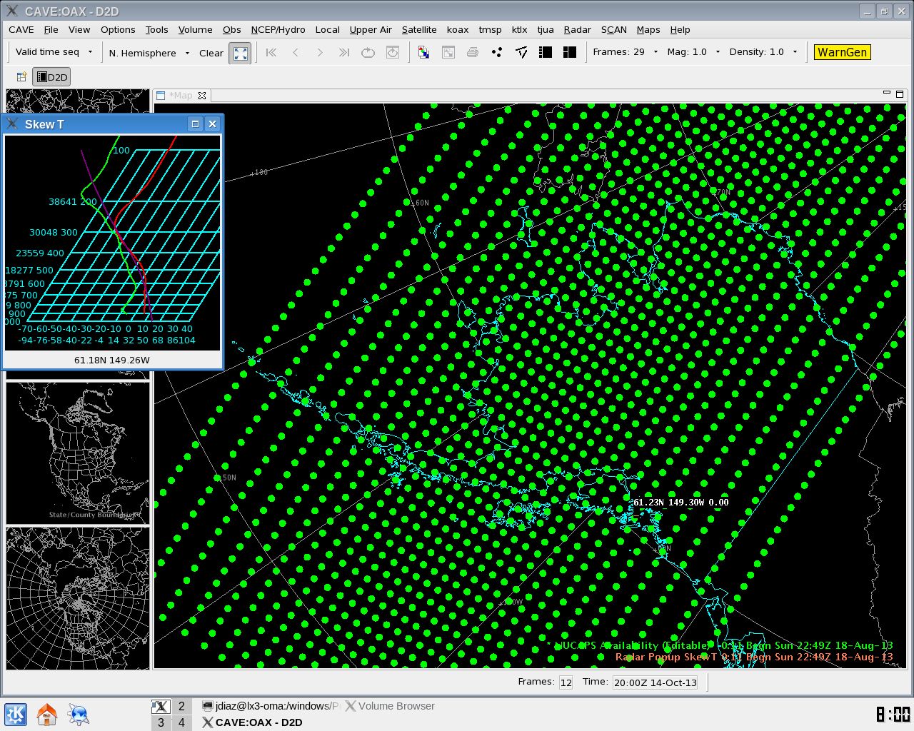 |  | Objective 10
 | Move the cursor around the display to sample the data. | Sampled value traces change as the cursor moves around the display. |  | Objective 10
 | MB1 click the Clear button. | The main display is cleared.
VIIRS Data Purge
 | Execute the following SQL command to locate the NPP data in the satellite tables.  select reftime from viirs order by reftime limit 5;  Make a note of the oldest VIIRS data entry. | The results of the SQL query show that the NPP data is stored in the database.  The oldest VIIRS data is dated __________
 | Open the Localization perspective. | The Localization perspective opens.
 | Select D2D → Purge Rules → viirsPurgeRules.xml | An entry for SITE (siteid) is available.
 | Double MB1 click SITE (siteid). | In the center pane under the viirsPurgeRules.xml – SITE Node and Content information displays.
 | MB1 click the right pointing triangle next to rule. When rule has expanded, MB1 click the right pointing triangle next to id. | The following items are under rule:  id with right-pointing triangle  pluginName viirs  key default  period with a content form of dd-hh:mm:ss
 | Modify the period content to 02:01:00:00 or to a period less than the oldest file in the database (if using current data ingest). Then save the viirsPurgeRules.xml file. This will set the purge to remove any files older than the set period. | The purge rules file is modified.
 | Wait at least 30 minutes, then proceed. | Go to next step after at least 30 minutes.
 | Execute the following SQL command to locate the NPP data in the satellite tables.  select reftime from viirs order by reftime limit 5;  NOTE:The default time for purge to run is every two hours. It may take at least 15 minutes to run. As a result the database may need to be queried several times before it can be determined that the viirs data has been purged from the database. | Current Data: If using current data, you should not see any data which exceeds the purge date/time set.  Canned Data: If using a canned data set, verify zero rows are returned. |  | Objective 11
 | Restore the period content to 02:01:00:00 in the viirsPurgeRules.xml file and save. | The purge rules file is restored.
 | Close all windows and log out. | All windows close.
The test case is completed.

- If requirements are attached to the test cases, then maintain them together. A reference can be made to Table 1.1-1.

Table 1.1-2. Requirements Verification Traceability Matrix (RVTM)
Number | Description | Test Step (s)
1 | confirm the receipt of NPP imagery | 4
2 | ingest NPP imagery | 4
3 | decode NPP imagery | 4
4 | confirm the receipt of NPP NUCAPS Sounding | 5
5 | ingest NPP NUCAPS Sounding | 5
6 | decode NPP NUCAPS Sounding | 5
7 | store of NPP VIIRS Imagery | 7
8 | store of NPP NUCAPS Sounding | 8
9 | display NPP imagery | 15, 19, 21, 24, 30, 33, 36, 39, 42, 50, 53, 56, 59, 62, 65, 68, 71, 74, 77
10 | display NPP NUCAPS Sounding product | 88, 90, 93-98, 107, 108
11 | purge NPP imagery | 117

