Title | Baseline Radar WSR-88D Dual Polarization | Test Case Execution Engineer
Test Case Creation Engineer | William Smith | Test Platform Used
Date Test Case Created | 12/14/2007 | Release Version on Testbed
CI | RD | Logged in User’s Role
Site Specific | N/A | Start Date / Time
TC Updated for Version | AWIPS II | Completion Date/Time
Last Modified By | William Smith 05/27/2015 | Total Test Time
Executable Steps | 65 (unique) + 09 (repeats) = 74 | Pass/Fail/Pending

Test Case: | Baseline Radar WSR-88D Dual Polarization
Test Case Description: | Provide capability in AWIPS to request, ingest and display WSR-88D Dual Polarization data.
Requirements: | - Ingest Dual Pol Products (see Table 1.1-3)  - AWIPS will provide the request for these products via the RPS, OTR, and RMR request applications.  - AWIPS will provide the capability to enable multiple user selectable (DUA) products to be stored in such a way as to enable time series looping.  - When products are selected for display, they will be decoded from the ingest format to display format, as is currently done. AWIPS will decode the DPR product from the Generic Radial format to display format.  - D-2D will display at the full resolution the following dual pol products: ZDR, CC, KDP, HC, Melting Layer, and QPE produced by the RPG.  - D-2D will display 4-bit products using default color tables contained in the product specification ICD; 8-bit product colors will be obtained by ramping 4-bit product colors.  - For 4-bit products, D-2D will use data levels contained in the product description block, since they can be modifiable at the RPG.  - The 4-bit products will be displayed explicitly from the 4-bit menu.  - AWIPS will provide a 4-panel layout containing either single or different paired products in each panel. Each type of 4-panel layout will have an all-tilts selection, with navigation and toggle capabilities.  - The simple 4-panel display will contain Z, ZDR, CC, and HC or KDP in the upper left, upper right, lower left, and lower right, respectively. There will be no toggle capability.  - In the general purpose 4-panel display, the individual panels will contain Z/V, ZDR/SRM, CC/HC, and KDP/STA.  - The precipitation 4-panel display will contain STA/OHA, STP/OHP, DSD/DOD, and DPR/HHC.  - Ideally, the cursor will remain linked on all four panels, and cursor readout will display the values of all four products currently on display.  - D-2D will display the HCA melting layer information, which is four contours showing the top and bottom of where the beam starts to intersect and is centered on the melting layer. This melting layer may be displayed for each tilt.  - The dual polarization products will be displayable in the Volume Browser either as a Constant Altitude PPI (CAPPI) or cross section.
Data Input: | N/A
Prerequisite Conditions: | - This test case assumes that all the servers on the AWIPS work site are operating normally, and the AWIPS work site is not experiencing any network anomalies, which may adversely affect communications between the various servers of the work site.

Table 1.1-1. Test Steps and Expected Results
Step # | Actions / Inputs | Expected Results | P/F | Comments
 | Open a terminal window and log on to the RadarServer server:  - ssh dx1f | Logged in on RadarServer server (currently on dx1).
 | On the RadarServer, verify that the ingest processes are running by typing:  - ps –ef | grep radarserver | The processes are running.
 | Verify that log files are created by typing:  - cd /awips2/rcm/data/logs  - ls -1 radar* | Log files exist for several days of radar server processes.
 | Verify in the radarserver log file that the following products are being received by searching for the product codes as defined in the table below.  - grep ‘code=###’ radarserver.log  where ### is the Product Code #. | Dual Pol radar products are received and being stored in the proper directories.  Note:  ### is the Product Code and PID is the process ID associated with a kxxx radar found in Step 2.  If all the products are not coming in, place the product in the current RPS List and wait for the product to arrive (see Steps 38-43 at the end of this test case), or submit a Radar Multiple Request for the Dual Pol products (see Steps 32-40 in this test case)
  Product | Product  Code
  ZDR | 158
  ZDR | 159
  CC | 160
  CC | 161
  KDP | 162
  KDP | 163
  HC | 164
  HC | 165
  ML | 166
  OHA | 169
  DAA | 170
  STA | 171
  STA | 172
  DUA | 173
  DOD | 174
  DSD | 175
  DPR | 176
  HHC | 177
 | Verify that the products are stored in their proper directories under  /data/fxa/radar/kxxx/<Product ID>/<elev>/<res>/<level> as specified in the Table 1 in the test case Requirements.  - cd /data_store/radar/kxxx  - ls –lR <Product ID> | more  For the following Product IDs: ZDR, CC, KDP, HC, ML, OHA, DAA, STA, DUA, DOD, DSD, DPR, HHC | Products are being stored in the proper directories.  kxxx is one of the ORPG radars.  elev is the elevation angle  res is the resolution\  Note: The Digital User Selectable Accum (DUA – Product #173) may not be available.
 | Exit from the dx1f server and close the terminal window. | User is logged off from dx1f.
 | Open a CAVE session and set the Scale to WFO. | CAVE is opened and the scale is set.
 | On a D-2D graphics display, select one of the kxxx dedicated radar menus. The menu should look similar to this:  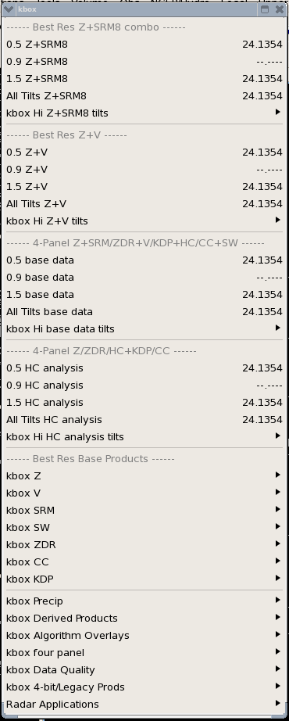 | The menu is as expected.
 | Select kxxx Algoritm Overlays -> Melting Layer menu selection.  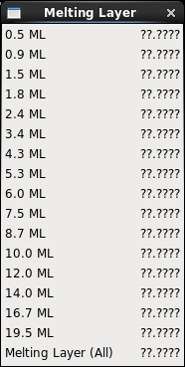  Load each of the above Melting Layer products. Verify that each menu item can be displayed and that the product auto-updates. | Pull right menu is as expected and the products load and auto-update.  Note: If the product is not routinely ingested, send out a One-time Request. Verify the product is ingested and displays.
 | Select the kxxx Diff Refl (ZDR) Pull Right menu  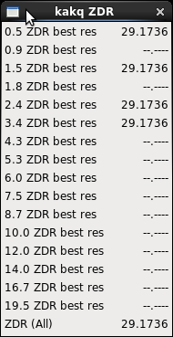  Load each of the above Diff Refl products. Verify that each menu item can be displayed and that the product auto-updates. | Pull right menu is as expected and the products load and auto-update.  Note: If the product is not routinely ingested, send out a One-time Request. Verify the product is ingested and displays.
 | Select the kxxx Corr Coeff (CC) Pull Right Menu  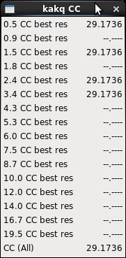  Load each of the above Corr Coeff products. Verify that each menu item can be displayed and that the product auto-updates. | Pull right menu is as expected and the products load and auto-update.  Note: If the product is not routinely ingested, send out a One-time Request. Verify the product is ingested and displays.
 | Select the kxxx Spec Diff Ph (KDP) Pull Right Menu  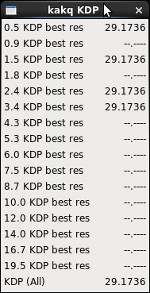  Load each of the above Diff Ph products. Verify that each menu item can be displayed and that the product auto-updates. | Pull right menu is as expected and the products load and auto-update.  Note: If the product is not routinely ingested, send out a One-time Request. Verify the product is ingested and displays.
 | Select the kxxx Derived Products -> Hydrometeor Classification Pull Right menu  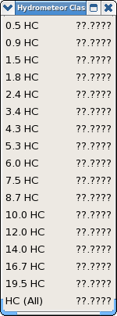  Load each of the above Hydrometeor Class products. Verify that each menu item can be displayed and that the product auto-updates. | Pull right menu is as expected and the products load and auto-update.  Note: If the product is not routinely ingested, send out a One-time Request. Verify the product is ingested and displays.
 | Select the kxxx Hi base data tilts 4-Panel menu.  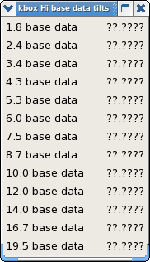  Load each of the 4 Panel products. Verify that each menu item can be displayed and that the product auto-updates. | Pull right menu is as expected and the products load and auto-update.  Note: If the product is not routinely ingested, send out a One-time Request. Verify the product is ingested and displays.
 | Select the kxxx Hi HC Analysis Tilts 4 Panel menu.  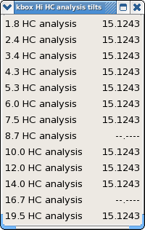  Load each of the 4 Panel products. Verify that each menu item can be displayed and that the product auto-updates. | Pull right menu is as expected and the products load and auto-update.  Note: If the product is not routinely ingested, send out a One-time Request. Verify the product is ingested and displays.
 | Load kxxx All Tilts HC Analysis | Products are loaded in D2D.
 | Tear off the individual product menus for the various dual pol products(ZDR, CC, KDP) | Menus are displayed to indicate when each is updated in D2D.  As the menu times update, ensure that the product updates within a few seconds to reflect new data.
 | Close all of the tear-off menus. | Tear-off menus are closed.
 | Load the kxxx Precip products. Menu entries look like this:  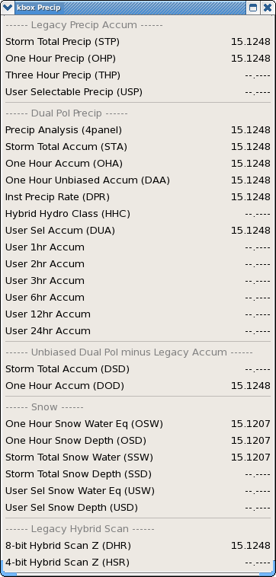  Verify that the Dual Pol Precip Products on the menu load and auto-update. | Dual Pol Precip products load and auto-update.
 | Verify that color tables exist for Dual Polarization products:  Select the Image Properties icon on D-2D or Image Properties from the D-2D Options menu.  Left click on the second button from the top (“Radar/DualPol/<>”).  Select the Radar pull-right menu and select the DualPol pull-right menu. The following color tables are available:  Differential Refl  Correlation Coeff  Spec Differential Phase  Hydrometeor Class  Precip Accumulation  Precip Rate  Select each of the above color tables and note the resulting color curves. | A default color table exists for each product and the color table can be changed using the Image Properties Dialog.  Note: A dual-pol product must be loaded in the main D2D pane.
 | Close the Imaging… dialog box. | The GUI is closed.
 | Select the following:  kxxx > Radar Applications > One time Request...  The Dedicated - One Time Request dialog box opens. It looks similar to this:  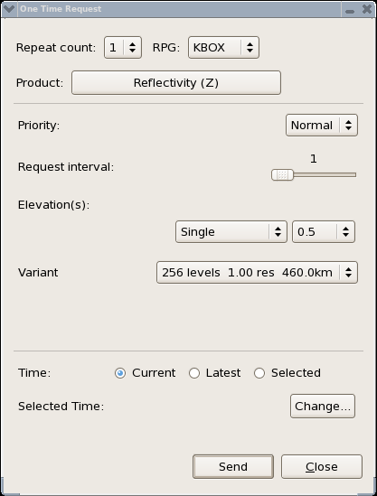 | The Dedicated - One Time Request dialog box appears.  Note: kxxx is a dedicated radar.
 | In the Dedicated - One time Request dialog box for the local radar, open the Product menu. In this menu, observe the following entries:  Dual Pol Base Prods (pull right)  Hydrometeor Class (HC)  Melting Layer (ML)  The Dual Pol Base Prods pull right menu has the following menu options:  Differential Refl (ZDR)  Correlation Coeff (CC)  Specific Diff Phase (KDP)  Further down in the products menu, there is an option for the Dual Pol Precip products. This pull right includes the following menu options:  Digital Inst Precip Rate (DPR)  Hybrid Hydrometeor Class (HHC)  One Hour Accum (OHA)  One Hour Unbiased Accum (DAA)  Storm Total Accum (STA)  User Select accum (DUA)  One Hour Diff (DOD)  Storm Total Diff (DSD) | Menu options are available as described.
 | After selecting a Dual Pol product, the user can select the following from the section labeled Elevation(s) :  All  All at or below:  Lowest 'n'  Single  All cuts  Single is the default option. | Note: The Elevation options are not available for the Melting Layer (ML) and Dual Pol Precipitation products.
 | Submit a One Time Requests for each of the products in Step 23. If the correct information for the product is not entered, the user may receive an AlertViz popup message.  Load each product and verify that the products display and menus update. | Correct entries can be created by looking at Table 1 in the test case requirements.  The products are retrieved from the RPG.  The displayed products and the menus options update.  Note that when requesting a Digital User Selectable Accum (DUA) product, that the Time span can be no less than 15 minutes.
 | Repeat the previous step using different Elevations and verify that the correct products are received from the RPG. | The correct products are received from the RPG.
 | Select the following:  kxxx > Radar Applications > Radar Multiple Request...  where kxxx is the local radar.  Observe the Radar Multiple Request (RMR) dialog box.  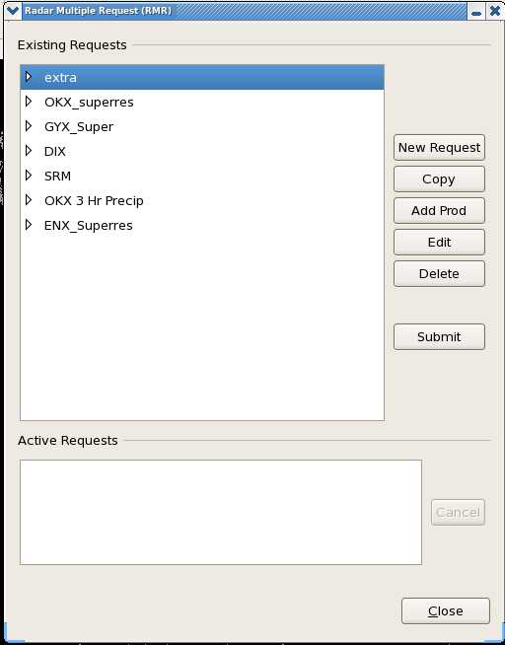 | The Radar Multiple Request (RMR) dialog box opens.
 | In the RMR dialog box, select the New Request... button. | The New Request dialog box opens.
 | Give the Request a name and indicate if the request is a Single request or a Multiple Request. If the request is a Multiple Request, select how often to repeat and the duration of the request. | Request is created.
 | Click on the OK button. | The Add Products dialog box opens.
 | Select the Radar Type, and choose either WSR-88D or TDWR. Then select a dedicated RPG from the list. | The radar is selected.
 | In the Products section, open the menu and in the menu, observe the following entries:  Dual Pol Base Prods (pull right)  Hydrometeor Class (HC)  Melting Layer (ML) | Menu contains the listed products.
 | In the Product section, note the Dual Pol Base Prods pull right menu. This menu contains the following menu options:  Differential Refl (ZDR)  Correlation Coeff (CC)  Specific Diff Phase (KDP)  Further down in the menu, note the Dual Pol Precip pull right menu. This menu contains the following menu options:  Digital Inst Precip Rate (DPR)  Hybrid Hydrometeor Class (HHC)  One Hour Accum (OHA)  One Hour Unbiased Accum (DAA)  Storm Total Accum (STA)  User Select Accum (DUA)  One Hour Diff (DOD)  Storm Total Diff (DSD)  Select a Dual Pol product, Request Interval, and Elevation(s). Again, note that with the selection of some of the Dual Pol products, the Elevation(s) default is Single and that the other available selections are All cuts, All, All at or below and Lowest 'n'. | The Dual Pol Base Prods pull right menu contains the indicated menu options.  The Dual Pol Precip pull right menu contains the indicated menu options.
 | Create a request with various Dual Pol Products and submit the request. If the correct information for the product is not entered, the user may receive an AlertViz popup message.  Correct entries can be created by looking at Table 1 in the test case requirements.  Verify that the products come in from the specified radar and that the product displays and menus auto-update. | The request is submitted.  The specified products are received from the correct radar and the product displays and menus auto-update.  Note that when requesting a Digital User Selectable Accum (DUA) product, that the Time span can be no less than 15 minutes.  Also note that when requesting a single DUA product, the interface is similar to the One Time Request for the DUA.
 | Repeat with the other Dual Pol Products listed in Step 33. | As expected.
 | Select the following:  kxxx > Radar Applications > RPS List Editor...  where kxxx is any radar. | The RPS List Editor dialog box opens.
 | Select View->Current List… on the RPS List Editor menu. Then choose a kxxx radar and select ‘OK.’ | The current RPS product list is displayed for the selected radar.
 | In the RPS List Editor dialog box, select Add. | The Add Product dialog box opens.
 | In the Product section of the Add Product dialog box, note the following:  Dual Pol Base Prods (pull right)  Hydrometeor Class (HC)  Melting Layer (ML)  The Dual Pol Base Prods pull right offers the following options:  Differential Refl (ZDR)  Correlation Coeff (CC)  Specific Diff Phase (KDP)  Further down in the menu, note the Dual Pol Precip pull right menu. This menu contains the following menu options:  Digital Inst Precip Rate (DPR)  Hybrid Hydrometeor Class (HHC)  One Hour Accum (OHA)  One Hour Unbiased Accum (DAA)  Storm Total Accum (STA)  User Select Accum (DUA)  One Hour Diff (DOD)  Storm Total Diff (DSD) | The menus are as described.
 | Select a Dual Pol Product and add it to the current request. If the correct information for the product is not entered, the user may receive an AlertViz popup message.  Correct entries can be created by looking at Table 1 in the test case requirements.  Add two new DUA entries as well. | Selected is the default Elevation option.  Note that when requesting a Digital User Selectable Accum (DUA) product, that the Time span can be no less than 15 minutes.  With the selection of some Dual Pol products, note the Elevation(s) portion of the dialog box. Note the available selections:  All  All at or below:  Lowest 'n'  Selected
 | Click on Send and choose the same radar selected in Step 36.  Exit from the RPS List Editor:  File->Exit  If an Unsaved Changes dialog box appears, select NO to exit the RPS editor without saving the updated list. | The new RPS request list is submitted.
 | After the request list is submitted, verify that the products display and that both the display and the menus auto-update. | The products are received and the display and menus auto-update.
 | Verification that Dual Pol products are available from the Volume Browser and that they can be loaded:  Clear D-2D and select the Regional scale.  Select the Volume->Browser GUI on D-2D.  Set the view to Cross Section.  Select Tools->Choose by ID  And enter the radar of choice (e.g. KENX) in the HOME field at the bottom of the GUI and press Enter. Then enter the same radar for a specified baseline and press Enter.  From the Volume Browser:  Source: Volume->Radar  Fields: Other-><Dual Pol Product>  Planes: Select a specified baseline.  Load a Dual Pol product:  Diff Refl  Corr Coeff  Spec Diff Phase  Hydrometeor Class | 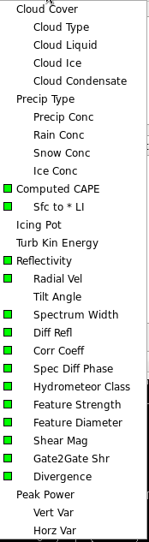  Product is loaded.  The dual polarization products will be displayable in the Volume Browser as a Cross Section. |  | DR 13671
 | Repeat Step 48 for other Dual Pol products. | Products are loaded. |  | DR 13671
 | Set the view to Plane View.  Select Tools->Choose by ID  And enter the radar of choice (e.g. KENX) in the HOME field at the bottom of the GUI  Source: Volume->Radar  Fields: Misc->Radar-><Dual Pol Product>  Planes: Select a height.  Load a Dual Pol product:  Diff Refl  Corr Coeff  Spec Diff Phase  Hydrometeor Class | Product is loaded.  The dual polarization products will be displayable in the Volume Browser as a Constant Altitude PPI (CAPPI).  Note: The ‘<’ button in D-2D may have to be pressed to display the data.
 | Repeat Step 50 for other Dual Pol products. | Products are loaded.
 | Using the Volume Browser, create a radar data bundle using radar data, and save the bundle in a procedure and exit the dialog. | A radar bundle is created using the Volume Browser.  e.g.:  Select Volume->Browser  Select Plan View  Sources: Volume->Radar  Fields: Radar->Reflectivity  Planes: Hgt->1500m  Highlight the listed data and press the Load button  File->Procedures->New…  Press the Copy In button  Save  The bundle is saved.
 | Clear D2D and select the WFO scale. On the main D2D menu, select the following:  Options > Data Scale  Load the radar bundle created in Step 47. | The Data Scale option has no effect on the bundle. For example, if the bundle was created on the Regional scale and the Data Scale button was selected, the resulting display would be displayed on the Regional Scale instead of a more local scale.
 | On the graphics workstation, select Volume > Browser...  In the Planes section, note the Temp menu. The selections in Temp look like this:  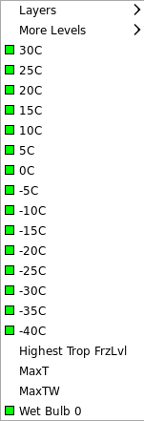  Load some products using the Temp menu. | The Volume Browser is displayed, and a Temp menu exists.  Products load as expected.
 | Note in the Temp menu, the addition of the Layers sub-menu.  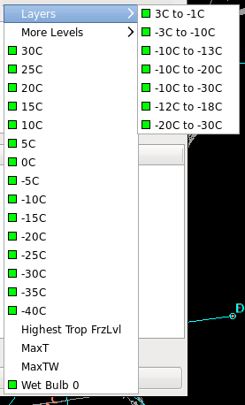  A More Levels sub-menu has also been added.  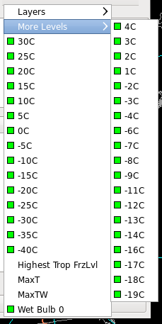  Load some products using these sub-menus. | In the Temp menu, the Layers and More Levels sub-menus exist.  Products load as expected.
 | Clear D2D and set scale to Regional. | Main pane of D2D is cleared and scale is set to Regional.
 | In D-2D, select the following:  kxxx >  kxxx four panel >  Z+V >  0.5 1.5 2.4 3.4  Observe that the four panel display displays the following:  Upper Left: 0.5 Z + 0.5 V  Upper Right: 1.5 Z + 1.5 V  Lower Left: 3.4 Z + 3.4 V  Lower Right: 2.4 Z + 2.4 V  or the best elevations available. | Displays are as expected.
 | Select Delete (in the cluster of keys above the up-down, right-left arrows). This will enter the Panel/Combo Rotate mode.  Observe that the resulting display is the 0.5 elevation, with only the Reflectivity product displayed. In the lower left corner of the display, note the +. This indicates that you are in the Panel/Combo Rotate mode.  Continue selecting the Delete key. As you continue selecting the key, note that the following are displayed:  Continuing to select the Delete key will start the sequence again.  Note that hitting the Backspace key presents the previous display. | The display in the upper left four-panel is displayed. A + is displayed in the lower left corner.  Hitting the Delete key sequences through the eight products of the four-panel.  Hitting the Backspace key presents the previous display. |  | DR 12496 - First panel is not 0.5 Z
  Hits on the Delete Key | Display
  2nd | 1.5 Z
  3rd | 2.5 Z
  4th | 3.5 Z
  5th | 0.5 V
  6th | 1.5 V
  7th | 2.5 V
  8th | 3.5 V
 | The numbers 1 through 4 on the regular keyboard will select the reflectivity (Z) elevation for panels 1 through 4 and 5 through 8 will select the velocity (V) elevation for panels 1 through 4. That is:  Or depicted like this:  With the mouse on the display, click and hold the right mouse button (3) and observe the pop-up menu. Note the Rotate Panels selection. Selecting Rotate Panels will step through the display sequentially. | The regular keyboard numbers are mapped to the indicated displays.  The pop-up menu selection Rotate Panels sequences through the display. |  | DR 12496 – Rotate Panel does not switch to Z
  Keyboard Number | Display
  1 | 0.5 Z
  2 | 1.5 Z
  3 | 2.5 Z
  4 | 3.5 Z
  5 | 0.5 V
  6 | 1.5 V
  7 | 2.5 V
  8 | 3.5 V
  1 + 5 | 2 + 6
  4 + 8 | 3 + 7
 | To exit the Panel/Combo Rotate mode, select End above the up-down, right-left arrows. Observe the return to the original four panel display.  Repeat with other four-panel displays. | Selecting End exits the Panel/Combo Rotate mode.
 | Select Clear in D-2D | Main pane cleared.
 | Load a four-panel radar display (for example the Z + V > 0.5 1.5 2.4 3.4) and enter the Panel/Combo Rotate mode. Note in this example that the kxxx 0.5 Z product is loaded.  Click and hold the right mouse button (3) to bring up the right pop-up menu, and select All Panel Sample. Repeat for the Sample menu item as well. Move the cursor over the 0.5 Z radar. Observe the sample output in the following order (from top to bottom):  0.5 Z  1.5 Z  2.5 Z  3.5 Z  0.5 V  1.5 V  2.5 V  3.5 V | The four-panel product displays.  All eight products sample output is displayed.
 | Move the mouse over the display and note that the sample data output is continual.  Deselect Sampling and note that the continual sampling is disabled. | Continual sampling is enabled with the pop-up menu selection Sampling.  Deselecting Sampling terminates the continual readout.
 | Select kxxx -> kxxx Data Quality -> NEXRAD Unit Status  Where kxxx is a dedicated radar (e.g.koax) | Verify that “SAILS” is displayed in the second line of “VCP Supplemental Info”  If this is not the case then select another dedicated radar. If a SAILS radar is not available then skip Steps 65 - 69
 | Make a One Time Request (OTR) for Super Res Z, 0.5 all cuts for the selected SAILS radar and send it. | The OTR request is sent.
 | Select kxxx -> kxxx Z -> 0.5 Z best res to load the product. Then step back one or two scans. | Verify that the latest 2 super res reflectivity products are within 2-3 minutes instead of 4-6 minutes.
 | Add Super Res Z, 0.5 all cuts to the RPS list for the selected SAILS radar. | Verify that the latest 2 super res reflectivity products are within 2-3 minutes instead of 4-6 minutes.
 | Repeat the previous step. | Verify that a duplicate request of super res Z 0.5 all cuts exists in the RPS list.
 | Load the current RPS list to the selected SAILS radar. | Verify that the duplicate request of super res Z 0.5 all cuts has been removed.
 | Close all windows and log out. | All windows close.
The test case is completed.

- If requirements are attached to the test cases, then maintain them together. A reference can be made to Table 1.1-1.

Table 1.1-2. Requirements Verification Traceability Matrix (RVTM)
Number | Description | Test Step (s)
1 | Ingest Dual Pol Products (see Table 1.1-3) | 2-5
2 | AWIPS will provide the request for these products via the RPS, OTR, and RMR request applications. | 24-44
3 | AWIPS will provide the capability to enable multiple user selectable (DUA) products to be stored in such a way as to enable time series looping. | 21
4 | When products are selected for display, they will be decoded from the ingest format to display format, as is currently done. AWIPS will decode the DPR product from the Generic Radial format to display format. | 10-18
5 | D-2D will display at the full resolution the following dual pol products: ZDR, CC, KDP, HC, Melting Layer, and QPE produced by the RPG. | 10-18
6 | D-2D will display 4-bit products using default color tables contained in the product specification ICD; 8-bit product colors will be obtained by ramping 4-bit product colors. | 10-11
7 | For 4-bit products, D-2D will use data levels contained in the product description block, since they can be modifiable at the RPG. | 10-11
8 | The 4-bit products will be displayed explicitly from the 4-bit menu. | 10-11
9 | AWIPS will provide a 4-panel layout containing either single or different paired products in each panel. Each type of 4-panel layout will have an all-tilts selection, with navigation and toggle capabilities. | 19-20
10 | The simple 4-panel display will contain Z, ZDR, CC, and HC or KDP in the upper left, upper right, lower left, and lower right, respectively. There will be no toggle capability. | 19-20
11 | In the general purpose 4-panel display, the individual panels will contain Z/V, ZDR/SRM, CC/HC, and KDP/STA. | 54
12 | The precipitation 4-panel display will contain STA/OHA, STP/OHP, DSD/DOD, and DPR/HHC. | 19-20
13 | Ideally, the cursor will remain linked on all four panels, and cursor readout will display the values of all four products currently on display. | 19-20
14 | D-2D will display the HCA melting layer information, which is four contours showing the top and bottom of where the beam starts to intersect and is centered on the melting layer. This melting layer may be displayed for each tilt. | 18
15 | The dual polarization products will be displayable in the Volume Browser either as a Constant Altitude PPI (CAPPI) or cross section. | 45-48

Table 1.1-3. Ingest Dual Pol Products
Product | Mnemonic | Data Levels | Product Code | Resolution
Differential Reflectivity | ZDR | 16 | 158 | 1.00
Differential Reflectivity | ZDR | 256 | 159 | 0.25
Correlation Coefficient | CC | 16 | 160 | 1.00
Correlation Coefficient | CC | 256 | 161 | 0.25
Specific Differential Phase | KDP | 16 | 162 | 1.00
Specific Differential Phase | KDP | 256 | 163 | 0.25
Hydrometeor Classification | HC | 16 | 164 | 1.00
Hydrometeor Classification | HC | 256 | 165 | 0.25
Melting Layer | ML | 16 | 166 | N/A
One Hour Accumulation | OHA | 16 | 169 | 2.00
Digital Accumulation Array | DAA | 256 | 170 | 0.25
Storm Total Accumulation | STA | 16 | 171 | 2.00
Digital STA | STA | 256 | 172 | 0.25
Digital User Selectable Accum | DUA | 256 | 173 | 0.25
Digital One Hour Diff Accum | DOD | 256 | 174 | 0.25
Digital Storm Total Diff Accum | DSD | 256 | 175 | 0.25
Digital Inst Precip Rate | DPR | 65536 | 176 | 0.25
Hybrid Scan HC | HHC | 256 | 177 | 0.25

