Title | Initial Configuration | Test Case Execution Engineer
Test Case Creation Engineer | Amanda Wu | Test Platform Used
Date Test Case Created | 07/21/2006 | Release Version on Testbed
CI | AvnFPS | Logged in User’s Role
Site Specific | WFO | Start Date / Time
TC Updated for Version | AWIPS2 | Completion Date/Time
Last Modified By | Amanda Wu, 11/30/11 | Total Test Time
Executable Steps | 56 (unique) + 07 (repeats) = 63 | Pass/Fail/Pending

Test Case: | B_AvnFPS_Initial Config
Test Case Description: | The purpose of this test case is to verify that the initial configuration and other set up of the AvnFPS system for the following features function correctly:  Add New TAF(s)  Add New Forecaster  The Rule Editor should not write corrupted configuration files  The AvnWatch GUI is 508 compliant
Requirements: | N/A
Data Input: | N/A
Prerequisite Conditions: | Log into graphical (lx) or text (xt) workstation as a valid AWIPS user & password.

Table 1.1-1. Test Steps and Expected Results
Step # | Actions / Inputs | Expected Results | P/F | Comments
 | Start CAVE. | The CAVE GUI is displayed.
 | Select CAVE>New>Aviation> Configuration GUI…… | The AvnFPS Setup GUI is displayed.
 | To edit or add TAF site Information, from the AvnFPS Setup GUI, select the TAF Site Info button. | The AvnFPS TAF Site Info Editor GUI appears.
 | Add new TAF site, from AvnFPS TAF site Info Editor GUI, enter Site ID ‘KBFI’ and press Update button. | Most of the text fields are filled in by defaults.
 | To make a default template for site entered above select Make button. | The corner of the status bar on the bottom of the screen is blinking indicating that the template file is created.
 | Press Save button. | File is saved at user config directory (e.g., /home/<username>/caveData/etc/site/<Localization ID, e.g., OAX>/aviation/config/tafs/XXXX/info.cfg directory.  Note: XXXX is the Site ID
 | Repeat step 4 – 6 for Site ID ‘KBLI and KSEA’. | Steps are repeated. |  | Note: Total of 6 actions/steps for both sites.
 | To modify TAF template for the site entered above, hold and press the left mouse button on the Issue drop down button then select any values and click on Edit button.  Note: Do not press the Make button, as this will overwrite your current templates. | The Text Editor popup window displays with the selected Issue value and XXXX site (e.g., a 06Z template for XXXX is XXXX DD0600Z DD0606=)
 | Modify the template as you wish, save and close the popup window. | The popup window closes.
 | Select ‘Close’ button on the TAF Site Info Editor window. | The TAF Site Info Editor window closes.
 | Editing TAF Product Definitions, from the AvnFPS Setup GUI, select TAF Products button. | TAF Product Configuration GUI opens.
 | To add a product, on the Products text box, enter a new product name and press ‘Enter’ key. (e.g. Seattle_Tafs) | An error message displays that “the product <Product Name that you just entered> does not exits, it will be created”. This is OK, as it’s being created.
 | Enter site ids KBFI on the Idents label text box and press ‘Enter’ key. | The TAF site id entered is displayed in the Idents list.
 | Repeat step 13 for site id ‘KBLI and KSEA’. | Step is repeated. |  | Note: Total of 1 action/step is repeated.
 | Click on Save button. | File is saved.
 | Press the Verify button to check whether all necessary files exist. | Message ‘Verify succeeded’ appears on the status bar.
 | Close the TAF Product Configuration GUI and the AvnFPS Setup GUI. | The TAF Product Configuration GUI and AvnFPS Setup GUI close.
 | From CAVE, click CAVE>New> Aviation>AvnFPS Menu… | The AvnFPS Menu window is displayed.
 | From the AvnFPS Menu, click the ‘TAFs’ button. | The AvnWatch GUI is displayed.
 | From the AvnWatch GUI, click on Backup button. | The AvnFPS Backup window is displayed.
 | From the AvnFPS Backup window, select the product name that you entered earlier (e.g., Seattle_Tafs) and click ‘OK’. | The confirmation pop-up window is displayed.
 | From the pop-up window, select ‘Yes’ | Verify that the TAFs for KBFI, KBLI, and SEA are displayed on the AvnWatch GUI.
 | Exit AvnFPS application | AvnFPS application closes.
 | From CAVE, click CAVE>New> Aviation>Configuration GUI… | The AvnFPS Setup window is displayed.
 | To delete a site, under the AvnFPS Setup GUI, select TAF Products button, click on the newly created product entered from step 12 and select a site id entered from step 13 & 14 on the Idents list and press the Delete button. | The deleted site ids disappear from the Idents list.
 | To delete a product, select product entered from step 12 on the Products list and presses the ‘Delete’ button. | A confirmation dialog is displayed.
 | Click OK to delete the selected product. | The selected product is deleted from the product list.
 | Select other product and click on Save button to update product definition file. | The product definition file is saved.
 | To mark a product as the default, select the product on the Products list and press the Default button. | This will designate the selected product as a default product.
 | Click on ‘Close’ button to close the TAF Product Configuration window and File >> Quit. | Both TAF Product Configuration and AvnFPS Setup windows close.
 | From CAVE, click CAVE>New> Aviation>AvnFPS Menu… | The AvnFPS Menu window is displayed.
 | From the AvnFPS Menu, click the ‘TAFs’ button. | The AvnWatch GUI is displayed.
 | Verify that the product you selected as default is displayed on the GUI. | Verified.
 | Exit AvnFPS application. | AvnFPS application closes.
Add New Forecaster
 | Select CAVE>New>Aviation>Configuration GUI….. | The AvnFPS Setup GUI is displayed.
 | From the AvnFPS Setup GUI, select Text Editor button. | The AvnFPS Text Editor window is displayed.
 | Click on the Open button. | The Open pops up window is displayed.
 | Select the aviationForecasterConfig.xml file and click on open button. | The forecasters file content is displayed.
 | Enter forecaster’s number, xmit_privilege and name by following the format specified in the file, see sample below:  <id>##</id>  <name>user login name (e.g., amandaw)</name>  <xmit>true (able to transmit)</xmit> or  <xmit>false (not able to transmit)</xmit>  And click on Save button. | The forecaster name entered is saved at /home/<username>/caveData/etc/site/OAX/aviation/avnwatch/aviationForecasterConfig.xml directory.
 | Select File menu > Close. | The forecasters file is closed & returns to AvnFPS Setup GUI.
The Rule Editor should not write corrupted configuration files
 | From AvnFPS Setup GUI, click on Monitoring Rules button | AvnFPS Monitoring Criteria window displays
 | By default the ‘mtrs’ tab should be selected, and Site Id text field set to ‘XXXX’ | Verify settings
 | Write default (that’s what XXXX means) mtrs.cfg file by pressing the ‘Save’ button. | Message bar in bottom ‘gutter’ should say “MTRS Rules saved for site XXXX” with blinking green indicator in lower left indicating successful write of the file.
 | Close Monitoring Criteria GUI and AvnFPS Setup GUI via the ‘Close’ button and File >> Quit option. | Both GUIs disappear.
 | Start AvnMenu by select ‘CAVE’ -> ‘New’ -> ‘Aviation’ -> ‘AvnFPS Menu…’ | The AvnMenu GUI is displayed.
 | Click on ‘TAFs’ button | AvnWatch appears with active monitoring rules reporting status of forecast and observation respectively.
 | Close AvnWatch via File >> Quit option and select the Yes option in the Confirm Close dialogue. | AvnWatch GUI is closed.
Verify the AvnWatch GUI is 508 compliant
 | Start AvnMenu by select ‘CAVE’ -> ‘New’ -> ‘Aviation’ -> ‘AvnFPS Menu…’ | AvnMenu GUI is displayed.
 | Click on ‘TAFs’ button | AvnWatch GUI is displayed with a variety of alert colors as shown below:
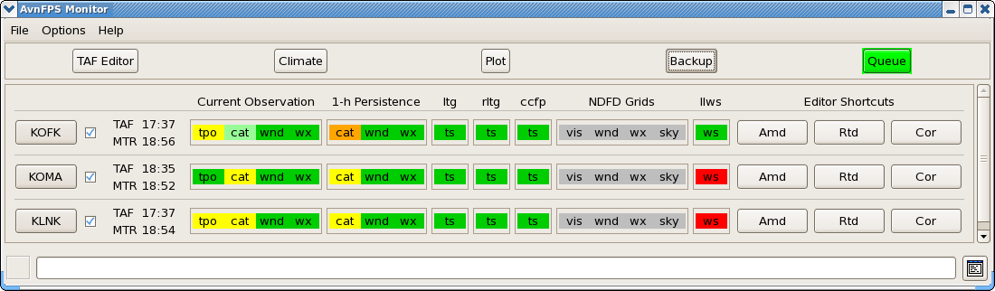
 | Start the Resource Editor by select the ‘Setup’ entry under ‘Options’ pop-down menu. | The Resource Editor GUI displays
 | Using the mouse, scroll down to where the various ‘alertLevel#’ resources are located. | The display as shown below:
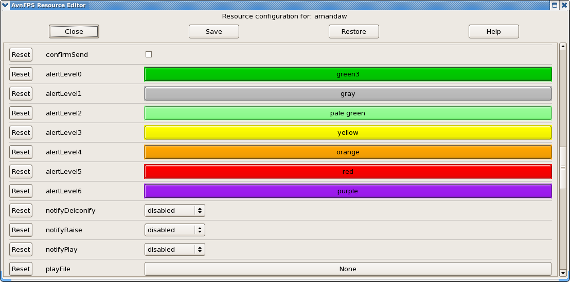
 | Change one or a few of the alert colors by clicking on the colored buttons. | Verify the colors change respectively as shown below:
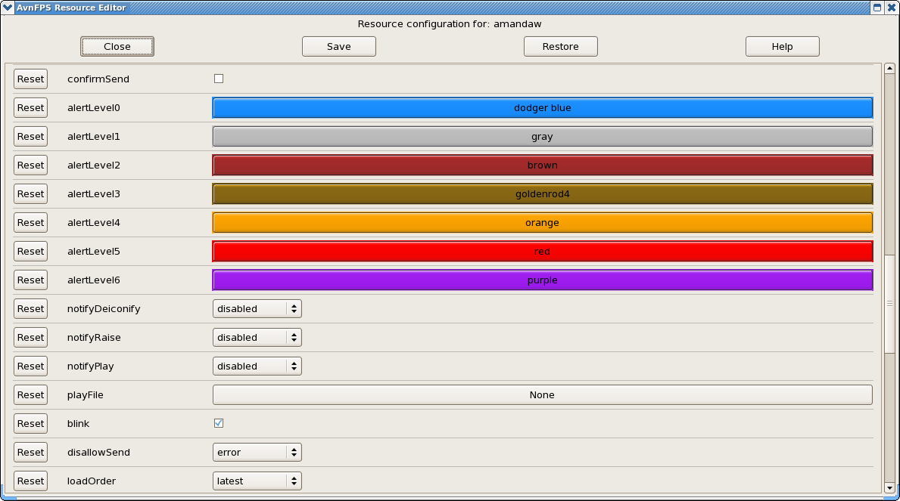
 | Press the Save button and restart the AvnWatch GUI as directed for the change to take effect. | AvnWatch is restarted and verify that the AvnWatch GUI should now display the altered colors as shown below: |  | DR#2847 (techblocked)
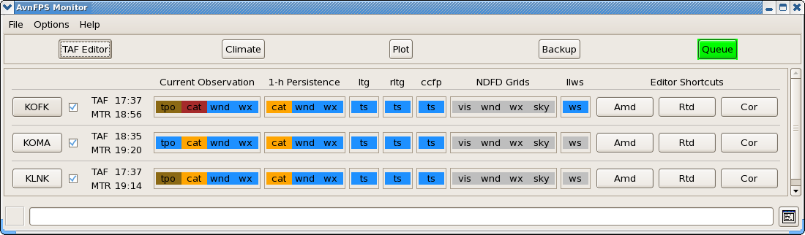
 | Restore original colors (or keep them if you wish) via resource editor. This time press the ‘Reset’ button, next to each resource to restore the ‘baseline’ colors | The colors change to ‘baseline’ colors after each ‘Reset’ button is pressed.
 | Again save the changes and restart AvnWatch GUI (or File >> Check Now). | The default (baseline) colors appear on AvnWatch GUI as shown below:
 | Close AvnWatch via File >> Quit option. | AvnWatch GUI disappears
The test case is completed.

Table 1.1-2. Requirements Verification Traceability Matrix (RVTM)
Number | Description | Test Step (s)

