Title | AvnFPS QC Check | Test Case Execution Engineer
Test Case Creation Engineer | Amanda Wu | Test Platform Used
Date Test Case Created | 01/12/2009 | Release Version on Testbed
CI | AvnFPS | Logged in User’s Role
Site Specific | WFO | Start Date / Time
TC Updated for Version | AWIPS2 | Completion Date/Time
Last Modified By | Amanda Wu (11/10/2011) | Total Test Time
Executable Steps | 30 (unique) + 8 (repeats) = 38 | Pass/Fail/Pending

Test Case: | B_AvnFPS_QC_Check
Test Case Description: | The purpose of this test case is to verify that when QC button is ‘left-clicked’ the various checks are performed as set in the Taf Site Info GUI. User will then override the default set of checks by clicking on the QC button again with the ‘right-most’ mouse click. Again, user will verify the overriding selections are performed instead of the defaults.
Requirements: | N/A
Data Input: | N/A
Prerequisite Conditions: | User must log into a graphics (lx) workstation or text (xt) workstation with a valid AWIPS username & password.

Table 1.1-1. Test Steps and Expected Results
Step # | Actions / Inputs | Expected Results | P/F | Comments
 | Start CAVE. | The CAVE GUI is displayed.
 | Select CAVE>New>Aviation>Configuration GUI…….. | The AvnFPS Setup GUI is displayed.
 | Click on button labeled ‘TAF Site Info’ | The AvnFPS TAF Site Info Editor GUI is displayed.
 | Enter a TAF id into the Site Id text field and then press ‘Load’ button | Information relevant to site loaded into the various text windows
 | In the section labeled ‘QC Checks’ all three buttons should be active. This is the default setting | Verify that the QC Checks section displays similar to the one as shown below:
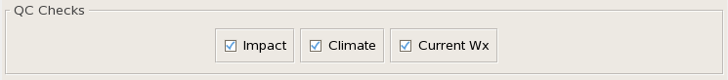
 | Click one or more QC Check buttons ‘off’. Note or Remember the setting for this site for later comparison. | The QC Checks button is clicked to ‘off’ similar to the one as shown below:
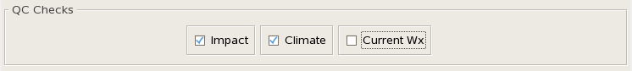
 | Press the Save button to preserve your selection for this site. | Settings are saved
 | From another monitor, open a terminal window and change the directory (cd) to /home/<username>/caveData/etc/site/<Localization Site Id (e.g., OAX)>aviation/config/tafs/<Site Id (e.g., KOMA)> and view the info.cfg file of the specified site. | Verify in [qc] section the changes that was saved from step #7 is reflected.
 | Repeat steps 4, 6 through 8, varying the active set of QC Checks for 2 more TAF sites (including no checks). Be sure to remember the settings for each one. | Settings re saved. These settings will become the default configuration for QC checks for each TAF location.
 | Close the TAF Site Info Editor GUI by clicking on the ‘Close’ button | TAF Site Info Editor GUI closes
- v | Close the Setup Main GUI via File > Quit | Setup Main GUI closes
 | From CAVE, select CAVE>New>Aviation>AvnFPS Menu. | The AvnFPS Menu is displayed.
 | Click on ‘TAFs’ button | AvnWatch appears similar to the one as shown below:
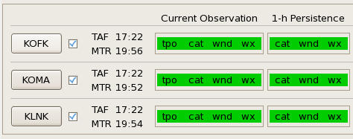
 | Start the TAF Editor by clicking on the Taf Editor button in the upper left portion of the AvnWatch GUI. | Taf Editor appears with nothing loaded into its text window.
 | Press ‘Load’ button on the TAF Editor GUI | Taf Loader appears similar to the one as shown below:
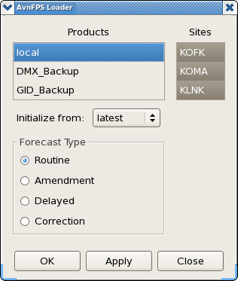
 | With all of the affected TAFs affected in steps 4 through 8 selected, “Initialized From” set to ‘latest’ and “Forecast Type” set to ‘Amendment’, press the ‘OK’ button | Most recent TAFs are loaded
 | Apply ‘Adjust Times’ procedure and click ‘Syntax’ button to verify proper TAF format. | TAFs are adjusted appropriately.
 | Now press the QC using the left-most mouse click. | After a few moments the status indicator in lower left should blink.
 | Now move the mouse over the TAFs. Whether highlighted or not, a balloon message should appear for each line in the TAFs. The balloon should report from each QC Check as configuration in step 4 through 8. | For current weather check the mouse is placed on the first line of the TAF similar to the one as shown below:
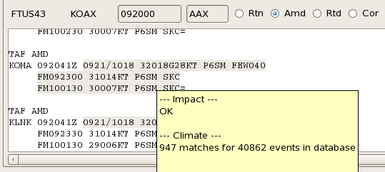
 | For other lines in the TAF, the balloon should report from each QC Check as configured in steps 4 through 8. | Other lines in the TAF may report from Impact and Climate checks but these are optional and should be consistent with what was configured in prior steps similar to the one as shown below:
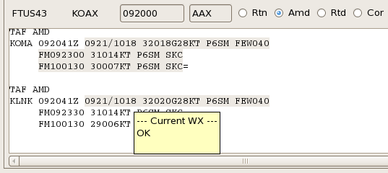
 | Now click on the QC button with the right most button. | QC dialog appears as shown below:
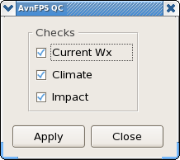
 | Proceed to click off and on various checks and press ‘OK’. This time the dialog will override any default configuration for each TAF. | The selection as shown below:
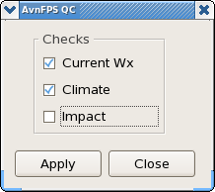
 | Move the mouse over the TAFs | Verify that a balloon message appears according to the selection from previous step as shown below:
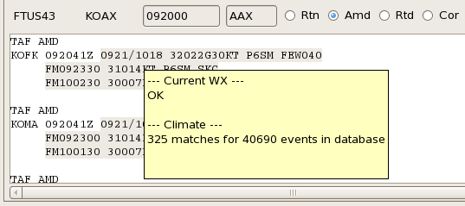
 | From another monitor, open a terminal window and change the directory (cd) to /home/<username>/caveData/etc/site/<Localization Site Id (e.g., OAX)>aviation/config/tafs/<Site Id (e.g., KOMA)> and view the info.cfg file of the specified site. | Verify in [qc] section the new values from step #22 did not override the change that was saved from step #7.
 | For any site, from QC dialog GUI, uncheck all QC options | All QC options are unchecked.
 | Move the mouse over the TAFs of the selected site from previous step | Verify that there should be no balloon message displays.
 | Proceed to try various combinations of the QC Checks via the QC dialog and confirm that the checks are done properly. Using the usual left-most mouse click results in the default, configured checks being performed. | QC check button performs as directed by either the default configuration defined in step 4 through 8 OR by the QC dialog.
 | Undo the changes from step 4 through 8 to set the QC Checks back to their original default setting. | The changes are rolled back to their original setting.
 | Close down the TAF Editor via the File > Close option. | TAF Editor closes.
 | Close AvnWatch via File > Quit option. | AvnWatch GUI closes.
End of test.

Table 1.1-2. Requirements Verification Traceability Matrix (RVTM)
Number | Description | Test Step (s)

