Title | B_Blended_TPW | Test Case Execution Engineer
Test Case Creation Engineer | Shen Zhao | Test Platform Used
Date Test Case Created | 06/02/2008 | Release Version on Testbed
CI | D2D | Logged in User’s Role
Site Specific | WFO | Start Date / Time
TC Updated for Version | AWIPS2 | Completion Date/Time
Last Modified By | Richard Barnhill (12/23/11) | Total Test Time
Executable Steps | 13 (unique) + 39 (repeats) = 52 | Pass/Fail/Pending

Test Case: | B_Blended_TPW
Test Case Description: | This test case is used to verify that two new derived satellite imagery products have been made available in AWIPS: Blended Total Precipitable Water (TPW) and Percent of Normal TPW. These two products will allow the forecasters to operationally monitor Total Precipitable Water fields using this unique observational data set. The Blended TPW product will provide the forecaster with the ability to (1) Monitor surges of moisture from the ocean areas into the U.S. (i.e., atmospheric rivers documented in scientific journals). These moisture surges can greatly influence the amount of rain produced by a storm. (2) Better anticipate and forecast heavy rain and flooding events.
Requirements: | - N These products will be generated for the Super national, Alaska, Hawaii, Puerto Rico and Guam sectors.  - AWIPS will display Blended TPW and Percent of Normal TPW images in D-2D when requested by a user. All normal D-2D image functionality shall be available for the displayed images (sampling, zooming, etc.).  - The Blended TPW and Percent of Normal TPW products will be generated 6 hours per cycle, four cycles per day.  - AWIPS will retain 32 Blended TPW image netCDF files in an appropriate nfs-mounted $FXA_DATA subdirectory for each product. The extra files will be automatically purged by the AWIPS purge scripts based on date and time.
Data Input: | N/A
Prerequisite Conditions: | N/A

Table 1.1-1. Test Steps and Expected Results
Step # | Actions / Inputs | Expected Results | P/F | Comments
 | In CAVE select the D2D perspective.. | D2D perspective opens.
 | From the Scale dropdown menu, select North America. Usually, CONUS is the default scale. | The main pane map scale changes to North America scale.
 | Click on Satellite → Derived Products Imagery → Blended Total Precip Water. | The Blended Total Precipitable Water image displayed.
 | Verify the image as shown below: | The color bar, legend, etc. should match.
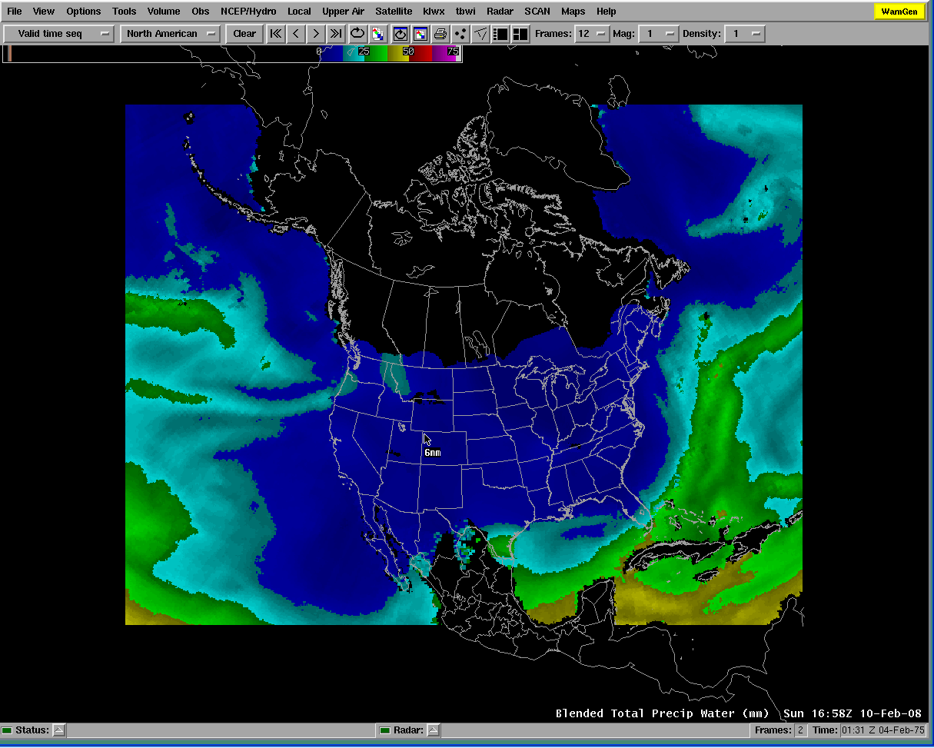
 | Press mouse button 1 and move the mouse. | The sampling unit is in mm.
 | Click on “<” or “>” button in the top panel of D2D display. | The products should be generated 6 hours per cycle, four cycles per day.
 | Repeat steps 3 - 6 with Percent Normal of TPW and the image as shown below: | The sampling should be “%”.
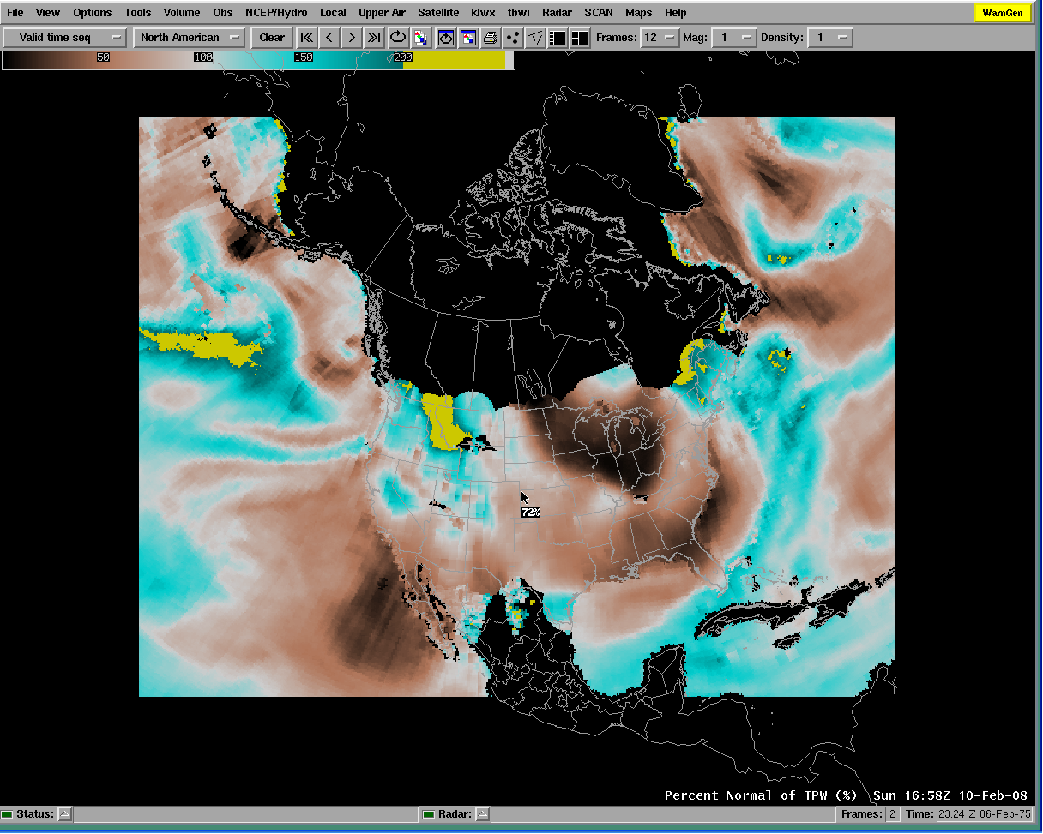
 | Test it with normal D2D features: panning, zooming, etc. | All should work normally.
 | Repeat steps 2 – 8 with CONUS, WFO, State(s), Regional, and N. Hemisphere scales.
 | Click on File → Exit. | D2D GUI closes.
Part 2. Purge
 | On any system, on an edex server, go to the directory list as below:  For sites at east CONUS, the products are stored in /awips2/edex/data/hdf5/satellite/polarE/conus_blended_pw/  and /awips2/edex/data/hdf5/satellite/polarE/conus_pct_pw/  For sites at west CONUS, the products are stored in /awips2/edex/data/hdf5/satellite/polarW/conus_blended_pw/ and /awips2/edex/data/hdf5/satellite/polarW/conus_pct_pw/ | The current directory is TPW directory.
 | Type “ls | wc –l” command to verify files are purged. | There shouldn’t be more than 32 data files + 1 template file + 1 extra file = 34 files in the directory (assuming at least one purge of the directory hourly) and shouldn’t be less than 33 files.
 | Log out and exit user access. | User exits from user access without incident.
Test Case Completed

Table 1.1-2. Requirements Verification Traceability Matrix (RVTM)
Number | Description | Test Step (s)
1

